**Design database for Zen class programme:**

**1.** Find all the topics and tasks which are thought in the month of October

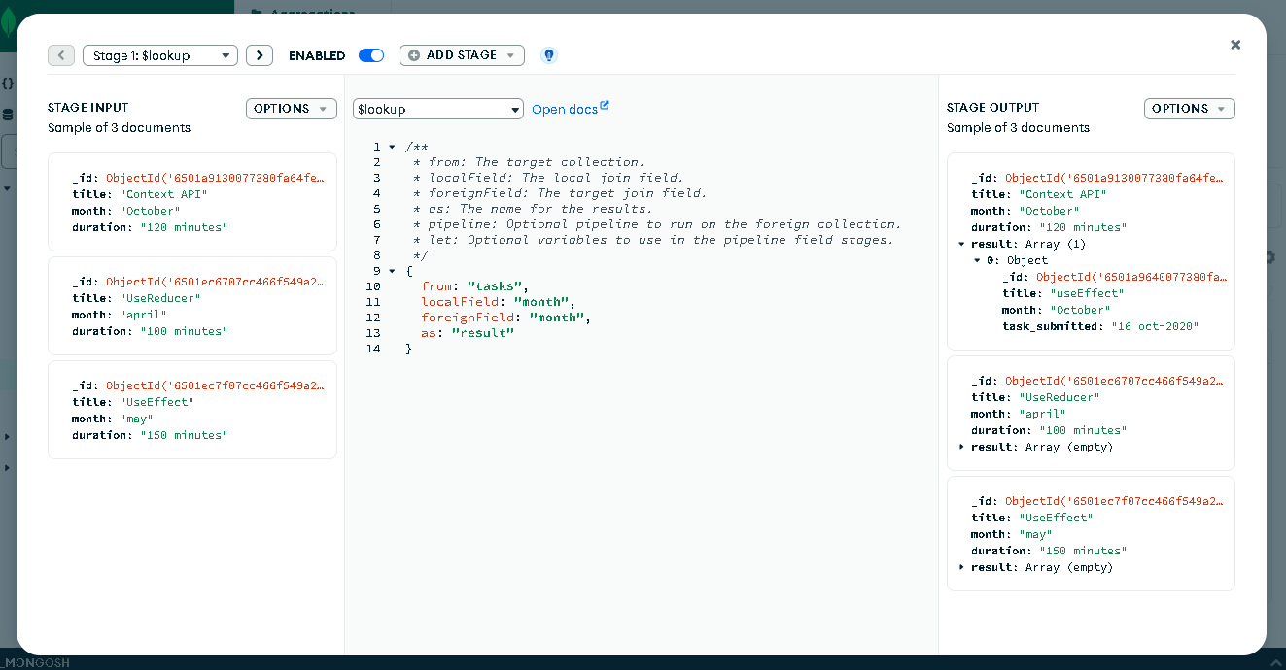

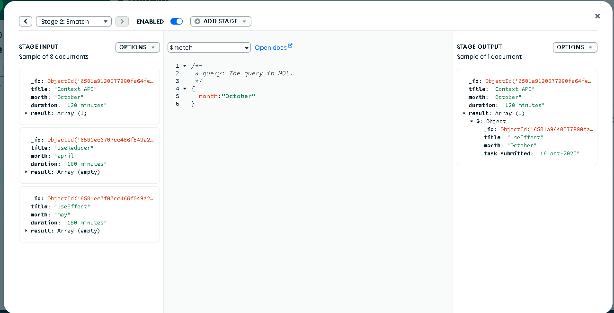

**********************

2. Find all the company drives which appeared between 15 oct-2020 and 31-oct-2020

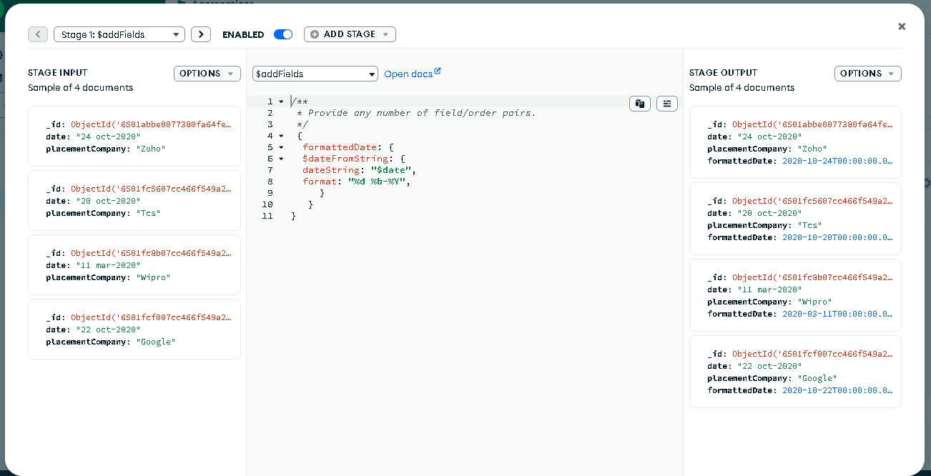

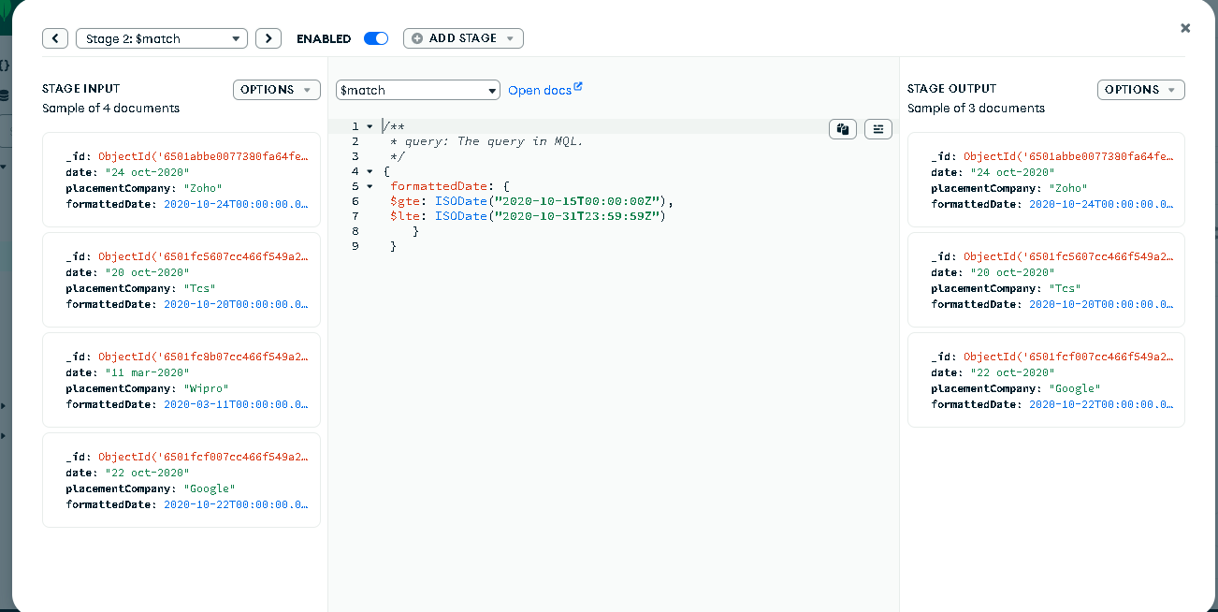

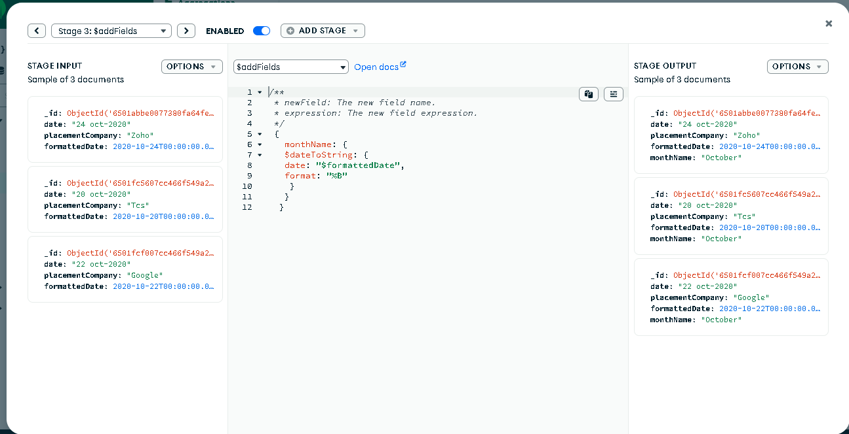

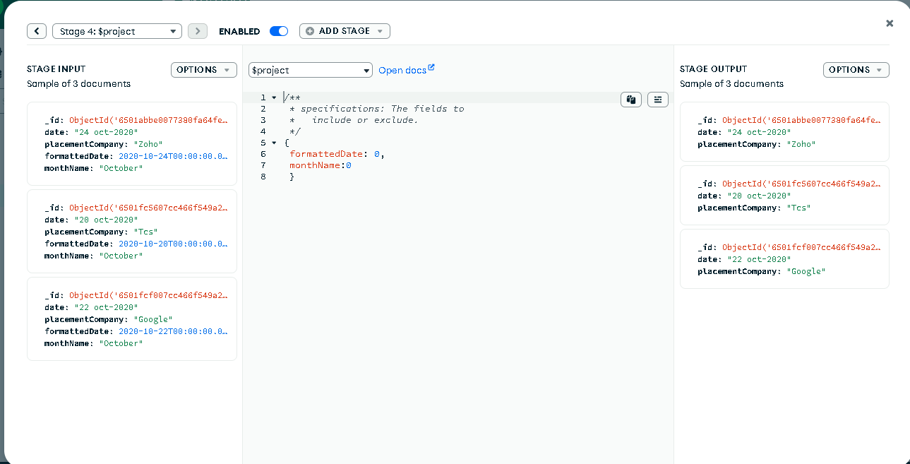

**********************

3. Find all the company drives and students who are appeared for the placement.

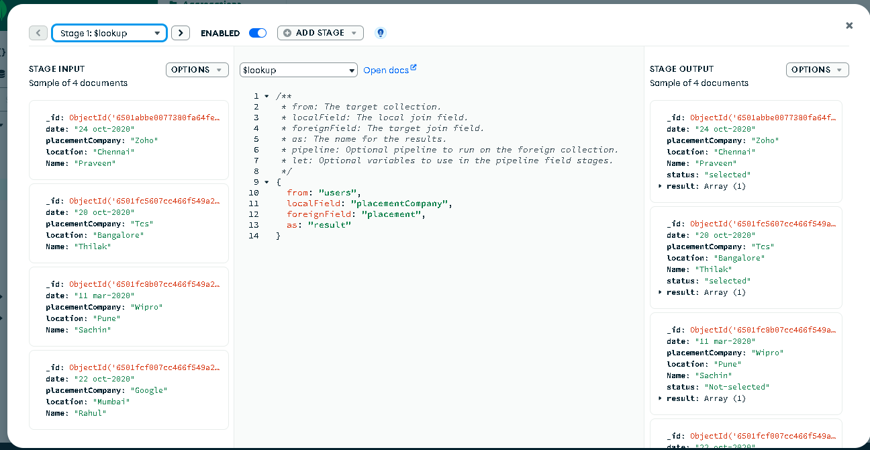

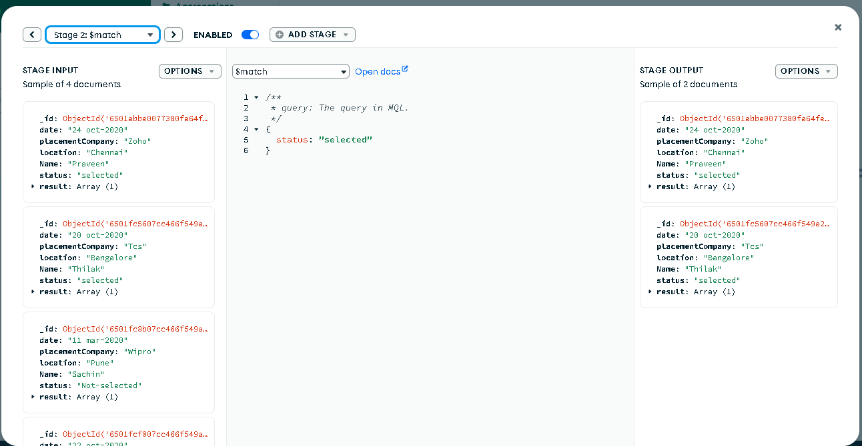

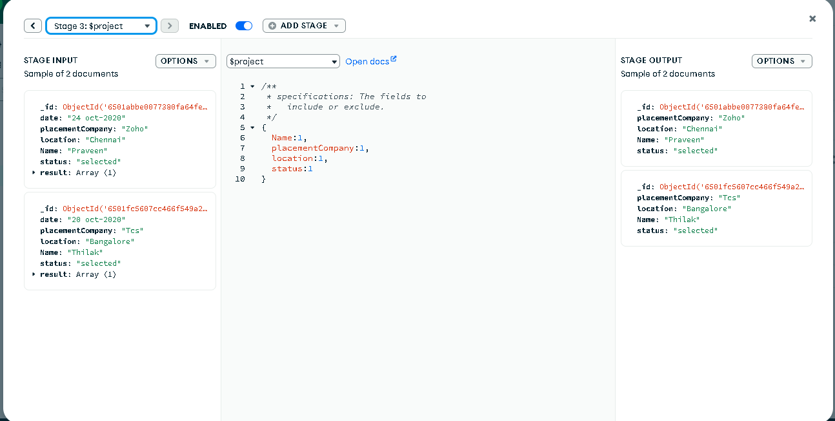

*************************

4.Find the number of problems solved by the user in Codekata

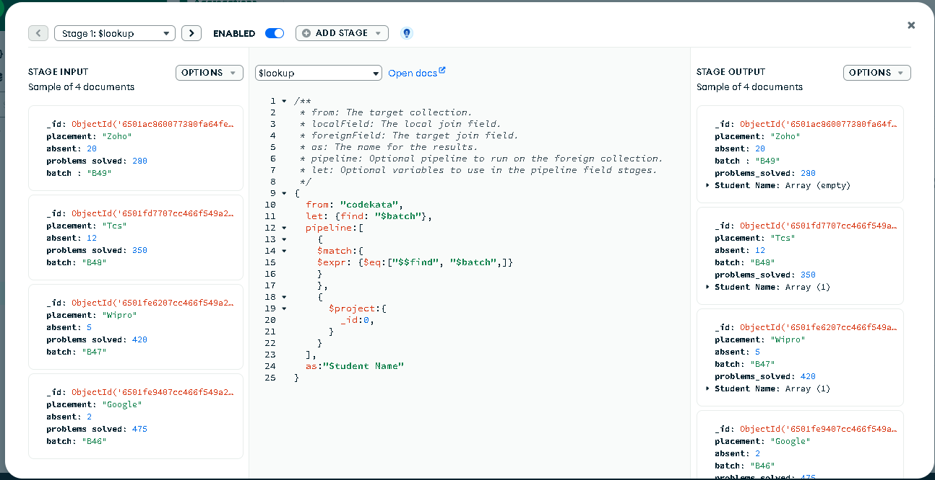

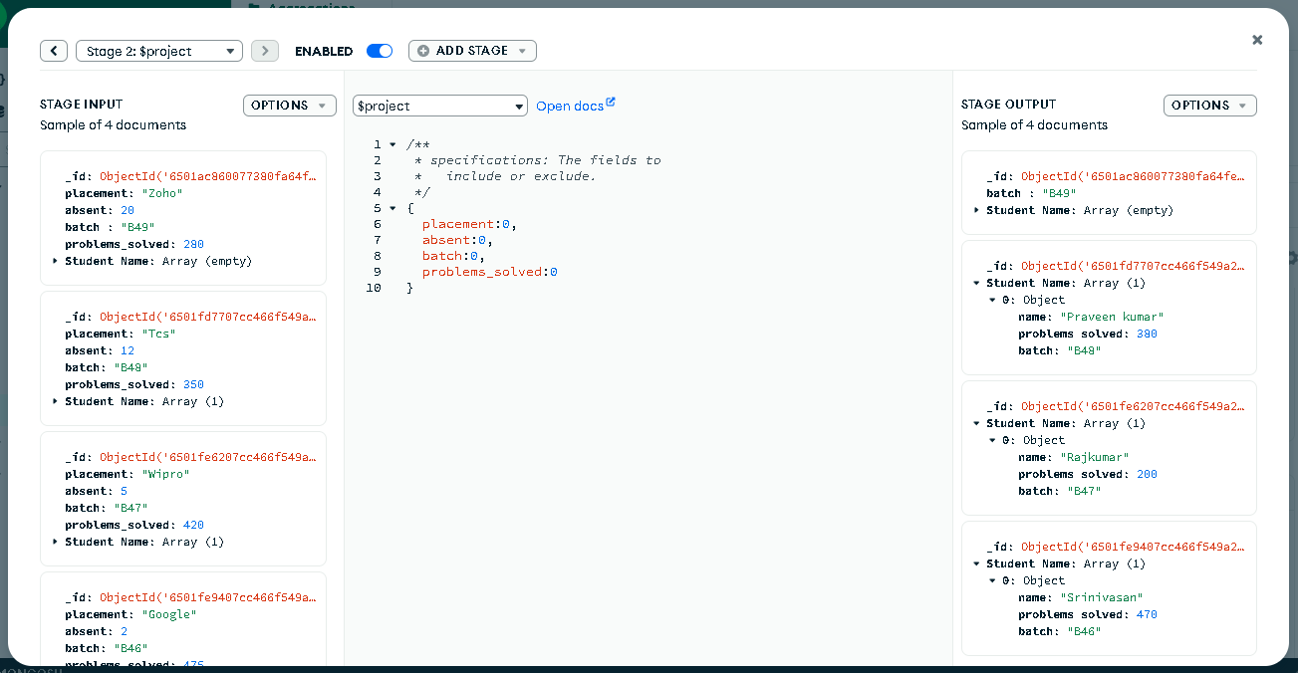

*********************

5. Find all the mentors with who has the mentee's count more than 15

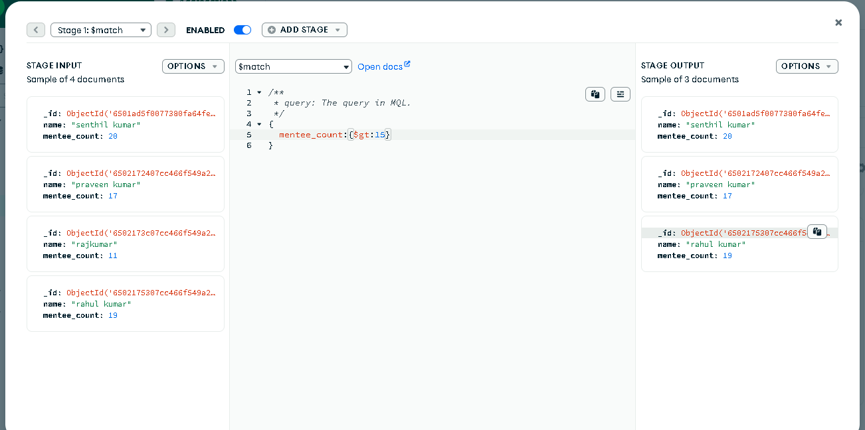

********************************

6. Find the number of users who are absent and task is not submitted  between 15 oct-2020 and 31-oct-2020

