Hall Booking API-Task

1.Creating a Room:

<http://127.0.0.1:3001/create_room>

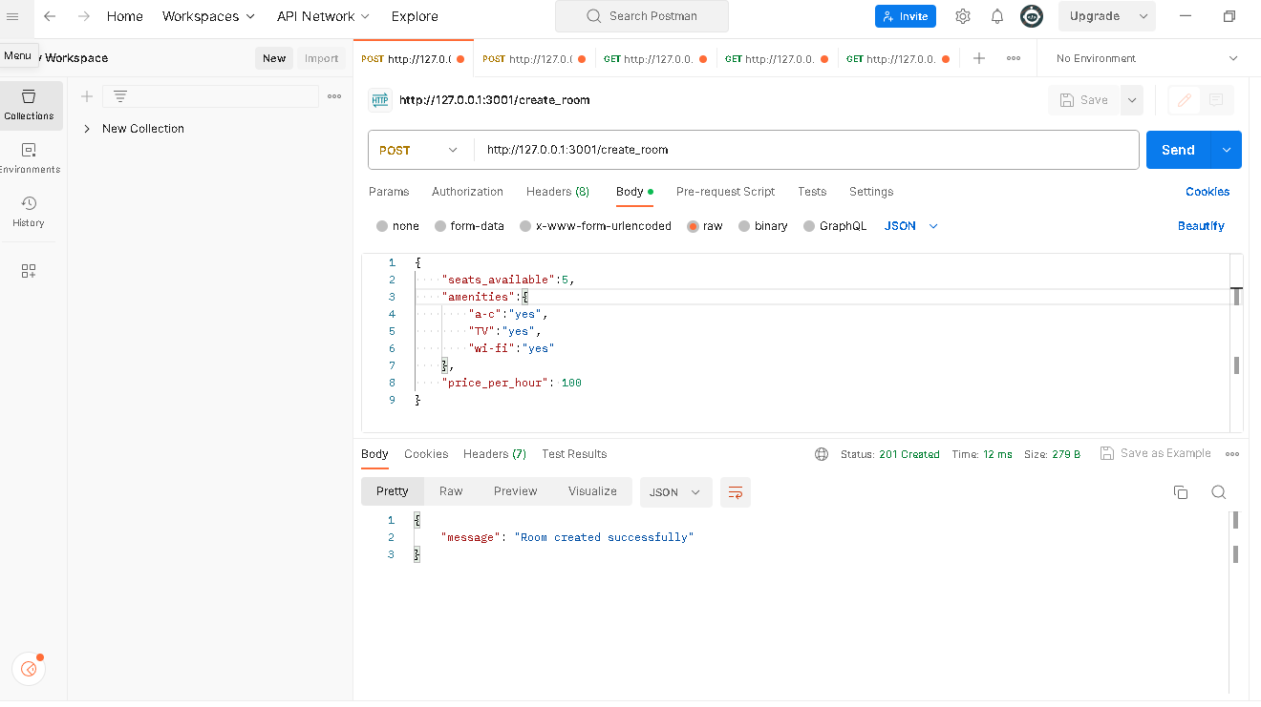

2.Booking a Room

<http://127.0.0.1:3001/book_room>

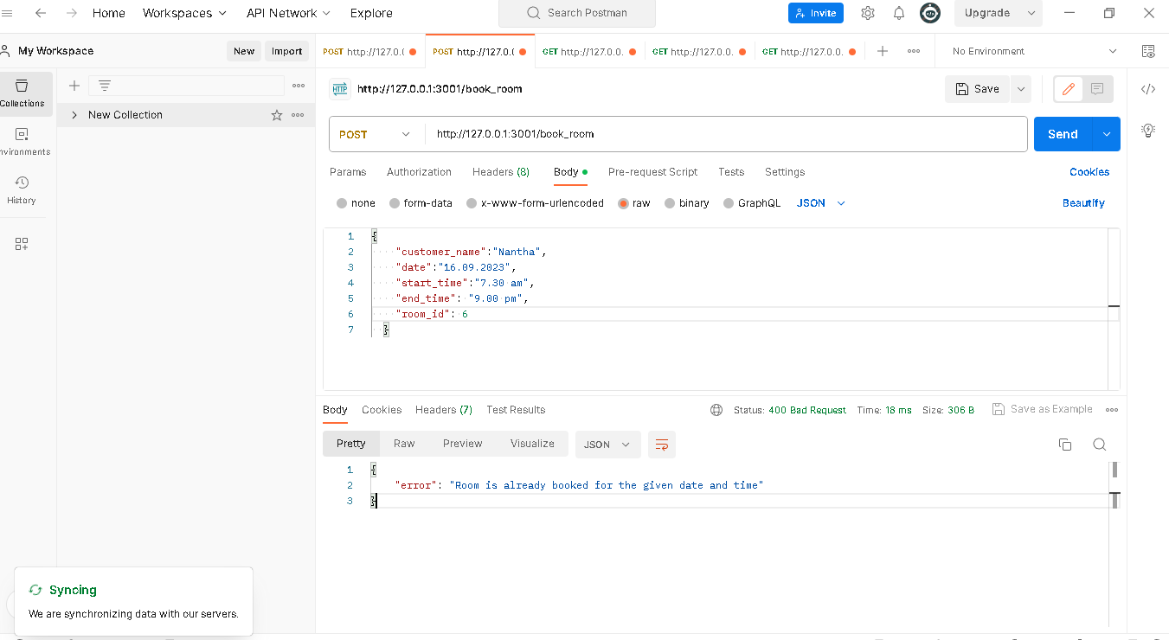

3.List all rooms with booked Data

<http://127.0.0.1:3001/list_rooms>

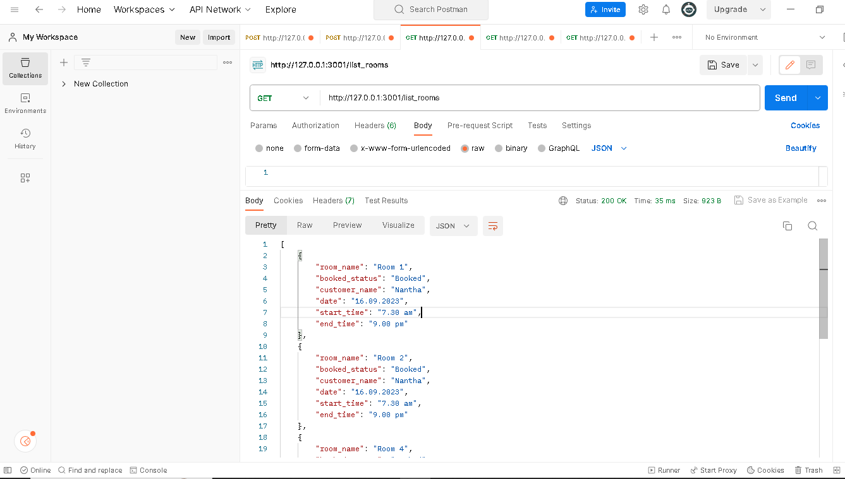

4.List all customers with booked Data

<http://127.0.0.1:3001/list_customers>

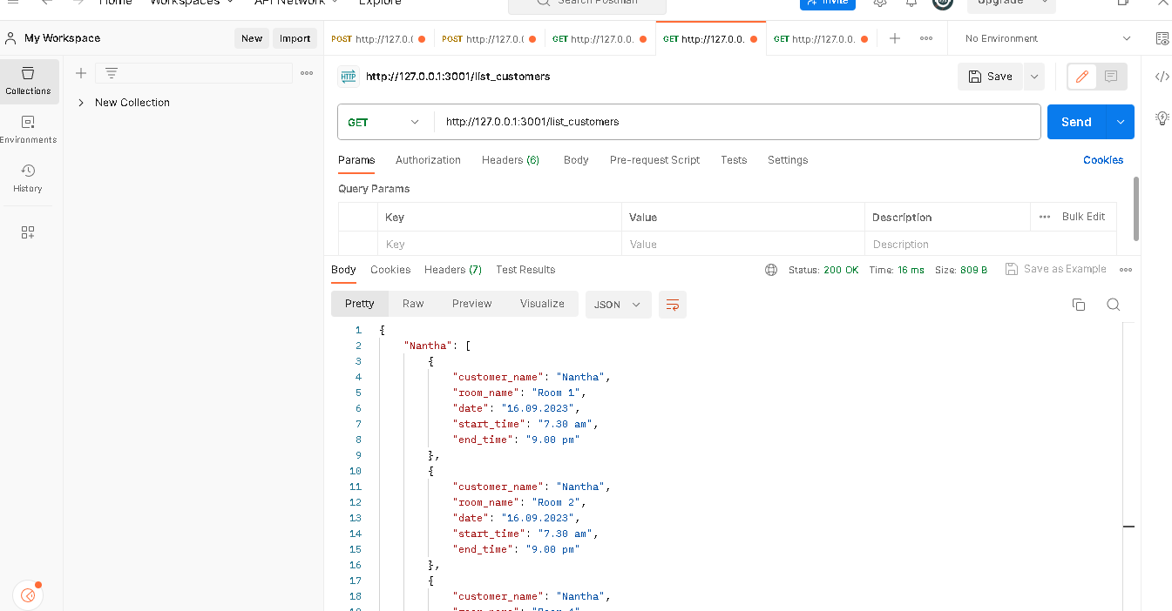

5.List how many times a customer book the room

<http://127.0.0.1:3001/customer_booking_count/Nantha>

