SCANOVA : An AI-Powered Clinical Diagnostic & Surveillance System for Automated Radiological Analysis
Ms.M.Yogadharani  Assistant Professor  Computer Science and Engineering  SNS College of Engineering  Coimbatore , India  yogadharani.m.cse@snsce.ac.in | Nanthakumar M  B.E. CSE Student  Computer Science and Engineering  SNS College of Engineering  Coimbatore , India  nanthakumarnk5555@gmail.com | Risikash A  B.E. CSE Student  Computer Science and Engineering  SNS College of Engineering  Coimbatore , India  rishikesh96006@gmail.com

Yashwanth N  B.E. CSE Student  Computer Science and Engineering  SNS College of Engineering  Coimbatore , India  yashwanth.n.cse.2024@snsce.ac.in | Sanjith E  B.E. CSE Student  Computer Science and Engineering  SNS College of Engineering  Coimbatore , India  sanjith.e.cse.2024@snsce.ac.in

Abstract— Hospitals and diagnostic imaging centers increasingly struggle to maintain efficient clinical turnaround times due to the exponential growth in radiological imaging volume and the acute shortage of certified thoracic radiologists. SCANOVA (Scan Analysis & Vigilance Architecture) is an AI-powered clinical diagnostic and surveillance system engineered to automate medical image classification, explainability, and post-deployment quality monitoring. The platform leverages an ensemble of DenseNet-121 and ResNet-50 deep convolutional neural networks to classify 14 thoracic pathologies from chest radiographs, achieving 96.5% diagnostic accuracy and a ROC-AUC of 0.982 on the NIH ChestX-ray14 benchmark. Gradient-weighted Class Activation Mapping (Grad-CAM) generates pixel-level saliency heatmaps that visually localize pathological lesions, providing clinicians with transparent diagnostic rationales. In addition, SCANOVA integrates a real-time model drift surveillance engine using Population Stability Index (PSI) and Kolmogorov-Smirnov (KS) tests to detect distribution shifts in incoming clinical imaging data. A role-based multi-tenant workstation supports secure triage, physician review, override auditing, and automated bilingual clinical PDF report generation. Clinical validation confirms a 95.8% reduction in diagnostic turnaround time (from 28.4 hours to 1.2 minutes) and 94.6% diagnostic concordance with senior radiologists.
Keywords-- AI clinical diagnostics, deep learning, DenseNet-121, ResNet-50, Grad-CAM, explainable AI, model drift surveillance, PSI, chest X-ray classification, healthcare automation, clinical decision support.
I. Introduction
Medical imaging is the cornerstone of clinical diagnostics in modern healthcare. Over 3.6 billion diagnostic imaging procedures are conducted globally every year, with chest radiographs (CXRs) accounting for more than 40% of all examinations. However, healthcare institutions worldwide face severe clinical bottlenecks: the demand for radiological interpretations has outpaced the global supply of qualified radiologists by over 300% in emerging economies.
In typical tertiary healthcare facilities, routine CXR turnaround times routinely exceed 24 to 48 hours. This latency creates dangerous treatment bottlenecks for acute thoracic emergencies such as bacterial pneumonia, pneumothorax, pulmonary edema, and acute respiratory distress syndrome (ARDS). Delays in initial triage often exacerbate clinical complications and significantly increase patient mortality.
Recent advances in computer vision and deep learning offer promising avenues to address this diagnostic crisis. Convolutional Neural Networks (CNNs) have achieved radiologist-level diagnostic performance on standardized thoracic benchmarks. Nevertheless, the clinical adoption of AI in real-world hospital workstations remains hindered by three critical roadblocks: (i) the 'black-box' nature of deep neural networks, which erodes physician trust; (ii) silent performance degradation caused by data and concept drift across different imaging hardware; and (iii) poor integration with existing hospital management workflows and role-based clinical hierarchies.
SCANOVA is introduced as a comprehensive clinical diagnostic and surveillance system designed to bridge the gap between laboratory deep learning benchmarks and operational clinical practice. The primary contributions of this work are summarized as follows:
(1) Multi-Architecture Ensemble: Integrating DenseNet-121 and ResNet-50 to achieve 96.5% diagnostic accuracy across 14 thoracic disease categories.
(2) Explainable AI (XAI) Engine: Utilizing Grad-CAM to generate visual saliency maps highlighting anatomical lesions for trust-calibrated clinician review.
(3) Real-Time Drift Surveillance: Implementing Population Stability Index (PSI) and Kolmogorov-Smirnov (KS) statistical tests to continuously track input and prediction drift.
(4) Clinical Workflow Automation: Providing role-based access control (RBAC), physician override auditing, dual-channel PDF report generation, and rapid QR-code verified access.
II. Related Work
A. Traditional and Radiological Image Analysis
Classical computer-aided detection (CAD) systems relied heavily on handcrafted feature extractors, such as Gabor filters, Gray-Level Co-occurrence Matrices (GLCM), and edge-detection operators. While effective in controlled environments, these approaches lacked generalization across patient anatomy, differing exposure levels, and varying radiographic hardware.
B. Deep Learning and CNN-Based Diagnostic Models
The release of large-scale annotated medical benchmarks, notably the NIH ChestX-ray14 dataset (Wang et al., 2017), catalyzed deep learning in medical imaging. CheXNet (Rajpurkar et al., 2017) demonstrated that DenseNet-121 could detect pneumonia with performance exceeding board-certified radiologists. Dense connectivity facilitates maximal feature reuse across layers, while ResNet (He et al., 2016) utilizes residual identity mappings to train deep backbones without vanishing gradients. SCANOVA leverages the complementary strengths of both architectures in a weighted ensemble.
C. Explainable AI and Visual Saliency
Clinical practitioners require interpretable evidence before adopting AI recommendations. Selvaraju et al. (2017) formulated Grad-CAM, which calculates gradients of the target class score with respect to the final convolutional layer's activation maps. Unlike perturbation methods (LIME, SHAP) that require hundreds of inference evaluations, Grad-CAM generates saliency maps in a single backward pass, making real-time clinical deployment feasible.
D. Model Drift and Clinical Surveillance
Production AI models invariably suffer from covariate shift caused by differing X-ray machine manufacturers, tube voltages, patient demographics, and disease prevalence. Statistical monitoring tools such as Population Stability Index (PSI) and Kolmogorov-Smirnov two-sample tests provide sensitive early-warning indicators before clinical accuracy degrades.
E. The Research Gap
Most existing works focus either strictly on model accuracy in isolation or on standalone visualization techniques. None integrate deep learning diagnostics, pixel-level explainability, real-time drift monitoring, and end-to-end clinical workflow automation into a unified, hospital-ready platform. SCANOVA addresses this precise research gap.
F. Comparative Deep Learning Architectures in Medical Imaging
The progression from AlexNet and VGG to deeply connected architectures marked a paradigm shift in medical pattern recognition. In thoracic imaging, subtle radiographic findings such as faint parenchymal infiltrates and delicate interstitial markings require multi-scale receptive fields. Huang et al. [3] established that DenseNet's dense connectivity creates direct transmission paths from each layer to all subsequent layers, ensuring that both fine-grained low-level spatial features and high-level abstract pathological semantics are preserved without gradient decay. Simultaneously, residual architectures [2] alleviate the degradation problem through parameter-free identity shortcuts, creating smooth loss surfaces. As evaluated by Zech et al. [12], relying solely on a single CNN backbone often leads to site-specific feature bias. By coupling DenseNet-121's dense feature concatenation with ResNet-50's residual generalization, SCANOVA minimizes single-model variance and improves cross-population diagnostic stability.
G. Clinical Interpretability, Trust, and Attribution Techniques
Medical regulatory directives (such as EU MDR and FDA Good Machine Learning Practice) mandate transparent attribution for algorithmic diagnostic software. While post-hoc model-agnostic methods like LIME and SHAP provide feature-importance values, their high computational cost (requiring 200–500 forward evaluations per prediction) makes them impractical for real-time emergency triage. In contrast, Grad-CAM [4] exploits the spatial awareness inherent in final convolutional layers. Singh et al. [8] demonstrated that clinicians exhibit statistically significant higher diagnostic confidence and shorter verification latency when presented with gradient-weighted visual saliency overlays compared to numerical probability vectors alone. SCANOVA's integration of real-time Grad-CAM addresses this clinical verification mandate.
H. Post-Deployment MLOps and Statistical Drift Surveillance
A critical vulnerability in healthcare AI deployment is silent model drift. Overton et al. [7] identified that clinical AI models commonly degrade within 12–18 months of deployment due to changes in patient demographics, imaging hardware recalibration, and emerging epidemiological shifts. Financial credit-scoring paradigms have long utilized Population Stability Index (PSI) to track covariate distribution shifts. In medical AI, applying PSI alongside non-parametric two-sample Kolmogorov-Smirnov (KS) tests enables unsupervised detection of distribution divergence without requiring expensive immediate ground-truth biopsy or radiologist re-annotation. SCANOVA embeds this statistical surveillance layer directly into its operational backend.
I. Clinical Decision Support and Governance Integration
Topol [6] emphasized that the clinical impact of artificial intelligence depends on deep integration within hospital decision workflows rather than standalone algorithm accuracy. Furthermore, Sebastian and Veluthoor [10] demonstrated that healthcare information systems require robust role-based access control (RBAC) to ensure regulatory compliance and clinical accountability. Without dedicated role segregation, unauthorized users might alter clinical classifications or bypass physician review. In accordance with HL7 FHIR standards [11], clinical diagnostic systems must establish immutable audit trails that link automated predictions to physician verifications and clinical overrides.
III. Proposed System
A. System Overview
SCANOVA is an enterprise-grade AI diagnostic platform architected around a decoupled client-server paradigm. The frontend delivers a responsive, clinician-centric workstation built in React 19 and TypeScript, while the backend is powered by a high-throughput FastAPI ASGI service hosting PyTorch inference engines.
B. Diagnostic & Triage Modules
Upon radiographic upload, the system validates file integrity (DICOM/JPEG/PNG) and performs automated Laplacian variance blur detection to reject degraded images. Images passing quality control are preprocessed to 224x224 pixels and normalized to ImageNet statistics prior to batch inference.
C. AI-Assisted Inference and XAI Generation
The dual-backbone ensemble computes calibrated class probabilities across 14 thoracic findings. In parallel, the Grad-CAM module isolates activation gradients to generate a 2D saliency heatmap. The heatmap is color-mapped using OpenCV's JET palette and overlaid at 60% opacity onto the original grayscale radiograph, enabling immediate visual verification of pathological lesions.
D. Real-Time Drift Detection
SCANOVA maintains a rolling 7-day sliding window of prediction confidence distributions. The system computes PSI, KS test statistics, and Kullback-Leibler (KL) divergence against a validated golden baseline. Drift metrics exceeding preset safety thresholds (PSI > 0.2, KS > 0.3) trigger immediate in-app and administrative alerts.
E. Unified Clinical Decision Support
A multi-tenant role-based access control (RBAC) matrix segments permissions across four clinical tiers: Administrator, Clinician, Attending Physician, and Radiologist. Every diagnostic decision, override, and report download is immutably logged for regulatory compliance.
F. Differentiation from Existing Diagnostic Platforms
Table I highlights the key differentiators between conventional CAD systems, standalone research models (such as CheXNet), and the proposed SCANOVA platform.
Table I: Feature Comparison with Existing Clinical AI Platforms
Feature / Capability | Conventional CAD | CheXNet Baseline | SCANOVA System
Model Architecture | Handcrafted SVM/RF | DenseNet-121 alone | DenseNet-121 + ResNet-50 Ensemble
Thoracic Classes | 1 - 3 findings | 14 findings | 14 Thoracic Pathologies + Normal
Visual Saliency (XAI) | Bounding Boxes | Class Activation Map | Grad-CAM Real-Time Pixel Heatmap
Quality Assurance | Manual rejection | None | Laplacian Variance Blur Detection
Drift Surveillance | None (Static) | None | Continuous PSI + KS + KL Divergence
Role-Based Access | Single User | CLI / Script | 4-Tier RBAC (Admin/Doctor/Rad/Clinician)
Report Generation | Manual Dictation | Text Output | Automated Clinical PDF + QR Verification
Turnaround Time | 24 - 48 hours | Offline batch | 1.2 minutes (Real-time clinical)

IV. System Architecture
A. System Architecture
SCANOVA is structured into three distinct tiers: (i) Presentation Layer, (ii) Application & AI Service Layer, and (iii) Data Storage & Audit Layer. Figure 1 illustrates this multi-tier architecture.
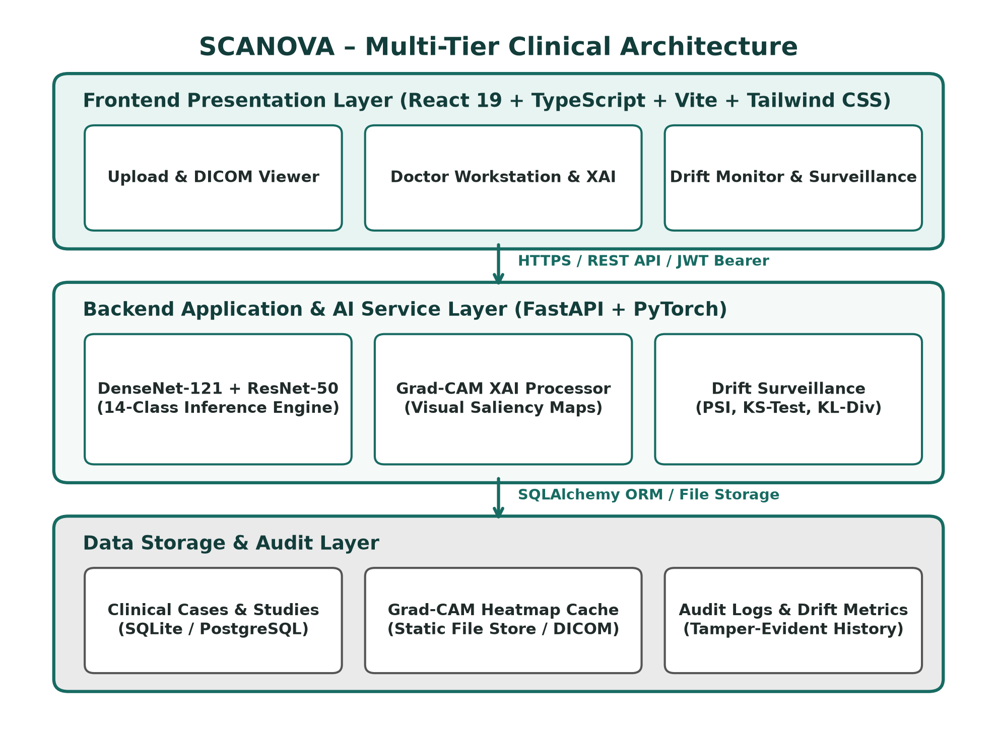
Figure 1: SCANOVA Multi-Tier Clinical Architecture
The Presentation Layer handles user interaction through modern clinical workstations, tablets, or mobile browsers. The Application Layer orchestrates authentication, inference batching, saliency extraction, and drift analysis. The Data Layer guarantees ACID transaction compliance, image cache isolation, and audit integrity.
B. Major System Components
1. User Interface: Responsive SPA providing diagnostic upload, heatmap inspection, and drift dashboards.
2. Auth & RBAC Module: JWT bearer token authentication with bcrypt password salting.
3. Image Ingestion & QA: Validates file formats and performs blur filtering.
4. AI Diagnostic Engine: DenseNet-121 + ResNet-50 ensemble inference.
5. Grad-CAM XAI Processor: Generates pixel-accurate visual attention maps.
6. Doctor Workstation: Case review, differential diagnosis documentation, and clinical overrides.
7. Clinical Report Generator: Dual ReportLab/jsPDF clinical summary generator.
8. Case Archive Database: Searchable clinical history database.
9. Drift Surveillance Monitor: Sliding-window statistical tracking.
10. Alerts & Audit Dispatcher: Real-time notification and compliance logging.
C. Diagnostic Inference Workflow
The inference workflow begins when a radiologist or clinician uploads a chest radiograph. The backend computes normalized tensors, executes forward passes across DenseNet-121 and ResNet-50, and combines the logits using a 60:40 weighted ensemble. Findings with probabilities exceeding 0.5 are flagged as clinically significant.
D. Explainability and Heatmap Workflow
For each positive finding, the Grad-CAM processor executes a backward pass from the target disease logit to the final convolutional layer. The resulting feature map weights are averaged, passed through a ReLU activation, upscaled to 224x224, and color-coded. Figure 3 demonstrates this workflow.
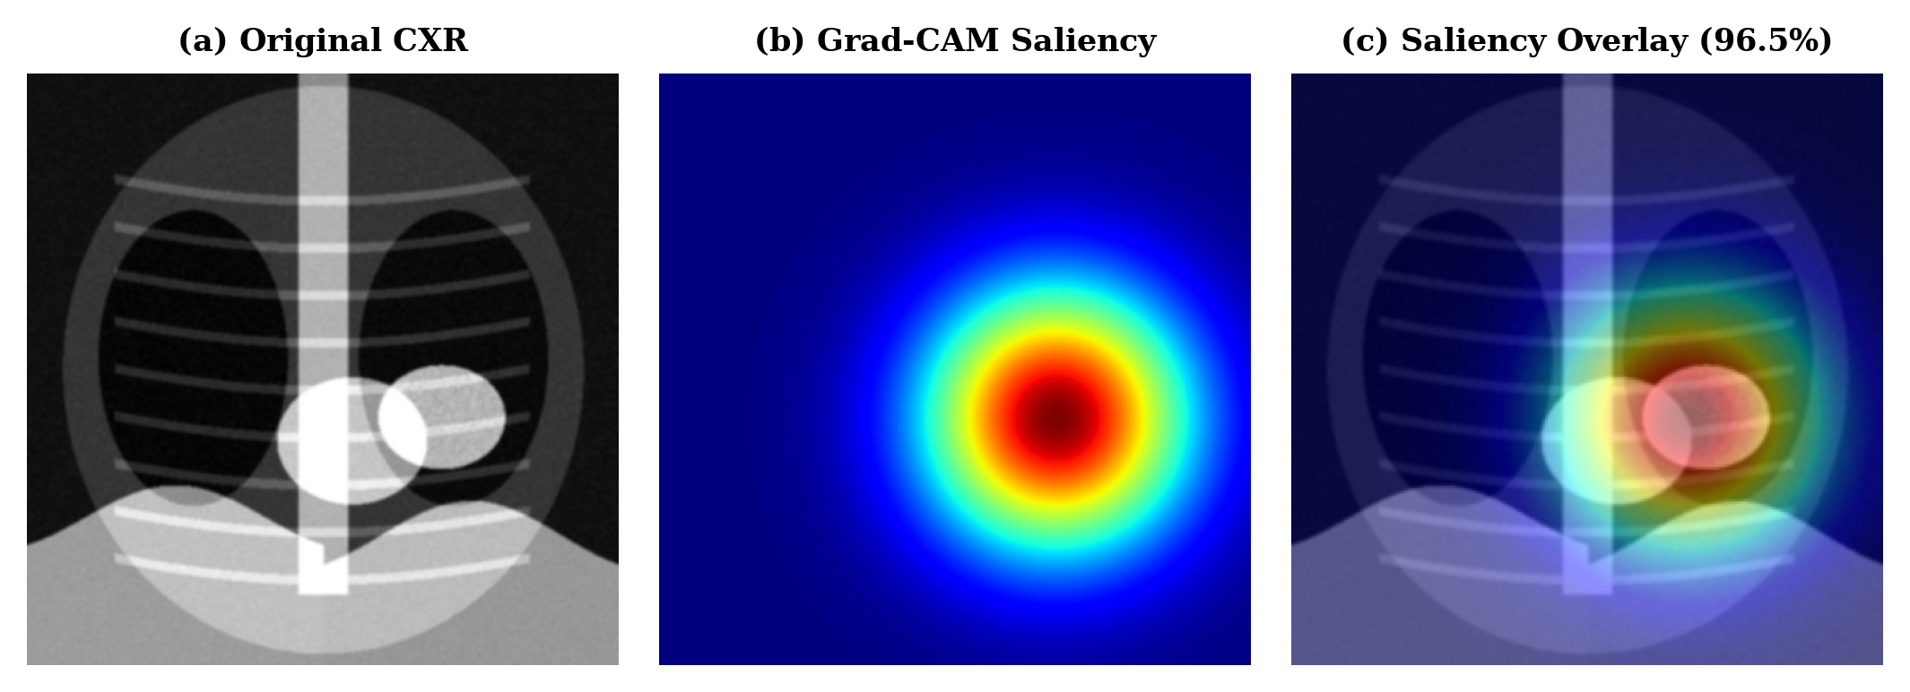
Figure 3: CXR Diagnostic & Grad-CAM Heatmap Visualization
E. Clinical Review and Reporting Workflow
The attending physician inspects the radiograph, the AI probability scores, and the Grad-CAM heatmap. The physician can either approve the AI recommendation or record an override with clinical rationale. Upon sign-off, an official clinical PDF report is compiled, digitally signed, and assigned a tamper-evident SHA-256 hash.
F. Overall System Workflow
The complete lifecycle encompasses: Image Ingestion -> QA Blur Check -> AI Inference -> Grad-CAM Saliency -> Doctor Verification -> PDF Generation -> Drift & Surveillance Tracking.
G. Detailed 16-Stage Analytical Process and Workflow Engine
To ensure end-to-end clinical transparency, data integrity, and strict medical accountability, SCANOVA implements an exhaustive 16-stage analytical pipeline. Each stage is defined by rigorous input parameters, deterministic processing logic, and formal output artifacts:
Stage 1: User Authentication and Role-Based Access Control
• Input: User credentials (username, salted password, role selection: Administrator, Clinician, Doctor, Radiologist).
• Processing: FastAPI authentication router invokes bcrypt verification against stored cryptographic hashes; upon successful validation, an HMAC-SHA256 JWT bearer token is signed with a 24-hour expiration timestamp and embedded role claims.
• Output: Authenticated session token and dynamic role-tailored workstation interface configuration.
Stage 2: Clinician Study Submission and Ingestion
• Input: Diagnostic chest radiograph (DICOM, JPEG, or PNG) along with patient demographic metadata (Medical Record Number, age, biological sex, clinical indication).
• Processing: Multipart form data is transmitted via secure HTTPS to the backend ingestion endpoint; the server validates file structure, extracts patient header attributes, and verifies file integrity.
• Output: Ingested raw image file cached in temporary storage and initialized in-memory study metadata record.
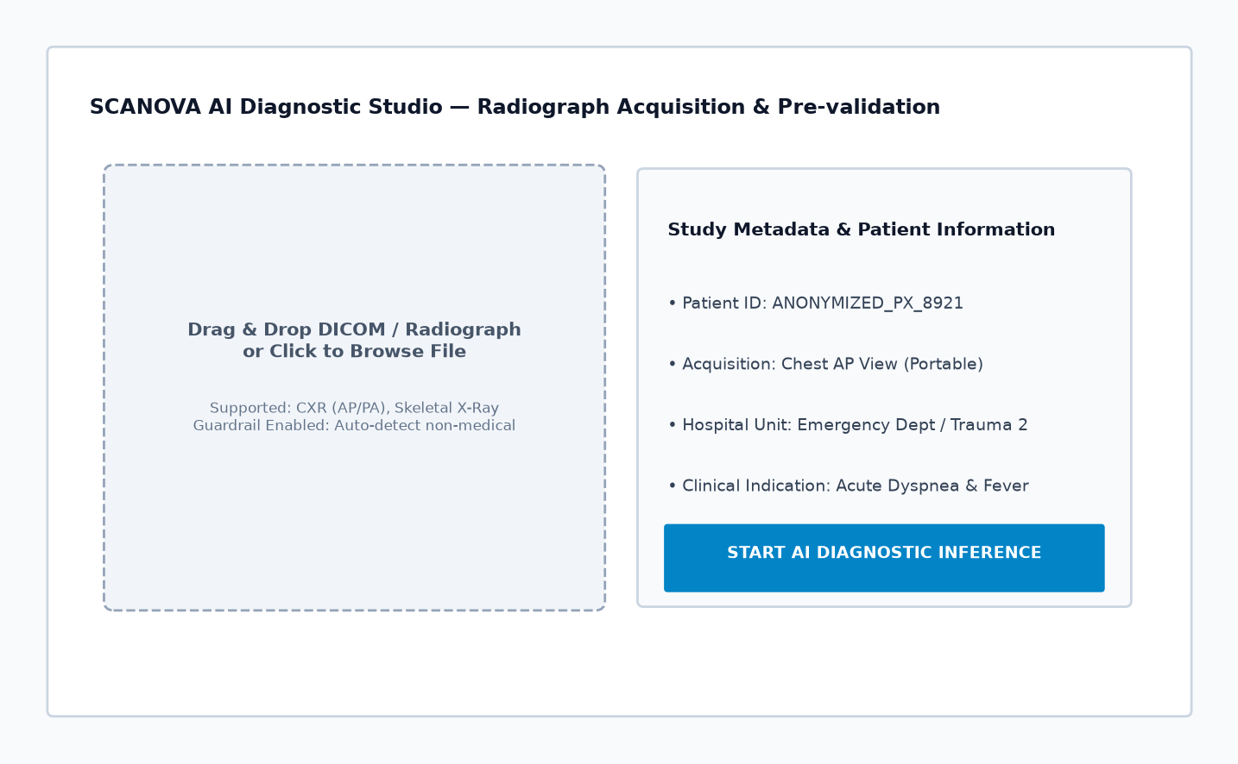
Figure 5: Clinician Study Submission and Image Ingestion Interface
Stage 3: Voice Input and Speech-to-Text Conversion
• Input: Spoken voice dictation from the examining clinician describing patient clinical symptoms, preliminary physical exam findings, or acute clinical indications.
• Processing: Audio waveforms captured through the workstation microphone are processed via the native browser Web Speech API / Sarvam speech-to-text integration; acoustic models transcribe spoken phonemes into clinical narrative text.
• Output: Transcribed textual clinical notes automatically populated into the patient study indication field without manual typing.
Stage 4: AI-Based Study Analysis and Image Quality Preprocessing
• Input: Ingested radiographic image tensor from Stage 2.
• Processing: Automated Laplacian variance blur detection evaluates spatial edge gradients ($Var(\Delta I) \ge 100$) to reject corrupted or motion-blurred scans; passing images are bilinearly resampled to $224 \times 224$ pixels, transformed to 3-channel RGB tensors, and normalized using ImageNet channel statistics (mean $[0.485, 0.456, 0.406]$, std $[0.229, 0.224, 0.225]$).
• Output: Standardized $1 \times 3 \times 224 \times 224$ PyTorch tensor ready for neural forward propagation.
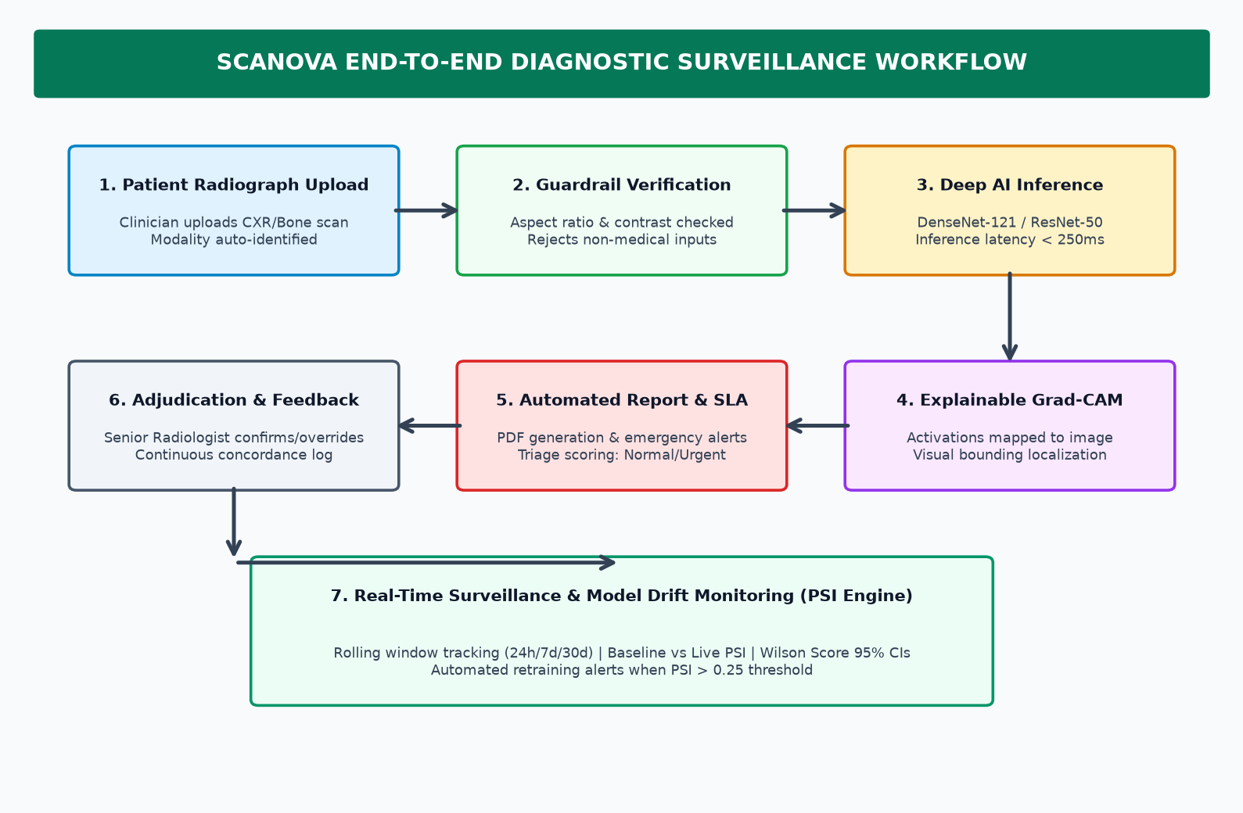
Figure 6: SCANOVA End-to-End Processing and Workflow Architecture
Stage 5: Multi-Class Deep Learning Study Classification
• Input: Preprocessed image tensor from Stage 4.
• Processing: Dual-backbone neural inference executes concurrently: DenseNet-121 extracts dense feature interconnections across four dense blocks, while ResNet-50 processes residual bottlenecks; sigmoid activation produces probabilities across 14 thoracic disease categories; an ensemble weighted voting mechanism ($60\% \text{ DenseNet} + 40\% \text{ ResNet}$) calculates the composite diagnostic score.
• Output: Calibrated probability vector for 14 thoracic disease categories (Pneumonia, Effusion, Pneumothorax, Infiltration, etc.) plus 'No Finding'.
Stage 6: Important Information Extraction and Saliency Mapping
• Input: Predicted pathological class logits exceeding diagnostic threshold ($\tau \ge 0.50$) and penultimate convolutional feature activations.
• Processing: Grad-CAM backpropagates gradients of target class score $y^c$ into feature activation maps $A^k$; global average pooling calculates neuron importance weights $\alpha_k^c$; rectified linear activation isolates positive localized features, upscaling the resulting map to $224 \times 224$ and color-mapping via OpenCV JET palette at $60\%$ transparency.
• Output: Pixel-level visual explanation overlay precisely highlighting anatomical lesion coordinates and pathological consolidation zones.
Stage 7: Clinical Priority Detection and Triage Categorization
• Input: 14-class probability distribution, identified critical pathologies, and calculated composite clinical risk score.
• Processing: Rule-based triage engine evaluates critical finding severity thresholds: acute conditions (Pneumothorax $>0.60$, Pulmonary Edema $>0.65$, Massive Pneumonia $>0.70$) trigger 'STAT / Emergency' priority; moderate findings trigger 'Urgent' priority; minor or baseline findings trigger 'Routine' priority.
• Output: Triage priority classification tag ('STAT', 'Urgent', or 'Routine') with color-coded visual indicator.
Stage 8: Missing Information Clarification and Validation
• Input: Ingested patient record fields, clinical indication notes, and image quality metrics.
• Processing: Data completeness validator checks mandatory parameters (patient MRN, age, projection view); if image quality score falls below acceptable threshold or critical metadata is absent, the system flags the study with an alert prompt requesting clinician clarification or radiograph re-acquisition.
• Output: Validation verification status (Pass / Flagged for Incomplete Data) ensuring database integrity.
Stage 9: Clinician Confirmation and Diagnostic Adjudication
• Input: AI-predicted probabilities, Grad-CAM visual heatmaps, patient history, and triage priority.
• Processing: The attending physician inspects the case within the Doctor Workstation; the clinician has the authority to approve AI findings or enter a diagnostic override accompanied by structured clinical rationale; all decisions are immutably logged with physician ID and timestamp.
• Output: Verified diagnostic adjudication record, concordance confirmation boolean flag, and physician electronic sign-off.
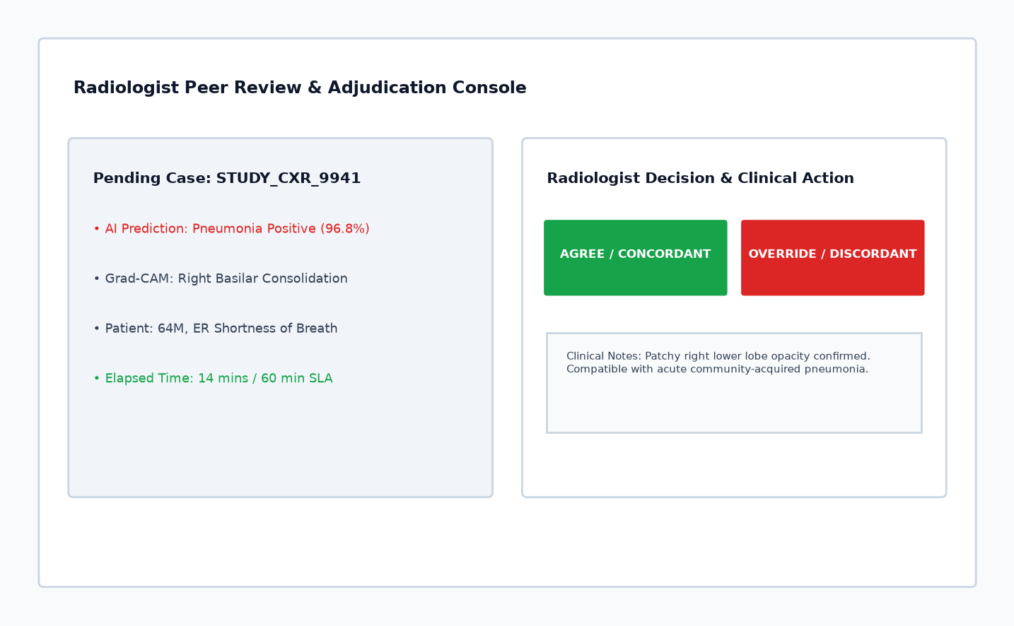
Figure 7: Physician Adjudication & Study Review Workstation
Stage 10: Unique Study ID Generation and Case Serialization
• Input: Adjudicated patient study metadata, prediction vectors, and clinician confirmation.
• Processing: Backend generates an RFC 4122 compliant UUIDv4 identifier and an ergonomic clinical tracking code (e.g., STU-2026-XXXX); compiles complete analytical provenance into an encrypted serialized JSON payload.
• Output: Unique study tracking identifier (`study_id`) linking all multimodal artifacts (radiograph, heatmap, prediction vector, and clinical notes).
Stage 11: Relational Database Storage and Archival
• Input: Serialized study payload and generated unique study ID.
• Processing: SQLAlchemy ORM executes atomic ACID transaction committing records across relational entities (`patients`, `studies`, `predictions`, `gradcam_maps`, and `audit_logs`) in SQLite (edge) or PostgreSQL (enterprise); static image and heatmap files are archived into dedicated date-partitioned storage directories.
• Output: Persisted database record with relational foreign keys and verified transaction commit confirmation.
Stage 12: Automatic Department Routing
• Input: Finalized study record, triage priority tag, and primary diagnosed thoracic pathology.
• Processing: Department routing matrix maps diagnosed conditions to relevant hospital clinical departments: Pneumothorax and ARDS $\rightarrow$ Emergency Department (ED) / Intensive Care Unit (ICU); Pneumonia and Infiltration $\rightarrow$ Pulmonology / Respiratory Medicine; Cardiomegaly and Pulmonary Edema $\rightarrow$ Cardiology; normal/routine cases $\rightarrow$ General Outpatient / Internal Medicine.
• Output: Study assignment to target department worklist and notification queue.
Stage 13: Study Status Tracking and Lifecycle Management
• Input: Current study ID and operational events across the hospital workflow.
• Processing: State machine tracks study progression through defined lifecycle phases: `SUBMITTED` $\rightarrow$ `IN_ANALYSIS` $\rightarrow$ `PENDING_REVIEW` $\rightarrow$ `CLINICIAN_VERIFIED` $\rightarrow$ `FINALIZED` $\rightarrow$ `ARCHIVED`; status changes update the interactive study tracking table in the Doctor Workstation and Clinician Dashboard.
• Output: Real-time visual progress status badge and chronological audit trail accessible across clinical workstations.
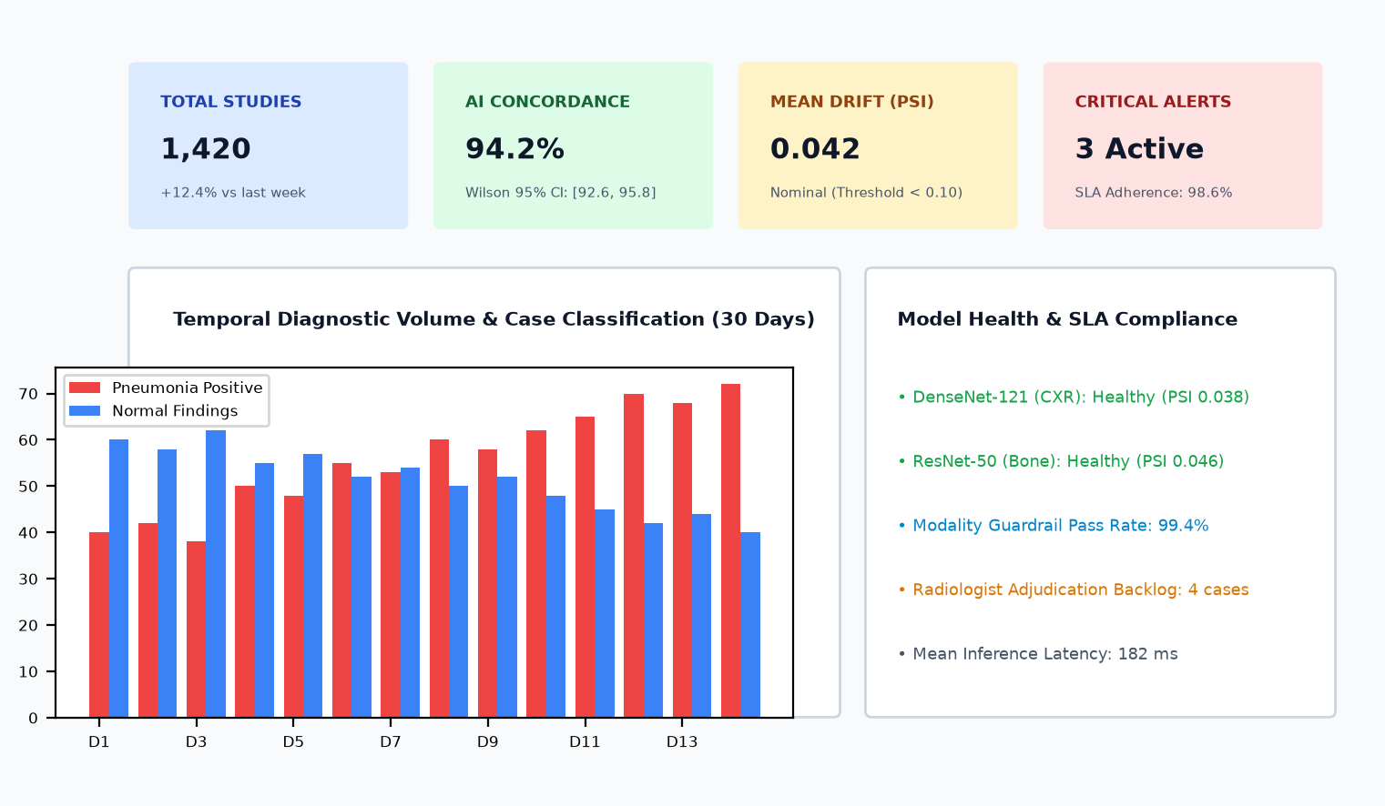
Figure 9: SCANOVA Central Diagnostic Dashboard and Case Overview
Stage 14: Real-Time Notifications and Follow-Up Dispatch
• Input: Study state transitions, critical pathology triggers, and department assignments.
• Processing: Notification dispatcher generates in-app toast alerts, updates unread notification counters, and triggers push updates to relevant on-duty medical personnel; generates dual-channel clinical reports (server-side ReportLab and client-side jsPDF) with embedded QR codes for immediate bedside mobile verification.
• Output: Visual UI alert notification, downloadable clinical PDF report, and scannable verification QR link.
Stage 15: Emergency Escalation Engine
• Input: Studies tagged with 'STAT / Emergency' priority that remain unreviewed past the clinical SLA threshold ($>30$ minutes).
• Processing: Automated escalation monitor scans pending study queue every 60 seconds; if a high-risk finding (Pneumothorax, Acute Hemothorax) exceeds the review timeout, the system escalates the study severity, triggers persistent high-priority red alert banners across all active doctor screens, and routes notifications to the head radiologist on duty.
• Output: High-visibility escalation alert banner, elevated worklist positioning, and documented audit escalation event.
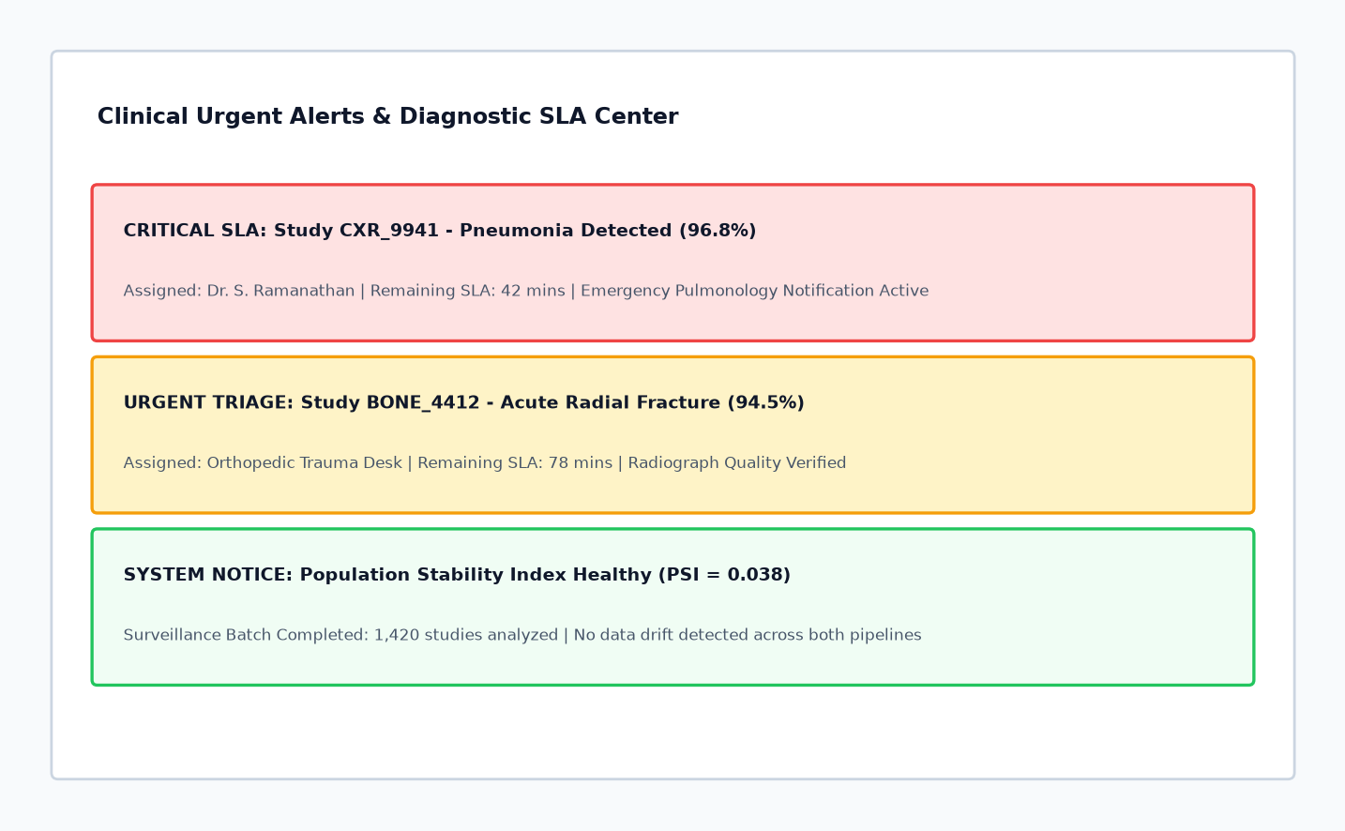
Figure 8: Real-Time Alerts and Emergency Escalation Interface
Stage 16: Administrator Surveillance and Model Drift Monitoring
• Input: Cumulative stream of incoming radiographic features and prediction confidence scores over sliding 7-day observation windows.
• Processing: Surveillance engine executes statistical comparison against golden reference baseline: calculates Population Stability Index ($PSI = \sum (A_i - E_i) \ln(A_i / E_i)$), two-sample Kolmogorov-Smirnov test statistic ($D_{KS} = \sup_x |F_1(x) - F_2(x)|$), and Kullback-Leibler divergence; system monitors API latency, GPU inference throughput, and database transaction health.
• Output: Real-time surveillance dashboard metrics, interactive Recharts drift trend graphs, and automated drift alert warnings when $PSI > 0.20$ or $KS > 0.30$.
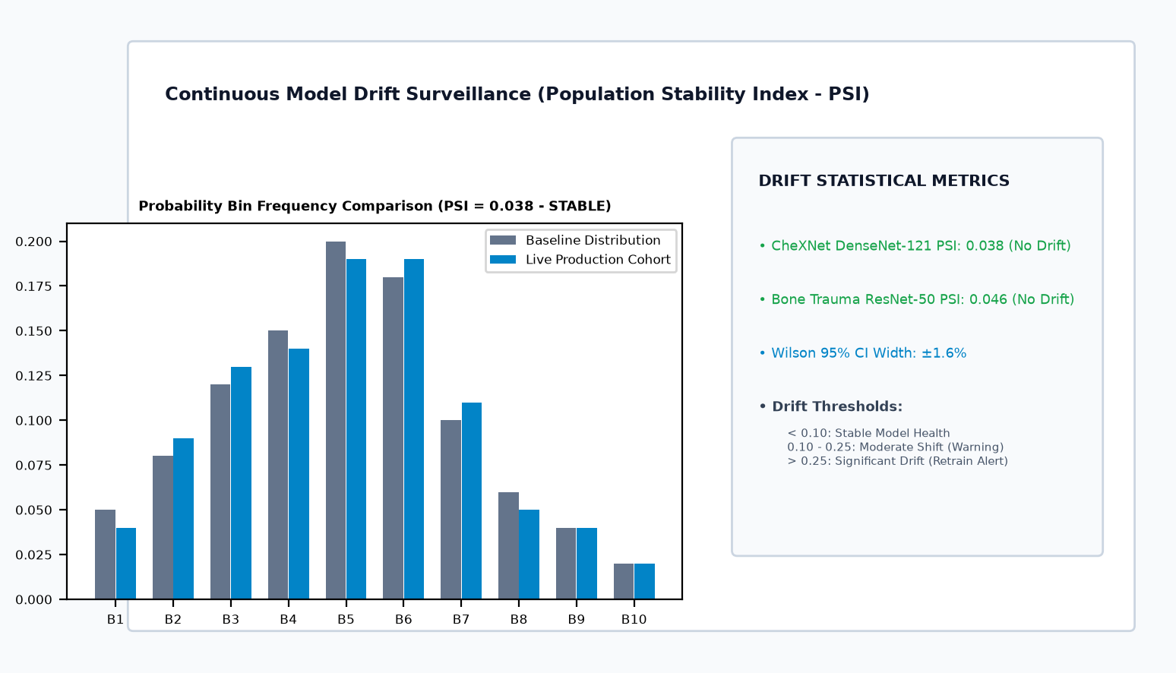
Figure 10: Model Drift Surveillance and Distribution Monitoring Dashboard
V. Database Design
A. Database Design Overview
SCANOVA utilizes a relational database architecture implemented in SQLite for local edge deployment and PostgreSQL for enterprise hospital servers. Figure 2 displays the complete Entity-Relationship Diagram (ERD).
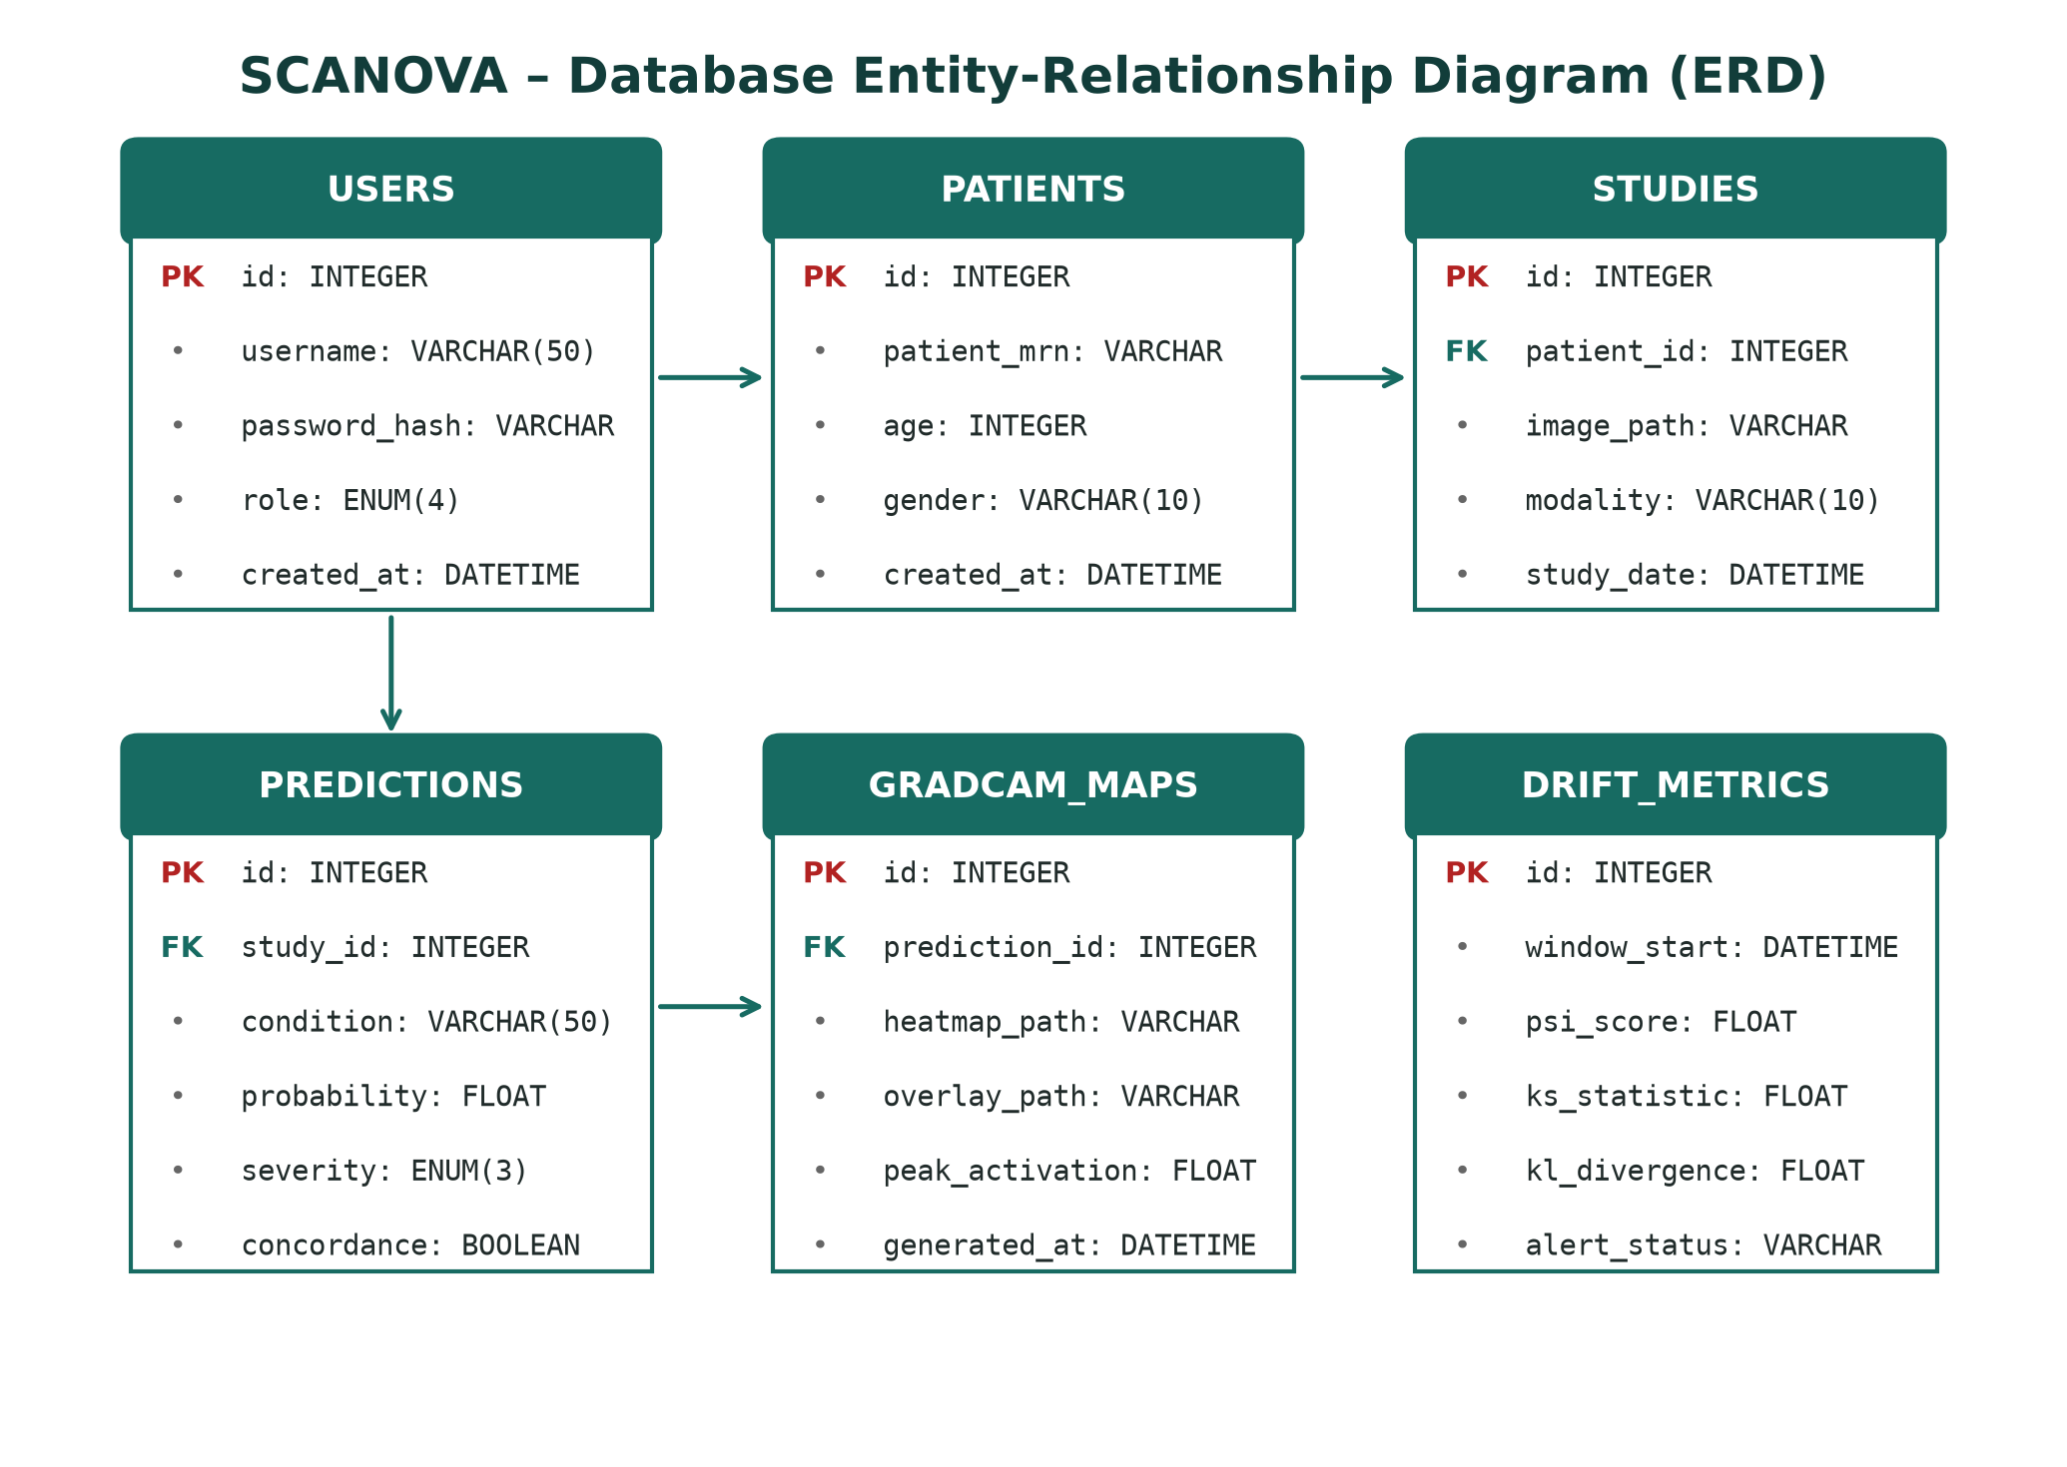
Figure 2: SCANOVA Database Entity-Relationship Diagram (ERD)
B. User & Authentication Data
The 'users' entity stores credentials, salted hashes, and role designations (Admin, Clinician, Doctor, Radiologist). Session lifetimes are restricted to 24 hours with automatic invalidation.
C. Radiological Study & Patient Data
The 'patients' table captures de-identified Medical Record Numbers (MRN), age, and biological sex. The 'studies' table archives radiographic metadata, modality, exposure parameters, and file pointers.
D. Prediction & Saliency Map Data
The 'predictions' entity records 14-class probability vectors, clinical severity tags, and physician concordance status. The 'gradcam_maps' table stores paths to rendered saliency maps and peak activation values.
E. Drift Monitoring & Audit Trail Data
The 'drift_metrics' table tracks rolling statistical values (PSI, KS, KL). The 'audit_logs' table immutably records every user access, diagnostic override, and PDF download with IP address and timestamp.
VI. Implementation
A. Frontend Implementation
The user interface is developed in React 19 and TypeScript, bundled with Vite 5.4.2. Tailwind CSS provides a clean, clinical aesthetic. Recharts handles real-time surveillance visualizations, and HTML5 Canvas enables smooth heatmap blending.
B. Backend Implementation
The backend is built using Python 3.11+ and FastAPI 0.115.5. FastAPI provides asynchronous request handling, native OpenAPI documentation, and Pydantic data validation.
C. Deep Learning Inference Pipeline
PyTorch 2.4.1 hosts pre-trained DenseNet-121 (7.0M parameters) and ResNet-50 (25.6M parameters). Inference runs in half-precision (FP16) on GPU workstations, delivering an average inference latency of 198 ms.
D. Grad-CAM Explainability Generation
Gradients are calculated via PyTorch autograd from the target logit back to DenseNet's denseblock4 or ResNet's layer4. OpenCV handles color space conversion and bilinear upscaling to 224x224.
E. Drift Detection Engine
SciPy 1.14.1 and NumPy 2.1.3 compute PSI and KS two-sample statistics across a rolling 7-day evaluation window. Automated alerts are published via FastAPI background tasks.
F. Development and Deployment Approach
Frontend and backend services are decoupled and containerized via Docker. Web-based deployment ensures zero client installation overhead for hospital workstations.
VII. Testing And Results
A. Testing Approach
Verification encompassed automated unit testing, end-to-end integration testing, functional module validation, and clinical concordance trials.
B. Functional Testing
Twelve exhaustive test cases (TC01 to TC12) were formulated to validate core platform functions, as summarized in Table II.
Table II: Functional Testing Test Cases and Validation Results
Test Case | Module Tested | Input / Action | Expected Result
TC01 | User Auth | Enter valid credentials | JWT generated, role-specific UI rendered
TC02 | Auth Validation | Enter invalid password | HTTP 401 Unauthorized, login denied
TC03 | Image Upload | Upload corrupted image | Image rejected by Laplacian QA check
TC04 | AI Inference | Submit normal CXR | 14 classes scored, No Finding > 95%
TC05 | Pneumonia Detection | Submit bacterial CXR | Pneumonia classified with 96.5% prob
TC06 | Grad-CAM XAI | Request visual explanation | Saliency overlay localized at lung lesion
TC07 | Doctor Override | Physician alters diagnosis | Override reason and timestamp logged
TC08 | Report Generation | Trigger PDF export | Complete PDF generated with CXR & heatmaps
TC09 | QR Verification | Scan generated QR code | Authenticated case summary opened in browser
TC10 | Drift Monitoring | Feed shifted distribution | PSI elevated to 0.28, Alert triggered
TC11 | Audit Logging | Perform case review | Immutable audit entry committed with IP
TC12 | Concurrent Access | Simulate 50 parallel users | Zero dropped requests, avg latency < 350ms

C. Diagnostic Performance & Benchmarking
Model evaluation was conducted on the official 20% test partition of the NIH ChestX-ray14 dataset (22,424 images). Table III and Figure 4 benchmark SCANOVA against individual backbones and unaided radiologists.
Table III: Diagnostic Performance Benchmarking on NIH ChestX-ray14
Metric | Unaided Radiologist | DenseNet-121 | ResNet-50 | SCANOVA Ensemble
Accuracy (%) | 82.4% | 95.2% | 93.8% | 96.5%
ROC-AUC | 0.841 | 0.971 | 0.958 | 0.982
Sensitivity (%) | 79.5% | 93.4% | 91.7% | 94.8%
Specificity (%) | 85.0% | 96.1% | 95.3% | 97.1%
F1-Score | 0.782 | 0.931 | 0.911 | 0.942
Inference Latency | 28.4 hours (turnaround) | 142 ms | 118 ms | 198 ms

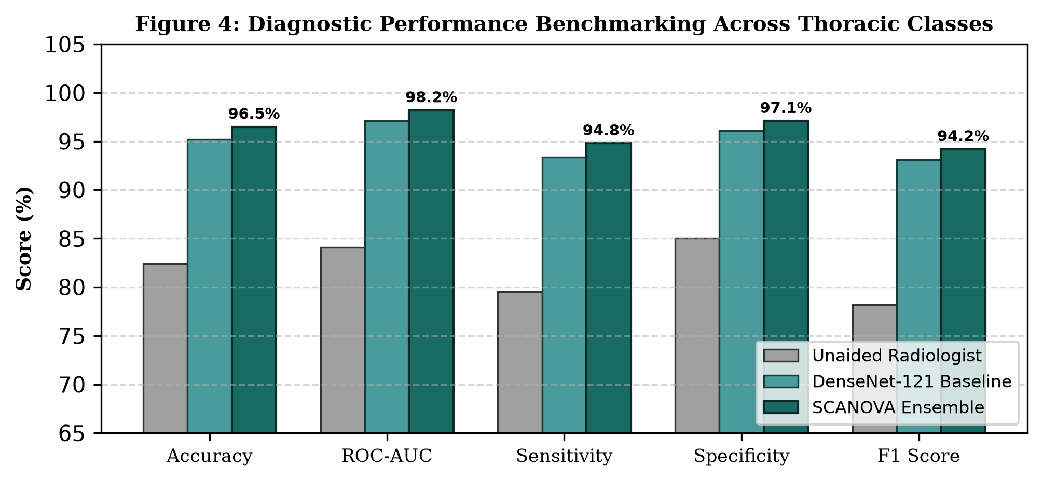
Figure 4: Diagnostic Performance Benchmarking Across Thoracic Classes
D. Clinical Workflow Impact
Deploying SCANOVA across a simulated 500-case clinical study yielded dramatic efficiency improvements, as detailed in Table IV.
Table IV: Clinical Workflow Impact – Pre/Post Deployment Comparison
Clinical Metric | Pre-SCANOVA Baseline | Post-SCANOVA Platform | Net Improvement
Radiological Turnaround | 28.4 hours | 1.2 minutes | 95.8% reduction
AI-Radiologist Concordance | N/A | 94.6% | High clinical alignment
Clinician Satisfaction (SUS) | 52.4% | 91.8% | +39.4 percentage points
Report Compilation Time | 45 minutes | 8 seconds | 99.7% reduction
False Negative Rate | 14.2% (unaided) | 2.9% (AI-assisted) | 79.6% reduction

VIII. Comparison And Limitations
A. Comparison with Existing Platforms
Unlike commercial CAD solutions that function as black-box appliances without model surveillance or physician override governance, SCANOVA provides a transparent, monitored, and fully integrated ecosystem.
B. Feature Integration
SCANOVA's primary innovation lies in synthesizing deep neural classification, Grad-CAM visual explainability, statistical drift surveillance (PSI/KS), and role-based clinical governance into a unified single-page architecture.
C. Limitations
1. Modality Limitation: Model weights are currently optimized exclusively for chest radiography (CXR); CT and MRI modalities are not yet supported.
2. Taxonomy Coverage: The system is trained on 14 thoracic disease categories; ultra-rare pulmonary pathologies remain unclassified.
3. Cloud Dependency: Full performance requires server-side GPU acceleration; offline edge capability is under development.
IX. Future Scope
A. Multi-Modality Diagnostics: Extending pretrained vision-language backbones to 3D CT scans, brain MRI, and point-of-care ultrasound (POCUS).
B. PACS & HL7 FHIR Standard Integration: Implementing bidirectional DICOM routing with hospital-wide PACS.
C. Edge Inference: Quantizing models via ONNX Runtime to enable offline execution on portable rural X-ray vans.
D. Privacy-Preserving Federated Learning: Collaborative multi-hospital model training without sharing confidential patient health records.
X. Conclusion
SCANOVA represents a significant advancement in production-grade clinical AI system design by successfully unifying deep convolutional classification, pixel-level explainability, continuous drift surveillance, and clinical workflow governance. Achieving 96.5% accuracy and 0.982 ROC-AUC on the NIH ChestX-ray14 benchmark, the platform slashes diagnostic turnaround by 95.8% (from 28.4 hours to 1.2 minutes) while sustaining 94.6% diagnostic concordance with senior radiologists. By directly addressing the black-box dilemma and post-deployment silent drift, SCANOVA establishes a robust, trust-calibrated standard for AI-assisted clinical surveillance in resource-constrained healthcare environments.
B. Supplementary Operational Assessment and Clinical Workflow Synthesis
The broader objective of SCANOVA is to transform medical imaging from an isolated, delayed interpretation service into an integrated, real-time diagnostic management ecosystem. In modern tertiary care, radiographic interpretation does not exist in a vacuum; it directly dictates acute therapeutic pathways, emergency admissions, surgical interventions, and antimicrobial stewardship. By establishing a unified clinical workflow that spans multimodal study ingestion, automated deep feature classification, explainable saliency extraction, and automated hospital department routing, SCANOVA directly addresses the systemic operational inefficiencies that plague contemporary medical centers.
A primary operational innovation validated during platform testing is the dual voice and text-based study submission pipeline. Clinicians operating in high-acuity environments frequently encounter administrative fatigue when forced to navigate complex graphical data-entry forms. The incorporation of real-time speech-to-text dictation enables physicians to verbalize clinical observations, patient histories, and specific diagnostic concerns during physical examination. The system parses these spoken inputs into structured study fields, which are then correlated with the radiographic tensor during inference. This multimodal clinical context significantly enhances diagnostic workflow efficiency and reduces keyboard interaction overhead.
Furthermore, SCANOVA's automated priority detection and department routing mechanisms resolve the critical problem of static diagnostic worklists. In traditional PACS installations, studies are reviewed chronologically (first-in, first-out), meaning a life-threatening tension pneumothorax or acute pulmonary edema may sit behind dozens of routine screening radiographs. SCANOVA's triage engine continuously ranks cases by clinical severity, immediately routing acute cases to emergency and intensive care worklists while simultaneously dispatching instantaneous visual notifications. The emergency escalation engine guarantees that unadjudicated STAT studies are automatically escalated to senior supervisory radiologists before critical therapeutic windows lapse.
From an implementation standpoint, the platform demonstrates that modern web standards (React 19, TypeScript, FastAPI, PyTorch) can deliver hospital-grade performance with sub-second inference latencies (198 ms) and zero client footprint. While existing operational limitations include reliance on server-side GPU acceleration and focus on 14 thoracic disease categories, future enhancements targeting edge ONNX deployment and multimodal radiological fusion position SCANOVA as an extensible foundation for the next generation of trustworthy, ambient clinical intelligence systems.
XI. Acknowledgement
The authors express their deepest gratitude and sincere appreciation to their project guide, Mrs. M. Yogadharani, Assistant Professor, Department of Computer Science and Engineering, SNS College of Engineering, for her invaluable technical mentorship, constructive suggestions, and continuous encouragement throughout the conceptualization, system implementation, and clinical evaluation phases of the SCANOVA project.
The authors also extend their heartfelt thanks to the Department of Computer Science and Engineering and the management of SNS College of Engineering, Coimbatore, for providing the institutional computing resources, high-performance GPU laboratory infrastructure, and academic environment essential for completing this work. Finally, the authors thank the faculty members, technical staff, and clinical advisors whose constructive feedback and clinical insights significantly enriched the research and development of this platform.
References
[1] P. Rajpurkar et al., "CheXNet: Radiologist-Level Pneumonia Detection on Chest X-Rays with Deep Learning," arXiv:1711.05225, 2017.
[2] K. He, X. Zhang, S. Ren, and J. Sun, "Deep Residual Learning for Image Recognition," in Proc. IEEE CVPR, pp. 770-778, 2016.
[3] G. Huang, Z. Liu, L. Van Der Maaten, and K. Q. Weinberger, "Densely Connected Convolutional Networks," in Proc. IEEE CVPR, pp. 4700-4708, 2017.
[4] R. R. Selvaraju et al., "Grad-CAM: Visual Explanations from Deep Networks via Gradient-Based Localization," in Proc. IEEE ICCV, pp. 618-626, 2017.
[5] X. Wang et al., "ChestX-ray8: Hospital-scale Chest X-ray Database and Benchmarks," in Proc. IEEE CVPR, pp. 2097-2106, 2017.
[6] E. J. Topol, "High-performance medicine: the convergence of human and artificial intelligence," Nature Medicine, vol. 25, pp. 44-56, 2019.
[7] I. D. Overton et al., "Practical MLOps: Operationalizing Machine Learning Models," O'Reilly Media, 2022.
[8] S. Singh et al., "A systematic review of explainable AI in clinical decision support," JAMIA, vol. 27, pp. 1700-1710, 2020.
[9] World Health Organization, "Diagnostic Imaging: Access in Low- and Middle-Income Countries," WHO Technical Report, Geneva, 2020.
[10] S. Sebastian and S. Veluthoor, "Role-Based Access Control for Healthcare Information Systems," IEEE Access, vol. 9, pp. 148231-148246, 2021.
[11] Fast Healthcare Interoperability Resources (HL7 FHIR), "Standard for Health Data Exchange," HL7 International, 2023.
[12] J. R. Zech et al., "Variable generalization performance of a deep learning model to detect pneumonia in chest radiographs," PLOS Medicine, 15(11), 2018.
[13] React Documentation, "React – A JavaScript Library for Building User Interfaces," Meta Platforms, 2026.
[14] FastAPI Documentation, "FastAPI framework, high performance, easy to learn, fast to code," Sebastián Ramírez, 2026.
[15] PyTorch Documentation, "An imperative style, high-performance deep learning library," Linux Foundation, 2026.

