**Salary Survey AnalysisAcross Global Industries**-Using Excel and SQL

**Name**: Nanthini H

**DA/DS**: May 2025

**Batch Number:**  RP-36

**Online/Offline**: Offline

**Roll Number**: 16525CBRE22

1. **Objective**

* The aim of this project is to analyze salary survey data to understand pay trends and patterns.
* The goal is to identify how salaries vary by job title, industry, location, gender, and experience level.
* The study focuses on the provided dataset, which contains detailed compensation information.

1. **Dataset Overview**
   * The dataset contains **28000 rows** and **16 columns** of salary and job-related information.
   * Data covers responses from professionals across multiple industries and countries.
   * Key fields include **Job Title, Industry, Location, Experience Level, Education, Gender, Salary, Additional Compensation**.
   * The data includes both numerical variables (salary) and categorical variables (job titles, industries, locations).
2. **Data Cleaning Process**

* Filled missing values where possible; excluded incomplete rows when necessary.
* Converted all salaries into USD for standard comparison.
* Standardized job titles, industries, and country names for consistency.
* Detected and addressed extreme outliers in salary data.
* Verified currency conversion rates and ensured data accuracy.

1. **SQL queries performed**

* Average Salary by Industry and Gender – Compared pay levels within industries split by gender to check for disparities.

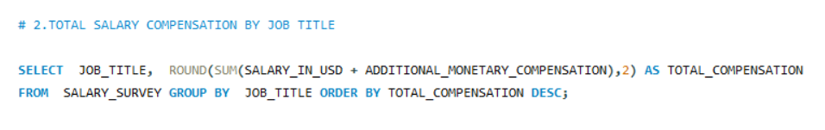

* **Total Salary Compensation by Job Title** – Calculated total base + additional compensation to identify top-paying roles.



* **Salary Distribution by Education** Level – Found average, minimum, and maximum salaries for each education category.



* **Number of Employees by Industry and Experience** – Counted employees in each industry segmented by experience level.

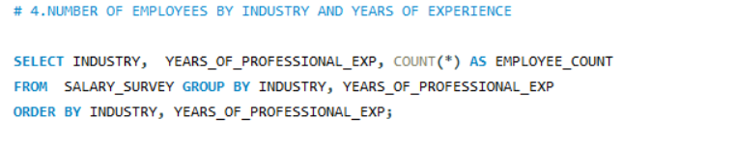

* **Median Salary by Age Range and Gender** – Measured central salary trends across different age groups and genders.

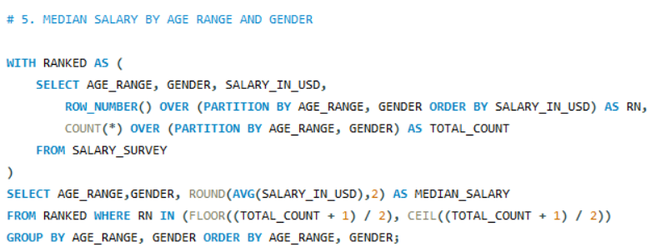

* **Highest-Paying Job Titles in Each Country** – Listed the best-paying roles per country to compare global pay patterns.

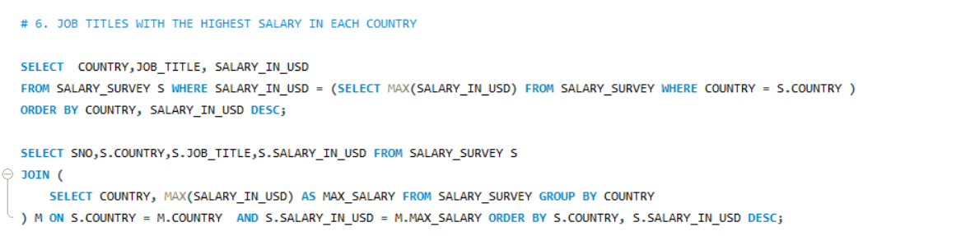

* **Average Salary by City and Industry** – Compared pay rates across cities for each industry.

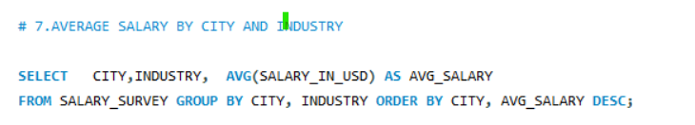

* **Percentage with Additional Compensation by Gender** – Checked how many employees receive bonuses or stock options, split by gender.

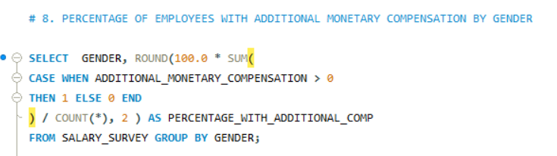

* **Total Compensation by Job Title and Experience** – Summarized full pay by role and years of experience.

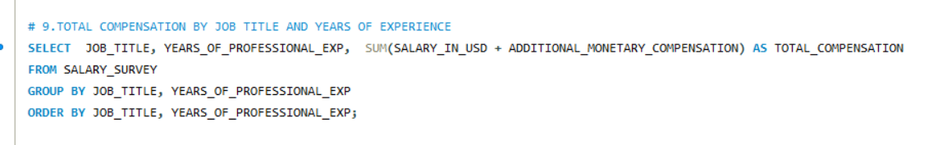

* **Average Salary by Industry, Gender, and Education** – Combined three factors to understand pay variation.

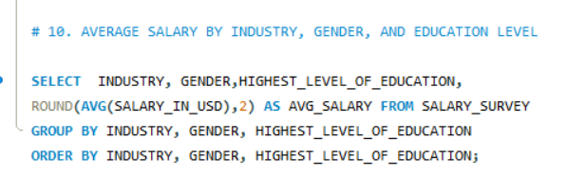

1. **Pivot Tables and Charts**
   * Created pivot tables to compare average salaries across job titles and industries.
   * Built charts showing salary trends by years of experience
   * Used bar charts to visualize top 5 highest-paying Industries.

|  |  |
| --- | --- |
| **Top 5 Industry** | **Avg of Salary_in_USD** |
| Communications & Public Relations | 105.8K |
| Pharmaceuticals & Biotechnology | 103.1K |
| Information Technology (IT) | 102.6K |
| Consumer Goods | 98.0K |
| Cosmetics & Personal Care | 92.5K |

1. **Dashboard**

* Designed an interactive salary analysis dashboard summarizing main KPIs.
* Displayed **average salary, median salary, and total respondents** as headline metrics.
* Used **bar charts** for salaries by job title, **line charts** for salary trends over years of experience, and **pie charts** for industry distribution.
* Added slicers for **country, gender, and experience level** to filter results.

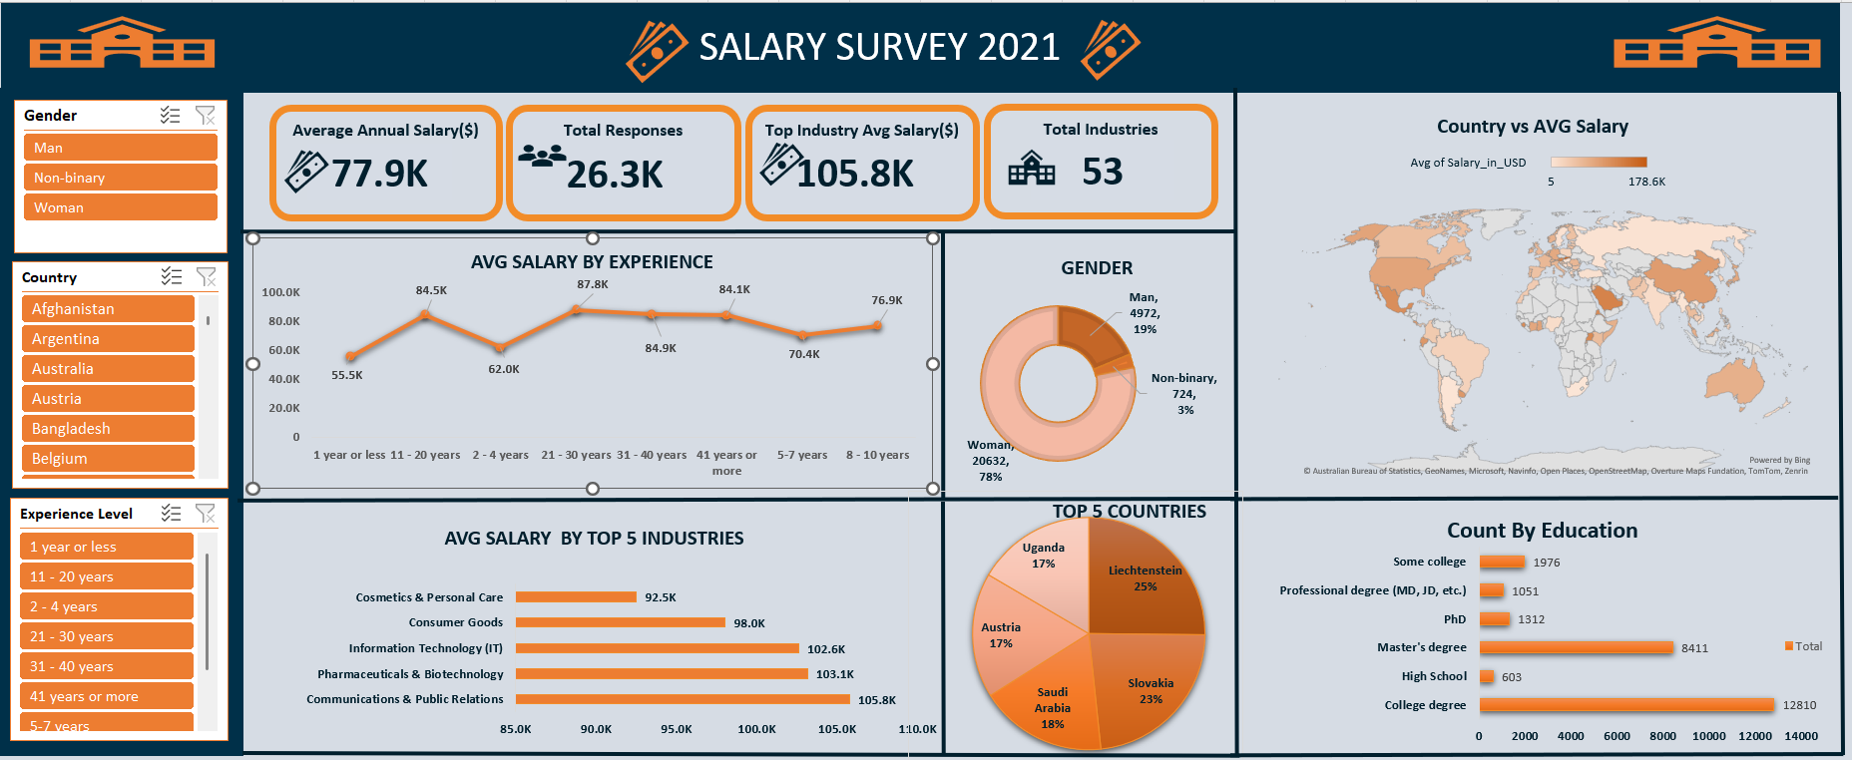

1. **Key Insights**

* Communications & Public Relations and Pharmaceuticals & Biotechnology are top paying industries
* Professionals with advanced degrees (Master’s/PhD) earn significantly more than those with only a Bachelor’s degree.
* Liechtenstein and Slovakia emerged as the top-paying countries in the dataset.

1. **Recommendations**

* Encourage organizations to review pay structures for equity across genders and locations.
* Provide salary transparency in recruitment to attract top talent
* Align pay raises with industry benchmarks and experience levels.
* Focus on skill development programs for employees in lower-paying categories.

1. **Conclusion**

* The salary survey analysis provided valuable insights into compensation trends and disparities.
* The dashboard offers a clear, interactive way to explore salary data across multiple dimensions.
* Findings can guide fair pay policies and competitive salary offerings.
* Future surveys can include more demographic variables for richer analysis.