**HEART DISEASE DATA ANALYSIS**

**NANTHINI H**

**DA&DS - 2025**

**Introduction:**

  Heart disease is a major health problem worldwide. Early detection and understanding of risk factors are very important.

This analysis studies patient data to find patterns and insights that can help in identifying high-risk individuals.

**Dataset Overview and Cleaning :**

The dataset contains 2500 rows and 14 columns about patients.

For better understanding, the column names has been renamed.

* Age – Patient’s age
* Sex – Male or Female
* Chest Pain Type – Typical Angina, Atypical, Non-Anginal, Asymptomatic
* Resting Blood Pressure – Measured in mm Hg
* Cholesterol – Serum cholesterol in mg/dl
* Fasting Blood Sugar – Above 120 mg/dl or not
* Resting ECG – ECG results
* Max Heart Rate Achieved – During exercise
* Exercise-Induced Angina – Yes or No
* ST Depression – Level of ST depression during exercise
* Slope – Slope of ST segment
* Number of Major Vessels – 0 to 3
* Thalassemia – Normal, Fixed Defect, or Reversible Defect
* Heart Disease – Presence (1) or Absence (0)

**DAX FUNCTIONS:**

1. Unique CP Types = DISTINCTCOUNT(Heart_Disease[Chest_Pain_Type])

2.Total_Patients = COUNTROWS(Heart_Disease)

3.Patients with Disease = CALCULATE(COUNTROWS(Heart_Disease),Heart_Disease[Result] =1)

4.Heart_Dis_Status = IF(Heart_Disease[Result]=1,"Has Disease","No Disease")

5.  FBS_Status = IF([Fasting_Blood_Sugar] = 1, "High (>120 mg/dl)", "Normal (≤120 mg/dl)")

6. Age_Group = IF(Heart_Disease[Age]<40,"Young",IF(Heart_Disease[Age]<60, "Middle-Aged","Senior"))

7. Disease % = DIVIDE(CALCULATE(COUNTROWS(Heart_Disease), Heart_Disease[Result] = 1), COUNTROWS(Heart_Disease))

8. Cholestrol_Category = SWITCH(TRUE(),Heart_Disease[Serum_Cholesterol]<200,"Normal",Heart_Disease[Serum_Cholesterol]<=239, "Borderline High",Heart_Disease[Serum_Cholesterol]> 239,"High","Unknown")

9.Thalassemia_Status =SWITCH(    [Thalassemia_Result], 0, "Normal", 1, "Fixed Defect",2, "Reversible Defect",    3, "Other/Unknown", "Not Specified")

10. % Normal BP (No Disease) = DIVIDE(  CALCULATE ( COUNTROWS('Heart_Disease'), 'Heart_Disease'[Resting_Blood_Pressure] < 120, 'Heart_Disease'[Result] = 0 ), CALCULATE(  COUNTROWS('Heart_Disease'), 'Heart_Disease'[Result] = 0  ),  0 )

**Dashboard Overview: HEART DISEASE ANALYSIS**

The Heart Disease Analysis Dashboard provides a summary of patient data, segmented by demographics, chest pain type, and disease prevalence.

The dashboard is designed to give a quick, visual understanding of heart disease distribution among patients.

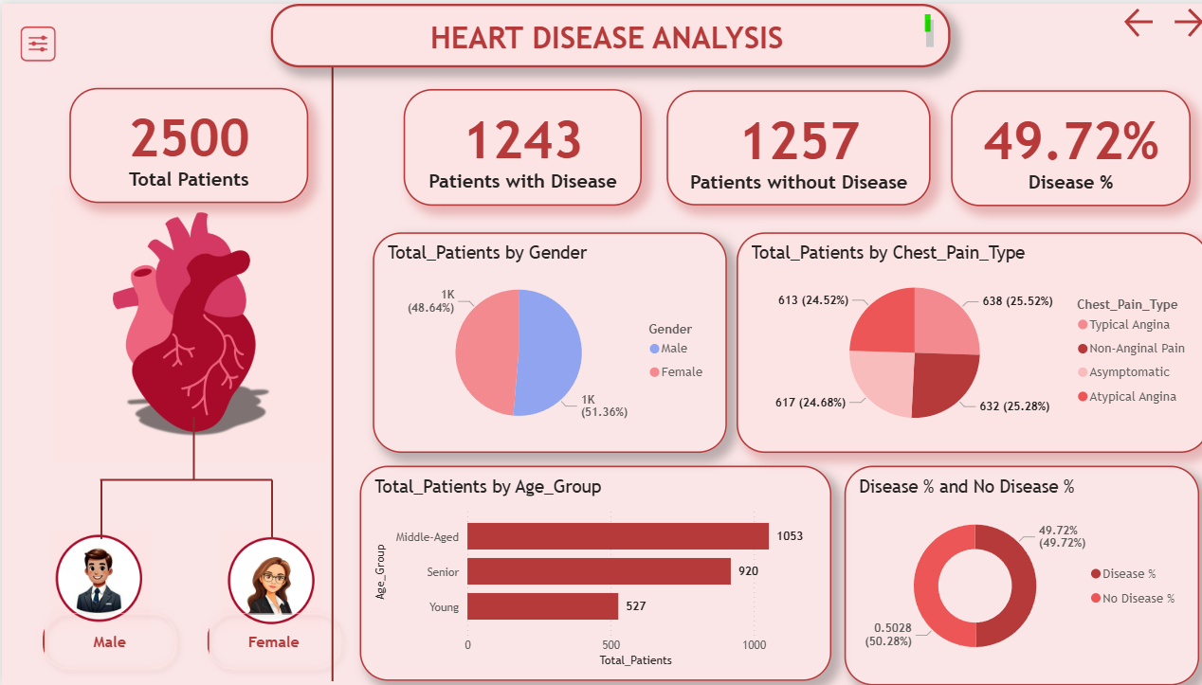

**Insights from the Dashboard**

Heart disease prevalence is nearly equal to the disease-free population.

Middle-aged and senior groups form the majority of patients, indicating higher vulnerability in older populations.

Gender distribution is fairly balanced between males and females.

Chest pain types are distributed almost evenly across categories, with non-anginal pain slightly more common.

**Dashboard Overview: PATIENTS WITH DISEASE**

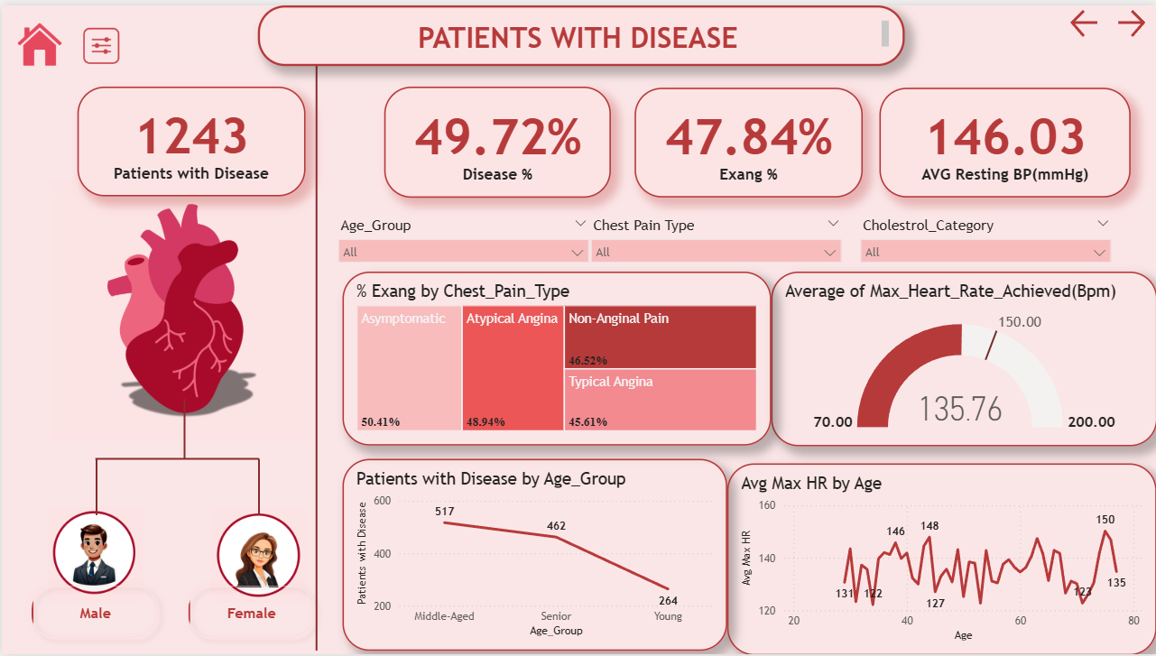This dashboard provides a summary of patients with heart disease based on different medical and demographic factors.

1. **By Gender**

Visual shows both male and female patient counts (though exact numbers are not labeled here).

2. **By Chest Pain Type & Exercise Angina (Exang)**

Asymptomatic: 58.41%

Atypical Angina: 65.94%

Non-Anginal Pain: 45.61%

Typical Angina: (partially visible but seems around 45–50%

This shows how chest pain type correlates with exercise-induced angina.

3**. By Age Group**

Middle-Aged: 517 patients

Senior: 462 patients

Young: 204 patients

-

**Heart Function Analysis**

Average Max Heart Rate Achieved (BPM): 135.76 bpm

Avg Max HR by Age: Line chart shows HR trends across age – higher in younger patients, gradually decreasing with age.

**Overall Insight:**

Nearly half of patients (49.72%) in the dataset are diagnosed with the disease.

Middle-aged and senior groups show higher prevalence than younger groups.

Chest pain type and exercise-induced angina are strong indicators of disease presence.

Patients generally have elevated resting BP (146 mmHg) and an average max HR ~135 bpm, which declines with age.

This dashboard helps in tracking patient distribution, identifying high-risk groups, and analyzing patterns across age, gender, and chest pain type.

**Dashboard Overview: PATIENTS WITHOUT DISEASE**

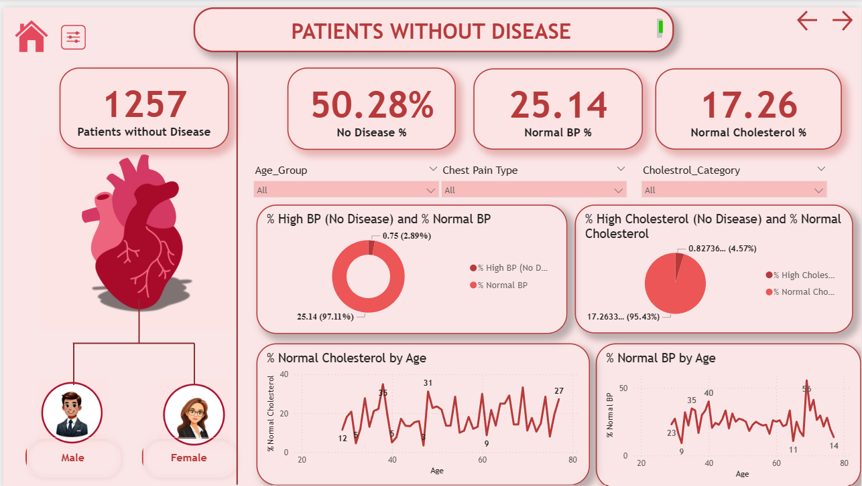

This dashboard provides an overview of patients without heart disease, summarizing their blood pressure, cholesterol levels, and other key health indicators.

**Key Metrics**

1. 1257 → Total patients without disease.

2. 50.28% → Percentage of patients without disease from the dataset.

3. 25.14% → Percentage of patients with normal blood pressure.

4. 17.26% → Percentage of patients with normal cholesterol levels.

**Insights from Dashboard**

Majority of patients without disease have normal BP (97%) and normal cholesterol (95%).

Only a small percentage of disease-free patients show high BP (2.9%) or high cholesterol (4.6%).

Trends suggest that cholesterol and BP variations are age-related.

***Recommendation:***

Regular monitoring of **BP, cholesterol, and blood sugar** for early detection.

Eat healthy food and avoid too much fat, sugar, and junk food, avoid smoking/alcohol.

**Exercise daily** to keep the heart strong.

People above 50, especially **Men,** should take extra care.

Watch out for **chest pain**or sugar problems – get checked early.

Spread awareness about heart disease and prevention targeting M**en under 50** and    W**omen post-55**.