Implement Client Script & UI Policy (Incident) in ServiceNow
Phase-7 -- Project Design Phase

Date | 28/09/2026
Team Id | SWTID-2026-6866
Project Name | Implement Client Script & UI Policy (Incident) in ServiceNow

Team Members:
NAME | Reg.No
NANTHINI M | U24CSE1430
ETHAYA C | U24CSE1410
MENAKA S | U24CSE1428
RAJESWARI V | U24CSE1437
PRIYADHARSHINI A | U24CSE1434
NANTHINI M | U24CSE1430

1.Introduction to Project Design
The Project Design Phase translates analyzed requirements into a precise implementation design. Its purpose is to define how the Incident form and list behave so developers can configure ServiceNow consistently and testers can validate outcomes.

  - Design converts requirement artifacts into implementation artifacts (UI Policy, Client Scripts).
  - Scope: Incident Management only—no server-side or external integrations.
  - Primary focus: UI Policies and Client Scripts to control field behavior and validation.
  - Goal: Provide a clear, testable structure for implementation and QA.

The design is grounded in the Requirement Analysis Phase. It defines relationships between Impact, Assignment Group, Urgency, Assigned To, and State, and describes user interactions on both the Incident form and Incident list. This structure reduces developer ambiguity and simplifies testing.

Overall System Design
The solution uses client-side ServiceNow components to enforce field behavior and validation. Each component has a well-defined responsibility to keep the implementation modular and testable.
Incident Table
Main store for Incident records; the target table for UI Policy and Client Scripts.
UI Policy
Controls client-side field properties when Impact = High (e.g., mandatory flags).
UI Policy Action
Applies read-only or visibility settings to specific fields (Urgency).
onChange Client Script
Runs when Impact changes; sets Urgency automatically and shows information messages.
onSubmit Client Script
Validates Assigned To on save when Impact = High; prevents incorrect saves.
onCellEdit Client Script
Prevents direct State changes from the Incident list and displays a warning.

Each component is client-side only and designed to interact with the Incident form and list UI. This keeps behavior consistent for agents without introducing server-side dependencies.

System Architecture / Component Design

The following text-based component sequence clarifies flow on the Incident form and the separate list- editing path.

Form sequence:

Incident Form ↓ Impact Field ↓ UI Policy + onChange Client Script ↓ Assignment Group / Urgency
↓ Assigned To Validation ↓ Incident Save

List-editing sequence:

Incident List ↓ State Field ↓ onCellEdit Client Script ↓ Block Direct State Change

- Incident Form: Presents fields to users; target for UI Policies and onChange logic.
- Impact Field: Triggers UI Policy and onChange script when edited.
- UI Policy + onChange: UI Policy enforces field properties; onChange sets Urgency and displays info messages.
- Assignment Group / Urgency: Assignment Group becomes mandatory; Urgency becomes read-only when Impact = High.
- Assigned To Validation: onSubmit script prevents saving when Assigned To is empty for High Impact incidents.
- Incident Save: Final step; allowed only when client-side validation passes.
- onCellEdit for List: Detects attempted inline edits to State and rejects them with a warning.

UI Policy Design
UI Policy Name: High Impact Control Table: Incident

Policy Settings:

- Table: Incident — the policy works on Incident records.
- Condition: Impact is 1 – High.
- Active: True — the UI Policy is enabled.
- Reverse if false: True — restores the normal field behavior when the condition is false.
- When Impact is High, the UI Policy becomes active.
- When active, Assignment Group becomes mandatory.
- The UI Policy Action controls Urgency as read-only, and when Impact changes away from High, the normal field behavior is restored.

User Flow:

Impact = High
↓

High Impact Control Active
↓

Assignment Group = Mandatory
↓

Urgency = Read-only

Impact ≠ High
↓

Reverse if False
↓
Normal Field Behavior Restored

UI Policy Action Design
This UI Policy Action is connected to the High Impact Control UI Policy and controls the Urgency field.

Field Settings

  - Field: Urgency
  - Read-only: True
  - Visible: No change
  - Table: Incident

Behavior:

- The UI Policy checks whether Impact = High.
- When Impact is High, the Urgency field becomes read-only.
- Users can still see the Urgency field on the Incident form.
- Users cannot manually change the Urgency value.
- The onChange Client Script automatically sets Urgency to High.
- When Impact changes from High to another value, the UI Policy is reversed.
- Urgency becomes editable again when the Impact is not High.

User Flow:

Impact = High ↓ UI Policy Active ↓ Urgency Read-only ↓ Urgency remains visible ↓ onChange Script sets Urgency = High

Impact ≠ High ↓ UI Policy Reversed ↓ Urgency becomes editable

onChange Client Script Design

Name: Auto set urgency for high impact
Table: Incident — Type: onChange — Field: Impact — Active: True Logic steps:
- User changes the Impact field.
- Script checks the new value.
- If Impact = High, set Urgency = High and display an information message.
- If Impact ≠ High, do not change Urgency (UI Policy Reverse handles field properties).

Yes, you can use this as the simple flow:

Impact Changed
↓

Is Impact = High?
↓ Yes

Set Urgency = High
↓

Display Information Message

Purpose: ensure the Urgency value aligns with Impact automatically and inform users of the action, reducing
manual errors.

onSubmit Client Script Design

Name: Prevent save if Assigned To missing
Table: Incident — Type: onSubmit — Active: True Logic:
- User clicks Submit (Save/Update).
- Script checks Impact value.
- If Impact = High, script checks Assigned To.
- If Assigned To is empty → show error message and block save.
- If Assigned To is present → allow save.

Flow:

Submit Incident
↓

Impact = High?
↓ Yes

Assigned To empty?
↓ Yes

Show Error Message
↓

Stop Save

Purpose: prevent incomplete High Impact incidents from being recorded, ensuring accountability and assignment before a record persists.

onCellEdit Client Script Design
Name: Prevent state change via list edit Table: Incident Type: onCellEdit Field: State Active: True

Behavior

- The script runs when a user tries to edit the State field from the Incident list.
- It checks the State field when the user attempts an inline edit.
- A warning message is displayed to inform the user that list editing is not allowed.
- The attempted State change is blocked by the script.
- The original State value remains unchanged after the blocked edit.
- The user can open the Incident record to change the State.
- This helps ensure that State changes are made through the Incident form.

Flow

Incident List
↓

Edit State
↓

onCellEdit Script
↓

Display Warning
↓

Block Change
↓

Open Incident Form for State Update

- Complete System Flow Chart & Field Behavior

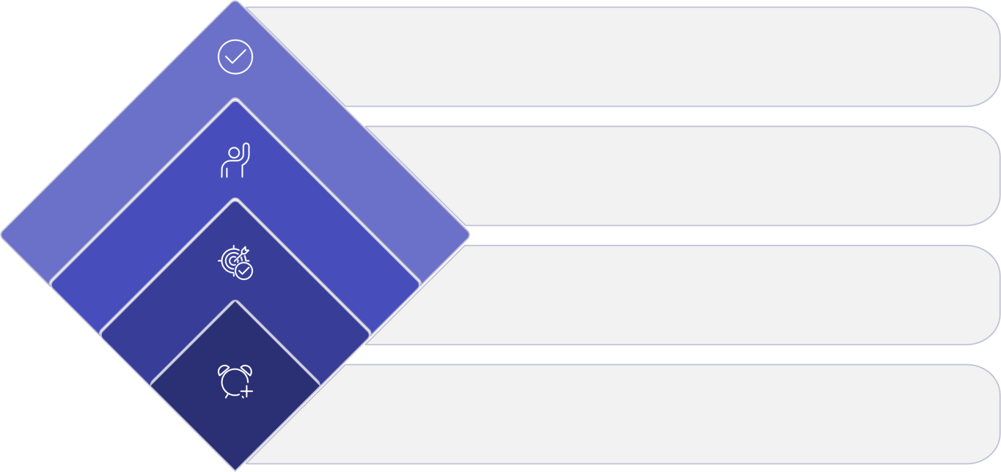
Validate Assigned
Require Assigned To if high
Is Impact High?
Decision point
Select Impact
Choose impact level
Start Incident
Open or create incident

The diagram above encapsulates the full system logic, including the separate list-editing flow. It emphasizes decision points and ensures every path is validated before save.

Field | Condition | Designed Behavior

Field | Condition | Designed Behavior
Impact | User changes value | Triggers UI Policy and onChange logic
Assignment Group | Impact = High | Mandatory
Urgency | Impact = High | Read-only (UI Policy Action)
Urgency | Impact changes to High | Automatically set to High (onChange)
Assigned To | Impact = High and empty | Save blocked (onSubmit)
Assigned To | Impact = High and filled | Save allowed
State | Direct list editing | Change blocked (onCellEdit)
State | Incident form edit | Change allowed (normal form save)
Each row above is enforced by the combination of UI Policy, UI Policy Action, and Client Scripts. The table
clarifies which controls act under which conditions and who can perform which actions.

