# Veritas wrestling systems

This manual contains guidelines and best practices for data collection. It is broken into four parts: before, during, after the match and logistical considerations. The latter-most (specifically) will be appended with each new addition.

## Pre-match

Before the match begins you should look at the bout card/sheet and copy the appropriate red/blue wrestler’s names to the corresponding boxes on the mobile application. You should also make sure that you have the correct weight class.

## Match

During the match it is important to follow the recording procedures outlined below. This part of the manual is broken into three sub-parts: neutral, top/bottom, and extras. It is important to note that all these techniques are only performable/recorded from the positions under which they are listed. For example, if a bottom wrestler, in attempting a reversal, ends up with a single leg (Head Inside) in the air, this is **NOT** recorded as a Head Inside attempt or as a Counter attempt for the other wrestler because they are still technically in the top/bottom position. Type “START” to begin the match.

#### Neutral

Neutral is the most fast faced and volatile position. It is at this time that you must be acutely aware. You will do most of your recording when there are NOT being points scored, so pay close attention. Remember that all the following are recorded for both wrestlers. Note that shots may change from their *initial* attempt to a new shot type, both shots should be recorded. (For example, a snap-down that turns into an ankle pick would be recorded as both a counter attempt AND a low shot attempt)

1. Head Inside attempt (hia)
   1. When one athlete initiates a shot attempt with his head **inside** his opponent’s body-box as shown below. To be considered an attempt, the initiator must either drop to a knee on the attempt or lock his hands around his opponent’s leg, above the knee.

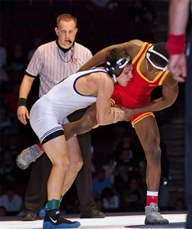

* 1. Conversions are recorded when an official awards 2 points for a takedown in succession of the attempt.

1. Head Outside attempt (hoa)
   1. When one athlete initiates a shot attempt with his head **outside** his opponent’s body-box as shown below. To be considered an attempt, the initiator must either drop to a knee on the attempt or lock his hands around his opponent’s leg, above the knee.
   2. 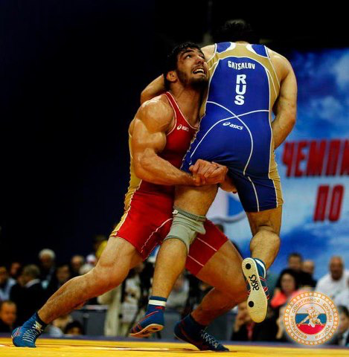Conversions are recorded when an official awards 2 points for a takedown in succession of the attempt.
2. Double attempt (da)
   1. When one wrestler initiates an attempt on **both** of his opponent’s legs (usually with his head outside his opponent’s body-box). To be considered an attempt the initiator must **only reach** for both legs and need not actually grab them. If it appears that an attempt was made to attack both legs, it should be recorded as a double attempt. It is common for these attempts to transfer into a new shot type.

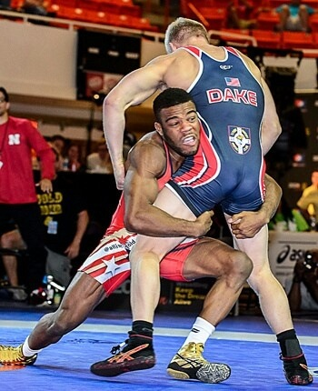

* 1. Conversions are recorded when an official awards 2 points for a takedown in succession of the attempt.

1. Low Shot attempt (lsa)
   1. When one wrestler initiates an attempt on **one** of his opponent’s legs **at or below the knee**. Low shots include low-singles, ankle picks, and knee picks. To be considered an attempt, the initiator must drop to a knee and reach for his opponent’s ankle/knee.

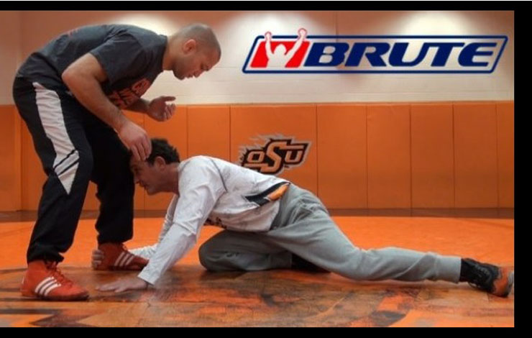

* 1. Conversions are recorded when an official awards 2 points for a takedown in succession of the attempt.

1. Counter attempt (GBa)
   1. Counters occur any time the opponent makes an attempt and the defending wrestler has time to react. The best position to describe a counter would be a sprawl-like position where the defender has his chest on the initiator’s back like a chest-lock position (far left). This can also occur from a snap-down. Counters are **not** recorded if the initiator makes an attempt and successfully converts (scores) or retreats away within one second as the defender never had time to counter. Another classic counter position is one in which the initiator is holding one of the defender’s legs in the air (middle). Another is from the crack-down position (far right).

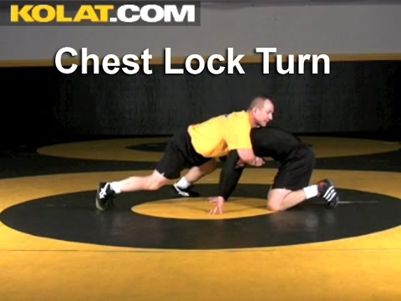 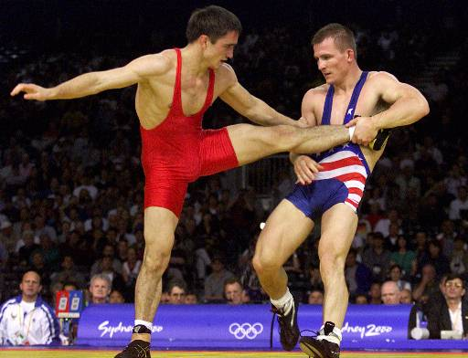 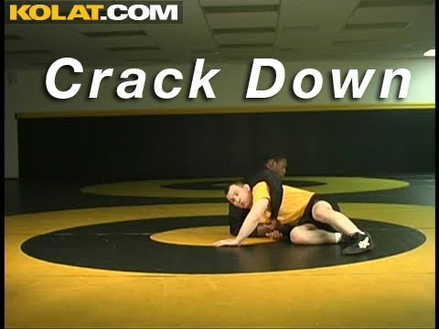

* 1. Conversions are recorded when an official awards 2 points for a takedown in succession of the attempt. Mostly in the case of counters this occurs via go-behinds or when a counter transitions to another shot type.

1. Throw attempt (ta)
   1. Throws are perhaps the most noticeable action in the neutral position. Throw attempts are recorded when one athlete attempts to lift the other in the air and return him to the mat (usually without grabbing his legs). Double leg attempts that result in a lift are **not**considered throws. Lateral drops, hip tosses, head-locks, etc. are classic throw techniques. Duck-under, inside-trip, and foot-sweep are also throwing techniques.

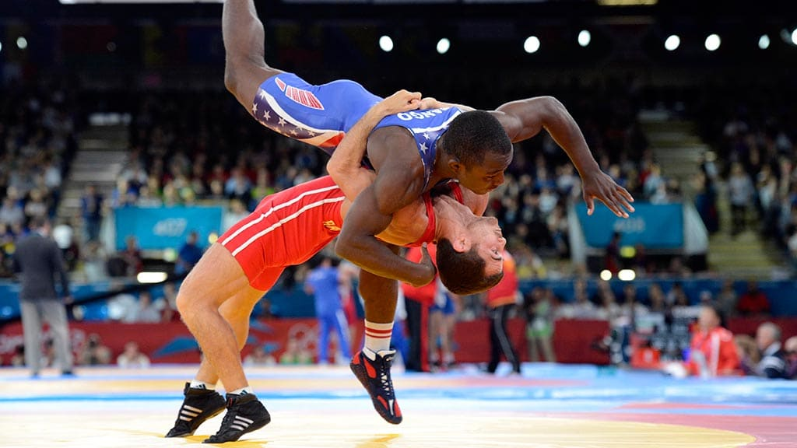

* 1. Conversions are recorded when an official awards 2 points for a takedown in succession of the attempt. In the case of throws the defending wrestler usually ends the position on his back.

#### Top/Bottom

These positions are reactive and whenever one wrestler performs a technique there is usually a counter that will quickly follow and must be recorded for the opposing wrestler. For this reason, this part of the manual will focus on three positions and the possible techniques executable from each. The positions are: base position, broken-down, and standing up. At the end of this section we will address techniques that can occur from any /all these positions. Only successful techniques are recorded in these positions (no attempts).

##### Base Position

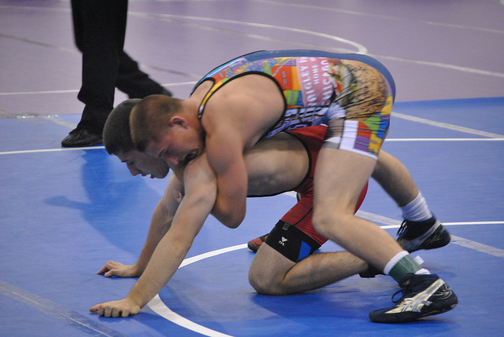

1. Top wrestler:
   1. In the referee’s position the top wrestler has one primary technique… to break the bottom wrestler down. A breakdown(bd) occurs when the top wrestler forces the bottom wrestler from the base position onto the mat with the bottom wrestler’s **hips AND chest** touching the mat. Simply putting the bottom wrestler’s hips OR face on the mat is not considered a breakdown. A successful breakdown is recorded and results in the broken-down position (seen below).
2. Bottom wrestler:
   1. From the referee’s position the bottom wrestler has one primary technique… to stand up. A stand-up(su) occurs when the bottom wrestler forces his way to his feet. Stand-ups are only recorded when the bottom wrestler is standing upright, and his hands are no longer touching the mat. Successful stand-up results in the standing position (seen below). (reversals=r)

Broken-down Position

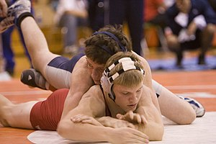

1. Top wrestler:
   1. In the broken-down position the top wrestler has two primary techniques. Both are forms of NearFall or turning the bottom wrestler to his back. NearFall 2 or NearFall 4 are recorded when the official awards “back points” to the wrestler and only then. (nf2 or nf4)
2. Bottom wrestler:
   1. From the broken-down position the bottom wrestler has no primary techniques. Building his base or returning to the base position is a form of technique but is not recorded.

Standing Position

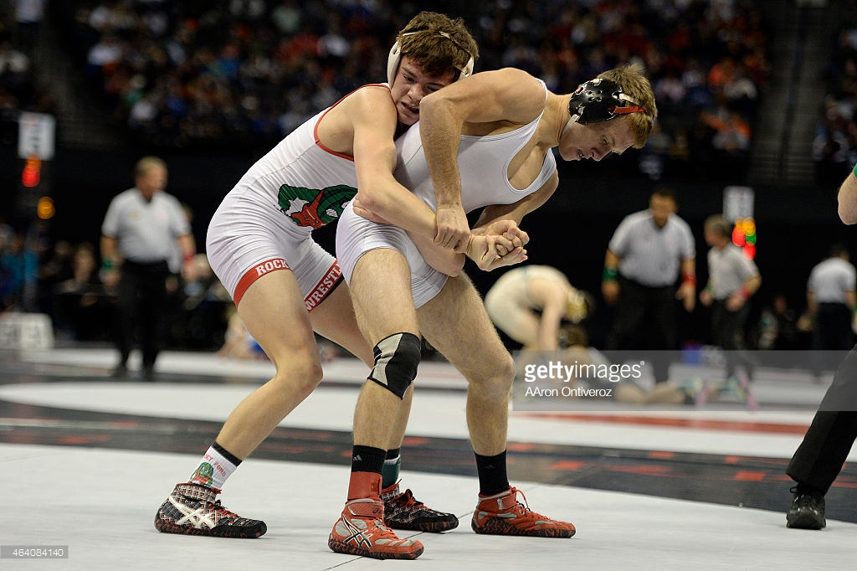

1. Top wrestler:
   1. In the standing position the top wrestler has one primary technique. A Mat Return (mr) involves returning the bottom wrestler back to the base position. Mat Returns are recorded when they result in the bottom wrestler going from standing to base position.
2. Bottom wrestler:
   1. From the standing position the bottom wrestler has one primary technique… to escape. An Escape (e) is when the bottom wrestler clears away from the top wrestler. Escapes result in the neutral position (from standing) and are recorded when the official awards one point to the bottom wrestler for an escape.
   2. If the top wrestler allows the bottom wrestler to escape (starting from the base position) it is recorded as a cut (C).

#### Extras

There are two types of Penalties: Technical Violations (tv) and Stalling (stall).

1. Technical Violations
   1. Are recorded anytime a penalty point is awarded to either wrestler that is **NOT** due to stalling. Examples include three cautions, unsportsmanlike conduct, and illegal holds.
2. Stalling
   1. Is recorded **anytime** stalling is called on either wrestler. **Including warnings.**
3. Riding Time (rt)
   1. The one bonus in a match is riding time. This is recorded at the end of the match and one wrestler has accumulated more time on top (determined by the riding time clock) than the other

## Post-match

Type “END to end the match. At the end of the match you should record the winner and how they won using the Result code. Remember the code representations for the Result are:

* blue fall: 1.75
* blue tech: 1.50
* blue major: 1.25
* blue decision: 1.10
* red decision: 0.90
* red Major: 0.75
* red tech: 0.50
* red fall: 0.25

Once you have completed all these steps, type “yes” to upload the information to the database.

## Logistics

This section contains specific situational issues that frequently occur. It is formatted in a discussion of each situation and unfortunately does not have many images to support it. Use your imagination to follow through each scenario.

#### Scenario 1 – Unconventional Low Shots

It sometimes occurs that a wrestler initiates a takedown attempt on the ankles of his opponent, but he does so in an unconventional way. Two examples are a head outside ankle grab, something Jason Nolf is quite good at a low double, something Logan Stieber is quite good at. Both shots and any shot attempt below the knee, especially around the ankle/foot region, is considered a Low Shot and should be recorded as such.

#### Scenario 2 – Sweep Singles

Sweep singles appear to resemble both Head Inside and Low Shot attempts. They are recorded as Head Inside due to their finishing nature.

#### Scenario 3 – Mat Return Specifics

Mat Returns can result in the recording of a Mat Return **AND** a Break Down if the top wrestler manages to return the bottom wrestler completely to his belly.

Mat Returns cannot be performed/recorded from the neutral position. Therefore, if a wrestler hits a duck under and then lifts and returns the opponent, this is simple a Counter attempt and conversion.

#### Scenario 4 – Near Fall 4 after a Pin

After a pin, automatically record NF4 for the wrestler who successfully performed the pin.

#### Scenario 5 – Riding Time with early termination

If a match ends early due to a fall or technical fall, Riding Time is NOT recorded.

#### Scenario 6 – Early Termination NOT due to Fall/Tech Fall

If a match ends early due to disqualification because of penalties, record it as a Fall for the wrestler who was NOT disqualified.

If a match ends early due to medical reasons, delete the recording.

#### Scenario 7 – Incomplete Match

If you are conducting film analysis (not live) and the entire match is unavailable (i.e. the first 30 seconds are missing) do NOT record the match.