# Veritas wrestling systems

This manual contains guidelines and best practices for data collection. It is broken into four parts: before, during, after the match and logistical considerations. The latter-most (specifically) will be appended with each new addition.

## Pre-match

Before the match begins you should look at the bout card/sheet and copy the appropriate red/blue wrestler’s names to the corresponding boxes on the mobile application. You should also make sure that you have the correct weight class.

## Match

During the match it is important to follow the recording procedures outlined below. This part of the manual is broken into three sub-parts: neutral, top/bottom, and extras. It is important to note that all these techniques are only performable/recorded from the positions under which they are listed. For example, if a bottom wrestler, in attempting a reversal, ends up with a single leg (Head Inside) in the air, this is **NOT** recorded as a Head Inside attempt or as a Counter attempt for the other wrestler because they are still technically in the top/bottom position. Type “START” to begin the match.

#### Neutral

Neutral is the most fast faced and volatile position. It is at this time that you must be acutely aware. You will do most of your recording when there are NOT being points scored, so pay close attention. Remember that all the following are recorded for both wrestlers. Note that shots may change from their *initial* attempt to a new shot type, both shots should be recorded. (For example, a snap-down that turns into an ankle pick would be recorded as both a counter attempt AND a low shot attempt)

1. Head Inside attempt (hia)
   1. When one athlete initiates a shot attempt with his head **inside** his opponent’s body-box as shown below. To be considered an attempt, the initiator must either drop to a knee on the attempt or lock his hands around his opponent’s leg, above the knee.

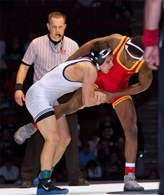

* 1. Conversions are recorded when an official awards 2 points for a takedown in succession of the attempt.

1. Head Outside attempt (hoa)
   1. When one athlete initiates a shot attempt with his head **outside** his opponent’s body-box as shown below. To be considered an attempt, the initiator must either drop to a knee on the attempt or lock his hands around his opponent’s leg, above the knee.
   2. 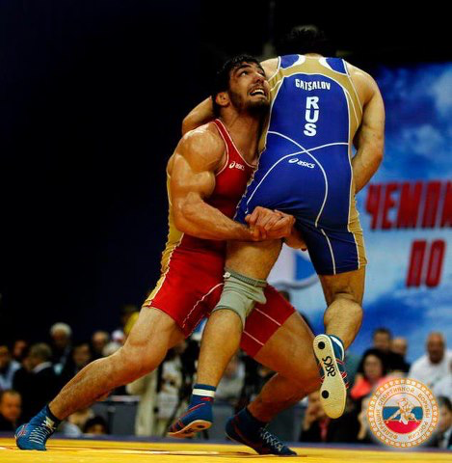Conversions are recorded when an official awards 2 points for a takedown in succession of the attempt.
2. Double attempt (da)
   1. When one wrestler initiates an attempt on **both** of his opponent’s legs (usually with his head outside his opponent’s body-box). To be considered an attempt the initiator must **only reach** for both legs and need not actually grab them. If it appears that an attempt was made to attack both legs, it should be recorded as a double attempt. It is common for these attempts to transfer into a new shot type.

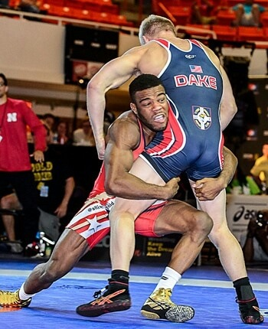

* 1. Conversions are recorded when an official awards 2 points for a takedown in succession of the attempt.

1. Low Shot attempt (lsa)
   1. When one wrestler initiates an attempt on **one** of his opponent’s legs **at or below the knee**. Low shots include low-singles, ankle picks, and knee picks. To be considered an attempt, the initiator must drop to a knee and reach for his opponent’s ankle/knee.

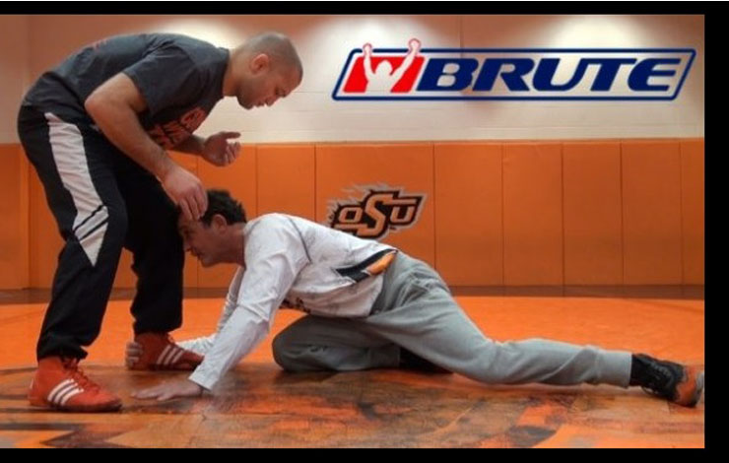

* 1. Conversions are recorded when an official awards 2 points for a takedown in succession of the attempt.

1. Counter attempt (GBa)
   1. Counters occur any time the opponent makes an attempt and the defending wrestler has time to react. The best position to describe a counter would be a sprawl-like position where the defender has his chest on the initiator’s back like a chest-lock position (far left). This can also occur from a snap-down. Counters are **not** recorded if the initiator makes an attempt and successfully converts (scores) or retreats away within one second as the defender never had time to counter. Another classic counter position is one in which the initiator is holding one of the defender’s legs in the air (middle). Another is from the crack-down position (far right).

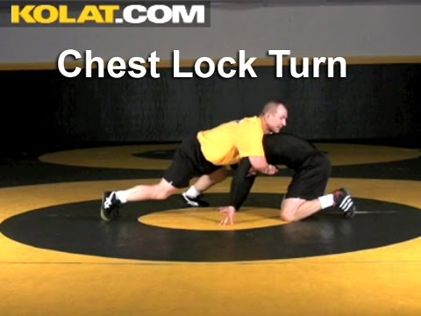 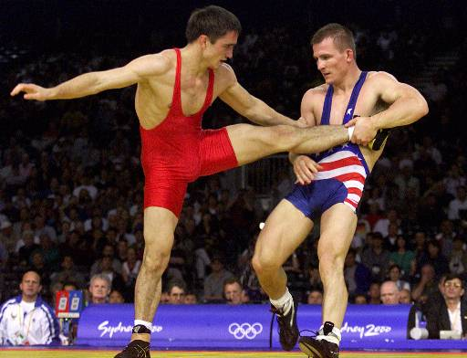 

* 1. Conversions are recorded when an official awards 2 points for a takedown in succession of the attempt. Mostly in the case of counters this occurs via go-behinds or when a counter transitions to another shot type.

1. Throw attempt (ta)
   1. Throws are perhaps the most noticeable action in the neutral position. Throw attempts are recorded when one athlete attempts to lift the other in the air and return him to the mat (usually without grabbing his legs). Double leg attempts that result in a lift are **not**considered throws. Lateral drops, hip tosses, head-locks, etc. are classic throw techniques. Duck-under, inside-trip, and foot-sweep are also throwing techniques.

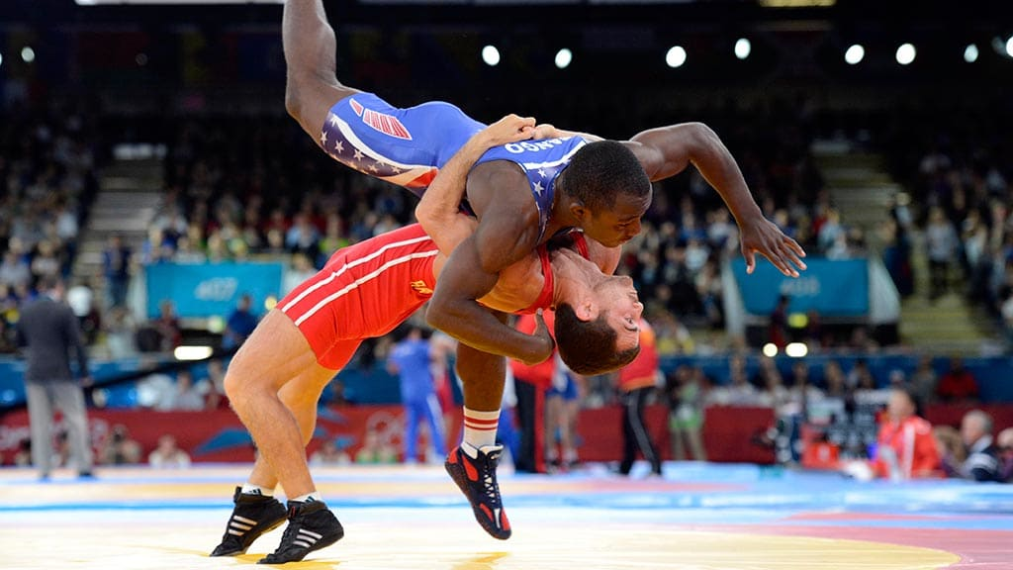

* 1. Conversions are recorded when an official awards 2 points for a takedown in succession of the attempt. In the case of throws the defending wrestler usually ends the position on his back.

1. Exposure (non-controlled)
   1. Non-controlled exposures occur often in freestyle wrestling from various positions. Anytime 2 points are awarded for exposure without a clear takedown (one wrestler finishing on top of the other) exposure should be recorded.
2. Bonus points (4 point moves)
   1. When an exposure occurs simultaneously as a takedown 4 points will be awarded. This should be recorded based on the takedown attempted and recorded as, for example, Dc4 (upon official confirmation).
3. Recovery
   1. Recovery should be awarded when one wrestler, after either being taken down or exposed, recovers on his/her opponent. Example: wrestler1 shoots a single but then wrestler2 exposes wrestler1 (2 points) BUT wrestler1 *recovers* and finished on top (1 point). This is also possible after being turned in parterre.
4. Pushout
   1. Recorded anytime a pushout occurs and is officially confirmed.

#### Parterre

This is when one wrestler is on top of the other wrestler. Most often the result of a takedown or throw. At the end of this section we will address techniques that can occur from any /all these positions. Only successful techniques are recorded in these positions (no attempts).

1. Gut
   1. Anytime the top wrestler locks his hands around the bottom wrestler’s waist and turns them. Can be high or low.
2. Leg Lace
   1. When the top wrestler locks the bottom wrestler’s legs in place and turns them.
3. Turn
   1. Any alternative form of turning from the top parterre position.

#### Extras

There are two types of Penalties: Technical Violations (tv) and Passivity (passive).

1. Official Confirmation
   1. Due to the three-part officiating process in freestyle, it must be written that techniques NOT be recorded until official confirmation is given. This will be signaled by points being placed on the board and/or the chairman confirming.
2. Passive
   1. Is recorded **anytime** passivity (sometimes referred to as “action” is called on either wrestler. **Including warnings.** This means an initial call (warning) followed by a second would put the athlete on the “activity clock” (aka shot clock) … thus TWO passive recordings. BUT not a third should the activity clock expire (see below).
3. Technical Violations
   1. Are recorded anytime a penalty point is awarded to either wrestler. Examples include loss of challenge, unsportsmanlike conduct, and illegal holds. Further, TV should be recorded should the activity clock expire.

## Post-match

Type “END to end the match. At the end of the match you should record the winner and how they won using the Result code. Remember the code representations for the Result are:

* blue fall: 1.75
* blue tech: 1.50
* blue decision: 1.10
* red decision: 0.90
* red tech: 0.50
* red fall: 0.25

Once you have completed all these steps, type “yes” to upload the information to the database.

## Logistics

This section contains specific situational issues that frequently occur. It is formatted in a discussion of each situation and unfortunately does not have many images to support it. Use your imagination to follow through each scenario.

#### Scenario 1 – Unconventional Low Shots

It sometimes occurs that a wrestler initiates a takedown attempt on the ankles of his opponent, but he does so in an unconventional way. Two examples are a head outside ankle grab, something Jason Nolf is quite good at a low double, something Logan Stieber is quite good at. Both shots and any shot attempt below the knee, especially around the ankle/foot region, is considered a Low Shot and should be recorded as such.

#### Scenario 2 – Sweep Singles

Sweep singles appear to resemble both Head Inside and Low Shot attempts. They are recorded as Head Inside due to their finishing nature.

#### Scenario 3 – 4-point turns from top/quad-pod

Should the top wrestler lift the bottom wrestler and then attempt a turn, this should be recorded as a throw attempt (and conversion). This applies to guts and reverse guts. Additionally, this applies to the quad-pod scenario where one wrestler is on top of the other but no supporting points have hit and so no takedown has been awarded.

#### Scenario 4 – Early Termination NOT due to Fall/Tech Fall

If a match ends early due to disqualification because of penalties, record it as a Fall for the wrestler who was NOT disqualified.

If a match ends early due to medical reasons, delete the recording.

#### Scenario 5 – Incomplete Match

If you are conducting film analysis (not live) and the entire match is unavailable (i.e. the first 30 seconds are missing) do NOT record the match.