INZPIRO

* DOCUMENTATION AND WORK DEPLOYMENT

Here we have documentation work in the initial stage for collecting the requirements from the clients or customers so that, this material provides official information or evidence that serves as a record . This documentation also known to be User Requirements Document. It is the primary input to the subsequent system design work and procurement specifications for pertinent system development contracts. Here the documentation team should analyses the record that they have is important..

1. Requirement Analysis will generally include

* Review of all relevant documents (including the Project Definition document and the Global Implementation Plan)
* Establishment of an initial system concept , if not already done.
* Consultation of clients
* Consolidation of inputs
* Negotiation of definitive statement of user requirements.

1. All users , both end-users and operators or maintainers , should be

Consulted . Consultation may include interviews ,workshops and e-mail.

1. There may be conflict of requirements ,when there are multiple stakeholders and users. These must be resolved before this document is finalised.

4) The final decision on approval of the specification of User Requirements should be with the pertinent sectoral Committee. Therefore:

* The User Requirement document should not be circulated as other than an unauthorised draft until that approval has been given.
* The User Requirement document should be in all respects presented at a level and in a manner suitable for evaluation and approval by the Sectoral Committee.

1. For easy Understanding , we can also represent in diagram like Use case Diagram.

For Example:

HOTEL MANAGEMENT SYSTEM

[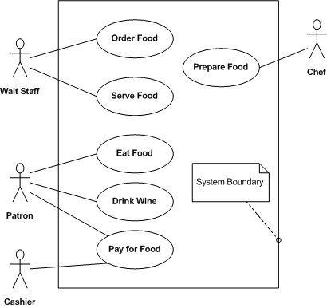](https://upload.wikimedia.org/wikipedia/commons/4/48/Restaurant-UML-UC.png)

For Work deployment , we have to assign people for the work .Here for assigning people ,we have to know the strength of each member and analyse the User requirement document by diagrams like

* Sequence Diagram
* Activity Diagram
* Data flow Diagram

The person who work for the deployment make sure you have the flow chart of your project , How it should proceed the project with the given span of time.

Skills Needed:

1. Working within a given span of time
2. Working under a pressure situations
3. Allocating resources if so many projects goes simultaneously.
4. Taking alternative decisions.
5. Making a live working environment .Etc.,

Some of the examples are given for easy understanding:

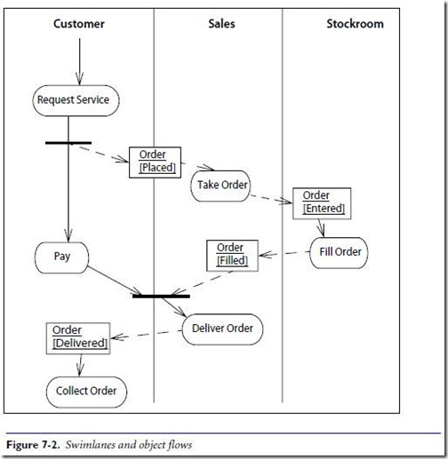



DATA FLOW DIAGRAM

* IDEA THINKING

The general ideas or opinion about a project can be given here by the group allocated for this process .The efficient ideas may be for example:

Coming up with new ideas which is cost effective , giving an implementation plan ,”How is going to work?”. And Analyzing the result of the project while implementing the idea. Result can be represented in graphs by comparing new and existing ideas.

This idea can be implemented after the approval of the Technical Team and Users.

* ANALYSIS AND FRAMING

Here analyse will come in all aspects like Analysing user requirements document, ideas, Analysing Resources Availability etc., Because, this Team is responsible for framing solutions, remedies for the problems comes in future.

Framing has 4 key ways is:

1. Define problems
2. Diagnose causes
3. make moral judgements
4. Suggest remedies.

Finally this team has the responsibility to finish their work as mentioned in the user Requirements without violating your organization rules. This team should fulfil their target as per the work schedule given by the work deployment Team.

* REPORT ANALYSIS

As per the organisation , Report Analysis is so much essential to know the completion of the work of each team. Here all the team should give their reports to the corresponding head or the work deployment team for tracking the work of each team to evaluate with the work Schedule .Here work corrections, mistakes be given through mail , meetings etc., after evaluating the report.

Through this we can evaluate the dedication of each team , estimating the time to complete the project , Resource availability ,Problems faced by each team is evaluated and taking necessary decision with the approval of head of the organization.

* MARKETING TEAM

It plays a vital role in promoting the business and mission of an organization. It serves as the face of your company and coordinating and producing all materials representing the business .Its job to reach out to prospects, customers ,investors and/or the community and create an overarching image that represents your company in a positive light-that is your brand.

The duties of the marketing team:

* Defining and Managing your brand:

This involves defining who you are ,what you stand for ,what you say about yourself ,what you do and how your company acts. This, in turn, defines the experience you want your customers and partners to have when they interact with you.

* Conducting campaign management for marketing initiatives:

Marketing proactively identifies the products and services to focus on over the course of your sales cycle, and then produces materials and communications that get the word out.

* Creating content providing search engine optimization for your website:

Your website is often the first (and possibly the only) place people go for information about you. Your marketing team will be responsible for keeping Web content current , while also working to ensure your site comes up quickly when someone searches for your type of business.

* Monitoring and Managing social media:

Marketing should contribute to ,manage and maintain your social media pages and accounts and carefully watch what’s being posted about your online.

* Producing internal communications:

Your employees need to understand your company ,its values ,its goals and its priorities. Marketing is often responsible for employee communications through a newsletter and/or internet.

* DOCUMENTATION TEAM

This documentation comes atlast after completing all the task of the project like Planning, Designing , Modelling ,Executing and delivery. This team will work as a database of the organization and evaluating all the work of departments like Finance, Marketing, IT , Supply chain etc., and try to conclude the impact of the project for an organization.

5 STAGES OF TEAM DEVELOPMENT

* FORMING
* STORMING
* NORMING
* PERFORMING
* ADJOURNING

For more information of each stage

Visit: <https://toggl.com/stages-of-team-development>

PERSONS IN AN ORGANIZATION

* **CHIEF EXECUTIVE OFFICER**

A chief executive officer (CEO) is the highest – ranking executive in a company, and their primary responsibilities include making major corporate decisions , Managing overall operations and resources of a company , and acting as the main point of communication between the board of directors and corporate operations.

Five Core Responsibility of CEO:

1. Own the Vision



A CEO should determine and communicate the organization’s strategic direction. While other people may help shape the strategic vision , the CEO must be able to describe it in a clear , engaging and exciting way for all stakeholders.

1. Provide the proper resources

Only the CEO can perform the task of balancing resources – the two most important ones being capital and people . The CEO must make both available in the proper quantities and at the right time for the company to succeed.

1. Build the Culture



Culture is the set of shared attitudes, goals, behaviours and values that characterize a group. The most critical part of culture is values: The CEO ensures that those values are applied consistently from top to bottom, across all departments. A good culture makes people feel safe and respected, enabling them to perform at their best.

1. Make good decisions



CEO is the person tasked with making the decisions. Many problems require a solution that will end up affecting multiple departments, and only the CEO is empowered to take such an action. Everyone else can pass the buck from time to time, but the CEO will make the final call when no one else will or can.

1. Oversee and deliver the company’s performance

Everyone agrees that the CEO is ultimately responsible for a company’s performance. To be successful, he or she must take an active role in driving the performance.



The CEO also serves as a interface between the internal operations and external stakeholders.

* **LEADER**

A leader sets a clear vision for the organization, motivates employees through the

Work process and builds morale. Leadership involves leading others towards achieving clear goals.

Top 5 Responsibilities of a leader

1. Inspiration And Motivation

As a leader, you must get others to do the work necessary for operating your business. You have to drop the idea of doing everything yourself and motivate others to complete tasks and reach objectives.

1. Setting an Example

You don’t always have a podium and a microphone to speak as a leader. Sometimes you set an example through you hard work, dedication and optimism.

1. Communicating Vision

Your vision organizes all of your employees efforts. You must let your work force know what you want to achieve in the long term, and you must explain how their daily activities relate to the long-term vision. Don’t leave the direction of your company up to employees, because they look to you for that direction.

1. Setting Company Priorities

Break down your vision into series of objectives so you know what has to get done before you can move onto the next objective. Employees might work hard, but if they work on the wrong tasks, you waste time and money getting them back on track. By setting priorities, you organize your employees work and give them a sense of orderly direction.

1. Seeking Solutions

No matter how strong your vision and how clear your priorities, you will encounter unexpected problems. You must convey the conviction that every problem has a solution .Either solve the problems or delegate problem- solving to responsible individuals. This will prevent demoralization when problems arise.

Present them as challenges that need to overcome effectively. Demonstrate that you expect these challenges to come along at any given moment and that you have confidence that you and your employees will find a solution for them.

* **MANAGER**

To run daily operations , coach employees , maintain quality control and ensure that its products and services are fulfilling customer needs. Managers must constantly review the company’s financial, budgetary and production goals.

Responsibilities of Manager:

1. Leadership

An effective manager must be able to set a vision for his organization or department, and have his staff see the value in that vision.

1. Administration

A manager must be able to oversee, or administer the operation of the area that he is responsible for. The day-to-day requirements vary, and he must be able to alter his current task, sometimes on a moment’s notice. The manager must be able to ensure that all requirements of his department are met on time.

1. Delegation

A great manager is able to delegate a department workload effectively and monitor its progress towards completion. He must also know exactly what each of his staff is capable of and give them work that they can complete effectively while also challenging them to achieve more.

* **EXECUTIVE DIRECTOR**

Someone who has the organization’s best interests at heart and is open to having frank – but supportive – dialog about the things that KEEP THE CEO AWAKE AT NIGHT. In short – a trusted advisor.

Responsibilities:

1. Working with the board

An experienced board of directors can provide strategic guidance, valuable contacts and resources to non-profit organizations. Executive Directors meet with the board regularly to keep them informed on operational issues and work with them to come up with strategic solutions to complex challenges.

1. Management Role

Executive Directors oversee the heads of each department in an organization including marketing, fundraising, program development, HR management and accounting. An executive Director may handle all accounting duties and half of the fundraising duties and may also work with program development managers to set standards for serving the organization’s targeted needs groups, in addition to the executive level duties.

1. Public Relations

Directors are expected to attend and possibly host range of fundraising events, new program inaugurations and public relations events. Directors often speak directly with reporters, donors, government representatives and members of the community at these events, spending a good deal of time acting as the public face of the organization.

1. Company Liaison

In addition to appearing at official events, executive directors act as a liaison between their organizations and a range of external Stakeholders. Directors

Develop and maintain relationships with other non- profit leaders.

For example, looking for opportunities to partner with other organizations to serve good cause.

Directors also work personally with leaders in the business and government world, cultivating long-term strategic partnerships or donor relationships to increase the organization’s effectiveness serving unmet needs.

* **DEVELOPERS**

They are responsible for the design, testing and maintenance of software programs for computer operating systems or applications, such as word processing or database management systems. Developers may create software programs customized for a specific organization, or software that is suitable for a wide variety of customers or business users.

ANALYSIS

Before they begin detailed design, developers work with users to obtain a full understanding of the software’s requirements. They analyze users’ needs and recommend new software programs or upgrades to existing programs. In larger terms, developers may collaborate with business or system analysts who carry out the detailed investigation into software requirements.

DESIGN

Developers translate the functional requirements of the software into a specification for detailed design. They may provide instructions that enable computer programmers to create the code for the software or they may write the code themselves. If they are instructing programmers, developers must have a detailed understanding of code so that they can evaluate the work of other team members.

TESTING

Software testing is a critical part of the development process. Developers test programs to ensure that they meet the requirements of the specification and that they are free of errors, known as bugs. Developers test the programs by entering data and trying out all program functions .They may also users to try versions of program to ensure that they are easy to use.

DOCUMENTATION

Developers prepare detailed documentation for software programs, Documentation provides a description of the functions and operation of the software that team members can refer to it. Documentation also provides the basis for operating instructions, guides for users, training programs and marketing guides.

PROJECT MANAGEMENT

Software development is a complex process that is broken into a number of stages, Developers collaborate with other members of the team to ensure that programs are completed on time and within budget. They establish schedules and monitor progress against key dates, Developers may also monitor costs against project budgets and prepare reports for team leaders.