# 商品模块

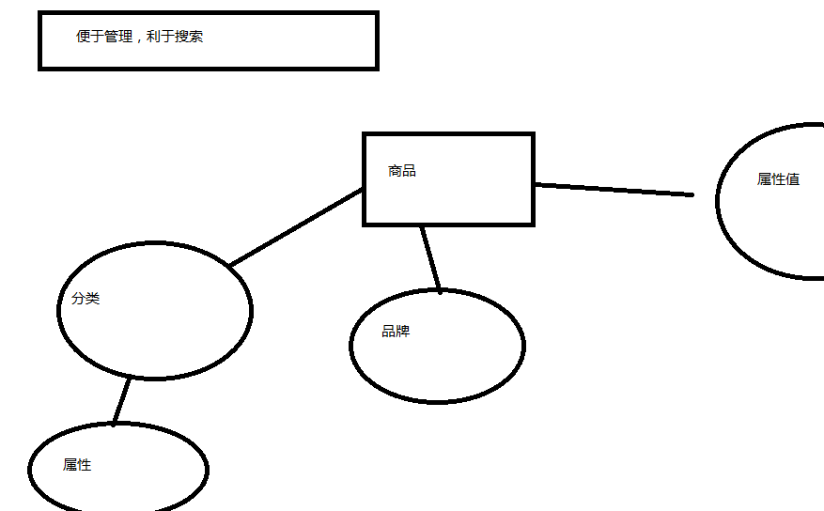

# 商品品牌

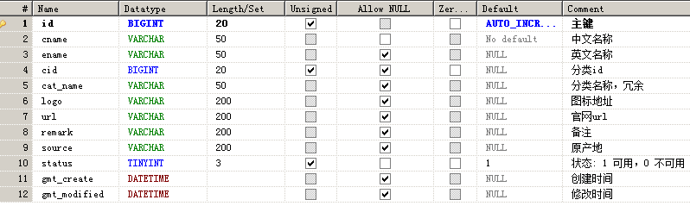

# 添加

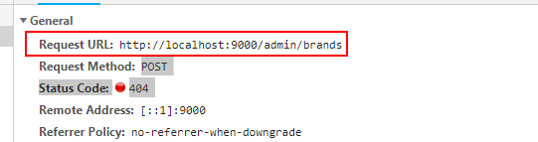

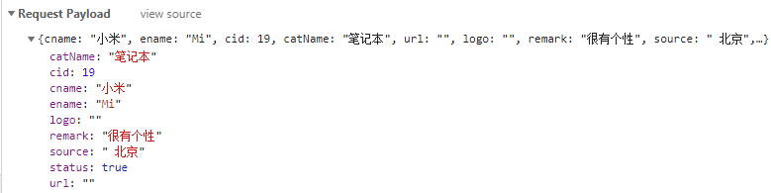

|  |
| --- |
| @RestController  @RequestMapping("/admin/brands")  **public** **class** BrandController {  @Autowired  **private** BrandService brandService;      @PostMapping  **public** ServiceMessage add(@RequestBody Brand brand) {  **try** {  brandService.add(brand);  **return** ServiceMessage.*ok*();  } **catch** (Exception e) {  e.printStackTrace();  **return** ServiceMessage.*error*();  }  }  } |

## 打印sql语句

|  |
| --- |
| spring:  datasource:  type: com.alibaba.druid.pool.DruidDataSource  url: jdbc:mysql://localhost:3306/go9?characterEncoding=utf-8&autoReconnect=true&failOverReadOnly=false  username: root  password: 111111  driver-class-name: com.mysql.cj.jdbc.Driver  server:  port: 9000  logging:  level:  root: info  com.go9.goods.mapper: debug  # 默认日志文件名  # file: log  # 默认日志路径  # path: ./log  # logback.xml路径，默认为classpath:logback.xml  # config: ./logback.xml |

# 分页查询

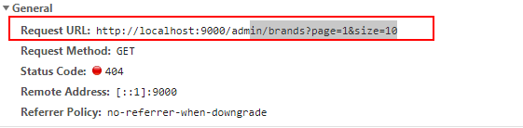

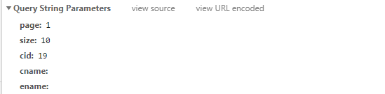

|  |
| --- |
| package com.go9.goods.controller;  import java.util.HashMap;  import java.util.List;  import java.util.Map;  import org.springframework.beans.factory.annotation.Autowired;  import org.springframework.web.bind.annotation.GetMapping;  import org.springframework.web.bind.annotation.PostMapping;  import org.springframework.web.bind.annotation.RequestBody;  import org.springframework.web.bind.annotation.RequestMapping;  import org.springframework.web.bind.annotation.RestController;  import com.go9.common.ServiceMessage;  import com.go9.goods.pojo.Brand;  import com.go9.goods.service.BrandService;  @RestController  @RequestMapping("/admin/brands")  public class BrandController {  @Autowired  private BrandService brandService;    @GetMapping  public ServiceMessage getByPage(int page, int size, Brand brand) {  try {  List<Brand> list = brandService.getBrandsByPage(page, size, brand);  // 这里为了配合前端的妹子，哥默默牺牲了接口的通用性  Map<String,Object> map = new HashMap<>();  map.put("rows", list);  int count = brandService.getCountByCondition(brand);  map.put("total", count);  return ServiceMessage.ok(map);  } catch (Exception e) {  e.printStackTrace();  return ServiceMessage.error();  }  }    @PostMapping  public ServiceMessage add(@RequestBody Brand brand) {  try {  brandService.add(brand);  return ServiceMessage.ok();  } catch (Exception e) {  e.printStackTrace();  return ServiceMessage.error();  }  }  } |

# 修改（作业）

# 删除（作业）