下载地址：<http://rocketmq.apache.org/release_notes/release-notes-4.4.0/>



上传到虚拟机

**rz**

**yum install unzip –y**

**unzip rocketmq-all-4.4.0-bin-release.zip -d /usr/local/**

**cd /usr/local/**

# 扩展小知识

‘

|  |
| --- |
| 使用&后台运行程序：   * 结果会输出到终端 * 使用Ctrl + C发送SIGINT信号，程序免疫 * 关闭session发送SIGHUP信号，程序关闭   使用nohup运行程序：   * 结果默认会输出到nohup.out * 使用Ctrl + C发送SIGINT信号，程序关闭 * 关闭session发送SIGHUP信号，程序免疫   平日线上经常使用nohup和&配合来启动程序：   * 同时免疫SIGINT和SIGHUP信号   同时，还有一个最佳实践：   * 不要将信息输出到终端标准输出，标准错误输出，而要用日志组件将信息记录到日志里 |

# Start Name Server

注意：这里要先修改内存，默认4g，请修改（学习时）

修改**vi bin/runserver.sh**

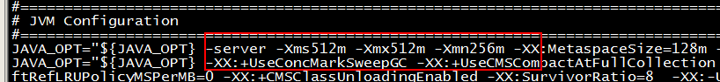

> nohup sh bin/mqnamesrv &

> tail -f ~/logs/rocketmqlogs/namesrv.log

The Name Server boot success...



**开了个端口 9876**

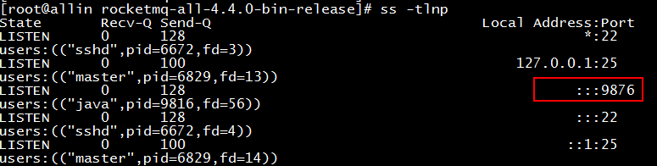

# Start Broker

修改**vi bin/runbroker.sh**

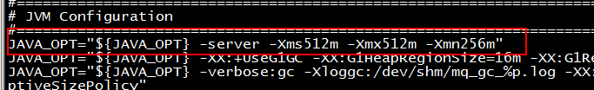

> **nohup sh bin/mqbroker -n localhost:9876 &**

> **tail -f ~/logs/rocketmqlogs/broker.log**

The broker[%s, 172.30.30.233:10911] boot success...

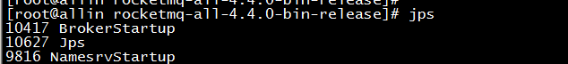

# Send & Receive Messages

Before sending/receiving messages, we need to tell clients the location of name servers. RocketMQ provides multiple ways to achieve this. For simplicity, we use environment variable NAMESRV_ADDR

> **export NAMESRV_ADDR=localhost:9876**

> **sh bin/tools.sh org.apache.rocketmq.example.quickstart.Producer**

SendResult [sendStatus=SEND_OK, msgId= ...

> **sh bin/tools.sh org.apache.rocketmq.example.quickstart.Consumer**

ConsumeMessageThread_%d Receive New Messages: [MessageExt...

# Shutdown Servers

> **sh bin/mqshutdown broker**

The mqbroker(36695) is running...

Send shutdown request to mqbroker(36695) OK

> **sh bin/mqshutdown namesrv**

The mqnamesrv(36664) is running...

Send shutdown request to mqnamesrv(36664) OK

# 理论

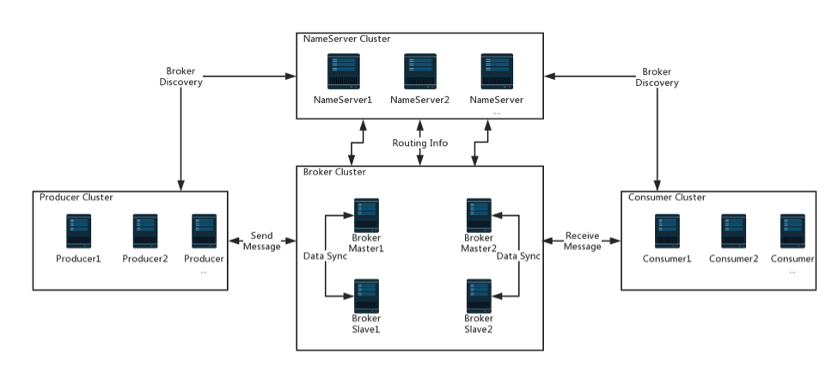

# 集群部署

我们部署的模式是：

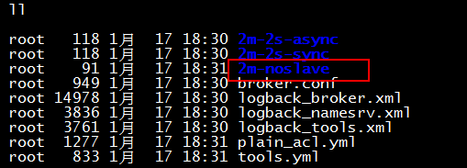

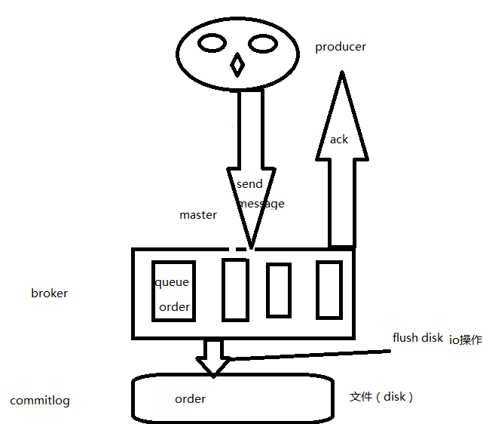

## 启动一个name server

**nohup sh bin/mqnamesrv &**

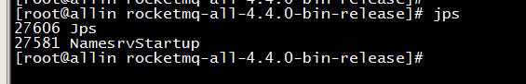

## 配置broker

**mkdir /rocketmq/2m-a/store -p**

**mkdir /rocketmq/2m-a/store/commitlog -p**

**mkdir /rocketmq/2m-a/store/consumequeue -p**

**mkdir /rocketmq/2m-b/store/consumequeue -p**

**mkdir /rocketmq/2m-b/store/commitlog –p**

**cd /usr/local/rocketmq-all-4.4.0-bin-release/conf**

**vi 2m-noslave/broker-a.properties**

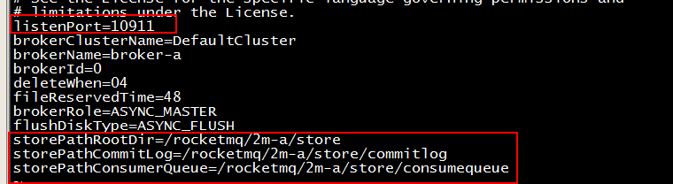

**storePathRootDir=/rocketmq/2m-a/store**

**storePathCommitLog=/rocketmq/2m-a/store/commitlog**

**storePathConsumerQueue=/rocketmq/2m-a/store/consumequeue**

**vi 2m-noslave/broker-b.properties**

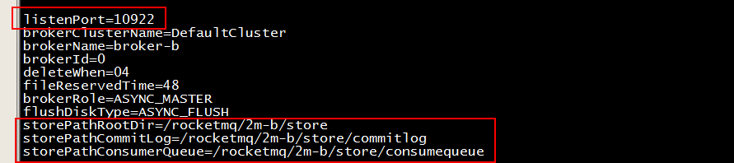

**storePathRootDir=/rocketmq/2m-b/store**

**storePathCommitLog=/rocketmq/2m-b/store/commitlog**

**storePathConsumerQueue=/rocketmq/2m-b/store/consumequeue**

## 启动broker

**在根目录下执行一波**

**nohup bash bin/mqbroker -c conf/2m-noslave/broker-a.properties -n 192.168.162.100:9876 &**

**nohup bash bin/mqbroker -c conf/2m-noslave/broker-b.properties -n 192.168.162.100:9876 &**

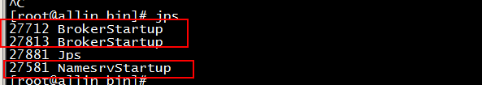

## 发送消息

**export NAMESRV_ADDR=localhost:9876**

**下面是一行的**

**sh bin/tools.sh org.apache.rocketmq.example.quickstart.Producer**

## 接受消息

**下面是一行的**

**sh bin/tools.sh org.apache.rocketmq.example.quickstart.Consumer**

## 关闭集群

**sh bin/mqshutdown broker**

**sh bin/mqshutdown namesrv**

## 查看集群

**在bin目录里**

**bash mqadmin clusterlist -n 192.168.162.100:9876**

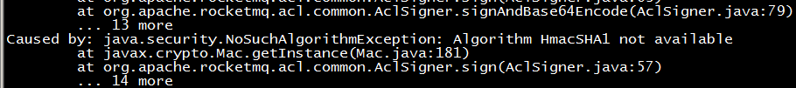

**如果出现以上问题，请配置java_home环境变量：**

**export JAVA_HOME=/usr/java/jdk1.8.0_202-amd64**

**在bin目录里**

**bash mqadmin clusterlist -n 192.168.162.100:9876**

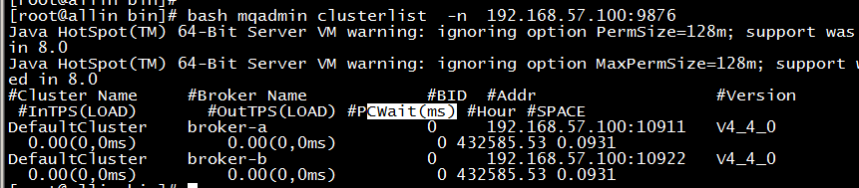

## 图形界面

<https://github.com/apache/rocketmq-externals/releases>

# 扩展知识

Jdk默认安装路径：

