Initiative to Evolve Significance Intermediate Links of COVID-19 with Related Infectious Disease

Abstract:
The main objective of this research is to extract the pattern and subtle connections from COVID-19 literature named as (CORD-19, 2020)[1]. The substructure and pattern signify by adding a more specific source relating to the infectious disease that ultimately pointing to the appealing feature of COVID-19. The research has focused on the infectious disease either bacterial or viral, their symptoms, drug compound and the era of exposure. The motivation of work to develop intermediate links by infection, infectious, drug compound, and time for developing causal events chain that ultimately lead for amelioration of COVID-19.
Key Word: COVID-19,
Introduction:
According to the medical experts of China, the initial finding in December 2019, the epidemic disease COVID-19 considers as a form of pneumonia that later take as the acute forms of SAR but intermediate hosts are still missing there [2]. The findings on newly faced disease has been varied between different sources. The worldwide epidemic disease spread exponentially by human attachment. According to our knowledge, till March 30, 2020, there is no vaccine and all the medical research departments and various agencies struggling to develop medicine. On Mar 16, 2020, the Chan Zuckerberg Initiative by providing relating data to emerges the new research on the novel COVID-19. The data has captured much of interest that covered the relating literature from (1972-2020 February). The data contained coronavirus relating research articles from different sources [...]. In this research, the initiative takes by applying feature mining techniques to infer direct relation and connections that suggested COVID-19 might to treat as other infectious diseases. The study has covered almost all subcategories that fall under ‘infection and infectious disease’. We are focused on most appealing feature of subject as cause, symptoms, drug compound and time that infer from the given literature (CORD-19, 2020). We have consider title and abstract part of the artiles for develop keen and direct intermediate links and connection. In research the title and abstract part of the paper are considered as the most informative part to ranked the similarities, for relevance and even in training of the word embedding in NLP [...]. This research applying a naive but direct approach to capture the direct information about COVID-19 by using the direct and most related literature of COVID-19 [1]. Across the relevant biomedical sources to develop insights on coronavirus literatures that directly relating to the infectious diseases used that linked in Data link part of paper. The study has focused on the infectious disease, relating symptoms, the approved drug compound, and also in which era the organism captured by it. This study is hypothesize the current epidemic situation by using the COVID-19 literature (CORD-19, 2020) as a key source to extract the information across the other biomedical source. This study is hypothesize the current epidemic situation by using the COVID-19 literature (CORD-19, 2020) as a key source to extract the information across the other biomedical source.

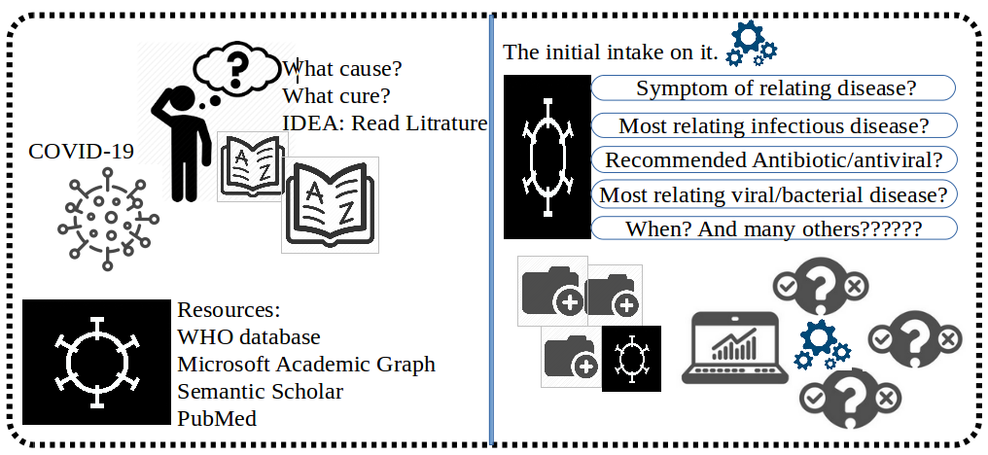

Problem statement:
Providing the literature on X, try to predict the relatedness and the hidden connection of X with Y and Z either to have direct and indirect relation based on α, β and others.
In the given scenario, the ultimate literature of coronavirus in textual form of data as a source and by applying NLP trick to evolve significant intermediate links between COVID-19 and with other diseases or to infer indirect hosts of disease based on the symptoms that guiding to the group of approved drugs compounds. The strategy to infer the information from textual literature has been picked from the recommended article by https://www.wired.com named as ‘Migraine and Magnesium: Eleven Neglected Connections’ [5]. This popular study on the uncertain disease, that initially had not cleared symptoms and cure, then the author is picked the textual literature based on the research articles to infer the hidden connection between the disease to disease with common symptoms and others [5]. The motive to amelioration for COVID-19 to make it possible to classify and learned a comprehensive path based under the specific era picked from the time (1972-2020 March).
Related Drug Data:
In this study, the data of approved drug compound has been taken from the WCG CenterWatch (The trusted Source for Clinical Trials Information). The drug compound collected under subcategories of the ‘Infections and Infectious Diseases’ all from A-to-Z named list. The insights for developing the sense and recommendation of these in given literature for specific approved drug compounds. On another side, the output information further interact relatedness and correlation develop with the symptoms and names of infectious diseases with the era of their application to validate the information trails.
Related Disease Data:
In collection of the related disease to COVID-19, the meta-data has collected from two sources. First source of disease terms data collection fall under category of “infectious and parasitic diseases” collected from 2020 ICD-10-CM Codes. Second source of Infectious Diseases term derived from the Rhode Island Department of Health.
Symptom Data:
Till to the March 30, 2020, On COVID-19 as a world wide disease has been effecting to the environmental and social facilities of developed countries. There is not a cleared picture of epidemic situation cause, symptoms. The major precuation consider to have a social distances for avoiding to be attacked by coronavirus. From a large list of observing symptom of this novel disease with few most symptoms specified by WHO include:
- fever
- tiredness
- dry cough
The above listed symptoms is too common that are pointing to the different viral/bacterial disease with most SARS, Influenza, Coronavirus, and other bacterial diseases. In this study, the disease symptom data from A-to-Z has taken from the NHS inform, a Scotland's national health information service. The data from source picked under categories of ‘Symptoms and self-help’ and includes information on common symptoms. Other Symptoms and signs involving the circulatory and respiratory systems also compiled from the ICD10CM fall under the Codes R00-R99.

Data links:
Infectious drug compound list:
www.centerwatch.com
Infectious disease terms data:
a) https://www.icd10data.com
b) https://health.ri.gov
Symptom data:
a) https://www.nhsinform.scot
b) https://www.icd10data.com
(CORD-19, 2020):
https://pages.semanticscholar.org/coronavirus-research

Names list of same disease (March 30, 2020):
- 2019-nCoV named by World Health Organization (WHO) on January 12, 2020
- Coronavirus Disease 2019 (COVID-19) by World Health Organization (WHO) on February 11, 2020
- Severe Acute Syndrome Coronavirus 2 (SARS-CoV-2) by International Committee on Taxonomy of Virus on February 11, 2020
- 2019-nCoV acute respiratory disease
- Novel coronavirus pneumonia
- Wuhan pneumonia [3,4]
- Wuhan coronavirus

References:
[1] COVID-19 Open Research Dataset (CORD-19). 2020. Version 2020-03-20. Retrieved from https://pages.semanticscholar.org/coronavirus-research. Accessed YYYY-MM-DD. doi:10.5281/zenodo.3715505
[2] Sun, P., Lu, X., Xu, C., Sun, W. and Pan, B., 2020. Understanding of COVID‐19 based on current evidence. Journal of medical virology.
[3] Campbell C (20 January 2020). "The Wuhan Pneumonia Crisis Highlights the Danger in China's Opaque Way of Doing Things". Time. Retrieved 13 March 2020.
[4] Lucey D, Sparrow A (14 January 2020). "China Deserves Some Credit for Its Handling of the Wuhan Pneumonia". Foreign Policy. Retrieved 13 March 2020.
[5] Swanson, Don R.. “Migraine and Magnesium: Eleven Neglected Connections.” Perspectives in Biology and Medicine 31 (1988): 526 – 557.
[6] World Health Organization (WHO): https://www.who.int/

