**Incremental Testing and Regression Testing**

Team:Nanxin Jin, Yang Shi, Weijie Meng, Jintao Zeng, Yaoxi Liang

1. **Classification of Components**

* **Define all components**

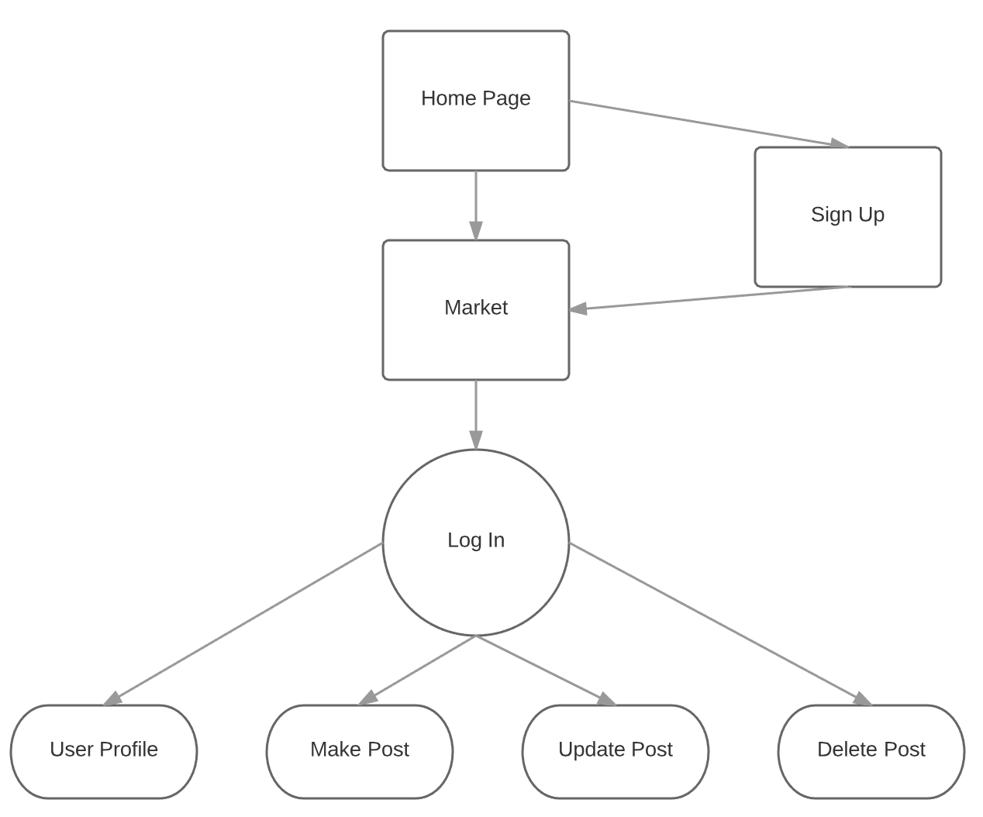

Homepage

Input:None

Ouput:None

Parent Dependency: None

Child Dependency:Sign up, Sign in

Sign Up

Input: Username,Password

Ouput: Success or fail message

Parent Dependency: Homepage

Child Dependency: Market Page

Market

Input:None

Ouput:None

Parent Dependency: Homepage

Child Dependency: Login

Login

Input:Username, password

Ouput:Success or fail message

Parent Dependency:

Child Dependency:Market page

User Profile:

Input: Personal info

Ouput: Success or fail message

Parent Dependency: Login

Child Dependency:None

Make Post:

Input: Item name, price, content

Ouput: Success or fail message

Parent Dependency: Login

Child Dependency:None

Update Post:

Input:Item name, price, content

Ouput: Success or fail message

Parent Dependency: Log in

Child Dependency: None

Delete Post:

Input: Post name

Ouput: Success or fail message

Parent Dependency: Sign in

Child Dependency:None

* **Which form of incremental testing did you follow**

Top-down incremental testing:

Since in the second sprint we will add more sub modules under our market, so we are using top down testing to test from main module to sub module which is not fully developed yet.

1. **Incremental and Regression Testing**

|  |  |  |  |
| --- | --- | --- | --- |
| Module | Homepage | | |
| **Incremental Testing** | | | |
| Defect # | Description | Severity | How corrected |
| 1 | User should not still remain on the homepage after clicking the login button | 3 | Set onClick action listener to the login button and generate a pop-out login window. |
| 2 | Market button should show up in the navigation bar | 2 | Fix the position attribute in CSS file |
| **Regression Testing** | | | |
| Defect # | Description | Severity | How corrected |
| 1 | Fixing the login button issue causes page to pop out a login window | 3 | The action listener is called and generate a pop-out login window |
| 2 | Fixing market button position in homepage causes the market button to show up in the right place | 2 | Position attribute of the market button set properly in CSS |

|  |  |  |  |
| --- | --- | --- | --- |
| Module | Login | | |
| **Incremental Testing** | | | |
| Defect # | Description | Severity | How corrected |
| 1 | When click on log in button, app.js cannot get the email and password from the input. | 3 | Place the jQuery.min.js ahead of app.js so the app.js can use the $ to get the input content |
| 2 | User should not still remain on the login page after clicking the cancel button | 2 | Add a href attribute to the cancel button. |
| **Regression Testing** | | | |
| Defect # | Description | Severity | How corrected |
| 1 | The input for email and password can be sent to app.js after clicking the login button. | 3 | The jQuery.min.js placed before the app.js and js can use $ to get the input message |
| 2 | Fixing the cancel button issue causes page to jump to the market page. | 2 | Cancel button directed to the market page. |
| 3 | Fixing the server cannot receive sign up data information causes password in database didn’t encrypt. | 3 | Move the continue function in user pre save function to right location. |
| 4 | Fixing the server cannot delete the user’s token in logout causes all the token being deleted. | 3 | Correct the query to find the right token to delete. |

|  |  |  |  |
| --- | --- | --- | --- |
| Module | Make Post | | |
| **Incremental Testing** | | | |
| Defect # | Description | Severity | How corrected |
| 1 | Making posts fail to save in database. | 2 | Correct the type of price from String to Number |
| 2 | Making posts always responds an error status. | 2 | Correct the response status in success condition. |
| **Regression Testing** | | | |
| Defect # | Description | Severity | How corrected |
| 1 | Fixing the server cannot receive data from client when making post causes an item saved twice. | 1 | Remove the duplicated save function |
| 2 | Fixing the server cannot receive data from client when making post causes the item didn’t saved with send user. | 2 | Implement the middleware correctly. |

|  |  |  |  |
| --- | --- | --- | --- |
| Module | Update Post | | |
| **Incremental Testing** | | | |
| Defect # | Description | Severity | How corrected |
| 1 | Server can’t receive any updated information | 2 | Fix the route setting for update part in the server |
| 2 | Front end can’t fetch the input message from the user | 3 | Fix the id attribute for input box |
| **Regression Testing** | | | |
| Defect # | Description | Severity | How corrected |
| 1 | JSON can be received correctly after user updates a post | 2 | The server can map to the correct route when front end sends the “put” request |
| 2 | Fixing the input issue causes input message to be fetched in the input box | 3 | The input message can be saved into the correct variables in js. |

|  |  |  |  |
| --- | --- | --- | --- |
| Module | Delete Post | | |
| **Incremental Testing** | | | |
| Defect # | Description | Severity | How corrected |
| 1 | The post should not remain on the post page after being removed | 2 | Fix the reference in the delete function |
| 2 | The other posts should not be removed after removing only one item | 2 | Change the query process in the backend |
| **Regression Testing** | | | |
| Defect # | Description | Severity | How corrected |
| 1 | Fixing the server cannot receive deleting item from client causes failing to delete any object | 2 | Correct the delete function and make it works. |
| 2 | Fixing deleting item function in server causes all the market being deleted. | 3 | Correct the query to find the right market to delete. |