ShipIt.exe
AI-Generated Fanfiction Trope Compatibility Engine — Project Proposal
MSc AI/ML Mini Project · Department of MCA · Christ (Deemed to be University), Bengaluru

1. Research Question
Does an LLM's chapter-by-chapter generated narrative between two fictional characters — including characters drawn from different fictional universes (crossover pairings) — align with recognized fandom character-dynamic conventions (as defined against a curated taxonomy modeled on Archive of Our Own's community tagging system for non-romantic/"gen" fiction), and does trope emphasis shift appropriately across a story's structural arc — setup, rising tension, turning point, and resolution? The taxonomy is deliberately scoped to platonic dynamics (found family, rivalry-to-partnership, mentorship, team-up) rather than romantic tropes, keeping the generated content and the research question appropriate for an academic submission.
A secondary question, explored as an enhancement rather than the core evaluation: can the same generated narrative undergo a full register/dialect shift into internet-slang ("Brainrot Mode") while preserving its underlying plot and detected tropes — testing style transfer under semantic-preservation constraints.

2. Motivation
Existing plot-prediction work (including this student's earlier approved project) evaluates whether an LLM can anticipate a fixed, pre-written ending. This project inverts the question: instead of predicting a known narrative, the LLM generates an original one, and the research evaluates whether that generation respects the same structural and tonal conventions real human fanfiction communities have already formalized through years of collaborative tagging. This grounds an otherwise purely generative, creative task in a citable convention system with an existing taxonomy, giving the evaluation a concrete reference point rather than relying on subjective judgments of "good writing."

3. Methodology

3.1 Trope Taxonomy
A curated set of approximately 16 tropes commonly used across fan-fiction communities for non-romantic ("gen") character dynamics (e.g. Found Family, Rivals to Partners, Mentor and Protégé, Fish Out of Water, Unlikely Allies, Trust Earned the Hard Way, Found Siblings, Protective Instinct), each with a working definition and characteristic textual markers. This taxonomy is static and curated by hand rather than scraped live from AO3, avoiding both scraping fragility and any terms-of-service concern, while still being modeled on that platform's real, community-maintained tagging conventions.

3.2 Story Generation
Given two user-specified fictional characters, the system generates a four-chapter narrative (The Spark → The Shift → The Turn → The Resolution), with each chapter generated as a separate call that carries forward prior chapters as context, maintaining character voice and continuity. Generation uses an open-weight instruction-tuned model (Llama 3.1 or Mistral) accessed via free hosted inference, since local CPU execution of a model at this quality tier is impractical within the notebook environment.

3.3 Trope Classification
After each chapter is generated, a classification pass scores which taxonomy tropes are present in that specific chapter and extracts the exact sentence(s) that triggered each classification, producing an explainable, evidence-grounded label rather than a black-box score.

3.4 Structural Analysis
Aggregating trope classifications across all four chapters and across multiple generated character pairs allows analysis of whether trope emphasis follows expected structural patterns — e.g., whether "Fish Out of Water" and "Culture Clash" concentrate in early chapters while "Found Siblings" or "Betrayal and Reconciliation"-coded tropes concentrate later, mirroring how human-written team-up/found-family fiction is conventionally structured.

4. Tech Stack
- Generation: Llama 3.1 / Mistral via hosted inference API (e.g. Groq free tier)
- Trope classification: sentence-level keyword + embedding similarity against taxonomy definitions (Sentence-Transformers)
- Backend: Python (pandas, requests)
- Frontend: single-file HTML/CSS/JS dashboard, no build step, Y2K/early-fandom-web aesthetic
- Notebook: Google Colab / Antigravity for reproducible execution

5. Feature Classification
Feature | Classification
Curated fandom trope taxonomy (~16 tropes, definitions) | Core
Chapter-by-chapter story generation (4 structural beats) via open-weight LLM (Llama 3.1 / Mistral, hosted inference) | Core
Per-chapter trope classification with quoted textual evidence | Core
Bond Meter: trope-intensity visualization evolving across chapters | Core
Research evaluation: does per-chapter trope classification align with the chapter's structural role (setup / rising tension / turn / resolution)? | Core
Prose "polish pass" (second LLM call refining pacing/dialogue) | Enhancement
Chapter-by-chapter reveal UI, Y2K/early-fandom-web aesthetic | Enhancement
Brainrot Mode: same chapter re-rendered in internet-slang register (style-transfer study) | Enhancement
Pre-cached flagship character pairs for demo reliability | Enhancement
Live AO3 tag scraping for ground-truth validation | Future Scope
User-submitted custom pairs at run time (needs live API key on stage) | Future Scope

6. Two-Week Timeline
Days | Milestone
1–2 | Finalize trope taxonomy (~16 tropes w/ definitions); set up hosted LLM API access; project scaffolding
3–5 | Build chapter generation pipeline (4-beat structure, carried character context)
6–8 | Build per-chapter trope classifier + evidence extraction
9–10 | Genre/structural-role analysis: does trope emphasis track chapter position in the arc?
11–12 | Build chapter-reveal dashboard UI (Bond Meter, trope badges, Brainrot Mode toggle)
13 | Polish pass integration, pre-cache flagship demo pairs
14 | Buffer, documentation, viva prep

7. Ethical Considerations
- All generated characters are fictional; the system does not generate content involving real, named public figures.
- Generated narratives are clearly labeled as AI-generated fiction throughout the interface.
- Brainrot Mode is a stylistic register shift, not a claim about any real internet community's speech being generated verbatim.
- The taxonomy and all example-generated content are scoped to non-romantic ("gen") character dynamics, keeping generated output appropriate for academic submission and review.
- Demo pairings may include characters from existing copyrighted franchises used transformatively (original, newly generated scenes and dialogue rather than reproductions of existing copyrighted text) — consistent with how fan-fiction communities' "gen" and crossover content is already conventionally produced and shared.

8. Explainability: Attention Lens
Beyond the evidence-quote system (which shows which sentence triggered a trope classification), the system includes a second, mechanism-level explainability layer: direct visualization of GPT-2's self-attention weights for key evidence sentences. Self-attention lets each word's representation be computed as a weighted combination of every other word's representation, with weights learned rather than fixed by word order alone — this is the mechanism underlying every transformer used in this project, from GPT-2 through Llama, Mistral, and Sentence-Transformers' MiniLM. The figure below shows, for one representative sentence per chapter, which words the model weighted most heavily (brighter = higher attention weight) when processing that sentence — averaged across all attention heads in the model's final layer.
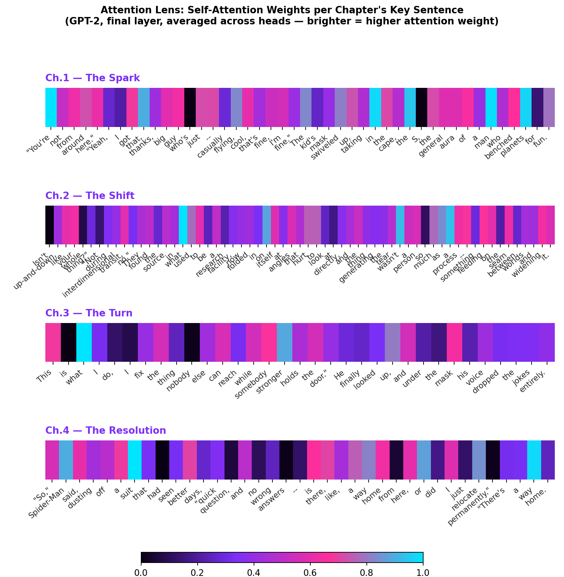
Note: this figure was generated using a small randomly-initialized model to validate the extraction pipeline in a network-restricted environment; running the same script with a downloaded pretrained gpt2 (available by default in Colab/Antigravity) produces the equivalent figure with genuine trained-model attention patterns.

9. Deliverables
- Reproducible Colab/Antigravity notebook implementing the full generation → classification → analysis pipeline
- Curated trope taxonomy (CSV/JSON) with definitions
- Interactive dashboard (dashboard.html) demonstrating chapter-by-chapter reveal, Bond Meter, and Brainrot Mode
- Short written report covering methodology, taxonomy design, and structural-alignment findings across generated pairs

