CIT 140 Systems Analysis and Design
Portfolio Review Packet — Weeks 1 through 7

Prepared By: | Nzubechi Anyanwu
Course & Term: | CIT 140 - Fall 2026
Artifact Files: | Anyanwu_Nzubechi_CIT140_Week08_Portfolio.docx / .pdf
Repository URL: | https://github.com/nanyanwu1985/CIT140-Portfolio

Section 01: Client Overview & Portfolio Purpose
This portfolio review packet provides an organized, transparent, and verifiable account of the systems analysis work completed across Weeks 1 through 7 for the Meridian Forge and Cedar Junction case studies. Prepared for review desk evaluation, this document structures our investigations, preserves original evidence links, explains analytical findings, and identifies open operational uncertainties prior to future solution comparison and design.
Case Separation & Operational Scope:
- Meridian Forge Cases (Weeks 1, 2, 3, 7): Focuses on robotics quality assurance, command authorization, retired test control, and inspection data quality.
- Cedar Junction Cases (Weeks 4, 5, 6): Focuses on community health clinic appointment management, visitor intake workflows, and inspection report routing systems.

Section 02: Table of Contents & Weeks 1–7 Inventory
Week | Case | Artifact | Packet Page | Original File Link | Status
Week 1 | Meridian Forge | Problem Brief: MR-17 Test K-44 Incident | Page 3 | Week01/Artifact/CIT -140 Week 1 Problem Brief.pdf | Complete
Week 2 | Meridian Forge | Business Case Recommendation: QA Control Review | Page 4 | Week02/Artifact/CIT140 Week 02 — Business Case Recommendation.pdf | Complete
Week 3 | Meridian Forge | Stakeholder Map & Consultation Register | Page 5 | Week03/Artifact/CIT140 Week 03 - Stakeholder Map.pdf | Complete
Week 4 | Cedar Junction | Validated Requirements Set (R-01 to R-08) | Page 6 | Week04/Artifact/CIT140 Week 4 Validated Requirements.pdf | Complete
Week 5 | Cedar Junction | As-Is Process Model Diagram & Analysis | Page 7 | Week05/Artifact/Anyanwu_Nzubechi_CIT140_Week05_As_Is_Process_Model.pdf | Complete
Week 6 | Cedar Junction | Data-Flow Model & Routing System Analysis | Page 8 | Week06/Artifact/Anyanwu_Nzubechi_CIT140_Week06.pdf | Complete
Week 7 | Meridian Forge | Data-Quality Report & Applied Steps | Page 9 | Week07/Artifact/Anyanwu_Nzubechi_CIT140_Week07.xlsx | Complete

Section 03: Weekly Artifacts, Findings, & Client Explanations

Week 1: Problem Brief (Meridian Forge)
Artifact: Problem Brief: MR-17 Test K-44 Incident (Figure 1); Original Location: Week01/Artifact/CIT140-Week01-Problem-Brief.html
Question Examined: Why did robot MR-17 begin repeating retired Test K-44 without an active scheduling assignment, and why did the operator stop request return ACTIVE_INSTRUCTION_PENDING?
Supported Finding: Incident logs (Nia Voss) confirm MR-17 accepted TEST_K44_START at 02:13:07. Maintenance records prove Test K-44 was marked retired 186 days prior. Command telemetry (Elias Chen) shows a validly formatted command originated from legacy_sync.exe, though service ownership remains unverified.
Client Importance: Production is currently paused in the affected QA cell. Understanding that the command was syntactically valid prevents premature assumptions of hardware failure and directs investigation toward software scheduling registries.
Uncertainty & Next Check: The records do not prove whether every copy, service, or schedule of Test K-44 was completely purged from active nodes when marked retired. The next check inspects active scheduling registries across all endpoints.

Week 2: Business Case Recommendation (Meridian Forge)
Business Case Recommendation: QA Control Review (Figure 2); Original Location: Week02/Artifact/CIT140_Week02_Business_Case_Recommendation.pdf
Question Examined: Is a bounded QA Control Review for the affected QA cell economically and operationally viable?
Supported Finding: The base estimate of $2,820 fits within the sponsor's $3,000 internal staff time envelope. The proposed 8-business-day elapsed timeline provides a 2-day safety margin against the 10-day limit across 48 total staff hours.
Client Importance: Establishes a defensible, structured review of command permissions and retired test controls without authorizing equipment repairs, software modifications, or unbudgeted expenditures.
Uncertainty & Next Check: Relies on the condition that read-only record exports arrive by day three. The sponsor and project lead must confirm access availability and staff allocation prior to final commitment.

Week 3: Stakeholder Map & Consultation Plan (Meridian Forge)
Artifact: Stakeholder (Figure 3); Original Location: Week03/Artifact/CIT140_Week03_Stakeholder_Map.pdf
Question Examined: Who is affected by the QA Control Review, and whose participation, technical expertise, or formal authority is required?
Supported Finding: Stakeholder analysis distinguishes operational roles: Nia Voss (Night QA Supervisor) and night-shift operators contribute hands-on workflow context; Elias Chen (Robotics Engineer) provides technical telemetry analysis; Mara Ilyan (Operations Manager) coordinates review routing.
Client Importance: Prevents operational friction by pairing daytime management reviews with asynchronous check-ins tailored to night-shift schedules, ensuring critical frontline insights are not overlooked.
Uncertainty & Next Check: Specific contact details and formal acceptance are missing for the designated Record Custodian and Authorizing Sponsor. These roles must be confirmed immediately; unassigned entries cannot be treated as implied budget approval.

Week 4: Validated Requirements Set (Cedar Junction)

Artifact: Validated Requirements Set (R-01 to R-08) (Figure 4); Original Location: Week04/Artifact/CIT140_Week4_Validated_Requirements.pdf
Question Examined: What functional, business, user, and non-functional requirements must the clinic appointment system satisfy, and how can they be validated?
Supported Finding: Developed eight requirements (R-01 through R-08) anchored in stakeholder interviews (Dana Ruiz, Dr. Lena Okafor, Priya Shah, Jordan Kim) and guided by IIBA and ISO/IEC/IEEE 29148 standards. Key rules mandate distinguishing held time slots from ready visitors (R-01), blocking same-day bookings without ready room/doctor resources (R-03), preserving communication preferences (R-05), and maintaining complete audit histories (R-08).
Client Importance: Ensures service reliability, accessibility compliance, and strict role-based data visibility without exposing unnecessary medical details on shared displays.
Uncertainty & Next Check: System performance under peak concurrent intake loads must be verified during prototype testing.

Week 5: As-Is Process Model (Cedar Junction)
Artifact: As-Is Process Model Diagram & Analysis (Figure 5); Original Location: Week05/Artifact/Anyanwu_Nzubechi_CIT140_Week05_As_Is_Process_Model.pdf
Question Examined: How does the appointment handling process flow from initial visitor request through scheduling to intake handoff and exception handling?
Supported Finding: The process model maps the normal path (request validation -> slot hold -> clinical readiness confirmation -> ready status -> visitor handoff) alongside an exception path where visitors arrive while status remains 'Held' because clinical operations did not finalize approval.
Client Importance: Exposes operational bottlenecks where front-desk staff receive visitors without confirmed clinical readiness.
Uncertainty & Next Check: The current records do not establish whether missing clinical approvals stem from procedural oversight or system interface failures. Requires log inspection and managerial review.

Week 6: Data-Flow Model (Cedar Junction)
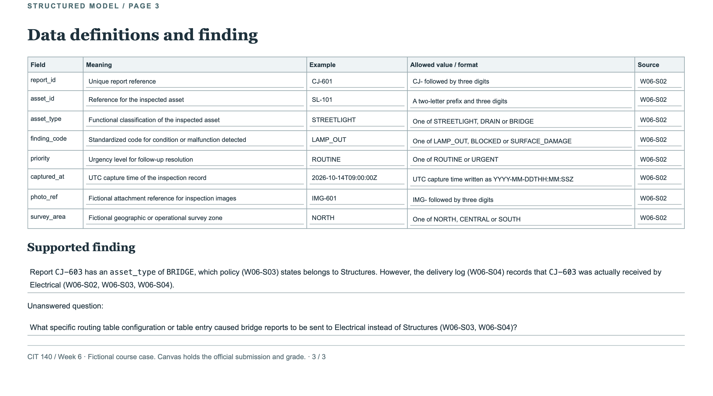
Artifact: Data-Flow Model & Routing System Analysis (Figure 6); Original Location: Week06/Artifact/Anyanwu_Nzubechi_CIT140_Week06.pdf
Question Examined: How do inspection reports move through the Inspection Report Routing System, and where do routing discrepancies occur?
Supported Finding: The data-flow diagram models external entities (Field Team, Electrical, Drainage, Structures), internal processes, D1 Report Register, and D2 Routing Table. Analysis reveals that Report CJ-603 (asset_type = BRIDGE) correctly belongs to Structures per policy (W06-S03), but delivery logs (W06-S04) record that Electrical actually received the work item.
Client Importance: Identifies systemic misrouting that could delay critical infrastructure maintenance.
Uncertainty & Next Check: Requires auditing the specific routing table configuration or table entry mapping in D2 to correct the misdirected bridge report workflow.

Week 7: Data-Quality Report (Meridian Forge)
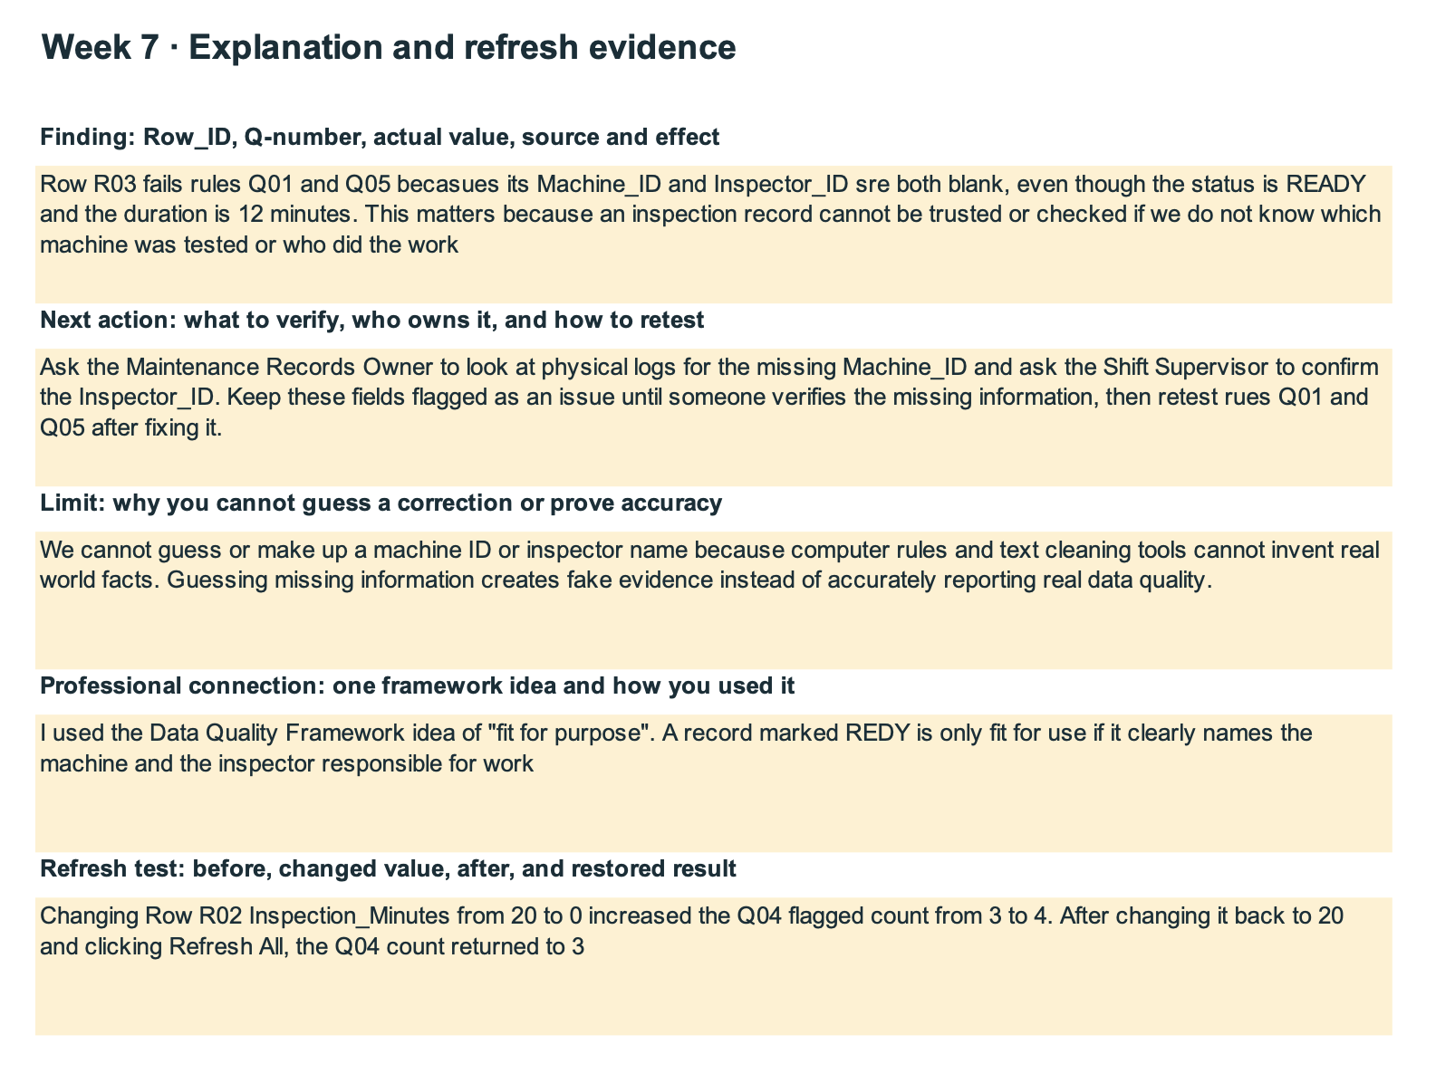
Artifact: Data-Quality Report & Applied Steps (Figure 7); Original Location: Week07/Artifact/Anyanwu_Nzubechi_CIT140_Week07.xlsx
Question Examined: Can Meridian Forge inspection records and cell telemetry be trusted for their stated operational safety purpose?
Supported Finding: Data-quality checks on inspection logs verify formatting consistency and completeness; however, automated formatting validation alone only confirms record structure, not physical reality.
Client Importance: Prevents false operational security by establishing that administrative compliance does not guarantee physical equipment integrity.
Uncertainty & Next Check: Sensor calibration records and physical inspection sign-offs must be verified independently before clearing equipment for active production.

Section 04: Closing Review & Response to Brief W08-B01

Response to Brief W08-B01 (Meridian Forge Safety Check)
Supported Finding: In examining Week 7 inspection records and data-quality rules for Meridian Forge, automated validation flags indicated that inspection logs met structural formatting standards. However, as noted in course safety guidance, a 'READY' label or successful formatting check alone does not prove that a machine or robotic cell is physically safe.
Source & Rule: Supported by Week 7 data-quality compliance rules and sensor log verification standards.
Client Importance: Relying solely on software status flags without physical sensor verification risks catastrophic mechanical failures and safety hazards in automated work cells.
Next Question / Design Check: Before making any design or restart decisions, analysts must perform a physical sensor calibration audit and verify physical emergency-stop hardware responsiveness independently of software status indicators.

Closing Review & Analytical Evolution
- Evolution of Analysis Since Week 1: In Week 1, our problem brief focused narrowly on isolating an immediate anomaly (MR-17 accepting Test K-44). By Week 8, our analytical scope has expanded systematically from problem definition and business feasibility to stakeholder governance, rigorous requirements engineering, process mapping, data-flow modeling, and data-quality verification. We now evaluate systems holistically across people, processes, data, and technology.
- Honest Identification of Unfinished Work: While structural models and requirements sets are complete, several items remain unverified: record custodian acceptance in Week 3, root causes of clinical approval delays in Week 5, and routing table misconfigurations in Week 6. These gaps are documented transparently rather than assumed away.
- Preparation for Solution Comparison and Prototyping: This portfolio provides the baseline evidence necessary to compare alternative future solutions, design future automated workflows, and construct targeted verification test plans in subsequent project phases.

Section 05: Evidence List
This evidence list indexes all original weekly source files, source labels, and what each artifact supports across the Meridian Forge and Cedar Junction case studies.
Case | Source Label | File Name or Working Link | What it Supports
Meridian Forge | Nia Voss / Elias Chen | Week01/Artifact/CIT -140 Week 1 Problem Brief.pdf | MR-17 incident timeline and command telemetry record.
Meridian Forge | Mara Ilyan / Nia Voss | Week02/Artifact/CIT140 Week 02 — Business Case Recommendation.pdf | QA Control Review estimate ($2,820) and 8-day schedule.
Meridian Forge | Nia Voss / Elias Chen / Mara Ilyan | Week03/Artifact/CIT140 Week 03 - Stakeholder Map.pdf | Stakeholder roles, consultation plan, and governance register.
Cedar Junction | Dana Ruiz / Dr. Lena Okafor | Week04/Artifact/CIT140 Week 4 Validated Requirements.pdf | Validated functional, business, user, and non-functional requirements.
Cedar Junction | As-Is Process Team | Week05/Artifact/Anyanwu_Nzubechi_CIT140_Week05_As_Is_Process_Model.pdf | Appointment request, scheduling, clinical readiness, and exception flow.
Cedar Junction | Field Team / Routing Log | Week06/Artifact/Anyanwu_Nzubechi_CIT140_Week06.pdf | Inspection report routing data-flow and bridge misrouting anomaly.
Meridian Forge | Inspection Export v1 | Week07/Artifact/Anyanwu_Nzubechi_CIT140_Week07.xlsx | Data-quality report, applied steps, and cell inspection records.

