Spatiotemporal pattern analysis of neuronal multi-unit activity in sleep-wake episodes

Neuronal assemblies are functional units comprised of interconnected neurons. Characterisation of the network activity of neuronal assemblies has been studied using numerous computational models. The challenge in understanding the underlying mechanisms of these functions is to relate such microscopic spatiotemporal patterns emerging from interactions of cortical neurons to physiological and functional significance. We adopted the definition of ‘microstates’ as synchronous neuronal assembly activities that constitute each oscillatory troughs of large-amplitude local field potential slow waves during successive sleep and waking episodes. By applying graph theory, we characterised each microstate as a connected small network where neurons are vertices and spiking sequences are directed edges, and constructed corresponding connectivity matrices. The motivation for characterising microstates is based on the experimental evidence that the group of neurons giving rise to a microstate often behave similarly under identical stimulus by sharing the input-output connection characteristics. We aim to study the systematic changes in microstate (spatiotemporal spiking patterns) in 78 episodes of spontaneous multi-unit activity recorded in prefrontal cortex of 9 freely-behaving rats.

One of the coordinating mechanisms appears to be the synchronization of neuronal activity by phase locking of self-generated network oscillations.
Scholarpedia – cell assemblies
Event synchronization (Quian Quiroga et al., 2002) acts as a coincidence detector and quantifies the level of synchrony from the number of quasi-simultaneous appearances of spikes.

According to von Neumann (1958) brains do in "very few short steps" what computers do with "exquisite numerical precision over many logical steps". The challenge is to characterize those few steps as neural operations by which spatiotemporal patterns emerge from interactions of cortical neurons over broadly distributed synaptic connections. The patterns are observed with multivariate recordings that serve to evaluate state variables as trajectories in brain state space and patterns as points along the trajectories.
A proposed way to model the intervening central steps is to conceive the synaptic connections of cortex as forming a continuous, self-similar hierarchy of scale-free connectivity. For heuristic purposes this hierarchy must be divided into levels, because measurement presupposes the imposition of scales. Each level has the statistical properties of divergence and convergence though with differing emphases. The time and space scales of the technologies used to observe and measure brain structures and activities give access to three levels of connectivity among cortical neurons: microscopic among neurons (synapses), mesoscopic among populations of neurons (hypercolumns), and macroscopic among modules within each cerebral hemisphere (modular networks). Note that the available technologies – which are each biased towards specific scales - tend to emphasise the existence of scale-specific structures over and above the rich scale-free architecture in which they are embedded. Such structures emerge from the scale-free background via developmental processes such as activity-dependent rewiring. The formation of ocular dominance columns is an exemplar. The development of canonical forms for structural and functional spectra is a key objective of ongoing research, and will allow the disambiguation of local spatial structures from both the global scale-free background in addition to observational artefacts such as volume conduction and EMG activity.
Input to cortex can change its activity in either of two ways. Perturbation by input may drive it but not change its state. The ratio of the output function to the perturbing input function defines the operation by the cortex on the input to give the output. Examples are impulse input with electrical shocks, light flashes, auditory clicks, etc., giving evoked potentials that document cortical relaxation to its initial condition without change in state. The return to baseline allows repetition and averaging over trials to give averaged evoked potentials. Contrastingly an input to cortex may induce a state transition. The difference is crucial for understanding cortical dynamics. Both processes are initiated by input. Both can result in spatially coherent oscillations at multiple frequencies. Both oscillations are modulated spatially in both the amplitude and phase of shared carrier waves.
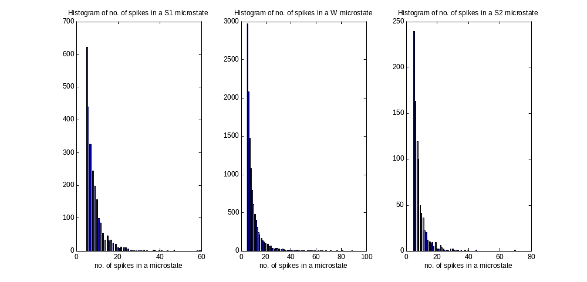
Real data rw170-BSL3\episode1\winsize9
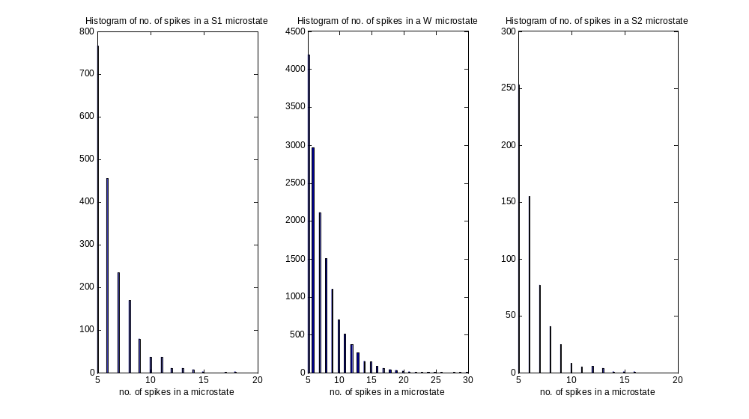
Simulated data rw170-BSL3\episode1\winsize9
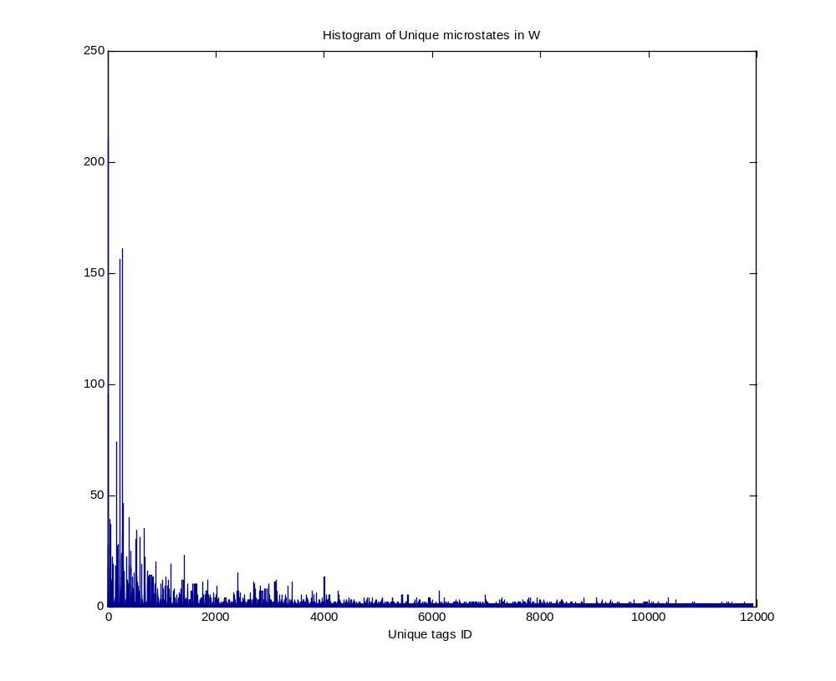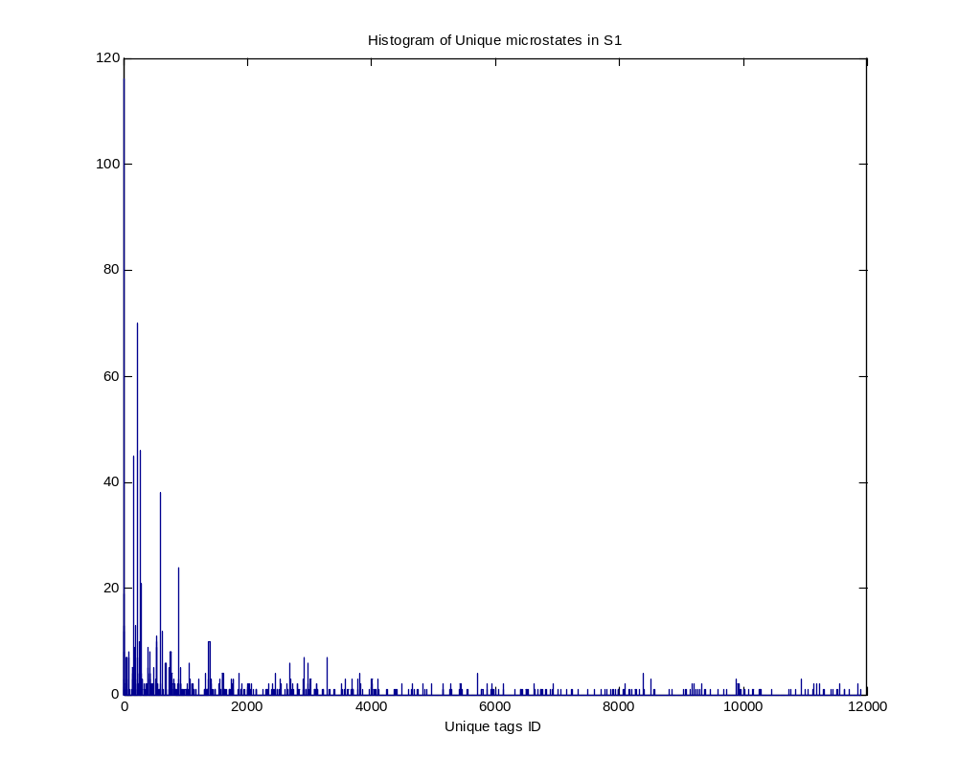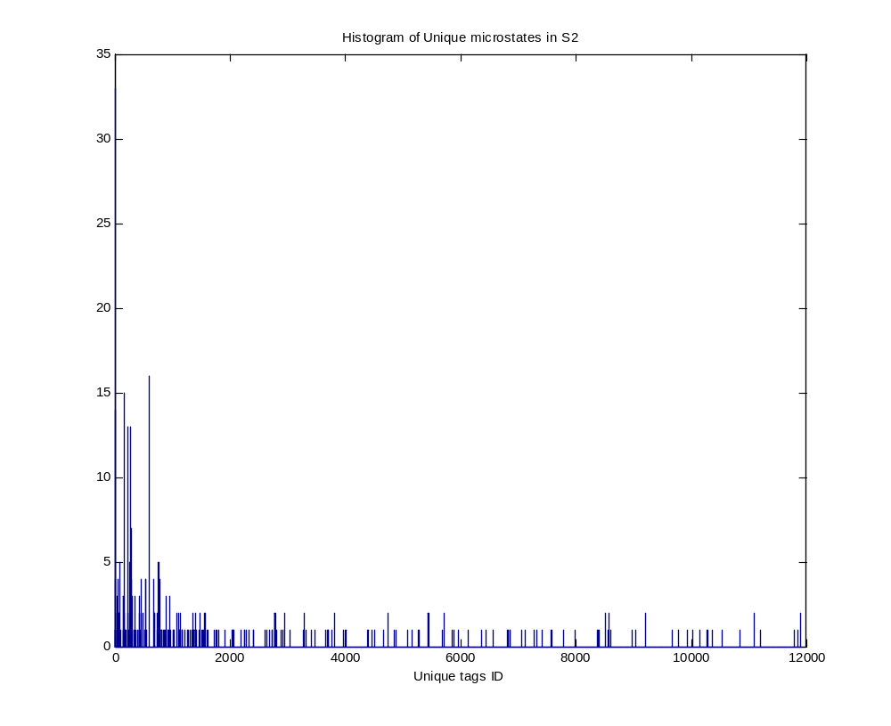
Analyzing Functional Connectivity Using a Network Likelihood Model of Ensemble Neural Spiking Activity
Murat Okatan, Matthew A. Wilson, and Emery N. Brown
Neural Computation 2005 17:9, 1927-1961

Temporally Structured Replay of Awake Hippocampal Ensemble Activity during Rapid Eye Movement Sleep
Kenway Louie, Matthew A. Wilson
Neuron - 1 January 2001 (Vol. 29, Issue 1, pp. 145-156) [Temporal correlation analysis: REM x RUN]

M. Abeles and G. L. Gerstein
Detecting spatiotemporal firing patterns among simultaneously recorded single neurons Neurophysiol September 1, 1988 60:(3) 909-924 [Repeating pattern detection]
Cajigas I, Malik WQ, Brown EN. nSTAT: Open-source neural spike train analysis toolbox for Matlab. J. Neurosci. Methods 211: 245–264, 2012.
Spine control to network refine McGill University

