Test Quarto Markdown

Simon Grimm

2024-02-27

Table of contents

# Overview

## Text Formatting

Explore various text formatting options in Quarto:

* *Italics*, **bold**, and ***bold italics***
* Superscript2 and subscript2
* ~~Strikethrough~~
* Verbatim code

## Headings

Demonstration of heading levels in Quarto:

# Header 1

## Header 2

### Header 3

#### Header 4

##### Header 5

###### Header 6

## Written Text

Lorem ipsum dolor sit amet, consectetur adipiscing elit, sed do eiusmod tempor incididunt ut labore et dolore magna aliqua. Ut enim ad minim veniam, quis nostrud exercitation ullamco laboris nisi ut aliquip ex ea commodo consequat. Duis aute irure dolor in reprehenderit in voluptate velit esse cillum dolore eu fugiat nulla pariatur. Excepteur sint occaecat cupidatat non proident, sunt in culpa qui officia deserunt mollit anim id est laborum.Lorem ipsum dolor sit amet, consectetur adipiscing elit, sed do eiusmod tempor incididunt ut labore et dolore magna aliqua. Ut enim ad minim veniam, quis nostrud exercitation ullamco laboris nisi ut aliquip ex ea commodo consequat. Duis aute irure dolor in reprehenderit in voluptate velit esse cillum dolore eu fugiat nulla pariatur. Excepteur sint occaecat cupidatat non proident, sunt in culpa qui officia deserunt mollit anim id est laborum.Lorem ipsum dolor sit amet, consectetur adipiscing elit, sed do eiusmod tempor incididunt ut labore et dolore magna aliqua. Ut enim ad minim veniam, quis nostrud exercitation ullamco laboris nisi ut aliquip ex ea commodo consequat. Duis aute irure dolor in reprehenderit in voluptate velit esse cillum dolore eu fugiat nulla pariatur. Excepteur sint occaecat cupidatat non proident, sunt in culpa qui officia deserunt mollit anim id est laborum.Lorem ipsum dolor sit amet, consectetur adipiscing elit, sed do eiusmod tempor incididunt ut labore et dolore magna aliqua. Ut enim ad minim veniam, quis nostrud exercitation ullamco laboris nisi ut aliquip ex ea commodo consequat. Duis aute irure dolor in reprehenderit in voluptate velit esse cillum dolore eu fugiat nulla pariatur. Excepteur sint occaecat cupidatat non proident, sunt in culpa qui officia deserunt mollit anim id est laborum.

## Lists

* unordered list
  + sub-item 1
  + sub-item 2
    - another item

1. ordered list
2. item 2
   1. sub-item 1
      1. sub-sub-item 1

## Math

Inline math: $E=mc^{2}$

Display math:

$$E=mc^{2}$$

## Quotes

Blockquote

## Figures



Example Figure



Example Figure at 50% Size

### Figure with Python

import numpy as np  
import matplotlib.pyplot as plt  
from scipy.stats import gamma  
  
# Parameters  
x = np.linspace(0, 20, 400) # x values  
a1, b1 = 1, 0.1 # Exponential curve 1 parameters  
a2, b2 = 1, 0.2 # Exponential curve 2 parameters  
k, theta = 2, 2 # Gamma distribution parameters  
  
# Exponential functions  
exp_curve1 = a1 * np.exp(b1 * x)  
exp_curve2 = a2 * np.exp(b2 * x)  
  
# Gamma distribution  
  
# Plotting  
plt.figure(figsize=(10, 6))  
plt.plot(x, exp_curve1, label="Exponential Curve 1: a=1, b=0.1", color="blue")  
plt.plot(x, exp_curve2, label="Exponential Curve 2: a=1, b=0.2", color="green")  
plt.title("Example Figure")  
plt.xlabel("x")  
plt.ylabel("y")  
plt.legend()  
plt.grid(True)  
plt.show()  
  
  
plt.show()

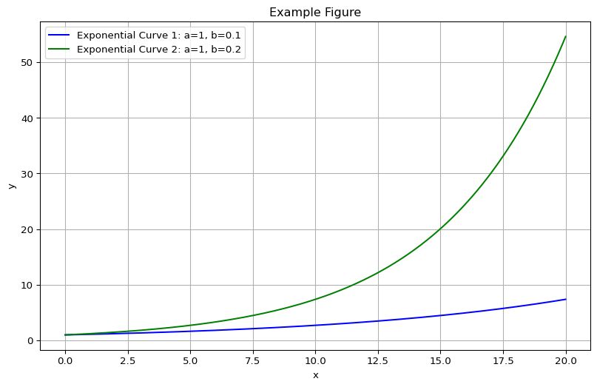

**Figure Caption: Figure 2: Nasal swabs vs Oro-pharyngeal and combined nasal/oro-pharyngeal swabs.** All data is taken from Goddall et al. 2022.

### Figure with R

#| label: fig-mtcars  
#| fig-cap: "MPG vs horsepower, colored by transmission."  
#| column: margin  
  
library(ggplot2)  
mtcars2 <- mtcars  
mtcars2$am <- factor(  
 mtcars$am, labels = c('automatic', 'manual')  
)  
ggplot(mtcars2, aes(hp, mpg, color = am)) +  
 geom_point() +  
 geom_smooth(formula = y ~ x, method = "loess") +  
 theme(legend.position = 'bottom')

# Footnotes

Test footnote 1[1] and test footnote 2[2]

# Asides

## Aside with Latex

We know from *the first fundamental theorem of calculus* that for $x$ in $\left[a,b\right]$:

$$\frac{d}{dx}\left(\int_{a}^{x}{f}\left(u\right) du\right)=f\left(x\right).$$

## Aside with a figure

1. This is the first footnote.
2. This is the second footnote.