|  |
| --- |
| **Ambo University**  **Hachalu Hundessa Campus**  **School of Informatics and Electrical Engineering**  **Department of Computer Science**  **C:\Users\Haftom\Downloads\Documents\images.jfif** |

Project Requirement Analysis Documentation on Online Bill System for Water Utility Case of Ambo Urban Water Supply and Sewerage Enterprise Authority

|  |  |  |
| --- | --- | --- |
| Group Members | | |
| N0. | Name | ID |
|  | Etana Alemu | Pgr/47263/13 |
|  | Firomina Ejeta | Pgr/47265/13 |
|  | Gemechu Gadisa | Pgr/47266/13 |
|  | Teshale Mirkena | Pgr/47272/13 |
|  | Yadeni Zegeye | Pgr/47275/13 |

***Table of Content***

Abbreviation and Acronyms iv

1 Introduction 1

1.1 Background 1

1.2 Problem Statement 2

1.2.1 Research Question 2

1.3 Objective of the Study 3

1.3.1 General Objectives 3

1.3.2 Specific Objectives 3

1.4 Scope of the project 3

1.5 Significance of the project 3

1.6 Methodology of the Project 4

1.6.1 Data Source 4

1.6.2 Fact-finding techniques 4

2 Current System 4

2.1 Players in Existing Current System 4

2.2 Function/ Activities in Current System 5

3 Proposed System 7

3.1 Overview 7

3.2 Functional Requirements 7

3.3 Non-Functional Requirements 7

3.4 System Models 8

3.4.1 Scenarios 8

3.4.2 Use Case Model 15

3.4.3 Object Model 16

3.4.4 Data Dictionary 16

3.4.5 Class Diagram 17

3.4.6 Sequence Diagram 18

3.4.7 User Interface-Navigational Path and Screen Mock-ups 19

4 Conclusion 21

References 22

Table 1 scenario for login 8

Table 2 scenario for View Complain 9

Table 3 Scenario for generate bill 10

Table 4 Scenario for pay bill 11

Table 5 Scenario for the user issue a complain 13

Table 6 Scenario (Detail Use Case) for transfer 14

Table 7 Data dictionary 16

Table 8 class Diagram for online bill management System 17

Table 9 Sequence diagram for login use case of the system 18

Figure 1 AWSA bill payment receipt 5

Figure 2 Bill Tarif 6

Figure 3 General Use case model 15

Figure 4 GUI for index/ Homepage 19

Figure 5 Customer Dashboard 19

Figure 6 Admin Page in bill Generation 20

Figure 7 Navigational Path 20

# Abbreviation and Acronyms

AWSSE: Ambo Water Supply and Sewerage Enterprise

AWSA: Ambo Water Supply Authority

AUWSA: Ambo Urban Water Supply and Sewerage Authority

PDA: Personal Digital Assistant

SMS: Short Message Services

3G: Third Generation

# Introduction

## Background

A mobile payment or m-payment may define as any payment where a mobile device is used to initiate, authorize and confirm an exchange of financial value in return for goods and services [1]. Mobile devices may include mobile phones, PDAs, wireless tablets and any other device that connect to mobile telecommunication network and make it possible for payments to be made [3].

In recent years, mobile and wireless technologies have been a hot topic [9]. Many mobile and wireless applications developments are still going on [8]. Instead of paying with cash, a consumer can use a mobile phone to pay for a wide range of services. Consumers and mobile industry representatives are looking forward to the third generation (3G) of mobile phones, one that promises higher quality services to consumers. There are already more than 6 billion mobile subscribers worldwide [2]. This rapid growth has made a mobile phone to provide extra functions and services like bill payment. Consumers are using their mobile phones not only as voice communication tools but also as multi-function tools that can send SMS, play games, and perform other functions. Mobile payment represents another opportunity for the mobile industry and financial service companies [6]. Perhaps, in the near future, it will be a service that demanded by consumers [6]. Imagine it is the last date of bill payment and you are stuck in an unavoidable meeting; imagine standing in long queues when you could be having fun with friends and family. By sending, an SMS your bills paid and payment is really just a click away. This research work is particularly to achieve electricity-billing system via mobile phone. The responsibility of AWSSE is to supply electricity to their numerous customers. It is desirable in this work to examine the potential technologies for mobile payments systems and to identify the opportunities and issues for mobile payments with respect to AWSSE.

## Problem Statement

There are a number of challenges facing the manual payment system. This approach is not effective in solving the perennial problem like bill distribution, billing and cash collection. According to the source, the following could identified as major shortcomings of a manual payment system:

* Time consuming
* Lack of real time information storage
* Lack of prompt updating
* Possibility of human error
* Lack of accurate and prompt reports
* Possibility of data duplication
* Possibility of loose

### Research Question

In addressing the research problem, the following research questions are required to be answer:

1. How can mobile bill payment prototype for AWSSE developed?
2. What is the usability of the developed mobile bill payment prototype for AWSSE?

## Objective of the Study

### General Objectives

To develop an online bill payment system for Ambo Urban Water supply and sewerage authority Enterprise

### Specific Objectives

* Assess the existing system and design better system
* To develop mobile billing application that will allow registered customers of AWSA
* To develop a mobile bill payment prototype for AWSA
* To make easy and suitable to pay the bill
* To evaluate the usability of the prototype developed

## Scope of the project

This project is limited for the online payment of the bill using service number in mobile for Ambo Water Supply and Sewerage customer. It makes the online payment more easy and accessible fast. In addition, this project do only bill payment operation no other organizational activities.

## Significance of the project

* Target beneficiaries of the system

This project has a desired significance to Ambo Water Supply and Sewerage Enterprise customer

(Customer with service number or contract number). Accordingly, the proposed system can have the following significance:

* Increasing speed of activity of the customer by easy facility
* To save time and resource

## Methodology of the Project

### Data Source

The required data and information be gathered by using the following fact-finding techniques

### Fact-finding techniques

* Interview:

This method is that used for the collection of data in which the team have the chance for asking different questions. We conduct the interview at work by going to the area and ask the stakeholder.

* Observation

Observing the existing system gives us a better understanding of our new system. During this, we observe the structure and organization by looking at previous thesis documents, procedures and guidelines, and others.

# Current System

In the existing system the customer, go to bank to pay for a bill the system is semi-computerized system. They also get a bill receipt from Ambo Urban Water Supply and Sewerage Authority office. Therefore, customers expected to go bank and AUWSA (AWSA) physically.

## Players in Existing Current System

The current system has four actors with different roles. Those are:

* Customers
* Administrator (Admin)
* Finance department
* Bank

## Function/ Activities in Current System

Currently AWSA have different function in different circumstances to provide services for the customer like giving reference number, new pipe installation, supply new water meter, as well as bill managing. The current system have six components

* Bill System: in this component AWSA generate a bill , manage the duration i.e. closing and creating date
* Customer Service: this component provide adding new customer and system portal view
* Mobile App Component
* Finance system: it provide income statement, trial balance, balance sheet, bank statement, ledger, bank deposit ship
* Payment portal
* Payroll: for human resource management

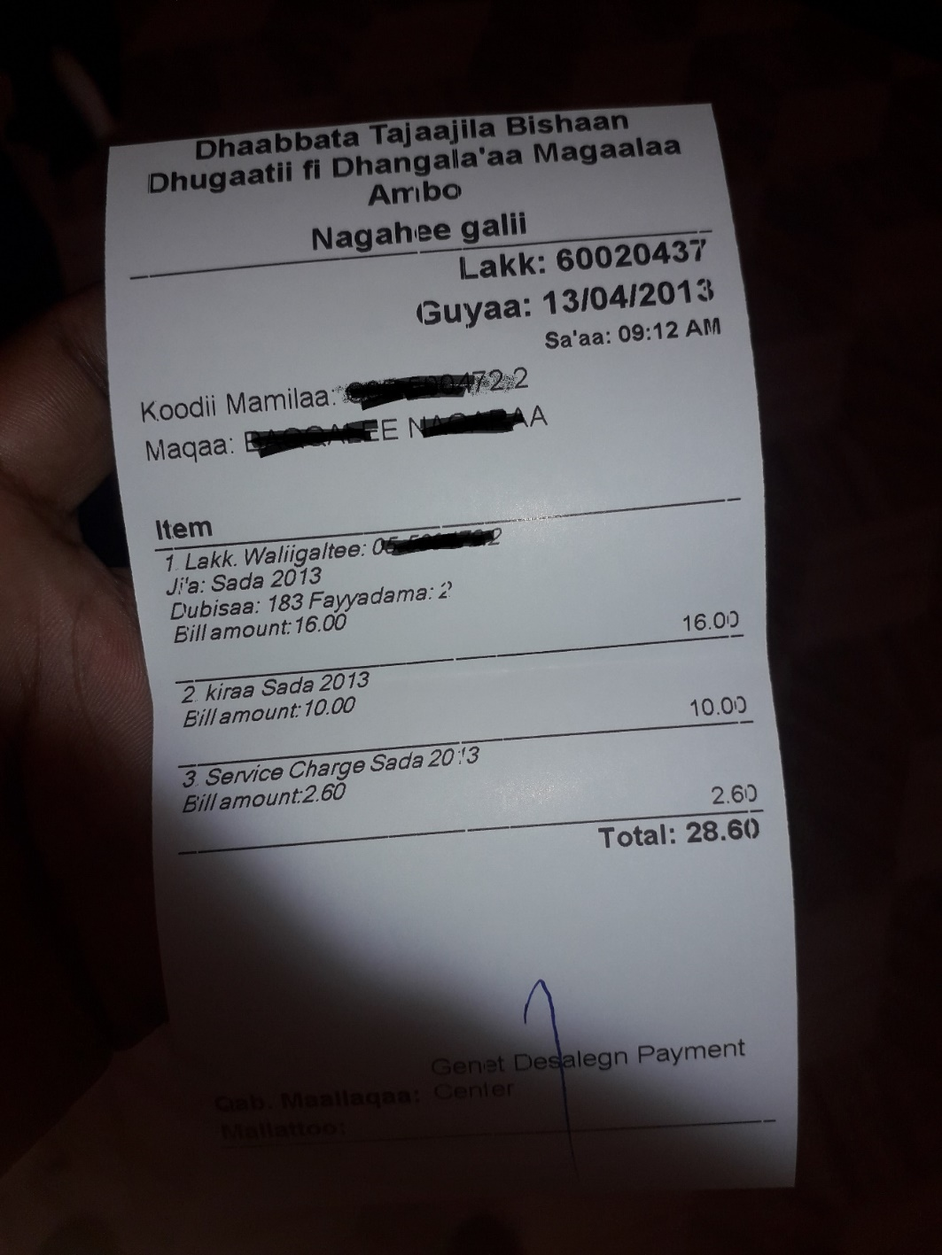

Figure AWSA bill payment receipt

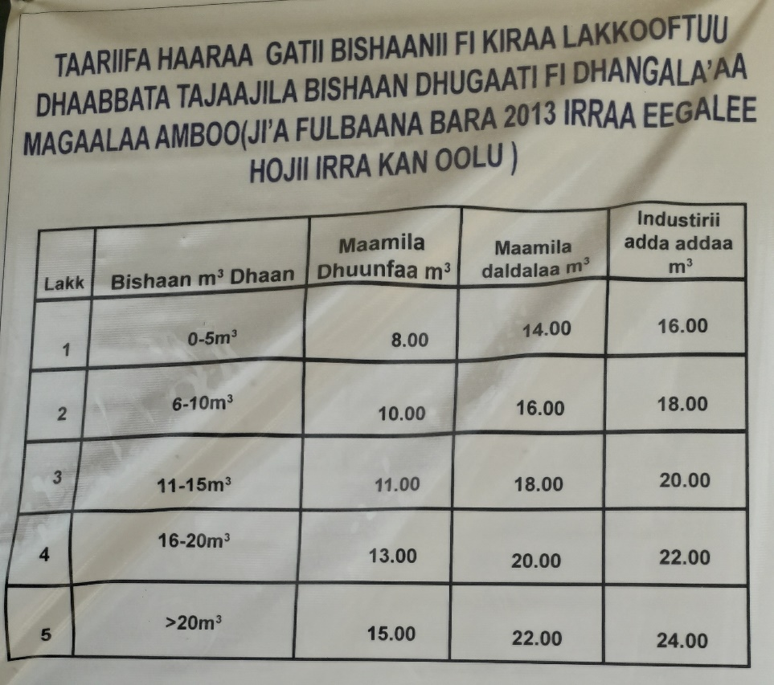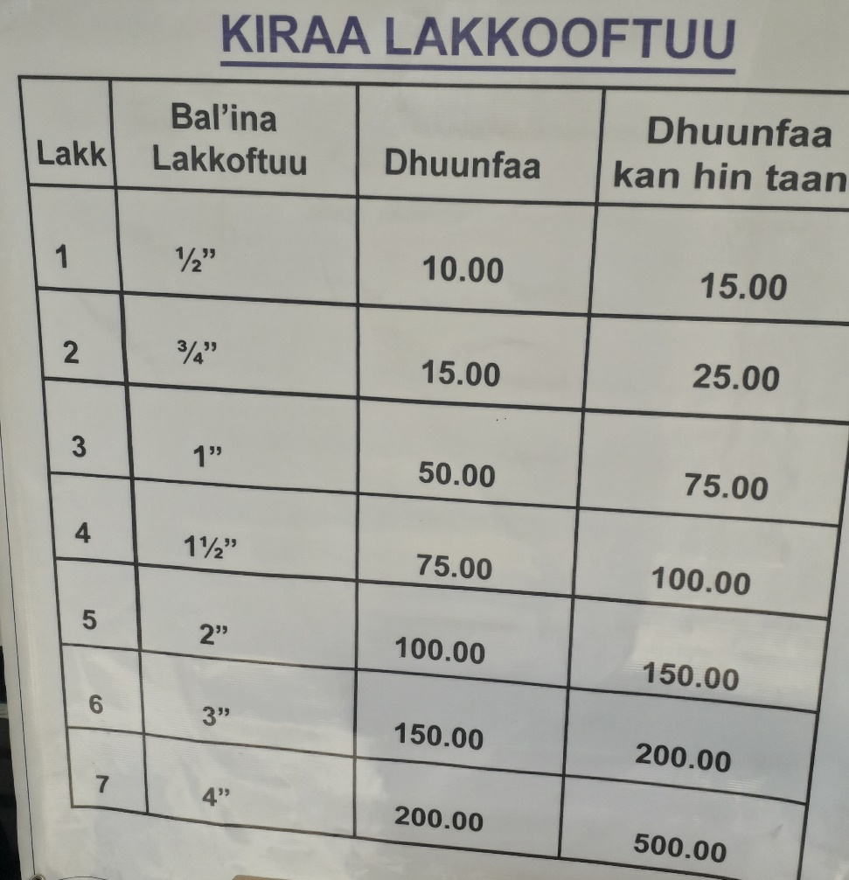

Figure Bill Tarif

# Proposed System

## Overview

The proposed online bill management system help the customer to pay a bill online by minimizing dispersed old system of the physical existence of the customer. The new system try to make easy use and simple clicking operation to accomplish their activities. The proposed system do only the billing system from all other organizational activities of existing system for good customer servicing.

## Functional Requirements

* Secure registration and profile management facilities for individual customers
* Easy communication
* Billing online rather than going physical existence to the finance and banks
* Complain issue relating with billing system

## Non-Functional Requirements

* Performance: the system is error free during many customers uses it and the system have good and easy response.
* User Interface: the system is run in any browser and it is user friendly
* Security and access permissions: The system try to secure with different security mechanisms. In another way authentication is provide to all the users, only authenticated users can use. It means if the user is an administrator then he/she can be able to manage the data. All others unregister users only have the rights to retrieve limited information from the system.
* Resource: the system is compatible with specified hardware and software environment.
* Usability: the system is easy to use and user friendly
* Backup and Recovery:

## System Models

### Scenarios

Scenario for Login

Table scenario for login

|  |  |  |
| --- | --- | --- |
| Use case | Login | |
| Actor | Customer, Admin | |
| Priority | High | |
| Goal | The actors login to the system. | |
| Precondition | The user should have an account in the system database. | |
| Basic course of action | **Actor action** | **System response** |
|  | 1. User opens the web page.  2. Select Login link.  4. Enter username and password.  5. User clicks on sign in button. | 3.Login form displayed  6.validate data entry  7. User’s homepage displayed. |
| Alternative course of action | * 1. If the user did not insert correct username and password, system displays incorrect username and password combination message. | |
| Post condition | The actor is logged in the system and provided with privileges for actions according to their roles | |

Scenario for View Complain

Table scenario for View Complain

|  |  |  |
| --- | --- | --- |
| Use case | View Complain | |
| Actor | Admin | |
| Priority | Medium | |
| Goal | Admin view (update or delete) customers complain. | |
| Precondition | Users must be registered before shall put complain and Admin must logged in to view complain | |
| Basic course of action | **Actor action** | **System response** |
|  | 1. Clicks on complain link in side bar of the system dashboard.  3. | 2. list of customer complain appear on the page |
| Alternative course of action |  | |
| Post condition | The customer complain information and table changed. The complaint will processed | |

Scenarios for Generating Bill

Table Scenario for generate bill

|  |  |  |
| --- | --- | --- |
| Use case | Generate Bill | |
| Actor | Admin | |
| Priority | Medium | |
| Goal | Admin view (update or delete) generate bill for customer | |
| Precondition | Users must be registered before shall pay and view bill and Admin must logged in | |
| Basic course of action | **Actor action** | **System response** |
|  | 1. Clicks bill link in side bar of the system dashboard.  3. Enter unit amount.  4. Click on generate bill button.  7. repeat the same procedure | 2. list of customer display  5. Validate data entered.  6. Display customer list on the same page |
| Alternative course of action | 5.1 the system display no such a unit amount exist | |
| Post condition | The Admin Generate a bill | |

Scenario for view bill

Table Scenario for pay bill

|  |  |  |
| --- | --- | --- |
| Use case | View Bill | |
| Actor | Customer | |
| Priority | Medium | |
| Goal | User view bill history and due date bill | |
| Precondition | Users must sign in with valid user account of username and password | |
| Basic course of action | **Actor action** | **System response** |
|  | 1. Clicks bill link in side bar of the system dashboard.  3. Click on bill history and due bill.  4. back to other page or log out | 2. reply a bill history and due date bill table |
| Post condition | The user view a bill history or due bill | |

Scenario for pay bill

Table Scenario of pay bill

|  |  |  |
| --- | --- | --- |
| Use case | Pay | |
| Actor | Customer | |
| Priority | Medium | |
| Goal | Allow the customer to pay bill | |
| Precondition | Users must sign in with valid user account of username and password | |
| Basic course of action | **Actor action** | **System response** |
|  | 1. Clicks pay link in customer dashboard.  3. Click on pay button located inside the due bill table.  5. back to another page or log out | 2. display a due bill table  4. the system check if the correct pay amount is paid |
| Alternative Action | 4.1 If the customer does not enter the exact amount alert message will pop up and stay in that page | |
| Post condition | The customer pays and back to customer home dash board page | |

Scenario Issue complain

Table Scenario for the user issue a complain

|  |  |  |
| --- | --- | --- |
| Use case | Issue Complain | |
| Actor | Customer | |
| Priority | Medium | |
| Goal | Allow the user to issue complain | |
| Precondition | Users must sign in with valid user account of username and password | |
| Basic course of action | **Actor action** | **System response** |
|  | 1. Clicks complaint link in left side bar of the system dashboard.  3. Click on new complaint button located top right most of the page.  5. back to other page or log out | 2. display a complaint table  4. display the new complaint tab dialog box with categorized complain |
| Alternative Action | 4.1 If the user not select any complain the system display to enter some complain | |
| Post condition | The user issue a complain | |

Scenario for Transfer

Table Scenario (Detail Use Case) for transfer

|  |  |  |
| --- | --- | --- |
| Use case | Transfer | |
| Actor | Complain | |
| Priority | Medium | |
| Goal | Allow the customer to transfer from one account to the system account, and view transaction | |
| Precondition | Users must sign in with valid user account of username and password | |
| Basic course of action | **Actor action** | **System response** |
|  | 1. Clicks transfer link in customer dashboard.  3. Click on transfer button  5. back to another page or log out | 2. display a transaction table  4. the system allow the customer to transfer by validating the customer account |
| Alternative Action | 4.1 If the customer does not account does not match the error message will come and enforce to enter the correct match with existing DB | |
| Post condition | The customer transfer from its account to AWSA account | |

### Use Case Model

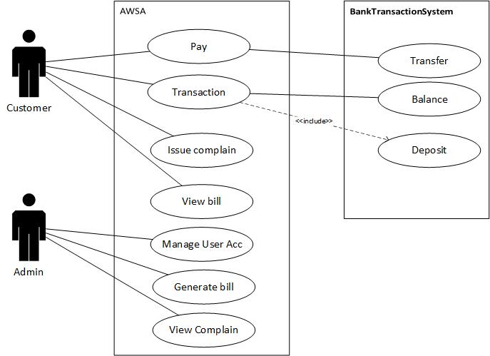

Figure General Use case model

### Object Model

### Data Dictionary

Table Data dictionary

|  |  |  |  |  |  |  |
| --- | --- | --- | --- | --- | --- | --- |
| Class Name | Class Description | Data type | length | P.Key | Nullable | Unique |
| Customer | Customer is a member of AWSA that pay bill | | | | | |
|  |  | int | 8-10 | true | false | True |
| Admin | Is an actor that generate bill and view complain | | | | | |
|  |  | int | 8-10 | true | true | True |
| Bank | Deposit transaction | | | | | |
|  |  | int | 10-14 | true | true | true |

### Class Diagram

Table class Diagram for online bill management System

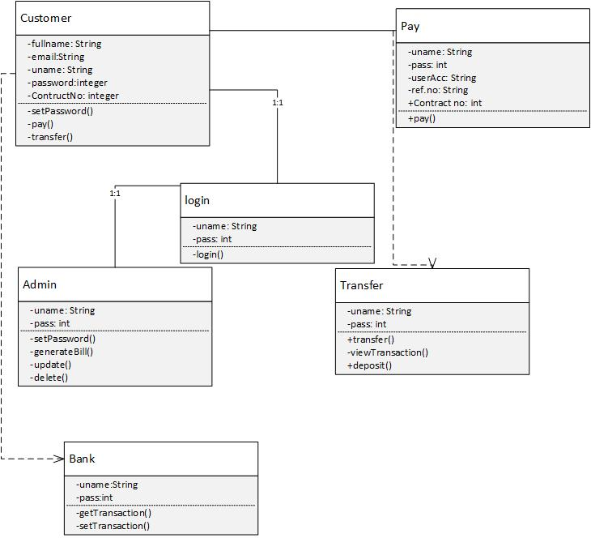

### Sequence Diagram

Table Sequence diagram for login use case of the system

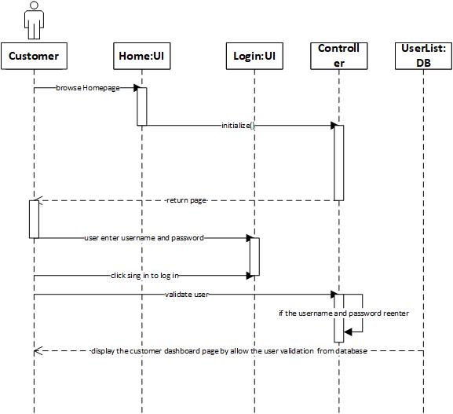

### User Interface-Navigational Path and Screen Mock-ups

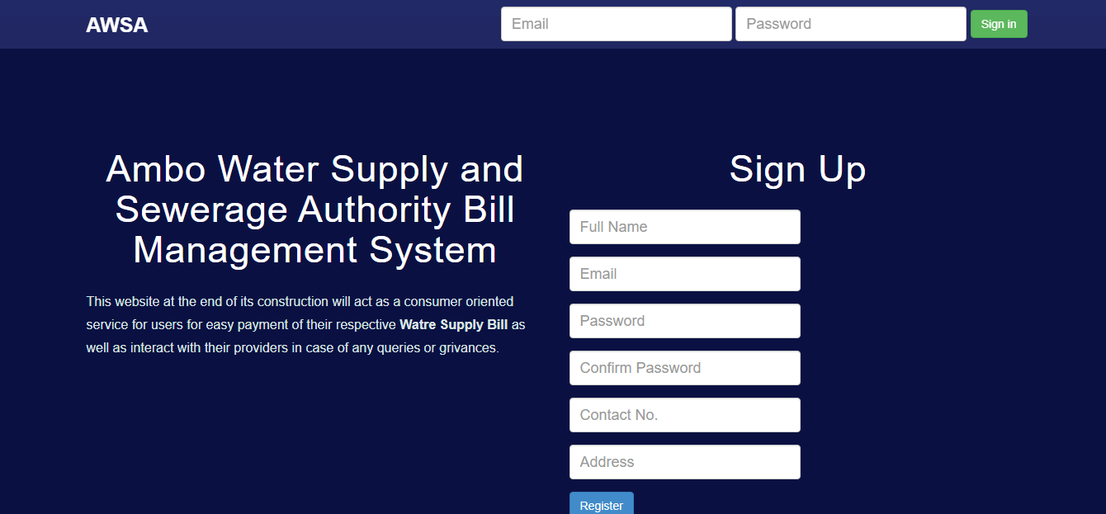

Figure GUI for index/ Homepage

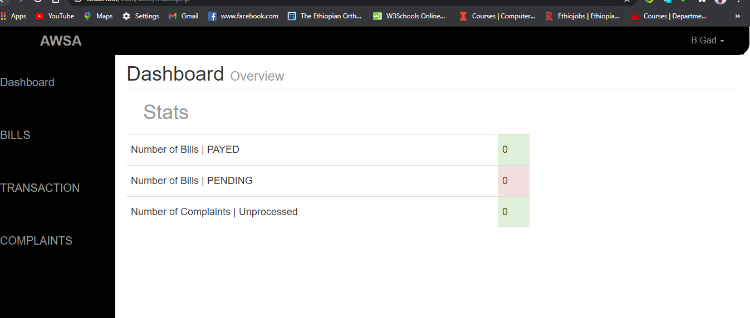

Figure Customer Dashboard

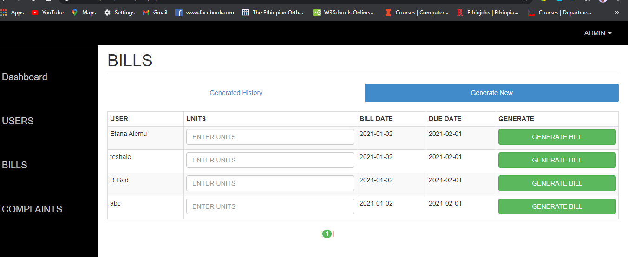

Figure Admin Page in bill Generation



Figure Navigational Path

# 4 Conclusion

Online bill Management system is a web application that allow the customer to pay a bill using organizational system in an easy and friendly of an automated system to minimize cost of time and resource by a simple click. Therefore, having an automate system for the organization help all stakeholder in performance and time

# References

[1] An, B., & Papavassiliou, S. (2001). A mobility-based clustering approach to support mobility management and multicast routing in mobile ad-hoc wireless networks. International Journal of Network Management, 11 (6), 387-395.

[2] ITU (2011). Global mobile statistic 2011-part A. Retrieved February 02, 2012 from mobilethinking.mobi/mobile-marketingtools/latest-stats/a#subscribers

[3] Karnouskos, S., & Fokus, F. (2004). Mobile Payment: a journey through existing procedures  
and standardization initiatives. IEEE Communications Surveys and Tutorials, 6(4), 44-66.

[3] Karnouskos, S., & Fokus, F. (2004). Mobile Payment: a journey through existing procedures and standardization initiatives. IEEE Communications Surveys and Tutorials, 6(4), 44-66.

[4] Mansi, C. Namita, K., & Avanish, C. (2009). Hospital Management System project (Masters dissertation Rajasthan Technical University, Kota, 2009). Retrieved April, 10, 2012 from <http://www.paombomghealthcare.googlecode.com>?

[5] Nelson, J. (1993). Usability Engineering Academic press Chapter 5, p 115. NFC Adoption Will Be Slower Than Expected. (n.d). About NFC Adoption. Retrieved October 5, 2011 from http://www.rfidupdate.com/articles/index.php?id=1554

[6] Senn, J. A. (2000). The Emergence of Mcommerce. Computer, 33(12), 148-150.

[7] Société Bénioise d’Energie Electrique (2011). Retrieved January 10, 2012 from [www.africaoilgas/sbee_(societe_beninoise_d’energie_electrique)-](http://www.africaoilgas/sbee_(societe_beninoise_d'energie_electrique)-) 1278-1-2-art.html

[8] Varshney, U, & Vetter, R. (2000). Emerging mobile and wireless networks. Communications of the ACM, 43 (6), 73-81.

[9] Varshney, U, & Vetter, R. (2002). Mobile commerce: framework, application and networking support. Mobile Networks and Applications, 7(3), 185-198.