Lab 3 – Docker

Nao Endo C00253544@setu.ie

# Part 2 - Containerize an application

Get the app;

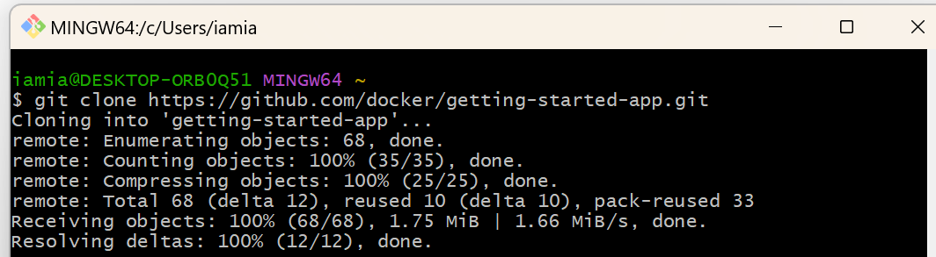

Build the app's image;

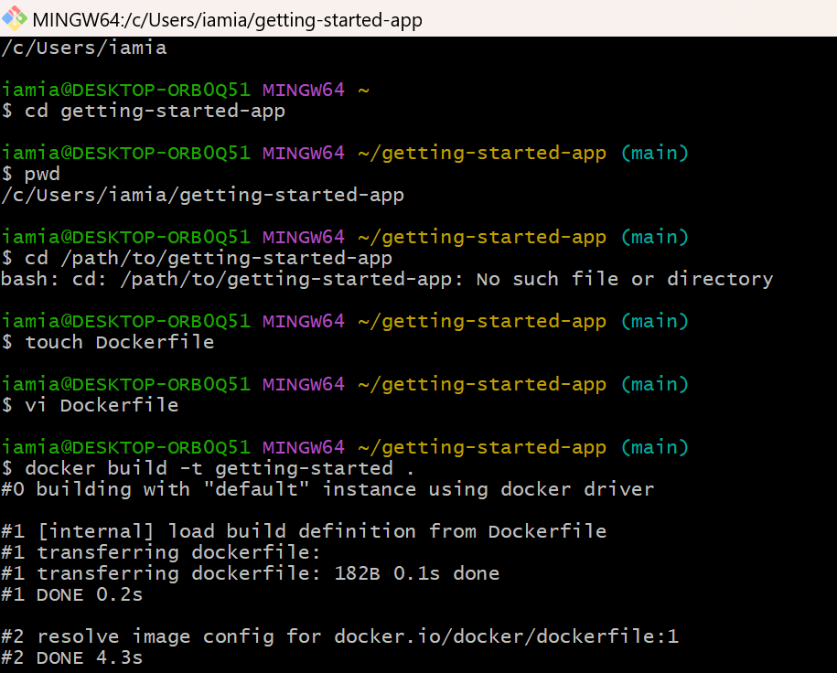

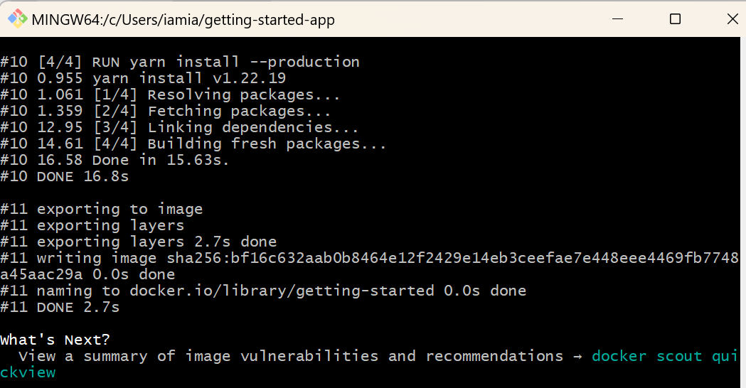

Start an app container;

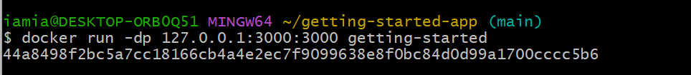

<http://localhost:3000/> opened in browser;

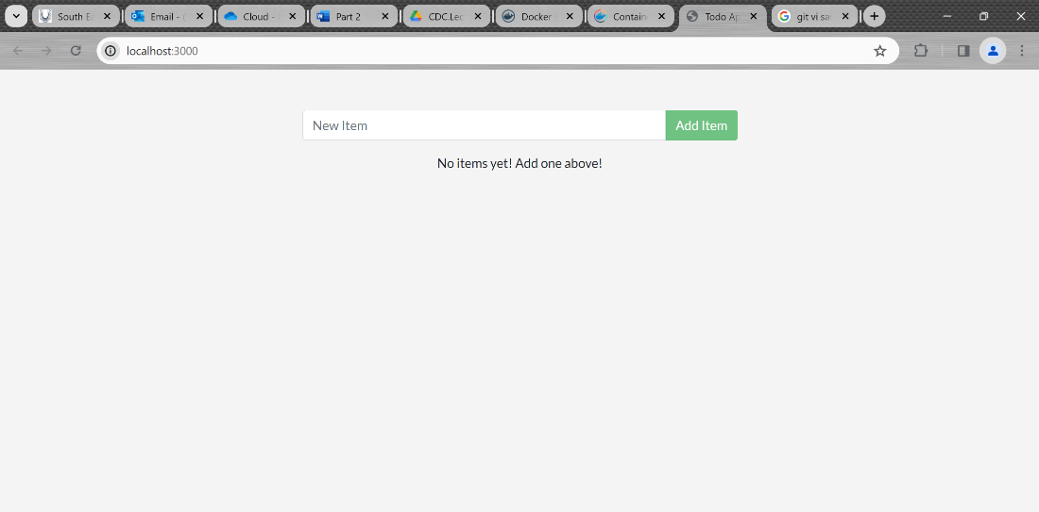

Added a few items;

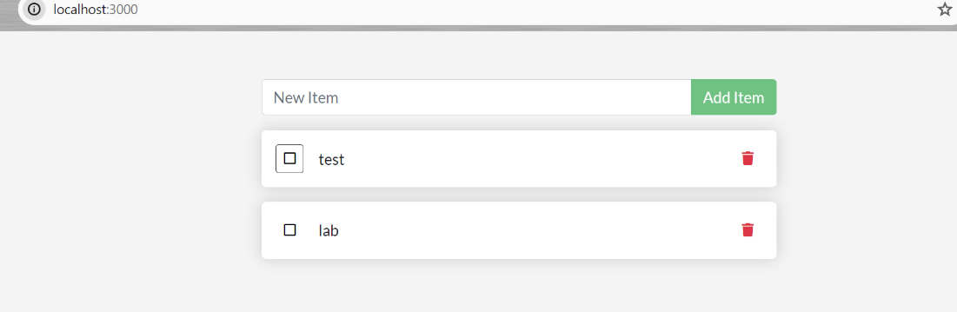

List containers;

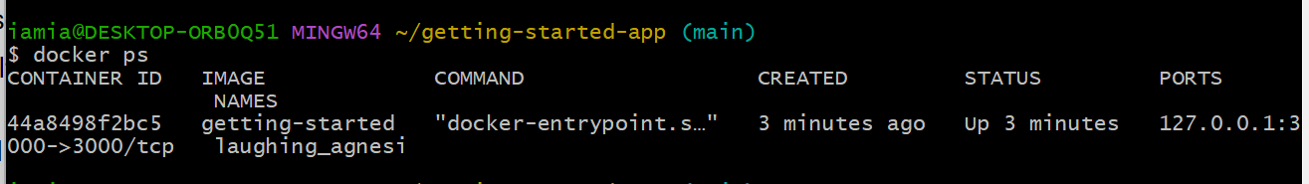

# Part 3 - Update the application

Update the source code;

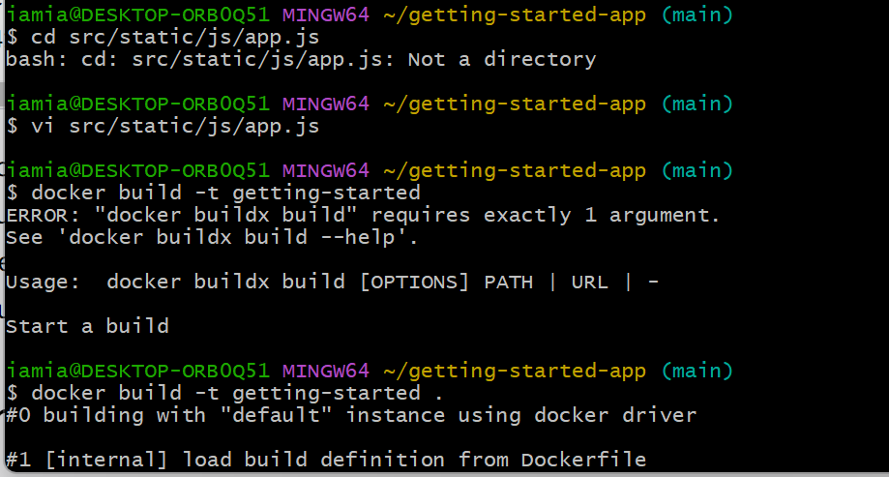

Remove the old container;

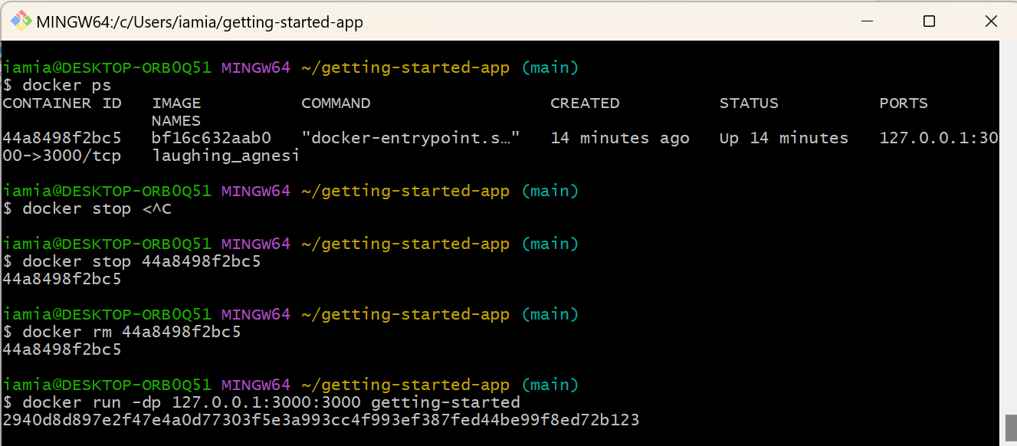

Start the updated app container (The text is changed to a new message.);

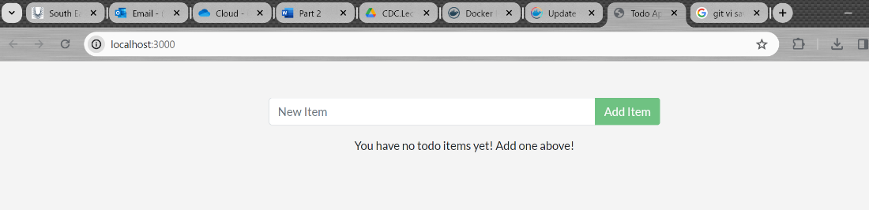

# Part 5 - Persist the DB

The container's filesystem

Start two containers and create a file in each;

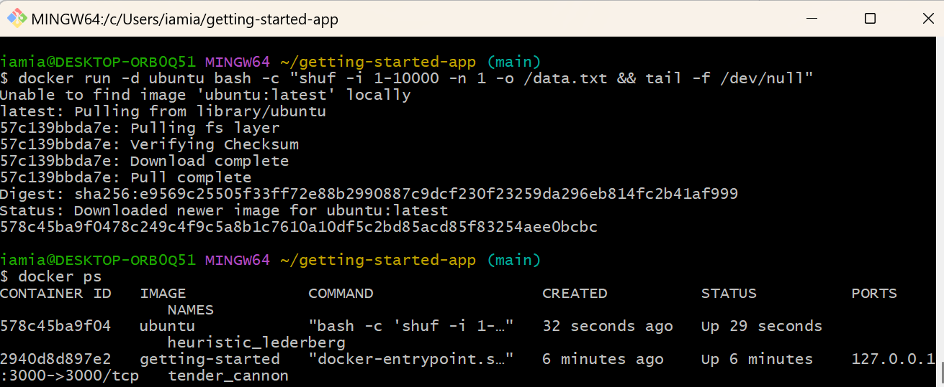

Validate to see the output by accessing the terminal in the container;

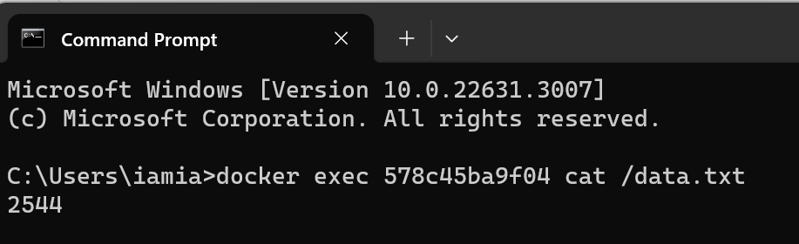

It was written to the scratch space for only the first container.

remove the first container;

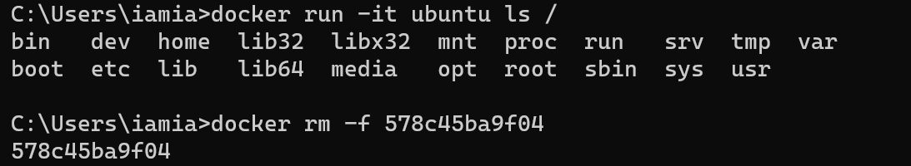

# Part 6 - Use bind mounts

Trying out bind mounts

start bash in an ubuntu container with a bind mount.

After running the command, Docker starts an interactive bash session in the root directory of the container's filesystem;

Create and delete a new file named myfile.txt under src;

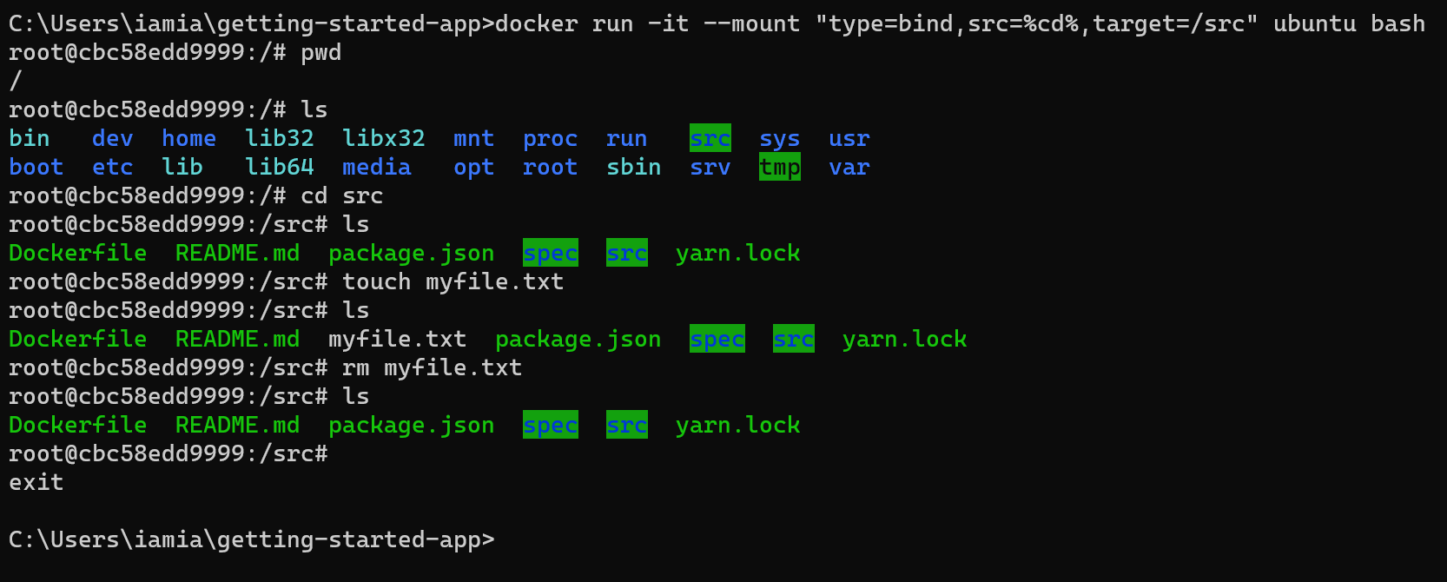

Development containers

Run your app in a development container;

Got an error and could not proceed...