Lab 5 Nao Endo

1. Download Istio

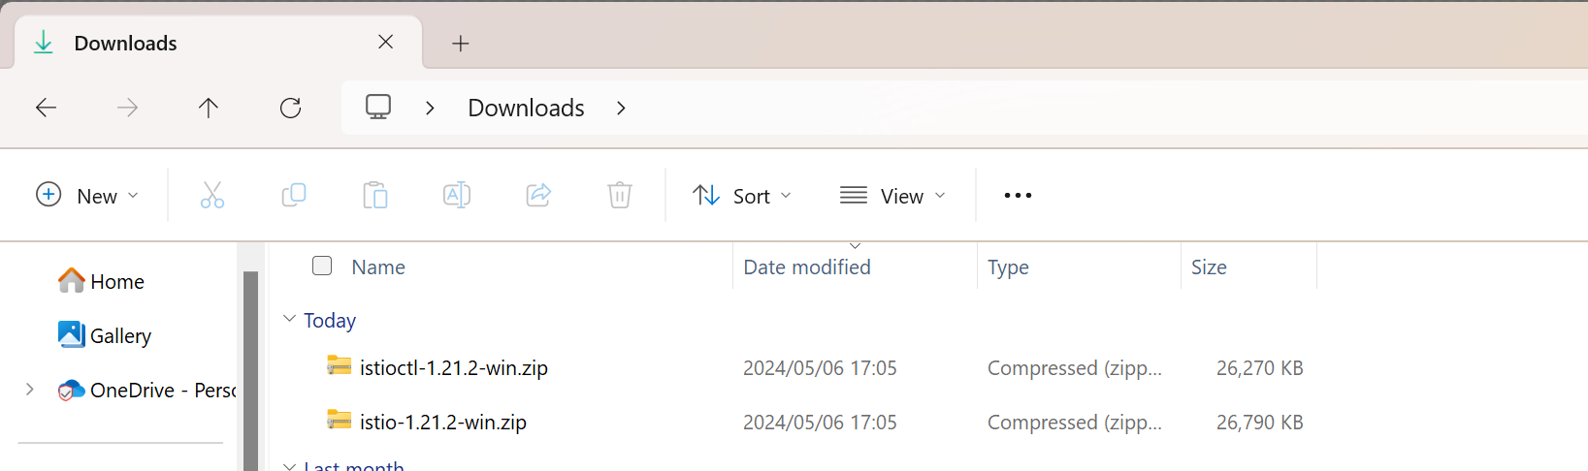

1. Install Istio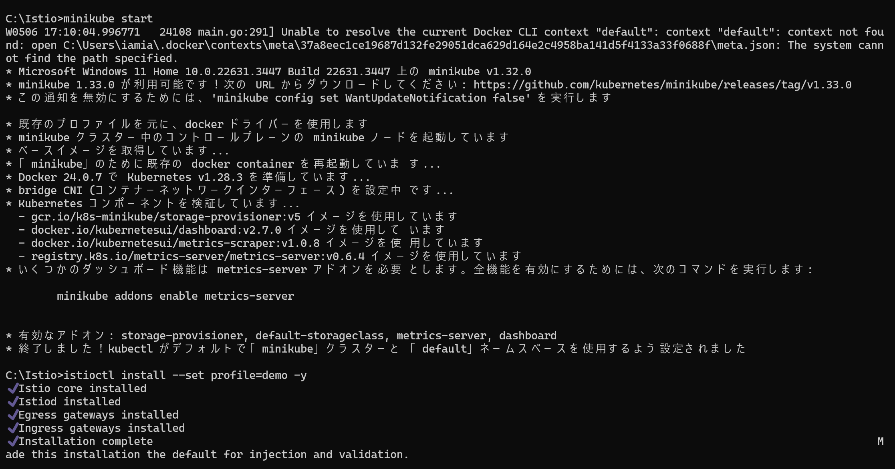

3. Deploy the sample application

Error: The path does not exit

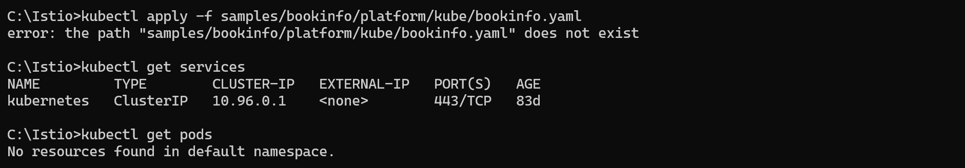

4. Open the application to outside traffic

Error: The path does not exit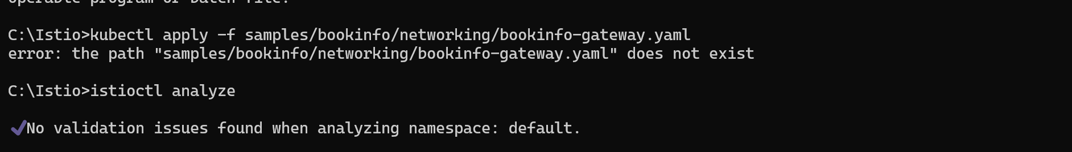

5. Determining the ingress IP and ports

Got a few errors on the commands

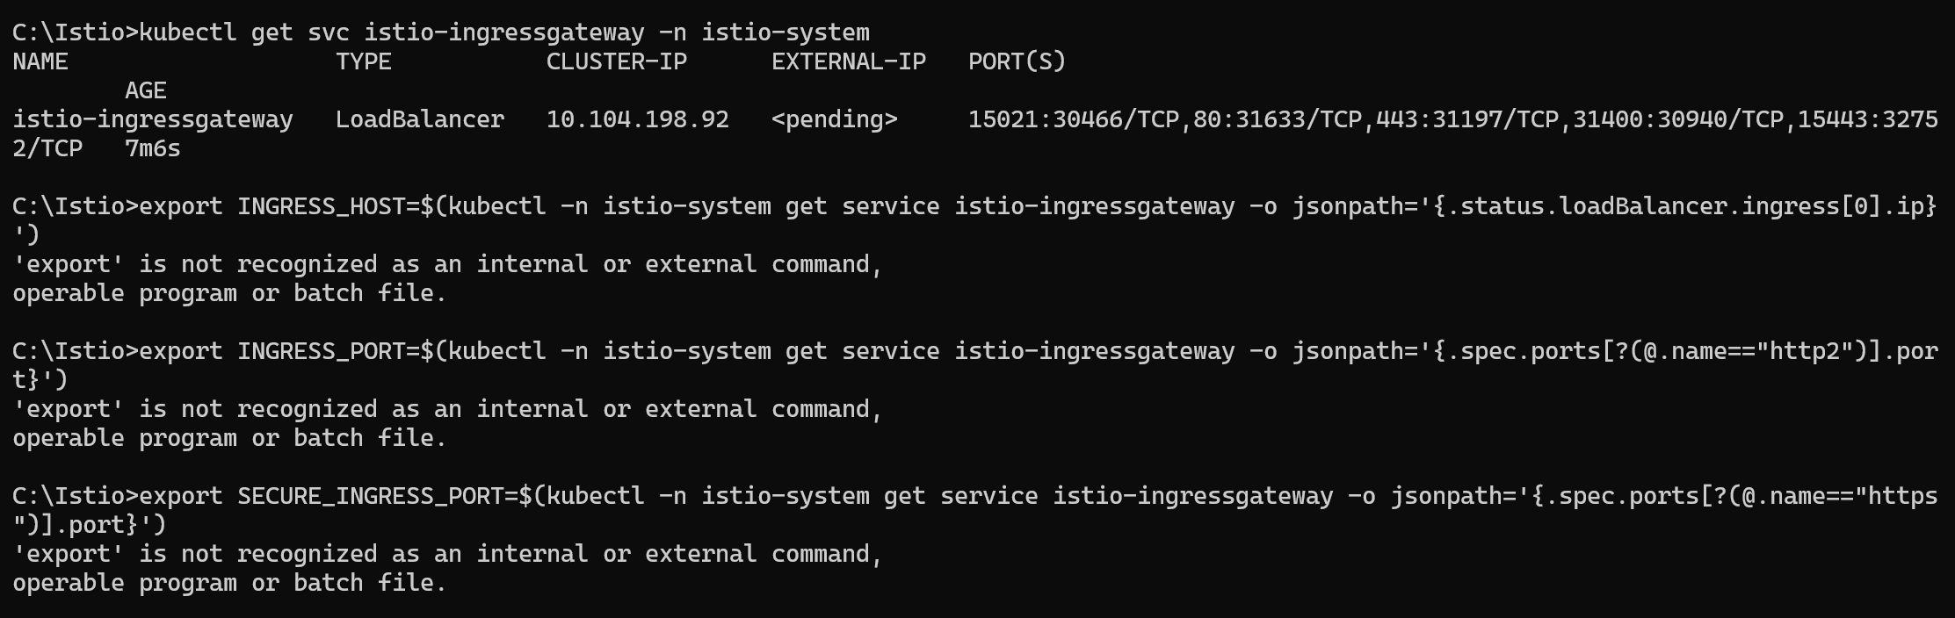6. View the dashboard

Got a few errors here as well.

