Brach: Adama
Full Name: {FullName_1}
Reg.No. {SN1}
Brach: Adama
Full Name: {FullName_2}
Reg.No. {SN2}

Age {Age_1}
Sex {Sex1}
3x4
Age {Age_2}
Sex {Sex2}
3x4

Occupation DOMESTIC WORK
Assessment Center : Malka Adama DW
This card is to be presented by the candidate at the session of
the assessment for which he/she is registered. It is illegal for the candidate to attempt to sit for the occupation for which he/she is not registered.
Occupation DOMESTIC WORK
Assessment Center : Malka Adama DW
This card is to be presented by the candidate at the session of the
assessment for which he/she is registered. It is illegal for the candidate to attempt to sit for the occupation for which he/she is not registered.

Brach: Adama
Full Name: {FullName_3}
Reg.No. {SN3}

Brach: Adama
Full Name: {FullName_4}
Reg.No. {SN4}

Age {Age_3}
Sex {Sex3}
3x4
Age {Age_4}
Sex {Sex4}
3x4

Occupation DOMESTIC WORK
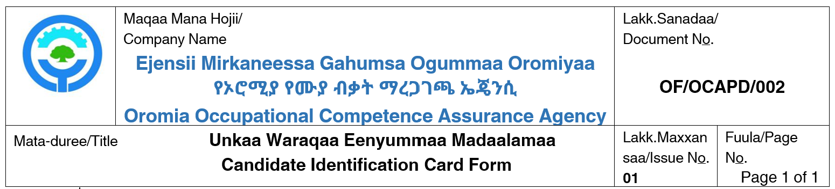

Assessment Center : Malka Adama DW
This card is to be presented by the candidate at the session of
the assessment for which he/she is registered. It is illegal for the candidate to attempt to sit for the occupation for which he/she is not registered.
Occupation DOMESTIC WORK
Assessment Center : Malka Adama DW
This card is to be presented by the candidate at the session of the
assessment for which he/she is registered. It is illegal for the candidate to attempt to sit for the occupation for which he/she is not registered.

