How Having Pets Improves Our Lives - Hypothesis Testing.

Naveya Novely Datta, 21101321
Department of computer science and engineering
Brac University
Naomi Afrin Jalil, 21201325
Department of computer science and engineering
Brac University
Nubah Nazifa Hossain, 21201717
Department of computer science and engineering
Brac University

Abstract— Pets have been long considered to be very good companions to humans, offering emotional support, relief stress, and overall well-being of their owner’s livelihood. This study investigates that whether having pets improves our lives. A survey was conducted amongst university students and their experience were recorded and analyzed using hypothesis testing to evaluate the benefits of having a pet. From our analysis the results showed that owning pets has a significant higher levels of stress relief, joy, and social engagement supporting the claim that pets help improve owners' lives.
Keywords— Pet Ownership, Activity, Stress, Relief, Hypothesis Testing, Data Analysis, improves.

Introduction
For a long time, pets have been considered to be very good companions to individuals and have provided their owners with emotional support, reduced stress, and overall improved their lives. The purpose of this study is to investigate whether pets help improve their lives. A survey was conducted among university students, and their experience with their pets was recorded. Through hypothesis testing and data analysis, this project aims to determine whether there is evidence supporting the belief that having pets can improve our lives.

Methodology.

Hypothesis Statement
- Null hypothesis (H₀): There is no change in people's lives with or without pets.
- Alternate Hypothesis (H₁): Having pets can improve people's lives.

Data Collection
Link to our primary dataset: https://docs.google.com/spreadsheets/d/1d2PRv0bFzTp0gozOBUXOqDBHxj8x0zwCHxWpxhjif5w/edit?gid=1981527510#gid=1981527510

For this study, the data were collected via a survey among university students. They aimed to explore how owning pets affects the various aspects of the owner’s livelihood.

The questionnaire included both qualitative and quantitative questions regarding having a pet or not, and their joy, stress relief, activity, and social interactions. Since we are focusing on having pets and improving life, we mainly retained and analyzed responses of the experiences of pet owners and non-pet owners.

Data preprocessing
Several steps were taken for the preparation of the analysis.
- Unnecessary columns were dropped ( Timestamp, email, what kind of pet(s) do you have?, How long have you had your pet(s)?, and Tell us one moment when your pet truly made your day better.). The reason for the removal was that it contained personal identifiers or open-ended responses, which may not be suitable for data analysis for this study.
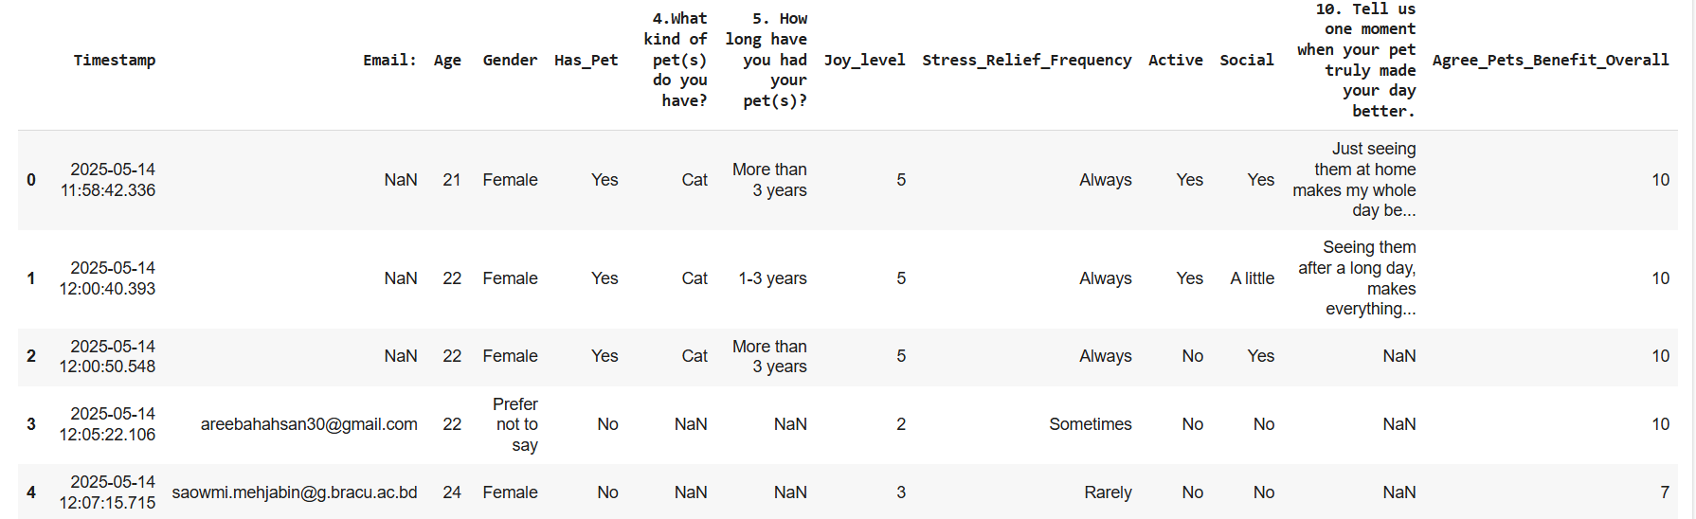
Figure.1: Before column removal.
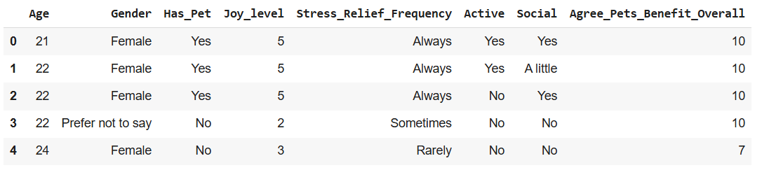Figure.2: After column removal

- Data encoding:
The data was next encoded to numerical values for the column gender, pet ownership status, mood improvement frequency, outdoor activity, social impact, and overall agreement on pet benefits.
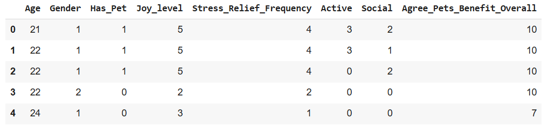
Figure.3: Encoded dataset.

- The rows with null values were removed as to ensure a complete dataset.
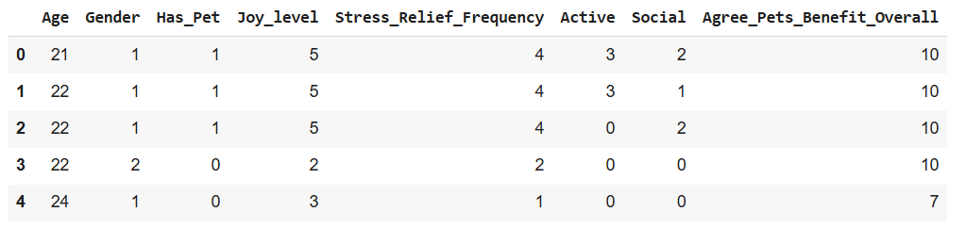
Figure.4: dataset after null value removal.

Data analysis.

Data visualization.
To begin the analysis, we first explored the dataset through visualization to identify patterns related to the pet and ownership.

- At first, we illustrated a histogram distribution of agreement scores on the statement "Pets Improve Overall Well-Being." The x-axis represents scores from 0 to 10, while the y-axis shows response counts.
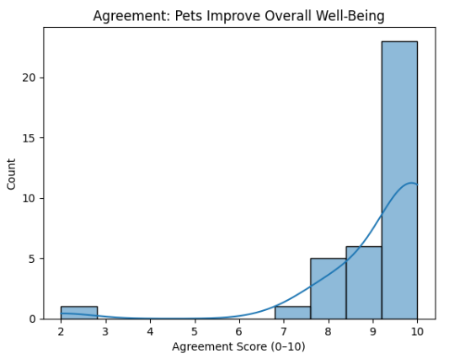
Figure.5: Distribution of agreement scores on the statement "Pets Improve Overall Well-Being."
From Figure. 5, we see most responses are clustered at a score of 9 and 10, which indicates a strong statement in agreement.
- Next, we illustrated a bar plot for the distribution of stress relief frequency amongst individuals who own or do not own pets.
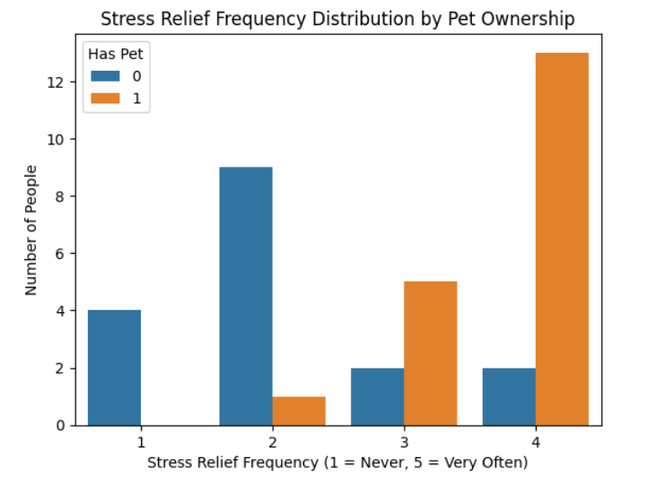
Figure.6: Distribution of stress relief frequency amongst individuals who own or do not own pets.
From figure.6, we see that pet owners showed a higher frequency of stress relief compared to people who do not have pets.

- Moving on, we illustrated the distribution of stress relief frequency among individuals who own or do not own pets.
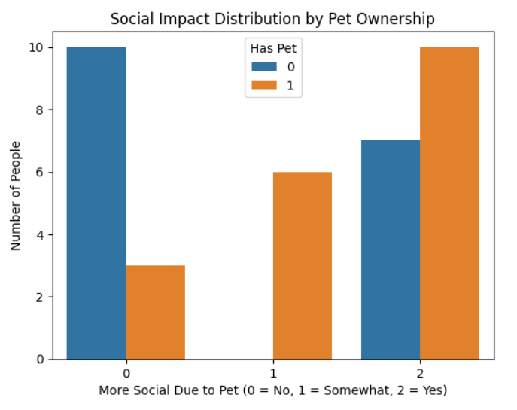
Figure.7: Distribution of stress relief frequency among individuals with and without pets.
From figure.7, we see that people who own pets showed higher frequencies of stress relief compared to people who do not have pets.

- Next, we illustrated the bar plot of the distribution of active levels amongst individuals who own or do not own pets.
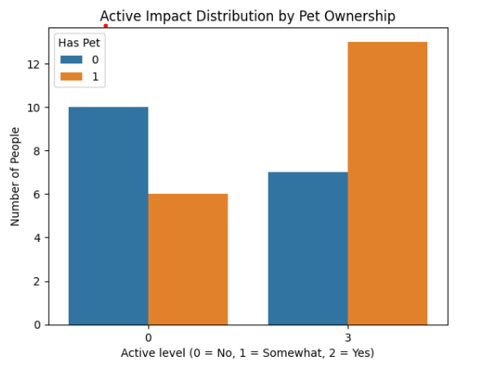
Figure.8: Distribution of active levels amongst individuals who own or do not own pets.
Figure.8 shows a higher level of activity among pet owners compared to owners without pets.

- Correlation Heatmap.
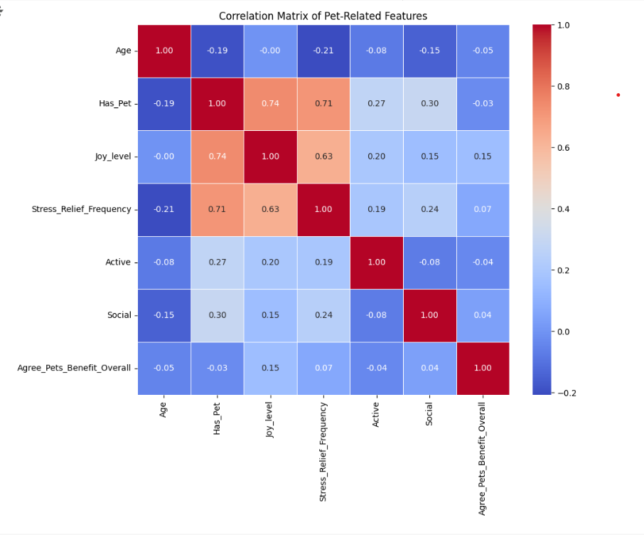
Figure.9. Correlation heat map.

Hypothesis analysis and results.

For the hypothesis testing, we conducted several statistical tests and compared pet owners and non-pet owners across different variables. The threshold was set at p < 0.05.

- Stress Relief - T Test
A t-test was conducted to compare the frequency of stress relief amongst people who own pets and those who do not.
Null hypothesis (H₀): Having a pet does not have any effect on an individual’s stress relief.
Results: t - statistics = 5.748, p - value = 0.000
Conclusion: Since p < 0.005, the null hypothesis is rejected. Therefore, we can say that having a pet can help the owner feel stress relief.
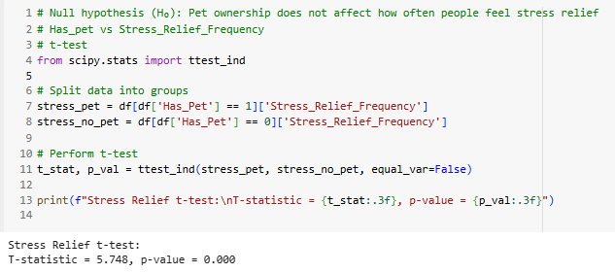
Fig.10. Stress Relief t-test.

- Social Impact - Chi-Square Test.
A chi-square test was performed to evaluate the relationship between people who own pets and those who do not.
Null hypothesis (H₀): Having a pet does not have any impact on the owner's social life.
Results: chi - square = 10.219, p - value = 0.006
Conclusion: Since p < 0.005, the null hypothesis is rejected. Therefore, we can say that having a pet does have an impact on the owner's social life. 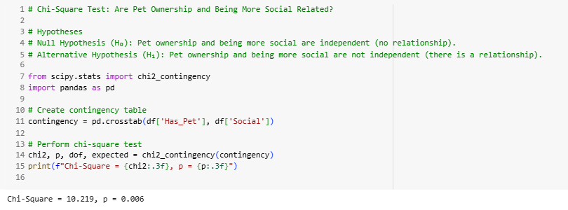
Figure.10. Social Impact - Chi-square Test.

- Joy level - Chi-square Test
We did another chi-square test to see if there is any relation between having pets and the level of joy amongst people who own pets and those who do not.
Null hypothesis (H₀): Having a pet does not have any impact on the owner's joy level.
Results: chi - square = 21.756, p - value = 0.000
Conclusion: Since p < 0.005, the null hypothesis is rejected. Therefore, we can say that having a pet does have an impact on the joy level of a pet owner. They feel more joy.

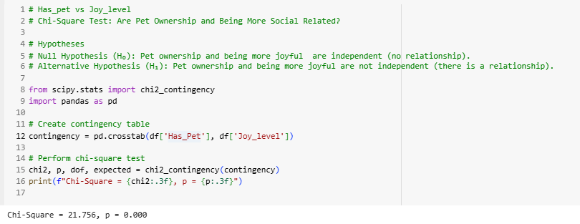
Figure.11. Joy level - Chi-square Test

- Activity Relate - Spearman Correlation.
A Spearman correlation test was done to see the relationship between having pets impacts the activity level amongst people who own pets and those who do not.
Null hypothesis (H₀): Having a pet does not have any impact on owners' activity.
Results: correlation = 0.274, p - value = 0.106
Conclusion: Since p > 0.005, we failed to reject the null hypothesis. Therefore, we can say that having a pet does not have a significant impact on an individual's activity.

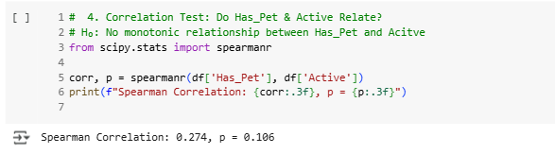Figure.12. Activity Relate - Spearman Correlation

Overall and conclusion
From the study conducted, we can say that owning a pet does have some significant impact on improving their lives, particularly in terms of stress relief, social engagement, and joy. Although there might be a significant relationship between having a pet and the activity of the individual, further investigation with a larger sample could help enhance the accuracy of the hypothesis testing. For future work, a broader demographic sample, longitudinal tracking, and deeper behavioral metrics could help expand more insights of this study.

