**RESULTS :**

Below are the contour plots at different initial stream line values.

# **a. At Ψinitial = 100**

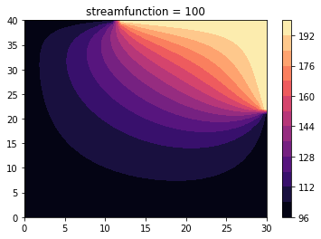

|  |  |  |  |
| --- | --- | --- | --- |
| **X=0** | **X=10** | **X=20** | **X=30** |
| 100 | 100 | 100 | 100 |
| 100 | 100.298 | 100.424 | 100 |
| 100 | 100.602 | 100.859 | 100 |
| 100 | 100.917 | 101.317 | 100 |
| 100 | 101.248 | 101.809 | 100 |
| 100 | 101.602 | 102.348 | 100 |
| 100 | 101.984 | 102.86 | 100 |
| 100 | 102.398 | 103.619 | 100 |
| 100 | 102.851 | 104.38 | 100 |
| 100 | 103.347 | 105.247 | 100 |
| 100 | 103.89 | 106.238 | 100 |
| 100 | 104.487 | 107.372 | 100 |
| 100 | 105.138 | 108.668 | 100 |
| 100 | 105.85 | 110.15 | 100 |
| 100 | 106.623 | 111.836 | 100 |
| 100 | 107.46 | 113.747 | 100 |
| 100 | 108.36 | 115.897 | 100 |
| 100 | 109.327 | 118.297 | 100 |
| 100 | 110.355 | 120.945 | 100 |
| 100 | 111.445 | 123.83 | 100 |
| 100 | 112.592 | 126.923 | 100 |
| 100 | 113.794 | 130.183 | 100 |
| 100 | 115.044 | 133.555 | 200 |
| 100 | 116.338 | 136.986 | 200 |
| 100 | 117.667 | 140.422 | 200 |
| 100 | 119.027 | 143.826 | 200 |
| 100 | 120.407 | 147.175 | 200 |
| 100 | 121.8 | 150.466 | 200 |
| 100 | 123.192 | 153.708 | 200 |
| 100 | 124.57 | 156.925 | 200 |
| 100 | 125.915 | 160.145 | 200 |
| 100 | 127.202 | 163.409 | 200 |
| 100 | 128.392 | 166.755 | 200 |
| 100 | 129.43 | 170.228 | 200 |
| 100 | 130.221 | 173.865 | 200 |
| 100 | 130.61 | 177.704 | 200 |
| 100 | 130.306 | 181.766 | 200 |
| 100 | 128.743 | 186.059 | 200 |
| 100 | 124.772 | 190.565 | 200 |
| 100 | 116.163 | 195.236 | 200 |
| 100 | 100 | 200 | 200 |

Table 1: Converged form for all y grid point

# **b. At Ψinitial = 150**

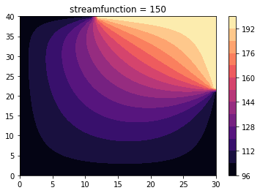

|  |  |  |  |
| --- | --- | --- | --- |
| **X= 0** | **X=10** | **X=20** | **X=30** |
| 100 | 100 | 100 | 100 |
| 100 | 101.1 | 101.224 | 100 |
| 100 | 102.201 | 102.454 | 100 |
| 100 | 103.302 | 103.695 | 100 |
| 100 | 104.403 | 104.955 | 100 |
| 100 | 105.506 | 106.239 | 100 |
| 100 | 106.61 | 107.558 | 100 |
| 100 | 107.715 | 108.919 | 100 |
| 100 | 108.825 | 110.334 | 100 |
| 100 | 109.937 | 111.815 | 100 |
| 100 | 111.054 | 113.377 | 100 |
| 100 | 112.176 | 115.034 | 100 |
| 100 | 113.305 | 116.806 | 100 |
| 100 | 114.439 | 118.708 | 100 |
| 100 | 115.582 | 120.761 | 100 |
| 100 | 116.729 | 122.98 | 100 |
| 100 | 117.884 | 125.383 | 100 |
| 100 | 119.042 | 127.973 | 100 |
| 100 | 120.205 | 130.753 | 100 |
| 100 | 121.365 | 133.707 | 100 |
| 100 | 122.525 | 136.811 | 100 |
| 100 | 123.675 | 140.019 | 100 |

|  |  |  |  |
| --- | --- | --- | --- |
| 100 | 124.816 | 143.282 | 200 |
| 100 | 125.94 | 146.542 | 200 |
| 100 | 127.044 | 149.752 | 200 |
| 100 | 128.12 | 152.872 | 200 |
| 100 | 129.164 | 155.886 | 200 |
| 100 | 130.166 | 158.788 | 200 |
| 100 | 131.121 | 161.594 | 200 |
| 100 | 132.012 | 164.326 | 200 |
| 100 | 132.829 | 167.02 | 200 |
| 100 | 133.545 | 169.715 | 200 |
| 100 | 134.128 | 172.458 | 200 |
| 100 | 134.524 | 175.292 | 200 |
| 100 | 134.645 | 178.263 | 200 |
| 100 | 134.337 | 181.408 | 200 |
| 100 | 133.314 | 184.756 | 200 |
| 100 | 131.014 | 188.316 | 200 |
| 100 | 126.294 | 192.077 | 200 |
| 100 | 116.926 | 195.995 | 200 |
| 100 | 100 | 200 | 200 |

Table 2: Converged Solution for all y-grid points.

## c. At Ψinitial = 200

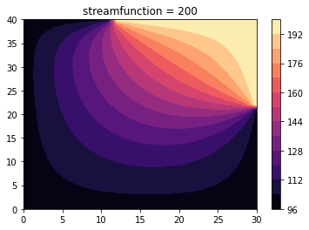

|  |  |  |  |
| --- | --- | --- | --- |
| **X= 0** | **X=10** | **X=20** | **X=30** |
| 100 | 100 | 100 | 100 |
| 100 | 101.032 | 101.164 | 100 |
| 100 | 102.066 | 102.335 | 100 |
| 100 | 103.104 | 103.521 | 100 |
| 100 | 104.149 | 104.731 | 100 |
| 100 | 105.2 | 105.97 | 100 |
| 100 | 106.262 | 107.257 | 100 |
| 100 | 107.335 | 108.593 | 100 |
| 100 | 108.421 | 109.993 | 100 |
| 100 | 109.522 | 111.47 | 100 |
| 100 | 110.639 | 113.039 | 100 |
| 100 | 111.772 | 114.715 | 100 |
| 100 | 112.923 | 116.515 | 100 |
| 100 | 114.09 | 118.457 | 100 |
| 100 | 115.275 | 120.56 | 100 |
| 100 | 116.475 | 122.837 | 100 |
| 100 | 117.689 | 125.304 | 100 |
| 100 | 118.913 | 127.965 | 100 |
| 100 | 120.145 | 130.819 | 100 |
| 100 | 121.379 | 133.85 | 100 |
| 100 | 122.611 | 137.03 | 100 |
| 100 | 123.836 | 140.314 | 100 |
| 100 | 125.047 | 143.649 | 200 |
| 100 | 126.237 | 146.976 | 200 |
| 100 | 127.401 | 150.246 | 200 |
| 100 | 128.53 | 153.418 | 200 |
| 100 | 129.618 | 156.473 | 200 |
| 100 | 130.655 | 159.406 | 200 |
| 100 | 131.633 | 162.23 | 200 |
| 100 | 132.537 | 164.968 | 200 |
| 100 | 133.354 | 167.656 | 200 |
| 100 | 134.059 | 170.333 | 200 |
| 100 | 134.62 | 173.044 | 200 |
| 100 | 134.982 | 175.834 | 200 |
| 100 | 135.058 | 178.75 | 200 |
| 100 | 134.696 | 181.831 | 200 |
| 100 | 133.612 | 185.105 | 200 |
| 100 | 131.244 | 188.585 | 200 |
| 100 | 126.45 | 192.259 | 200 |
| 100 | 117.005 | 196.087 | 200 |
| 100 | 100 | 200 | 200 |

Table 3: Converged solution form for all y-grid points.

1. **CONCLUSION:**

From the above tabular form and the contour plots we see that for all values of initial guesses, the generation of the streamline pattern is same. The number of iterations to converge for the different initial guess values of 100, 150 and 200 are 470, 439 and 697 respectively. Here, we can see the initial middle guess value is converging to that exact solution faster and is efficient among the other guess value. However, as we do iterations we see any number between 100 and 200 led to fast convergence to that of exact value.

1. **REFERENCES**
2. J. D. Anderson “Computational Fluid Dynamics, The Basics with Applications”, University of Maryland, McGraw-Hill, pp. 1-563, 1995
3. 2. C. Hirsch, “Numerical computations of Internal and External flows”,

Vol 1: Fundamentals of Numerical Discretization, John Wiley, pp. 1-

524, 1989