Naomi Almero
Enhancement Three: Databases
The artifact chosen for the Databases enhancement is my full-stack Travlr application, originally created for my CS 465: Full Stack Development course. Travlr is a MEAN-stack web application that uses MongoDB as its database layer, with a Node.js and Express backend and an Angular frontend. The application supports viewing, adding, updating, and managing trip data, demonstrating how database-stored information is retrieved, modified, and presented across a full-stack architecture.
I selected this artifact for my ePortfolio because it effectively demonstrates my ability to design, implement, and enhance database-driven applications while managing interactions between the database, server, and client layers. The project showcases essential database and software development skills, including MongoDB schema design, RESTful API development, and data consistency across application layers. Key components that highlight these skills include the MongoDB collections and schemas used to store trip data, Express API endpoints that perform CRUD operations, and middleware that manages request validation and structured responses between the backend and frontend .
For the enhancement, I focused on improving the robustness, performance, and analytical capabilities of the database layer. First, I strengthened the backend input validation to ensure that all incoming data conforms to expected formats and constraints before being written to the database. This prevents invalid, incomplete, or malicious data from compromising database integrity. I then implemented consistent error handling across API endpoints, returning standardized responses that improve reliability and protect the application from unexpected failures. To address performance, I added database indexes on frequently queried fields such trip codes and destination names, reducing query execution time and improving scalability as data volume increases. Finally, I extended the database functionality by implementing MongoDB aggregation pipelines, enabling advanced queries such as grouping trips by destination and calculating totals to identify popular travel locations.
This enhancement meets the course outcomes I identified in Module One. Through this work, I demonstrated the ability to design and evaluate computing solutions using appropriate practices while considering trade-offs related to performance, maintainability, and security. I also applied well-founded techniques to improve database efficiency and functionality, moving beyond basic CRUD operations to include indexed queries and analytical data processing. No updates to my outcome-coverage plan were necessary, as the enhancement fully addressed the originally targeted outcomes.
Reflecting on the enhancement process, I gained a deeper understanding of how schema design, query optimization, and structured error handling directly affect application stability, performance, and usability. One challenge I encountered was modifying schemas and aggregation queries without disrupting the existing API functionality or breaking frontend data consumption. Addressing this challenge reinforced the importance of careful planning, backward compatibility, and thorough testing when enhancing database-driven systems. Overall, this enhancement strengthened my confidence in building secure, scalable, and efficient applications that rely on well-designed database architectures.
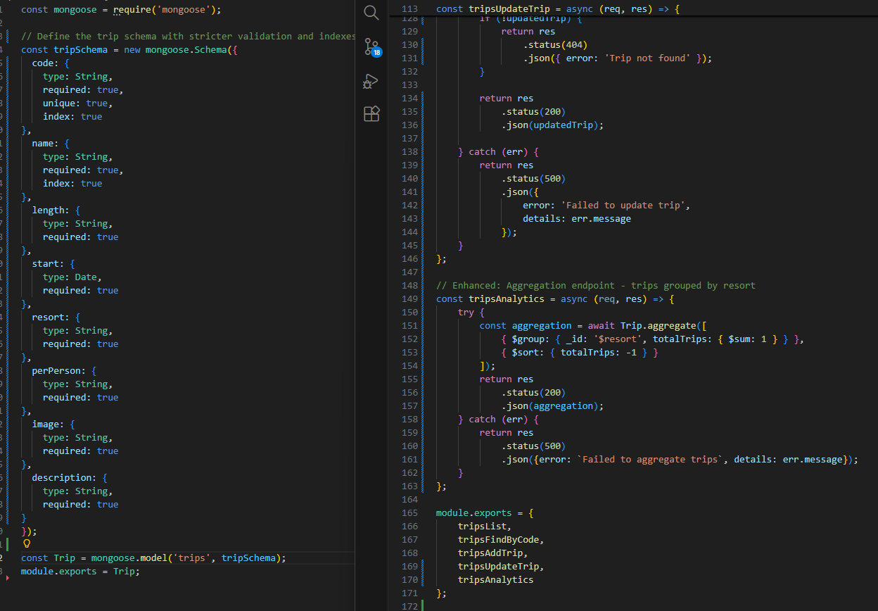
This included screenshot illustrates a comparison between the original and enhanced versions of the Travlr application’s database logic. The original implementation supports basic schema definitions and CRUD operations, while the enhanced version introduces a MongoDB aggregation pipeline that groups trips by destination and calculates summary values. This improvement demonstrates my ability to extend a database beyond simple storage into meaningful data analysis while improving server-side efficiency and application insight.

