Naomi Almero
Enhancement Three: Databases
The artifact I selected for the Databases category is my full-stack MEAN Travlr application, originally created in my CS 465 course. The application used MongoDB as its data layer and supported displaying trip data through a Node/Express backend and Angular frontend. It allows users to view, add, update, and manage trip data, demonstrating how database-driven information flows through a full-stack application.
I included this artifact in my ePortfolio because it highlights my ability to design and work with database-backed systems while managing interactions across multiple layers of an application. The project demonstrates essential software development skills, including schema design, RESTful API development, and data consistency between the database and user interface. Specific components that showcase these skills include the MongoDB collections and schemas, API endpoints that perform CRUD operations, and middleware used to manage requests and responses.
For the enhancement, I focused on strengthening backend input validation to ensure all incoming data meets expected formats and constraints. Then, I implemented improved error handling, providing consistent responses across all API endpoints to protect against invalid or malicious inputs. I enhanced the database layer by creating indexes on frequently queried fields, such as trip code and names. Finally, I added advanced query capabilities using aggregation pipelines, enabling analytical queries like calculating the most popular destinations.
Through this work, I have met the course outcomes I planned to address in Module One. I demonstrated the ability to design and evaluate computing solutions using appropriate practices while managing trade-offs related to performance, maintainability, and security. I also applied well-founded techniques to implement database improvements that enhance functionality and deliver value. By strengthening input validation and error handling, I have continued to develop a security mindset that anticipates vulnerabilities and ensures data security.
Reflecting on the enhancement process, I learned how improvements to schema design, query optimization, and error handling can significantly impact application stability and usability. One challenge I faced was updating the schema and aggregation queries without disrupting the existing API functionality. Addressing this reinforced the importance of thorough testing and careful planning when implementing backend and database improvements. Overall, enhancing this artifact strengthened my confidence in building secure, scalable database-driven applications.
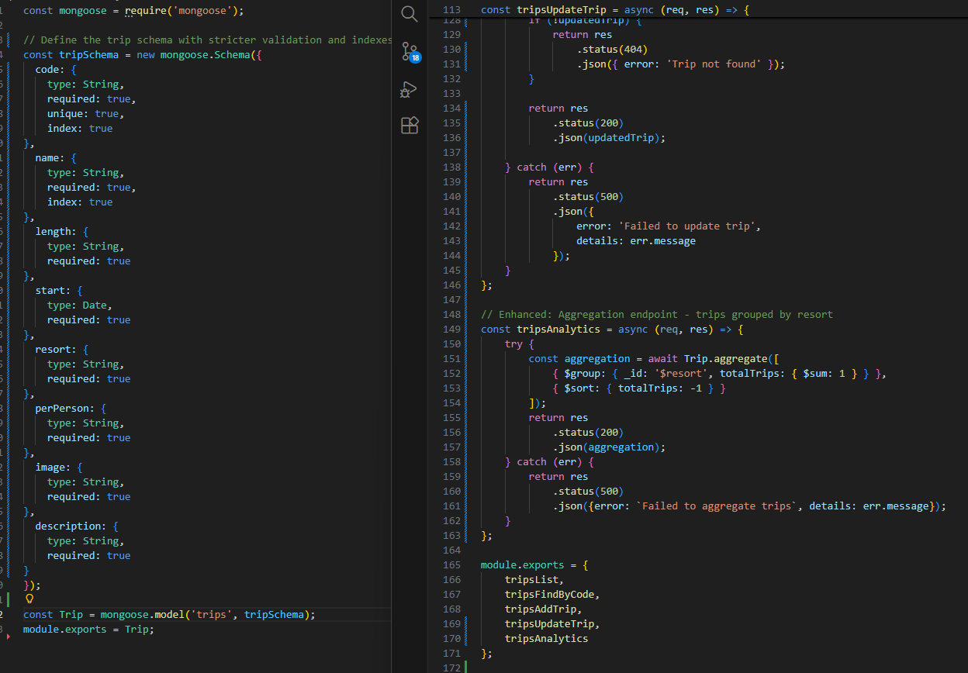
This screenshot shows a direct comparison between the original and enhanced versions of the Travlr application’s database logic. The original code on the left supports basic schema definitions and CRUD operations, while the enhanced code on the right introduces a MongoDB aggregation pipeline that groups trips by resort and calculates totals. This improvement enables analytical queries, improves performance through more efficient server-side processing, and demonstrates my ability to extend a database beyond basic data storage into meaningful data analysis.

