Wildfire Descriptive Statistics Report (SPSS Framework)

1. Research Variables
• Dependent Variable: Fire Size (incident_acres_burned)
• Independent Variables (Weather):
- Maximum Temperature (MAX_TEMP)
- Precipitation (PRECIPITATION)
- Average Wind Speed (AVG_WIND_SPEED)

2. Descriptive Statistics

Table 1. Basic Descriptive Statistics
Descriptive Statistics
 | N | Minimum | Maximum | Mean | Std. Deviation
incident_acres_burned | 1562 | 2 | 1032648 | 4601.80 | 42892.757
PRECIPITATION | 1562 | .00 | 2.03 | .0030 | .06325
MAX_TEMP | 1562 | 59 | 102 | 74.44 | 6.073
AVG_WIND_SPEED | 1562 | .00 | 14.99 | 7.5956 | 1.44801

Interpretation:
- Fire size has a highly skewed distribution (mean >> median, a few very large fires).
- Temperature varies from 59–102°F, average ~74°F.
- Precipitation is nearly always zero.
- Wind speed averages around 7.6 mph.

Table 2. Median & Percentiles (Explore Output)
Variable | Mean | Median | 25th Percentile | 75th Percentile | Skewness | Kurtosis
Fire Size (Acres) | 4601.8 | 75 | 27 | 300 | >0 (Right skewed) | High (many extreme values)
MAX_TEMP (°F) | 74.4 | 74 | 71 | 77 | ≈0 | ≈0
PRECIPITATION (inches) | 0.003 | 0.0 | 0.0 | 0.0 | Right skewed | High (zero-inflated)
AVG_WIND_SPEED (mph) | 7.6 | 7.6 | 6.7 | 8.3 | ≈0 | ≈0
Interpretation:
- Fire size median (75 acres) << mean (4601 acres), confirming extreme skewness.
- Weather variables (temperature, wind speed) are closer to normal distribution.
- Precipitation is almost always zero, highly skewed.

3. Graphs (to include from SPSS)
- Histogram of Fire Size (shows skewed distribution)
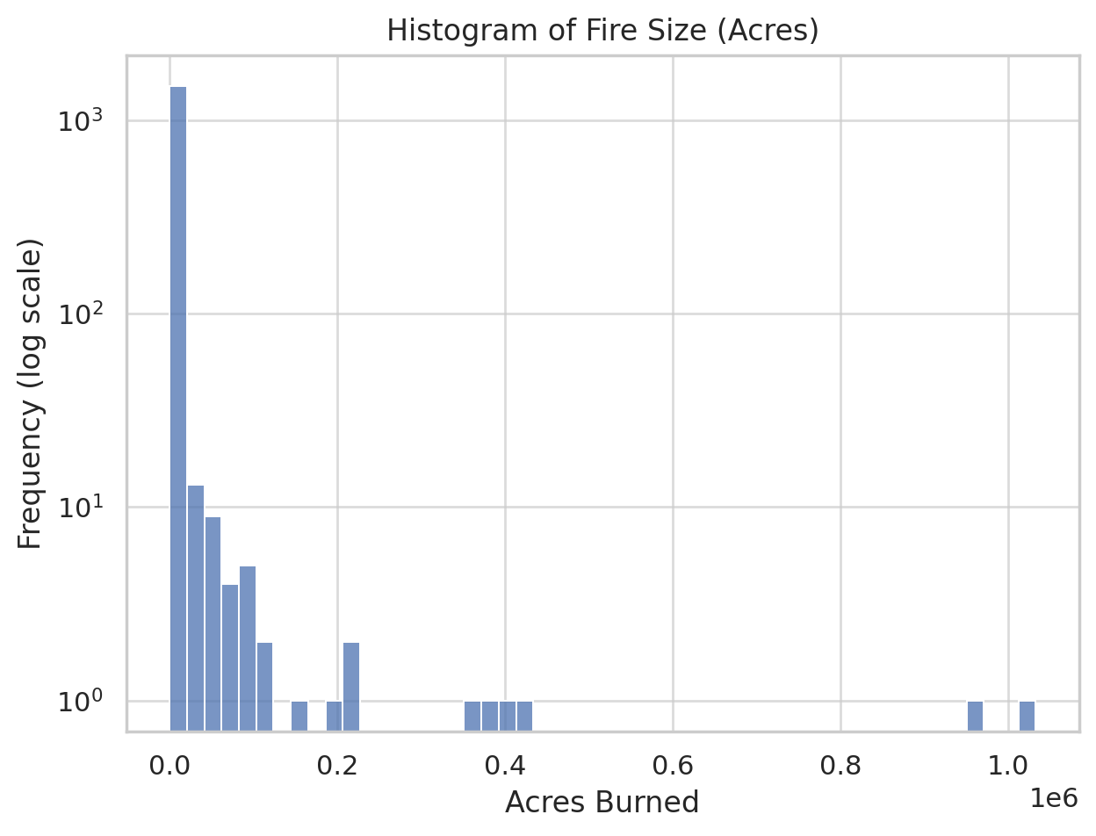

- Boxplot of Fire Size (shows extreme outliers)
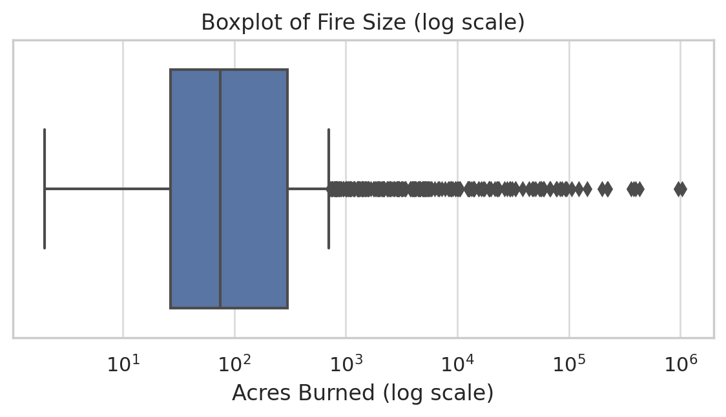
- Histograms of Temperature, Wind Speed, Precipitation
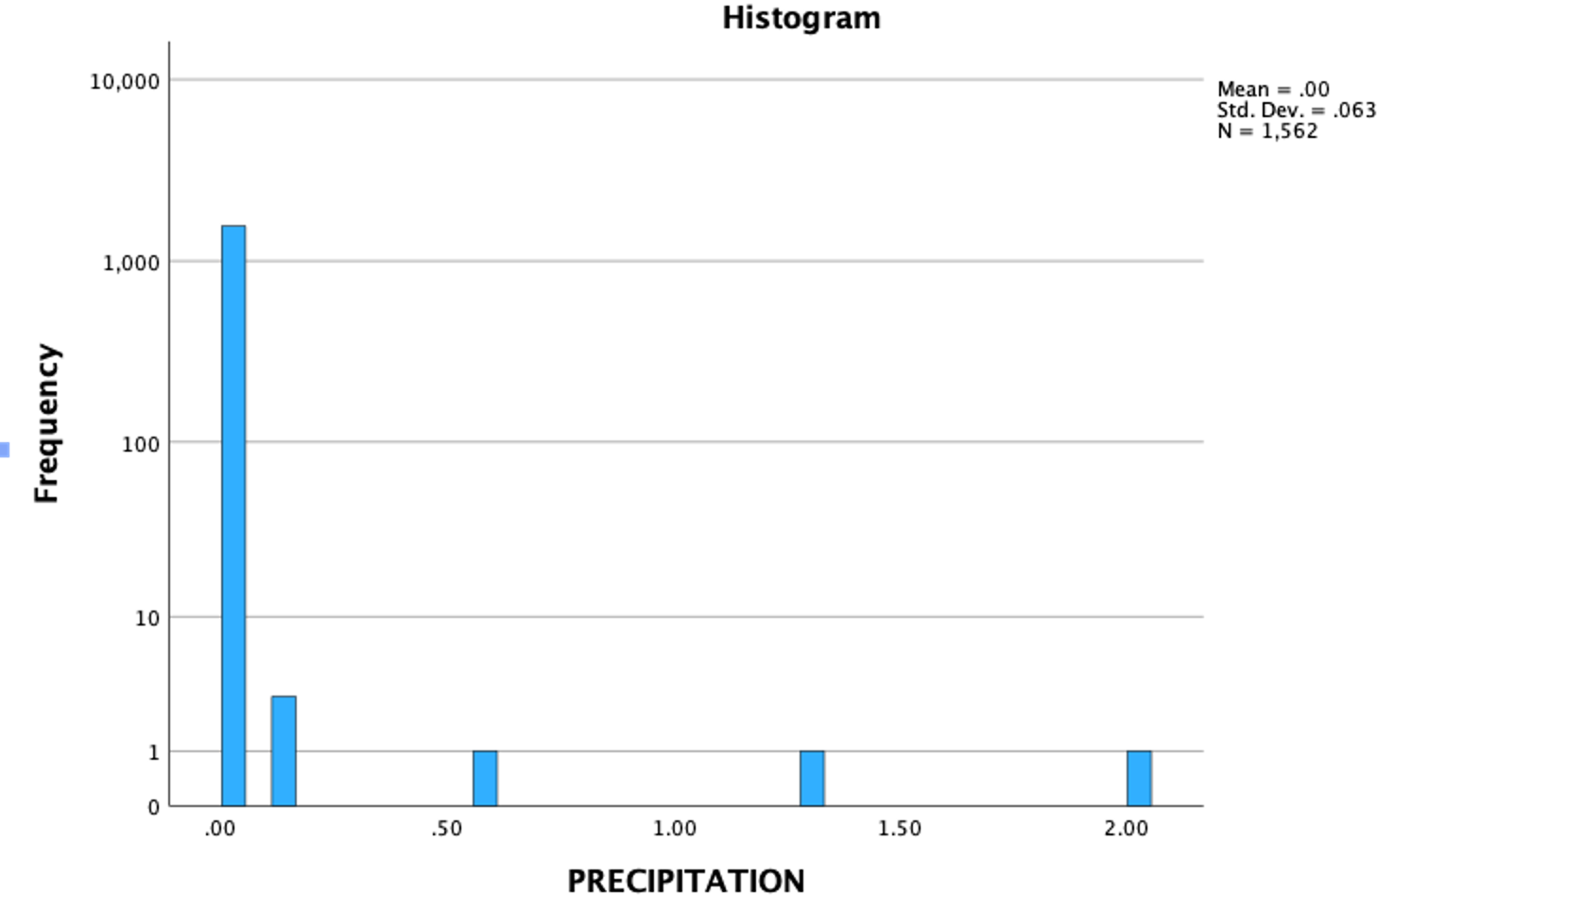

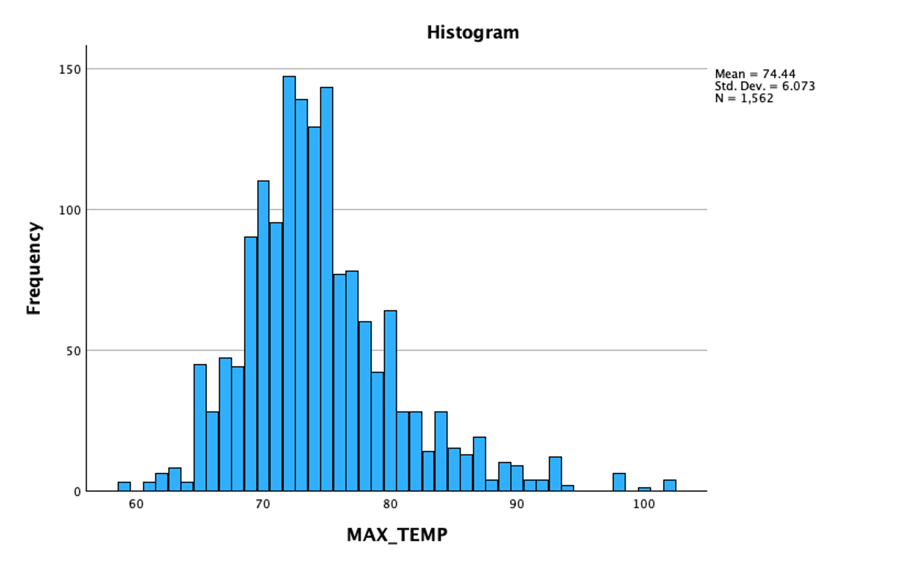
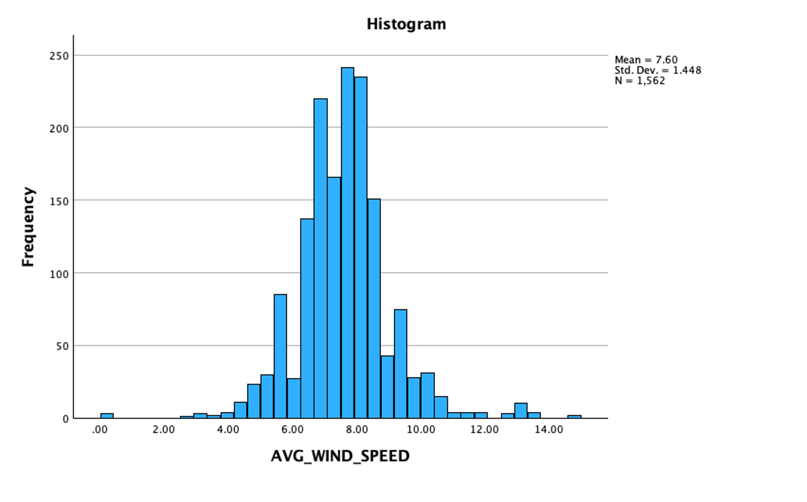

4. Preliminary Conclusions
1. Fire size distribution is extremely right-skewed: most fires are small, a few are extremely large.
2. Fires mostly occur on warm days (~74°F), with low precipitation (near zero), and moderate wind speed.
3. Descriptive statistics suggest further analysis should use log-transformed fire size or non-parametric methods.

