**Weather Data Results**

VERSION B

**Runtimes:**

1. **Sequential**

maximum time 1606

minimum time 1019

average time 1155.8

1. **No Lock**

No lock maximum time 1288

No lock minimum time 368

No lock average time 486.9

SpeedUp: 2.37

1. **Coarse Lock**

Coarse lock maximum time 1463

Coarse lock minimum time 510

Coarse lock average time 641.0

SpeedUp: 1.8

1. **Fine Lock**

Fine lock maximum time 1539

Fine lock minimum time 365

Fine lock average time 526.2

SpeedUp: 2.19

1. **No Sharing**

No Sharing maximum time 1288

No Sharing minimum time 401

No Sharing average time 553.5

SpeedUp: 2.08

No of threads used in my laptop = 4

VERSION C

**Runtimes with Fibonacci**

1. Sequential

Sequential maximum time 14327

Sequential minimum time 11135

Sequential average time 11879.0

1. No Lock

No lock maximum time 10156

No lock minimum time 4286

No lock average time 4922.5

SpeedUp: 2.413

1. Coarse Lock

Coarse lock maximum time 8026

Coarse lock minimum time 4398

Coarse lock average time 4994.6

SpeedUp: 2.37

1. Fine Lock

Fine lock maximum time 9775

Fine lock minimum time 4274

Fine lock average time 5057.2

SpeedUp: 2.34

1. No Sharing

No Sharing maximum time 12538

No Sharing minimum time 4556

No Sharing average time 5800.4

SpeedUp: 2.04

Questions:

1. Which program version (SEQ, NO-LOCK, COARSE-LOCK, FINE-LOCK, NO-SHARING) would you normally expect to finish fastest and why? Do the experiments confirm your expectation? If not, try to explain the reasons.

Answer: I would normally expect No Lock version to finish the fastest as all 4 threads work simultaneously and no thread waits for the other record to update the shared data structure. But there might be data inconsistency in case of no lock and multiple threads are trying to update the same record. My experiments also show that No Lock version is the fastest.

1. Which program version (SEQ, NO-LOCK, COARSE-LOCK, FINE-LOCK, NO-SHARING) would you normally expect to finish slowest and why? Do the experiments confirm your expectation? If not, try to explain the reasons.

Answer: I would expect SEQ to finish slowest as all the 8mil records in the file are getting processed by the same thread one by one. My experiments also prove that SEQ finishes slowest.

1. Compare the temperature averages returned by each program version. Report if any of them is incorrect

Answer: NO lock does not have correct entries for temperature averages as multiple thread try to update the same data structure (maybe same value) as the same time. Also FINE LOCK

1. Compare the running times of SEQ and COARSE-LOCK. Try to explain why one is slower than the other. (Make sure to consider the results of both B and C—this might support or refute a possible hypothesis.)

Answer: SEQ takes almost double the time than COARSE-LOCK in both the B and C versions. This is because while SEQ will always perform the execution of a per record basis, COARSE-LOCK might in some cases allow for slightly faster data processing.

1. How does the higher computation cost in part C (additional Fibonacci computation) affect the difference between COARSE-LOCK and FINE-LOCK? Try to explain the reason.

Answer: According to my experiments FINE-LOCK takes approx 50ms more than COARSE-LOCK when Fibonacci computation is added whereas it was taking about 100ms less than COARSE-LOCK.

**Word Count Local Execution**

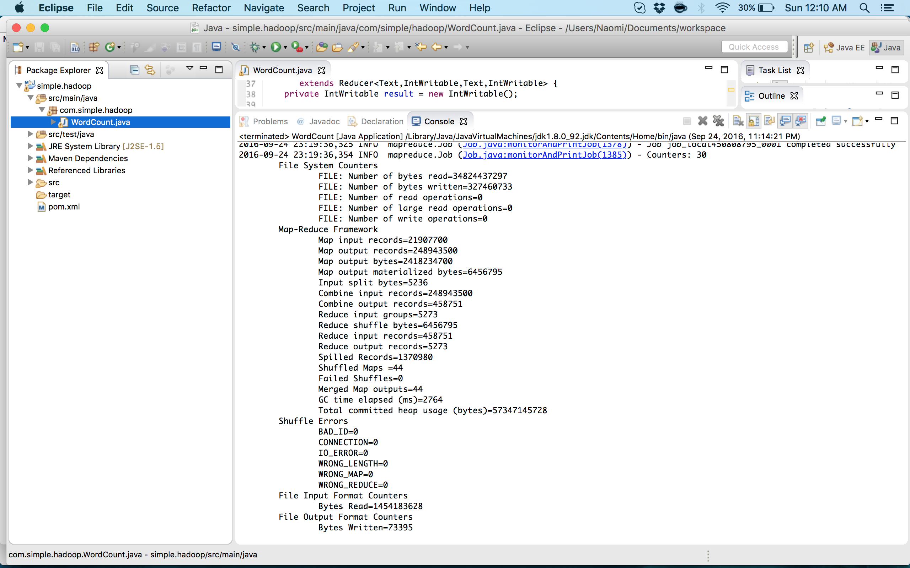

**Word Count AWS Execution**

