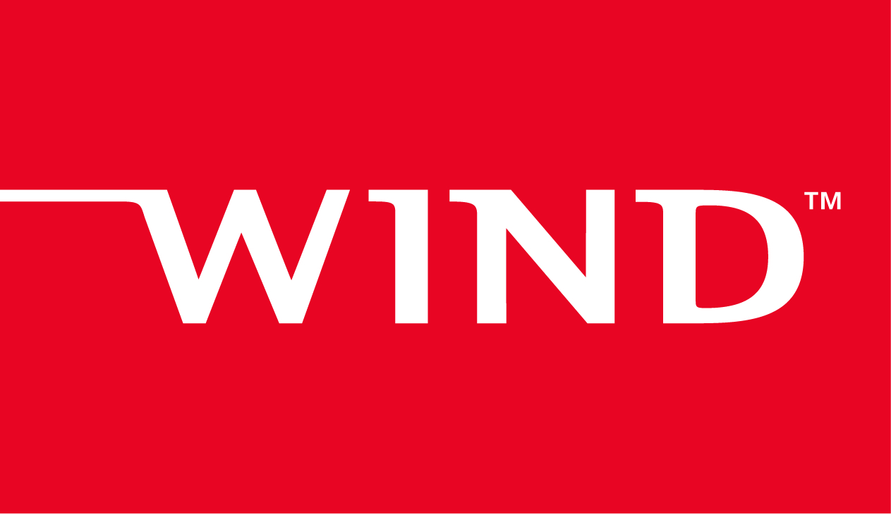

**Feature Test Plan Template**

Document ID:

Author:

Version:

Version Date:

Status:

**Copyright Notice**

Copyright © 2020 Wind River® Systems, Inc.

All rights reserved. No part of this publication may be reproduced or transmitted in any form or by any means without prior written permissions of Wind River Systems, Inc.

**Trademarks**

Wind River, Simics, Tornado, and VxWorks are registered trademarks of Wind River Systems, Inc. Helix, Pulsar, Rocket, Titanium Cloud, Titanium Control, Titanium Core, Titanium Edge, Titanium Edge SX, Titanium Server, and the Wind River logo are trademarks of Wind River Systems, Inc. Any third-party trademarks referenced are the property of their respective owners. For further information regarding Wind River trademarks, please see:

<http://www.windriver.com/company/terms/trademark.html>

This product may include software licensed to Wind River by third parties. Relevant notices (if any) are provided for your product on the Wind River download and installation portal, Wind Share:

<http://windshare.windriver.com>

Wind River may refer to third-party documentation by listing publications or providing links to third-party websites for informational purposes. Wind River accepts no responsibility for the information provided in such third-party documentation.

**Corporate Headquarters**

Wind River

500 Wind River Way

Alameda, CA 94501-1153

U.S.A.

Toll free (U.S.A.): +1-800-545-WIND

Telephone: +1 510 748 4100

Facsimile: +1 510 749 2010

For additional contact information, see the Wind River website:

[http://www.windriver.com](http://www.windriver.com/)

For information on how to contact Customer Support, see:

<http://www.windriver.com/support>

**Revision History**

|  |  |  |  |
| --- | --- | --- | --- |
| Date | Version | Initials | Summary |
|  |  |  |  |
|  |  |  |  |
|  |  |  |  |
|  |  |  |  |
|  |  |  |  |

Table of Contents

1 Release Information 1

1.1 Release Schedule 1

1.2 Test Environment 1

1.3 New RPMs List 1

1.4 Compiler Update and Impact (Optional) 1

1.5 Test Plan Review 1

2 New Feature Testing 1

2.1 Feature Test Plan 1

2.1.1 Test matrix 1

2.1.2 Performance summary 1

3 Basic Regression Test 1

4 Integration & System Testing 1

5 Test Result 2

5.1 Test Result Location 2

5.2 Defect Query 2

6 Risks and Dependencies 2

# Release Information

## Release Schedule

* Ready to merge date:
* Planned RTO/GA date:

## Test Environment

Describe your test environment here

## New RPMs List

List new RPMs here

## Compiler Update and Impact (Optional)

## Test Plan Review

Add code collaborator review link here

# New Feature Testing

## Feature Test Plan

### Test matrix

### Performance summary

# Basic Regression Test

* List your regression test matrix and results here

# Integration & System Testing

* By default, nightly test will include as integration test and system level test should also be considered during you feature testing

# Test Result

## Test Result Location

* Feature test result should be imported into LTAF

## Defect Query

* Add feature ID as label for the defect related with the feature

# Risks and Dependencies

* List feature test risks and dependencies here