1. Overview

The availability of international news nowadays raises a question of how America perceives itself compared to the world. This paper attempts to do so by analyzing the sentiment of news headlines from sections “US” and “World” in the New York Times, one of the most objective news sources.

1. Analysis

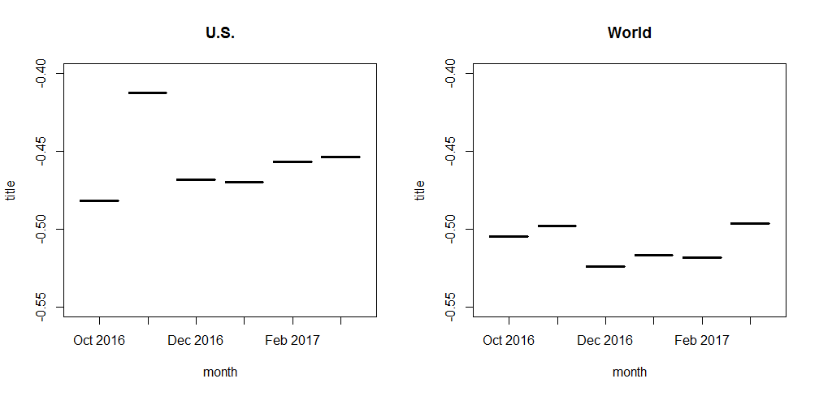Our first finding is at every month, the news in “World” section is more pessimistic on average than news in “U.S.” section. Furthermore, there seems to be a cutoff separating the monthly sentiment between the two sections: The most negative month for US news is in October 2016, with a value of -0.48 while the least negative monthly value for World news is -0.497, on March 2017.

Analysis of Findings: Present your findings. Include images of important visualizations, and analyze them. What does each tell us? What does each NOT tell us us (limitations)? This is perhaps the most important part of the paper because this is the section that demonstrates your ability to “read” data and to do so with sound reasoning.

Outline:

* Which more negative? US? World?

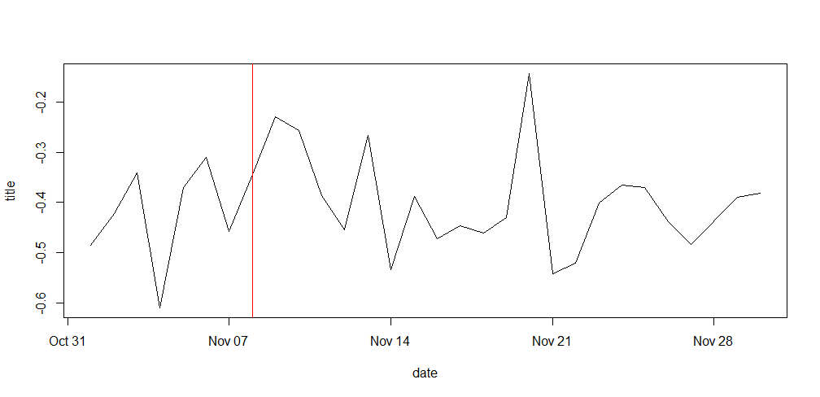The graph suggests that the most optimistic month for US articles is November 2016, when the election result is released. This is unexpected with respect to New York Times’ criticism of Donald Trump. Moreover, the most pessimistic month is October 2016, the month before the election result release and despite all the news about scandals and disorganization on the new government. However, this is the only month before the release so it does not make a strong evidence for the upwards trend in positivity in “U.S.” news. Let’s zoom into the most optimistic month for “U.S.” news: