Naomi Yang

SDEV-435  
12/13/2020

GoTest E-Learning Platform

# Executive Summary

The purpose of the project is to develop an online E-learning platform called ‘GoTest’ that provides access to allow users to obtain certifications and to show the progress of each learner’s assessment. Due to the increasing number of events in today’s society and remote work, Go Test will be made to anyone that has access to the internet. Each student will have the ability to register and login. There will be a library of assessment that are made available to all users. There will be a set of questions that will require a passing score before a certification can be awarded. Each quiz will be customized for a different learning goal to fit each agency. The test results will help a business provide the status of knowledge of current learners for their employees or group. The results may also assist a group with identifying where learners are excelling. Go Test may also Additional assessments may be added as they are identified

**Github link to files:**

<https://github.com/naomiprojects/GoTest2>

**Link to Video recording:**

<https://drive.google.com/file/d/1LZfrtnkZ59B6earVK3WMmEhfS7dcj4ZE/view?usp=sharing>

# Login | Username and Password required

Login2.php file: Enter a login to enter the assessments.

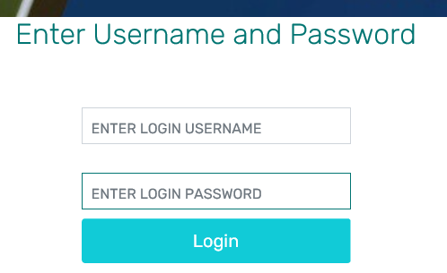

If wrong login is used, error will appear:

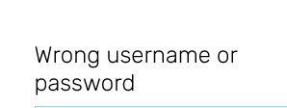

If correct login is used, user will be sent to the Go Test Assessments page (use “guest” password “123”)

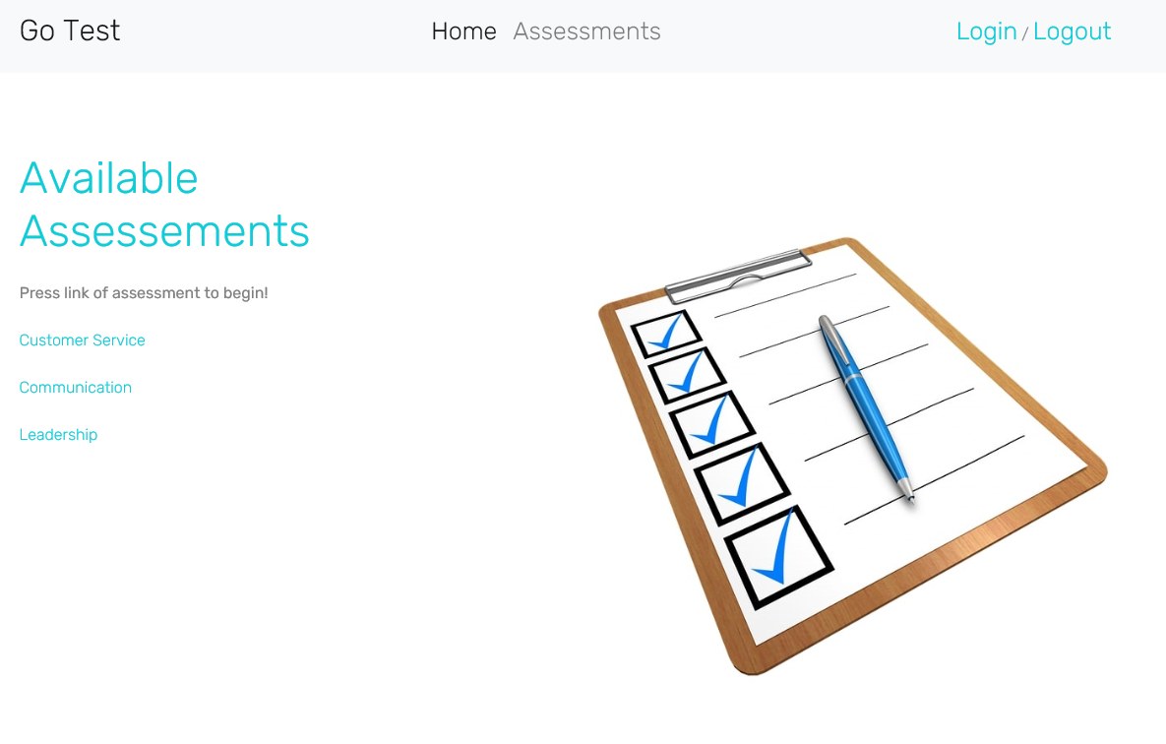

# Registration | Setup a username and password

Register.html file: New users can create a username and password through this page.

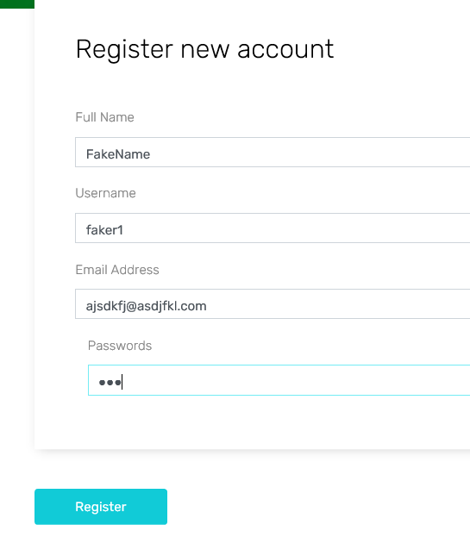

Any required fields missing will show an error:

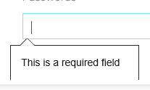

Press the registration button and a confirmation page will appear if username creation is successful:

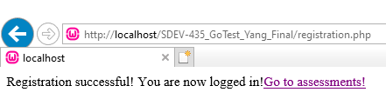

Press the Go to Assessments link to see available asessments

# Assessments | How to access Assessments

On the assessments page, choose a link to take a quiz:

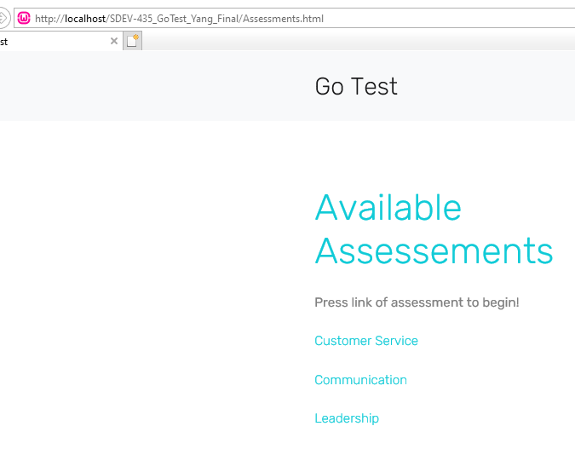

Enter First Name, Last Name and email and press the “Start Assessment” button to proceed:

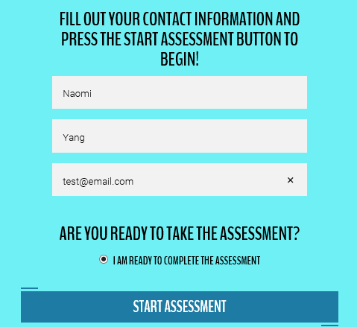

Assessment has 10 questions and will show your progress:

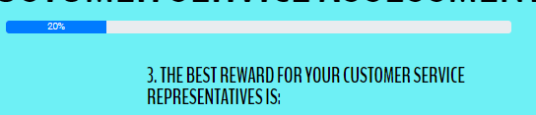

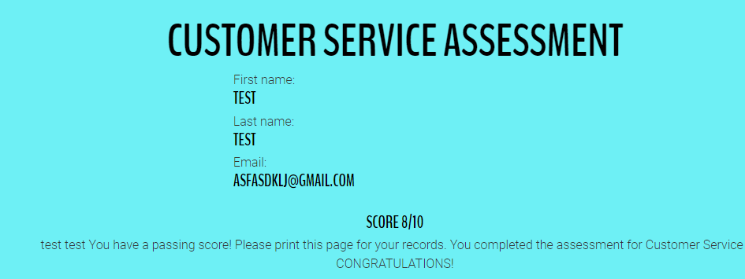

If you fail, following message will appear:

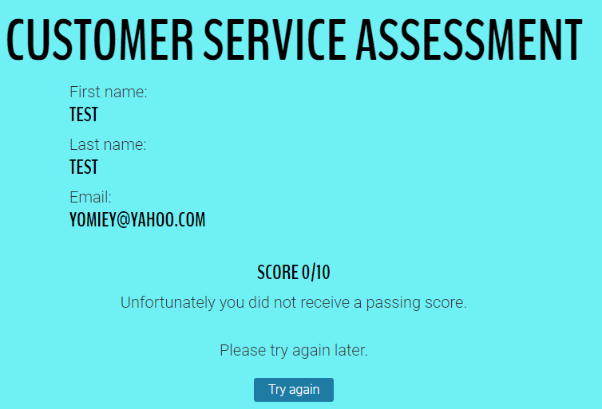

# Logout| Logout and go to login

After logging in, you should see a Logout link at the top right. Once pressed, page will exit and confirmation page will appear.

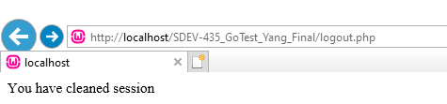

User will then be forwarded to login page

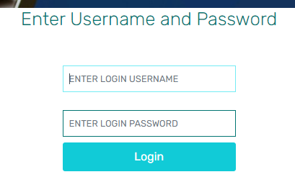

# Suspendisse Ipsum

# System Architecture

There are several elements that are linked with the student profile. This allows the profile to show historical information and differentiate one learner from another. The only list that may contain external data would be the question and answer list that will be maintained. There will not be a separate module or page to upload questions, instead it will be added to a javascript file. The login and username will be maintained on a Wampserver PHP mysql table.

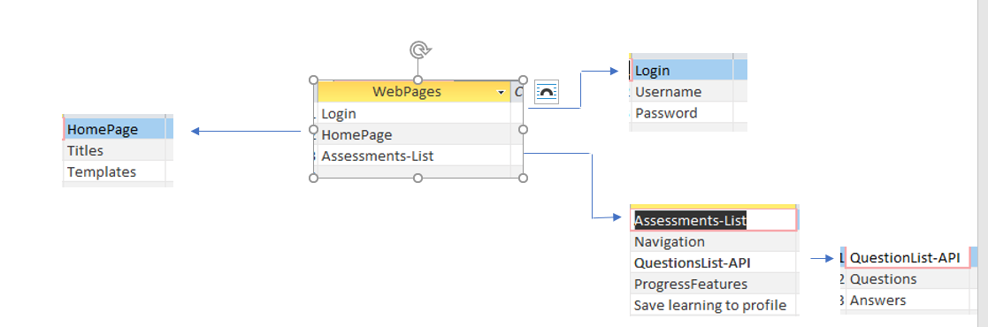

## Source Code Structure

Source code structure introduction. The following is a summary of the source code directories and their contents:

|  |  |
| --- | --- |
| **Code Directory** | |
| **Directory** | **Usage** |
| GoTest (main) | Contains the html and php files used to execute the application |
| Css | Contains the cascading style sheets used for the site and the assessments |
| Images | Contains the images that are displayed throughout the website |
| js | Contains the javascript files mainly used for the assessments question/answers. Also used for some of the effects that are made on the website |
| *Highlighted rows indicate directories containing source code. (they all contain source code)* | |

# Executables

The development tools that will be used to build this E-learning platform will include the include the IDE Visual Studio Code. A text editor that may also be utilized is Sublime Text. The languages that will be utilized are html, CSS and javascript. The data for the quizzes will be stored through a directory of an application programming interface (API). The registration portion requires wampserver or php local server to operate correctly. If there are any built-in maintenance features in the project, describe them here and elaborate on their usage. For example, if there will be a built-in feature so users can change their password that should be documented here along with any other built-in maintenance functions in the system.

### EXE Short Name (EXEFileName.exe)

Description of the EXE and its usage in the project.

### EXE Short Name (EXEFileName.exe)

Description of the EXE and its usage in the project.

# Code Architecture

## Database or Data Store for registration username/login

Introduction to the database or data store.

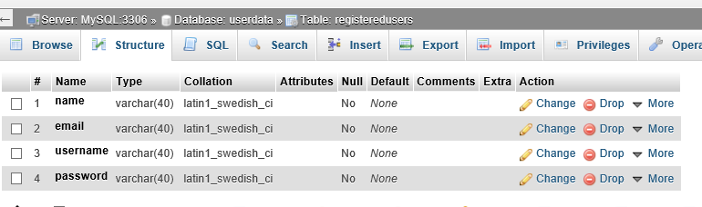

Additional information about the database design should go here.

## Views, Stored Procedures and User Defined Functions

If views, stored procedures and/or user defined functions are used they should be described here.

The Register.html file has a form that allows the user to enter custom data. Once the ‘Register’ button is pressed, the action is to post it against the localhost phpadmin table.

The assessments are currently all separate and are activated with the javascript and html commands.

External Files & Data

If any external files are used and/or if information is stored in the Registry, that information should be documented here. If this information needs security of some type that should be documented here as well. Be sure to address WHAT security steps have been taken if they are required.

The external files that are required to execute this program would be a local host with php admin. I used WampServer to store my login data. No other data was external unless referenced by a url link.

Database is called “userdata”

Table is called “registeredusers”



Programming Language | html/css/javascript/php

The website was primarily built with html and css. Html was used to format the display of the web pages and css set the layout and text formatting. Html also provided the navigation links to the users.

Javascript was used for more complex features that included the assessments. There were questions, answers, and progress bar built into the assessments with javascript.

Php was primarily used for the registration capability of the website. Php is a hypertset processer that allows more dynamic content and to store databases of information. For example, the database needed to be connected to the php file to allow the storage of the username registration:

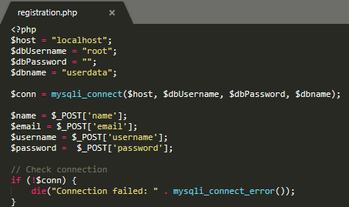

Project Classes

Classes within the project are used to abstract re-usable pieces of code. Classes are also used to group related values, known as properties. The project utilizes these classes:

### block | block-8.cls

Used to align information on the website and allows bullets to appear and hide when selections were made

### Site-hero| site-hero.overlay

Was primarily used for buttons, and separating data or the overlay of some pictures.

### header| header.nav

Associated with a lot of the navigation selection to be used for the website. It allowed information to hover, show, be hidden and specific position depending on the header selection

Project Modules

Modules are used for procedural based code that does not require state data like class modules do. Complete the introduction to modules.

### Short Module Description | ModuleFileName.cls

Class description here.

### Short Module2 Description | ModuleFileName2.cls

Class description here.

### Short Module3 Description | ModuleFileName3.cls

Class description here.

Program Start and End Flow

Describe and then diagram the program flow. Here is an example of program flow from a fat-client based PC application.

START

Login2.php

New user?

NO

YES

Register as new user

Login

Assessments

Summary

The system documentation includes the different file types:

.js

.php

.html

.css

.jpg

The github depository files are available here:

[**https://github.com/naomiprojects/GoTest2**](https://github.com/naomiprojects/GoTest2)

# APPENDIX B (BUILD AND RELEASE PROCESS)

Describe the build & release process required to implement an update.

# APPENDIX C (CLIENT INSTALLATION INSTRUCTIONS)

To edit and run the application, you may use any web browser and text editor. I used Sublime to edit my text.

# APPENDIX D (DEVELOPER SETUP INSTRUCTIONS)

Download the files from Github repository.

Must have the following also installed:

* Localhost
* WampServer or PHPAdmin/mySql

1. Put Go Test folder in localhost to test. Must setup PHPAdmin/mysql with the following database and table (must use root/nopassword):
2. Run the following sql script in phpadmin to create the table:

CREATE TABLE IF NOT EXISTS `registeredusers` (

`name` varchar(40) NOT NULL,

`email` varchar(40) NOT NULL,

`username` varchar(40) NOT NULL,

`password` varchar(40) NOT NULL

) ENGINE=MyISAM DEFAULT CHARSET=latin1;

1. Press register and fill out the required field forms. You will be logged in.
2. Go to local host and open file login2.php.
   1. You may use the following information to test
      1. Username: guest
      2. Password: test
3. Go to the Assessments link at the top and choose an assessment to take by clicking the hyperlink of 1 of the 3 available. Follow instructions to complete the assessment.