Weak Prompts:
- Explain Regression
- Help me understand SQL
- Create a dataset

Improved Prompt:
- What is regression in programming? Explain to a beginner. 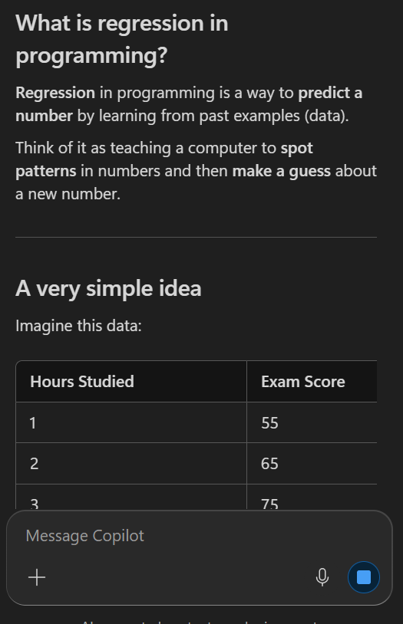
Explanation:
My response is stronger because I added context like “programming” so that AI could be more specific. I also added for a beginner so that it could provide a simple explanation and a simple dataset

Improved Prompt:
- Explain SQL to me as a beginner and provide examples
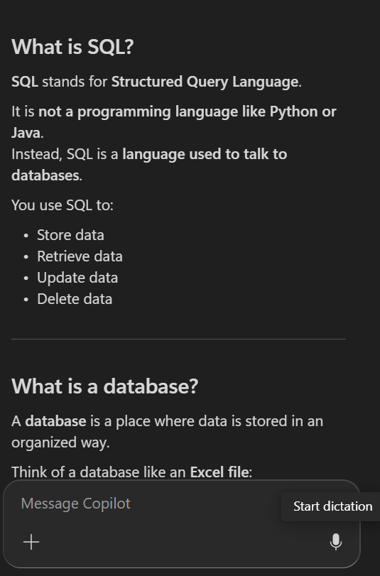
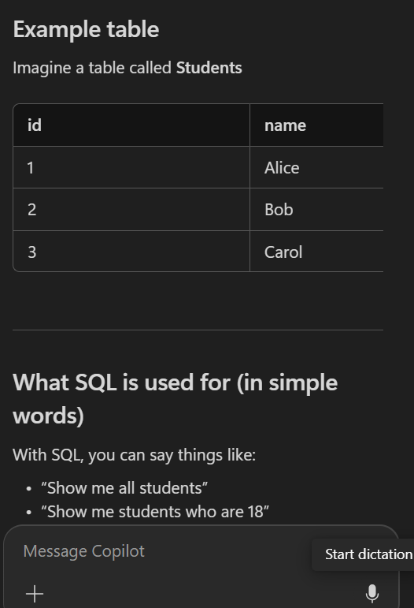
Explanation:
I made sure to add “as a beginner” because I’m inquiring that I don’t know what SQL is, so I want the most digestible version of it and providing examples gives me a visual on datasets that relate to SQL.
Improved Prompt:
Create a data set that can help me understand what a dataset should look like
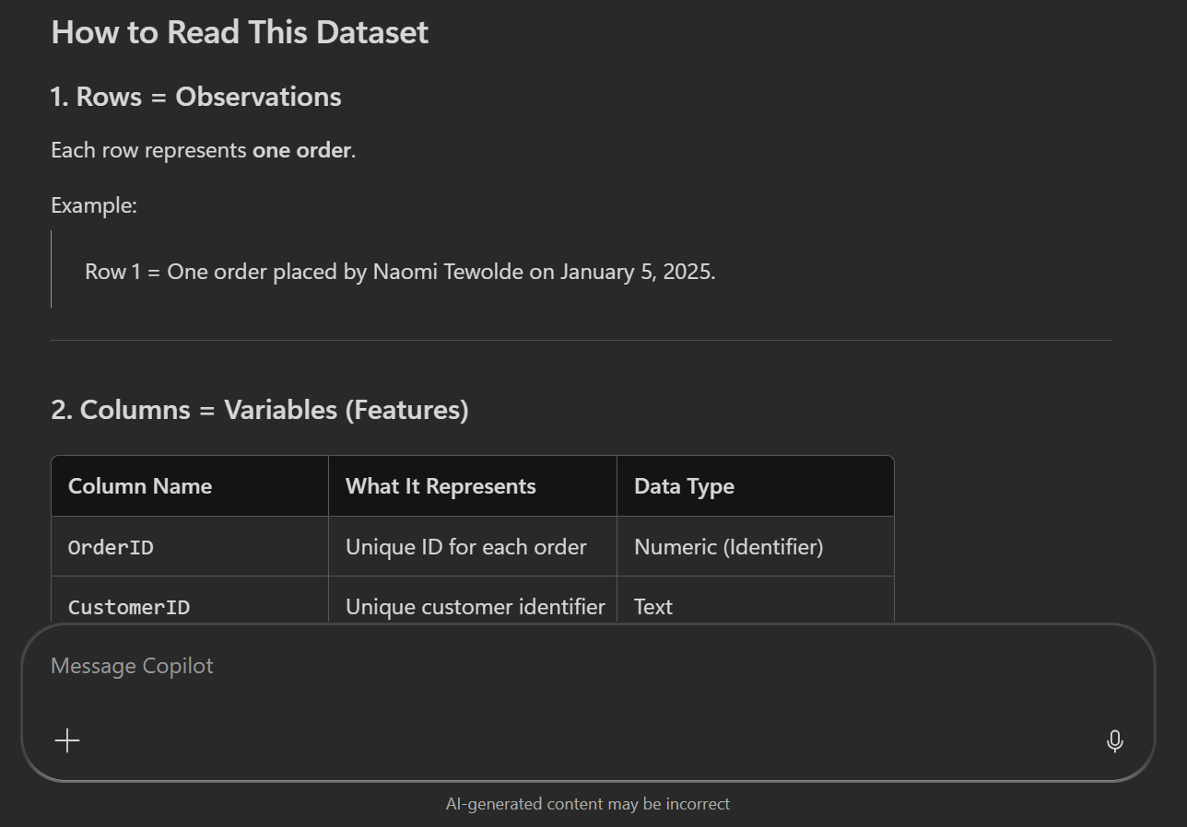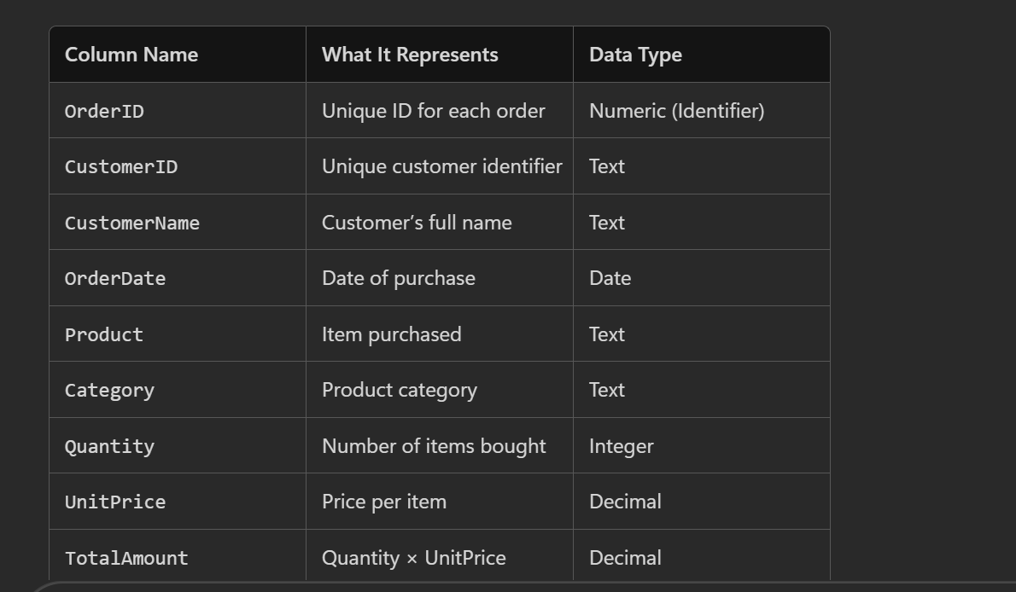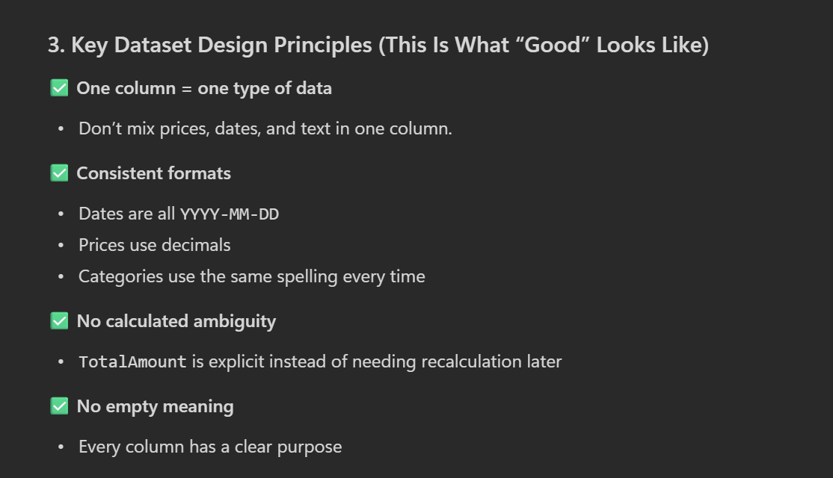Explination:
I made sure to give more specific instruction instead of vaguely asking AI to create a dataset.

