**Human Computer Interaction – 5CS020**

Report on Usability in Web Application

**Full Name:** Naomi Thing

**Student ID:** 2332244

**Group:** L5CG4

**Lecturer:** Mr. Abhishek Sitaula

**Tutor:** Ms. Nerisha Shrestha

1. Link to Prototype

[ComicZone](https://www.figma.com/file/6LL7HHVvQehjfmhSArojVY/CZ?type=design&node-id=5730%3A150&mode=design&t=rSf1wGkQ6MjsfBTW-1)

1. Link to Design Processes
   1. Brainstorming

[Brainstorm_CZ](https://www.figma.com/file/6LL7HHVvQehjfmhSArojVY/CZ?type=design&node-id=5561%3A2&mode=design&t=rSf1wGkQ6MjsfBTW-1)

* 1. User Persona

[UserPersona_CZ](https://www.figma.com/file/6LL7HHVvQehjfmhSArojVY/CZ?type=design&node-id=2%3A6&mode=design&t=rSf1wGkQ6MjsfBTW-1)

* 1. User Stories

[UserStories_CZ](https://www.figma.com/file/6LL7HHVvQehjfmhSArojVY/CZ?type=design&node-id=1502%3A9&mode=design&t=rSf1wGkQ6MjsfBTW-1)

* 1. User Flow and Task Flow

[UserFlow_CZ](https://www.figma.com/file/6LL7HHVvQehjfmhSArojVY/CZ?type=design&node-id=2%3A7&mode=design&t=rSf1wGkQ6MjsfBTW-1)

* 1. Lo-Fi Wireframes

[LO-Fi_WireFrames_CZ](https://www.figma.com/file/6LL7HHVvQehjfmhSArojVY/CZ?type=design&node-id=1515%3A5&mode=design&t=rSf1wGkQ6MjsfBTW-1)

* 1. Wireflow

[Wireflow_CZ](https://www.figma.com/file/6LL7HHVvQehjfmhSArojVY/CZ?type=design&node-id=5742%3A139&mode=design&t=rSf1wGkQ6MjsfBTW-1)

1. Screenshots of Design Processes

3.1 Brainstorming

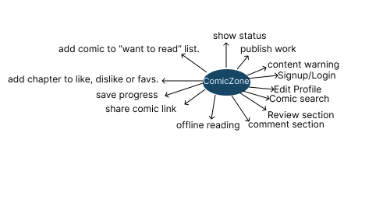

3.2 User Persona

3.3 User Stories

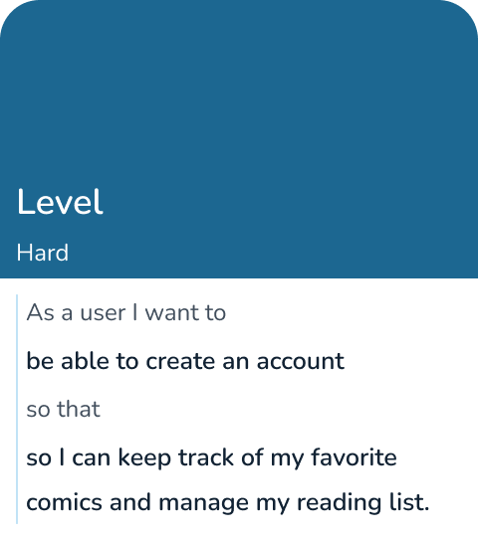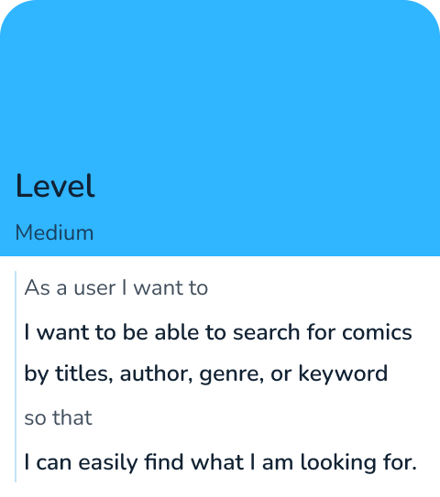7890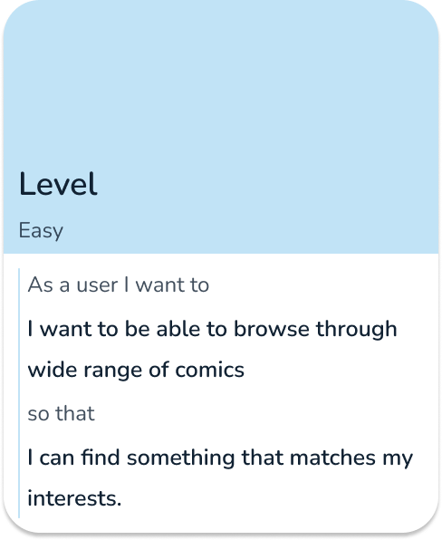

3.4 User Flow and Task Flow

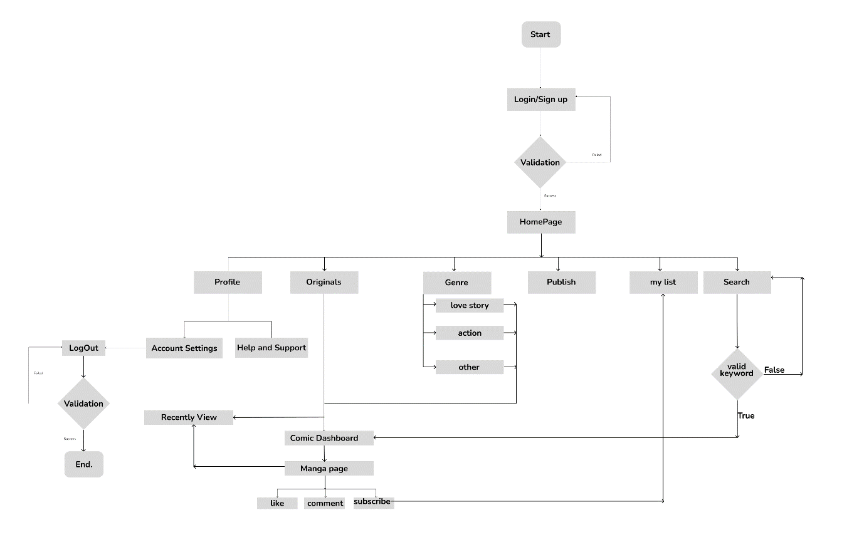

3.5 Lo-Fi Wireframes

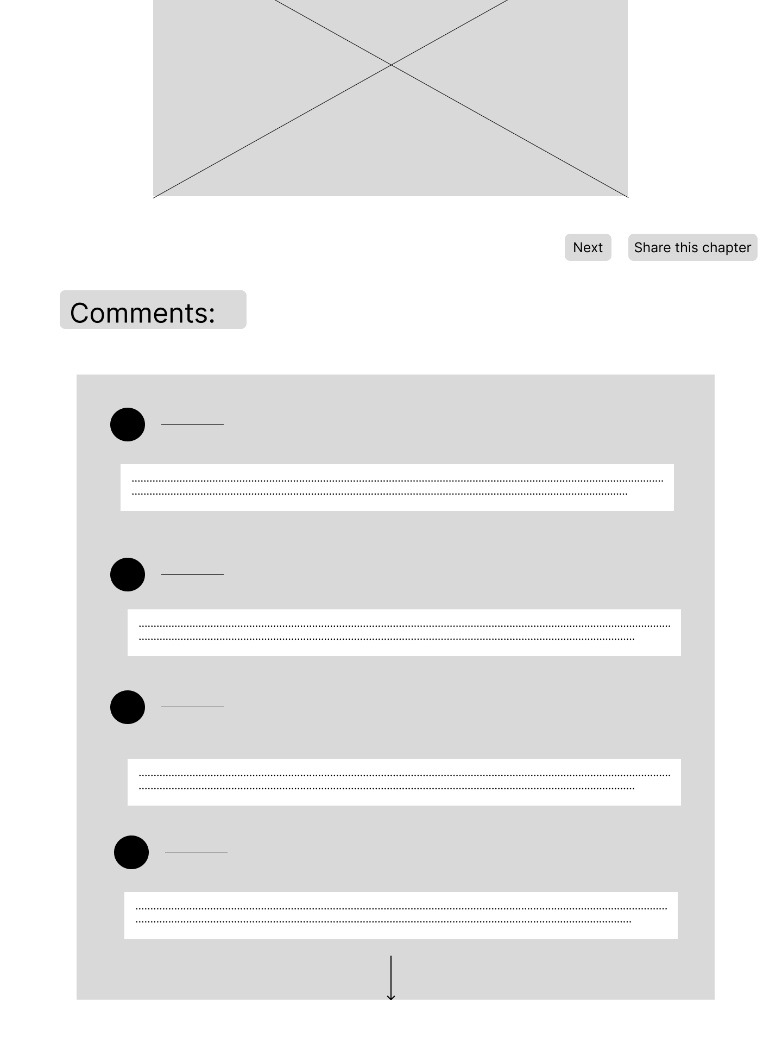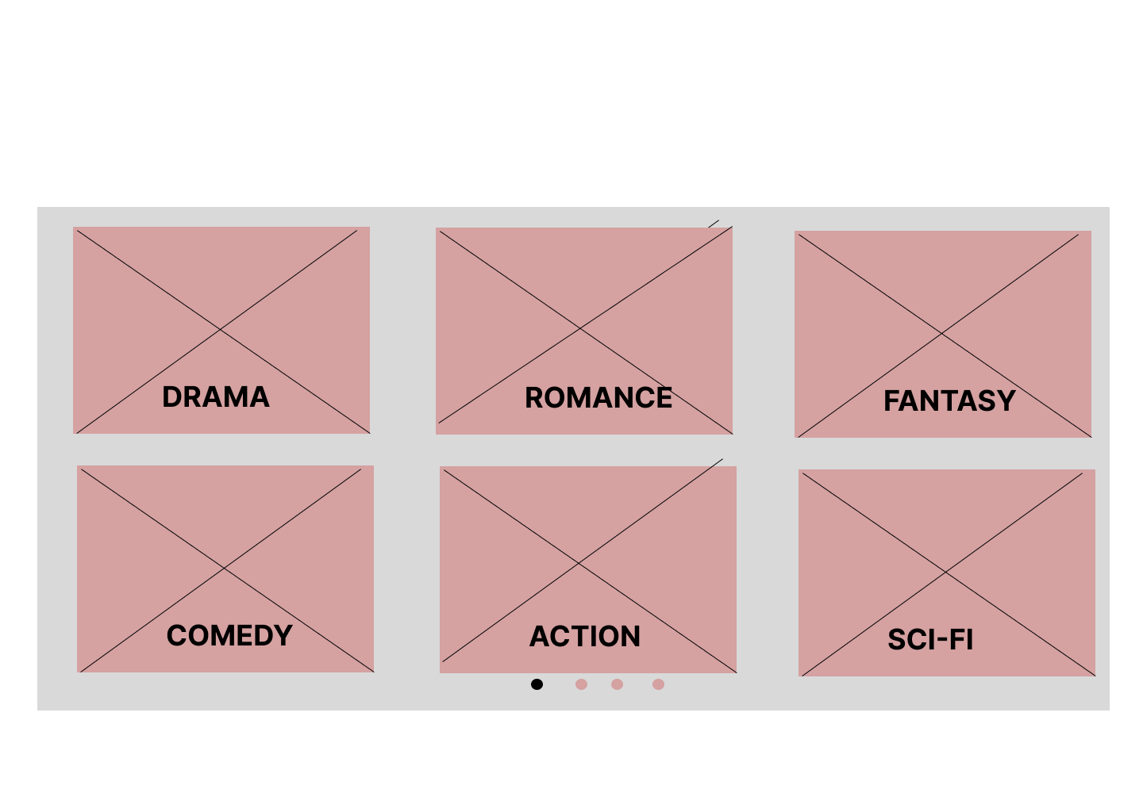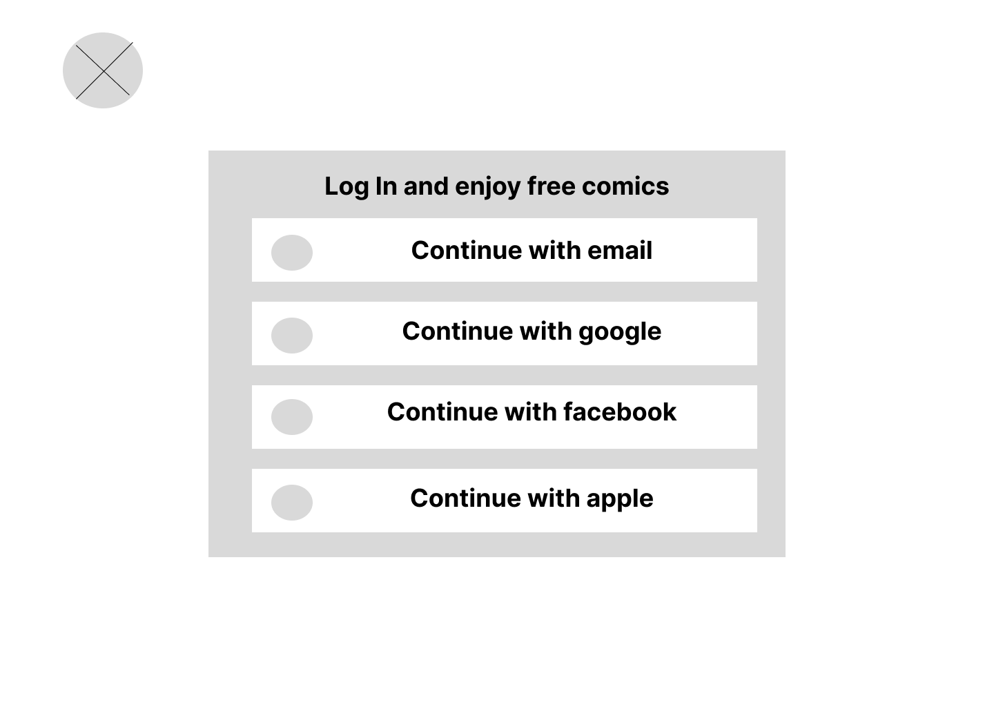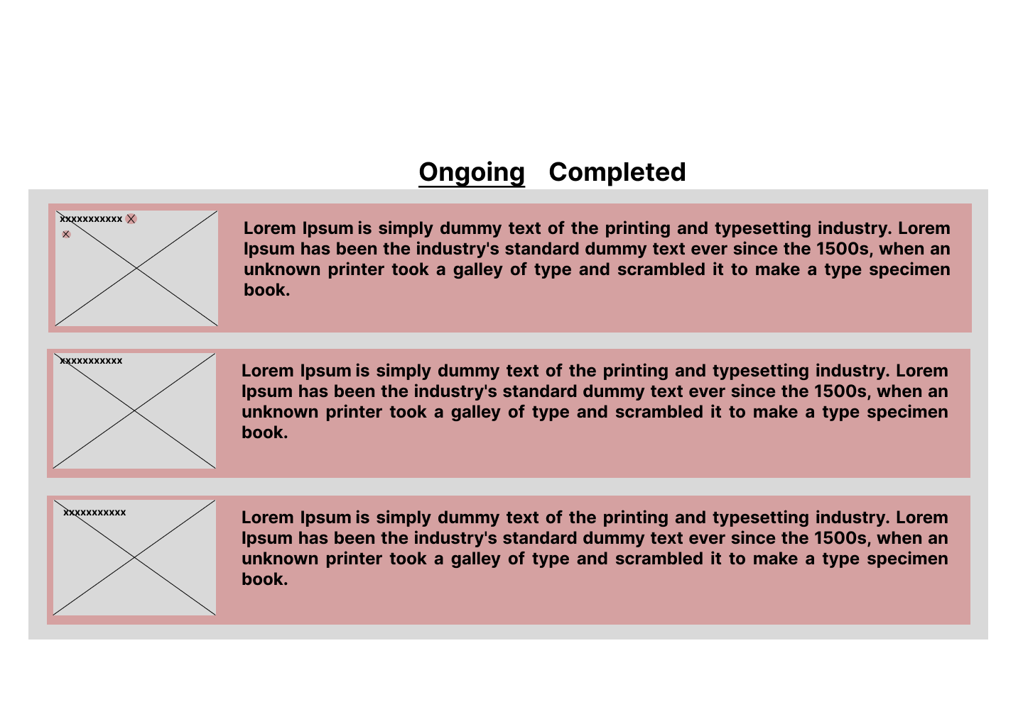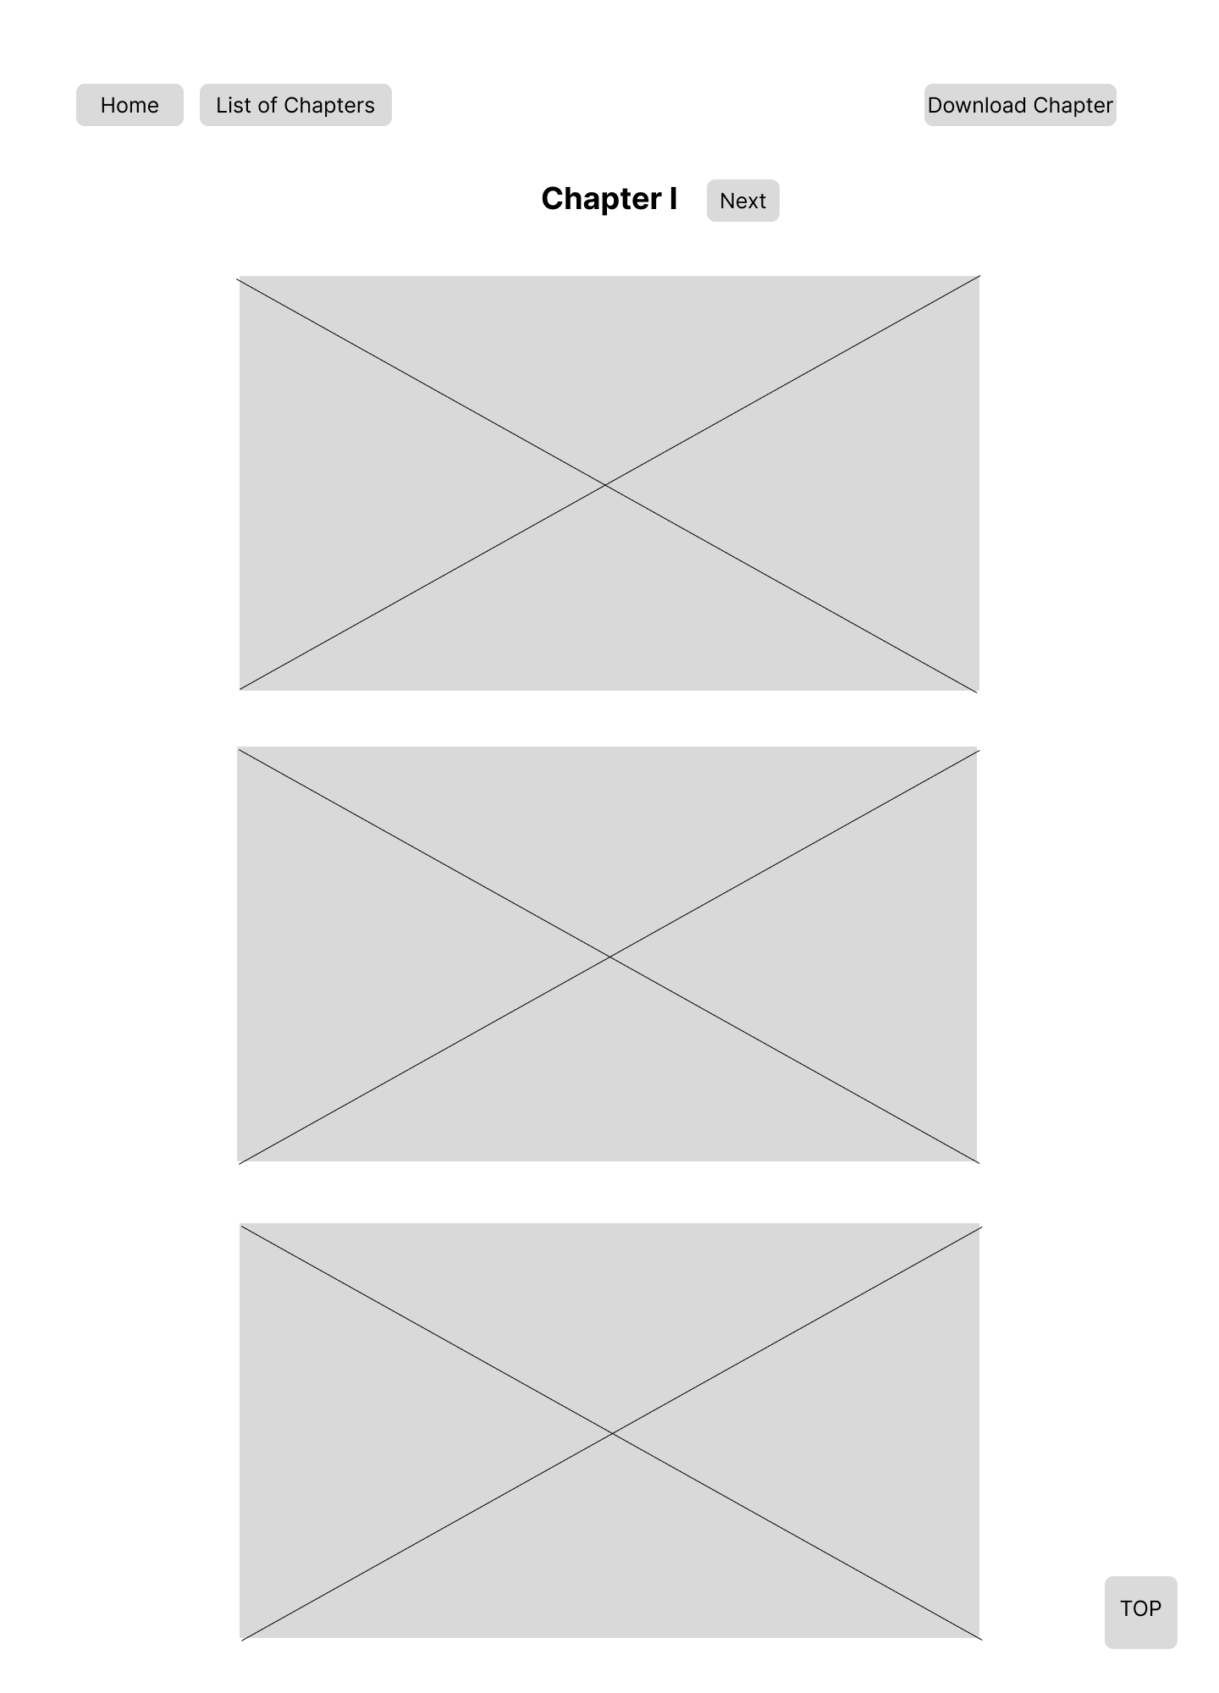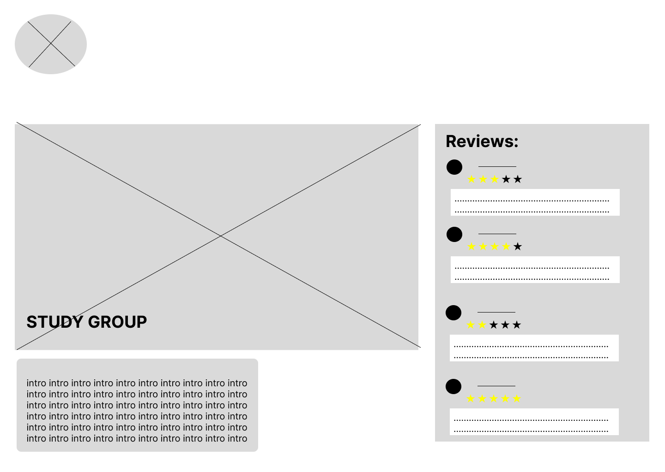

* 1. Wireflow

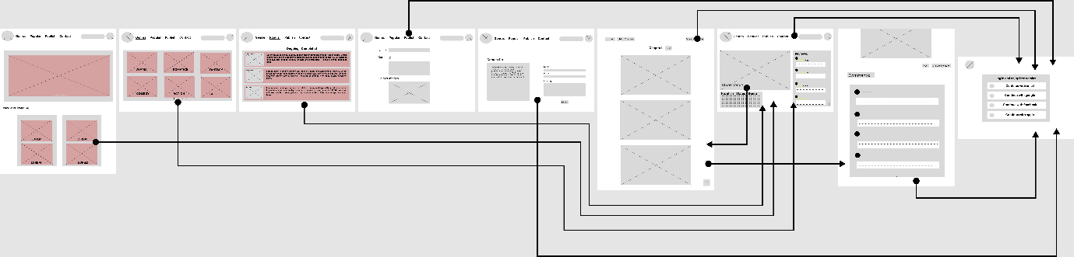

1. Final Prototype

[ComicZone_Desktop](https://www.figma.com/file/6LL7HHVvQehjfmhSArojVY/CZ?type=design&node-id=2%3A19&mode=design&t=rSf1wGkQ6MjsfBTW-1)