



**Academic Skills and Team-based Learning (4CI018)**

**Report Writing (Final Report)**

**Student Id: 2332244**

**Student Name: Naomi Thing**

**Group: L4CG4**

**Lecturer: Mr. Manish Deuja**

**Word Count: 3365**

**Submitted on: 2023/02/12.**

# Acknowledgement

I want to express my gratitude to Wolverhampton university and Herald College Kathmandu for providing me with the fantastic opportunity to finish this coursework. I also want to thank my professors for giving me the information and direction I needed to finish this report. Their priceless insights and motivation were necessary for getting the job done. In addition, I appreciate and thank my classmates for their encouragement and sincere criticism throughout this journey. Their recommendations and insights played a crucial role in figuring out how this report turned out in the end.

Table of Contents

1. Link to Weekly blogs: https://naomi738.wordpress.com .............................................................................................................................. 1
2. Link to Video Statement: https://drive.google.com/file/d/1_FaysPubdfgGBJqx71go77dwDm4InXUA/view?usp=drive_web&authuser=0 . 1
3. Week 8 Report Writing .................................................................................................................................................................................. 1

Acknowledgment ..............................................................................................................................1

* 1. Introduction.................................................................................................................................................... 1
     1. Herald College Kathmandu (HCK) ...................................................................................................................... 1
     2. University of Wolverhampton (WLV)......................................................................................................... 1
     3. Himalayan IT Solutions ........................................................................................................................ 2
  2. Discussion ........................................................................................................................................ 2
     1. Distinctions between Herald College Kathmandu (HCK) and other local colleges in

Nepal................................................................. 2

3.2.2.: In terms of Skill Orientation .............................................................................................................................................................. 3

3.2.3.: In terms of teaching method............................................................................................................................................................. 3

3.2.4.: In terms of Curriculum ...................................................................................................................................................................... 3

3.2.5.: In terms of study Credit-hours .......................................................................................................................................................... 4

3.2.6.: In terms of Internship ....................................................................................................................................................................... 4

3.2.7.: In terms of Communities................................................................................................................................................................... 5

* 1. 8.: In terms of Events and extracurricular activities ............................................................................................................................... 5
  2. Course Structure of IT or computer science in Herald College .......................................................................................................5

Kathmandu (HCK)

* 1. Interrelationship between HCK course and corporate task .................................................................... 9
  2. Conclusion............................................................................................................ 9
  3. Reference .......................................................................................................................................... 10

1. Professionalism Task ................................................................................................................................................................................... 10
   1. Curriculum Vitae............................................................................................................10

........................................................................................................................................................................ 11

* 1. Cover Letter: ................................................................................................................................................... 12
  2. Graduate Form: ......................................................................................................................................................... 14

1. AI Debate: .................................................................................................................................................................................................... 21
2. Professional Organization Report ................................................................................................................................................................ 22

Acknowledgement ..................................................................................................................................................................................... 22

* 1. Introduction ........................................................................................................................................................... 22
     1. Introduction to Professional Organisations......................................................... 22
     2. Introduction to ACM ....................................................................................................................................... 22
  2. Body ................................................................................................................................................................. 23
     1. ACM membership requirements

....................................................................................................................................................... 23

* + 1. Positive Aspects of ACM

.................................................................................................................................................................... 23

* + 1. Adverse Effects of ACM

..................................................................................................................................................................... 24

* 1. Conclusion ...................................................................................................................................... 24
  2. References ........................................................................................................................................................... 24

1. Final Group Presentation Slides ................................................................................................................................................................... 25

**Table of Figures:**

Figure 1: Year 1 course structure .............................................................................. 6

Figure 2: Year 2 course structure .................................................................................... 7

Figure 3: Year 3 course structure ...................................................................................... 8

Figure 4: CV ..................................................................................... 11

Figure 5: graduate form 1 ........................................................................................ 14

Figure 6: graduate form 2 .............................................................................................................15

Figure 7: graduate form 3 ................................................................................................................. 16

Figure 8: graduate form 4 ................................................................................................................. 17

Figure 9: graduate form 5 ................................................................................................................. 18

Figure 10: graduate form 6 ...............................................................................................................20

Figure 11: graduate form 7 ...............................................................................................................20

Figure 12: Logo of ACM ....................................................................................................................23

Figure 13: Slide 1 ..............................................................................................................................25

Figure 14: Slide 2 ...............................................................................................................................26

Figure 15: Slide 3 ...............................................................................................................................26

Figure 16: Slide 4 ...............................................................................................................................27

Figure 17: Slide 5 ...............................................................................................................................27

Figure 18: Slide 6 ...............................................................................................................................28

Figure 19: Slide 7 ...............................................................................................................................28

Figure 20: Slide 8 ...............................................................................................................................29

Figure 21: Slide 9 ...............................................................................................................................29

Figure 22: Slide 10 .............................................................................................................................30

Figure 23: Slide 11 .............................................................................................................................30

Figure 24: Slide 12 .............................................................................................................................31

Figure 25: Slide 13 .............................................................................................................................31

Figure 26: Slide 14 .............................................................................................................................32

Figure 27: Slide 15 .............................................................................................................................32

Figure 28: Slide 16 .............................................................................................................................33

Figure 29: Slide 17 .............................................................................................................................33

1. **Link to Weekly blogs:** [**https://naomi738.wordpress.com**](https://naomi738.wordpress.com/)
2. **Link to Video Statement:**

[**https://drive.google.com/file/d/1_FaysPubdfgGBJqx71go77dwDm4I nXUA/view?usp=drive_web&authuser=0**](https://drive.google.com/file/d/1_FaysPubdfgGBJqx71go77dwDm4InXUA/view?usp=drive_web&authuser=0)

# 3. Week 8 Report Writing

**Acknowledgment**

I owe a huge debt of gratitude to Herald College and Wolverhampton University for giving me the chance to finish this coursework. The study compares the credentials of graduates from the University of Wolverhampton and other Nepali universities, with a focus on the abilities that make Wolverhampton graduates better suited for a particular position at the reputable IT company Himalayan IT Solutions.

## 3.1 Introduction

### 3.1.1 Herald College Kathmandu (HCK)

- Herald College Kathmandu is regarded as one of Nepal's most prestigious private universities. It is well-known for its excellent administrative and training staff. HCK has a long history of educational excellence and is widely regarded as a top choice for students looking for a high-quality education. The university supplies undergraduate and graduate programs in areas such as business, engineering, and computer science. Qualified and experienced instructors instruct this program. Internships and other firsthand learning opportunities are provided by the university in collaboration with several local and international organizations. Herald College Kathmandu provides students with a variety of extracurricular activities and opportunities, such as sports teams, clubs, and libraries, in addition to academic programs. (Herald College Kathmandu, 2023)

### 3.1.2 University of Wolverhampton (WLV)

- The University of Wolverhampton was founded in 1835. The university conducts applied research and collaborated with several regional and national organizations. ITrelated courses are offered for both undergraduate and graduate students in this university. Students can specialize in areas like artificial intelligence, human-computer interaction, or web development. The university also offers research-based programs like MPhil and Ph.D. in Computer Science, allowing students to delve deeper into specific areas of interest in IT. (University of Wolverhampton, 2023)

### 3.1.3 Himalayan IT Solutions

- Himalayan IT Solutions is a Nepal-based IT company that offers a variety of IT services to clients all over the world. Software development, web design and development, and IT consulting are among the services offered by the company. Software development, web design and development, and IT consulting are among the services offered by the company. Himalayan IT Solutions is a skilled and dependable IT company that offers a wide range of high-quality IT services to customers all over the world. The company is well-positioned to aid its clients in achieving their business goals, thanks to a team of experienced IT professionals and a reputation for excellent customer service. (Himalayan IT solution , 2023)

## 3.2. Discussion

### 3.2.1 Distinctions between Herald College Kathmandu (HCK) and other local colleges in Nepal

- There are many distinctions between HCK and local Nepalese colleges. One of the most notable distinctions is that Kathmandu Herald College is internationally affiliated, while many of Nepal's local universities are not. This distinction is significant because universities and employers accept Herald College Kathmandu’s diplomas and transcripts all over the world, while local universities in Nepal may have difficulty recognizing students' diplomas outside of Nepal. This contrast is significant because it implies that Herald College Kathmandu can provide a more diverse and rich educational experience, allowing students to interact with people from various backgrounds and cultures. Few other differences varying on different terms are explained below:

### 3.2.2.: In terms of Skill Orientation

* The graduates of Herald College Kathmandu are well-known for their engineering and management abilities. They supply a wide range of courses in computer science, electronics, civil engineering, and business administration, among other things. Herald College Kathmandu is well-known for supplying a solid foundation in fundamental computer science concepts such as programming, data structures, algorithms, and databases. Specialized courses in software engineering, network engineering, and cybersecurity are also provided by HCK.
* Local Nepalese universities, on the other hand, may have less developed IT departments and a lesser emphasis on providing students with direct experience through internships and projects.

### 3.2.3.: In terms of teaching method

* HCK's teaching combines traditional classroom lectures with interactive learning methods such as group work, problem-based learning, and direct projects. Innovative teaching aids such as multimedia and digital tools, as well as interactive whiteboards are used to enhance the learning experience.
* Local universities in Nepal, on the other hand, uses a more traditional teaching method, with an emphasis on classroom lectures and rote memorization. These universities do not have the same resources and ability as Herald College Kathmandu, and they do not provide opportunities for firsthand learning and interaction with industry experts.

### 3.2.4.: In terms of Curriculum

* The syllabus is regularly updated to keep you up to date on the latest trends and technologies in the field. In addition to the curriculum, Herald College Kathmandu provides students with the opportunity to gain practical experience through internships and projects, allowing them to develop their skills and prepare for the job market. The university is connected to the IT industry and receives regular visits from IT professionals seeking industry insights. When compared to Nepalese universities, Herald College Kathmandu has an advantage in terms of competency orientation in the IT sector.
* On the other hand, local Nepalese colleges have less modernized curricula, less industry exposure, or underdeveloped facilities than Herald College. Curriculum may be out of date and out of step with industry demands.

### 3.2.5.: In terms of study Credit-hours

* The IT department at Herald College Kathmandu complies to the semester and credit hours systems popular in United Kingdom.
* While the local colleges in Nepal, imposes completely different credit hour requirements on their IT programs, and their curricula and facilities are not as up to date and tailored to industry needs as Herald College.

### 3.2.6.: In terms of Internship

* Herald College Kathmandu is known for its IT faculty internships, which allow students to gain direct experience through internships and projects. This assists students in honing their skills and preparing for the job market. Many HCK graduates are hired by the companies where they did their interns.
* When compared to Nepalese universities, internship availability may vary. Some local universities provide students with direct experience through internships and projects, but their resources, facilities, and industry connections may not be as developed as Herald College Kathmandu. There is one. Some local universities have few industry connections or do not have a dedicated career development department to help with internships.

### 3.2.7.: In terms of Communities

- Herald College Kathmandu outperforms Nepal's local colleges. The university has a vibrant student community, with several student-run clubs and organizations focusing on various areas of computer science and information technology. These clubs and organizations provide students with opportunities to develop skills, network with peers, and connect with industry professionals. Many of these clubs’ host events and workshops that help to supply added knowledge and learning opportunities. Some of the communities in HCK are: Ethical HCK, UI-vision, Idea City, and many more. - While in the local colleges in Nepal have fewer student-run computer science and information technology clubs and organizations, giving students fewer opportunities to network with peers and connect with industry professionals.

### 3.2.8.: In terms of Events and extracurricular activities

* Herald College Kathmandu has an upper hand over other Nepalese college. Workshops, seminars, hackathons, and other competitions are held on a regular basis at the university as extracurricular activities. These events allow students to learn new skills, network with peers and industry professionals, and display their abilities. In addition, the university hosts regular guest lectures, industry visits, and collaborations with a variety of IT firms.
* Events and extracurricular activities are infrequent or inconsistent. There may not be lots of opportunities for students to take part in extracurricular activities and events at rural colleges in Nepal, or they may not be organized on a regular basis.

# 3.3. Course Structure of IT or computer science in Herald College Kathmandu (HCK)

3.3.1.:

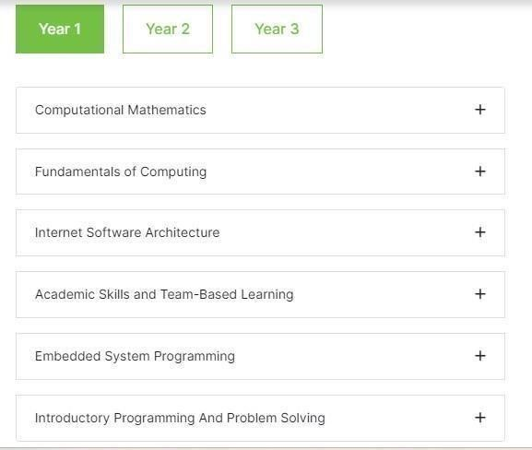

*Figure 1: Year 1 course structure*

3.3.2.:

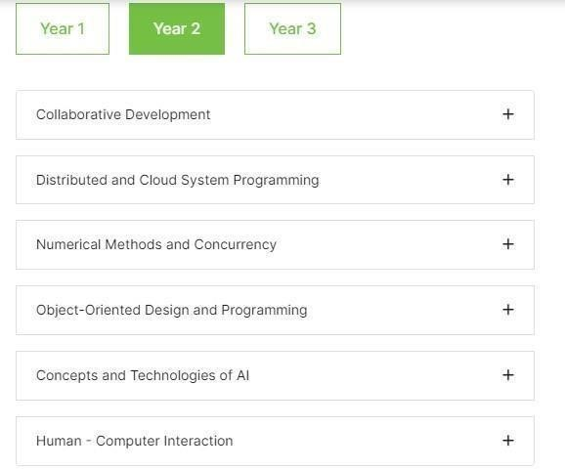

*Figure 2: Year 2 course structure*

3.3.3.:

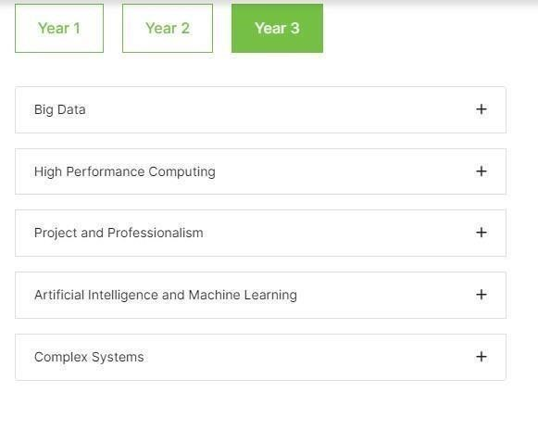

*Figure 3: Year 3 course structure*

## 3.4. Review on Himalayan IT solutions company

- Himalaya IT Solutions Company employs a team of skilled and knowledgeable IT professionals who specialize in software development, web design and development, and IT consulting. Custom software solutions for platforms such as Windows, Linux, and macOS, as well as database integration, are among the company's software development services. The web design and development services for the company include developing responsive and user-friendly websites with a variety of web technologies. This company has experience with popular content management systems such as WordPress and Joomla, as well as ability in developing his websites using technologies such as HTML, CSS, JavaScript, PHP, Python, SQL, and C#. Other IT services offered by this company include digital marketing, mobile app development, cloud computing, and IT support. They have a team of highly skilled and experienced IT professionals who can deliver quality solutions to meet the business needs of our clients.

## 3.5. Interrelationship between HCK course and corporate task

- Herald College Kathmandu's Software Engineering and Web Development course equips students with the skills and knowledge needed to develop and support software systems and websites, which is a necessary task in many corporate settings. Similarly, network engineering and cybersecurity courses teach students the skills and knowledge needed to design, implement, and secure network systems, which is an important task in today's corporate environment. The college is also linked to some IT industry, and IT professionals pay regular visits to gain industry insights. This allows students to better their understanding current industry trends and needs and tailor their education accordingly.

## 3.6. Conclusion

- To sum up everything that has been said, we encourage organizations to adopt computer science courses graduated from Herald College Kathmandu by understanding the business needs of companies as well as the skills and competencies of computer science course graduates. Their technical and applicable skills are best suited to support the company's future business goals and are more likely to have a significant impact on their role as a graduate program participant.

## 3.7. Reference

Herald College Kathmandu, 2023. *Herald College Kathmandu.* [Online] Available at: https://heraldcollege.edu.np/ [Accessed Thursday January 2023].

Himalayan IT solution , 2023. *Himalayan IT solution.* [Online] Available at: http://himalayanit.com.np/ [Accessed Thursday January 2023].

University of Wolverhampton, 2023. *University of Wolverhampton.* [Online] Available at: https://www.wlv.ac.uk/ [Accessed Thursday January 2023].

# 4. Professionalism Task

## 4.1 Curriculum Vitae

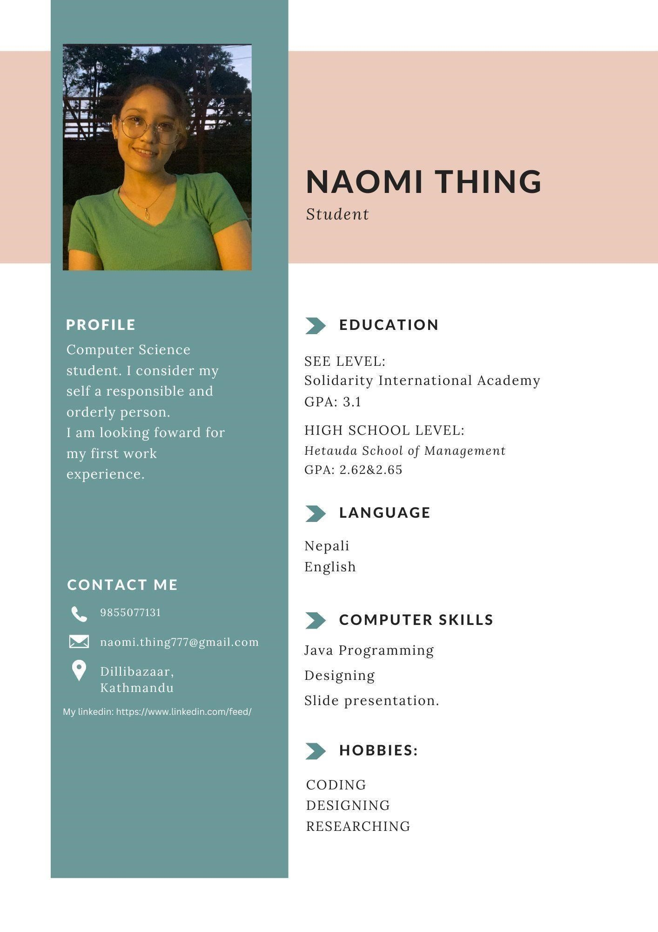

*Figure 4: CV*

**4.2 Cover Letter:**

**NAOMI THING**

:naomi.thing777@gmail.com : +977-9855077131 : Dili bazaar, Kathmandu 28th December 2022

Mr. Rubin Baraily

Himalayan JAVA Coffee

Kosi Zone, Nepal info@himalyanjava.com Dear Mr. Rubin Baraily

I am writing to Himalayan JAVA coffee to let them know how interested I am in the barista employment. I am confident in my ability to provide value to your staff as a highly skilled and customer-focused individual with knowledge in the industry of food and beverages.

I had working experience as a barista at my earlier workplace which was “Grace Cafe” in Hetauda, where I got the necessity of supplying good customer service and keeping the workplace tidy and organized. In this position, I was in charge of making a range of hot and cold beverages, serving them to customers, and responding to their inquiries. Thanks to my ability to multitask and perform well under pressure, I have been successful in challenging environments like packed coffee shops. I have a desire for studying new brewing methods and coffee bean varieties, and I am an expert at using commercial coffee equipment. My high diligence and knowledge of inventory management have enabled me to precisely track and replenish supplies. I am interested in your company because I discovered that you supplied the best knowledge to the workers in your working place.

I am thrilled about the chance to join the team at Himalayan JAVA coffee and supply my ability to contribute to the success of a satisfying and memorable client experience. I would appreciate it if you would look at my application. I am eager for the chance to talk to you in more depth about my qualifications. If I am suited to be the barista you are searching for, please contact me via my phone number or my given email address.

**Sincerely,**

Naomi Thing

**4.3 Graduate Form:**



*Figure 5: graduate form 1*

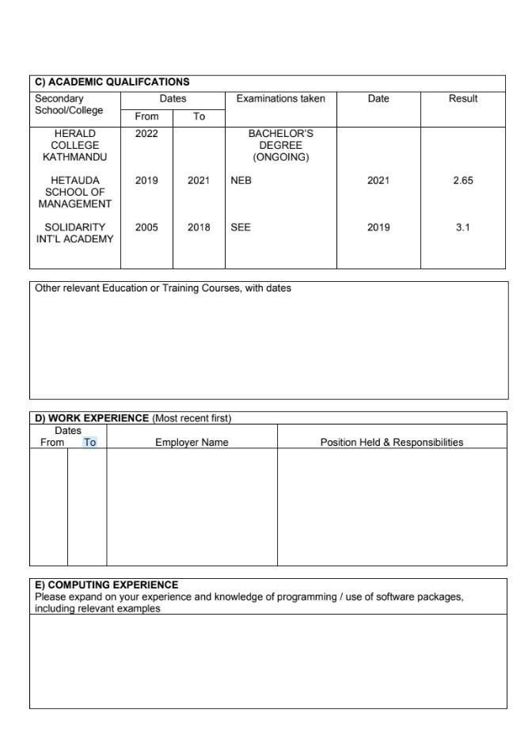

*Figure 6: graduate form 2*

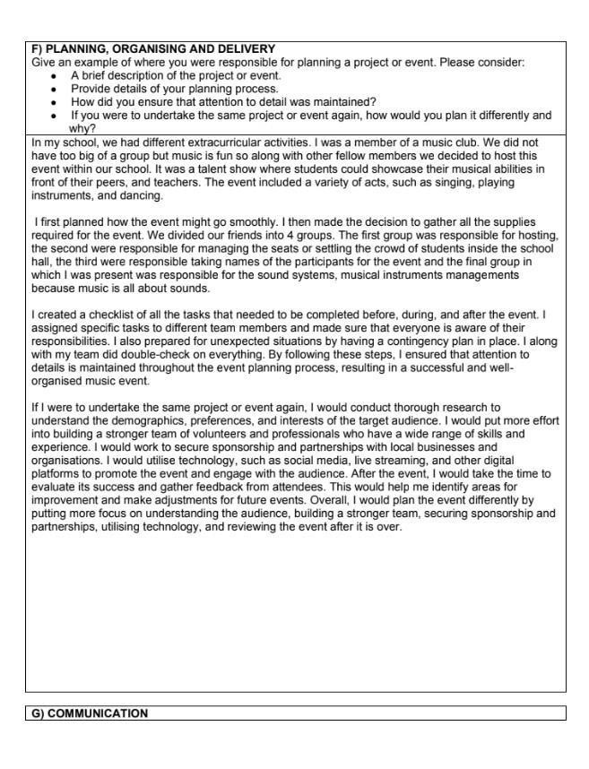

*Figure 7: graduate form 3*

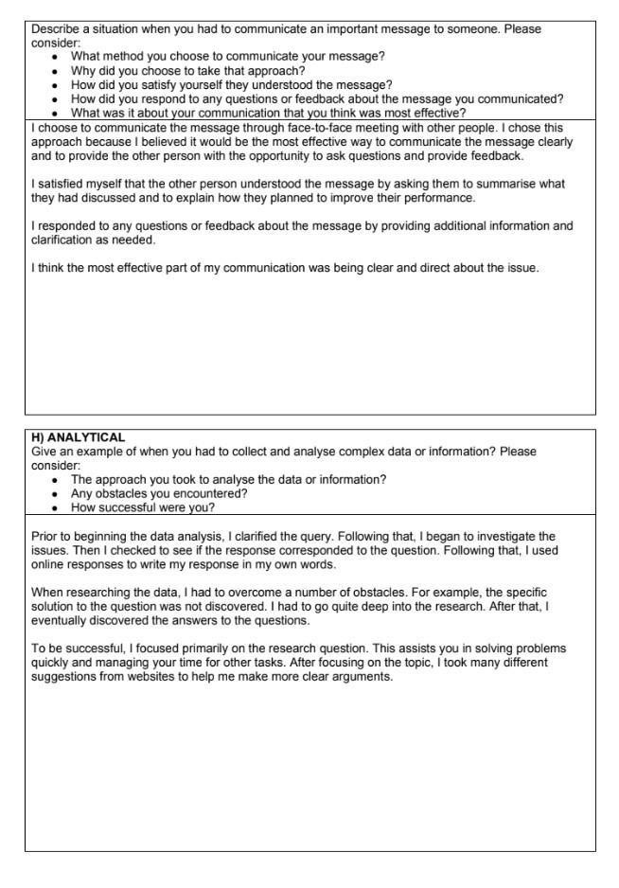

*Figure 8: graduate form 4*

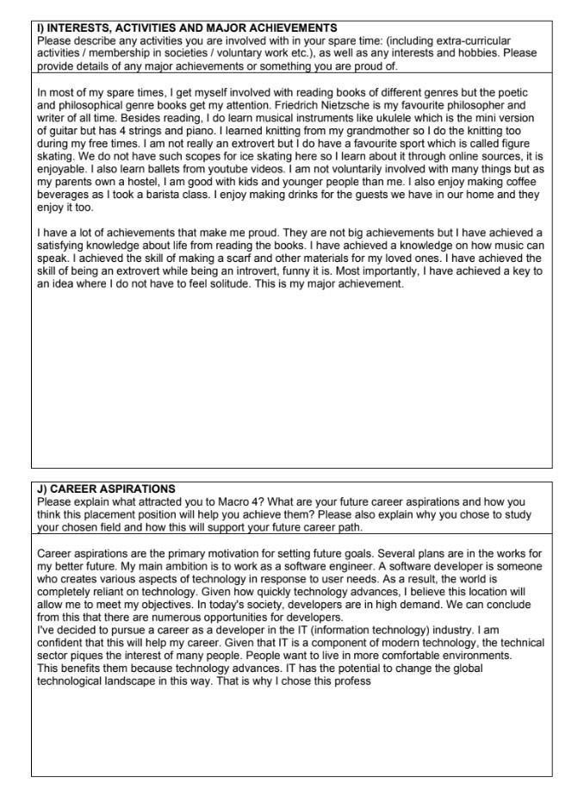

*Figure 9: graduate form 5*



*Figure 10: graduate form 6*

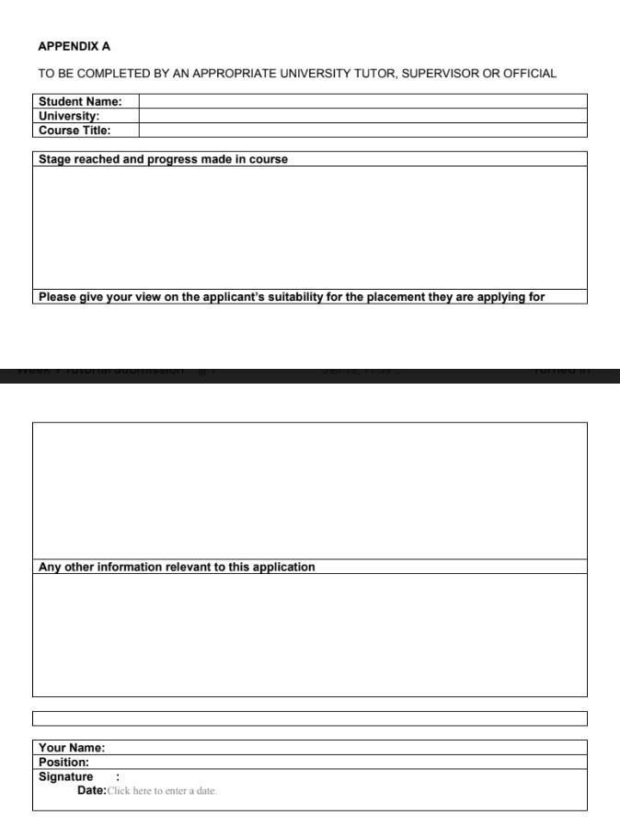

*Figure 11: graduate form 7*

**5. AI Debate:**

**Debate on why AI is dangerous for human beings.**

= Talking about AI, it stands for Artificial Intelligence. AI is a branch of computer science concerned with development of intelligent machines that work and react in the same way that humans do. It is something that is smartest than all other humans in the existence. Artificial Intelligence is does have numbers of advantages but as the dark sides exists within the good, AI also has its disadvantages which could be risky for human race.

The debate over the dangers of AI is multifaced, with concerns raised about AI’s potential to become more intelligent than humans, resulting in a loss of control over technology. Let us start with an example of case of disaster. For example, if a fire breaks out in the building, the humans can use fire extinguisher or fire exit. Even a child runs because humans have instinct, or consciousness, but it is different for AI, it might get destroyed. Suppose if an AI is not familiar with the fire breakout case, they wouldn’t know what to do and might get destroyed as it is built to perform what it told to do. This leads to the cost and expenses of AI as well. It is true that an AI is expensive, but it is told that no lunch is free. AI needs a significant first investment which causes the companies to invest in AI frameworks, including cutting-edge hardware and software. Besides, compared to human brains AI is not creative. AI makes human lazy because humans depend on AI of how it can perform everything. AI also has a pessimist impact on employment. Traditional jobs will certainly be replaced by AI in the future, resulting in the unemployment of those who perform them.

Thus, this is how I would like to conclude why is dangerous for human beings.

# 6. Professional Organization Report

## Acknowledgement

I would like to start by expressing my sincere gratitude to the ACM group for providing me with the wealth of knowledge and tools that were essential to the completion of this report. They have been an inspiration to me because they are committed to advancing technology so that humanity can benefit. Additionally, I would like to express my gratitude to my professors at the University of Wolverhampton and Herald College Kathmandu for their support, advice, and aid with this project. Their helpful criticism and motivation have been crucial in deciding how this report will turn out.

## 6.1 Introduction

### 6.1.1 Introduction to Professional Organisations

A group of people who have been brought together because they share a professional or industry interest is understood as a professional organisation. These groups associations provide their representatives with a range of advantages, including networking possibilities, opportunities for professional growth, access to resources and information related to the industry, and advocacy for the interests of the latter. A few examples of professional associations include the Association for Computing Machinery (ACM), British Computer Society (BCS), the Institution of Engineering and Technology (IET), and Guide Share Europe (GSE). (journals, 2023)

### 6.1.2 Introduction to ACM

ACM standing for Association for Computing Machinery is a global organisation whose goals include advancing computing and encouraging the use of technology for societal good. With more than 100,00 members from more than 190 countries, Association for

Computing Machinery is one of the world’s largest computer societies and was founded in 1947. Association for Computing Machinery was founded with the goals of advancing computing as a science and a profession, encouraging the free exchange of ideas, and giving its members access to professional and educational opportunities.

The individuals of ACM receive a range of benefits, such as discounted conference registration, access to digital libraries, opportunities for professional development, and the chance to network with other IT experts and stay current on industry news. (ACM Hsitory Committee, 2023)

 *Figure 12: Logo of ACM*

## 6.2 Body

### 6.2.1 ACM membership requirements

It is necessary to set criteria for the membership to uphold high standards of quality, to set up and advance the profession, to enhance moral conduct, to encourage community and cooperation, and to offer resources and advantages. Being one of the well-known organisations worldwide, Association for Computing Machinery (ACM) has its own membership requirements. It requires that one must a hold a position of authority in the field of computing or a closely related discipline in order to join. An individual must comply to adhere by the ACM code of Professional Conduct and Ethics which establishes moral guidelines for those working in the computer industry. Association for Computing Machinery also requires payment of an annual membership fee in order to become a member. The cost varies by location and enrollment category (-for example, student, regular, senior, etc.). The eligibility requirements and benefits for the various membership categories offered by ACM (such as scholar, regular, and senior) vary. Organisations can also become members of ACM through this category. (ACM Hsitory Committee, 2023)

### 6.2.2 Positive Aspects of ACM

The Association for Computing Machinery (ACM) offers its associates with a wealth of tools and chances for career advancement. The organization’s members have exposure to the most recent advances in computing and cutting-edge research through its alternative learning programs and assets. Additionally, ACM appears to offer its members the chance to network with other professionals to form connections and work together on projects. Members can also attend ACM-hosted conferences and events and have entry to sizable library of resources on computers. ACM also offers the members the chance to be acknowledged for their contributions to the field and by their peers through its awards and recognition program. ACM is an affordably priced and helpful source of information for computer professionals because it also offers discounts on a wide range of goods and services. (acm, 2023)

### 6.2.3 Adverse Effects of ACM

Participation in the Association for Computing Machinery (ACM) does have some drawbacks, just like any other organisations. The membership fee might be a disadvantage because some people think it is too expensive. Additionally, not all the participants may be proper or beneficial for using the tools and opportunities provided by ACM and some members might believe they are not receiving their membership’s full benefits. Additionally, there might be some restrictions on the support and direction provided to members, particularly those who are just beginning their careers in computing. Finally, some members might think that ACM’s emphasis is too constrained or specialized and not in line with their interests and goals. These disadvantages, however, differ from person to person based on their unique needs and circumstances. (IvyPanda, 2022)

## 6.3 Conclusion

In proper conclusion, the Association for Computing Machinery (ACM) is an association of professionals in the fields of computing and related fields. Among the many advantages provided by ACM to its members are opportunities for professional growth, access to research and publications, networking opportunities, and reward schemes. ACM continues to be a helpful resource for computing professionals and is widely regarded as a leader in the field despite some potential drawbacks, such as the cost of membership or a lack of relevance for some members. ACM offers their personnel a wealth of tools and resources to support them in their professional endeavors, whether through its educational initiatives, networking possibilities, or emphasis on the advancement of the computing profession.

## 6.4 References

ACM Hsitory Committee, 2023. *acm.* [Online] Available at:

https://www.acm.org/aboutacm/acmhistory#:~:text=Introduction,and%20address%20the%20fi eld's %20challenges. [Accessed 03 Februrary 2023]. acm, 2023. *acm.org.* [Online]

Available at: https://www.acm.org/code-of-ethics [Accessed 03 February 2023].

IvyPanda, 2022. *IvyPanda.* [Online]

Available at: https://ivypanda.com/essays/association-of-computing-machinery- acm/#:~:text=Disadvantages%20of%20ACM&text=This%20is%20discouraging%20to%20m embers,rel ated%20expenses%20(ACM%2C%20Inc. [Accessed 03 February 2023].

journals, S., 2023. *SAGE journals.* [Online]

Available at: https://journals.sagepub.com/doi/abs/10.1177/0011392111402584?journalCode=csia [Accessed 03 February 2023].

# 7. Final Group Presentation Slides

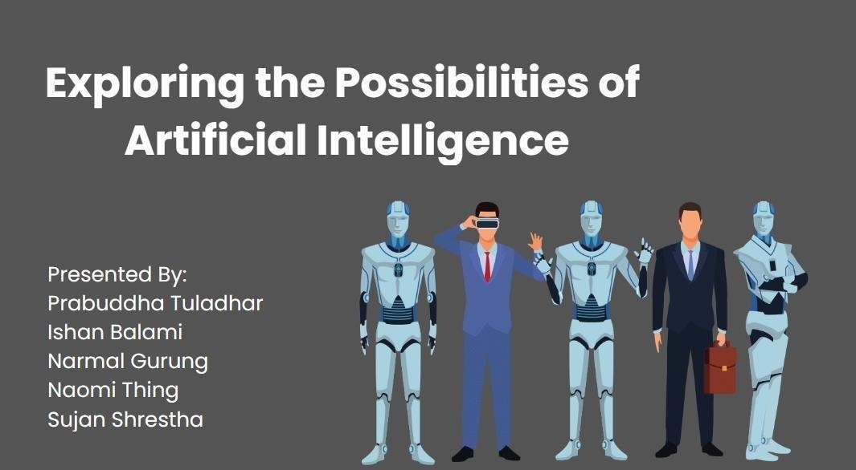

*Figure 13: Slide 1*



*Figure 14: Slide 2*

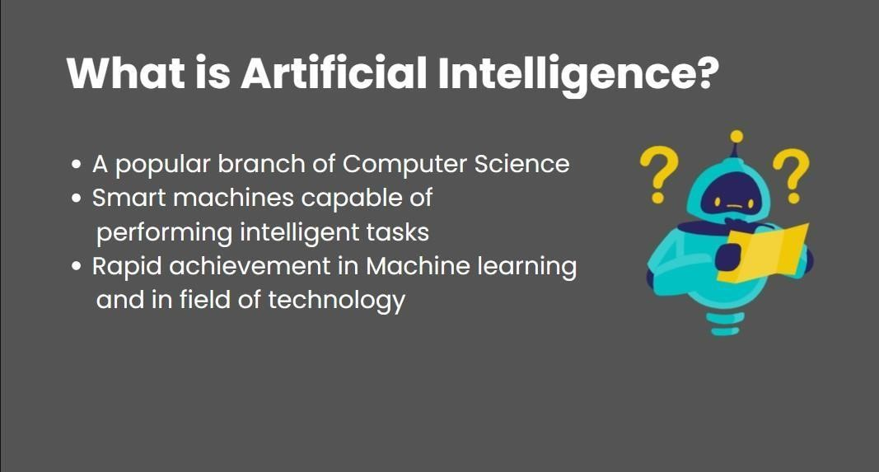

*Figure 15: Slide 3*

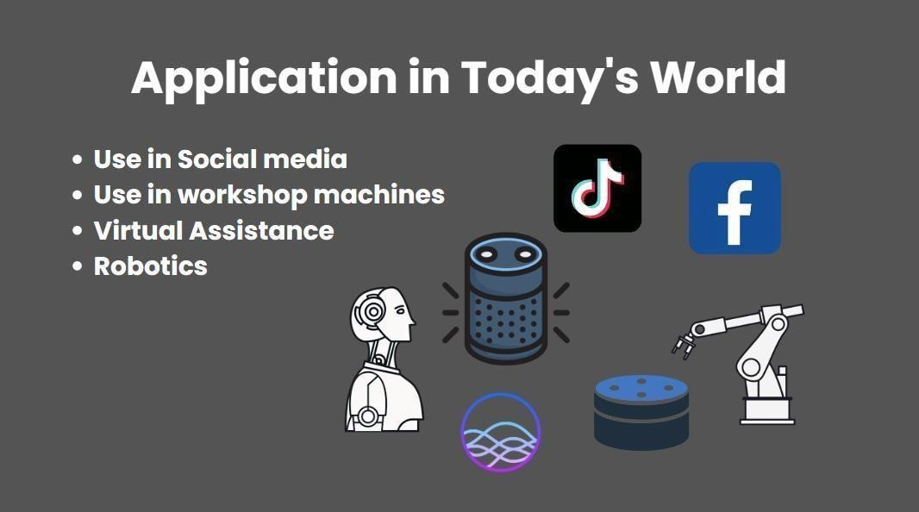

*Figure 16: Slide 4*

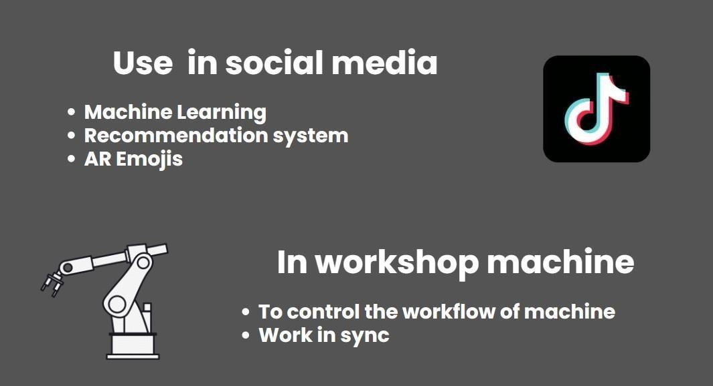

*Figure 17: Slide 5*

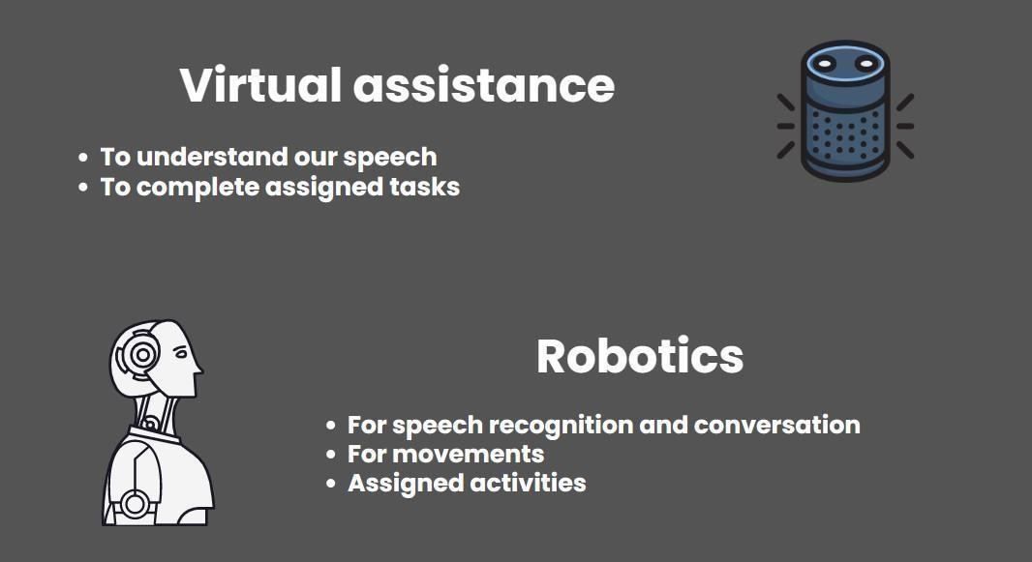

*Figure 18: Slide 6*

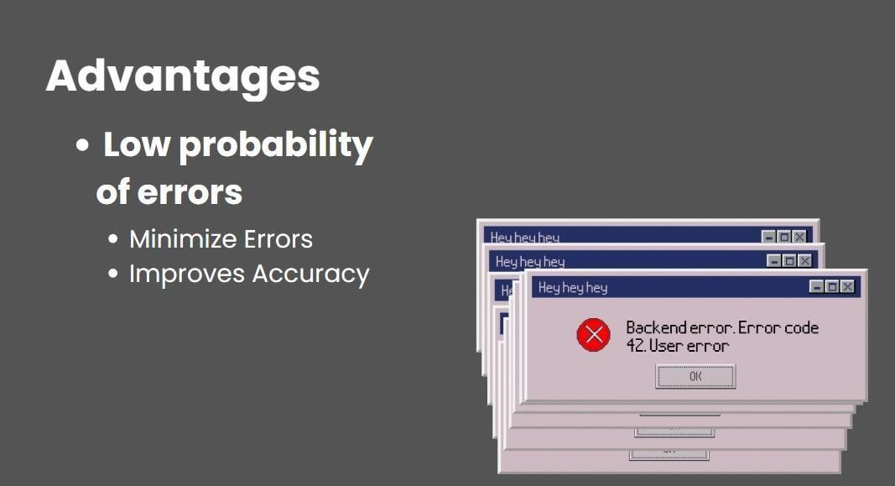

*Figure 19: Slide 7*

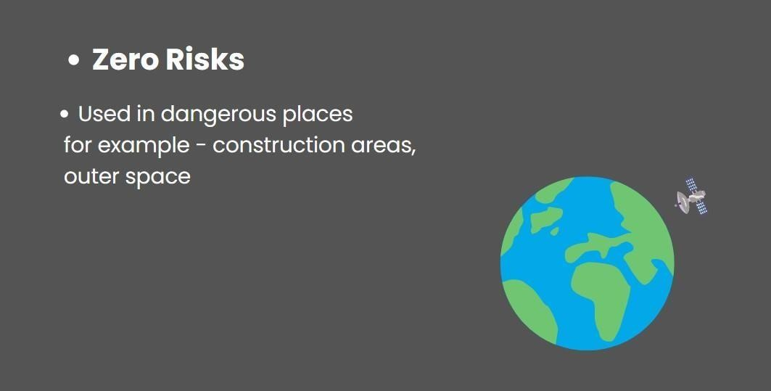

*Figure 20: Slide 8*



*Figure 21: Slide 9*

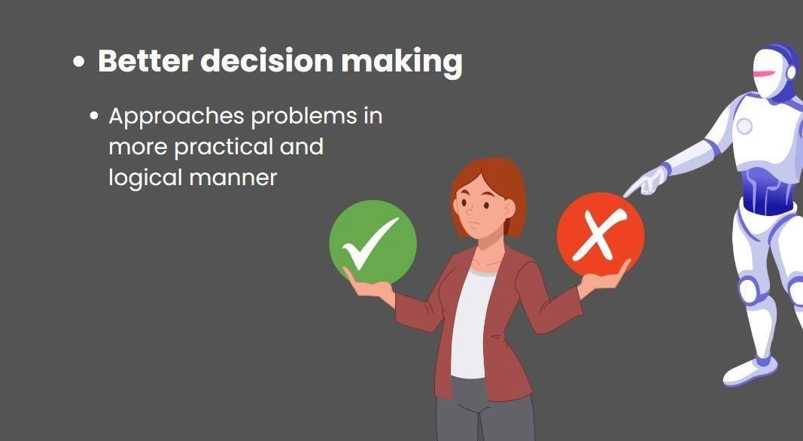

*Figure 22: Slide 10*

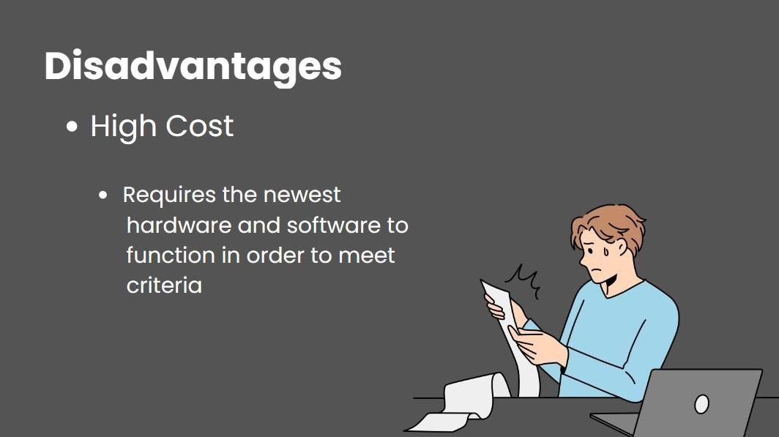

*Figure 23: Slide 11*

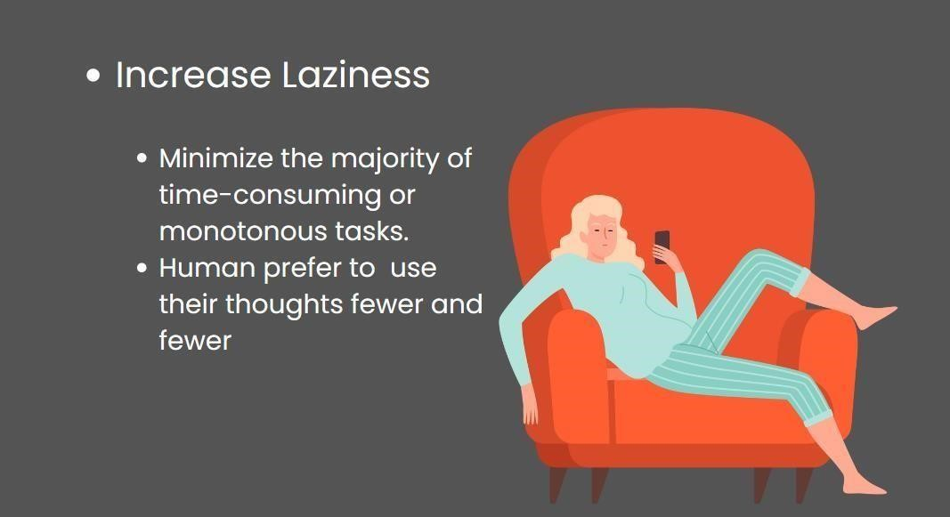

*Figure 24: Slide 12*



*Figure 25: Slide 13*

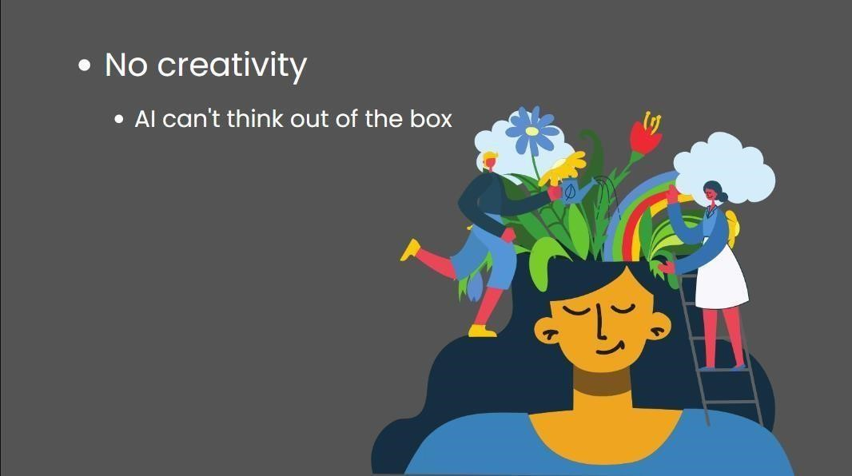

*Figure 26: Slide 14*

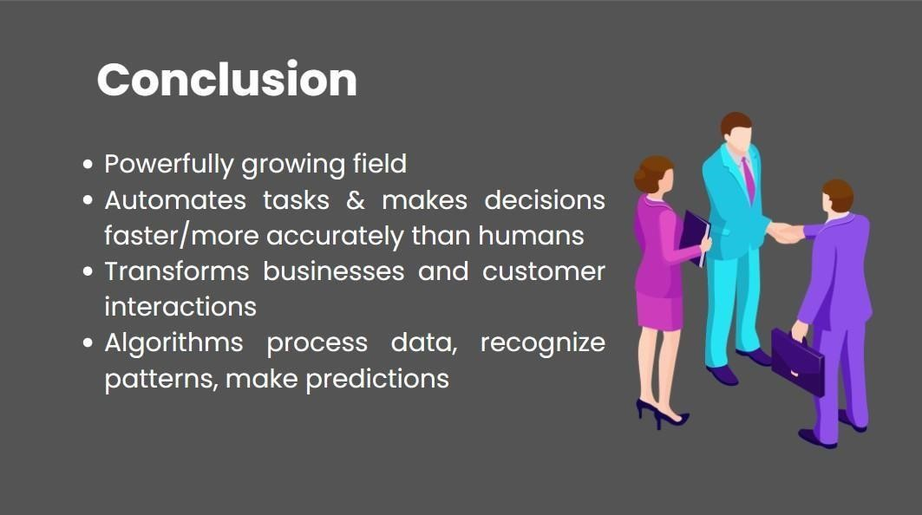

*Figure 27: Slide 15*



*Figure 28: Slide 16*



*Figure 29: Slide 17*