Instruction:

Complete all questions in 1 hour.

1. Differentiate between Data and Information.

|  |  |
| --- | --- |
| Data | Information |
| It refers to raw, unprocessed facts and figures, such as a collection of numbers of text.  Data can include things like a list of people’s names, addresses, and phone numbers.  An input is a data. | It refers to data that has been processed, organized, and given context, making it usable and meaningful.  However, when the data is transformed to produce a directory or phone book, it turns into information that can be used to locate and get in touch with people.  Information is a result of processing, analysing, or interpreting data in some way to produce an output. |

1. Write short notes on:
2. DBMS= DBMS stands for Database Management System is a piece of software that allows you to create, organize, and manage data storage in a database. It aids in the elimination of data redundancy and the improvement of data consistency. DBMS has lots of key features. It helps in data modelling. It has the capability of inserting, updating, deleting, and retrieving data. It could control data access and prevent unauthorized access. It can regain data in case of crash or failure. DBMS can deal with multiple users accessing the database at the same time. Data integrity is also one of its key feature, it keeps data accurate and consistent. DBMS has a capability to retrieve data from database using a specialized language, or query language.
3. SQL= SQL standing for Structured Query Language refers to a programming language that is widely used to maintain and deceive relational databases. Most relational database management systems, including MySQL, Oracle, Microsoft SQL Server, etc., support SQL, which is extensively utilized in a variety of industries. SQL has numbers of key features were allowing creation, modification, and deletion of database structure such as tables, views, indexes, etc. By using a SELECT statement it retrieves the data from the database. SQL does a data manipulation which means it allows the use of INSERT, UPDATE, and DELETE statements to add, update, and delete data from the database. SQL uses aggregate functions like SUM, AVG, COUNT, etc. to group and summarize data. Data Constraints is also one of the keys features the SQL includes, this allows for the enforcement of rules like NOT NULL, UNIQUE, PRIMARY KEY, FOREIGN KEY, etc. on data.
4. File System= A file system is the mechanism by which an operating system organizes and stores files on a storage device (such as a hard drive, flash drive, or SSD). It allows for the organization of files into directories and subdirectories, resulting in a tree-like structure. The file management key feature of file system is a function which allows one to create, read, write, copy, and delete files. Accessing to files and directories can be restricted using the mechanisms provided by permissions and security, such as read/write permissions for specific users or groups. File naming which is another key feature of the file system enables the naming and referencing of files in a meaningful manner, such as by extension (for example, .txt, .jpg) or full path. Each file’s size, creation date, modification date, and type are all stored in the file’s metadata. File system also determines whether the files are stored in the storage device memory blocks, groupings, or index nodes. File system types includes several types, each with unique features and restrictions, such as FAT, NTFS, ext2, ext3, HFS, etc. However, computer systems depend heavily on file systems for proper operation, and the system’s stability, security, and effectiveness can all be significantly impacted by the file system that is selected.
5. Download and install XAMPP from any browser.

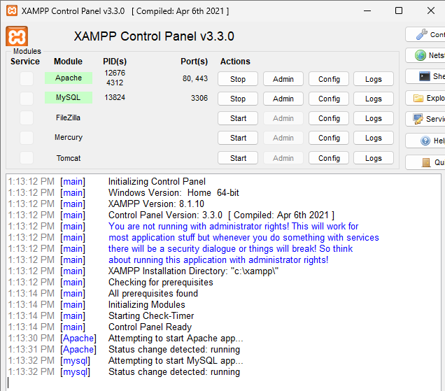

1. Create a database named HCK

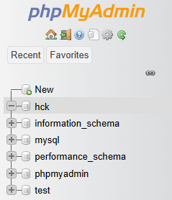

1. Create tables named Students, Parents and Tutors.

1. Create the attributes like (id, full_name, email, phone_no, address and gender) in all the above tables with suitable data types.

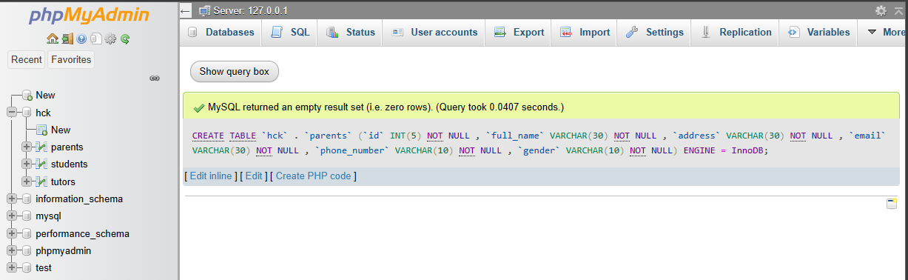

1. Insert the data using SQL Commands in all the table. (3 data)

Students:

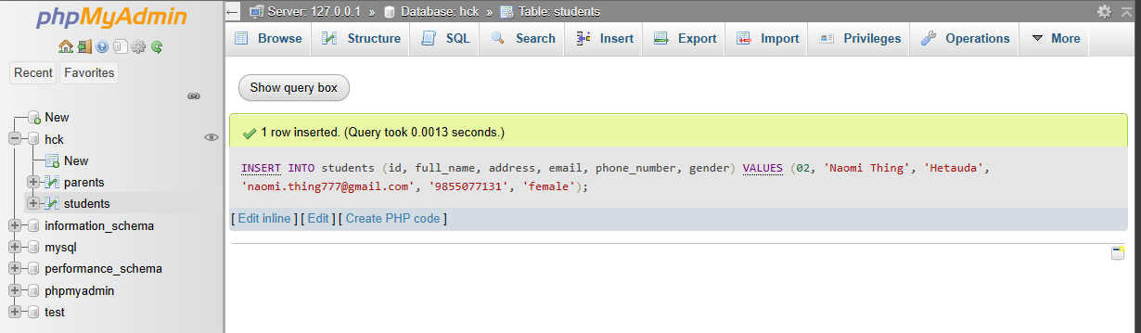

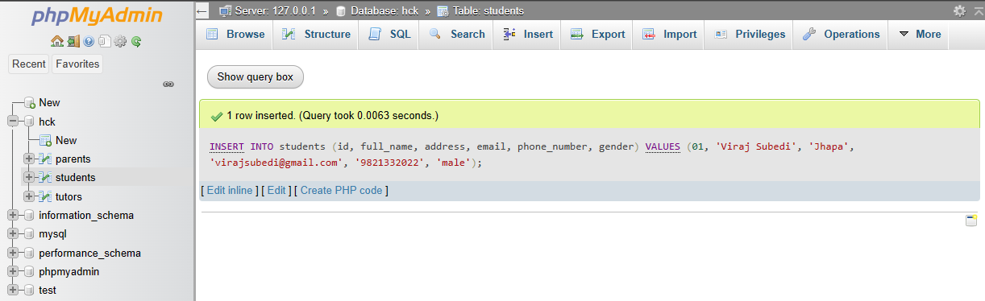

Parents:

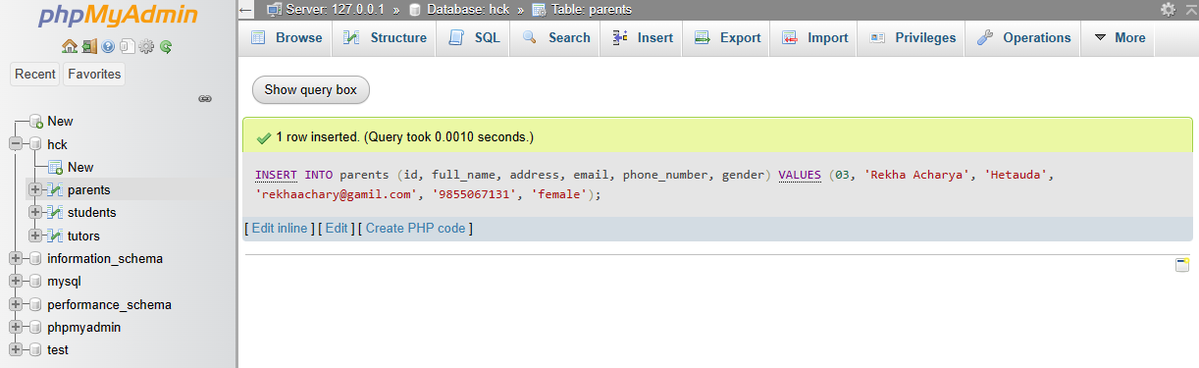

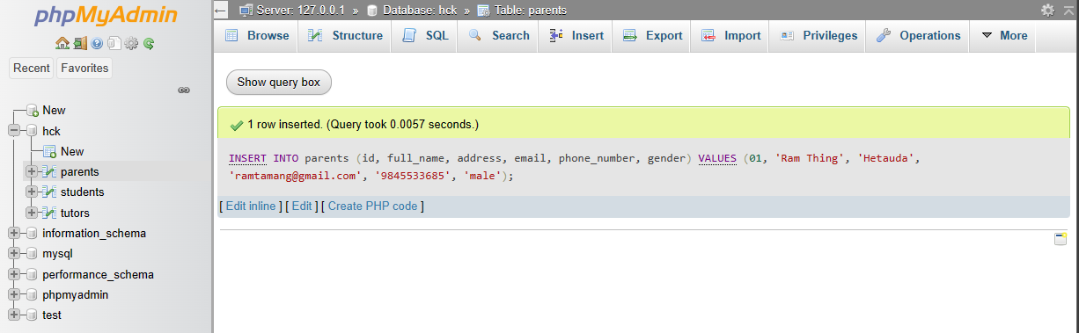

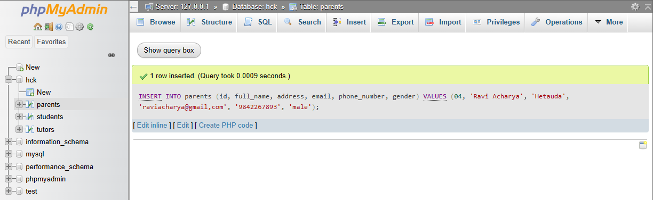

Tutors:

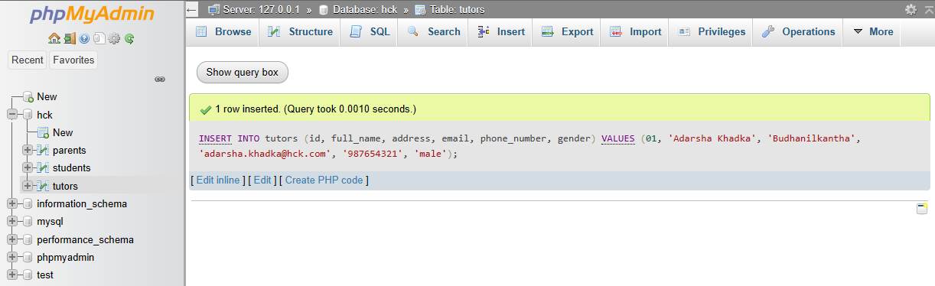

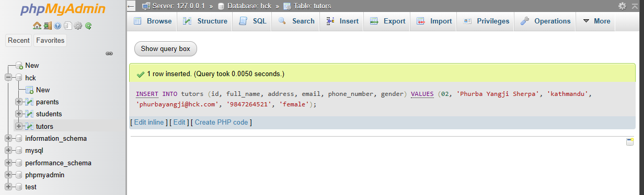

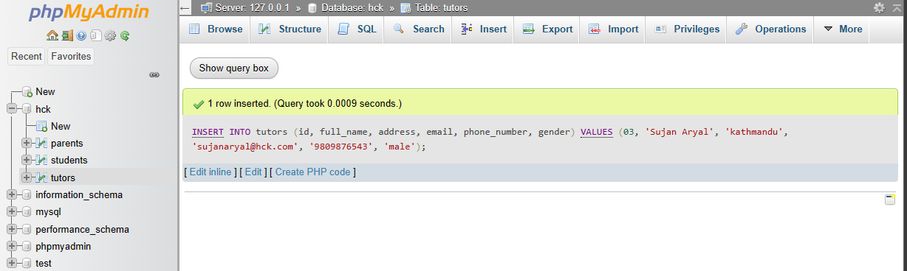

1. Display the all data of the table Tutors.

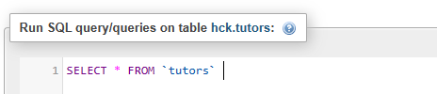

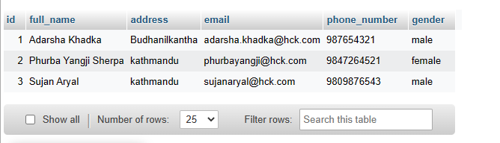

1. Display only male students from table Students.

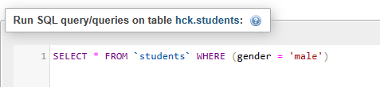

1. Drop column Parents using SQL command.

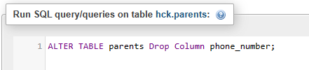

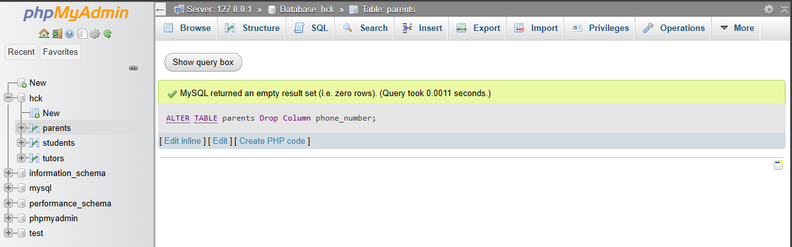

1. Delete a row in student using SQL command.