SB+ Cohort - MSc in Data Analytics
Author: Naomi Uamai
Email: sba24137@cct.ie
Student ID: sba24137

Contents
Abstract 2
Introduction 2
Exploratory Data Analysis 3
Data Preparation for Machine Learning & Statistics 3
CRISP DM 4
Machine Learning Techniques and Models 4
Plotting graphs 6
Poisson & Binomial Distribution 6
Normal Distribution 8
Programming 10
Findings 10
Evaluation 12
Conclusion 12
References 12

Abstract
Irish tourism has had a vast of amount of data collection relating to it. From this data we can find valuable insights to see just how Ireland performs in the tourism sector. In the last 14 years there have been major world events that would impact tourism such as Brexit and the COVID-19 pandemic. As expected the number of travelers will fluctuate from month to month, with people constantly coming and going. Ireland receives tourists from many different backgrounds and nationalities. Where Ireland is based in the world, may impact which nationals frequent; the UK being the closet country. With data analysis we can delve deeper to draw out findings from the tourism dataset.

Introduction
The chosen dataset is from the CSO statistics website. This dataset is based on inbound travel into Ireland from January 2010 until August 2024. It focuses on air and sea travel. The aim is to analyze this dataset and gain valuable insights about tourism in Ireland. The dataset will be analyzed through python in a separate Jupyter Notebook. Firstly, exploratory data analysis will be used to dissect the data and learn about it. After this the data will be prepared for machine learning and statistic analysis. Methods such as dropping null values and encoding will be used to prepare the dataset. Afterwards data will be visualized. Poisson, Binomial & Normal distribution will be used. The report will touch on the various Python program paradigms used for data analysis. Lastly, the report will then dig into the findings gained from the mentioned methods and evaluate the data analysis process. A conclusion will be included and the reference list and various citations as well.

Exploratory Data Analysis
To gain an understanding of the dataset exploratory data analysis is conducted. Restat (2022, p.1), emphasizes the importance of having ‘good quality’ data to make ‘good quality decisions and predictions’. Python libraries NumPy and pandas were imported. After the dataset was read, code was run to display the first five lines and another to display the last five lines. Through this, we find out how many features (6336) and rows (6) my dataset has. Belgium, UAE and Great Britain are few of the countries mentioned in the dataset. Further to this, more code was run to get information from the dataset. All but one of the six columns have a float datatype whereas the rest are object. As the data set has only one column with values, the describe was only applied to it. The value column was displayed against the country column on a graph to gauge the number of travelers from each country. The ‘All Countries’ column had the most travelers; however, this title is slightly misleading as it doesn’t tell us the exact name of countries. Great Britain has the second highest number of travelers while Spain has the third highest. To finish the EDA, the dataset was checked for missing values. It had only four null values in the VALUE column which will be taken care of later. To verify the number of missing values, df.isnull().sum().sum() was run as outlined by Mukhiya & Ahmed (2020, p.114).

Data Preparation for Machine Learning & Statistics
To prepare the dataset for Machine Learning, it was decided to drop all missing values. Since there are only four missing values, this made sense as this would not take away much from the dataset. Imputation was another method for dealing with these missing values. However, since the missing values number was not ‘large’, it was not ‘unreasonable to...discard’ them (Li, 2018, p.2). I used the dropna to remove these values and was then left with 6332 columns. As the dropna command did not permanently remove rows with null values, I then used fillna(0, inplace = True) as outlined by Ranjan (2024). The encoding data frame was then checked for null values and the return was False, meaning missing values had been dropped permanently. My dataset deals mainly with categorical data therefore I decided that encoding would be a suitable way to transform my data. I made use of both one-hot encoding and label encoding. Since the “Month” and “Direction” columns have more than one unique value, I used label encoding here. One-hot encoding is not recommended when there are “not may unique values” (Bolikulov et al, 2024, p.10). By using label encoding, I was able to move the categorical data to “integer” values according to their “sequence” (Bolikulov et al, 2024, p.9). For the “STATISTICAL Label”, column I used one-hot encoding as the column has the same value throughout.

CRISP DM
Crisp DM is a suitable project management framework for a data science project. Like any framework used for managing a project it has different phases, “business understanding”, “data understanding”, “data preparation”, “modelling”, “evaluation” and lastly “deployment” (Lee & Baxter, 2023, p.2). Like an agile way of working, the framework takes an iterative approach meaning that the phases can be moved around in any sequence. It is not restrictive and allows flexibility (Lee & Baxter, 2023, p.2). From CRISP DM, models like “KDD Process” and “SEMMA Process” materialized (Wang, 2024, p.3). It came into existence in the 90s and is used widely for analytic projects (Lee & Baxter, 2023, p.3). This framework can be used in many real-life domains such as healthcare, a study in 2022 by Lin & Glas looks at applying CRISP DM in this domain. They utilized 3 of the phases, business understanding, data understanding and lastly deployment. By interviewing staff from a healthcare IT department, Lin & Glass (2022, p. 8.) set out to “investigate the” company’s “data mining process”. Their main findings were that several barriers can hinder a healthcare organizations data mining process. Their conclusion was that CRISP DM can not only be used to edge at various “levels of abstraction” but also gives a unique “guide to the data mining process” (Lin & Glas, 2023, p.26). Another scenario where CRISP-DM was applied was for predicting the failure of students in Morocco. Here all six phases of the framework were used, and the team was able to prove the importance of student performance prediction “to improve teaching performance” (Lebkiri et al, 2021, p.351).

Machine Learning Techniques and Models
For my dataset, it was decided to go with a supervised machine learning as I wanted to be able to “make predictions” (Li, 2020). SVM a semi-supervised model; a ‘classification training model” was used (Bonaccorso, 2018, p.19). Whether tourism in Ireland has increased or decreased, what nationalities travel to Ireland regularly and has the pandemic affected Irish tourism are a few of the areas, the machine learning models could look at. Earlier on we saw that after the ‘All Countries’, ‘Great Britain’, had the highest number of travelers in Ireland. Using the decision tree algorithm, the direction passengers travelled could potentially be predicted. To prepare for this, code from a class tutorial was used, the necessary packages NumPy and pandas were imported first. Also, sklearn’s Decision Tree Classifier, train test split and metrics were imported. Lastly, warnings were suppressed. After this, I defined my feature columns (STATISTIC Label, Month, Country, UNIT, VALUE) and X & y, X being the feature columns from the encoded dataset and y being my target variable (Direction). The data was then split into train and test and then built the model. Lastly, the accuracy of the model was measured. A max depth of 3 was used which should allow for ‘the highest validation accuracy’ (Bonaccorso, 2018, p.253). The accuracy was low at 0.48%. Then optimizing thew model bas attempted using the ‘Gini’, index as a hyperparameter. This index considers the likelihood of ‘misclassification if a label is’ chosen at random, ‘using the probability distribution of the branch’ (Bonaccorso, 2018, p.247). Using the Gini index did not make a significant difference here, as the accuracy remained the same as well the visualization.
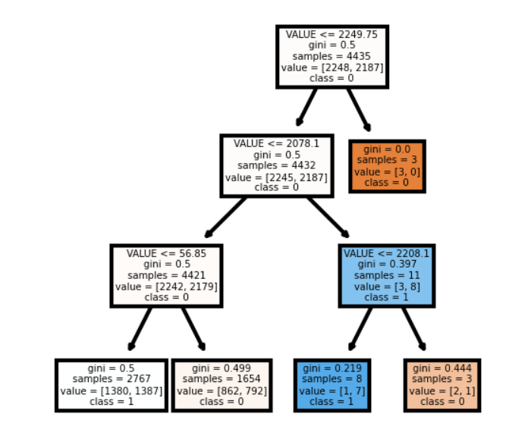
Fig.1 Decision Tree
Next the SVM (Support Vector Machine) was used, and necessary libraries imported. Originally, the dataset was to be reloaded using a new data frame and then the dataset be split into independent and dependent variables using the iloc function as outlined by Zafar (2023). However, this did not work out for so instead the data was split using NumPy’s asarray with the encoded data frame. The Direction column was dropped from the X axis and kept it in the y axis. The y values equaled to were replaced 0 with a -1. After this, I got the number of columns and rows, displayed the first 15 y values. The train test split library was then imported and the data split into test and train. The test size was kept at 0.2 for an 80 and 20 per cent split and random was 1. Standard scaler was used, and the normalized version of X train and test defined. The confusion matric was then built. To display it, a heatmap was used. Then the accuracy score was measured, just like the decision tree score, it was .48. A comparison of the decision tree and SVM models was then attempted. Additional libraries were imported, including gridspec, Ensemble Vote Classifier and plot decision regions. Three classifiers were prepared, X, and y axis defined as well gs and fig. The graph was then plotted, however when code was run there was a Value Error. Comparing the accuracy score received from both models, we see it is low. According to Basit, 2023 a low accuracy score can happen for various reasons. One being low quality data, another selecting the wrong machine learning model (Basit, 2023). He also touches on more reasons such as not tuning the hyperparameter correctly and ‘overfitting or underfitting’.

Plotting graphs
Three graphs were plotted; a bar chart, a histogram and a boxplot. The bar chart was created to see how often a country was represented by a tourist arriving at or departing from Ireland. A bar chart was selected as an optimal way to show ‘qualitative data’ (Weiss, 2017, p.67). The chart deviated from recommendations by Weiss, as the qualitative data in this case is represented on the horizontal axis. Certain data like ‘All countries’ & ‘Other Countries (42)’ could have been dropped from the dataset as these do not tell us much, in other words they are specific. Next a histogram was plotted, here we are looking at how frequent we have a certain number of travelers in Ireland. Between 0 – 250 thousand travelers traveling in either direction looks to be the most frequent range. While anything higher than 1750 thousand is the lowest frequent range. Lastly, a box plot was created using the Country column from the encoded data frame, this column was label encoded. Box plots are generally used for data that is quantitative hence why the encoded column was utilized (Weiss, 2017, p.88).

Poisson & Binomial Distribution
In this analysis both Poisson and Binomial distribution are used. Poisson distribution looks at the frequency of a specific scenario happening during a certain time (Weiss, 2017, p.273). Real life applications may include the number of tickets logged onto a service desk weekly or how many lipsticks were sold at a pharmacy during the month of December. Weiss (2017, p.283) provides other examples like “the number of patients” arriving “at an emergency room” during a 6pm to 7pm timeframe. This will work well with the current dataset to find out the number of passengers in any given month and year arriving or departing Ireland. When using a binomial distribution, we are concerned with scenarios where the trial has “two possible outcomes” (Weiss, 2017, p.260). This distribution is repeated; a trial may be done several times, for example to find out how effective a drug is on a patient, many patients will take it (Weiss, 2017, p.260). In this example the trial is repeated, and we find out if the drug is effective or not after these results are analyzed (Weiss, 2017, p.260). For the analysis of the tourism dataset, this distribution will work best on the direction column as it has two possible outcomes; either the passenger arrived at or departed from Ireland. Findings can be drawn such as the average amount of passengers departing Ireland in a certain month or the average amount of arrivals during summer months etc.

In the analysis, describe is used to find the count, mean, standard deviation, minimum, percentages (25, 50, 75) and max values of the value column. After this the Poisson library is imported, then random values are generated with the mean rounded up and a sample size of 100 using code from Bobbit (2021). The sample size array is then printed. The mean was used to look at the average instead and a sample size of 100 was chosen due to the large size of the dataset. Poisson is used to find the probability of two scenarios then it is displayed on a histogram. Using a mean of 140 and size of 100, we can see how the density of travelers fluctuates. The graph almost forms a normal curve.
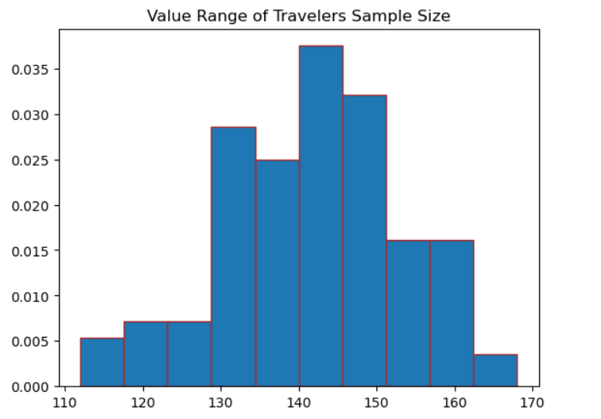

Fig. 2 Histogram – Poisson Distribution
After this histogram, we have another which was created with the intention of showing a normal curve. However, the data is not skewed normally, to allow for a normal curve to be shown. Next we look at Binomial distribution, binom was imported as a prerequisite. In the bar chart, the probability of a passenger arriving in Ireland in any given Month is looked at. The number of months is defined as n, then the probability of a passenger arriving which is a 50 50 outcome. The dataset looks at the direction of the tourists, they either arrived in or departed from Ireland. Next the number of possible arrivals is defined. Then pmf is defined, this is the binomial distribution consisting of the n, p and k values. Plotting was then completed before the addition of text to display the probability figures on each bar. This created the plot below.
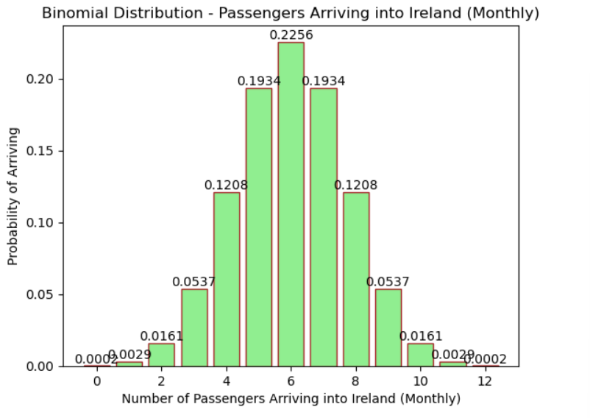
Fig 3. Bar Chart – Binomial Distribution
Further to the plot, the probability is also displayed in an array by first defining probability then printing it. The same results shown above the bars are displayed in the array.

Normal Distribution
Normal distribution was used in the analysis. It can be said that a variable is normally distributed only if the distribution is in the shape of a bell curve (Weiss, 2017, p.284). To display the VALUE column of the dataset, a histogram was plotted see below figure.

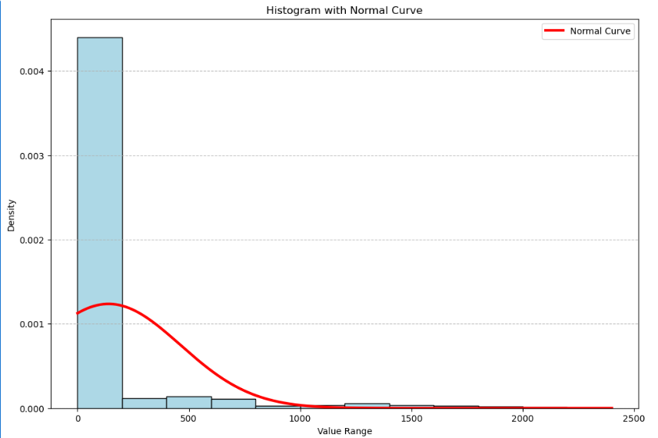
Fig 4. Histogram with a Normal Curve
To test normality, the Shapiro-Wilk test was used. We can see that the statistics and p-value returned were nan and the if statement further tells us that the sample is not normally distributed. Further to this, a q-q plot was used to see if the data followed a specified distribution and we can conclude based on the plot that it does not.
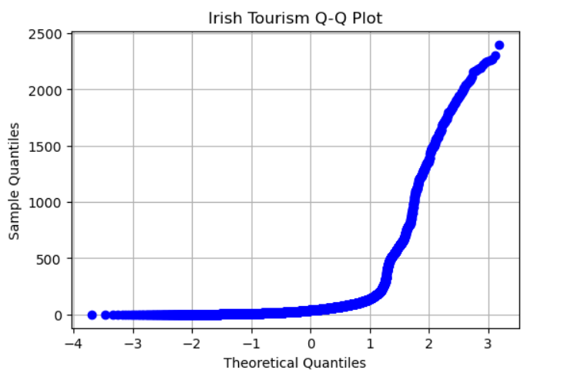
Fig. 5 Irish Tourism Q-Q Plot

Programming
A range of programming paradigms were used in the Jupyter notebook for analyzing the dataset. For exploration of the data the pandas library was used to find out more about the data analysis. To begin with the library was imported, and the dataset read by creating a data frame, df. Then code such as ‘df.info’, ‘df.head’ were used. The first code shows ‘the rows, columns, data types, and memory used by the data frame’ (Mukhiya & Ahmed, 2020, p. 30). While df.head displays the first five lines of the dataset. To display the last 5 lines of the dataset the tail code was used. The shape code will give us the exact number of features and rows in a dataset. The only column in the dataset with nominal data was ‘VALUE’, when the describe code was run it was only applied here. This code gives us information such as the mean, count and standard deviation of the column. NumPy and seaborn were also imported; the latter was needed to create the plot seen in Fig 6.
The pandas library has code that can be used to deal with missing or null values. To first find out if the dataset had missing values df.isnull() was run. To drop these missing values dropna was used, to then make the drop permanent inplace = True, was then added. To prepare the dataset for machine learning encoding was the chosen method specifically Label and One-Hot. For this the necessary libraries were imported from the “sklearn preprocessing functionality” (Mukhiya & Ahmed, 2020, p.306). For the month column label encoder was used as each value would be assigned a different number then one hot encoding was used for the direction column as it had only two values.
For the machine learning models, more libraries from sklearn were used; Decision Tree Classifier and SVC. To plot the decision tree, the matplotlib library was imported. This library is useful for plotting ‘linear datasets’, tuning ‘axes’ and grids etc. frame’ (Mukhiya & Ahmed, 2020, p. 22). To train the data the train test split library was utilized. The confusion matrix required it library namesake and the classification report both from sklearn. Seaborn which was imported previously allowed for the creation of the heatmap.
Using pythons various graphs were plotted for the statistical aspect of the report such as bar charts and histograms. The histogram was a valuable way of visualizing the frequency of travelers. By importing the Poisson library, various probability scenarios could be tested, such as the probability of there being 155 thousand travelers in a month. By plotting a histogram with a normal curve, it was found out that the data was rightly skewed.

Findings
Various findings can be drawn from this analysis. Through EDA the highest number. of countries with travelers coming to and from Ireland was found out. If we ignore ‘All Countries’, we see that Great Britain had the highest number of travelers into Ireland. Spain coming second and in third place Germany, France, Italy, Selected EU countries and United States. These nationalities make up a huge part of tourists. It can be said that majority of the tourists come from the European continent, this could be due to the distance and ease of travel with EU countries. With factors like Brexit, we still see that the travelers from the UK are still quite high.

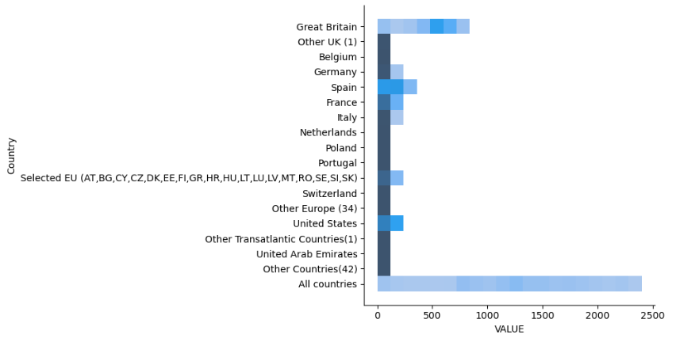
Fig 6. Plot of Country Column against VALUE column
Frequency of Travelers is looked at in Fig.7 below. From the original dataset we already know that travelers come in their thousands monthly. With the below plot, we see how frequent certain number ranges were. The 0 – 250 thousand range had the highest frequency as displayed in the plot, whereas the 2250 – 2500 thousand had the lowest frequency. Ireland certainly maintains a frequent number of travelers this benefiting the tourism sector.

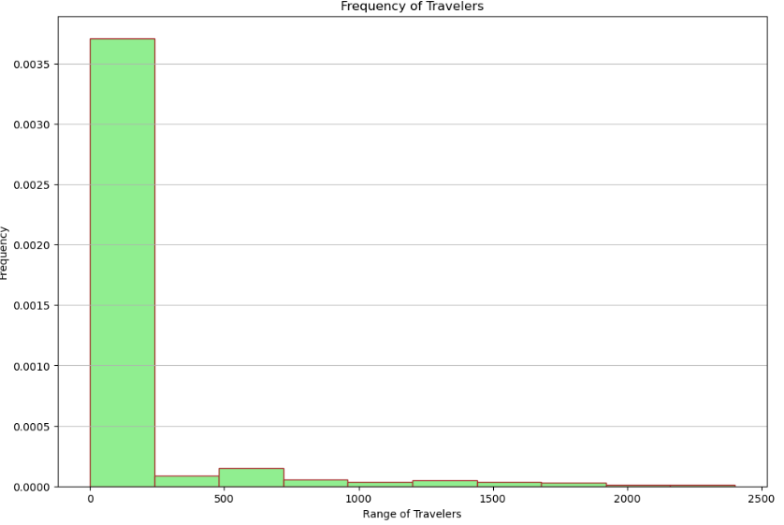
Fig 7. Frequency of Travelers Plot
From the distributions (Poisson, Binomial & Normal), further findings are drawn. Before the Poisson distribution was used, the below was found out about the VALUE column using the describe function. The average number of travelers in a month was 139.7 thousand. We see that the standard deviation is almost twice the amount of the mean.
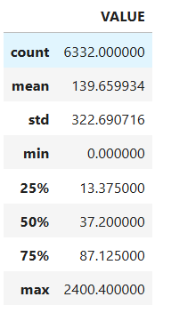
Fig 8. df.describe() output
On average there are 140 thousand arriving in or departing from Ireland monthly; we get this by rounding up the mean. To check the probability of there being 155 thousand in one-month Poisson was used. The probability of this is 0.015 percent, although it is low there is still a chance Ireland could have this number of travelers in a month. Further to this, the probability of having 100 thousand travelers in a month was checked. This is 6.94 percent, again the chances of this are low but it is a possibility.
In the below histogram, the value range of the Travelers sample size was displayed. Seeing as the mean is 140 thousand, this makes sense that 135 – 145 thousand range is the highest. Earlier the probability of there being 100 thousand travelers in a month was checked. The probability of this was less than 1 percent; in the graph the 105 – 110 thousand range is the lowest.

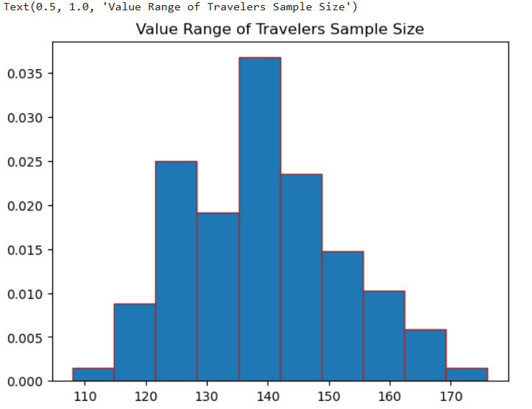
Fig 9. Histogram - Value Range of Travelers Sample Size

We have established that Binomial Distribution generally looks at two possible outcomes; from the below bar chart we can find out the probability of a traveler arriving in Ireland in any given month. If we say the months are in order by number; we can say that month 6 (June) has the highest possibility of traveler arriving in Ireland.

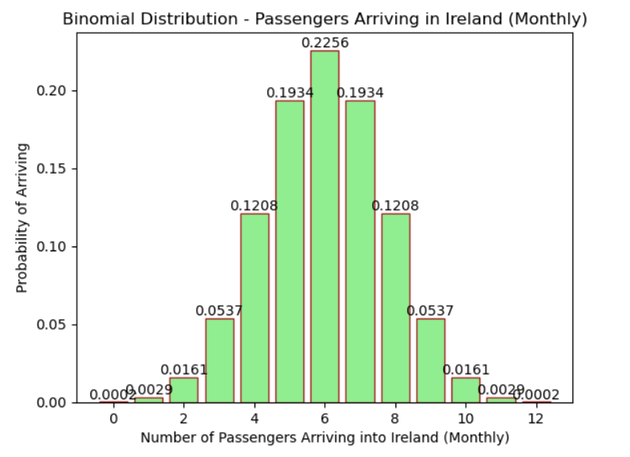
Fig 10. Binomial Distribution – Passengers Arriving in Ireland (Monthly)
The VALUE column was plotted in a histogram with the intent of showing a normal curve in Fig 11. We see that the curve is not quite the bell curve we spoke about earlier. The data is skewed to the right.

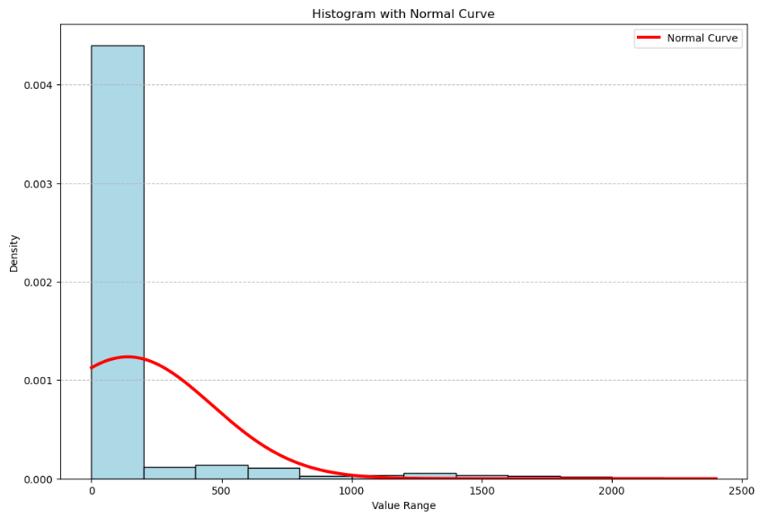
Fig 11. Histogram with a Normal Curve

Evaluation
To improve the data analysis of this report, different machine learning models could have been used to get a better accuracy score and allow for better predictions. Further research could have been done to allow the machine learning models to be compared properly. Additionally, another dataset with more nominal data could have further enhanced machine learning. For the statistical aspect perhaps additional code could have allowed Fig.1 to display a better normal curve.

Conclusion
A Juptyer notebook was used throughout the analysis. EDA was used and data preparation methods such as encoding. Building and displaying two machine learning methods was attempted and comparing them. Three different distributions were used. Pythong programming was used. To conclude, through different methods the dataset was analyzed and valuable insights were gained.

References
- Central Statistics Office (2024) Air and Sea Travel. Available at: https://data.cso.ie/table/ASM03 [Accessed 13th October 2024]
- Suresh Kumar Mukhiya and Usman Ahmed (2020). Hands-On Exploratory Data Analysis with Python: Perform EDA Techniques to Understand, Summarize, and Investigate Your Data. Birmingham, UK: Packt Publishing. Available at https://research.ebsco.com/linkprocessor/plink?id=a7a86a4e-5138-33a3-8d22-3d92ff037bb3 [Accessed 26th, 27th & 28th October and November 2024]
- Restat, V. (2023) ‘Towards “all-inclusive” Data Preparation to ensure Data Quality’. arXiv: 2308.14617
- Li, M. (2018) ‘Missing Value Estimation Algorithms on Cluster Representativeness Preservation of Gene Expression Microarray Data’. arXiv: 1809.05969
- Wang, W. (2024) ‘Data-driven analysis of carbon emissions from buildingization under the CRISP-DM framework, Applied Mathematics and Nonlinear Sciences’ 9(1) pp. 1-20. Available at https://sciendo.com/article/10.2478/amns-2024-1778 [Accessed 28th October 2024]
- Bolikulov, F., Nasimov, R., Rashidov, A., Akhmedov, F. and Cho, Y. (2024) ‘Effective Methods of Categorical Data Encoding for Artificial Intelligence Algorithms, Mathematics’ 12(16) doi: 10.3390/math12162553
- Lee, F. and Baxter, C. (2023). ‘Using Supervised Machine Learning and CRISP-DM to Predict an Acquittal Verdict, Information Systems Education Journal’, 21 pp.23-36. Available at https://files.eric.ed.gov/fulltext/EJ1403991.pdf [Accessed 28th October 2024]
- Lind, E. and Glas, S. (2022) ‘Data Mining in Practice, An Application of the CRIPS-DM framework in Healthcare, Informatic Student Paper Master (INFSM)’. Available at https://umu.diva-portal.org/smash/get/diva2:1679362/FULLTEXT01.pdf [Accessed 28th October 2024]
- Lebkiri, N. Soulaymani, A., Daoudi, M., Abidli, Z.,Elturk, J., Benattou, M., Khatori, Y., and El Madhi, Y. (2021) ‘Using Machine Learning for Prediction Students Failure in Morocco, An Application of CRISP DM Methodology’, International Journal of Education and Information Technologies, 15, pp. 344-352. doi: 10.46300/9109.2021.15.36
- Neil. A. Weiss (2017). Introductory Statistics. England, UK: Pearson Educational Limited. Available at https://moodle.cct.ie/course/view.php?id=1746 [Accessed November 2024]
- Simplilearn (2023) The Best Guide On How To Implement Decision Tree In Python.
Available at https://www.simplilearn.com/tutorials/machine-learning-tutorial/decision-tree-in-python [Accessed 4th November 2024]
- Basit, A (2023) Unraveling the Mystery of Low Model Accuracy: Causes and Solutions Available at https://www.linkedin.com/pulse/unraveling-mystery-low-model-accuracy-causes-solutions-abdul-basit [Accessed November 2024]
- Bhutani, K. (2023). Python | Delete rows/columns from DataFrame using Pandas.drop(). Available at https://www.geeksforgeeks.org/python-delete-rows-columns-from-dataframe-using-pandas-drop/ [Accessed November 2024]
- Zafar, A. (2023) SVM Implementation in Python From Scratch- Step by Step Guide Available at https://www.mltut.com/svm-implementation-in-python-from-scratch/ [Accessed November 2024]
- Giuseppe Bonaccorso (2018). Machine Learning Algorithms: Popular algorithms for data science and machine learning. Birmingham, UK: Packt Publishing. Available at https://viewer.ebscohost.com/EbscoViewerService/ebook?an=1881497&callbackUrl=https%3a%2f%2fresearch.ebsco.com&db=e250xww&format=EK&profId=eds&lpid=&ppid=&lang=en&location=https%3a%2f%2fresearch.ebsco.com%2fc%2fjzntuu%2fsearch%2fdetails%2frvfrfer4y5%3flimiters%3dFT%253AY%26q%3dmachine%2blearning%2balgorithms&isPLink=False&requestContext=&profileIdentifier=jzntuu&recordId=rvfrfer4y5 [Accessed November 2024]
- Ranjan, S. (2024). Python | Pandas dataframe.replace(). Available at https://www.geeksforgeeks.org/python-pandas-dataframe-replace/ [Accessed November 2024]

