字体：font

大小 font-size

粗细 font-weight

样式 font-style normal/italic

文本：text

颜色 color

文本对齐(水平) text-align: center/left/right

装饰文本 text-decoration: underline/overline/line-through

文本缩进 text-indent: px/em

行间距 line-height

内嵌 style

<link rel="stylesheet" href="Index.css">



背景 background

颜色 -color: transparent/color

图片 -image: none/url()

背景平铺 -repeat: repeat/no-repear/repeat-x/repeat-y

背景图像固定 -attachment: scroll/fixed

背景色半透明 background: rgba(color, color,color, %)

边框 border : -width/-style/-color

-style: none/hidden/dotted/dashed/solid/double/groove/ridge/inset/outset

border -top/-bottom/-left/-right



内边距（边框与内容） padding -top/-bottom/-left/-right

margin -top/-bottom/-left/-right



清除默认边距

圆角 border-radius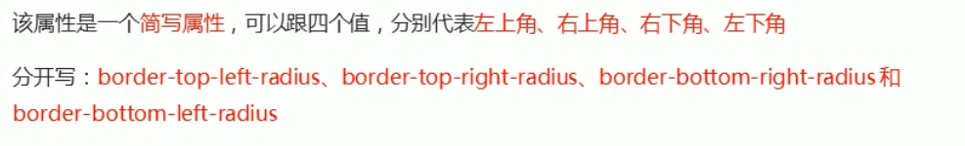

盒子阴影 box-shadow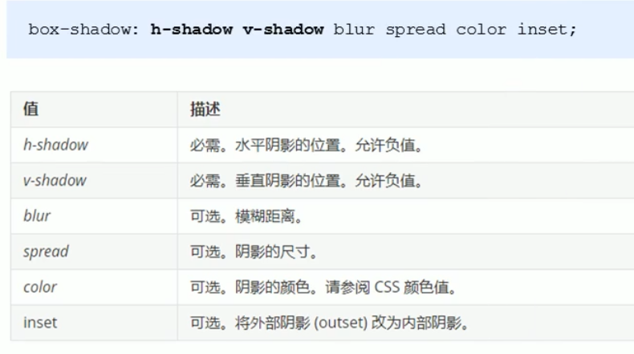

文字阴影 text-shadow

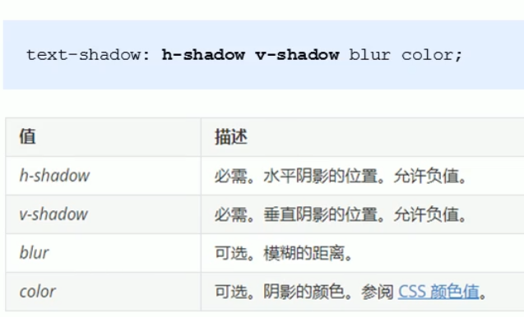

浮动 float

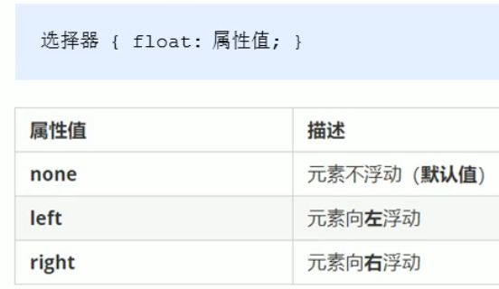

清除浮动 clear

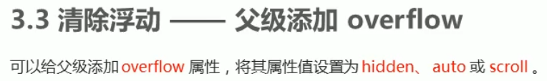

.clearfix:before, .clearfix:after {

    content:"";

    display: table;

}

.clearfix:after{

    clear:both;

}

.clearfix {

    \*zoom: 1;

}