Executive Summary (0.25) & Conclusion (0.25) | 0.5 points
I. Business Requirements | 1.0 points
II. System Requirements Analysis (each sub item is 1pts) | 3.0 points
III. System Requirements Analysis (each sub item is 1pts) | 3.0 points
IV .System Requirements Implementation | 2.0 points
V. System Testing, Deployment and Demo | 1.5 points
(include Visio/PowerDesign/Drawing source + source code)
Total | 11 points

You are encouraged to use Power Design software to conduct modelling including but not limited to UML class diagram to see how to generate both SQL and Java/C# code to earn points for implementation.

Remove all picture / unused part from this template, you should keep the titles, when you conduct your report.

Should maintain the navigation on the left hand-side of this report when opening with MS Word.

PROCESS A LOAN BABY HUT SYSTEM

Requirements Analysis & Design (RAD)
By Students:
- 521H0093 : Nguyen Minh Ky
- 519H0208: Truong Tuan Nhan

Reference: | Team_02_RAD_Requirements_Modelling_v0.1
Audience: | Mr. Pham Thai Ky Trung | Document Version: | December, 2022
Outcome: | Process A Loan System
Abstract: | This document provides an in-depth analysis of a proposed video rental system with the requirements modelled utilizing the UML framework. The document is a collaboration between the members of Team XX.

Intellectual Property
Copyright 2022 Team 02.

The following documentation, the content therein and/or the presentation of its information is proprietary to and embodies the confidential processes, designs, technologies and otherwise of Team 02. All copyright, trademarks, trade names, patents, industrial designs, and other intellectual property rights contained herein are, unless otherwise specified, the exclusive property of Team 02.

The ideas, concepts and/or their application, embodied within this documentation remain and constitute items of intellectual property which nevertheless belong to Team 02.

The information (including, but by no means limited to, data, drawings, specification, documentation, software listings, source and/or object code) shall not be disclosed, manipulated, disseminated or otherwise in any manner inconsistent with the nature and/or conditions under which this documentation has been issued.

The information contained herein is believed to be accurate and reliable. Team 02 accepts no responsibility for its use in any way whatsoever. Team Five shall not be liable for any expenses, damages and/or related costs which may result from the use of the information contained herein.
The information contained herein is subject to change without notice.

All Rights Reserved. Copyright herein is expressly protected at common law, statute and under various International and Multi-National Treatises (including, but by no means limited to, the Berne Convention for the Protection of Literary and Artistic Works).

Table of Contents
Intellectual Property 3
Table of Contents 4
Table of Figures 5
Executive Summary (0.25 point) 6
I. Business Requirements (1 point) 7
1.1 Organization Chart / Project Chart/Gantt Chart 7
1.2 Business Modelling / Requirements 7
1.3 Business Processes / Flowchart of Requirements 8
1.4 Activity Diagram 8
1.5 List of Requirements 9
II. System Requirements Analysis (3.0 points) 10
2.1 Translate from Business Use Case 10
2.1.1. System Narrative 10
2.1.2. Users and their goals 10
2.1.3. List of Events 11
2.1.4. List of Actors 11
2.1.5. Use Case Diagram 12
Use Case Descriptions 14
2.2.1. Use Case: HAVE A LOAN 14
2.2.2. Use Case: SCAN BAR CODE 17
2.2.3. Use Case: Scan title 20
2.2.4. Use Case: Check out 21
2.3.1. Verifying uses cases: Name 1 for Customer 23
2.3.2. Verifying uses cases for Actor 2 23
2.3.3. Verifying uses cases for Actor 3 23
2.3.4. Verifying uses cases for Actor 4 23
III. System Requirements Design (3.0 points) 24
3.1 Design Class for Have a Loan 24
3.2.1. Design Classes in Detailed Design 24
3.2.2. Design Class Diagram 27
i. Domain Design Class 27
ii. Controller 27
iii. UI 28
iv. Data Access 28
v. Design Class 28
3.2.3. OOD with Sequence Diagram 29
3.2.4. Final Design Class Diagram 29
3.2 Design Class for Scan Bar Code 30
3.2.1. Design Classes in Detailed Design 30
3.2.2. Design Class Diagram 31
i. Domain Design Class 32
ii. Controller 32
iii. UI 33
iv. Design Class 33
3.2.3. OOD with Sequence Diagram 34
3.2.4. Final Design Class Diagram 34
3.3 Design Class for Scan titles 34
3.2.1 Design Classes in Detailed Design 34
v. Domain Design Class 37
vi. Controller 37
vii. UI 38
viii. Design Class 38
3.2.5. OOD with Sequence Diagram 39
3.2.6. Final Design Class Diagram 40
3.4 Design Class for Check out 40
3.2.2 Design Classes in Detailed Design 40
ix. Domain Design Class 43
x. Controller 43
xi. UI 44
xii. Design Class 44
3.2.7. OOD with Sequence Diagram 45
3.2.8. Final Design Class Diagram 45
IV. System Requirements Implementation (2pts) 47
4.1 Package Diagram for Sub System 48
4.2 Implementation 49
4.3.1. Map persistent objects to the tables in a database 49
4.3.2. Modifying sequence diagrams 50
4.3.3. UI design 50
4.3.4. SQL Code 51
4.3.5. Software Classes Method Code 51
V. SYSTEM TESTING, DEPLOYMENT AND DEMONSTRATION (1.5 pts) 52
5.1 Testing: Test plan & Test case 52
5.2 Deployment 52
5.3 Demonstration 52
Conclusions/ Recommendations (0.25 point) 53
References 53
Appendix 53

Table of Figures
Figure 1: Org Chart 7

Executive Summary (0.25 point)
The purpose of this document is to provide an overview of the proposed system….

Business Requirements (1 point)

Organization Chart / Project Chart/Gantt Chart
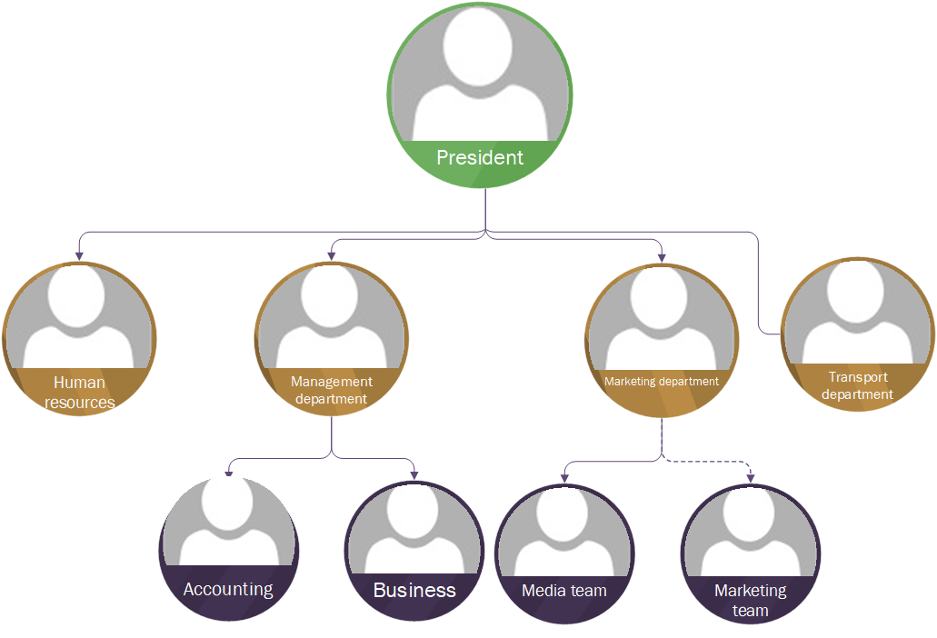
Figure 1: Org Chart

Business Modelling / Requirements
MODEL BUSINESS USE CASE
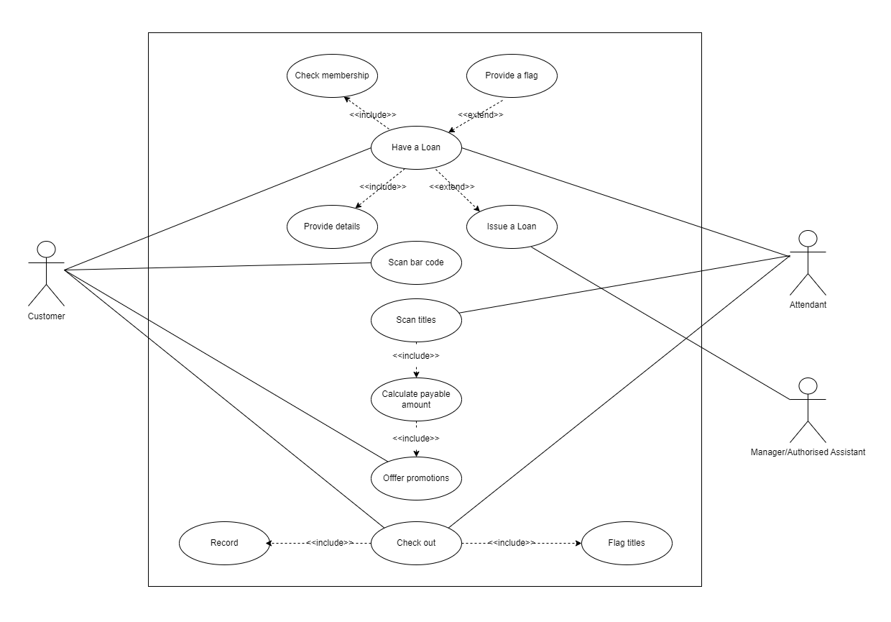
Figure 2: Use Cases Diagram

Business Processes / Flowchart of Requirements
If you think about the process then you can refer to the following :

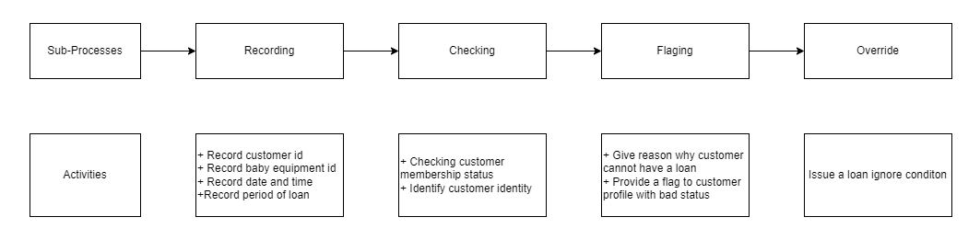
Activtites on the picture can also mean “use case” or “ system function”

Activity Diagram
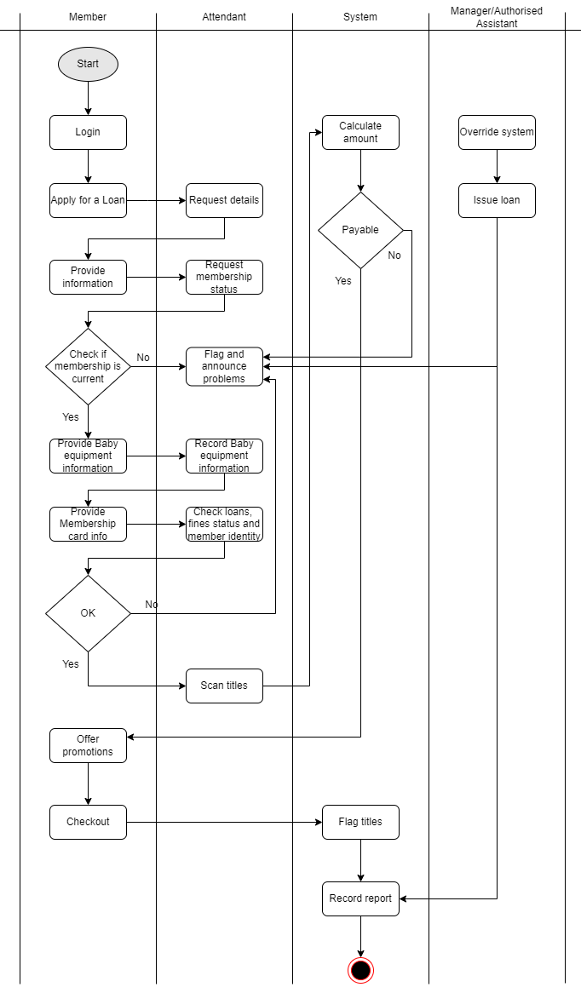
Figure 3: The workflow of process a loan

List of Requirements
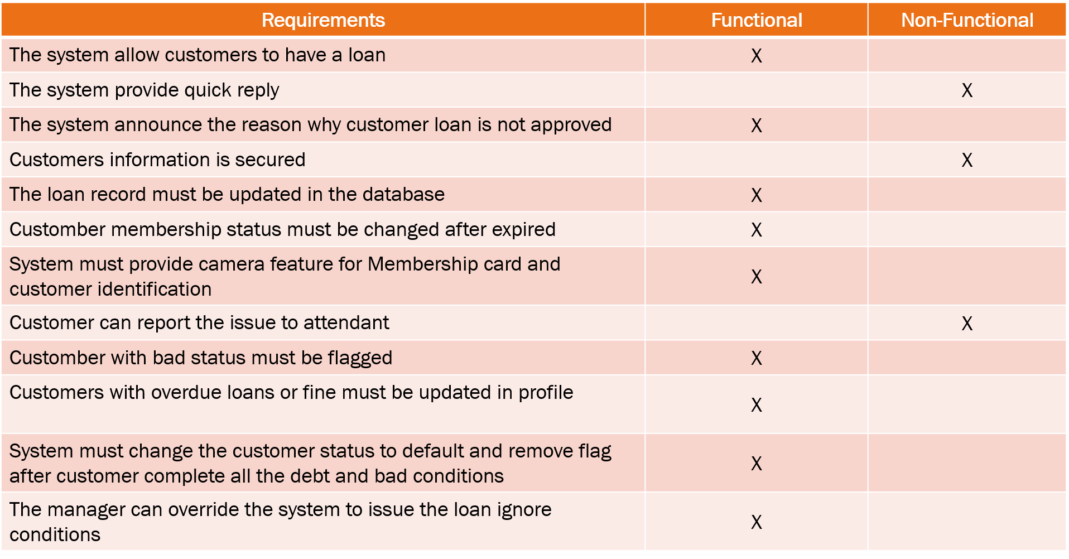

System Requirements Analysis (3.0 points)

Translate from Business Use Case

System Narrative

Customer have a bad finance or they want to use to sevice:
- The customer chooses Have a loan service when purchasing the item. Then, taken to an attendant.
- The attendant requires information about the customer and the baby equipment they want.
- The customer provides Membership card information
- After checking, the attendant approves the loan and updates the loan information.
- Customer profile update with the loan status and period of loan.
Alternate scenario – Customer has bad status and be flagged in profile. The attendant annouces reason why the loan is not approved. – Manager/Athuorised Assistant override the system to issue the loan.

Users and their goals

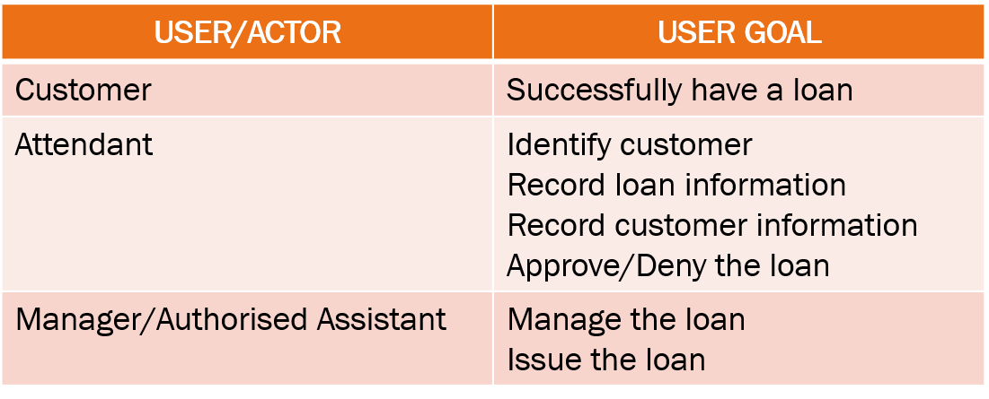

List of Events
List of events and its use case

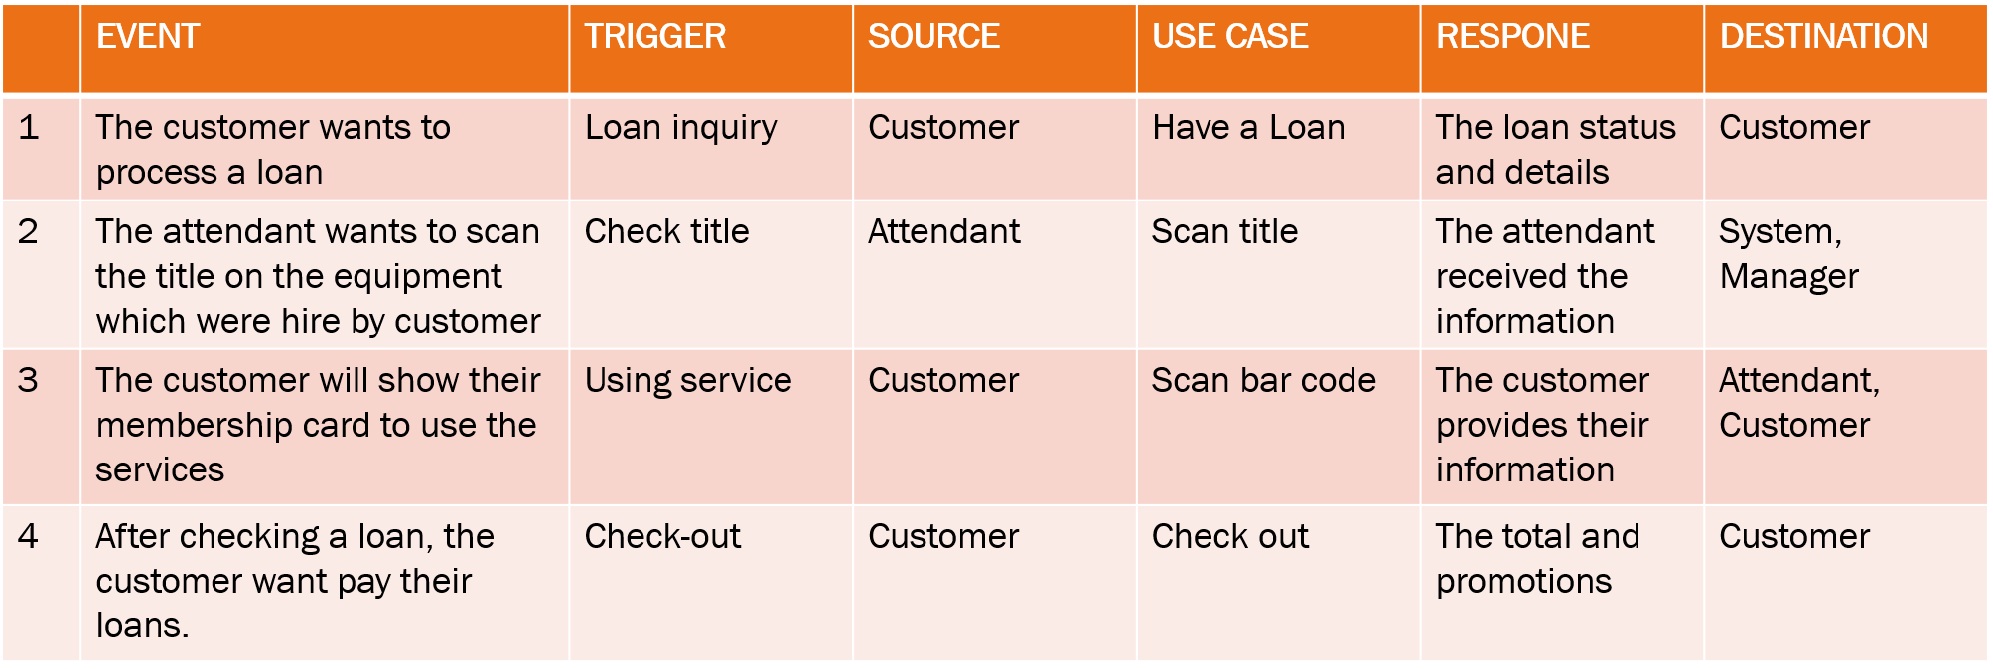

List of Actors
- Customer: interacts with the system to rent and purchase baby equipment include using extrax services . There are three types of member.
  - Local
  - Suburband and global
  - New(after registration successffully)
- Attendant: the representative from the Baby Hut chains that communicate with customers in rental, payment and extrax sercvices.
- Manager: manage the employee and work of the Baby Hut chains include reports and incomes.
- Authorised Assitant: Be able to override the system (iusse loans, reports,…) like Manager.

Use Case Diagram
The use case diagram of Process A Loan System can be draw-able as the following :

Domain Class Model Diagram

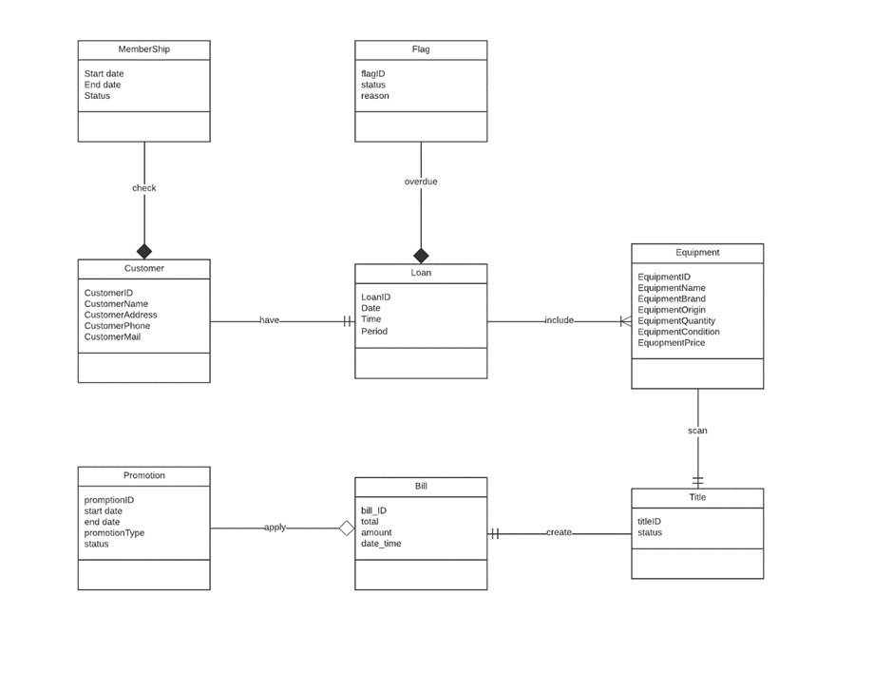

Use Case Descriptions

Use Case: HAVE A LOAN
- Use case : Have a Loan
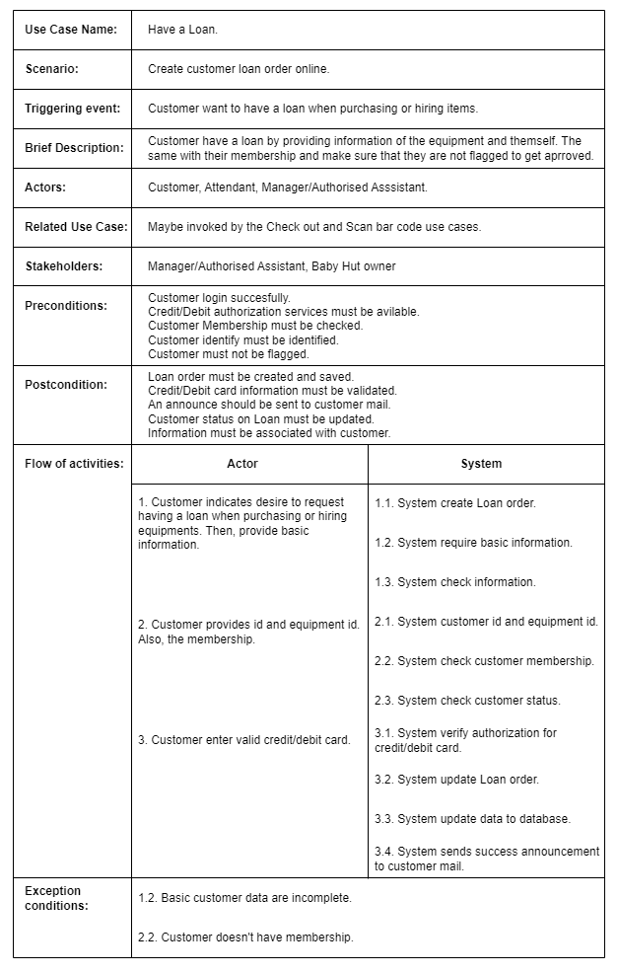

- Activity diagram for Use Case: HAVE A LOAN

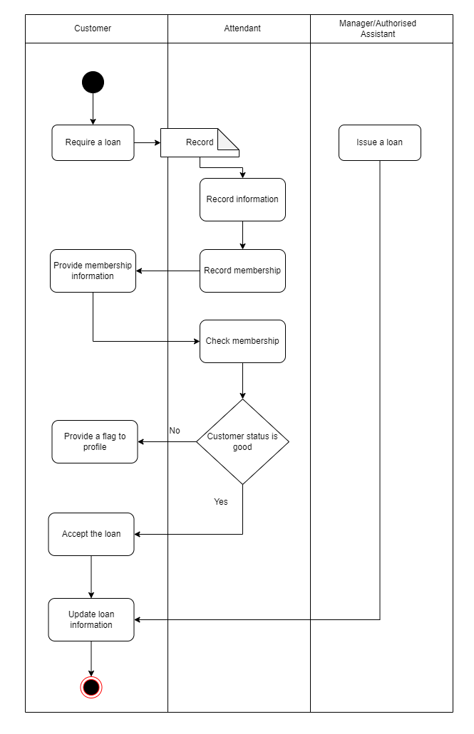

- System sequence diagram for Use Case: Have a Loan

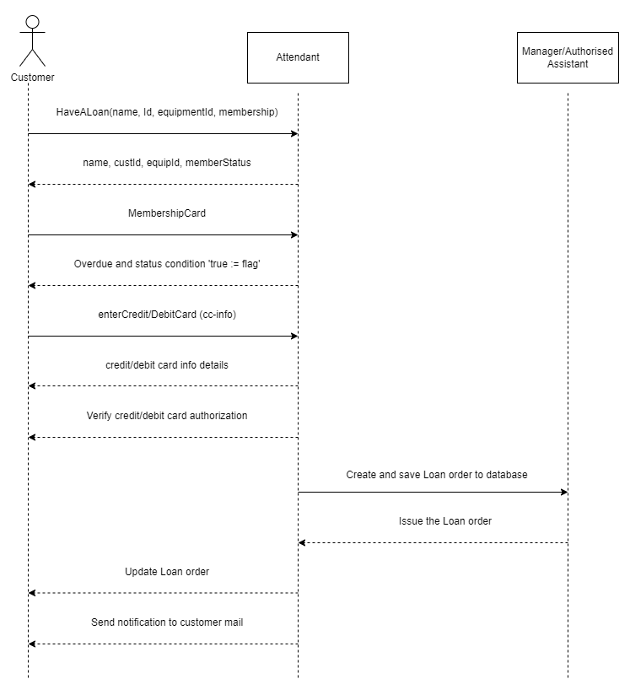
System

Use Case: SCAN BAR CODE

- Use case : SCAN BAR CODE
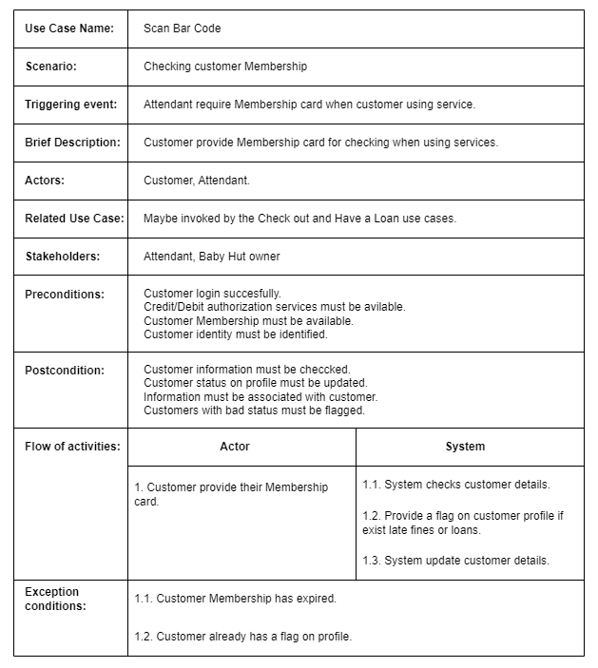

- Activity diagram for Use Case: Scan Bar Code
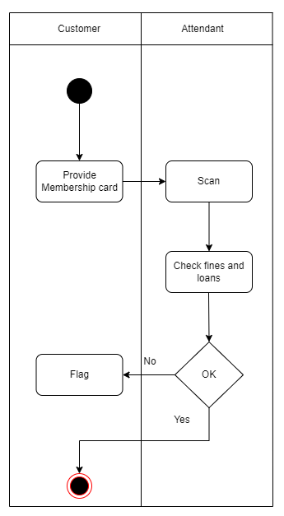

- System sequence diagram for Use Case: Scan Bar Code
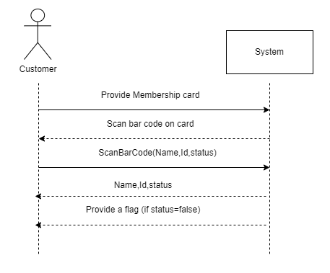

Use Case: Scan title
- Use case : Scan Title
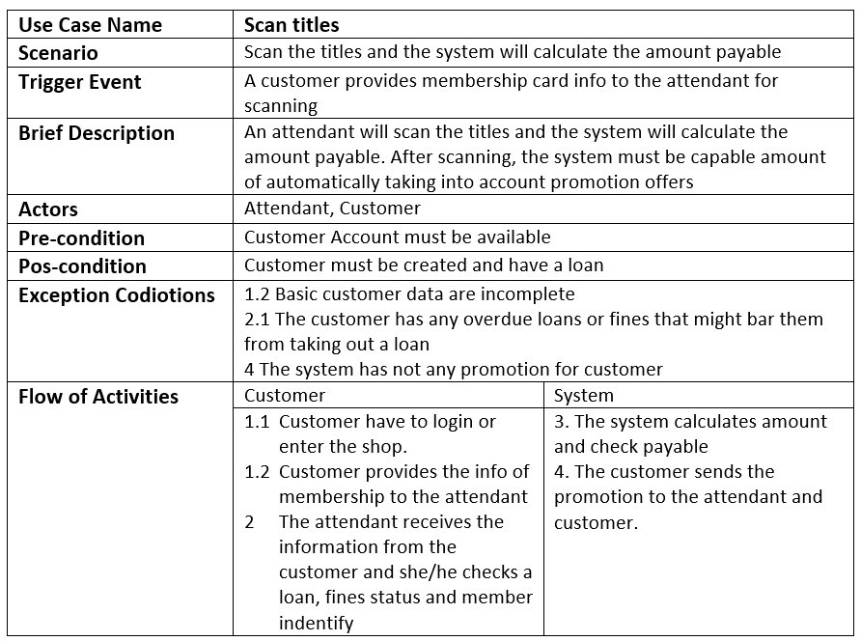

- Activity diagram for Use Case: Scan titles
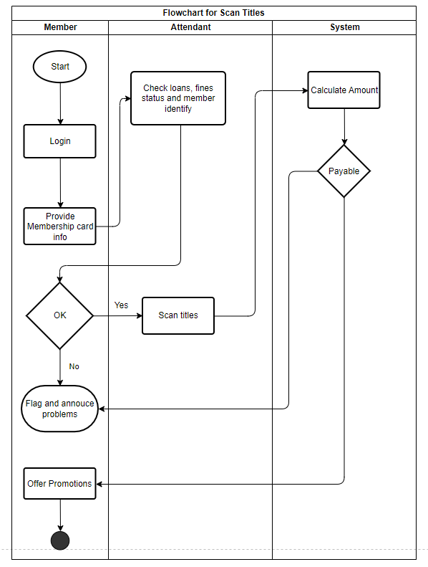
- System sequence diagram for Use Case: Scan titles
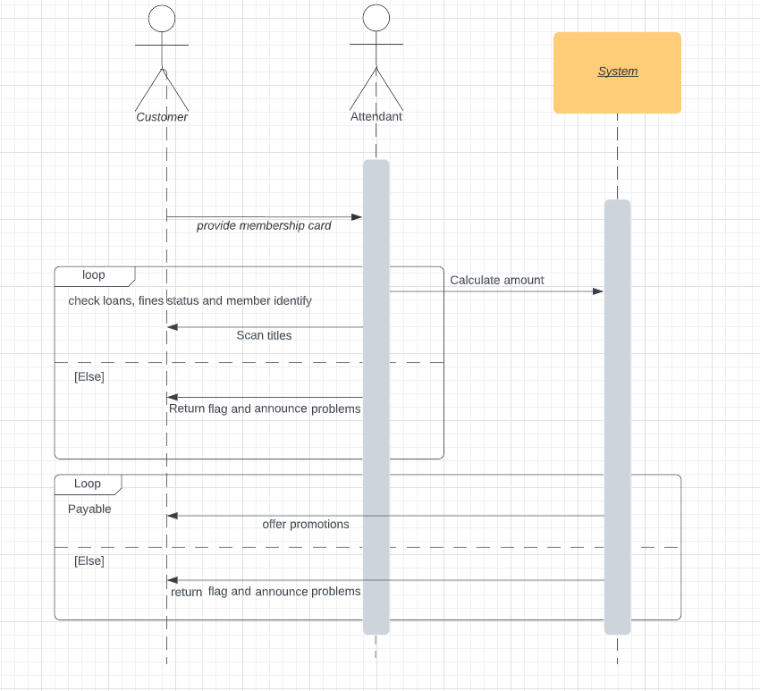

Use Case: Check out
- Use case : Check out
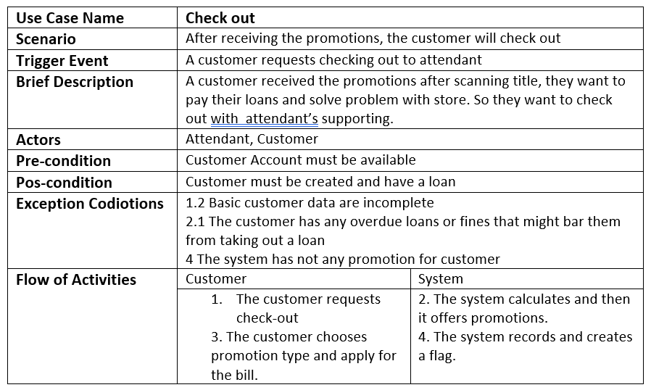

- Activity diagram for Use Case: Check out
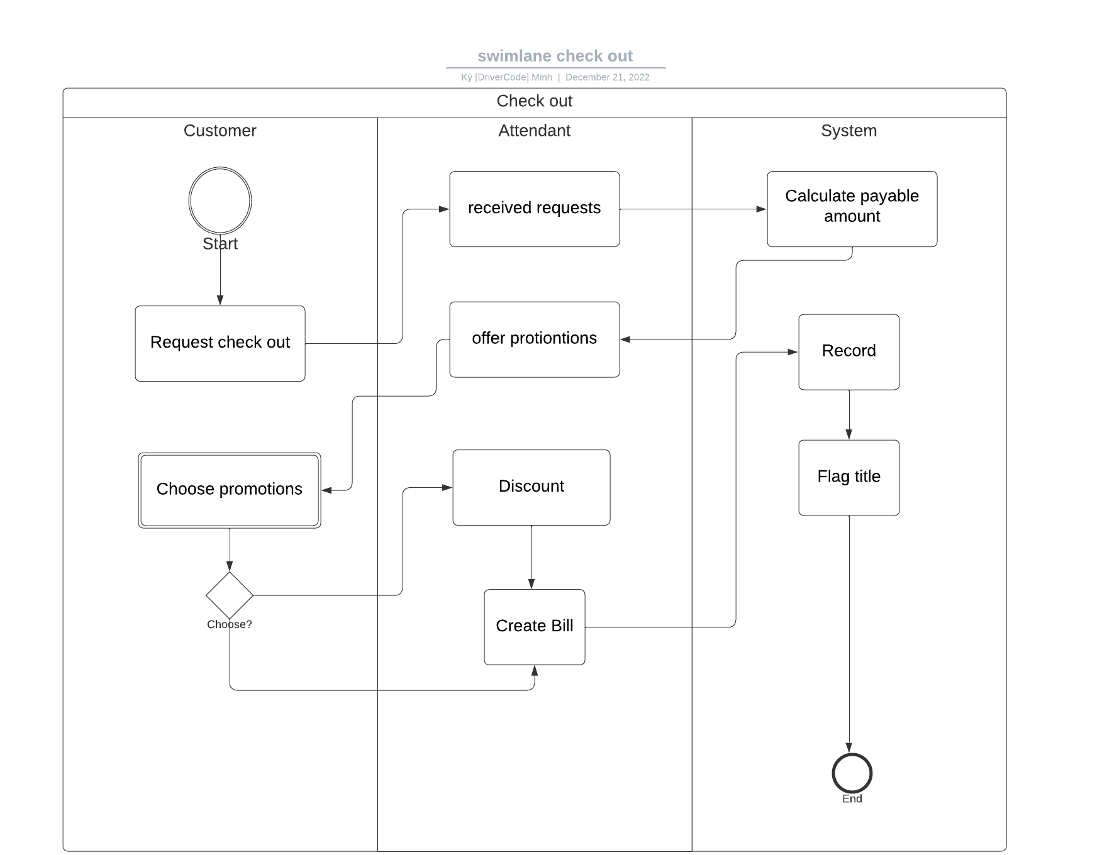
- System sequence diagram for Use Case: Check out

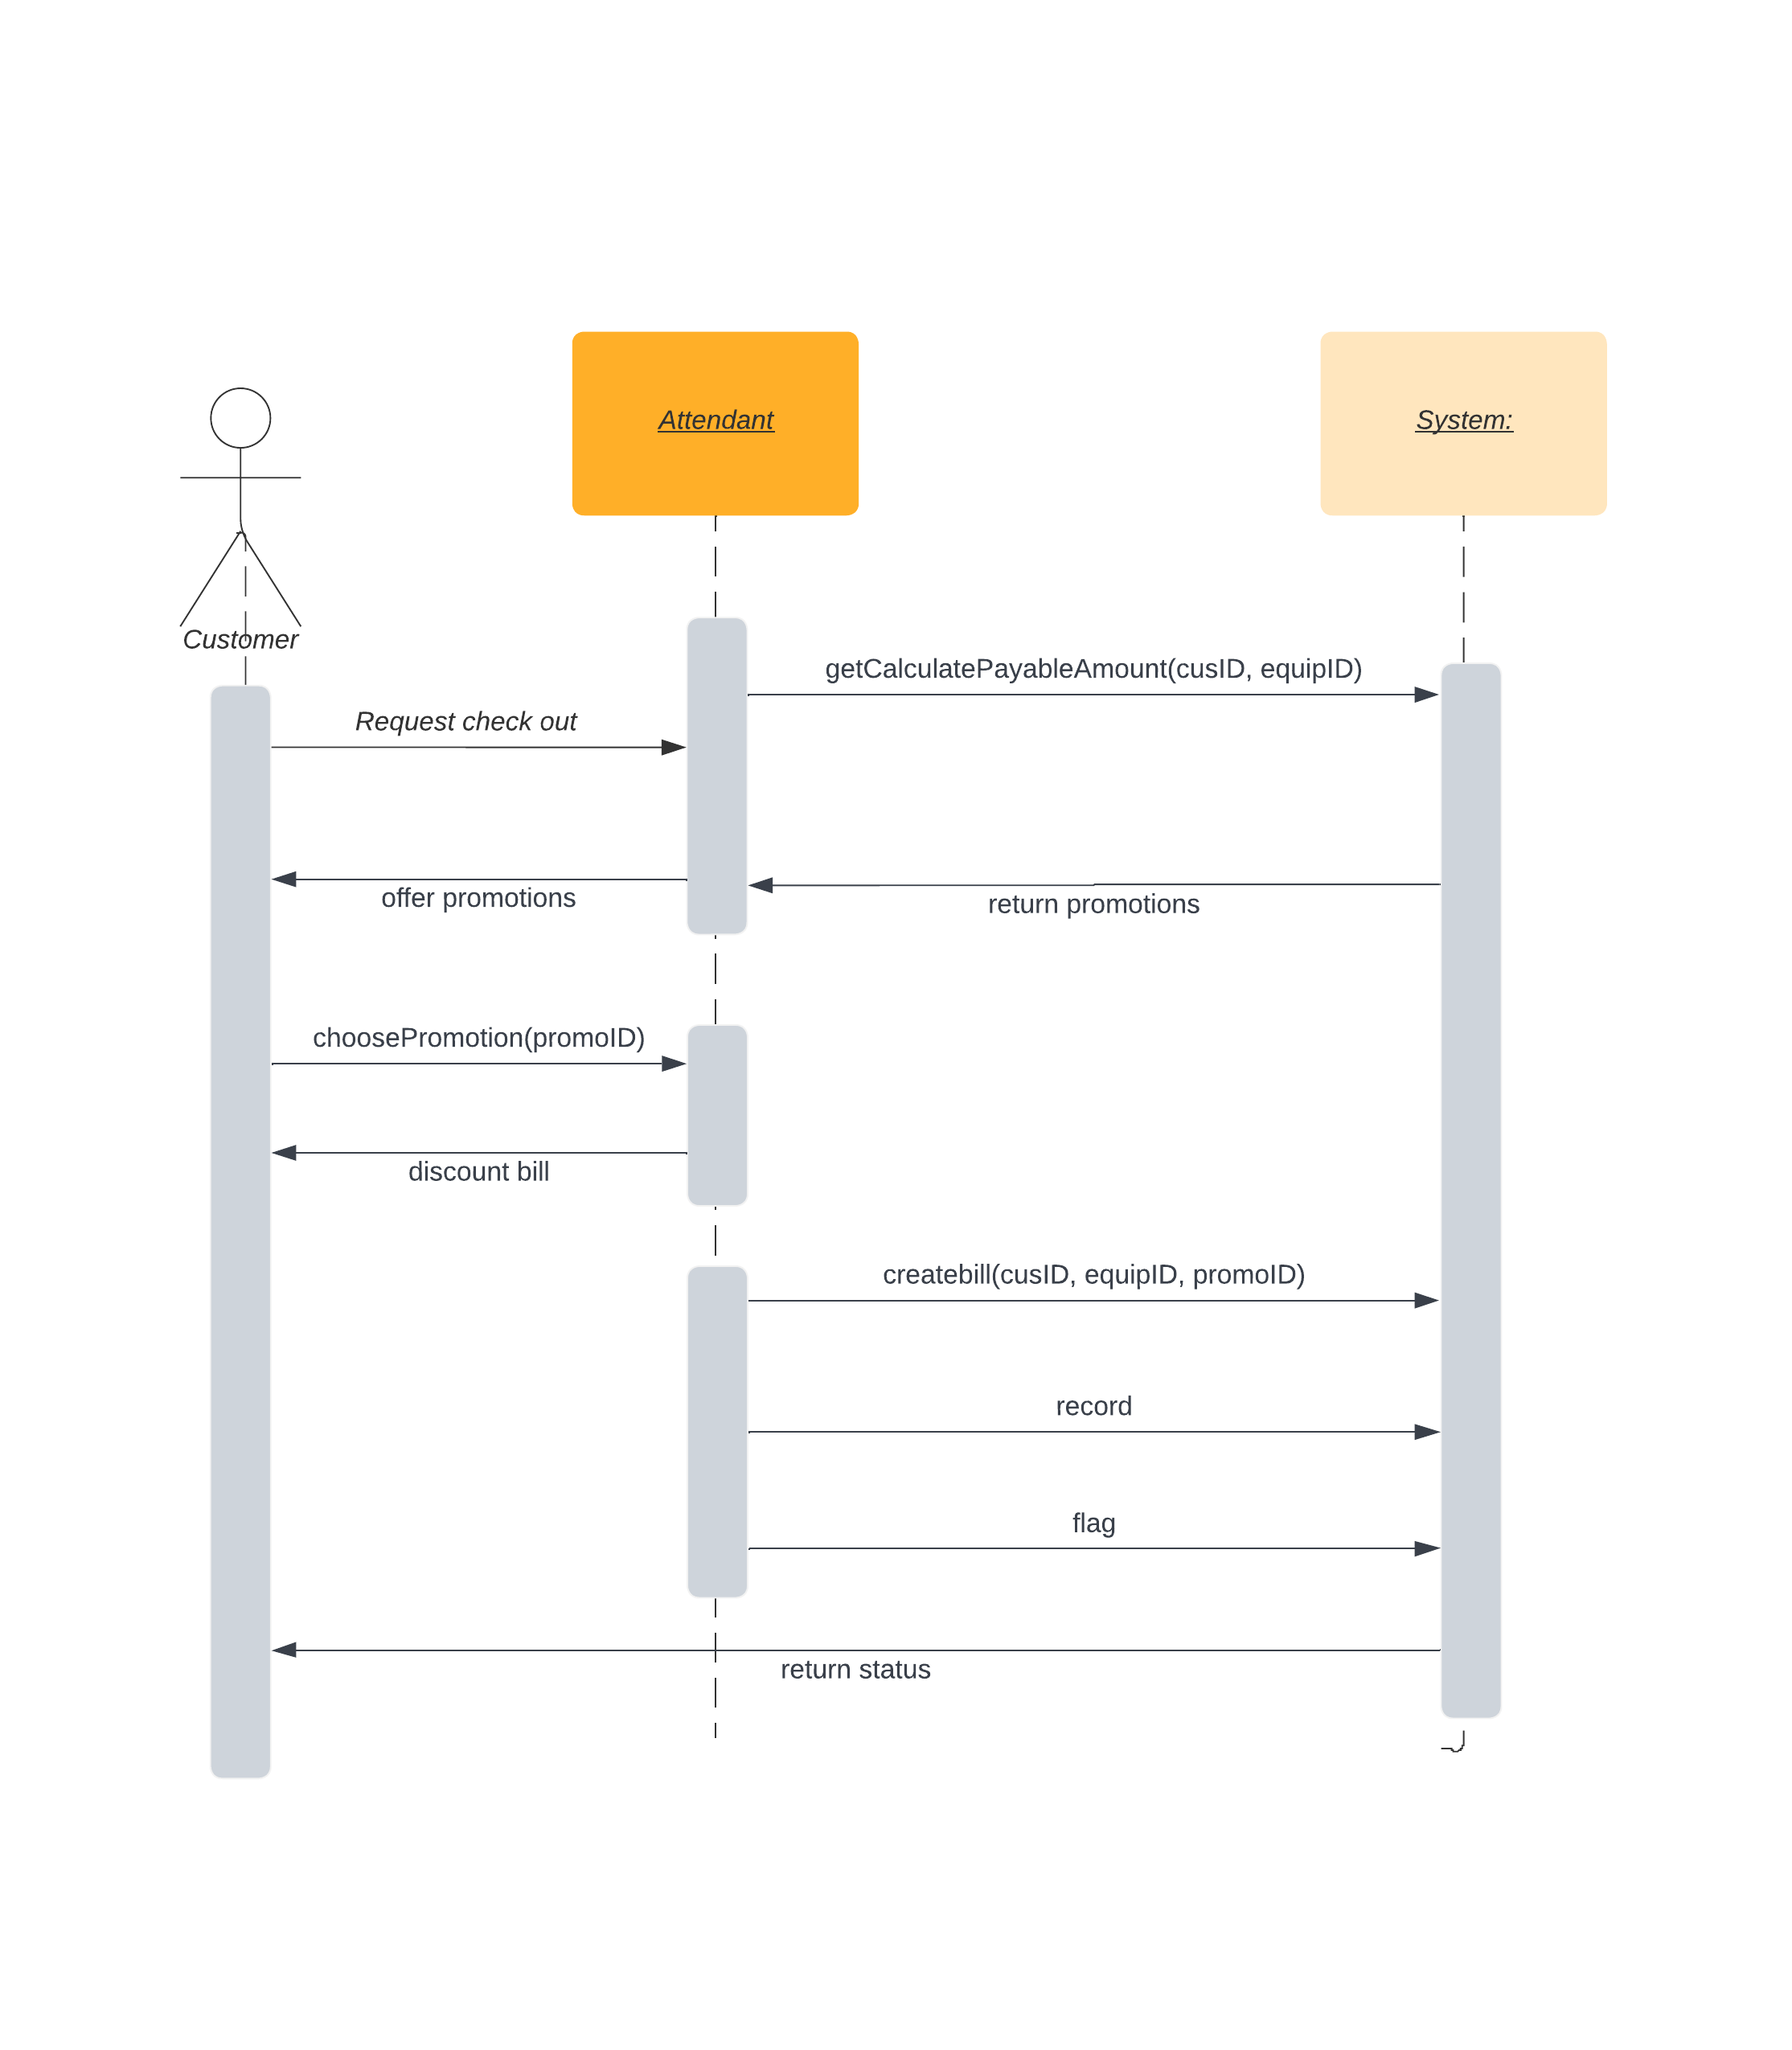
Verifying use cases for Actor

Verifying uses cases: Name 1 for Customer

Data entity/domain class | C R U D | Verified use case
Customer | Create | Create customer account
 | Read/report | Look up customer  Produce customer usage report
 | Update | Process account adjustment  Update customer account
 | Delete | Update customer account (to archive)

Verifying uses cases for Actor 2

Data entity/domain class | C R U D | Verified use case
 | Create
 | Read/report
 | Update
 | Delete

Verifying uses cases for Actor 3

Data entity/domain class | C R U D | Verified use case
 | Create
 | Read/report
 | Update
 | Delete

Verifying uses cases for Actor 4

Data entity/domain class | C R U D | Verified use case
 | Create
 | Read/report
 | Update
 | Delete

System Requirements Design (3.0 points)
This part is to conduct from Analysis to Design:
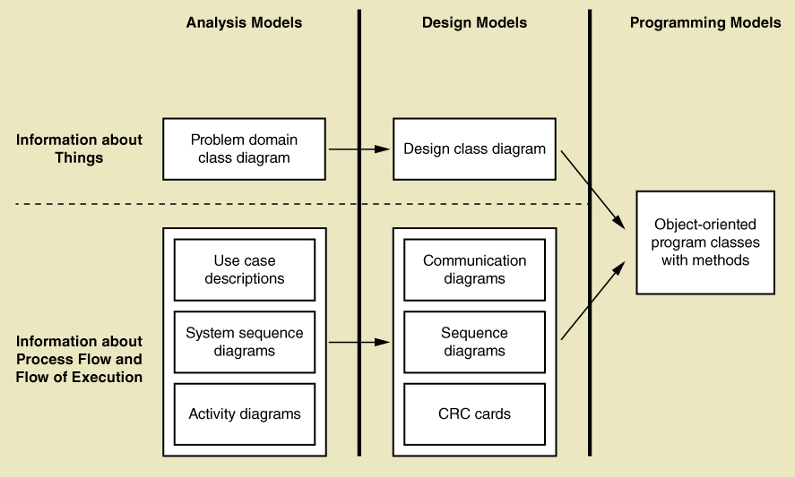
For this part, you should complete Design Models Diagram as above.

Design Class for Have a Loan

Design Classes in Detailed Design

Convert Domain Classes to Design Classes

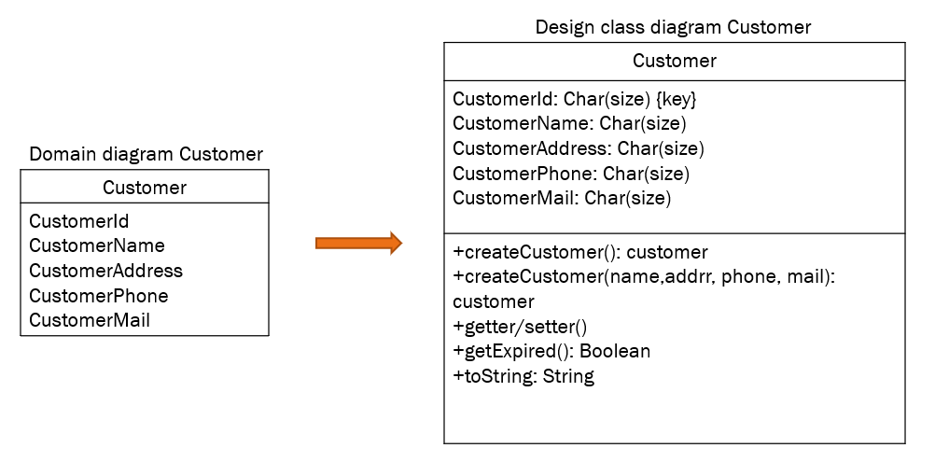
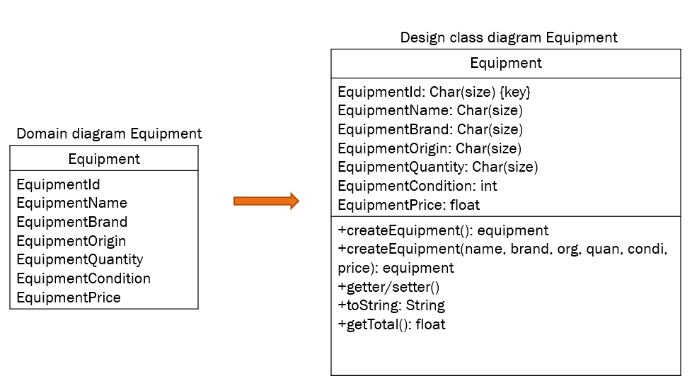
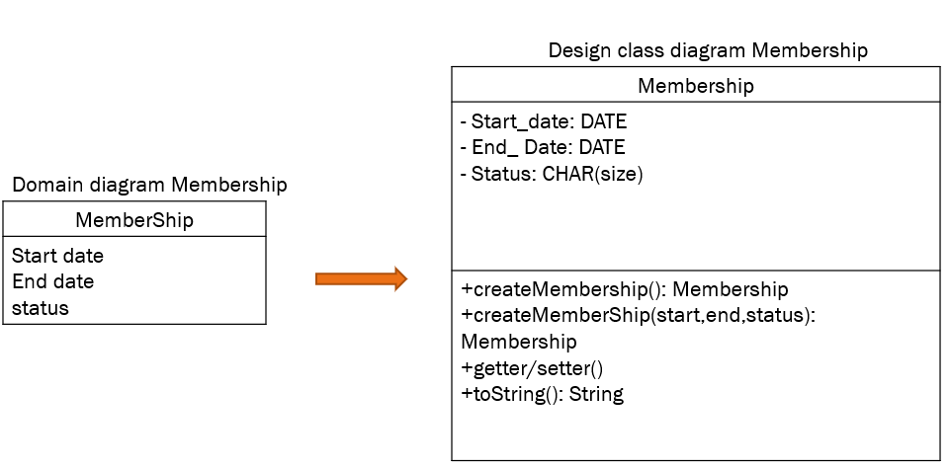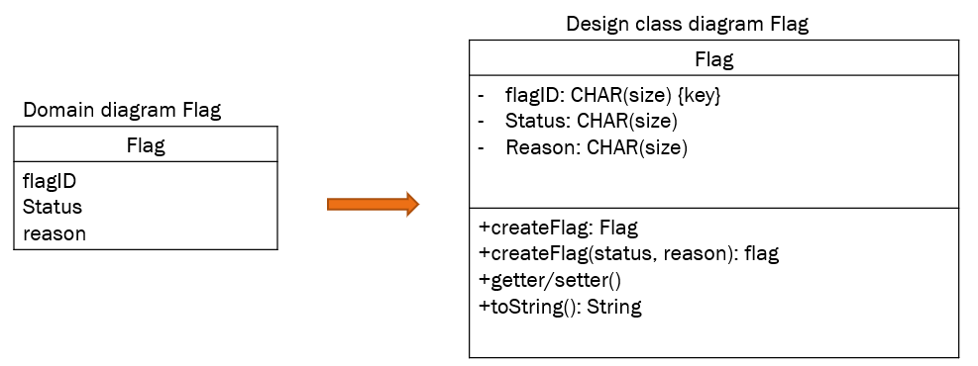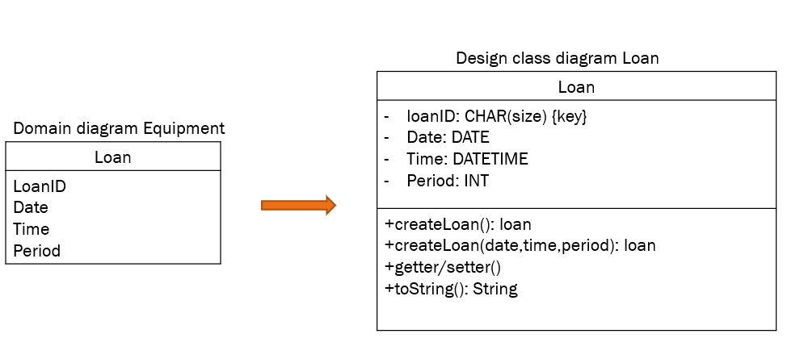

Design Class Diagram

Domain Design Class
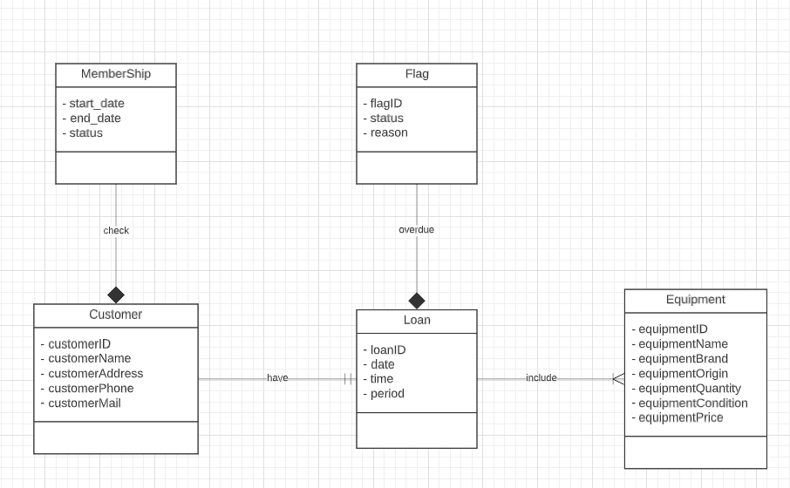

Controller
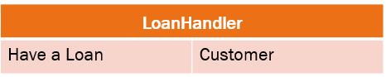
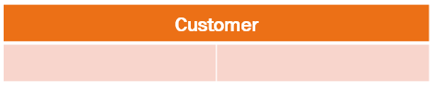

UI
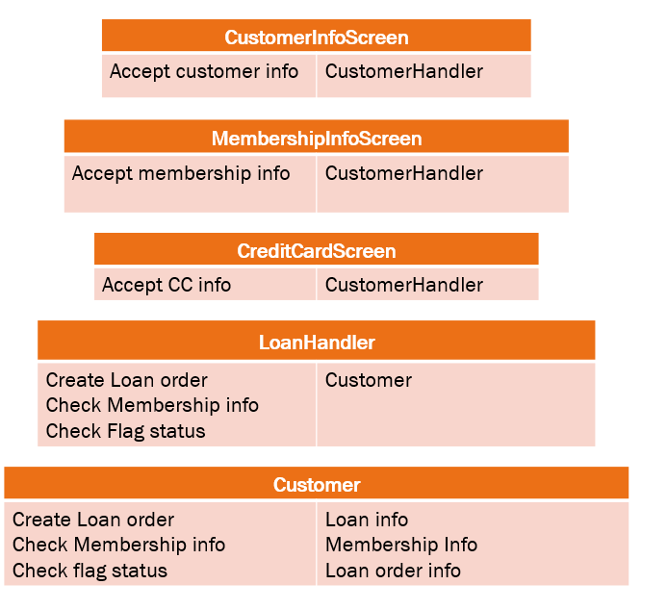

Data Access

Design Class

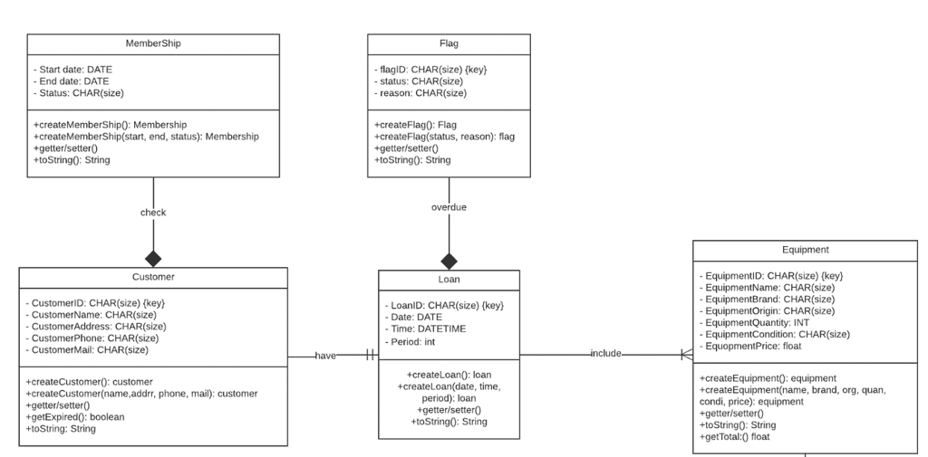

OOD with Sequence Diagram

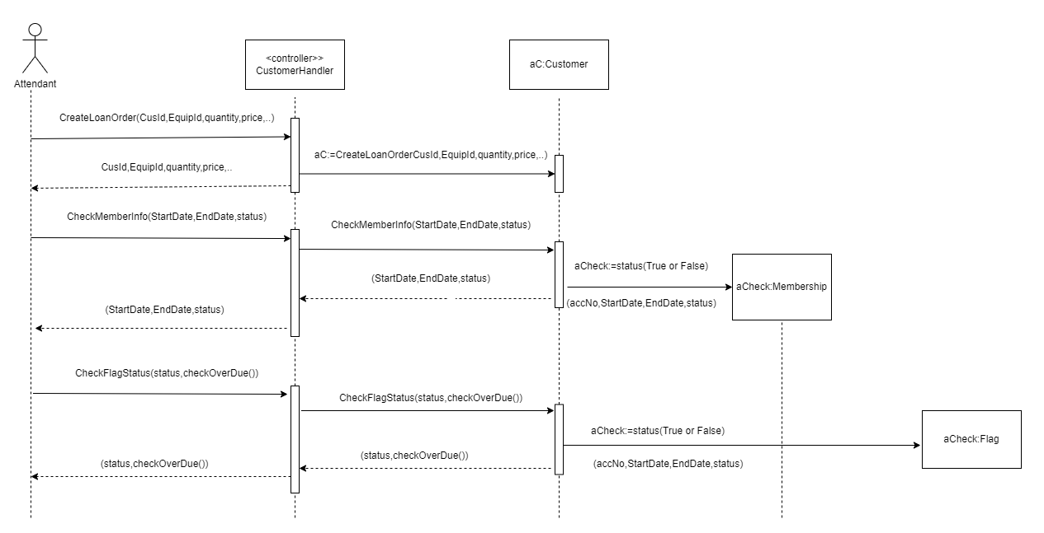

Final Design Class Diagram
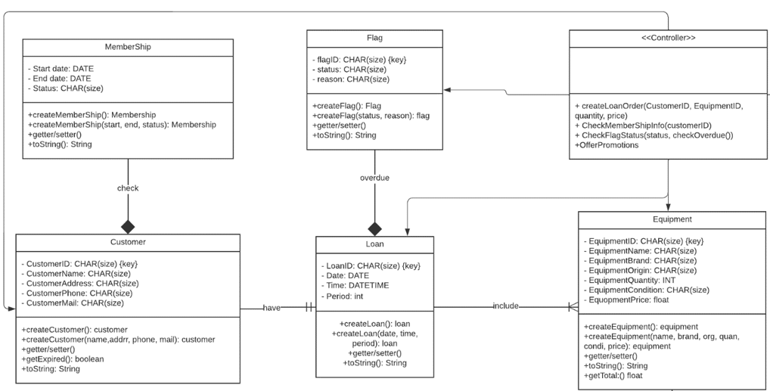

Design Class for Scan Bar Code

Design Classes in Detailed Design

Design Class Diagram

Domain Design Class

Controller
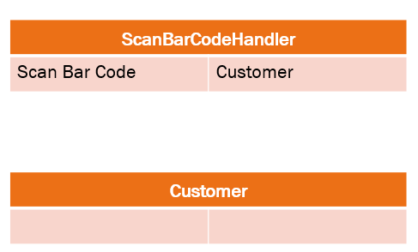

UI
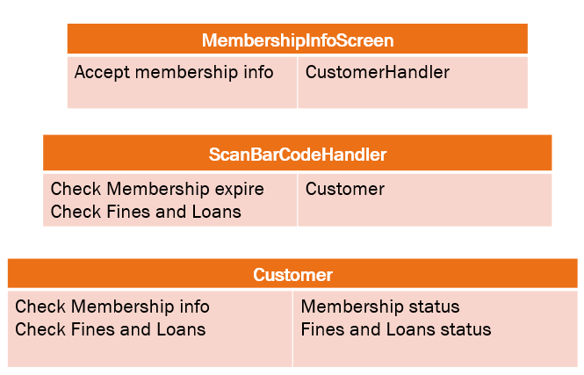

Design Class
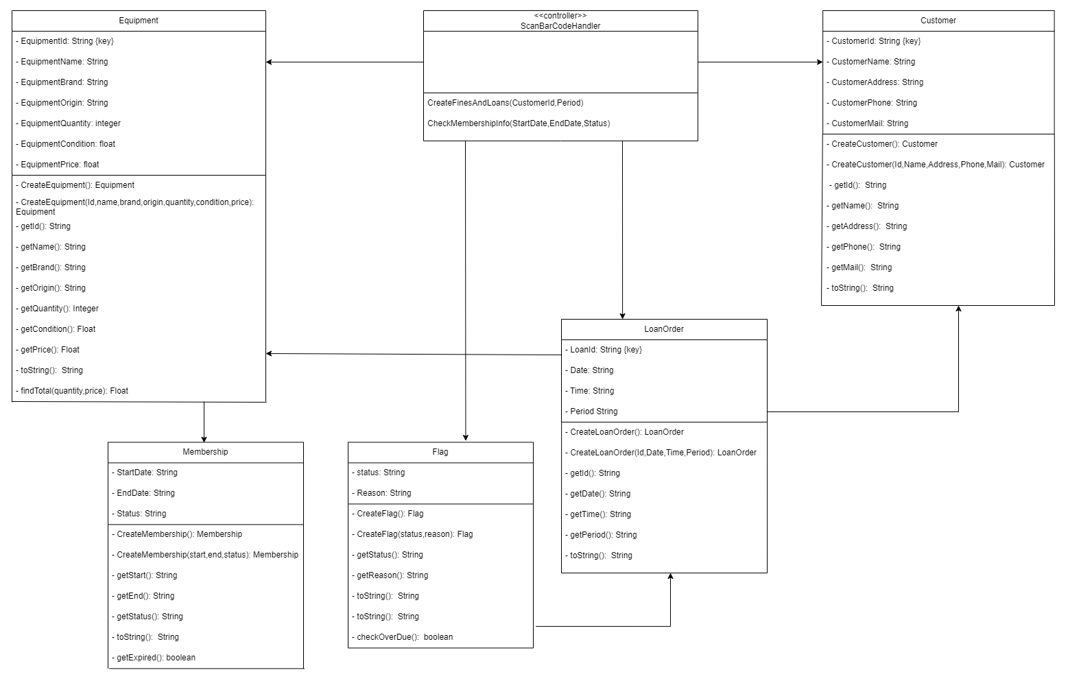

OOD with Sequence Diagram
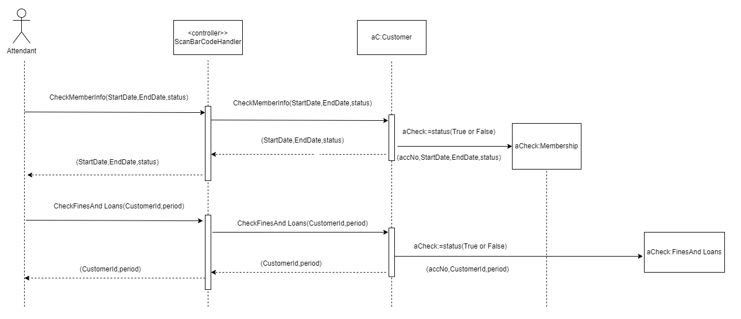

Final Design Class Diagram

Design Class for Scan titles

Design Classes in Detailed Design

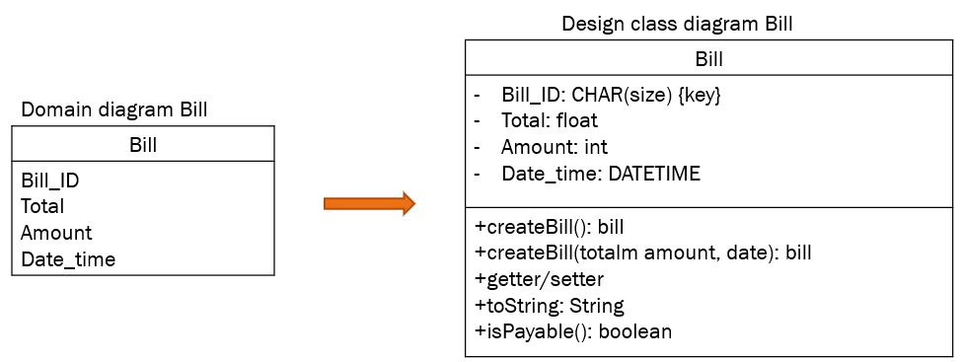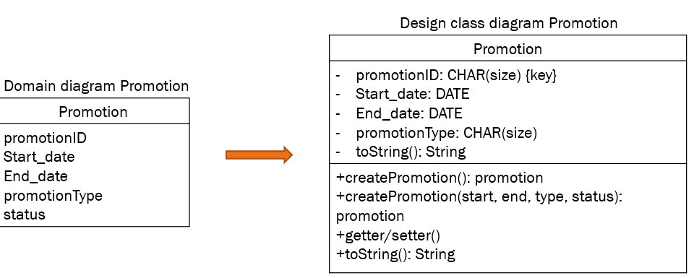
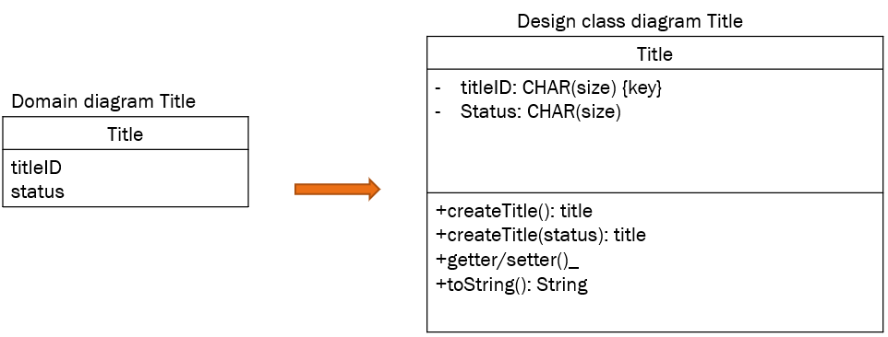

Domain Design Class
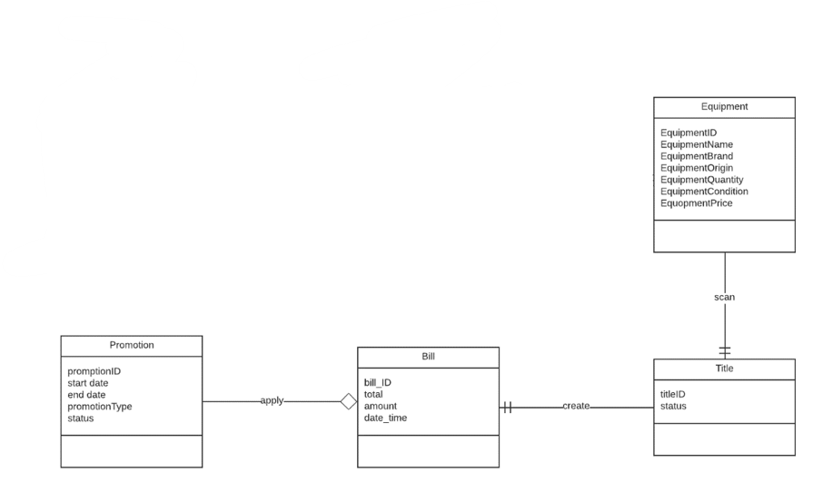

Controller
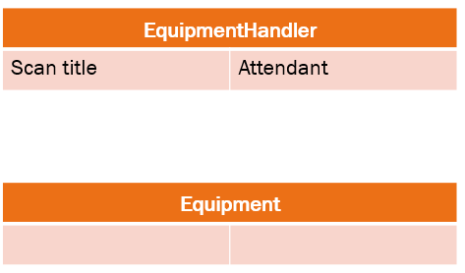

UI
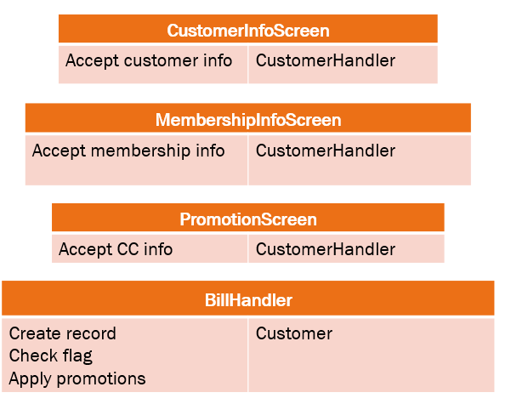

Design Class
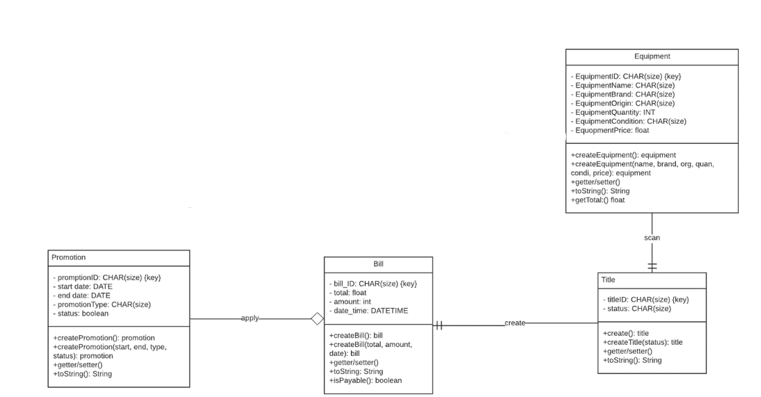

OOD with Sequence Diagram
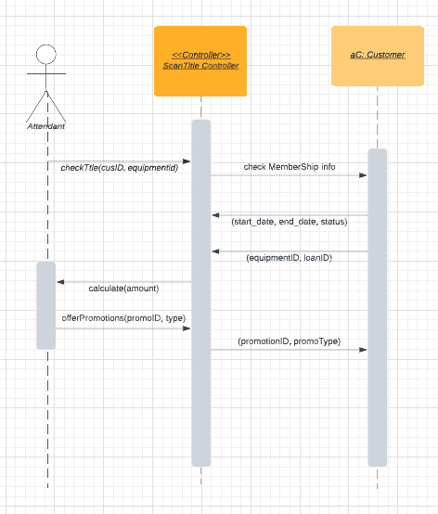

Final Design Class Diagram
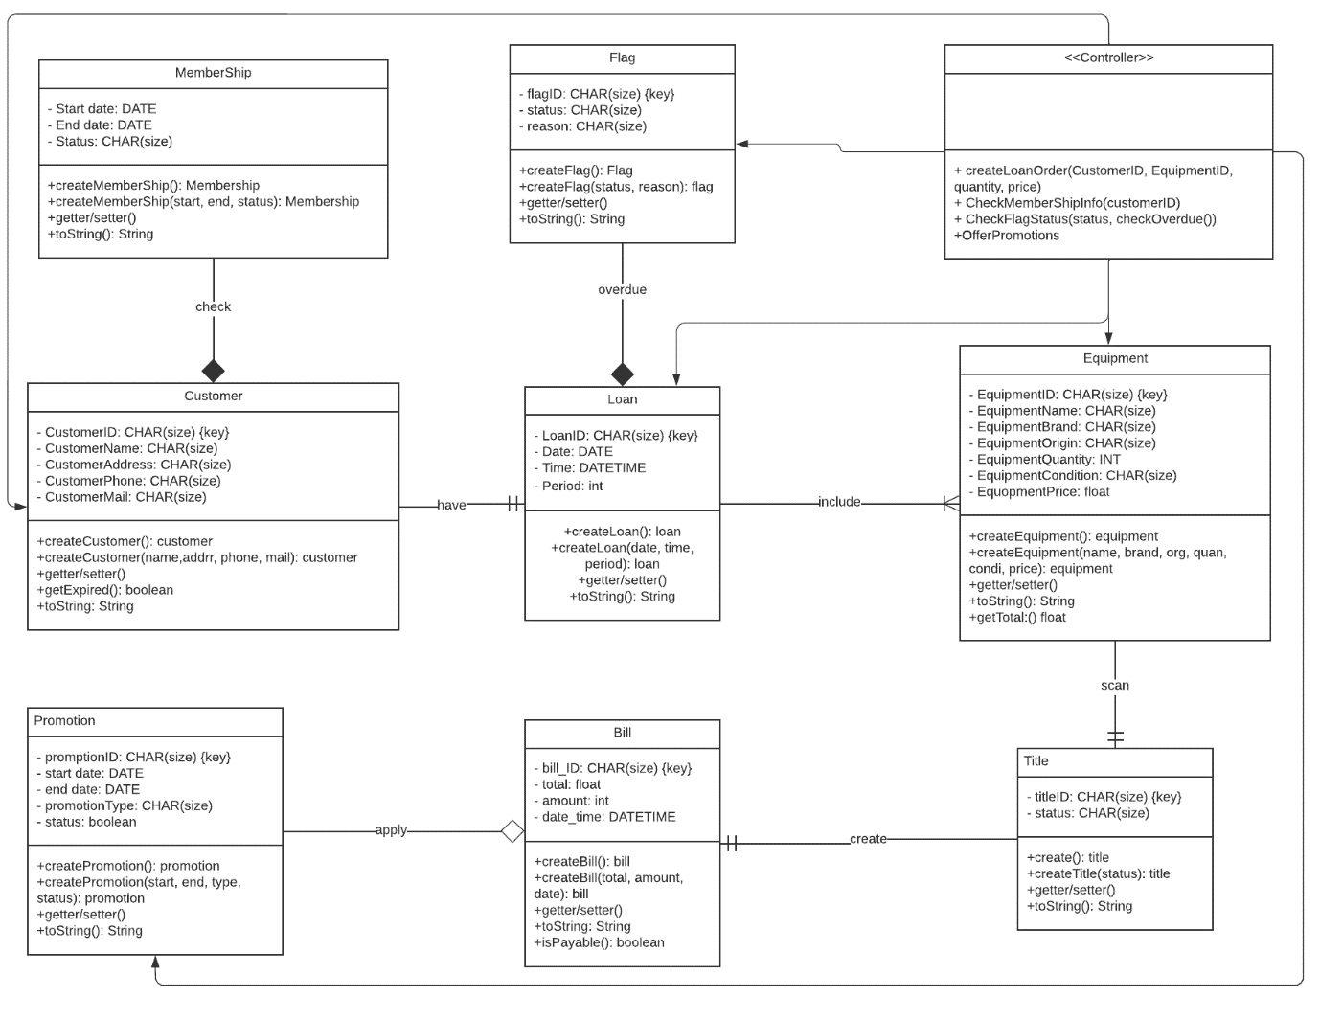

Design Class for Check out

Design Classes in Detailed Design

Domain Design Class

Controller
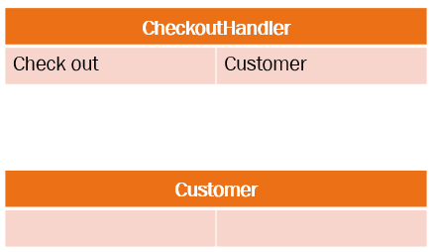

UI
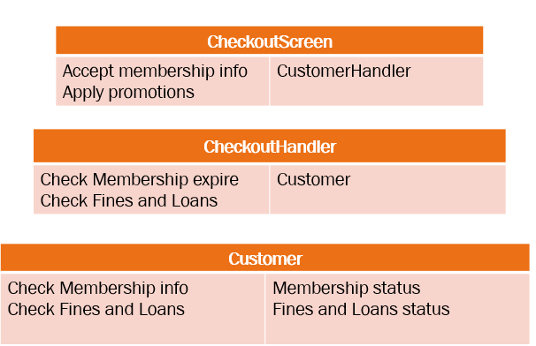

Design Class

OOD with Sequence Diagram
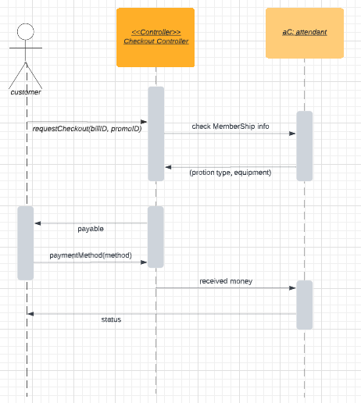

Final Design Class Diagram

System Requirements Implementation (2pts)

Package Diagram for Sub System
Develop architecture of your sub-system by package diagram

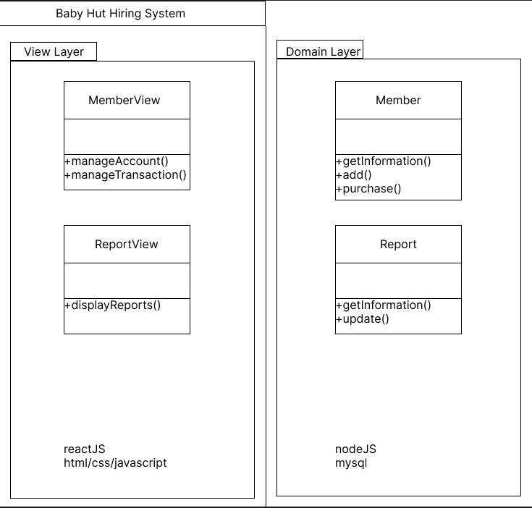

Implementation

UI design
Design prototype of your sub-system

SQL Code
- Create Database
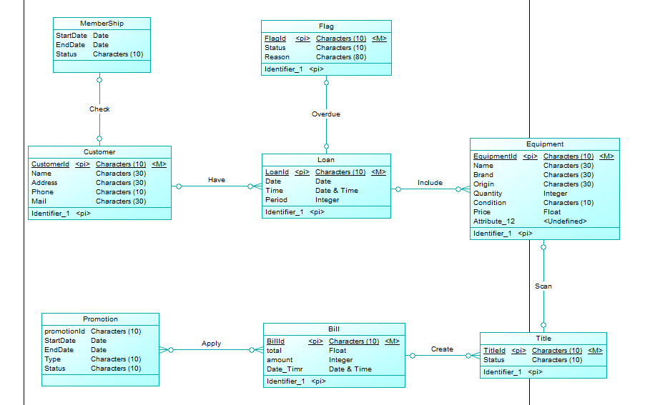

- Create Table
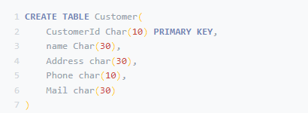

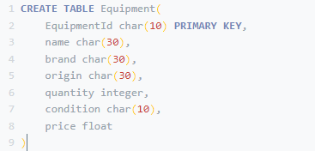

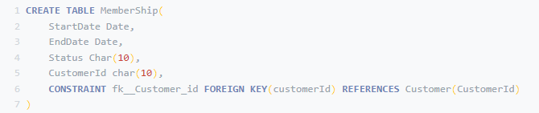

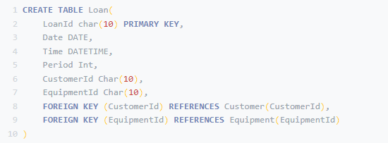

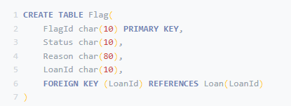

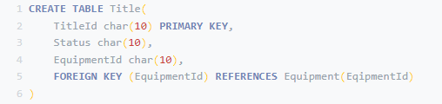

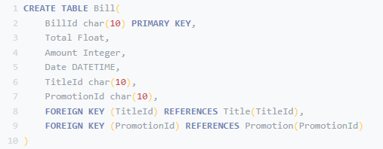

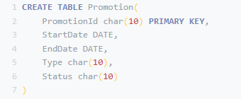

Software Classes Method Code
- C#, VB.NET, JAVA
Write the Code for the Design Class to Implement
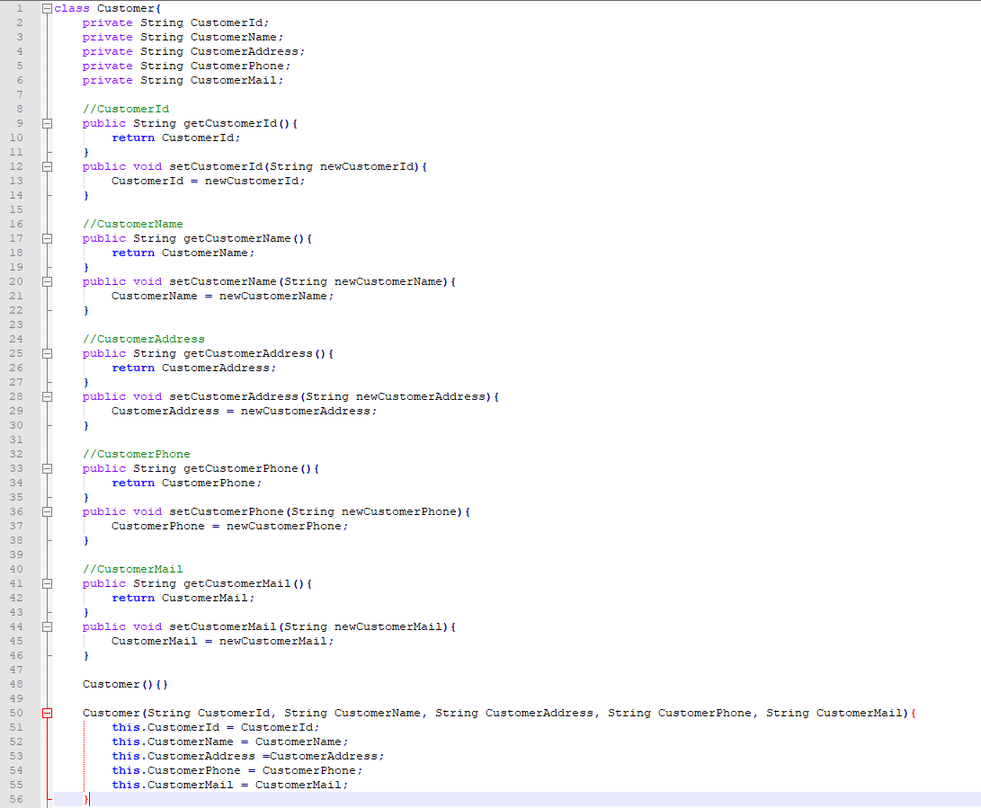

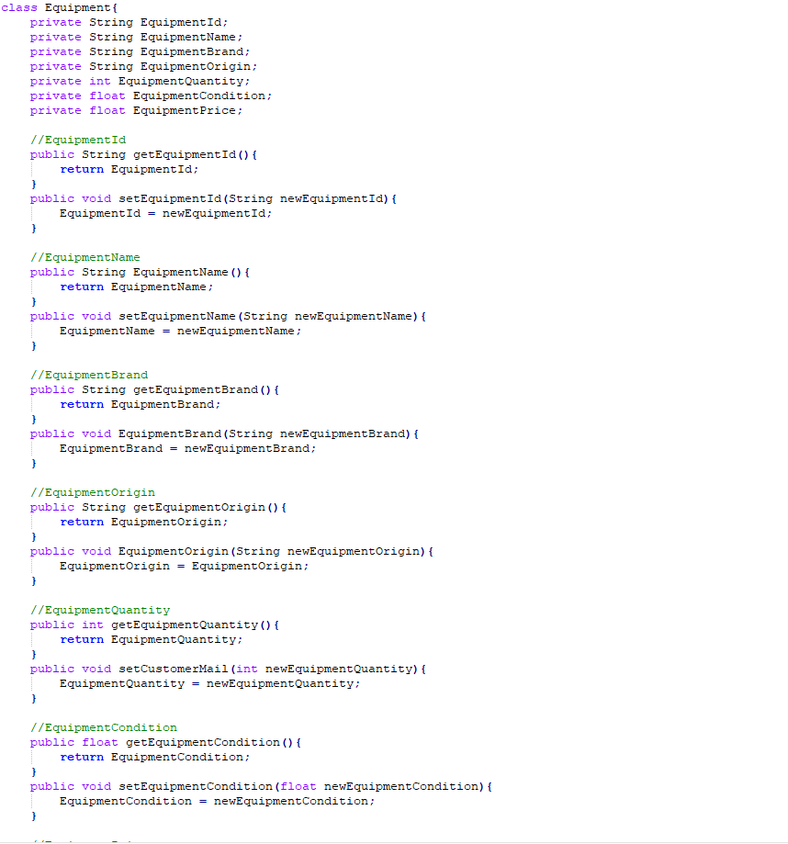

SYSTEM TESTING, DEPLOYMENT AND DEMONSTRATION (1.5 pts)

Testing: Test plan & Test case
Proposed your Test plan for this part, you should develop each use case for each test case
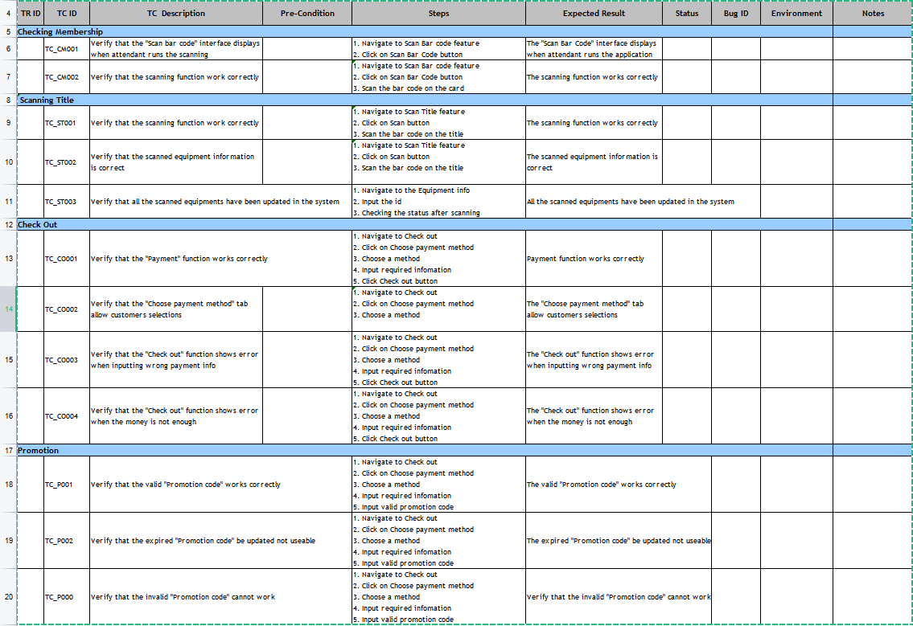

Deployment
Propose your plan to deploy the sub-system
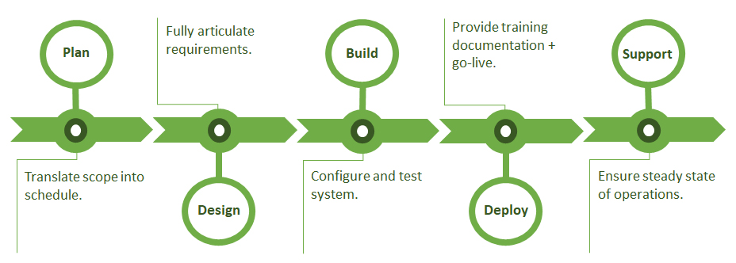

Demonstration
Demo your sub-system: can be a prototype with steps how to use your sub-system or your developed software for sub-system
The step to use:
+ Choose Create Loan order
+ Input basic information of customer and required equipments
+ Choose scan Membership to check customer Membership status. Furthermore, checking if exist late fines or loans
+ Tick on Flag of customer ID if the status is bad
If the Loan order is approved:
+ Choose scan Title to update info of required equipments
+ Customer then be moved to Check out
+ Customer can input Valid Promotion if it still not expired

Conclusions/ Recommendations (0.25 point)
This system is just a functional process without complicated process so far. The identified actors play an important role to the full functioning of the business,….

References
- Slide Requirements Modelling

- Book-MultiAuthor, Gra

Internet Link:

- http://www.uml-dox.net/Addison.Wesley-UML.for.Mere.Mo/0321246241/ch02lev1sec6.html

Appendix
Please see next page

Appendix 1: the Full size of use case Diagram

Appendix 2: the full size of Collaboration Diagram

Appendix 3: the full size of Class Diagram

