VIBRATION DEVICE

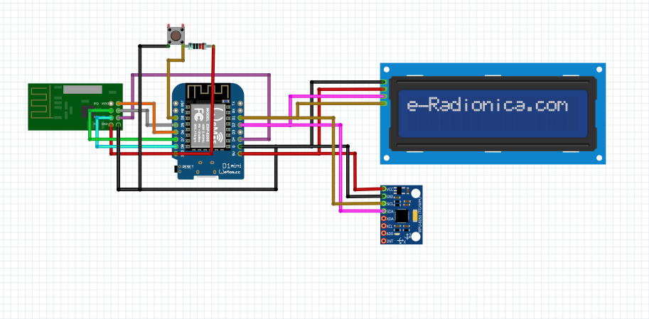

NRF24L01

LCD

VIBRATION SENPR

CURRENT DEVICE

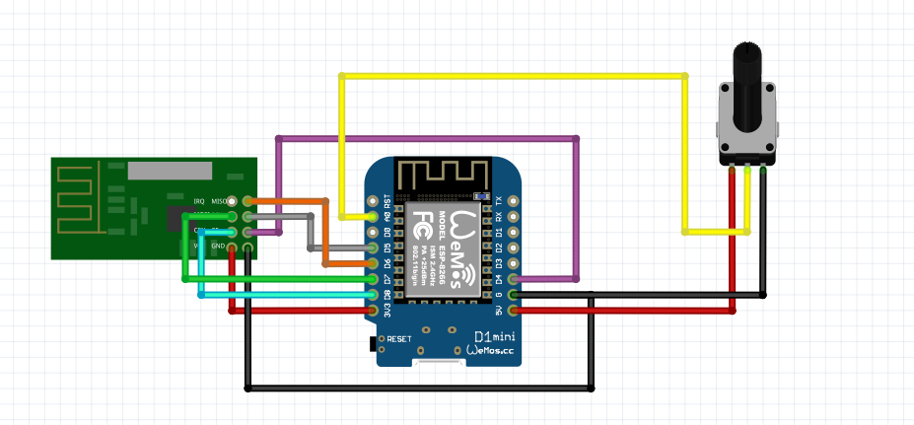

CURRENT SENSOR

NRF24L01