Barangay Incident Report Management System

I. Introduction
In every barangay, maintaining peace, order, and safety within the community is a top priority. The barangay serves as the smallest political unit in the Philippines, yet it plays a crucial role in governance, conflict resolution, and public safety. One of its essential responsibilities is the documentation and management of incident reports—ranging from minor disputes and accidents to major violations of laws or ordinances. These records serve as vital references for decision-making, legal actions, and community safety improvements.
Traditionally, barangays rely on manual methods of recording incidents through logbooks and handwritten reports. Although this approach has been practiced for decades, it often results in inefficiency and data management issues such as loss of information, redundancy, and difficulty in retrieval. During emergencies or investigations, barangay officials may face challenges in locating specific incident records, which can delay appropriate action and response. As the volume of incident reports increases, the manual system becomes even more difficult to manage effectively.
With the continuous advancement of information technology, the need for a digital solution has become more evident. Automating the process of incident recording and management allows barangay officials to access accurate and organized data in real time. The proposed Barangay Incident Report Management System (BIRMS) provides an innovative way to store, process, and retrieve incident-related information efficiently. It enables barangay staff to log incidents electronically, generate reports instantly, and track the progress or resolution of each case through a centralized database.
Moreover, this system promotes transparency, accountability, and accessibility among barangay officials. It also reduces the dependency on paper-based documents, minimizes human errors, and ensures that vital information is properly secured and backed up. The development of this system aligns with the government’s vision of digital transformation and good governance at the grassroots level.
In essence, the Barangay Incident Report Management System serves as a modern approach to community data management. It bridges the gap between traditional record-keeping and modern technology, empowering barangay offices to perform their duties more efficiently and deliver better services to their constituents.

II. Problem Statement
The barangay, being the smallest unit of government, serves as the primary planning and implementing arm of national policies and community programs. One of its major functions is to maintain peace and order by properly recording and addressing incidents within its jurisdiction. However, the manual system currently used by most barangays to document incidents has proven to be inefficient, error-prone, and outdated in today’s fast-paced environment.
The traditional approach involves writing incident details in logbooks or printed forms, which are then manually filed and stored. Over time, this method results in numerous challenges. Physical records are prone to damage, loss, or misplacement due to poor storage conditions or unforeseen disasters such as fire or flooding. Retrieving specific records from large volumes of files can also be time-consuming, especially during emergencies or legal proceedings. Furthermore, the absence of a digital system makes it difficult to monitor incident trends, analyze data, or generate summary reports that could aid in decision-making.
Another issue observed is the inconsistency and redundancy in record-keeping. Since the process depends heavily on human input, there is a high tendency for errors in data entry and incomplete information. Some reports may even be duplicated or lost due to unstandardized documentation procedures. These inefficiencies hinder the barangay’s ability to respond quickly and accurately to community concerns.
With these problems identified, there is a pressing need for a computerized Barangay Incident Report Management System that will automate the process of recording, storing, and retrieving incident data. The system should ensure accuracy, security, and accessibility of information while reducing the workload of barangay staff. By implementing such a system, barangays can improve the efficiency of their operations, enhance transparency, and provide better service to their constituents.

III. Objectives
General Objective:
The main objective of this study is to design and develop a Barangay Incident Report Management System (BIRMS) that will digitalize and automate the process of recording, managing, and retrieving incident reports within the barangay. The system aims to improve the accuracy, efficiency, and accessibility of incident-related information to support effective decision-making and promote good governance at the community level.
Specific Objectives:
- To develop a digital platform that allows barangay officials to create, edit, and manage incident reports in an organized and efficient manner.
2. To provide a centralized database system where all incident records are securely stored and easily retrieved when needed.
3. To enable fast searching and filtering of incident data, allowing users to locate specific reports quickly without the need for manual record checking.
4. To generate automated summary and analytical reports (e.g., daily, weekly, monthly, or annual) that can be used for decision-making and performance monitoring.
5. To ensure data integrity and security by implementing user authentication, role-based access control, and data backup features.
6. To minimize the reliance on paper-based records, thereby reducing human error, physical storage issues, and environmental impact.
7. To enhance the efficiency and accountability of barangay operations by providing a transparent, traceable, and user-friendly system.

IV. Scope and Limitation
The Barangay Incident Report Management System (BIRMS) is developed to streamline and digitalize the process of recording, managing, and reporting incidents within a barangay. It enables authorized officials to create, update, and monitor incident reports, as well as generate summaries such as daily, weekly, and monthly records to support administrative decision-making. The system securely stores data in a centralized database accessible only to authorized personnel. As noted by Laureano et al. (2020), digital transformation in local governance enhances transparency, accessibility, and accuracy in information management. Likewise, Flores and Dela Cruz (2021) emphasize that automating local processes promotes efficiency and accountability among barangay officials.
However, the system also has limitations. It is primarily intended for internal barangay use and does not directly integrate with other government agencies such as the Philippine National Police (PNP) or City Hall. Internet or local network connectivity is required to access the database, and mobile application functionality is not included in the current version. Moreover, the system focuses solely on record management and report generation rather than automated investigation or predictive analysis. The system’s reliability and effectiveness also depend on proper user management, maintenance, and adherence to data privacy protocols, as discussed by Santos et al. (2019) in their study on local government information systems.

Scope:
• The system will allow authorized barangay officials to create, manage, and monitor incident reports.
• It will include incident details such as date, time, location, persons involved, and type of incident.
• The system will store data in a centralized database accessible only to authorized personnel.
• Includes user authentication and access control.
• The system can generate reports (daily, weekly, monthly).
Limitations:
• The system is limited to internal barangay use only and does not automatically connect to other agencies.
• Requires an internet or local network connection.
• Does not include mobile application support in its initial version.
• Does not perform automatic case investigation or tracking.

V. System Requirements
A. Hardware Requirements
Component | Minimum Specification
Processor | Intel Core i3 or higher
RAM | 4GB or higher
Storage | 500GB HDD or 128GB SSD
Monitor | 15 inches or above
Printer | Optional (for printing reports)
B. Software Requirements
Component | Specification
Operating System | Windows 10 or higher / Linux (Ubuntu)
Programming Language | Python 3.8 or higher
Framework | Flask or Django (for web-based version)
Database | SQLite / MySQL
Frontend Technologies | HTML, CSS, Bootstrap, JavaScript
IDE / Code Editor | PyCharm / Visual Studio Code
Web Server | Built-in Flask/Django server or Apache (optional)
Browser | Google Chrome or Mozilla Firefox
Other Tools / Libraries | pandas, SQLAlchemy, Jinja2, reportlab (for report generation)

VI. Flow Chart of the System
A. Flow Chart

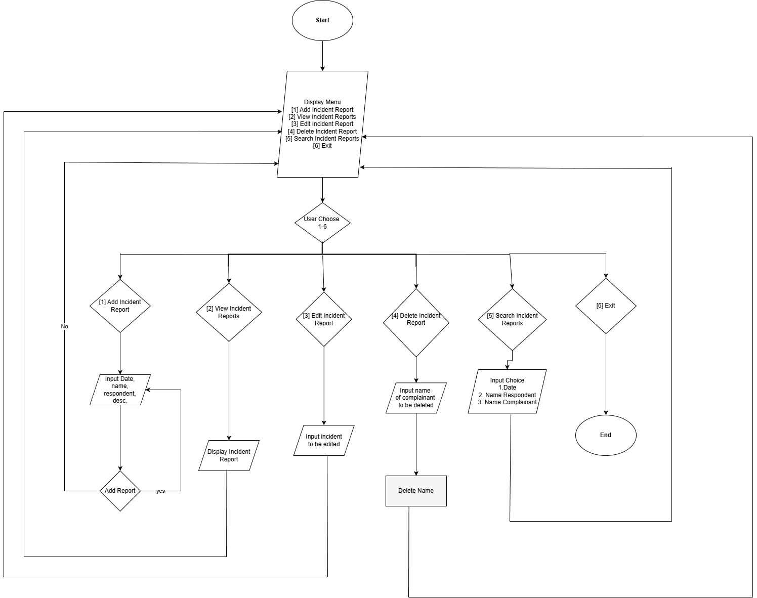

- Description of the Flow Chart
The Barangay Incident Report Management System Flowchart illustrates the overall process and logical flow of operations within the system. It demonstrates how users interact with the system, starting from login authentication to managing and maintaining incident records.
- Start - The process begins when the user launches the system application. This marks the entry point of the entire process flow.
- Log-in Process - Upon accessing the system, the user is required to log in using a valid username and password.
- If the entered credentials are valid, the system verifies them against the database and grants access to the main dashboard.
- If the credentials are invalid, the system displays an error message prompting the user to re-enter the correct information.
- Dashboard - After successful authentication, the user is redirected to the dashboard. The dashboard serves as the central control panel where users can view summaries, access modules, and navigate to various system functions such as adding, viewing, or editing incident reports.
- View Incident Report - This process allows the user to retrieve and view a list of all incident reports stored in the database. Each report displays important information, including the incident ID, title, and current status. The user can choose to update or delete specific reports from this interface.
- Edit Incident Report - If modifications are necessary, the user can access an existing record to make changes, such as updating incident details or changing its status (e.g., from “Open” to “Resolved”). The system then updates the corresponding record in the database.
- Delete Incident Report - The user may remove a report that is no longer needed. Upon confirmation, the system permanently deletes the record from the database to maintain data relevance and accuracy
- Log-out - After completing all necessary operations, the user logs out of the system. This process terminates the current session to ensure data security and prevent unauthorized access.
- End - The flowchart concludes once the user exits the system. This marks the end of the transaction cycle within the Barangay Incident Report Management System.

- Screenshots
- Dashboard
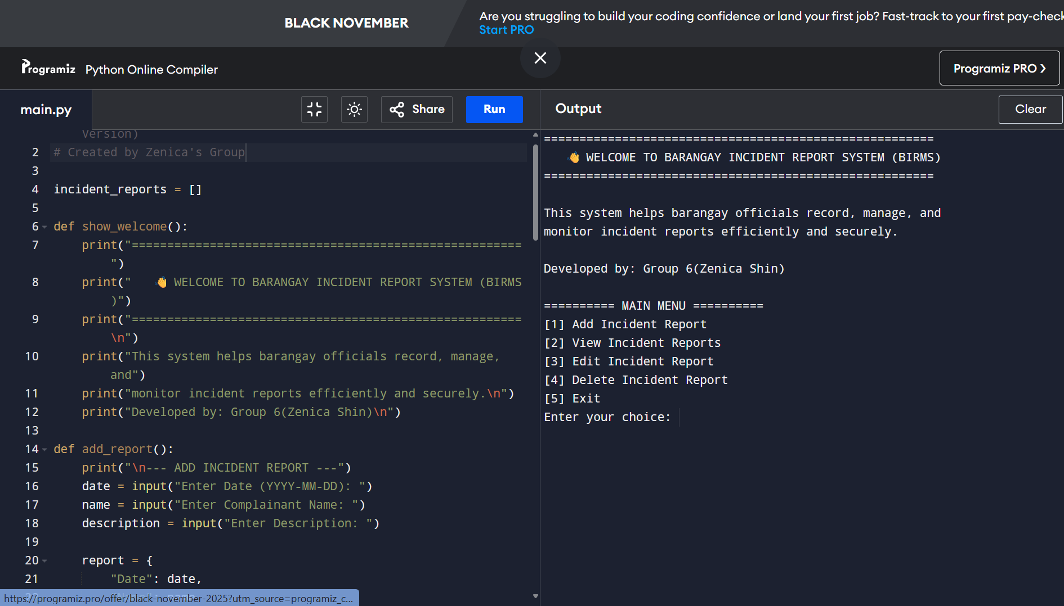

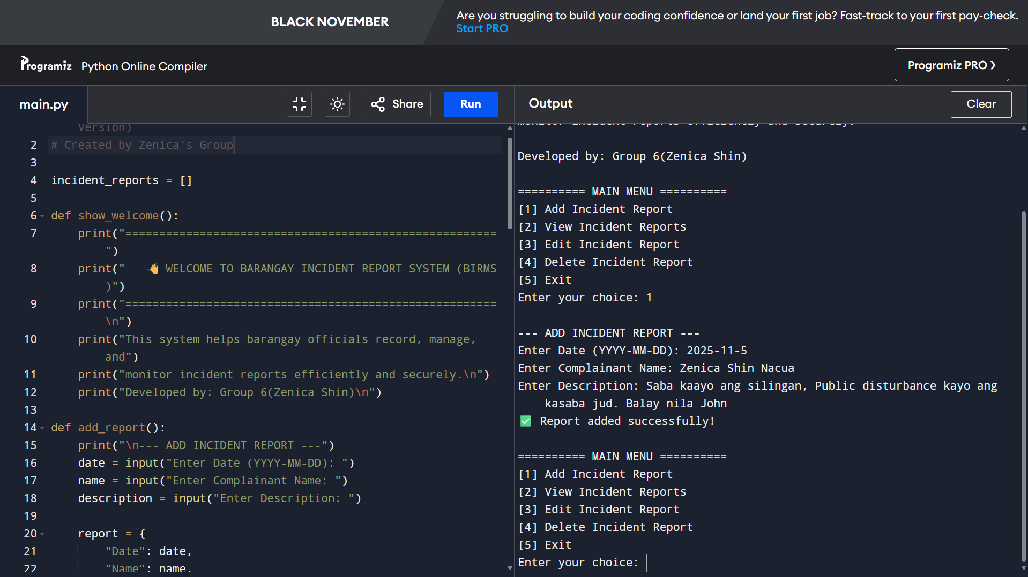
- Add Incident Report

- View Incident Report
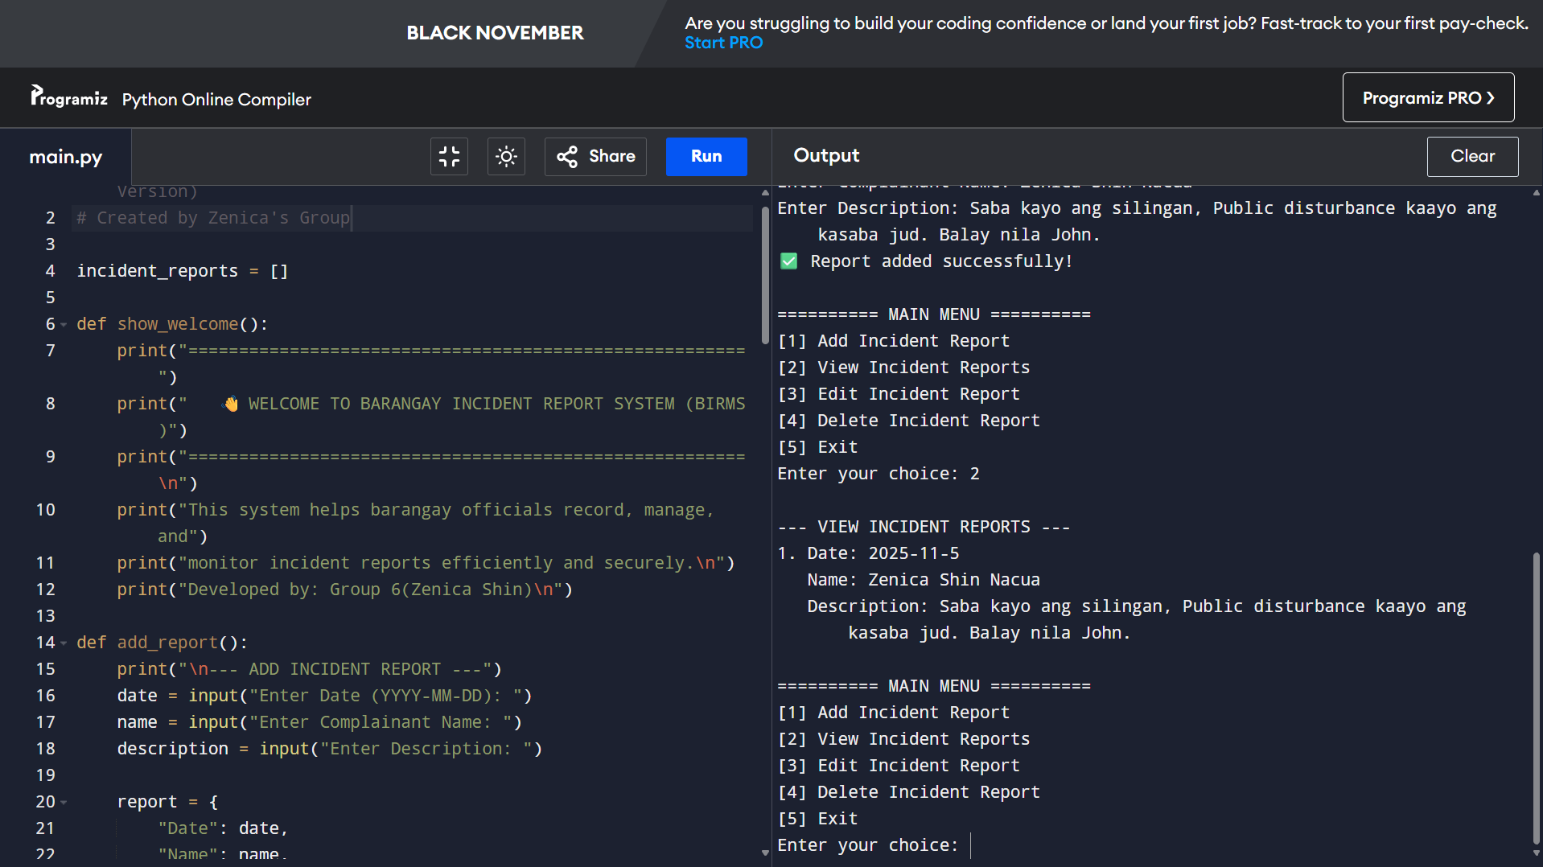

- Edit Incident Report

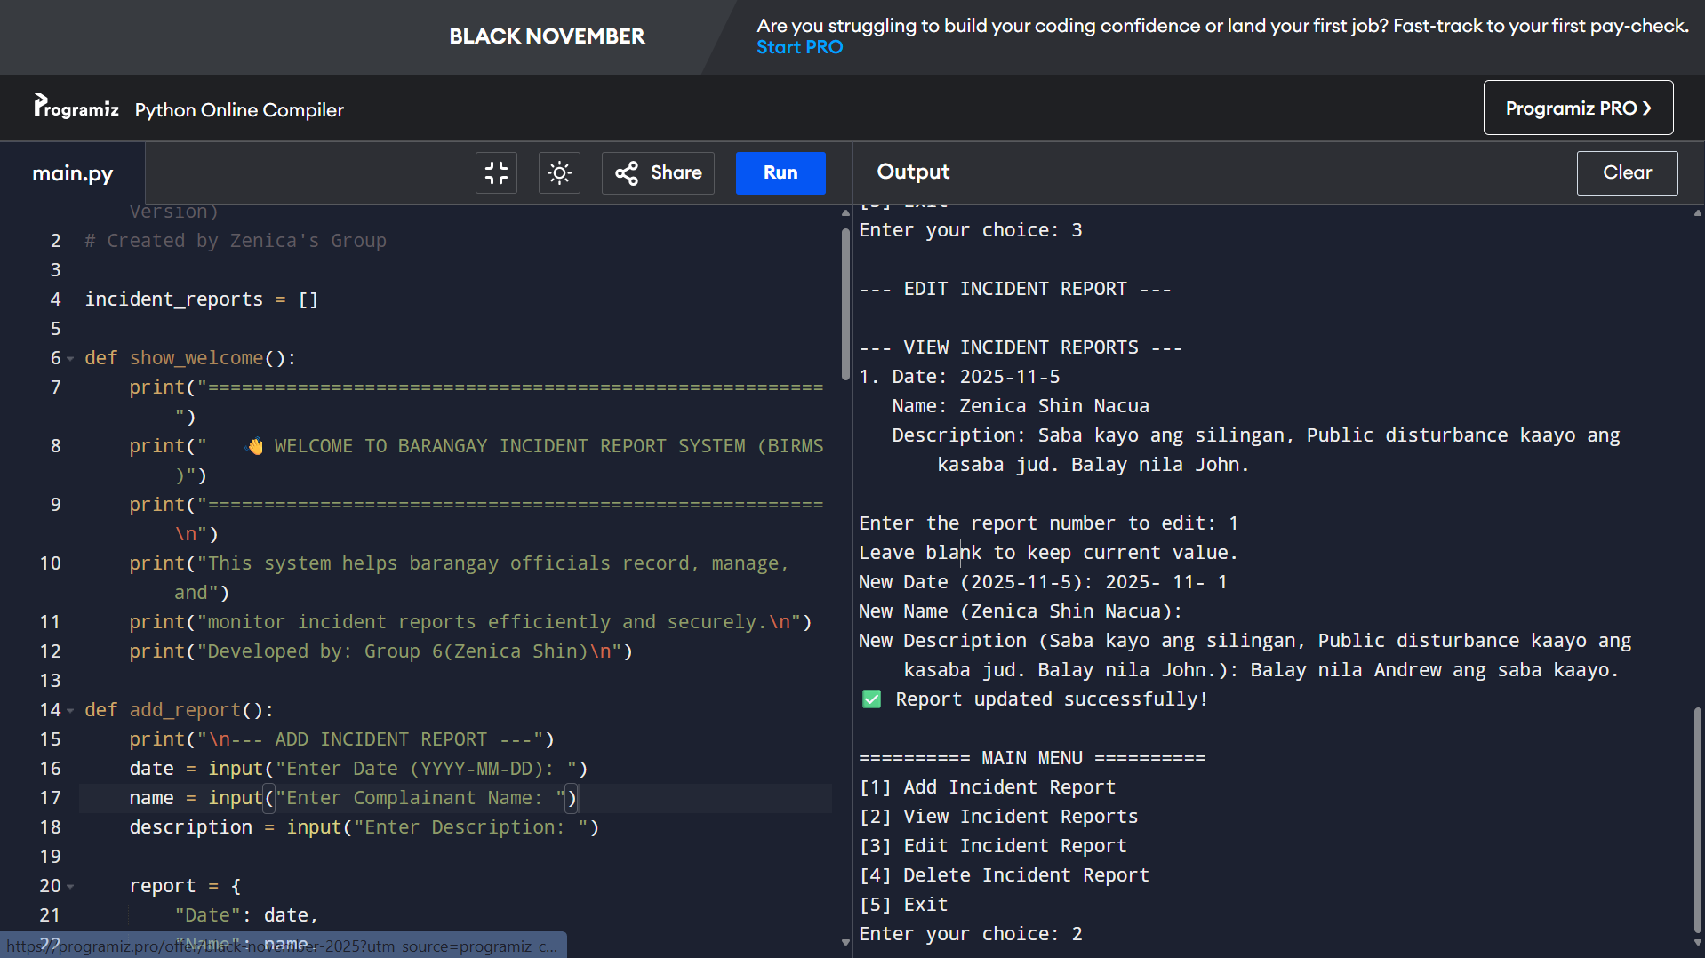

- Delete Incident Report
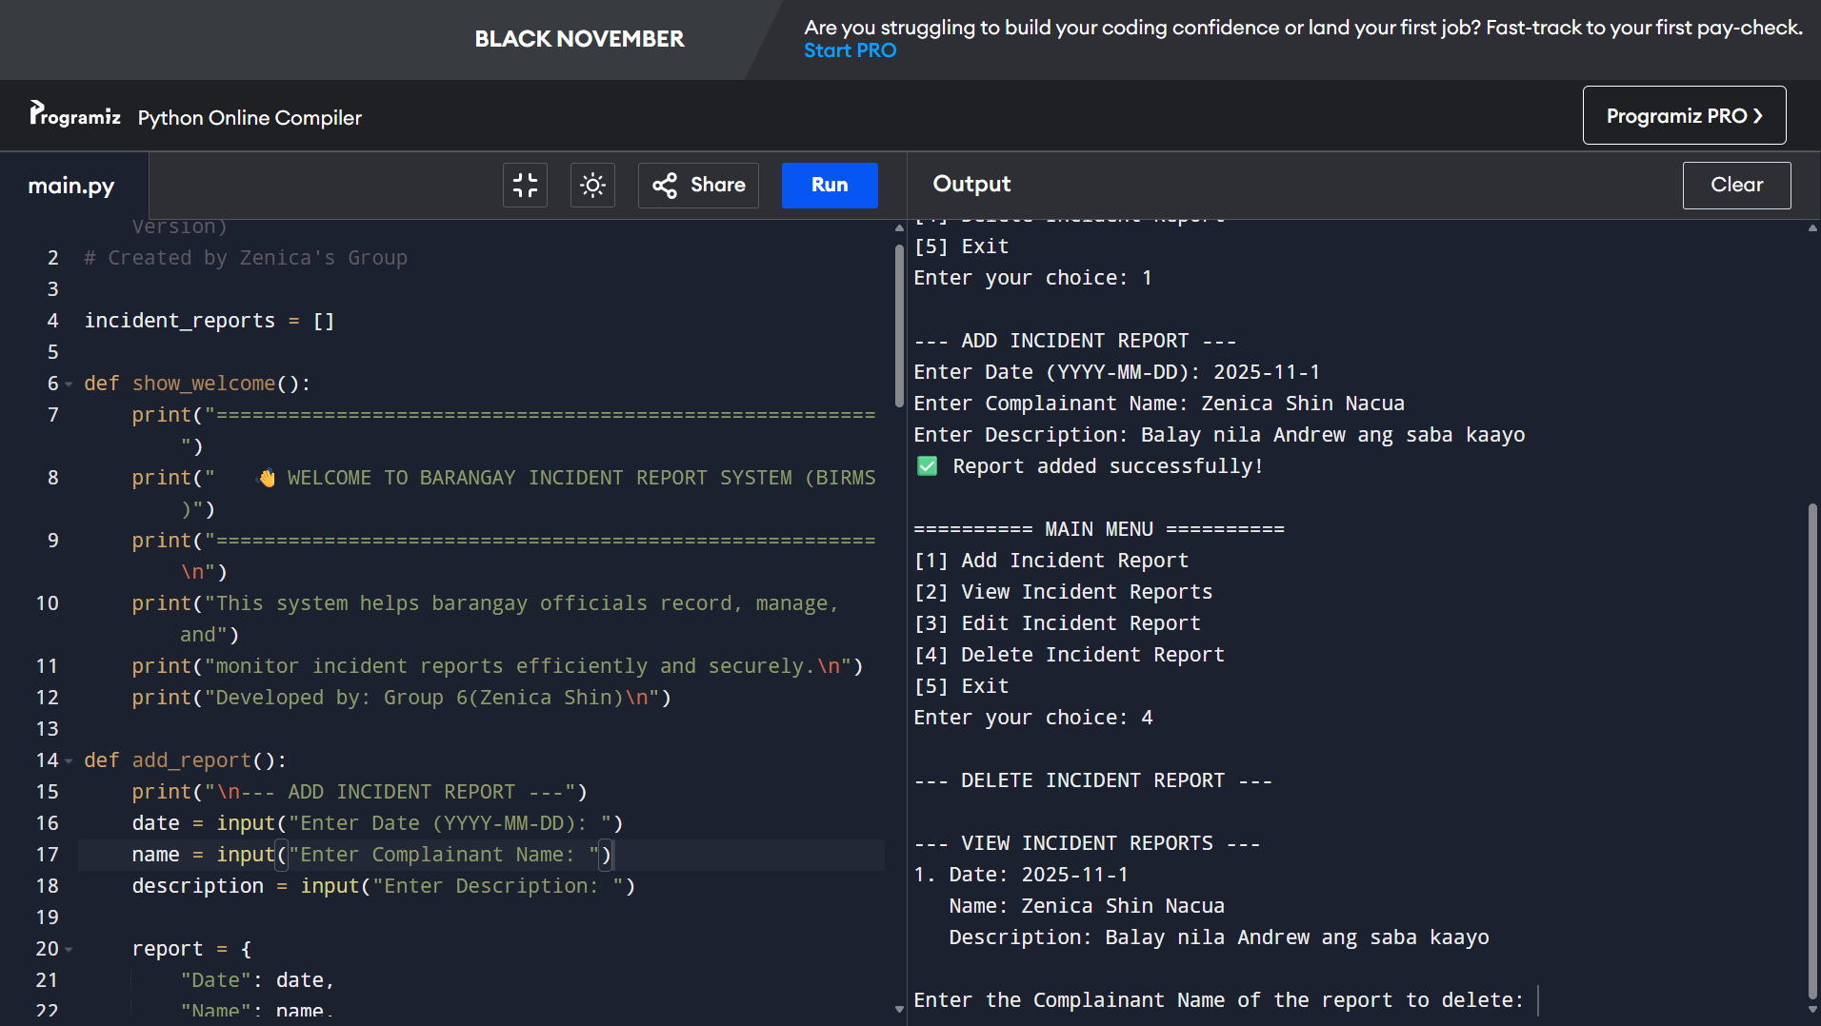

- Search Incident Report
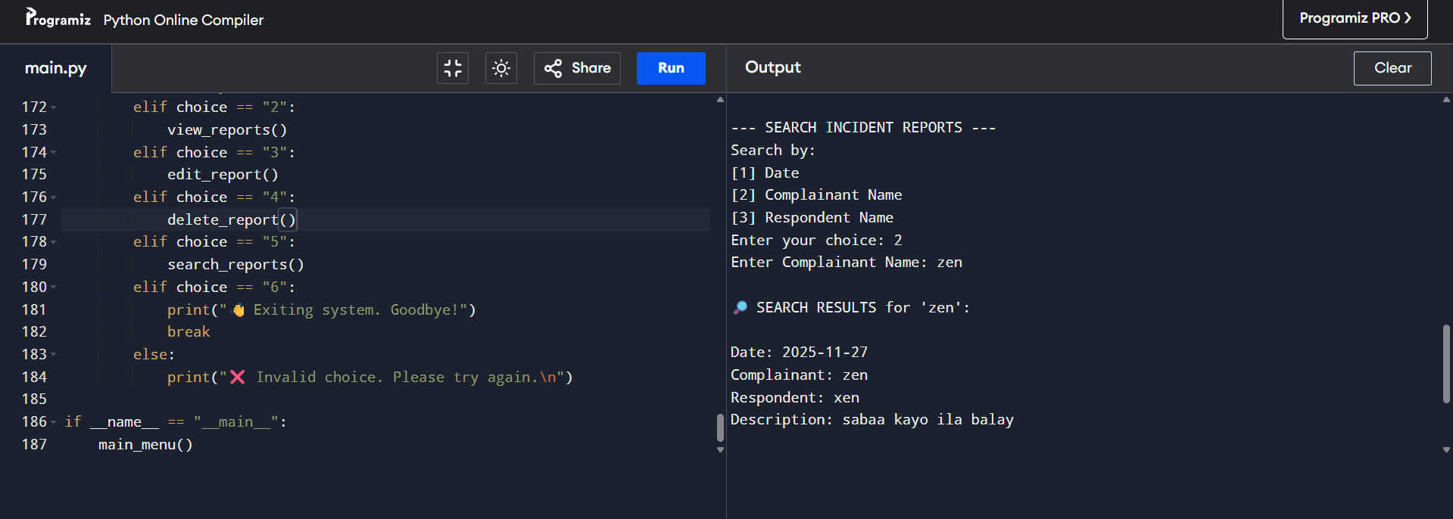

- Exit Incident Report

