Accent Perception Analysis
  - Stella Survey (Status & Solidarity Ratings)
Ersin Gultekin
2025-02-28
Table of contents

# Load required libraries
library(tidyverse)
library(knitr)
library(kableExtra)
library(flextable)
library(viridis)
# Read in the cleaned data
stella_data <- readRDS("../data/stella_survey_clean.rds")
# Create participant-level data (removing duplicates)
participant_data <- stella_data %>%
select(ppt_id, gender, age, student, lessons_English, contact_English) %>%
distinct()
# Define a custom theme with better spacing for plots
my_custom_theme <- theme_minimal() +
theme(
axis.title.x = element_text(margin = margin(t = 20, r = 0, b = 0, l = 0), size = 10),
axis.title.y = element_text(margin = margin(t = 0, r = 20, b = 0, l = 0), size = 10),
plot.margin = margin(t = 30, r = 30, b = 30, l = 30),
plot.title = element_text(margin = margin(b = 15), size = 14),
axis.text = element_text(size = 10)
)

1. Introduction

1.1 Topic and Hypotheses
This study investigates language attitudes toward different English accents, focusing on how standard and non-standard accents are perceived in terms of status and solidarity dimensions. It also examines the effects of speaker gender and differences between UK Received Pronunciation (RP) and US General American (GA) accents.
The main hypotheses tested in this study are:
- Hypothesis 1: Standard accents will be rated higher on status dimensions, while non-standard accents will receive higher scores on solidarity dimensions.
- Hypothesis 2: Speaker gender will influence perception of accents, with potential differences in how male and female speech is evaluated on status and solidarity dimensions.
- Hypothesis 3: UK Received Pronunciation (RP) will receive higher status ratings compared to US General American (GA) accents.

1.2 Data Description and Analysis Approach
This analysis uses data from the Stella Survey, which collected perceptions of different English accent varieties from non-native English speakers. The dataset includes 1536 observations from 96 unique participants who evaluated various English accent recordings.

1.2.1 Packages Used
The analysis was conducted using R with the following packages:
- tidyverse for data manipulation and visualization
- knitr and kableExtra for table formatting
- flextable for creating publication-ready tables
- viridis for colorblind-friendly visualizations

1.2.2 Data Characteristics
The dataset contains 1536 observations with 12 variables. Each participant rated multiple accent samples on scales measuring status and solidarity dimensions. Key variables include:
- standard: Whether the accent is classified as standard or non-standard
- speaker_gender: Gender of the speaker (male or female)
- country: Country of origin for the accent (UK or US)
- status: Rating on status dimension (higher values indicate higher perceived status)
- solidarity: Rating on solidarity dimension (higher values indicate higher perceived friendliness/approachability)

1.2.3 Participant Characteristics
The study included 96 participants with the following characteristics:
- Gender distribution: 33.3% female and 66.7% male
- Age range: 20 to 33 years (M = 24.7, SD = 3.6)
- Student status: 37.5% were currently enrolled as students
- English learning experience: Most participants had completed 8 years of formal English instruction, with an average of 6.9 years across all participants

2. Results

2.1 Hypothesis 1: Standard vs Non-standard Accents
# Status by Accent Type
ggplot(stella_data, aes(x = standard, y = status, fill = standard)) +
geom_bar(stat = "identity", alpha = 0.7, width = 0.2) +
theme_minimal() +
scale_fill_viridis_d(option = "A") +
labs(x = "Accent Type",
y = "Status Rating") +
my_custom_theme +
theme(legend.position = "none")
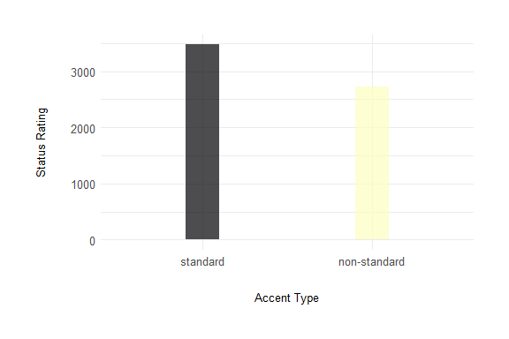
Figure 1: Status ratings by accent type. Standard accents received significantly higher status ratings compared to non-standard accents.
# Solidarity by Accent Type
ggplot(stella_data, aes(x = standard, y = solidarity, fill = standard)) +
geom_bar(stat = "identity", alpha = 0.7, width = 0.2) +
theme_minimal() +
scale_fill_viridis_d(option = "H") +
labs(x = "Accent Type",
y = "Solidarity Rating") +
my_custom_theme +
theme(legend.position = "none")
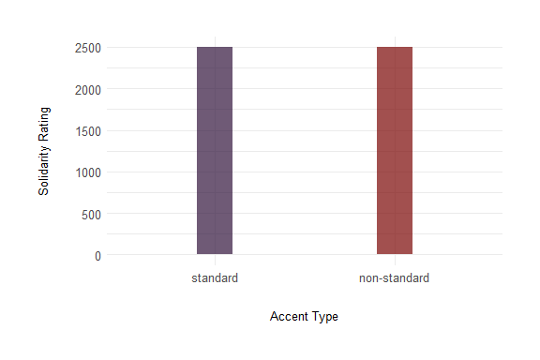
Figure 2: Solidarity ratings by accent type. Standard and non-standard accents received identical mean solidarity ratings.
# Create summary statistics for Hypothesis 1
h1_summary <- stella_data %>%
group_by(standard) %>%
summarize(
status_mean = mean(status, na.rm = TRUE),
status_sd = sd(status, na.rm = TRUE),
solidarity_mean = mean(solidarity, na.rm = TRUE),
solidarity_sd = sd(solidarity, na.rm = TRUE),
n = n() / 2
) %>%
mutate(across(where(is.numeric), ~round(., 2)))
# Create a formatted table
cat("\n\nTable 1: Status and solidarity ratings by accent type\n\n")
Table 1: Status and solidarity ratings by accent type
h1_table <- flextable(h1_summary) %>%
set_header_labels(
standard = "Standard",
status_mean = "Status Mean",
status_sd = "Status SD",
solidarity_mean = "Solidarity Mean",
solidarity_sd = "Solidarity SD",
n = "n") %>%
theme_vanilla() %>%
padding(padding = 6, part = "all") %>%
autofit()
h1_table
Standard | Status Mean | Status SD | Solidarity Mean | Solidarity SD | n
standard | 4.52 | 1.23 | 3.25 | 1.26 | 384
non-standard | 3.55 | 1.20 | 3.25 | 1.32 | 384

The data in Figure 1 shows clear differences in how standard and non-standard accents are perceived. Standard accents received higher status ratings (M = 4.52, SD = 1.23) compared to non-standard accents (M = 3.55, SD = 1.2). This supports the first hypothesis that standard accents are associated with higher status.
For solidarity ratings shown in Figure 2, I observed that standard and non-standard accents received identical mean solidarity ratings (both M = 3.25, with SD = 1.26 for standard accents and SD = 1.32 for non-standard accents). This finding does not support the hypothesis that non-standard accents would be perceived as more friendly, approachable, or relatable, and instead suggests that accent standardness may not impact solidarity perceptions in the participant sample.

2.2 Hypothesis 2: Gender Effect
# Status by Gender
ggplot(stella_data, aes(x = speaker_gender, y = status, fill = speaker_gender)) +
geom_bar(stat = "identity", alpha = 0.7, width = 0.2) +
theme_minimal() +
scale_fill_viridis_d(option = "C") +
labs(x = "Speaker Gender",
y = "Status Rating") +
my_custom_theme +
theme(legend.position = "none")
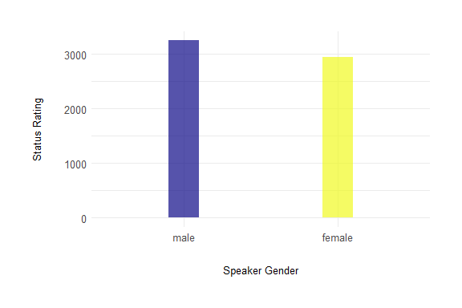
Figure 3: Status ratings by speaker gender. Male speakers received higher status ratings than female speakers.
# Solidarity by Gender
ggplot(stella_data, aes(x = speaker_gender, y = solidarity, fill = speaker_gender)) +
geom_bar(stat = "identity", alpha = 0.7, width = 0.2) +
theme_minimal() +
scale_fill_viridis_d(option = "D") +
labs(x = "Speaker Gender",
y = "Solidarity Rating") +
my_custom_theme +
theme(legend.position = "none")
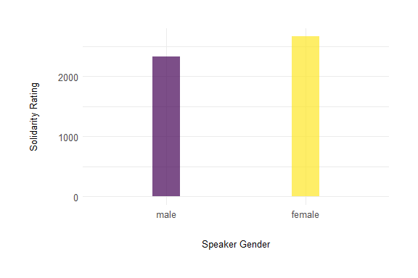
Figure 4: Solidarity ratings by speaker gender. Female speakers received higher solidarity ratings than male speakers.
# Create summary statistics for Hypothesis 2
h2_summary <- stella_data %>%
group_by(speaker_gender) %>%
summarize(
status_mean = mean(status, na.rm = TRUE),
status_sd = sd(status, na.rm = TRUE),
solidarity_mean = mean(solidarity, na.rm = TRUE),
solidarity_sd = sd(solidarity, na.rm = TRUE),
n = n() / 2
) %>%
mutate(across(where(is.numeric), ~round(., 2)))
# Create a formatted table
cat("\n\nTable 2: Status and solidarity ratings by speaker gender\n\n")
Table 2: Status and solidarity ratings by speaker gender
h2_table <- flextable(h2_summary) %>%
set_header_labels(
speaker_gender = "Speaker Gender",
status_mean = "Status Mean",
status_sd = "Status SD",
solidarity_mean = "Solidarity Mean",
solidarity_sd = "Solidarity SD",
n = "n") %>%
theme_vanilla() %>%
padding(padding = 6, part = "all") %>%
autofit()
h2_table
Speaker Gender | Status Mean | Status SD | Solidarity Mean | Solidarity SD | n
male | 4.23 | 1.39 | 3.03 | 1.34 | 384
female | 3.84 | 1.19 | 3.46 | 1.20 | 384

The analysis of gender effects seen in Figure 3 and Figure 4 reveals interesting patterns in how male and female speakers are perceived. As shown in Figure 3, female speakers received lower status ratings (M = 3.84, SD = 1.19) compared to male speakers (M = 4.23, SD = 1.39).
For solidarity ratings, Figure 4 demonstrates that female speakers were rated higher (M = 3.46, SD = 1.2) than male speakers (M = 3.03, SD = 1.34). These findings support the second hypothesis that speaker gender influences perception, with potential implications for how different genders are evaluated in professional and social contexts.

2.3 Hypothesis 3: RP vs GA Comparison
# Status by Country
ggplot(stella_data, aes(x = country, y = status, fill = country)) +
geom_bar(stat = "identity", alpha = 0.7, width = 0.2) +
theme_minimal() +
scale_fill_viridis_d(option = "E") +
labs(x = "Country",
y = "Status Rating") +
my_custom_theme +
theme(legend.position = "none")
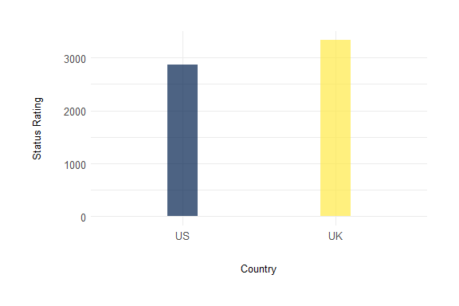
Figure 5: Status ratings by country (RP vs GA). UK accents (RP) received higher status ratings than US accents (GA).
# Solidarity by Country
ggplot(stella_data, aes(x = country, y = solidarity, fill = country)) +
geom_bar(stat = "identity", alpha = 0.7, width = 0.2) +
theme_minimal() +
scale_fill_viridis_d(option = "F") +
labs(x = "Country",
y = "Solidarity Rating") +
my_custom_theme +
theme(legend.position = "none")
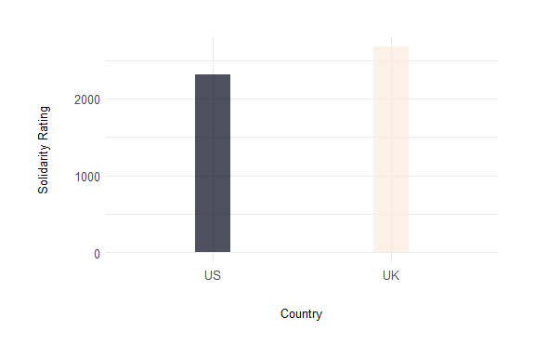
Figure 6: Solidarity ratings by country (RP vs GA). UK accents (RP) received higher solidarity ratings than US accents (GA).
# Create summary statistics for Hypothesis 3 - Status
h3_status_summary <- stella_data %>%
group_by(country) %>%
summarize(
status_mean = mean(status, na.rm = TRUE),
status_sd = sd(status, na.rm = TRUE),
status_median = median(status, na.rm = TRUE),
n = n() / 2
) %>%
mutate(across(where(is.numeric), ~round(., 2)))
# Create a formatted table
cat("\n\nTable 3: Status ratings by country (RP vs GA)\n\n")
Table 3: Status ratings by country (RP vs GA)
h3_table_status <- flextable(h3_status_summary) %>%
set_header_labels(
country = "Country",
status_mean = "Status Mean",
status_sd = "Status SD",
status_median = "Status Median",
n = "n") %>%
theme_vanilla() %>%
padding(padding = 6, part = "all") %>%
autofit()
h3_table_status
Country | Status Mean | Status SD | Status Median | n
US | 3.74 | 1.26 | 4 | 384
UK | 4.33 | 1.30 | 4 | 384

# Create summary statistics for Hypothesis 3 - Solidarity
h3_solidarity_summary <- stella_data %>%
group_by(country) %>%
summarize(
solidarity_mean = mean(solidarity, na.rm = TRUE),
solidarity_sd = sd(solidarity, na.rm = TRUE),
solidarity_median = median(solidarity, na.rm = TRUE),
n = n() / 2
) %>%
mutate(across(where(is.numeric), ~round(., 2)))
# Create a formatted table
cat("\n\nTable 4: Solidarity ratings by country (RP vs GA)\n\n")
Table 4: Solidarity ratings by country (RP vs GA)
h3_table_solidarity <- flextable(h3_solidarity_summary) %>%
set_header_labels(
country = "Country",
solidarity_mean = "Solidarity Mean",
solidarity_sd = "Solidarity SD",
solidarity_median = "Solidarity Median",
n = "n") %>%
theme_vanilla() %>%
padding(padding = 6, part = "all") %>%
autofit()
h3_table_solidarity
Country | Solidarity Mean | Solidarity SD | Solidarity Median | n
US | 3.02 | 1.29 | 3 | 384
UK | 3.48 | 1.25 | 4 | 384

Comparing Received Pronunciation (UK) and General American (US) accents reveals differences in both status and solidarity perceptions. As shown in Figure 5, UK accents received higher status ratings (M = 4.33, SD = 1.3) compared to US accents (M = 3.74, SD = 1.26).
Similarly, for solidarity ratings, Figure 6 demonstrates that UK accents were also rated higher (M = 3.48, SD = 1.25) than US accents (M = 3.02, SD = 1.29). This pattern indicates a consistent preference for UK accents across both dimensions of language attitudes.
These findings strongly support the third hypothesis that UK accents (RP) would be rated higher in status than US accents (GA), while additionally revealing that UK accents were also perceived as more friendly and approachable. This suggests that UK accents may carry more prestige and are perceived more positively overall in the context of this study.

2.4 Participant Demographics
# Demographics
demographics_summary <- data.frame(
total_participants = nrow(participant_data),
female_count = sum(participant_data$gender == "female", na.rm = TRUE),
female_percent = round(100 * sum(participant_data$gender == "female", na.rm = TRUE) / nrow(participant_data), 1),
male_count = sum(participant_data$gender == "male", na.rm = TRUE),
male_percent = round(100 * sum(participant_data$gender == "male", na.rm = TRUE) / nrow(participant_data), 1),
mean_age = round(mean(participant_data$age, na.rm = TRUE), 1),
sd_age = round(sd(participant_data$age, na.rm = TRUE), 1),
min_age = min(participant_data$age, na.rm = TRUE),
max_age = max(participant_data$age, na.rm = TRUE)
)
# English learning characteristics
english_summary <- data.frame(
mean_lessons = round(mean(as.numeric(participant_data$lessons_English), na.rm = TRUE), 1),
sd_lessons = round(sd(as.numeric(participant_data$lessons_English), na.rm = TRUE), 1),
median_lessons = median(as.numeric(participant_data$lessons_English), na.rm = TRUE),
mean_contact = round(mean(participant_data$contact_English, na.rm = TRUE), 1),
sd_contact = round(sd(participant_data$contact_English, na.rm = TRUE), 1),
median_contact = median(participant_data$contact_English, na.rm = TRUE)
)

# Create a demographics table
kable(demographics_summary,
caption = "Table 5: Participant demographics",
col.names = c("Total Participants", "Female Count", "Female %", "Male Count", "Male %",
"Mean Age", "SD Age", "Min Age", "Max Age"),
align = "rrrrrrrrr")
Table 5: Participant demographics
Total Participants | Female Count | Female % | Male Count | Male % | Mean Age | SD Age | Min Age | Max Age
96 | 32 | 33.3 | 64 | 66.7 | 24.7 | 3.6 | 20 | 33

# Create a english learning table
kable(english_summary,
caption = "Table 6: English learning duration and contact frequency",
col.names = c("Mean Lessons", "SD Lessons", "Median Lessons",
"Mean Contact", "SD Contact", "Median Contact"),
align = "rrrrrr")
Table 6: English learning duration and contact frequency
Mean Lessons | SD Lessons | Median Lessons | Mean Contact | SD Contact | Median Contact
6.9 | 2 | 8 | 2.3 | 1.2 | 2

2.4.1 Demographic Plots
ggplot(stella_data, aes(x = age, fill = as.factor(age))) +
geom_bar(alpha = 0.7, width = 0.5) +
theme_minimal() +
labs(x = "Age",
y = "Count") +
scale_fill_viridis_d() +
my_custom_theme +
theme(legend.position = "none")
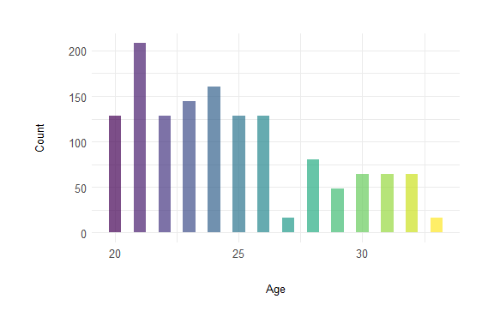
Figure 7: Age distribution of participants. The majority of participants were between 20 and 26 years old, with a mean age of 24.7 years.
The age distribution shown in Figure 7 reveals that most participants were young adults, with a concentration between 20 and 26 years old.
ggplot(stella_data %>% distinct(ppt_id, .keep_all = TRUE),
aes(x = gender, fill = gender)) +
geom_bar(alpha = 0.7, width = 0.2) +
scale_fill_viridis_d() +
theme_minimal() +
labs(x = "Gender",
y = "Count") +
my_custom_theme +
theme(legend.position = "none")
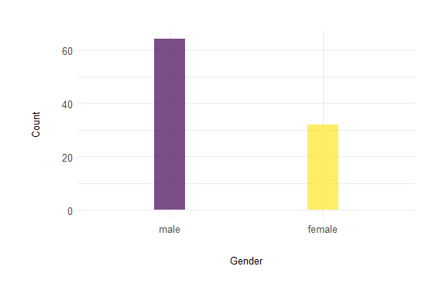
Figure 8: Gender distribution of participants. The sample included more male participants (66.7%) than female participants (33.3%).
Figure 8 illustrates the gender composition of the participant pool. There is a notable imbalance, with approximately twice as many male participants as female participants. This gender distribution should be taken into account when interpreting the results, particularly for findings related to gender effects in accent perception.
ggplot(stella_data %>% distinct(ppt_id, .keep_all = TRUE),
aes(x = student, fill = student)) +
geom_bar(alpha = 0.7, width = 0.2) +
theme_minimal() +
scale_fill_viridis_d(option = "H") +
labs(x = "Student Status",
y = "Count") +
my_custom_theme +
theme(legend.position = "none")
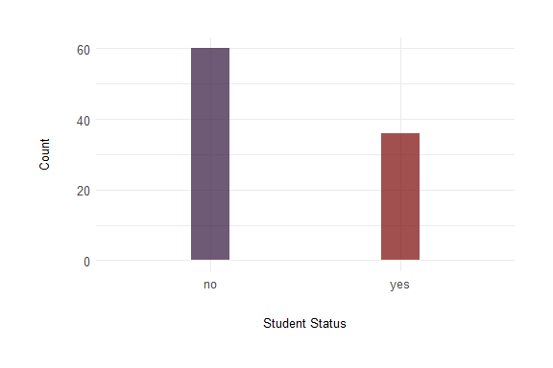
Figure 9: Distribution of student status among participants.
Figure 9 shows the distribution of student status among participants. The majority of participants (62.5%) were not enrolled as students at the time of data collection. This relatively low proportion of student participants should be considered when interpreting the results, as it may influence how accents are perceived in academic or educational contexts.

ggplot(stella_data %>% distinct(ppt_id, .keep_all = TRUE),
aes(x = lessons_English, fill = factor(lessons_English))) +
geom_bar(alpha = 0.7, width = 0.5) +
scale_fill_viridis_d() +
theme_minimal() +
labs(x = "Years of English Lessons",
y = "Count") +
my_custom_theme +
theme(legend.position = "none")
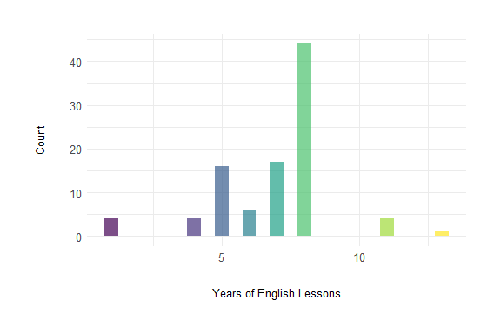
Figure 10: Distribution of English learning duration. Most participants had between 5 and 8 years of English instruction.
As shown in Figure 10, participants in this study had varying levels of formal English instruction. There is a pronounced peak at 8 years of instruction, with approximately 45 participants reporting this duration, which is significantly more than any other category. While there are smaller numbers of participants with 5-7 years of instruction, the overall pattern indicates that most participants had completed substantial formal English education. This range of English learning experience may influence how participants perceive and evaluate different English accents.
ggplot(stella_data %>% distinct(ppt_id, .keep_all = TRUE),
aes(x = factor(contact_English, exclude = NULL),
fill = factor(contact_English, exclude = NULL))) +
geom_bar(width = 0.5) +
scale_fill_viridis_d(na.value = "gray80") +
theme_minimal() +
labs(x = "Contact Level",
y = "Count") +
my_custom_theme +
theme(legend.position = "none")
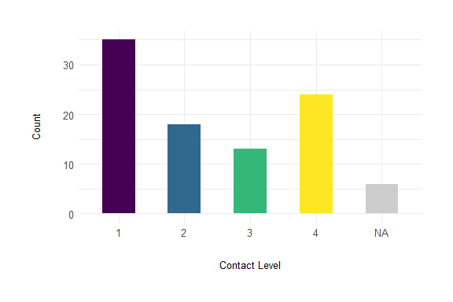
Figure 11: Frequency of English contact. Most participants reported moderate levels of regular contact with English.
Figure 11 displays the distribution of participants’ reported frequency of contact with English. Contrary to what might be expected, the largest group of participants (approximately 35) reported the lowest level of contact, while the second largest group (approximately 24) reported high contact (level 4). Moderate levels of contact (2-3) were reported by fewer participants. This somewhat polarized pattern of language contact may have important implications for interpreting the results, as participants’ varying degrees of familiarity with English could influence their perception of and attitudes toward different English accents, potentially affecting their ratings of status and solidarity dimensions.

3. Conclusion
The results of this study provide insights into how accent types, speaker gender, and country of origin influence perception in terms of status and solidarity dimensions.
For the first hypothesis, I found that standard accents were indeed rated higher on status measures (as shown in Figure 1). However, contrary to my expectations, standard and non-standard accents received identical solidarity ratings, suggesting that accent standardness may not impact perceptions of friendliness or approachability in the sample.
Regarding the second hypothesis, I observed gender differences in both status and solidarity ratings, as illustrated in Figure 3 and Figure 4. This indicates that speaker gender is an important factor in how speech is evaluated, potentially reflecting broader social attitudes and expectations associated with gender.
For the third hypothesis comparing UK (RP) and US (GA) accents, both Figure 5 and Figure 6 clearly demonstrate that UK accents were rated higher in both status and solidarity dimensions. This consistent pattern suggests that UK accents were perceived more positively overall, carrying both more prestige and greater social appeal among the participants.
The demographic characteristics of the participants provide important context for interpreting these results. The majority were young adults (between 20 and 26 years old) and predominantly male (approximately two-thirds). Most participants were not students, which may influence their language attitudes compared to those in academic environments. Additionally, participants typically had substantial formal English instruction (with a pronounced peak at 8 years) but showed a polarized pattern of English contact frequency, with most reporting either very low or relatively high contact rather than moderate levels. These demographic factors likely influenced how participants perceived and evaluated the different English accent varieties in this study.

