Aim:
To implementation and time analysis of Quicksort
Algorithm:
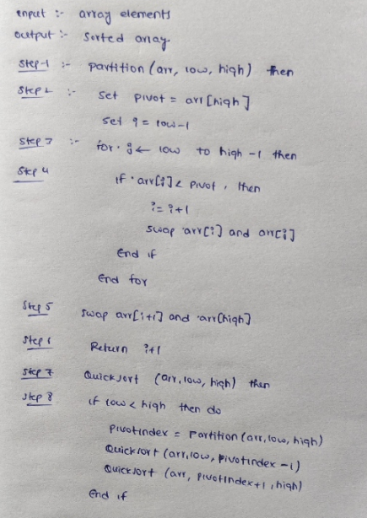

Code:
#include <iostream>
using namespace std;
int partition(int arr[], int low, int high) {
int pivot = arr[high];
int i = low - 1;
for (int j = low; j < high; j++) {

if (arr[j] < pivot) {
i++;
int temp = arr[i];
arr[i] = arr[j];
arr[j] = temp;
}
}
int temp = arr[i + 1];
arr[i + 1] = arr[high];
arr[high] = temp;
return i + 1;
}
void quickSort(int arr[], int low, int high) {
if (low < high) {
int pi = partition(arr, low, high);
quickSort(arr, low, pi - 1);
quickSort(arr, pi + 1, high);
}
}
int main() {
int n;
cout << "Enter number of elements: ";
cin >> n;
int arr[n];
cout << "Enter " << n << " elements: ";
for (int i = 0; i < n; i++) {
cin >> arr[i];
}
quickSort(arr, 0, n - 1);
cout << "Sorted array: ";
for (int i = 0; i < n; i++) {
cout << arr[i] << " ";
}
return 0;
}

Output:
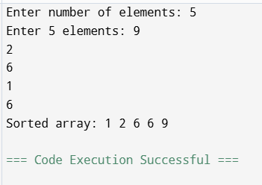

Time complexity:

