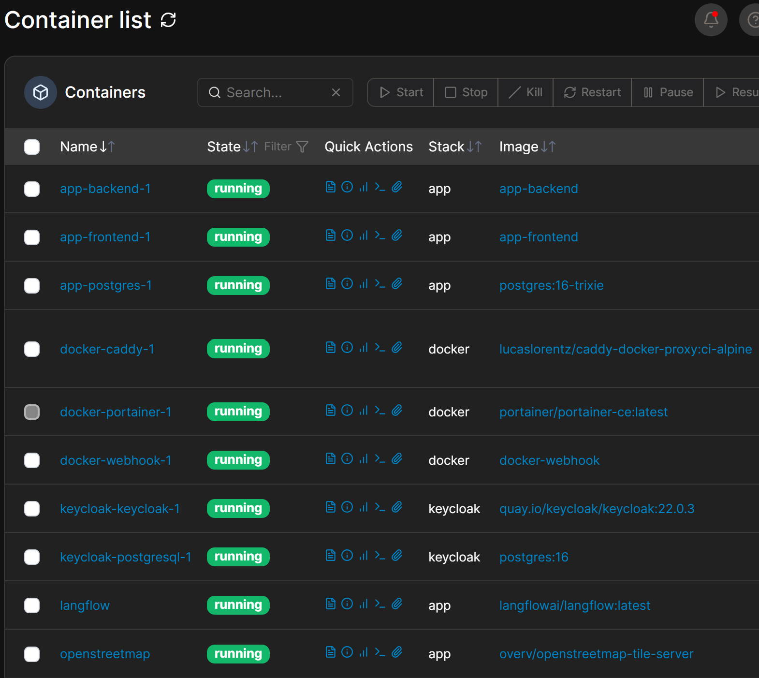

Feature | WireGuard | OpenVPN | Headscale (Tailscale)
Speed / Latency | 🚀 Extremely Fast | 🐢 Moderate | 🚀 Extremely Fast
Codebase Size | ~4,000 lines (Easy to audit) | ~100,000+ lines (Complex) | Leverages WireGuard
Topology | Peer-to-Peer or Hub-and-Spoke | Client-Server | Full Mesh (Direct peer connections)
NAT Traversal | Requires manual port forwarding | Requires manual port forwarding | 🪄 Automatic (STUN/ICE hole-punching)
Best Used For | High-performance, fixed point-to-point connections. | Complex enterprise environments with legacy firewalls. | Seamlessly connecting multiple roaming devices without port forwarding.

The Strategy
- Public Layer: Only your frontend container retains its caddy labels on safepath.duckdns.org. Caddy will route global traffic to the frontend only.
- Private Layer (The VPN): Drop all Caddy routing labels from your backend, OSM, and Langflow services.
- Internal Routing: Your frontend app runs in the user's browser, meaning it still needs to talk to an API endpoint. Instead of routing browser API traffic out to a public sub-domain, you will connect your VPN container directly to the caddy network. Caddy will then use local IP/domain routing restricted to the VPN interface, or you can query services directly via the VPN network mesh.
🛠️ Step 1: Clean up docker-compose.yml
Remove the public Caddy labels from backend and openstreetmap. They will still live on the caddy network so they can talk to each other internally, but they will no longer have domain endpoints exposed to the wild.

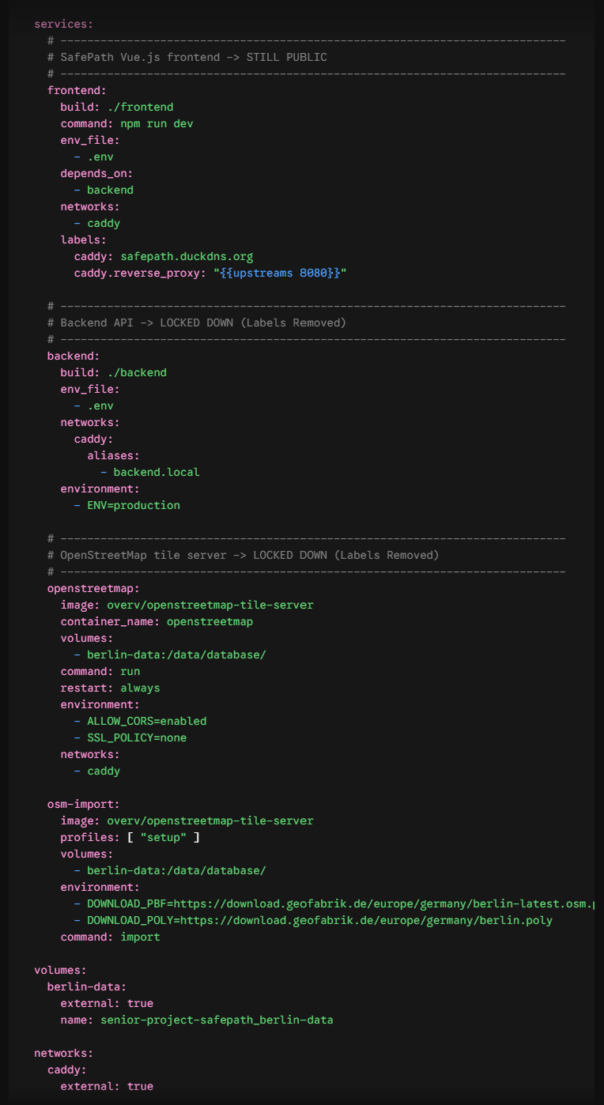
🛠️ Step 2: Clean up docker-compose-langflow.yml
Remove the Caddy labels from Langflow so it is no longer exposed to the public web via langflow.safepath.duckdns.org.
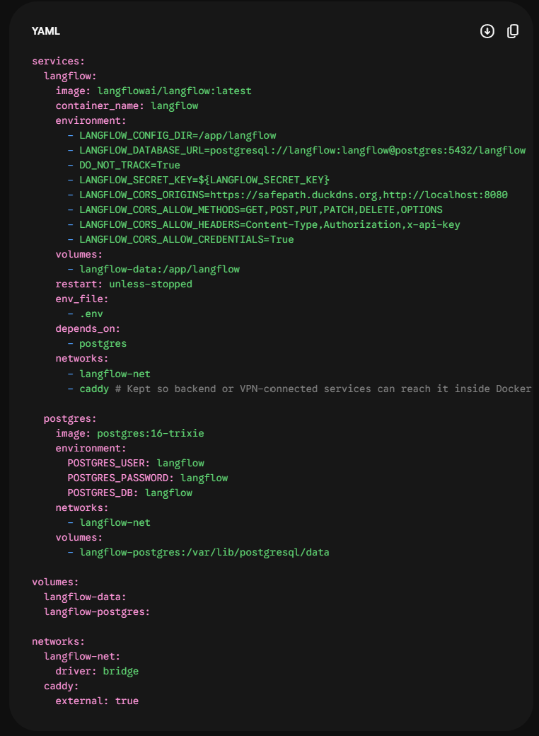
🛠️ Step 3: Implement WireGuard - Create a new docker-compose-infra.yml
To access these hidden components from your local development machine or phone, add a simple WireGuard service container to your server infrastructure stack. This configuration places WireGuard on the same external caddy network, allowing you to access any container by its internal container name or container IP once connected.
Add this service to a standalone core infrastructure file:
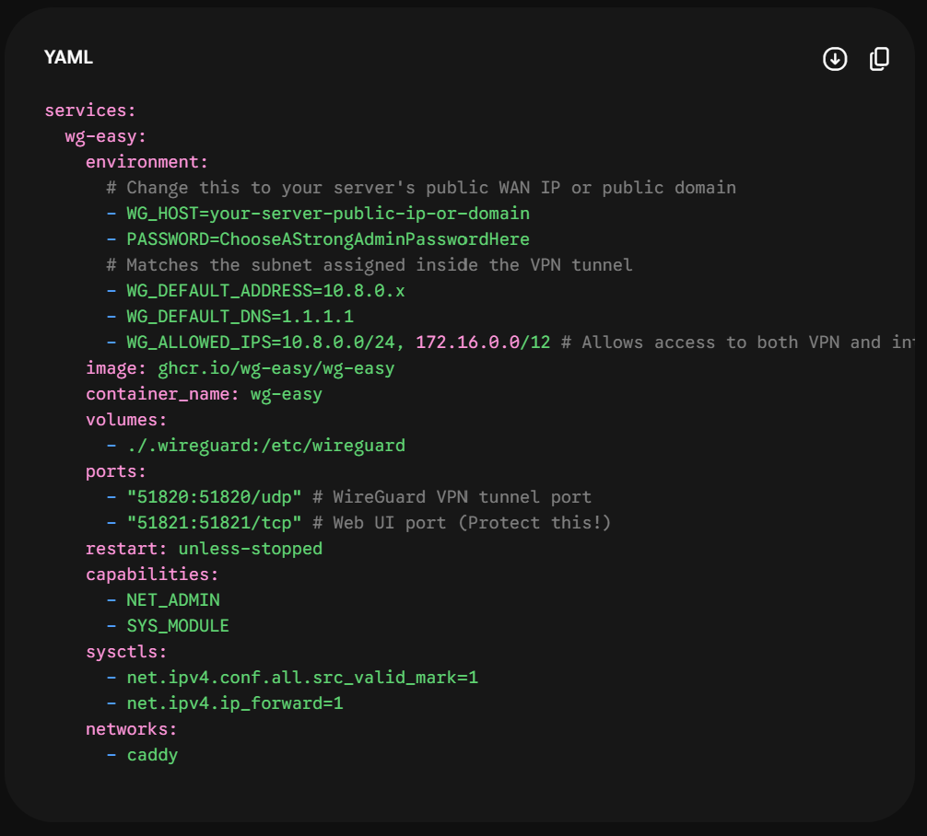

🛠️ Step 4: Update deploy.sh
