jQuery Tutorial 2

You will need the files timetable.htm, timetable.css and timetable.js

The file timetable.htm shows a timetable for a group of students. In this tutorial you will add to the file timetable.js to make it respond to user actions. The main components are the main table and the **key** table.

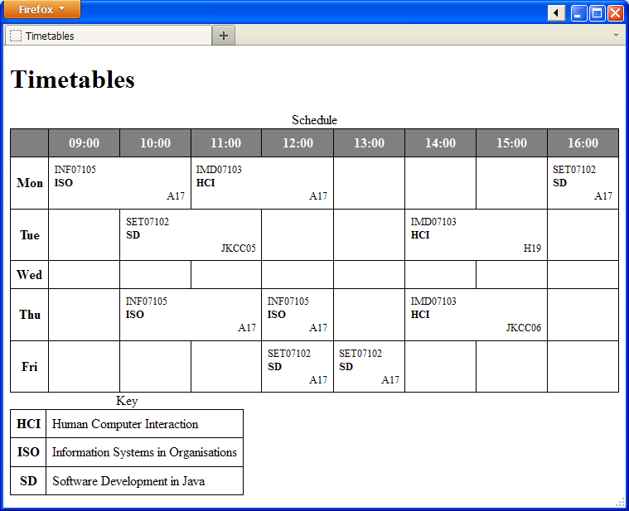

Each td in the main table includes three div elements. For example:

|  |
| --- |
| <td>  <div>SET07102</div>  <div>SD</div>  <div class='room'>A17</div>  </td> |

## 1) Show and Hide the Key

Update timetable.js so that the **Hide Key** message shows at the top:

|  |  |
| --- | --- |
| timetable.js | Appearance |
| $(document).ready(  function () {  $('body').prepend($('<div/>',  {text:'Hide key',  css:{color:'blue', cursor:'pointer'},  }));  }); |  |

To make the link work – it should hide or reveal the table with id key you must add a click attribute.

|  |  |
| --- | --- |
| timetable.js |  |
| $(document).ready(  function () {  $('body').prepend($('<div/>',  {text:'Hide key', css:{color:'blue', cursor:'pointer'},  **click:function(){**  **$('#key').toggle('slow');**  **}**  }));  }); |  |

## 2) Highlight Cells on mouseover

You can make the <td> cells in the table appear with a red background as the user rolls over with the mouse:

|  |  |
| --- | --- |
| timetable.js |  |
| $(document).ready(  function () {  **$('td').mouseover(function(){**  **$(this).css('background-color','red');**  **});**  }); |  |

Notice that the colour *sticks* even after the mouse has moved on. You can fix this by attaching a mouseout function in the same way. In mouseout you should set the background colour to **white** or **inherit**.

## 3) Traversing from $(this)

The expression $(this) refers to the element that has been acted on. You can navigate to include more or fewer elements.

Take a look at some of the options available at <http://api.jquery.com/category/traversing/>

Perform the following changes:

1. Empty cells should not be highlighted on mouseover - you can **test $(this).children().length**
2. When you mouse over a cell in the key table, highlight the whole row
3. When you mouse over the name of a day of the week, highlight the room div elements for that day.

Answers:

|  |
| --- |
| $('td').mouseover(function(){  if ($(this).children().length>0)  $(this).css('background-color','red');  });  $('#key th').mouseover(function(){  $(this).parent().css('background-color','green');  });  $('th').mouseover(function(){  $(this).parent().find('.room').css('background-color','blue');  }); |

You will need to create corresponding **mouseout** functions to make the highlighting go away.

## 4) Highlight Module Events

When the mouse moves over a particular event, all other events with the same module code should be highlighted.

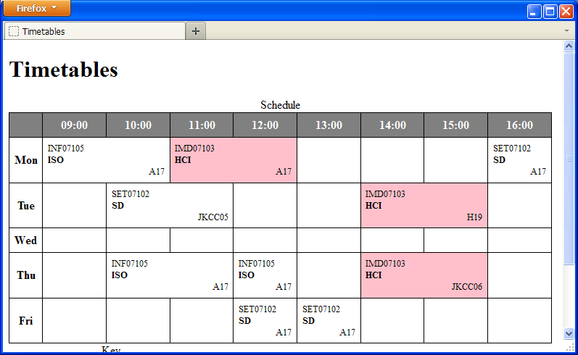

To do this you will have to use the html() function to extract the text from the first div – this value is the **code** for the event.

|  |
| --- |
| var code = $(this).find('div').first().html(); |

You can then traverse all td elements in the document and highlight all that have a matching first element. The filter function can do this:

|  |
| --- |
| $('td').filter(function(index){  return $(this).find('div').first().html()==code;  }).css('background-color','pink'); |

## 5) Wikipedia for a Small Screen

We return to the Catch-22 example.

For a small screen device we want only the first heading and the <h2> headings to show initially.

When the user clicks on the one of these headings then the following text (up to the next h2 heading should be revealed or hidden.

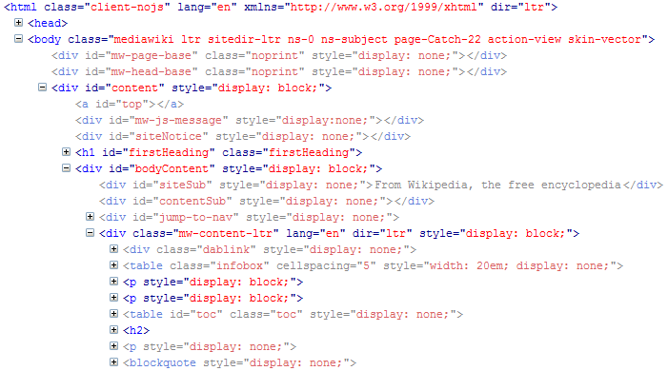Initially we want to show

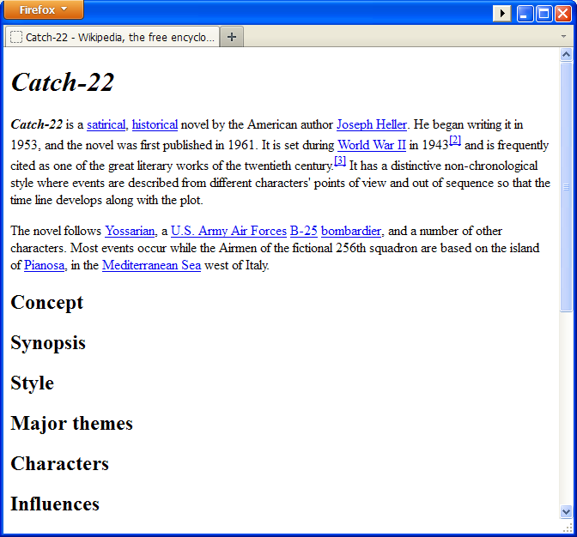

## Answers

|  |
| --- |
| $(document).ready(function(){  $('div').hide();  $('#content').show();  $('.firstHeading').show();  $('#bodyContent').show();  $('.mw-content-ltr').show();  $('.mw-content-ltr>:not(h2)').hide();  $('.mw-content-ltr>h2 span.editsection').hide();  $('div.mw-content-ltr').children().first().nextUntil('h2').show();  $('.infobox,#toc').hide();  $('.mw-content-ltr>h2').css('cursor','pointer');  $('.mw-content-ltr>h2').click(function(){  $(this).nextUntil('h2').toggle('slow');  });  }); |