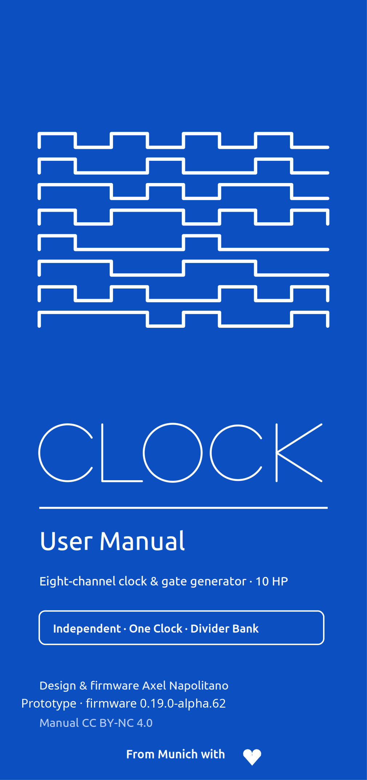
1 Start here
CLOCK is an eight-channel Eurorack clock and gate-rhythm generator. It can be a conventional master clock, build eight independent rhythmic streams, duplicate one shared clock to all outputs, or act as an eight-output divider bank.
The three ways CLOCK can route its outputs
Topology | What the eight outputs do
Independent | Each channel independently uses Off, Clock, Euclid or Sequencer.
One Clock | One shared clock configuration drives all eight outputs. This is the factory topology.
Divider Bank | One shared clock feeds eight fixed divider outputs from a selectable family.
PROTOTYPE — FIRMWARE 0.19.0-ALPHA.62
This is prerelease hardware and firmware. The software timing model, presets and display transports are implemented, but external SYNC/RST hardware routing and physical timing sign-off are not final. Treat INTERNAL clocking as the verified operating path until HIL validation is complete.
One rule that explains the design
All eight outputs share one deterministic master timeline. PLAY/PAUSE, STOP, Tap Tempo and global phase are master-level operations. Independent channels change what they derive from that timeline; they do not run eight unrelated transports.
2 Panel, power and boot
CLOCK uses one 128×64 OLED, one push encoder, three transport/navigation buttons, SYNC and RST inputs, and eight gate outputs with activity LEDs.
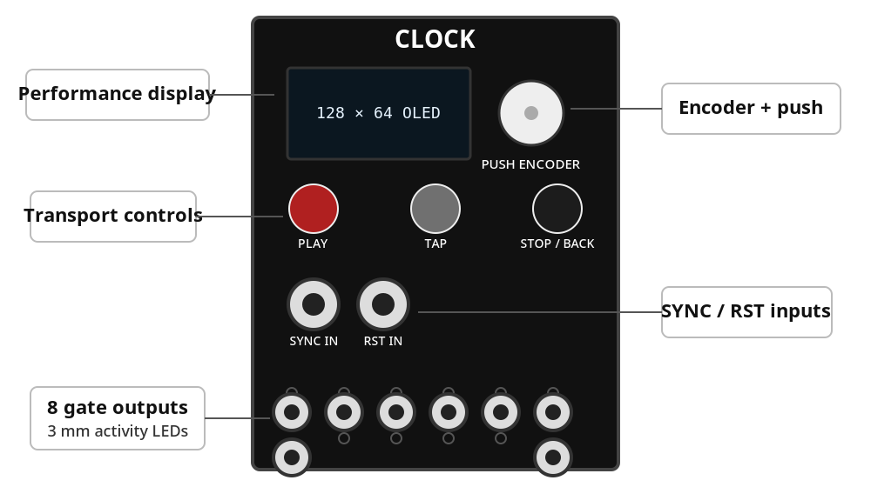
Panel element | Purpose
OLED | Performance view, menus and editors
Encoder | Turn to select/change; short and long push have different jobs
PLAY | Start or pause the master transport
TAP | Tap Tempo; also a modifier for Settings and mode selection
STOP / BACK | STOP from Performance; BACK/cancel elsewhere
SYNC IN | External clock input (prerelease hardware path)
RST IN | External reset/phase input (prerelease hardware path)
OUT 1–8 | Gate/clock outputs; LED mirrors each logical output
Installation
Use a standard Eurorack 2×8 power cable. Align the red stripe with −12 V and verify the connector orientation before applying power.
Safe boot
Every power-up enters STOP. The gate buffer remains disabled while the firmware initializes; channel source pins are driven LOW before the output stage is enabled. A previously saved PLAY state is never resumed automatically.
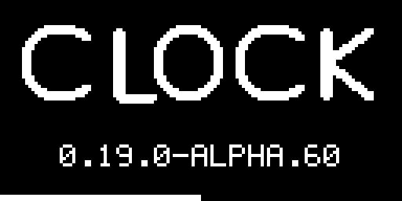
The boot screen lasts about one second and shows CLOCK, the firmware version and a two-pixel progress bar. Holding the encoder push continuously through the boot screen launches the selected Easter egg; see section 19.
3 Two-minute quick start
FACTORY STATE
One Clock · 120 BPM · 4/4 · INTERNAL source · STOP · ×1 rate · 0% Swing · 10 ms gates · 0% Phase · Humanize OFF · Clock screensaver after 2 min in STOP, dim after 5 min, OLED off after 10 min.
Get eight identical clocks
- 1. Power the rack. CLOCK must finish booting in STOP.
- 2. Patch any of OUT 1–8 to modules that accept a clock or trigger.
- 3. Turn the encoder on Performance to set the master BPM.
- 4. Press PLAY. In the factory One Clock topology, all eight outputs now follow the same clock.
- 5. Press PLAY again to pause. Press STOP / BACK from Performance to stop and reset global phase.

Move from One Clock to independent rhythms
- 1. Short-press the encoder to open the global overview.
- 2. Hold TAP and turn the encoder. The six-function palette appears.
- 3. Choose CLOCK, EUCLID or SEQUENCER. Releasing TAP opens CHANGE MODE? with NO selected.
- 4. Select YES and press the encoder. Choosing one of those channel functions switches to Independent operation for the selected channel context.
- 5. From Performance, short-press the encoder to select among channels 1–8.
SAFE CONFIRMATION
Changing between channel functions and global output topologies is never applied merely by brushing past a choice. CHANGE MODE? defaults to NO.
4 The control language
Most of CLOCK becomes predictable once the distinction between a short encoder press, a long encoder press and a TAP chord is clear.
Gesture | What it means
Encoder turn | Performance: change master BPM. Overview: move highlight. Settings/editor: move cursor or change the edited value.
Encoder short press | Performance: open overview. Independent overview: confirm highlighted channel and return. Settings/editor: enter, confirm or toggle a sequencer step.
Encoder long press (~650 ms) | From Performance or overview: open the settings belonging to the current/highlighted channel or global topology.
TAP + encoder press | From Performance: open the root Settings tree.
Hold TAP + encoder turn | From an overview: open and move through the six-function mode palette. Release TAP to commit the highlighted choice.
Button | Contextual behavior
PLAY | Performance: play/pause. Sequencer editor: next 16-step page.
TAP | Performance: Tap Tempo. Overview: modifier for mode selection. Sequencer editor: previous 16-step page.
STOP / BACK | Performance: STOP + global phase reset. Elsewhere: back/cancel.
Editing a value
- 1. Turn to select a row.
- 2. Press to edit or open it.
- 3. Turn to change the value.
- 4. Press to confirm.
Only the value being edited is inverted. BACK leaves the current page or cancels the current confirmation workflow.
SHORT OR LONG?
A short encoder push from Performance is for orientation: it opens the overview. A long push is the direct route to the settings that belong to the current context.
5 Read the Performance screen
Performance is intentionally sparse. It shows the state needed while patching; detailed editing lives on dedicated pages.
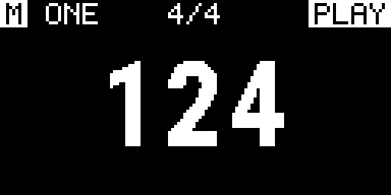
Header
- M / S: filled M = master; outlined S = slave.
- Padlock: shown beside S when external timing is locked.
- CHn + pictogram: selected Independent channel and its generator.
- Meter: master meter in the center.
- Transport: PLAY, PAUSE or STOP at the right.
Tempo area
The BPM number stays mathematically centered. A non-zero Swing value appears at the left; a Clock rate other than ×1 appears at the right. Zero Swing and ×1 are omitted to keep the display quiet.
Pattern feedback
Euclid and Sequencer use the lower display for live pattern feedback. Filled cells are gates, outlined cells are rests, and an underline marks the current step. A sequence longer than 16 steps adds a block indicator for the active 16-step segment.
6 Select channels and change functions
Independent channel overview
In Independent topology, short-press the encoder from Performance to open SELECT CHANNEL. The 2×4 grid shows channels 1–8 and their pictograms. Turn to move the inverted highlight. Short-press to select that channel and return to Performance; long-press to open the highlighted channel settings.
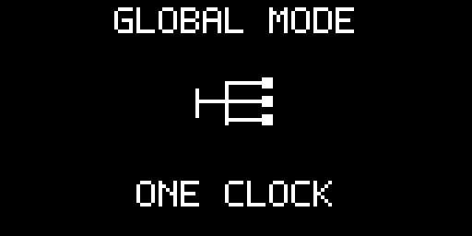
Global overview
One Clock and Divider Bank do not pretend to have eight independent channel menus. Their overview shows the active global topology. A short press returns to Performance; a long press opens that topology’s settings.
Six-function palette
Function | Scope | Destination after confirmation
Off | Selected channel / Independent | Performance (---)
Clock | Selected channel / Independent | Performance
Euclid | Selected channel / Independent | Euclid settings
Sequencer | Selected channel / Independent | 16-step editor
One Clock | Global topology | One Clock settings
Divider Bank | Global topology | Divider family setting
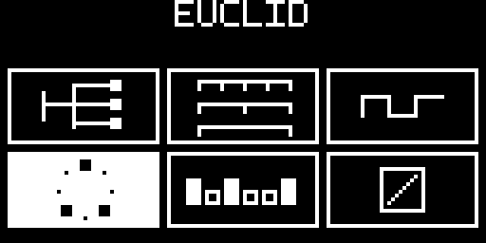
Hold TAP and turn in the overview, then release TAP. If the highlighted function differs from the current one, CHANGE MODE? appears with NO selected by default.

7 Transport and tempo
PLAY, PAUSE and STOP
Action | Result
PLAY from STOP or PAUSE | Transport enters PLAY.
PLAY while playing | Transport enters PAUSE and preserves position.
STOP / BACK from Performance | Transport enters STOP and resets global phase according to reset policy.
Set BPM with the encoder
Turn the encoder on Performance. Manual tempo changes obey the user MIN BPM and MAX BPM limits. Factory limits are 20…999 BPM; those limits can themselves be set anywhere within the technical 1…999 BPM range.
Tap Tempo
Tap TAP repeatedly on Performance. The first tap starts a measurement; the second produces the first estimate; later taps use a rolling average of recent intervals. A valid Tap Tempo result is clamped to the configured user range and selects INTERNAL as the clock source. After 65 seconds without a tap, the next tap starts a new measurement.
WHY TAP SELECTS INTERNAL
Tap Tempo is an explicit request to make CLOCK the timing authority. External synchronization is therefore left rather than silently competing with the tapped tempo.
8 Independent channels
Independent topology lets each of the eight outputs choose Off, Clock, Euclid or Sequencer while remaining phase-related to the same master timeline.
What every active channel can set
Parameter | Range / meaning
RATE | ÷32, ÷24, ÷16, ÷12, ÷8, ÷6, ÷4, ÷3, ÷2, ×1, ×2, ×3, ×4, ×6, ×8, ×12, ×16, ×24, ×32
Numerator / denominator | 1…16 each; enables rational ratios such as 2:3 or 3:2
SWING | 0…50%
PROBABILITY | 0…100%
GATE | 1, 2, 5, 10, 20, 50 or 100 ms
PHASE | 0…99%
RESET | GLOBAL or FREE
MUTE | Suppress output without discarding the generator setup
OFF versus MUTE
OFF | MUTE
Removes the channel from event scheduling. | Keeps the generator running but suppresses its output.
Forces logical output LOW. | Useful for temporary silence.
Stored configuration remains available for later reuse. | Mode and settings remain active.
RESET POLICY
GLOBAL channels follow global phase resets and external alignment. FREE channels keep their local cycle position when global phase is reset.
9 Clock mode
Clock mode emits a gate at every eligible channel event. Use it for conventional clock trees, multiplied clocks, polymetric relationships and phase-shifted timing.
Clock-specific settings
Setting | Range / use
Meter beats | 1…16
Meter unit | 2, 4, 8 or 16
RATE DIV/MULT | Conventional integer divisions and multiplications
Ratio | Numerator/denominator for exact rational relationships
The timing engine retains fractional remainders instead of truncating them, so rational ratios do not accumulate drift simply because an interval is not an integer number of scheduler quanta.
Example: 3 against 2
- 1. Select a Clock channel.
- 2. Open RATE.
- 3. Set numerator to 3 and denominator to 2.
- 4. Keep RESET = GLOBAL if it must return to the common downbeat.
10 Euclid mode
Euclid distributes a chosen number of hits as evenly as possible over a cycle. It is useful for percussion, accents and repeating rhythmic structures that remain easy to reshape.
Parameter | Range
STEPS | 1…64
HITS | 0…STEPS
ROTATE | 0…STEPS − 1
At RATE ×1, each Euclid step is a sixteenth note. In 4/4, 16 steps therefore span one bar. RATE scales that step grid. Reducing STEPS automatically clamps HITS and, where needed, rotation to valid values.
Build a 16-step pattern
- 1. Choose Euclid for a channel.
- 2. Set STEPS = 16.
- 3. Set HITS to the desired density.
- 4. Use ROTATE to move the pattern around the bar without changing the number of hits.
- 5. Use PROBABILITY for controlled variation without rewriting the Euclid pattern.
11 Sequencer mode
Each Sequencer channel stores a 64-bit gate pattern and an active length from 1 to 64 steps. At RATE ×1, one step is a sixteenth note.
Page item | What it does
EDITOR | Open the step editor
LENGTH | 1…64 active steps
ROTATE | Rotate inside the active length
INVERT | Invert every step inside the active length
CLEAR | Remove all gates
FILL ALTERNATE | Fill alternating steps, beginning with step 1
COPY | Copy the 64-bit pattern
PASTE | Paste and clamp to the destination length

Editor controls
- Encoder turn — move the cursor through active steps.
- Encoder press — toggle the selected gate.
- PLAY — next 16-step page.
- TAP — previous 16-step page.
- STOP / BACK — return to Sequencer settings.
The four editor pages are 1–16, 17–32, 33–48 and 49–64. The cursor cannot move beyond the active sequence length.
12 One Clock
One Clock is the simplest global topology: a single clock configuration drives all eight physical outputs. This is the factory state.
Setting | Range
DIV/MULT | ÷32 … ×32
Numerator / denominator | 1…16 each
Swing | 0…50%
Gate length | 1, 2, 5, 10, 20, 50 or 100 ms
Phase | 0…99%
Humanize | OFF, 250, 500, 1000 or 2000 µs
Humanize
Humanize adds a small deterministic per-output timing displacement while preserving the common restart/downbeat. It exists only in One Clock; OFF gives exact coincidence across the eight outputs.
USE ONE CLOCK WHEN
You need one authoritative clock on several destinations and do not want eight separate channel configurations.
13 Divider Bank
Divider Bank derives eight deterministic clocks from the master timeline. Only the divider family and shared gate length are editable.

Family | OUT 1…8
POW2 | ×1 · ÷2 · ÷4 · ÷8 · ÷16 · ÷32 · ÷64 · ÷128
INT | ×1 · ÷2 · ÷3 · ÷4 · ÷5 · ÷6 · ÷7 · ÷8
PRIME | ×1 · ÷2 · ÷3 · ÷5 · ÷7 · ÷11 · ÷13 · ÷17
The Performance screen shows all eight assignments, so there is no synthetic per-channel settings page in this topology.
14 Settings map
Hold TAP and press the encoder from Performance to open the root Settings tree. The hierarchy is intentionally shallow and context-sensitive.
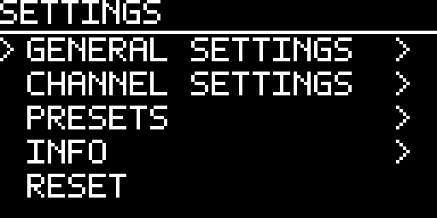
Root item | Contains / does
GENERAL SETTINGS | CLOCK, SYNC, SCREENSAVER
CHANNEL SETTINGS | Current Independent channel, One Clock or Divider Bank settings
PRESETS | CURRENT auto-save, Load Preset, Save Preset, Templates
INFO | Name, firmware version, author, licenses, update QR
RESET | Apply global phase reset; this is not Factory Reset
GENERAL SETTINGS → CLOCK
Setting | Range
BPM | Current master tempo
MIN BPM | 1…MAX; factory 20
MAX BPM | MIN…999; factory 999
Meter beats | 1…16
Meter unit | 2, 4, 8 or 16
Changing MIN or MAX clamps the current manual tempo if necessary. External synchronization deliberately follows the external timing source rather than the manual BPM limit.
15 External SYNC and RST
The engine-side synchronization model is implemented, including pulse filtering, PPQN interpretation, loss policy and external reset semantics. The final comparator-to-timer capture routing and hardware-in-the-loop sign-off are still prerelease work.
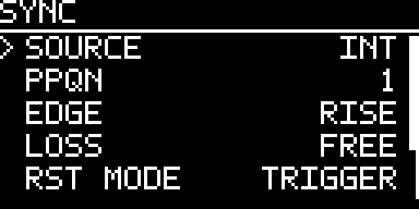
SYNC setting | Options / meaning
SOURCE | INTERNAL · EXTERNAL · AUTO
PPQN | 1 · 2 · 4 · 24 pulses per quarter note
EDGE | Rising or falling
LOSS | STOP · FREE (continue at last known tempo) · INTERNAL (fall back to internal BPM)
RESET INPUT | TRIGGER · GATE
FILTER | 0…5000 µs in 250 µs steps
TIMEOUT | 200…5000 ms in 100 ms steps
Source behavior
INTERNAL makes CLOCK the timing master. EXTERNAL follows accepted SYNC pulses. AUTO uses external timing while a usable external source is locked and internal timing otherwise.
RST behavior
In TRIGGER mode, the accepted reset edge resets global phase. In GATE mode, the external reset level controls the reset gate state. Channels whose local RESET policy is FREE are intentionally not forced back to the global cycle position.
PRERELEASE HARDWARE LIMITATION
Do not claim production-grade external sync from software tests alone. The final LM393/comparator input path, STM32 capture routing, thresholds and timing distribution must be measured on the real module. Until that HIL work is complete, INTERNAL is the reference operating path.
16 Presets, autosave and templates
CURRENT — automatic recovery
CLOCK continuously stages the complete working state. A coalescing delay avoids writing every small edit immediately. Physical STM32 Flash commits are deferred while transport is PLAYING and are flushed after PAUSE or STOP, so Flash erase/program work cannot stall the live gate path. On the next boot, a valid CURRENT state is restored but transport is still forced to STOP.
Eight named user presets
LOAD PRESET and SAVE PRESET expose eight durable user slots. Names are up to 16 characters. Saving over an occupied slot requires an explicit OVERWRITE PRESET confirmation with NO selected by default.
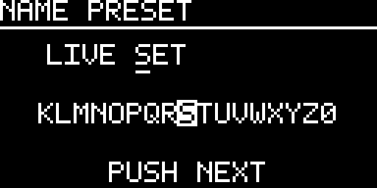
Factory templates
Template | Starting configuration
ALL MASTER | Factory One Clock state
CLOCK TREE | Independent: ×1, ÷2, ÷4, ÷8, ×2, ×4, ×8, ×16
DIVIDERS | Independent: ×1, ÷2, ÷3, ÷4, ÷6, ÷8, ÷12, ÷16
POLYRHYTHM | Ratios 1:1, 2:3, 3:2, 3:4, 4:3, 4:5, 5:4, 5:8
EUCLID KIT | Eight 16-step Euclid channels with differentiated hits/rotation
HYBRID | CH1–3 Clock, CH4–6 Euclid, CH7–8 Sequencer; CH2 ÷2, CH3 3:2
PRESET ≠ TEMPLATE
A named preset is your durable snapshot. A template is a factory starting point that replaces the current working configuration. Loading a template does not create a named preset.
17 Screensaver and display protection
Display protection advances only while transport is STOP. Any front-panel activity wakes the display immediately. PLAY and PAUSE do not accumulate the screensaver timers.
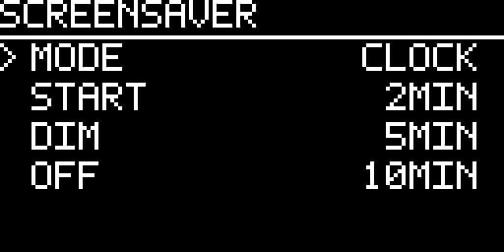
Factory timings
Stage | Factory value
Screensaver start | 2 minutes
Dim | 5 minutes
OLED power-off | 10 minutes
CLOCK enforces START ≤ DIM ≤ OFF. Choosing screensaver OFF disables the animation but does not disable the later DIM/OFF protection.
Available animations
Mode | Character
OFF | No animation; dim/off protection remains
CLOCK | Factory default; scrolling clock traces
PLUG | Damped plucked-string motion
HEARTBEAT | Pulsating heart
ACID | Bouncing/rotating acid-style smiley
SPECTRUM | Synthetic 16-band display; it does not sample audio
FIELD | Slow monochrome contour field
BLOX | Procedural triangular bodies fall and stack
MATRIX | Original monochrome digital rain
CUBE COVER | 8×8 cube tiles cover the OLED in changing traversal orders
FRACTAL | Curated Barnsley-fern crops
ORBIT | Sparse orbital animation
18 Gate outputs and LEDs
Gate length
Gate length is selectable as 1, 2, 5, 10, 20, 50 or 100 ms; the factory value is 10 ms. The scheduler caps a pulse against the effective event interval so an excessively long setting cannot consume the next rising edge.
Voltage level
The current output-stage target is 0 V LOW and nominal +5 V HIGH. +10 V is not a project requirement; changing to that level would require a different output stage rather than the planned 74HCT244 path.
Activity LEDs
Each LED mirrors the corresponding logical channel signal. It is not a cable-presence indicator. Normal boot does not animate the output LEDs.
HARDWARE SIGN-OFF
Voltage levels, boot behavior at the jacks and timing jitter remain physical HIL measurements. Host tests verify logic, not analog thresholds or actual edge placement at a Eurorack socket.
19 Hidden boot features
Hold the encoder push continuously from power-up until the boot screen completes. CLOCK then starts the compile-time selected Easter egg before the normal real-time scheduler.
Build selection | Feature | Controls / behavior
1 (default) | Pixel Raid | Encoder moves; TAP fires; ranked arcade game
2 | Formula 1 | Encoder steers; ranked arcade game
3 | Breakout | Encoder moves paddle; TAP launches; ranked arcade game
4 | Egg Journey | Encoder moves; TAP jumps; ranked arcade game
5 | BEATKNECHT | TAP changes rhythm style; encoder changes BPM; drives OUT 1–8 intentionally
Arcade flow
Pixel Raid, Formula 1, Breakout and Egg Journey share a game-specific intro, score/high-score tracking, three-letter initials entry when a score qualifies, and a scrollable Top 100. Their external gate-output stage stays disabled.

Exit
A long encoder hold is the game-exit gesture. After exit, normal firmware startup continues and transport remains STOP. BEATKNECHT is deliberately different from the arcade games: it enables the output stage only while it is intentionally generating its eight rhythm gates, and returns all outputs LOW on exit.
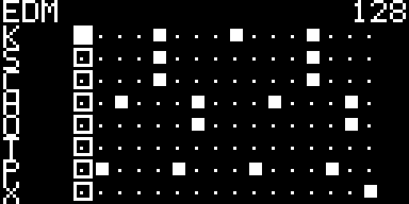
20 Practical recipes
Eight exact copies of one master clock
- 1. Select One Clock.
- 2. Set RATE to ×1 and HUMANIZE to OFF.
- 3. Choose the gate length.
- 4. Press PLAY.
A conventional clock tree
- 1. Switch to Independent.
- 2. Load the CLOCK TREE template or set channel rates manually.
- 3. Use RESET = GLOBAL on channels that must return to the same downbeat.
A Euclidean percussion line
- 1. Choose Euclid.
- 2. Set STEPS = 16.
- 3. Choose HITS.
- 4. Use ROTATE for placement.
- 5. Use PROBABILITY for controlled omissions.
A 64-step gate phrase
- 1. Choose Sequencer.
- 2. Set LENGTH = 64.
- 3. Open EDITOR.
- 4. Use PLAY/TAP to move forward/back through the four pages.
- 5. Toggle gates with encoder presses.
- 6. BACK returns to Sequencer settings.
21 Troubleshooting
Symptom | Check first
No gates after power-up | Normal until PLAY is pressed. Then check topology, OFF/MUTE, PROBABILITY and gate routing.
All eight outputs are identical | Factory topology is One Clock. Switch to a channel function to enter Independent operation.
Tempo stops at a value | Check GENERAL SETTINGS → CLOCK → MIN BPM / MAX BPM.
Tap Tempo changed clock source | Intentional: a valid Tap Tempo result selects INTERNAL.
RESET did not restart one channel | That channel may use RESET = FREE.
Screensaver does not start | Timers advance only in STOP, not PLAY or PAUSE.
Preset save asks for confirmation | The slot is occupied; NO is the safe default.
External lock is unavailable or unstable | External SYNC/RST hardware capture is prerelease and requires HIL sign-off; use INTERNAL as the reference path.
A USEFUL DIAGNOSTIC ORDER
First establish topology → transport → selected channel/mode → MUTE/OFF/PROBABILITY → rate → clock source. This avoids chasing timing settings when the problem is simply that no event is eligible to reach the output.
22 Technical status and specifications
Timing architecture
The current prerelease uses a 20 kHz TIM3 scheduler (50 µs service quantum). The hard timing path is interrupt-driven and does not use an RTOS. The intended interrupt priority is TIM3 scheduler first, then EXTI/encoder/SYNC/RST, then I²C, with foreground work last.
Display transports
SPI is the preferred/default reference display path and performs fast dirty-page transfers. I²C remains supported, but display work is deliberately bounded and deferred: present() only publishes the latest framebuffer, at most one I²C transaction is serviced per foreground pass, data packets contain at most 24 framebuffer bytes, dirty pages are used, stale UI frames may be dropped, and NACKs are retried. Display refresh is never allowed to decide gate timing.
REQUIRED HIL A/B TEST
Before beta, SPI and I²C must be compared on the real STM32 under maximum display activity. A lower I²C frame rate is acceptable; additional gate jitter, lost edges, SYNC/RST faults or encoder losses are not.
Prototype specifications
Parameter | Current documented value
Format | Eurorack, 3U
Width | 10 HP
MCU | STM32F401CCU6 Blackpill
Display | 128×64 SSD1306/SSD1315; SPI reference, I²C supported
Outputs | 8 gate/clock outputs; target 0/+5 V
Inputs | SYNC and RST, final hardware capture/routing prerelease
Controls | Push encoder, PLAY, TAP, STOP/BACK, 8 activity LEDs
Scheduler | 20 kHz hard timing domain
Persistence | CURRENT auto-save + 8 named presets, schema/CRC protected
Firmware | 0.19.0-alpha.62 (prototype)
Verification boundary
The source release has host tests, sanitizer checks, architecture/documentation checks and high code coverage. Those checks validate software behavior. They do not prove comparator thresholds, electrical output levels, physical gate jitter, startup pulses at the jack or final SPI/I²C signal integrity. Those remain HIL measurements.
COLOPHON
CLOCK — User Manual. Typeset in Ubuntu.

This manual is licensed under Creative Commons Attribution–NonCommercial 4.0 International (CC BY-NC 4.0). The firmware is licensed separately under the PolyForm Noncommercial License 1.0.0; third-party components retain their upstream licenses.
Design, firmware and documentation: Axel Napolitano.
Prototype documentation — firmware 0.19.0-alpha.62, baseline 10 September 2026.
© 2026 Axel Napolitano · From Munich with 
