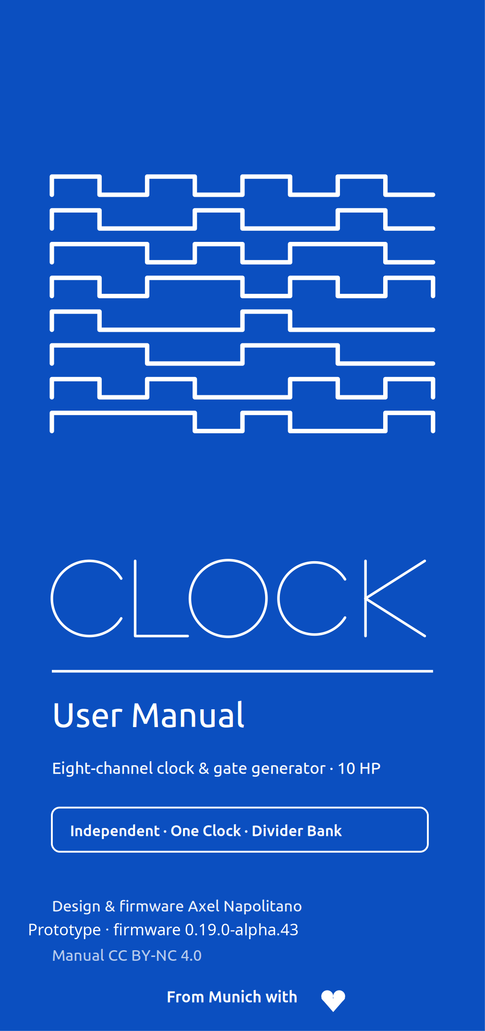
1 Introduction
CLOCK is an eight-channel Eurorack clock and gate-rhythm generator (10 HP, 3U). It can act as a master clock, follow an external clock, produce independent rhythms on eight outputs, duplicate one shared clock across all outputs, or act as an eight-output divider bank.
The eight physical outputs share one deterministic master timeline. Transport and Tap Tempo are master-level operations. In Independent operation each channel still owns its own generator, rate, phase, swing, probability, gate length, reset behaviour and pattern settings.
Three output topologies
- Independent: each output independently uses Off, Clock, Euclid or Sequencer.
- One Clock: one shared clock configuration drives all eight outputs.
- Divider Bank: one shared clock feeds eight fixed divider outputs from a selected family.

PROTOTYPE — FIRMWARE 0.19.0-ALPHA.43
This is prerelease hardware and firmware. The final external-sync input-capture path, lock behaviour, diagnostics, event-driven scheduler, PCB pin assignment and hardware-in-the-loop sign-off are not complete. This manual documents the currently implemented behaviour. Baseline: 7 September 2026.

2 Panel overview
CLOCK is operated entirely from a display, one encoder and three buttons. Two inputs accept an external clock (SYNC) and a reset (RST); the eight outputs each have a status LED above them.
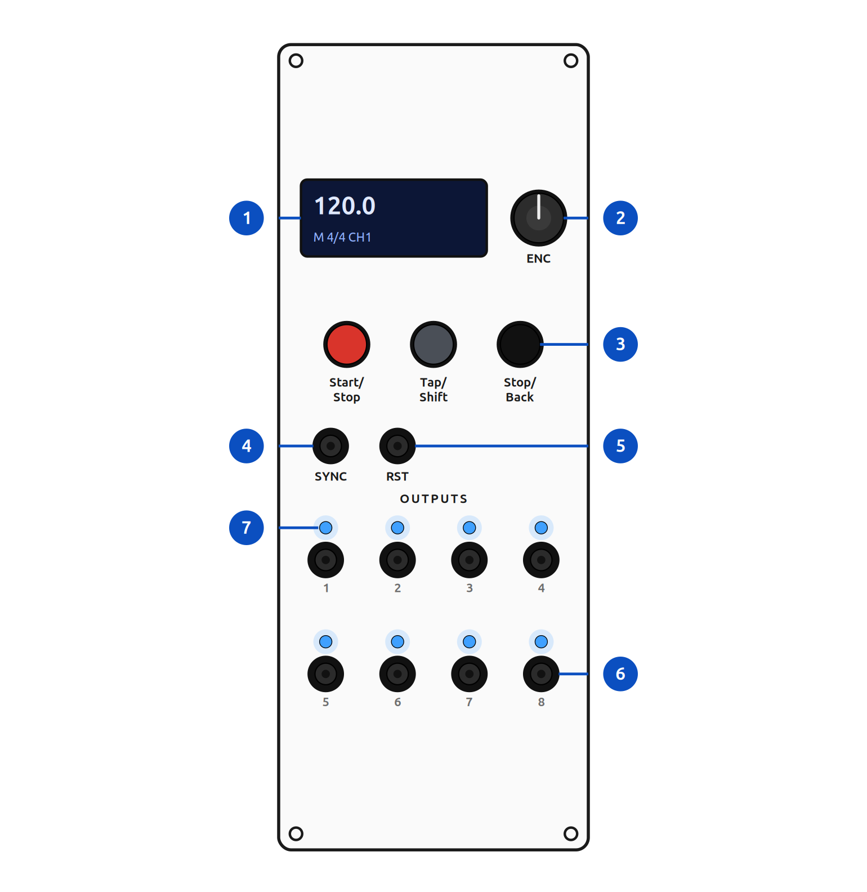
CLOCK — front panel (prototype)
Ref. | Panel element
 | Display — Performance screen, menus and editors
 | Encoder — turn to change / select, push to open / confirm
 | Buttons — Start/Stop (red), Tap/Shift (dark grey), Stop/Back (black)
 | SYNC — external clock input
 | RST — external reset / phase-align input
 | Outputs 1–8 — gate / clock outputs (two rows of four)
 | Status LEDs — one above each output, mirror the channel signal

BUTTON NAMES
The three buttons are printed Start/Stop (red), Tap/Shift (dark grey) and Stop/Back (black). Tap/Shift doubles as the SHIFT modifier used for menus. Final PCB pin assignment for the SYNC / RST jacks is still being finalised (prototype).
Installation
CLOCK needs a standard Eurorack power cable (2×8 pin). Line up the red stripe with the −12 V side of the header and check seating before powering up.

3 Before you start
Power-up behaviour
Every power-up starts in STOP, even if the last saved transport state was PLAY. The gate buffer is held disabled while the firmware initialises, all channel source pins are driven LOW, the scheduler starts from STOP, and only then is the output stage enabled. This prevents a normal startup from producing accidental triggers.
Boot screen
The boot screen appears for about one second and shows the product name, firmware version and a progress bar. Holding the encoder push switch for the complete boot screen starts the hidden Pixel Raid game before the clock scheduler starts (see section 14).
Factory working state
- Topology: Independent
- Tempo: 120 BPM (user range 20–999 BPM)
- Master meter: 4/4
- Clock source: Internal
- Transport: STOP
- Channels: all in Clock mode at ×1
- Per-channel: 0% swing, 100% probability, 10 ms gates, 0% phase, GLOBAL reset, MUTE off
- Display: fractal screensaver after 2 min in STOP, dim after 5, off after 10

4 Quick start
- 1. Power the module. Confirm the transport display reads STOP.
- 2. Turn the encoder on the Performance screen to set the master tempo.
- 3. Press the encoder to open the channel overview.
- 4. Turn the encoder to select a channel.
- 5. To change its function, hold Tap/Shift and turn the encoder. Release Tap/Shift, select YES in the confirmation dialog and press the encoder.
- 6. Configure the selected mode with the encoder.
- 7. Press Start/Stop to start.
- 8. Press Start/Stop again to pause, or press Stop/Back from Performance to stop and reset global phase.

5 Front-panel controls
The same physical controls do different things depending on the current screen.
Control | Performance | Overview / mode | Settings / editor
Encoder turn | change master BPM (MIN–MAX) | select a channel or mode | move cursor / change value
Encoder press | open channel/global overview | open settings / confirm mode | enter, confirm or toggle a step
Tap/Shift + press | open the Settings tree | — | —
Tap/Shift + turn | — | open the six-function palette; release to commit | —
Start/Stop | start / pause playback | — | Sequencer editor: next page
Tap/Shift (short) | Tap Tempo | — | Sequencer editor: previous page
Stop/Back | STOP + reset global phase | go back / cancel | go back / cancel

Standard editing grammar
Most parameter edits follow the same four actions:
- 1. Turn to select a row.
- 2. Press to enter edit mode.
- 3. Turn to change the value.
- 4. Press to confirm and leave edit mode.
Only the edited value is inverted. Stop/Back leaves the current page or cancels a confirmation workflow.

6 Performance screen
The Performance screen is deliberately sparse so that status stays readable while playing.
Header status
- A clock-role badge at the far left
- A lock symbol beside the slave badge when external timing is locked
- The selected channel as CHn with a compact mode pictogram
- The master meter in the centre
- The transport state at the right
Clock-role badge | Meaning
Filled M | Master
Outlined S | Slave
Padlock beside S | external timing is locked

Tempo and channel information
The centred tempo uses dedicated high-legibility numerals. A nonzero Swing is shown at the left and a Clock rate other than ×1 at the right; zero Swing and ×1 are omitted to reduce clutter.
Live pattern strips
For Euclid, filled cells are hits, outlined cells are rests and an underline marks the current step.
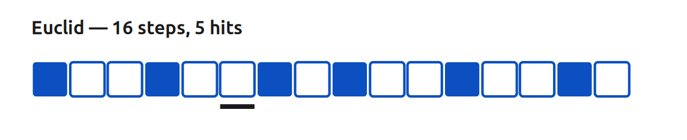
For Sequencer, the display shows the active 16-step block. For lengths above 16 steps a lower block indicator shows which segment is active.
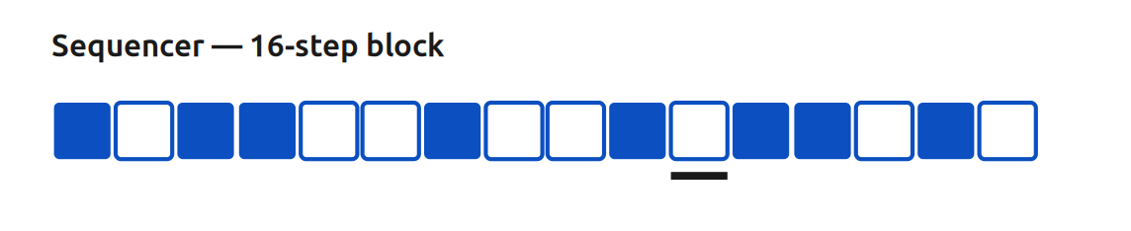
STOP DISPLAY PROTECTION
Screensaver, dimming and display-off only advance while transport is STOP. Any front-panel activity wakes the display immediately; the animation does not run during PLAY or PAUSE.

7 Channels and topology
Selecting a channel
In Independent topology, press the encoder from Performance to open SELECT CHANNEL. All eight channels appear in a 2×4 grid; the selected tile is fully inverted. Turn to select 1–8, press to open its settings, Stop/Back to return. In One Clock and Divider Bank there is no per-channel selection — the encoder opens a global overview and then the relevant global settings.
Changing a channel function or output topology
From the overview, hold Tap/Shift and turn the encoder to open the six-function palette:
# | Function | Scope
1 | Off | selected channel (Independent)
2 | Clock | selected channel (Independent)
3 | Euclid | selected channel (Independent)
4 | Sequencer | selected channel (Independent)
5 | One Clock | global output topology
6 | Divider Bank | global output topology

Release Tap/Shift to commit the highlighted choice. If it differs from the current function, CHANGE MODE? appears with NO selected by default. Select YES and press to apply. After confirmation, Off and Clock return to Performance; Euclid opens its pattern settings; Sequencer opens its step editor; One Clock opens its shared-clock settings; Divider Bank opens its divider-family setting.

8 Transport and Tap Tempo
PLAY, PAUSE and STOP
- From Performance, Start/Stop changes STOP or PAUSE to PLAY.
- While playing, Start/Stop changes PLAY to PAUSE.
- Stop/Back from Performance changes the transport to STOP and resets global phase.
PAUSE preserves the current position. STOP restarts the global timing reference according to the reset policy.
Tap Tempo
Tap the Tap/Shift button repeatedly on the Performance screen. The first tap starts a measurement; the second produces the first estimate; further taps use a rolling average of recent intervals. The result is clamped to the configured user tempo range. Registering a valid Tap Tempo also selects INTERNAL as the clock source. If no tap arrives for 65 seconds, the next tap begins a new measurement.

9 Independent channel settings
The Channel page only shows settings relevant to the active generator. Off shows MODE only; Clock, Euclid and Sequencer show MODE, RATE, the mode-specific page, SWING, PROBABILITY, GATE, PHASE, RESET and MUTE.
RATE
DIV/MULT: ÷32, ÷24, ÷16, ÷12, ÷8, ÷6, ÷4, ÷3, ÷2, ×1, ×2, ×3, ×4, ×6, ×8, ×12, ×16, ×24, ×32.
Numerator / denominator: each 1–16. The rational pair supports polymetric relationships such as 2:3, 3:2, 4:5 and 5:4. The engine keeps fractional remainders, avoiding long-term drift from integer truncation.
Common parameters
Parameter | Range / behaviour
SWING | 0–50% — alternates timing around the nominal grid
PROBABILITY | 0–100% — chance each eligible event produces a gate
GATE | 1, 2, 5, 10, 20, 50 or 100 ms
PHASE | 0–99% — offsets the channel relative to its cycle
RESET — GLOBAL | follows global phase resets and external alignment
RESET — FREE | keeps local cycle state when global phase is reset
MUTE | suppresses output but keeps the mode and configuration

OFF VERSUS MUTE
OFF removes the channel from event scheduling and forces the output LOW; its stored configuration remains for later reuse. MUTE keeps the generator and settings active but suppresses the output. Use OFF when the channel should not participate; use MUTE for a temporary silence.

10 Modes
Clock mode
Clock mode produces a gate at every eligible channel event. It supports the full RATE controls, a local meter, swing, probability, gate length, phase, reset behaviour and mute.
Clock page | Value
Meter beats | 1–16
Meter unit | 2, 4, 8 or 16

Use integer division/multiplication for conventional clock trees; use the rational numerator and denominator for polymetric relationships.
Euclid mode
Euclid distributes a chosen number of hits as evenly as possible across a cycle.
Parameter | Range
STEPS | 1–64
HITS | 0 to STEPS
ROTATE | 0 to STEPS − 1

At RATE ×1 each Euclid step uses a sixteenth-note grid; in 4/4 a 16-step cycle therefore spans one bar, and RATE scales this grid. If STEPS is reduced below HITS, HITS is clamped; if the rotation no longer fits, it returns to zero. The Performance strip uses the same generated pattern as the timing engine.

Sequencer mode
Each channel has a 64-bit gate pattern and an active length of 1–64 steps. At RATE ×1 one step is a sixteenth note, so 16 steps span one 4/4 bar.
# | Sequencer page
1 | EDITOR — open the step editor
2 | LENGTH — 1–64 steps
3 | ROTATE — 0 to LENGTH − 1
4 | INVERT — invert every step inside the active length
5 | CLEAR — remove all gates
6 | FILL ALTERNATE — fill alternating steps, starting with the first
7 | COPY — copy the 64-bit pattern to the clipboard
8 | PASTE — paste and clamp to the destination length

Step editor controls
- Turn the encoder to move through active steps.
- Press the encoder to toggle the selected gate.
- Start/Stop — next 16-step page.
- Tap/Shift — previous 16-step page.
- Stop/Back — return to the Sequencer page.
The pages are 1–16, 17–32, 33–48 and 49–64. Cursor movement is limited to the active sequence length.

11 One Clock and Divider Bank
One Clock
One Clock drives all eight outputs from one shared Clock configuration — an eight-way master-clock multiple.
Setting | Range
DIV/MULT | ÷32 … ×32
Numerator / denominator | each 1–16
Swing | 0–50%
Gate length | 1, 2, 5, 10, 20, 50 or 100 ms
Phase | 0–99%
HUMANIZE | Off, 250, 500, 1000 or 2000 µs

HUMANIZE
Humanize applies a small deterministic, per-output timing displacement while the common restart / downbeat stays exact. It is available only in One Clock. Independent Euclid and Sequencer settings remain stored but do not drive the outputs in this topology.
Divider Bank
Divider Bank derives eight clocks from the master timeline. Only the divider family and shared gate length are editable; the Performance screen shows all eight assignments.
Family | Divisions
POW2 | ×1, ÷2, ÷4, ÷8, ÷16, ÷32, ÷64, ÷128
INT | ×1, ÷2, ÷3, ÷4, ÷5, ÷6, ÷7, ÷8
PRIME | ×1, ÷2, ÷3, ÷5, ÷7, ÷11, ÷13, ÷17

12 Global settings
Hold Tap/Shift and press the encoder from Performance to open the Settings tree: MASTER, SYNC, the topology page (CHANNEL / ONE CLOCK / DIVIDER BANK), PREFERENCES, TEMPLATES, INFO and RESET.
MASTER
Setting | Range / note
TEMPO | current BPM, constrained by MIN/MAX
MIN BPM | 1 up to MAX (factory 20)
MAX BPM | MIN up to 999 (factory 999)
METER BEATS | 1–16
METER UNIT | 2, 4, 8 or 16

Changing MIN or MAX also clamps the current tempo if necessary.

SYNC
Setting | Options
SOURCE | INTERNAL · EXTERNAL · AUTO (external while locked, internal otherwise)
PPQN | 1, 2, 4 or 24 pulses per quarter note
EDGE | rising or falling
LOSS | STOP · FREE (last known tempo) · INTERNAL (fall back to internal BPM)
FILTER | 0–5000 µs in 250 µs steps
TIMEOUT | 200–5000 ms in 100 ms steps

EXTERNAL-SYNC HARDWARE LIMITATION
The timing engine and phase-following behaviour exist, but the current hardware build does not yet have the final comparator input-capture path or a frozen sync / jack-detect pin assignment. Do not treat external synchronisation as production-ready until the hardware-in-the-loop work is complete. Use INTERNAL timing for hardware operation until then.

PREFERENCES and automatic recovery
CURRENT — AUTO SAVE continuously stages the complete working configuration after a short coalescing delay. Physical Flash commits are deferred while transport is PLAYING and flushed after PAUSE or STOP, so Flash erase/program work cannot stall the live gate path. A valid CURRENT record is restored at power-up, but transport is always forced to STOP.
User presets
There are eight named user-preset slots; names hold up to 16 characters.
Load: SETTINGS ▸ PREFERENCES ▸ LOAD PRESET, select a slot, press the encoder.
Save: SETTINGS ▸ PREFERENCES ▸ SAVE PRESET, select a slot; if occupied, confirm OVERWRITE PRESET (NO by default); turn to choose each character and press to advance; confirm the final character to save. Stop/Back cancels name entry.
TWO INDEPENDENT STORES
CURRENT auto-save and named presets are separate. All records are schema-versioned and CRC-32 protected.
Screensaver
Setting | Value
MODE 1 — FRACTAL | animated fixed-point fractal (factory default)
MODE 2 — ORBIT | sparse orbital animation
MODE 3 — NONE | no animation; dim / off still apply
START | 1 minute up to DIM
DIM | START up to OFF
OFF | DIM up to 120 minutes

The firmware enforces START ≤ DIM ≤ OFF. Factory values are 2, 5 and 10 minutes.

Factory templates
Selecting a template applies it immediately, returns to Performance, restarts channel scheduling and preserves the current transport state. If transport is PLAY, output behaviour can change immediately. Templates are starting configurations, not named presets.
Template | Configuration
ALL MASTER | factory state; eight Clock channels at ×1
CLOCK TREE | ×1, ÷2, ÷4, ÷8, ×2, ×4, ×8, ×16
DIVIDERS | Independent Clock at ×1, ÷2, ÷3, ÷4, ÷6, ÷8, ÷12, ÷16
POLYRHYTHM | ratios 1:1, 2:3, 3:2, 3:4, 4:3, 4:5, 5:4, 5:8
EUCLID KIT | eight 16-step Euclid channels, differentiated hits/rotations
HYBRID | CH1–3 Clock, 4–6 Euclid, 7–8 Sequencer; CH2 ÷2, CH3 3:2

INFO and RESET
INFO is read-only: product, firmware version, author, licence identifiers, MCU, scheduler frequency and build date.
RESET IS A PHASE RESET, NOT A FACTORY RESET
It applies the global reset policy. Channels configured as FREE retain their independent cycle state.

13 Output LEDs
During clock operation each LED mirrors the corresponding logical channel signal. The LEDs do not indicate whether a cable is connected. During a normal boot the output LEDs are not animated; the hidden game may animate MCU-side LEDs only while the external gate-output stage stays disabled.
14 Hidden Pixel Raid game
Hold the encoder push switch continuously from power-up until the boot screen completes.
- Turn the encoder to move the cannon horizontally.
- Press Tap/Shift to fire.
- Long-press the encoder (~0.9 s) to open EXIT GAME?; select YES or NO and press to confirm.
- After a new high score, enter three initials A–Z with the encoder, confirming each with a press.
The game runs before the real-time scheduler starts and the gate-output stage stays disabled. The high score is stored in a dedicated CRC-protected record. Exiting continues normal startup in STOP.

15 Practical examples
Eight identical clocks
- 1. Select One Clock from the palette.
- 2. Set DIV/MULT to ×1.
- 3. Set the gate length.
- 4. Leave HUMANIZE off for exact coincidence, or a small value for controlled separation.
- 5. Start transport.
A conventional clock tree
- 1. Choose Clock for the selected channel (Independent).
- 2. Apply CLOCK TREE, or set rates manually.
- 3. Use GLOBAL reset on channels that must return to a common downbeat.
A Euclidean percussion voice
- 1. Select a channel and choose Euclid.
- 2. Set STEPS to 16.
- 3. Choose the HITS value.
- 4. Rotate to move accents without changing density.
- 5. Adjust probability for controlled variation.
A 64-step gate pattern
- 1. Choose Sequencer for a channel.
- 2. Set LENGTH to 64.
- 3. Open EDITOR.
- 4. Use Start/Stop and Tap/Shift to move between the four pages.
- 5. Toggle steps with encoder presses.
- 6. Return with Stop/Back.

16 Troubleshooting
- Powers up but no gates: Expected until PLAY is pressed (startup is STOP). Check: the channel is not OFF, MUTE is off, PROBABILITY > 0%, the correct topology is active. If SOURCE is EXTERNAL, the prerelease hardware limitation may prevent lock.
- Tempo will not move past a value: Check MASTER ▸ MIN BPM / MAX BPM. Encoder and Tap Tempo are clamped to this range.
- Tap Tempo changed the source: Intentional — a valid Tap Tempo estimate selects INTERNAL.
- RESET did not restart one channel: Check that channel's RESET setting; FREE channels keep their independent cycle state.
- Screensaver does not start: It runs only while transport is STOP, not during PLAY or PAUSE.
- A preset save asks for confirmation: The slot is occupied; NO is the safe default, select YES to continue.
- External lock unavailable: The prerelease lacks the final input-capture and pin assignment; use INTERNAL timing for now.

17 Persistence, safety and known limitations
- Complete working-state auto-save and eight named presets are implemented.
- Stored records are versioned and CRC protected.
- Flash commits are deferred during PLAY.
- Startup always forces STOP regardless of saved transport history.
- The scheduler currently runs at 20 kHz; display and control polling stay outside the timing path.
- External-sync hardware capture and final PLL / lock behaviour are unfinished.
- The final compare / event-driven scheduler is unfinished.
- The full diagnostics menu is unfinished.
- Final PCB pin assignment for external sync and jack detection is unfinished.
- Physical hardware-in-the-loop sign-off is unfinished.

18 Specifications
Parameter | Value
Format | Eurorack, 3U
Width | 10 HP
Outputs | 8 gate/clock outputs, 0/5 V
Input | 1 external clock / sync input
Controls | display, encoder (push), 3 buttons, 8 status LEDs
Scheduler | 20 kHz timing engine
Memory | auto-saved working state + 8 named presets (CRC-32)
Firmware | 0.19.0-alpha.43 (prototype)

NOTE
These are the values documented for the current prototype. Depth and current draw are not covered by the source material and are intentionally omitted.

COLOPHON
CLOCK — User Manual. Typeset in Ubuntu.

This manual is licensed under a Creative Commons Attribution–NonCommercial 4.0 International (CC BY-NC 4.0) license. You are free to share and adapt this material for non-commercial purposes, provided you give appropriate credit and indicate changes. Full terms: creativecommons.org/licenses/by-nc/4.0/
The firmware is licensed separately under the PolyForm Noncommercial License 1.0.0 (Copyright © 2026 Axel Napolitano); that licence does not extend to this manual. Third-party components and derived font raster data retain their upstream licences.
Illustrations and visual design were created with the assistance of AI — Claude (Anthropic), 2026.
Design, firmware and documentation: Axel Napolitano.
Prototype documentation — firmware 0.19.0-alpha.43, baseline 7 September 2026.
© 2026 Axel Napolitano · From Munich with 
