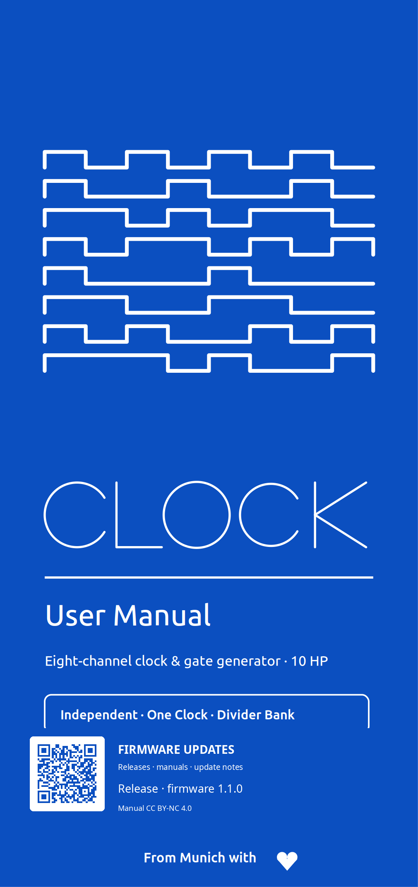
Contents
1 Start here | 3
2 Panel, power and boot | 5
3 Two-minute quick start | 8
4 The control language | 10
5 Read the Performance screen | 12
6 Select channels and change functions | 14
7 Transport and tempo | 16
8 Independent channels | 18
9 Clock mode | 20
10 Euclid mode | 21
11 Sequencer mode | 22
12 One Clock | 24
13 Grooves and Custom Groove Record | 26
14 Divider Bank | 29
15 Settings map | 30
16 Configurable external inputs | 37
17 Presets, autosave and templates | 42
18 Screensaver and display protection | 44
19 Gate outputs and LEDs | 48
20 Hidden boot features | 49
21 Practical recipes | 52
22 Troubleshooting | 54
23 Firmware installation and updates | 55
24 Technical status and specifications | 59

1 Start here
CLOCK is an eight-channel Eurorack clock and gate-rhythm generator. It can be a conventional master clock, build eight independent rhythmic streams, duplicate one shared clock to all outputs, or act as an eight-output divider bank.
The three ways CLOCK can route its outputs
Topology | What the eight outputs do
Independent | Each channel independently uses Off, Clock, Euclid or Sequencer.
One Clock | One shared clock configuration drives all eight outputs. This is the factory topology.
Divider Bank | One shared clock feeds eight fixed divider outputs from a selectable family.
CURRENT RELEASE — FIRMWARE 1.1.0
CLOCK 1.1.0 is the current stable firmware release. It includes Pre-Count, configurable INPUT 1 / INPUT 2 roles, deterministic factory Grooves, named Custom Grooves, the graphical Groove Editor, live TAP Record, and the horizontal Channel Mode carousel. The production SPI display path, final GPIO routing, and interrupt-driven input capture are implemented. Physical comparator thresholds, jack-level timing, gate jitter, Groove timing, and TAP-record latency/jitter remain tracked HIL qualification evidence.
One rule that explains the design
All eight outputs share one deterministic master timeline. PLAY/PAUSE, STOP, Tap Tempo and global phase are master-level operations. Independent channels change what they derive from that timeline; they do not run eight unrelated transports.
Why no general CV modulation?
CLOCK deliberately stays in the digital timing, gate and trigger domain. Hardware Rev 1 has dedicated SYNC and RST inputs, but no general parameter-CV inputs, analog modulation outputs or CV modulation matrix. This is a product boundary, not a missing V1 feature.
A quality eight-channel analog modulation-output path would require an eight-channel 16-bit DAC-class solution plus two quad output-op-amp stages. A 12-bit MCP-class shortcut is not considered adequate for this product direction. The current project estimate is roughly EUR 30-40 additional BOM cost before the added fine-pitch SMD assembly, PCB, calibration and validation burden. CLOCK therefore spends its complexity budget on precise digital timing and rhythm; later cross-channel interaction can remain internal and event-based.

2 Panel, power and boot
CLOCK uses one 128×64 OLED, one push encoder, three transport/navigation buttons, SYNC and RST inputs, and eight gate outputs with activity LEDs.

Panel element | Purpose
1 - OLED | Performance view, menus and editors
2 - Encoder | Turn to select/change; short and long push have different jobs
3 - PLAY | Start or pause the master transport
4 - TAP | Tap Tempo; also a modifier for Settings and mode selection
5 - STOP / BACK | STOP from Performance; BACK/cancel elsewhere
6 - SYNC IN | External clock input (conditioned SYNC on PA8)
7 - RST IN | External reset/phase input (conditioned RST on PA9)
8 - OUT 1–8 | Gate/clock outputs; LED mirrors each logical output
9 - Activity LEDs | One 3 mm indicator above each output; shows output activity
Installation
Use a standard Eurorack 16-to-10-pin ribbon cable. The module-side connector is a keyed 10-pin (2×5) Eurorack header. Align the red stripe with −12 V and verify both cable and header orientation before applying power.
Safe boot
Every power-up enters STOP. The final hardware has no MCU-controlled shared output-enable. Firmware therefore keeps all eight gate-source GPIOs LOW throughout initialization and only permits normal gate requests after startup is complete. A previously saved PLAY state is configuration metadata only and can never authorize output activity during boot.
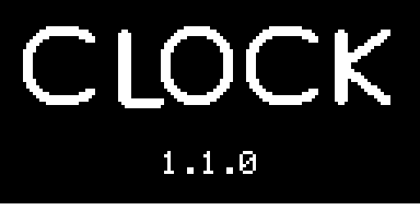
The boot screen lasts about one second and shows CLOCK, the firmware version and a two-pixel progress bar. Holding the encoder push continuously through the boot screen launches the selected Easter egg; see section 20.

3 Two-minute quick start
FACTORY STATE
One Clock · 120 BPM · 4/4 · AUTO source · SYNC smoothing LOW · STOP · ×1 rate · 0% Swing · 10 ms gates · 0% Phase · Humanize OFF · Clock screensaver after 2 min in STOP, dim after 5 min, OLED off after 10 min.
Get eight identical clocks
- 1. Power the rack. CLOCK must finish booting in STOP.
- 2. Patch any of OUT 1–8 to modules that accept a clock or trigger.
- 3. Turn the encoder on Performance to set the master BPM.
- 4. Press PLAY. In the factory One Clock topology, all eight outputs now follow the same clock.
- 5. Press PLAY again to pause. Press STOP / BACK from Performance to stop and reset global phase.

Move from One Clock to independent rhythms
- 1. Short-press the encoder to open the global overview.
- 2. Hold TAP and turn the encoder. The six-function palette appears.
- 3. Choose CLOCK, EUCLID or SEQUENCER. Releasing TAP opens CHANGE MODE? with NO selected.
- 4. Select YES and press the encoder. Choosing one of those channel functions switches to Independent operation for the selected channel context.
- 5. From Performance, short-press the encoder to select among channels 1–8.
SAFE CONFIRMATION
Changing between channel functions and global output topologies is never applied merely by brushing past a choice. CHANGE MODE? defaults to NO.

4 The control language
Most of CLOCK becomes predictable once the distinction between a short encoder press, a long encoder press and a TAP chord is clear.
Gesture | What it means
Encoder turn | Performance: change master BPM. Overview: move highlight. Settings/editor: move cursor or change the edited value.
Encoder short press | Performance: open overview. Independent overview: confirm highlighted channel and return. Settings/editor: enter, confirm or toggle a sequencer step.
Encoder long press (~650 ms) | From Performance or overview: open the settings belonging to the current/highlighted channel or global topology.
TAP + encoder press | From Performance: open the root Settings tree.
Hold TAP + encoder turn | From an overview: open and move through the six-function mode palette. Release TAP to commit the highlighted choice.
Button | Contextual behavior
PLAY | Performance: play/pause. Sequencer editor: play/pause while the edit cursor stays in place.
TAP | Performance: Tap Tempo. Overview: modifier for mode selection. Sequencer editor: previous eight-step viewport; TAP + encoder press opens step expression.
STOP / BACK | Performance: STOP + global phase reset. Elsewhere: back/cancel.
Editing a value
- 1. Turn to select a row.
- 2. Press to edit or open it.
- 3. Turn to change the value.
- 4. Press to confirm.
Only the value being edited is inverted. BACK leaves the current page or cancels the current confirmation workflow.
SHORT OR LONG?
A short encoder push from Performance is for orientation: it opens the overview. A long push is the direct route to the settings that belong to the current context.

5 Read the Performance screen
Performance is intentionally sparse. It shows the state needed while patching; detailed editing lives on dedicated pages.
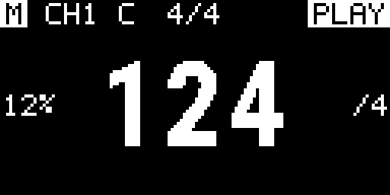
Header
- M / S: filled M = master; outlined S = slave.
- Padlock: shown beside S when external timing is locked.
- CHn + pictogram: selected Independent channel and its generator.
- Meter: master meter in the center.
- Transport: PLAY, PAUSE or STOP at the right.
Tempo area
The BPM number stays mathematically centered. A non-zero Swing value appears at the left; a Clock rate other than ×1 appears at the right. When Groove is active, G:<name> appears lower-left for Clock/One Clock or above the pattern strip for Euclid/Sequencer; Custom Grooves use their stored user name. Default values are omitted to keep the display quiet.
Pattern feedback
Euclid and Sequencer use the lower display for live pattern feedback. Filled cells are gates, outlined cells are rests, and an underline marks the current step. A sequence longer than 16 steps adds a block indicator for the active 16-step segment.
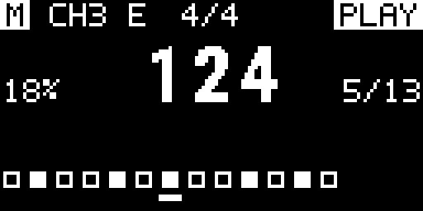
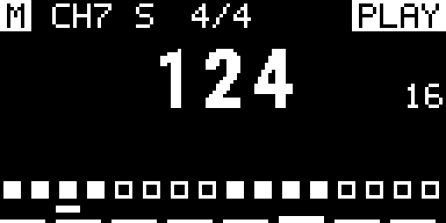

6 Select channels and change functions
Independent channel overview
In Independent topology, short-press the encoder from Performance to open SELECT CHANNEL. The 2×4 grid shows channels 1–8 and their pictograms. Turn to move the inverted highlight. Short-press to select that channel and return to Performance; long-press to open the highlighted channel settings.
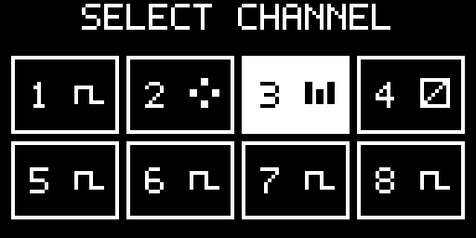
Global overview
One Clock and Divider Bank do not pretend to have eight independent channel menus. Their overview shows the active global topology. A short press returns to Performance; a long press opens that topology’s settings.
Horizontal mode carousel
Function | Scope | Destination after confirmation
Off | Selected channel / Independent | Performance (---)
Clock | Selected channel / Independent | Performance
Euclid | Selected channel / Independent | Euclid settings
Sequencer | Selected channel / Independent | 16-step editor
One Clock | Global topology | One Clock settings
Divider Bank | Global topology | Divider family setting
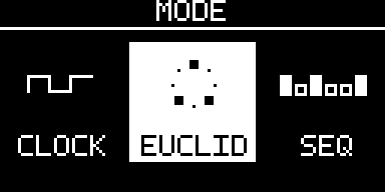
Hold TAP and turn in the overview to open the horizontal mode carousel. Turning scrolls the catalog while the selected mode remains centered and inverted; its immediate neighbors are unframed pictograms with labels. Release TAP to request the selected function. If it differs from the active function, CHANGE MODE? appears with NO selected by default.


7 Transport and tempo
PLAY, PAUSE and STOP
Action | Result
PLAY from STOP or PAUSE | Transport enters PLAY.
PLAY while playing | Transport enters PAUSE and preserves position.
STOP / BACK from Performance | Transport enters STOP and resets global phase according to reset policy.
Set BPM with the encoder
Turn the encoder on Performance. Manual tempo changes obey the user MIN BPM and MAX BPM limits. Factory limits are 20…999 BPM; those limits can themselves be set anywhere within the technical 1…999 BPM range.
Tap Tempo
Tap TAP repeatedly on Performance. The first tap starts a measurement without visual feedback; the second produces the first estimate and starts a four-frame 8×8 shrinking-dot animation immediately to the right of the BPM numerals. Every following tap in the same sequence restarts that animation while the estimator continues to use a rolling average of recent intervals. A valid Tap Tempo result updates the internal/fallback BPM only and preserves the selected INTERNAL, EXTERNAL, or AUTO clock source. The sequence remains valid for one beat at the configured MIN BPM; after a longer pause the next tap starts a new measurement and is again visually silent.
TAP TEMPO AND CLOCK SOURCE
Tap Tempo updates only the internal/fallback BPM. It never changes SOURCE; an external lock remains authoritative in AUTO or EXTERNAL.

Pre-Count
SETTINGS → MODE & CLOCK → PRE COUNT adds an optional silent count-in of OFF or 1–64 beats. A fresh STOP→PLAY starts the count at the configured master tempo while all eight gate outputs remain LOW and the musical pattern phase stays at zero. PAUSE freezes an active count, PLAY resumes it, and STOP cancels it so the next PLAY begins the full count again.
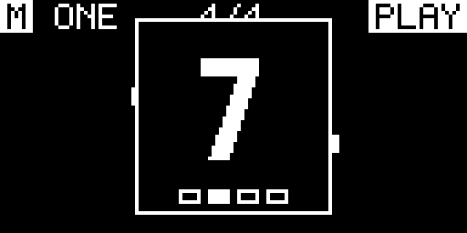
During Pre-Count the Performance screen keeps its normal context and adds a centered count popover. The large number is the remaining beat count; the lower meter row marks the active beat within the master meter. When the count reaches zero, the popover disappears and normal gate generation begins from the shared phase-zero boundary. With locked external SYNC, accepted edges advance the count according to PPQN and the configured meter beat unit.

8 Independent channels
Independent topology lets each of the eight outputs choose Off, Clock, Euclid or Sequencer while remaining phase-related to the same master timeline.
What every active channel can set
Parameter | Range / meaning
RATE | ÷32, ÷24, ÷16, ÷12, ÷8, ÷6, ÷4, ÷3, ÷2, ×1, ×2, ×3, ×4, ×6, ×8, ×12, ×16, ×24, ×32
Numerator / denominator | 1…16 each; enables rational ratios such as 2:3 or 3:2
SWING | 0…50%
PROBABILITY | 0…100%
GATE | 1, 2, 5, 10, 20, 50 or 100 ms
PHASE | 0…99%
RESET | GLOBAL or FREE
MUTE | Suppress output without discarding the generator setup
OFF versus MUTE
OFF | MUTE
Removes the channel from event scheduling. | Keeps the generator running but suppresses its output.
Forces logical output LOW. | Useful for temporary silence.
Stored configuration remains available for later reuse. | Mode and settings remain active.
RESET POLICY
GLOBAL channels follow global phase resets and external alignment. FREE channels keep their local cycle position when global phase is reset.

9 Clock mode
Clock mode emits a gate at every eligible channel event. Use it for conventional clock trees, multiplied clocks, polymetric relationships and phase-shifted timing.
Clock-specific settings
Setting | Range / use
Meter beats | 1…16
Meter unit | 2, 4, 8 or 16
RATE DIV/MULT | Conventional integer divisions and multiplications
Ratio | Numerator/denominator for exact rational relationships
The timing engine retains fractional remainders instead of truncating them, so rational ratios do not accumulate drift simply because an interval is not an integer number of scheduler quanta.
Example: 3 against 2
- 1. Select a Clock channel.
- 2. Open RATE.
- 3. Set numerator to 3 and denominator to 2.
- 4. Keep RESET = GLOBAL if it must return to the common downbeat.

10 Euclid mode
Euclid distributes a chosen number of hits as evenly as possible over a cycle. It is useful for percussion, accents and repeating rhythmic structures that remain easy to reshape.
Parameter | Range
STEPS | 1…64
HITS | 0…STEPS
ROTATE | 0…STEPS − 1
At RATE ×1, each Euclid step is a sixteenth note. In 4/4, 16 steps therefore span one bar. RATE scales that step grid. Reducing STEPS automatically clamps HITS and, where needed, rotation to valid values.
Build a 16-step pattern
- 1. Choose Euclid for a channel.
- 2. Set STEPS = 16.
- 3. Set HITS to the desired density.
- 4. Use ROTATE to move the pattern around the bar without changing the number of hits.
- 5. Use PROBABILITY for controlled variation without rewriting the Euclid pattern.

11 Sequencer mode
Current post-1.1 Sequencer 2.0 development stores P1–P8 per channel with 1–128 active steps. The OLED is an eight-step viewport; at RATE ×1, one step is a sixteenth note.
Page item | What it does
EDITOR | Open the eight-step viewport
PATTERN | Select persistent P1…P8
LENGTH | 1…128 active steps
ROTATE | Rotate inside the active length
MODE | FORWARD / REVERSE / PINGPONG / RANDOM
LOOP | LOOP or ONCE end behavior
EXPRESSION | Probability, Gate/Duty, Ratchet 1…8, Tie
OPERATIONS | Invert, clear/fill, copy/paste and pattern tools
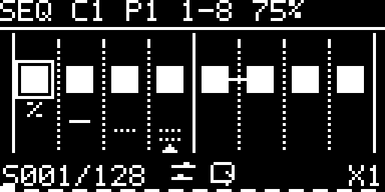
Editor controls
- Encoder turn — move the cursor through active steps.
- Encoder press — toggle the selected gate.
- PLAY — play/pause transport while the edit cursor remains stationary.
- TAP — previous eight-step viewport; TAP + encoder press opens expression for the selected step.
- STOP / BACK — return to Sequencer settings. Long encoder press opens Pattern Operations.
Turning the encoder crosses eight-step viewport boundaries automatically. Solid four-step beat lines and dotted step lines replace per-step numbers. A rectangle is the edit cursor; during PLAY a separate bottom triangle is the live playhead. % marks Probability, Tie keeps the gate-connection line, and Ratchet uses one dot row for 2–4 or two rows for 5–8. Direction and LOOP/ONCE use compact status pictograms.

12 One Clock
One Clock is the simplest global topology: a single clock configuration drives all eight physical outputs. This is the factory state. In firmware 1.1.0 it also owns one global deterministic Groove assignment in addition to Swing and Humanize.
Setting | Range
DIV/MULT | ÷32 … ×32
Numerator / denominator | 1…16 each
Swing | 0…50%
Gate length | 1, 2, 5, 10, 20, 50 or 100 ms
Phase | 0…99%
Humanize | OFF, 250, 500, 1000 or 2000 µs
Humanize
Humanize adds a small deterministic per-output timing displacement while preserving the common restart/downbeat. It exists only in One Clock; OFF gives exact coincidence across the eight outputs.
USE ONE CLOCK WHEN
You need one authoritative clock on several destinations and do not want eight separate channel configurations.

Swing, Groove and Humanize — what is the difference?
All three change when an output edge occurs, but they solve different musical problems and remain separate controls.
Timing layer | What it changes
SWING — regular long/short feel | Alternates every second subdivision. Use 0–50% for the classic two-step shuffle.
GROOVE — repeating timing fingerprint | Deterministic factory or 1–64-step Custom pattern. AMOUNT scales it; ROTATE changes its starting step.
HUMANIZE — small output spread | One Clock only. Adds bounded deterministic per-output displacement around the already shaped grid; the common restart/downbeat remains exact.
Swing is the direct choice for a regular alternating shuffle. Groove is for repeatable microtiming that can span more than two events and, for Custom Grooves, can place steps early as well as late. Humanize is different again: it slightly separates otherwise coincident One Clock outputs and is never stored as part of a Groove.
The layers may be combined. CLOCK first shapes the nominal event with Swing and Groove and then applies the bounded One Clock Humanize displacement. Safety limits reduce effective displacement when necessary so adjacent events remain ordered and at least one scheduler quantum apart.

13 Grooves and Custom Groove Record
Groove is deterministic microtiming on the same master timeline used by Clock, Euclid and Sequencer. It is separate from One Clock Humanize and does not create a second free-running clock. Factory choices are SWING 54 / 58 / 62 / 66 and POCKET A / B / C, with Amount 0–100% and rotation. One Clock owns one global Groove; Independent stores Groove per channel; Divider Bank remains Groove-free.
Custom Groove Editor
EDITOR opens a 1–64-step beat/step grid. Diamond markers show signed early/late timing around the nominal grid; the selected marker is filled. TAP selects the next marker, encoder turn moves it finely, TAP+turn moves it coarsely, and PLAY+turn performs FIT / 32 / 16 / 8 / 4 quick zoom without issuing transport. Changes preview live but remain temporary until SAVE; BACK opens DISCARD CHANGES? only when the shared draft is dirty.
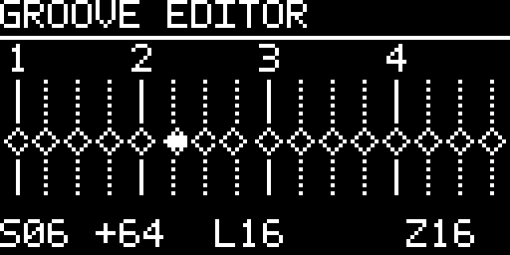
Custom Groove Editor — the grid is nominal time; diamonds are stored microtiming positions.
TAP Record
RECORD is a second input mode over the same Custom Groove draft. PLAY starts/stops capture and rewinds on stop; TAP records a high-resolution timing event and is not routed to Tap Tempo; PLAY+turn zooms; a long encoder press opens the Record menu. Recorder Count-In is independently configurable OFF / 1–64 with a factory default of 4. ONE SHOT stops after one pattern pass; ENDLESS wraps and replaces only steps that receive a new TAP. The visible playhead follows the same engine phase used for capture, and the result can be opened immediately in EDITOR for manual cleanup.
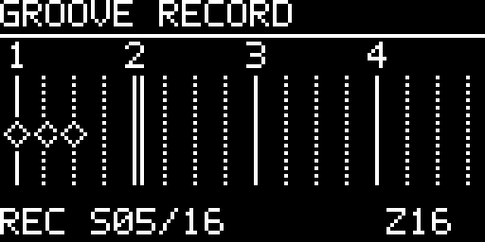
Groove Record — TAP events become signed offsets while the engine-phase playhead traverses the pattern.

Record a Groove by feel
Step | Do this
1 | Open TIMING → GROOVE → RECORD. The recorder opens on the same Custom Groove draft used by EDITOR.
2 | Long-press the encoder. Set LENGTH (1–64), recorder COUNT IN (OFF / 1–64; default 4), and MODE (ONE SHOT or ENDLESS).
3 | Press PLAY. Recorder Count-In runs first when enabled; capture begins only when that local count reaches zero.
4 | Tap the rhythm with TAP. Each press becomes one high-resolution timing event; Tap Tempo is disabled while RECORD is active.
5 | Press PLAY again to stop. The recorder rewinds its playhead to the start; the recorded draft remains available.
6 | Choose EDITOR > for precise marker correction, then SAVE to a named Custom Groove slot when the result is ready.
ENDLESS is non-destructive to untouched steps: only steps that receive a new TAP are replaced on later passes. ONE SHOT stops automatically after one pattern cycle.

Pre-Count versus Recorder Count-In
These are separate features. Global Pre-Count delays the start of normal transport from STOP and keeps all outputs LOW. Recorder Count-In belongs only to GROOVE → RECORD and prepares the capture window; it does not change the configured global Pre-Count value.
Save, load and library
The frozen 1.1.0 scope provides 10 named durable Custom Groove slots. New Grooves start with an editable generated two-word default name. LOAD is available directly from the Groove page; overwrite, rename and delete use explicit safe confirmations. The Performance screen shows the actual stored Custom Groove name rather than a generic CUSTOM label. The earlier 99-slot idea remains a later storage target.

14 Divider Bank
Divider Bank derives eight deterministic clocks from the master timeline. Only the divider family and shared gate length are editable.

Family | OUT 1…8
POW2 | ×1 · ÷2 · ÷4 · ÷8 · ÷16 · ÷32 · ÷64 · ÷128
INT | ×1 · ÷2 · ÷3 · ÷4 · ÷5 · ÷6 · ÷7 · ÷8
PRIME | ×1 · ÷2 · ÷3 · ÷5 · ÷7 · ÷11 · ÷13 · ÷17
The Performance screen shows all eight assignments, so there is no synthetic per-channel settings page in this topology.

15 Settings map
Hold TAP and press the encoder from Performance to open the root Settings tree. Settings are split by scope: GENERAL SETTINGS changes global clock/device behavior, while CHANNEL SETTINGS changes the currently selected Independent channel or the active global topology.
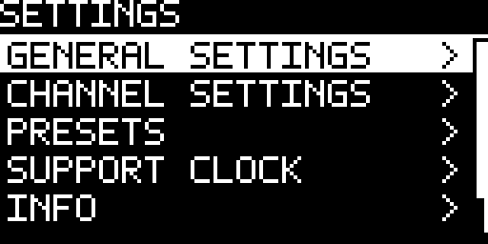
Root Settings — global configuration, current channel/topology settings, presets, information and phase reset.
Root item | Contains / does
GENERAL SETTINGS | Global CLOCK, INPUTS, SCREENSAVER, DIAGNOSTICS and HARDWARE pages.
CHANNEL SETTINGS | Current Independent channel, One Clock or Divider Bank. The available pages change with the active topology/mode.
PRESETS | CURRENT auto-save, Load Preset, Save Preset and factory Templates.
INFO | Product/version information, license details, update QR and guarded Factory Reset.
PHASE RESET | Apply a non-destructive global musical phase reset. No settings, presets or scores are erased.
GENERAL SETTINGS — global clock and device configuration
GENERAL SETTINGS is deliberately small. It holds values that are shared by the whole device rather than one output channel. CLOCK here means the master clock configuration, not the Independent channel mode named CLOCK.
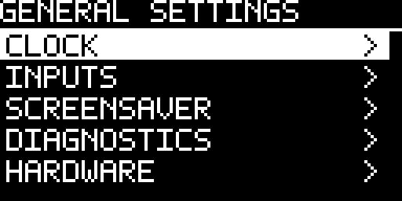
GENERAL SETTINGS — five global areas. INPUTS contains both role assignment and the shared external clock/reset configuration.
Page | What belongs here
CLOCK | Master BPM, editable BPM limits, master meter and global Pre-Count.
INPUTS | INPUT 1 / INPUT 2 role assignment plus SOURCE, PPQN, EDGE, LOSS, RESET INPUT, FILTER, SMOOTHING and TIMEOUT.
SCREENSAVER | Screensaver mode and STOP-only display-protection timers.
DIAGNOSTICS | Live conditioned INPUT 1 / INPUT 2 states and the eight gate-driver output states.
HARDWARE | Encoder direction and complete 0° / 180° framebuffer orientation.
CLOCK — tempo, meter and Pre-Count
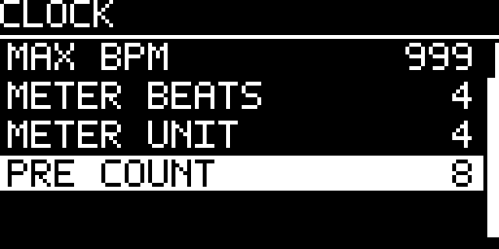
The CLOCK page defines the master musical timebase. The meter is not cosmetic: METER UNIT defines which note value one master beat represents, and METER BEATS defines how many of those beats form one bar.
Setting | Meaning
BPM | Internal/fallback tempo. It is the active tempo in INTERNAL and the fallback value used when the selected external-loss policy returns to internal timing.
MIN BPM | Lower user/Tap-Tempo limit, 1…MAX; factory 20 BPM.
MAX BPM | Upper user/Tap-Tempo limit, MIN…999; factory 999 BPM.
METER BEATS | 1…16 beats per bar. This drives the bar/beat counter and the beat cells shown by Pre-Count.
METER UNIT | 2 / 4 / 8 / 16. A unit of 4 means quarter-note beats; 8 means eighth-note beats, etc. Rate conversion and external Pre-Count use the same unit.
PRE COUNT | OFF or 1…64 beats. A fresh STOP→PLAY counts silently with every gate held LOW, then starts normal output from phase zero.
How the meter changes musical time
CLOCK keeps BPM and meter separate. BPM is the quarter-note tempo reference; METER UNIT selects the note value represented by one master beat, and METER BEATS selects how many of those beats form one bar. Changing the meter therefore changes beat/bar structure without rewriting the stored BPM number.
Example at 120 BPM | Master-beat result
4/4 | METER UNIT 4 → one 500 ms quarter-note beat; four beats form a 2.0 s bar.
3/4 | METER UNIT 4 → one 500 ms quarter-note beat; three beats form a 1.5 s bar.
6/8 | METER UNIT 8 → one 250 ms eighth-note beat; six beats form a 1.5 s bar.
2/2 | METER UNIT 2 → one 1000 ms half-note beat; two beats form a 2.0 s bar.
The same meter definition is used by the bar/beat counter and by Pre-Count. With external SYNC, PPQN still describes pulses per quarter note; CLOCK converts accepted pulses into the configured master-beat unit.
MIN/MAX limit manual encoder and Tap-Tempo results. A valid external clock is measured as received; those manual limits do not clamp external BPM.
CHANNEL SETTINGS — timing and output are separate
In Independent mode the channel menu separates TIMING from OUTPUT. Generator-specific pages (CLOCK, EUCLID or SEQUENCER) define the pattern itself; the shared timing/output pages define when eligible events occur and what the resulting gate does.
Control | What it changes
RATE / NUM / DEN | Clock relationship to the master timeline. DIV/MULT provides common integer ratios; NUM/DEN provides exact rational relationships such as 3:2.
SWING | 0…50% alternating timing displacement. It changes event placement, not BPM.
GROOVE | Factory or Custom deterministic microtiming, with AMOUNT and ROTATE.
PROBABILITY | 0…100% chance that an otherwise eligible event actually emits a gate. The underlying timeline does not drift when an event is skipped.
GATE | Fixed pulse duration: 1 / 2 / 5 / 10 / 20 / 50 / 100 ms. It is a time value, not duty cycle.
PHASE | 0…99% offset relative to the common timeline.
RESET | GLOBAL re-anchors on global reset/external alignment; FREE preserves the channel’s local cycle position.
MUTE | Suppresses physical output while keeping the generator and its configuration active.
Gate length — fixed pulse time, not duty cycle
Aspect | Behavior
Selectable values | 1 / 2 / 5 / 10 / 20 / 50 / 100 ms.
Meaning | The value is an absolute HIGH duration. It is not a percentage and does not scale as a duty-cycle control when tempo changes.
Fast channels | If the next rising event would occur before the requested HIGH time has elapsed, CLOCK shortens the effective pulse so the next event is not consumed.
Resolution | Gate scheduling follows the 20 kHz timing service, so physical edge requests are resolved on the 50 µs scheduler quantum.
This distinction matters most with high multiplication ratios: a 100 ms request is possible at slow rates, but it cannot be allowed to cover the next scheduled onset on a fast channel.
One Clock and Divider Bank settings
Topology page | Controls
ONE CLOCK → TIMING | Rate, numerator/denominator, Swing, Groove and Humanize for the shared clock.
ONE CLOCK → OUTPUT | Gate length and Phase for all eight shared outputs.
DIVIDER BANK | Divider family (POW2 / INT / PRIME) and one shared Gate length.
INFO, licenses and maintenance
Read-only values stay compact in the menu. When a value does not fit, the row shows an ellipsis; pressing the row opens the complete value. License identifiers are a better example than personal attribution because several legal strings are deliberately longer than one OLED row.
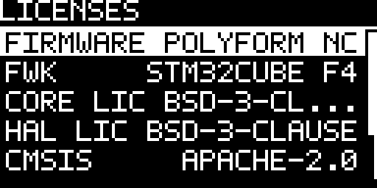
LICENSES — CORE LIC is truncated on the row and can be opened as complete read-only information. The same overflow rule applies to other long read-only values.
PHASE RESET is the routine non-destructive reset. FACTORY RESET remains the final INFO action, defaults to NO, stops transport, clears CURRENT, all eight named presets and score data, then writes factory configuration as the new CURRENT state.

16 Configurable external inputs
The two LM393-conditioned jacks are electrically equivalent digital inputs. Firmware names them INPUT 1 and INPUT 2 so either physical path can own a musical role. Factory assignment remains INPUT 1 = SYNC and INPUT 2 = RESET. Active roles are exclusive across the two inputs; only OFF may be assigned twice. FILL is reserved and is not selectable in 1.1.0.
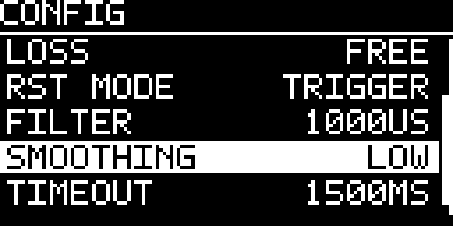
INPUT CONFIG — shared timing/reset parameters used by whichever input currently owns SYNC or RESET.
Roles, SOURCE and LOSS are separate decisions
Control | Question it answers
INPUT 1 / INPUT 2 role | What does this physical jack mean right now — SYNC, RESET, RUN, START, STOP, RESTART, TAP or OFF?
SOURCE | Who owns musical time — CLOCK itself (INTERNAL), the assigned SYNC input (EXTERNAL), or automatic handover between them (AUTO)?
LOSS | Only after an external clock had lock: what should happen if that clock disappears — STOP, FREE at the last measured tempo, or return to INTERNAL?
A jack assigned to SYNC does not by itself force external timing ownership. The role makes that jack available as a clock input; SOURCE decides whether the timing engine actually follows it.
Assigning input roles
Role | Behavior
OFF | Ignore the conditioned input. OFF may be assigned to both inputs.
SYNC | Use selected edges as the external clock source for period measurement, lock and phase alignment.
RESET | Use the input as global phase reset; RESET INPUT selects TRIGGER or GATE semantics.
RUN | Level-authoritative transport after arming: HIGH = PLAY, LOW = STOP. Selecting/restoring RUN first baselines the present level and waits for a later physical change.
START | A positive edge requests PLAY.
STOP | A positive edge requests STOP.
RESTART | A positive edge performs deterministic STOP→PLAY from phase zero.
TAP | A positive edge is passed to the normal Tap-Tempo estimator with its captured input timestamp.
Changing a role drains queued edges from the old meaning before the new role becomes active, so the same electrical transition is never reinterpreted as a different command.
SOURCE — who owns musical time?
SOURCE | What CLOCK does
INTERNAL | CLOCK is the master. The configured internal BPM and meter drive musical time; external SYNC does not take timing ownership.
EXTERNAL | CLOCK follows a valid assigned SYNC input. The first accepted selected edge starts acquisition; the second establishes the first measurable period, BPM and lock.
AUTO | CLOCK runs from internal timing until a valid external period is acquired, then follows the external clock. Loss behavior is controlled by LOSS.
AUTO — lock in four steps
Step | What happens
1 — no valid external period | CLOCK runs on the configured internal/fallback BPM.
2 — first accepted selected edge | Acquisition starts. There is not yet a measurable period, so CLOCK does not advertise lock.
3 — second valid selected edge | CLOCK measures the first period, derives external BPM, acquires lock and re-anchors external phase to zero. Transport may auto-start only while auto-transport is armed.
4 — clock disappears | After the effective timeout, lock is lost and the configured LOSS policy decides STOP / FREE / INTERNAL behavior.
An explicit user STOP or PAUSE has priority. Incoming clock cannot silently undo a manual transport decision.
LOSS — what happens when external clock disappears?
LOSS | After lock is lost
STOP | Transport stops. A later valid reacquisition may restart only when the stop was caused by sync loss; a manual STOP stays authoritative.
FREE | Continue at the last measured external tempo. The last external BPM remains the effective/visible tempo after lock is lost.
INTERNAL | Continue using the configured internal/fallback BPM.
PPQN, edge filtering and tempo response
Setting | What it means / when it matters
PPQN | 1 / 2 / 4 / 24 pulses per quarter note. It must match the external source because period-to-BPM conversion uses this value.
EDGE | Rising or falling. Only the selected transition is a timing pulse; pulse width itself is not the clock period.
FILTER | 0…5000 µs minimum inter-edge rejection floor. Shorter selected-edge intervals are treated as glitches and do not replace the previous accepted reference pulse.
SMOOTHING | OFF = 100% newest period; LOW = 75% new / 25% previous; MEDIUM = 50/50; FULL = 25% new / 75% previous. LOW is factory default.
TIMEOUT | 200…5000 ms configured lock-loss floor. The effective timeout is never shorter than roughly two expected pulse periods, preventing slow valid clocks from timing out between pulses.
FILTER and SMOOTHING solve different problems: FILTER rejects implausibly short edge spacing before it can become the next period reference; SMOOTHING decides how quickly valid period changes alter the measured tempo. A large FILTER can reject legitimate very-fast clock edges, while heavy SMOOTHING deliberately reacts more slowly to real tempo changes.
RESET — TRIGGER versus GATE
RESET INPUT | Behavior
TRIGGER | An accepted active/high edge requests one global phase reset. RESET does not itself PLAY, PAUSE or STOP transport.
GATE | The conditioned input level becomes a held reset state. Entering HIGH resets phase and holds the scheduler’s musical progression; returning LOW releases the hold and re-anchors runtime at the transition.
Global reset still respects each Independent channel’s RESET policy: GLOBAL channels re-anchor; FREE channels preserve their local cycle relationship where the channel reset contract allows it. Transport roles (RUN/START/STOP/RESTART) are separate from the RESET role.

17 Presets, autosave and templates
CURRENT — automatic recovery
CLOCK continuously stages the complete working state. A coalescing delay avoids writing every small edit immediately. Physical STM32 Flash commits are deferred while transport is PLAYING and are flushed after PAUSE or STOP, so Flash erase/program work cannot stall the live gate path. On the next boot, a valid CURRENT state is restored but transport is still forced to STOP.
Eight named user presets
LOAD PRESET and SAVE PRESET expose eight durable user slots. Names are up to 16 characters. Saving over an occupied slot requires an explicit OVERWRITE PRESET confirmation with NO selected by default.
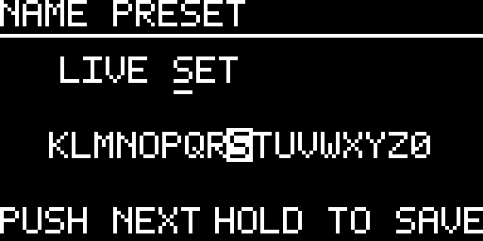
Factory templates
Template | Starting configuration
ALL MASTER | Factory One Clock state
CLOCK TREE | Independent: ×1, ÷2, ÷4, ÷8, ×2, ×4, ×8, ×16
DIVIDERS | Independent: ×1, ÷2, ÷3, ÷4, ÷6, ÷8, ÷12, ÷16
POLYRHYTHM | Ratios 1:1, 2:3, 3:2, 3:4, 4:3, 4:5, 5:4, 5:8
EUCLID KIT | Eight 16-step Euclid channels with differentiated hits/rotation
HYBRID | CH1–3 Clock, CH4–6 Euclid, CH7–8 Sequencer; CH2 ÷2, CH3 3:2
PRESET ≠ TEMPLATE
A named preset is your durable snapshot. A template is a factory starting point that replaces the current working configuration. Loading a template does not create a named preset.

18 Screensaver and display protection
Display protection advances only while transport is STOP. Any front-panel activity wakes the display immediately. PLAY and PAUSE do not accumulate the screensaver timers.
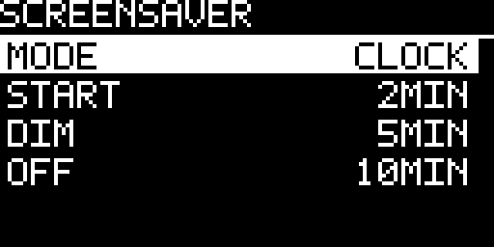
Factory timings
Stage | Factory value
Screensaver start | 2 minutes
Dim | 5 minutes
OLED power-off | 10 minutes
CLOCK enforces START ≤ DIM ≤ OFF. Choosing screensaver OFF disables the animation but does not disable the later DIM/OFF protection.
Available animations
Mode | Character
OFF | No animation; dim/off protection remains
CLOCK | Factory default; scrolling clock traces
PLUG | Damped plucked-string motion
HEARTBEAT | Pulsating heart
ACID | Bouncing/rotating acid-style smiley
SPECTRUM | Synthetic 16-band display; it does not sample audio
FIELD | Slow monochrome contour field
BLOX | Procedural triangular bodies fall and stack
MATRIX | Original monochrome digital rain
CUBE COVER | 8×8 cube tiles cover the OLED in changing traversal orders
FRACTAL | Curated Barnsley-fern crops
ORBIT | Sparse orbital animation
MAKE MUSIC | Builds MAKE·MUSIC·NOT·WAR one glyph at a time, row by row
LABYRINTH | Generates and progressively draws a new 16×8 perfect maze
STARFIELD | Three independently moving depth layers create monochrome parallax
FIREWORKS | Pixel rocket launches from changing positions and bursts in the upper display area
Screensaver gallery
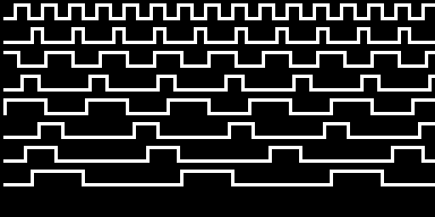  CLOCK - scrolling clock traces | 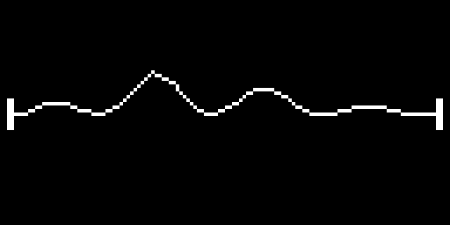  PLUG - damped plucked string
  HEARTBEAT - pulsing trace |   ACID - bouncing smiley
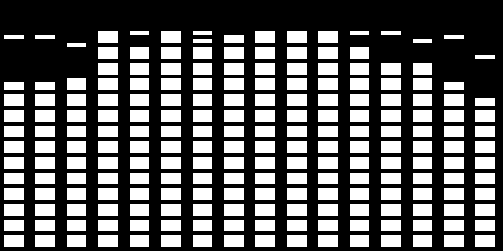  SPECTRUM - synthetic 16-band display |   FIELD - moving contour field
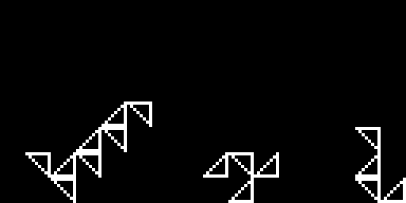  BLOX - falling procedural bodies | 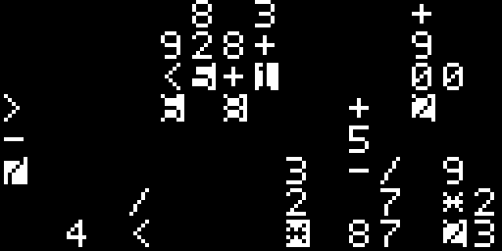  MATRIX - monochrome digital rain
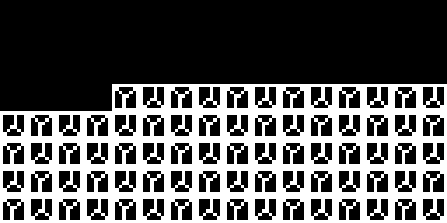  CUBE COVER - tiled cube sweep | 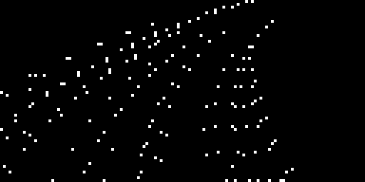  FRACTAL - curated fern crop
  ORBIT - sparse orbital motion | 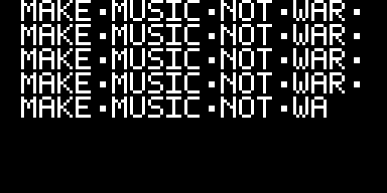  MAKE MUSIC - progressive text stream
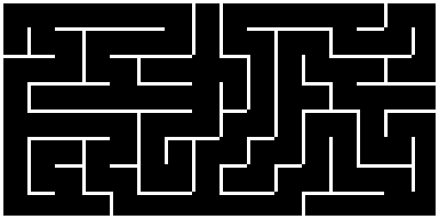  LABYRINTH - generated maze |   STARFIELD - three-depth parallax
  FIREWORKS - pixel rocket and burst |   OLED OFF - final protection stage

19 Gate outputs and LEDs
Gate length
Gate length is selectable as 1, 2, 5, 10, 20, 50 or 100 ms; the factory value is 10 ms. The scheduler caps a pulse against the effective event interval so an excessively long setting cannot consume the next rising edge.
Voltage level
The current output-stage target is 0 V LOW and nominal +5 V HIGH. +10 V is not a project requirement; changing to that level would require a different output stage rather than the 74HCT541-class path.
Activity LEDs
Each LED mirrors the corresponding logical channel signal. It is not a cable-presence indicator. Normal boot does not animate the output LEDs.
HARDWARE SIGN-OFF
Voltage levels, boot behavior at the jacks and timing jitter remain physical HIL measurements. Host tests verify logic, not analog thresholds or actual edge placement at a Eurorack socket.

20 Hidden boot features
Hold the encoder push continuously from power-up until the boot screen completes. CLOCK then starts the compile-time selected Easter egg before the normal real-time scheduler. The shipped/default selection is BEATKNECHT.
After the individual retro intro, BEATKNECHT starts with PLAY. The four ranked arcade games start from their intro with TAP or an encoder press.
Build selection | Feature | Controls / behavior
1 | Pixel Raid | Encoder moves; TAP fires; ranked arcade game
2 | Formula 1 | Encoder steers; ranked arcade game
3 | Breakout | Encoder moves paddle; TAP launches; ranked arcade game
4 | Egg Journey | Encoder moves; TAP jumps; ranked arcade game
5 (default) | BEATKNECHT | PLAY/PAUSE controls transport; STOP resets to step 1; TAP changes style; encoder changes BPM; long encoder push opens EXIT GAME?; drives OUT 1–8 intentionally
Easter-egg gallery
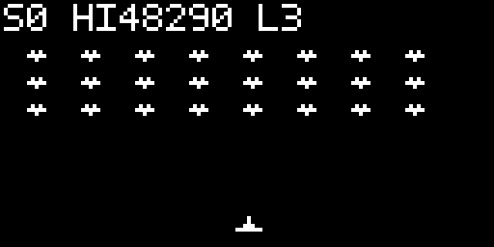  Pixel Raid - move and TAP to fire | 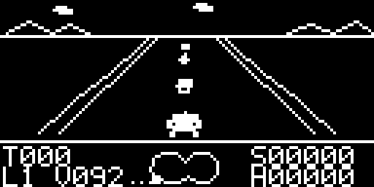  Formula 1 - steer through the course
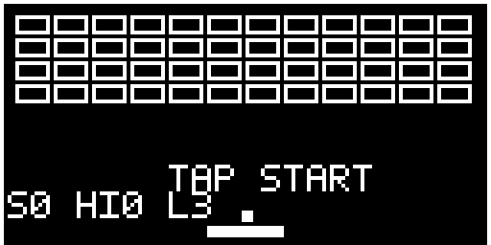  Breakout - paddle, ball and modifiers | 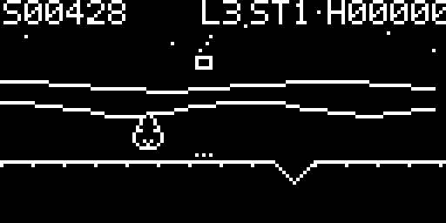  Egg Journey - jump through incoming hazards
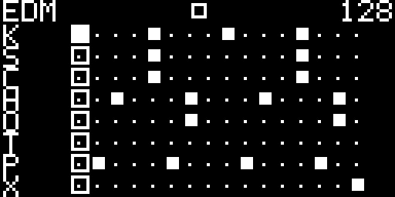  BEATKNECHT - default eight-gate rhythm egg |   Top 100 - ranked arcade leaderboards
Arcade flow
Pixel Raid, Formula 1, Breakout and Egg Journey share a game-specific intro, score/high-score tracking, three-letter initials entry when a score qualifies, and a scrollable Top 100. Their external gate-output stage stays disabled.
Exit
A long encoder hold is the exit gesture for the ranked arcade games. BEATKNECHT uses a guarded exit instead: a long encoder push opens EXIT GAME? with NO selected by default. Opening the prompt immediately silences all gates. NO returns to the exact previous transport state; if the rhythm was playing, playback resumes from the preserved phase, and if it was paused it remains paused. YES stops the rhythm, resets the pattern, forces every gate LOW, disables the output stage, and returns to the normal clock firmware in STOP. The long press that opened the dialog cannot confirm it until the encoder has first been released.

21 Practical recipes
Eight exact copies of one master clock
- 1. Select One Clock.
- 2. Set RATE to ×1 and HUMANIZE to OFF.
- 3. Choose the gate length.
- 4. Press PLAY.
A conventional clock tree
- 1. Switch to Independent.
- 2. Load the CLOCK TREE template or set channel rates manually.
- 3. Use RESET = GLOBAL on channels that must return to the same downbeat.
A Euclidean percussion line
- 1. Choose Euclid.
- 2. Set STEPS = 16.
- 3. Choose HITS.
- 4. Use ROTATE for placement.
- 5. Use PROBABILITY for controlled omissions.
An expressive 64-step gate phrase
- 1. Choose Sequencer and open EDITOR.
- 2. Set LENGTH = 64 and choose the required P1–P8 pattern slot.
- 3. Turn the encoder through the pattern; the eight-step viewport follows automatically.
- 4. Toggle gates with encoder presses. Use TAP + encoder press for Probability, Gate/Duty, Ratchet or Tie.
- 5. Press PLAY to audition without losing the edit cursor; the triangle is the independent playhead.
- 6. BACK returns to Sequencer settings.
Record a Groove by feel
Use this short workflow when the musical feel matters more than drawing offsets by hand. The detailed recorder/editor behavior is described in Chapter 13.
Step | Do this
1 | Open TIMING → GROOVE → RECORD.
2 | Long-press the encoder. Set LENGTH, recorder COUNT IN and MODE (ONE SHOT or ENDLESS); choose ZOOM if useful.
3 | Press PLAY. If Recorder Count-In is active, wait for it to reach zero; only then does capture begin.
4 | Tap the feel on TAP while the playhead moves. Each press records one high-resolution timing event; Tap Tempo is disabled in Recorder mode.
5 | Press PLAY again to stop. The recorder rewinds to the beginning and keeps the recorded draft.
6 | Open EDITOR > for precise marker cleanup, then SAVE to a named Custom Groove slot.
Recorder Count-In is local to Groove Record. It does not change the global Pre-Count setting. In ENDLESS mode, later passes overwrite only the steps that receive a new TAP.

22 Troubleshooting
Symptom | Check first
No gates after power-up | Normal until PLAY is pressed. Then check topology, OFF/MUTE, PROBABILITY and gate routing.
All eight outputs are identical | Factory topology is One Clock. Switch to a channel function to enter Independent operation.
Tempo stops at a value | Check GENERAL SETTINGS → CLOCK → MIN BPM / MAX BPM.
Tap Tempo changed clock source | Tap Tempo updates the internal/fallback BPM but preserves the selected clock source. In AUTO or EXTERNAL, check the SYNC lock and LOSS policy if the tapped value is not currently authoritative.
RESET did not restart one channel | That channel may use RESET = FREE.
Screensaver does not start | Timers advance only in STOP, not PLAY or PAUSE.
Preset save asks for confirmation | The slot is occupied; NO is the safe default.
External lock is unavailable or unstable | Use DIAGNOSTICS → INPUTS to confirm conditioned INPUT 1 / INPUT 2 transitions, then check GENERAL SETTINGS → INPUTS for role assignment and CONFIG for SOURCE, PPQN, EDGE, FILTER, SMOOTHING and TIMEOUT. AUTO is the factory source. Physical comparator thresholds and jack-level timing remain HIL measurements.
A USEFUL DIAGNOSTIC ORDER
First establish topology → transport → selected channel/mode → MUTE/OFF/PROBABILITY → rate → clock source. This avoids chasing timing settings when the problem is simply that no event is eligible to reach the output.

23 Firmware installation and updates
CLOCK uses an STM32F401 Black Pill. There are two supported programming paths: ST-LINK/SWD is the most robust choice for a first installation or recovery, while the built-in USB DFU bootloader is the convenient path for routine updates. The procedures below deliberately preserve the Flash areas used for settings, presets and high scores.
USB POWER SAFETY
Never connect the Black Pill USB port while CLOCK is also powered from the Eurorack bus. Before any USB update or USB-only test, switch the rack off and preferably unplug CLOCK’s Eurorack ribbon cable. Leave the rack cable disconnected until the USB cable has been removed.
Which method should I use?
Use ST-LINK for a blank Black Pill, first installation, recovery from a failed flash, or debugging. Use USB DFU for normal firmware updates when the module already works and you simply want to load a newer build.
Method A — ST-LINK / SWD
ST-LINK talks directly to the STM32 debug interface and does not depend on the installed firmware. This makes it the preferred recovery path. The example below uses STM32CubeProgrammer to write the address-aware ELF generated by PlatformIO.
- 1. Switch the Eurorack power off. Use exactly one target power source. If you power the Black Pill from its USB connector while programming, unplug the Eurorack ribbon cable first.
- 2. Connect ST-LINK GND to GND, SWDIO to SWDIO, and SWCLK to SWCLK. Connect the probe target-voltage reference (VTref / VDD_TARGET) to the Black Pill 3.3 V rail. NRST is optional but recommended for reliable recovery. On an official ST-LINK, VTref is a target-voltage reference; do not assume that it powers the module.
- 3. Install PlatformIO and open the CLOCK source tree. Build the required firmware, for example: pio run -e release_default
- 4. The resulting address-aware image is .pio/build/release_default/firmware.elf. In STM32CubeProgrammer choose ST-LINK and SWD, connect to the target, open that ELF file, then use Download/Program with verification enabled.
- 5. Reset or power-cycle the Black Pill after programming. For a normal update, do not use Full chip erase: a full erase also removes settings, presets and high scores.
The release_default environment builds the normal BEATKNECHT image. The alternative build environments are release_pixel_raid, release_formula_1, release_breakout and release_egg_journey.
Method B — USB DFU with PlatformIO
The STM32F401 contains an ST system-memory USB DFU bootloader, so routine updates do not require an external programmer. CLOCK’s PlatformIO configuration uses a project-specific upload helper that programs only the firmware-owned Flash regions and leaves the A/B persistence sectors untouched.
- 1. Switch the Eurorack power off and unplug CLOCK’s Eurorack ribbon cable. This is mandatory before connecting USB.
- 2. Use a data-capable USB cable and connect the Black Pill to the computer.
- 3. Enter DFU mode: hold BOOT0, press and release NRST/RESET while BOOT0 remains held, wait roughly half a second, then release BOOT0. Alternatively, with the board unpowered, hold BOOT0 while connecting USB and release it after roughly half a second.
- 4. Open a terminal in the CLOCK source directory and run: pio run -e release_default -t upload
- 5. Wait for PlatformIO to report a successful upload. The uploader writes the application region at 0x0800C000 first, writes sector 0/vector table at 0x08000000 last, leaves persistence sectors 1 and 2 untouched, then asks the ROM bootloader to leave DFU mode from the vector-table address. If the board does not restart automatically, make sure BOOT0 is released and press RESET once.
- 6. Leave the Eurorack ribbon cable disconnected for the first functional check. CLOCK can boot from the Black Pill USB supply, so you can verify the display, encoder, buttons, menus and general UI before returning the module to the rack.
- 7. When finished, disconnect USB first. Then reconnect the Eurorack ribbon cable with the red stripe at −12 V and only then power the rack again.
DO NOT FLASH A FLAT FIRMWARE.BIN
CLOCK reserves Flash sectors 1 and 2 for power-loss-tolerant A/B persistence. A conventional contiguous firmware.bin can span that reserved gap and destroy saved state. Use the project PlatformIO upload command, the release DfuSe image with a DfuSe-aware tool, or the address-aware firmware.elf over ST-LINK.
PlatformIO installation
For most DIY builders, PlatformIO IDE for Visual Studio Code is the easiest installation because PlatformIO Core is included. If you prefer the command line, install PlatformIO Core separately. Official installation documentation: https://docs.platformio.org/en/stable/integration/ide/vscode.html and https://docs.platformio.org/en/stable/core/installation/
On Windows, an STM32 device in ROM DFU mode should appear as an STM32 bootloader/DFU device (ST VID:PID 0483:DF11). If the driver is missing, install the current STM32CubeProgrammer package and its DFU driver. On Linux, install PlatformIO’s current udev rules as described in the PlatformIO documentation.
If an update is not detected
- 1. Confirm that the USB cable carries data; charge-only cables are a common cause of apparently dead DFU connections.
- 2. Repeat the BOOT0/RESET sequence and check that the host sees VID:PID 0483:DF11 before running the upload command.
- 3. If ST-LINK cannot connect, first check target power, common GND, VTref, SWDIO and SWCLK; add NRST when recovering a target that behaves unexpectedly.
- 4. If settings or presets disappear after an update, check whether a Full chip erase or a flat contiguous binary was used. The normal CLOCK update paths are designed to preserve persistence.

24 Technical status and specifications
Timing architecture
CLOCK uses a 20 kHz TIM3 scheduler (50 µs service quantum) and no RTOS. Both conditioned comparator paths are captured through GPIO EXTI and consumed by the scheduler after global role assignment. The physical PEC11L encoder uses PB6/PB7 in STM32 TIM4 encoder mode, so quadrature transitions are counted in hardware rather than through encoder EXTI. Display and foreground work remain subordinate to the musical timing path.
Display transports
SPI is the production display path. The target OLED connector is labeled GND, VCC, CLK, DIN, RES, DC, CS; PA5 drives CLK and PA7 drives DIN. The earlier prototype module labeled those same SPI wires SCL and SDA. The legacy I²C transport remains host-covered for regression only and is not a production Blackpill wiring profile. Display refresh is never allowed to decide gate timing.
REQUIRED HARDWARE CHECK
Final hardware qualification must exercise the SPI path, PB6/PB7 encoder path and both conditioned comparator inputs together under maximum display activity. Additional gate jitter, lost input events or encoder detents are not acceptable. Automated regressions cover first-detent response, reversal, wraparound, corrupted-transition recovery, menu-entry phase re-anchoring, configurable input roles and role-change queue invalidation; physical electrical behavior remains HIL evidence.
Current specifications
Parameter | Current documented value
Format | Eurorack, 3U
Width | 10 HP
MCU | STM32F401CCU6 Blackpill
Display | 128×64 SSD1306/SSD1315; production 4-wire SPI
Outputs | 8 gate/clock outputs; target 0/+5 V
Inputs | SYNC on PA8 and RST on PA9 through the conditioned external-input path
Controls | Push encoder, PLAY, TAP, STOP/BACK, 8 activity LEDs
Scheduler | 20 kHz hard timing domain
Persistence | CURRENT auto-save + 8 named presets, schema/CRC protected
Firmware | 1.1.0
Verification boundary
The 1.1.0 release baseline exposes 496 named Native tests plus sanitizer, simulator, architecture, dependency, documentation, and coverage gates. Repository-wide host coverage is 95.79% executable lines, 98.29% functions, and 90.28% source decision branches. Physical HIL remains separate evidence; host/simulator tests do not replace bench captures.
LICENSES AND SOURCE
Firmware license
CLOCK firmware is licensed under the PolyForm Noncommercial License 1.0.0. Required Notice: Copyright © 2026 Axel Napolitano. Commercial use is not licensed under these terms. The complete firmware license and Required Notice are included with every binary release as LICENSE.md and NOTICE.txt.
Third-party license notices
STM32CubeF4 HAL/device support is distributed under BSD-3-Clause. CMSIS/CMSIS Device and the Roboto-derived bitmap numerals are distributed under Apache License 2.0. The desktop simulator uses SDL3 under the zlib license and is not linked into STM32 firmware.
Tagged firmware is built with the pinned GNU Arm Embedded Toolchain 7.2.1. Runtime code actually pulled from GCC support libraries and Newlib/Newlib-nano/libnosys retains its upstream terms, including the applicable GCC Runtime Library Exception and Newlib notices. Each release includes the license material captured from the exact toolchain package used for that build, plus linker-map-derived BUILD-INFO.txt.
Complete third-party notices and license texts are included with the release in THIRD_PARTY_NOTICES.md, the BSD/Apache/SDL license files, and GNU-ARM-EMBEDDED-7.2.1-LICENSES.zip.
Source repository
Firmware source, documentation, build scripts and release history: https://github.com/napolitano/eurorack-clock-firmware

Scan the QR code to open the CLOCK firmware repository.
Support CLOCK
CLOCK is developed independently by South Signal Lab. If the project is useful to you, you can support ongoing development through GitHub Sponsors or Ko-fi. On the module, open SETTINGS → SUPPORT CLOCK to view the same destinations.
GitHub Sponsors: https://github.com/sponsors/napolitano
Ko-fi: https://ko-fi.com/X8X21EOLQ9
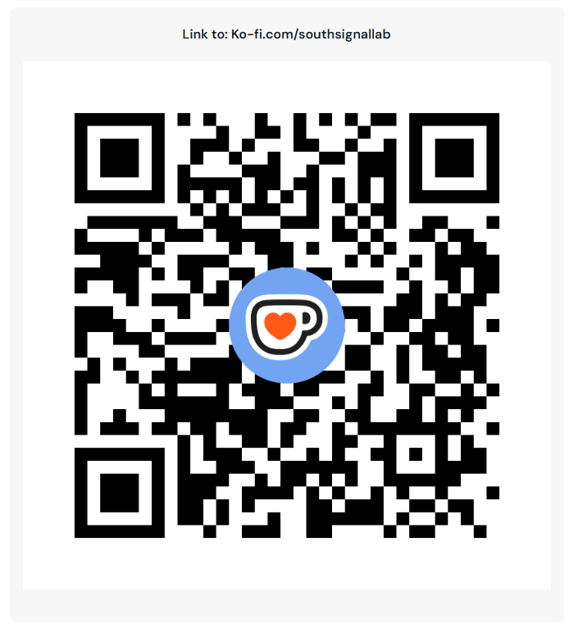
Scan the QR code to open the CLOCK Ko-fi support page.
COLOPHON
CLOCK — User Manual. Typeset in Ubuntu.

This manual is licensed under Creative Commons Attribution–NonCommercial 4.0 International (CC BY-NC 4.0). The firmware is licensed separately under the PolyForm Noncommercial License 1.0.0; third-party components retain their upstream licenses.
Design, firmware and documentation: Axel Napolitano.
Release documentation — firmware 1.1.0, baseline 23 September 2026.
© 2026 Axel Napolitano · From Munich with 
