1 Introduction
Drift is a modulation source for evolving control voltages. This firmware is available in six compile-time algorithm banks: Classic preserves the four Drift modes derived from the original firmware, Organic explores continuous and nonlinear movement, Generative adds memory and evolving structure, Ambient concentrates on slow long-form modulation, Electronica adds rhythm-first modulation for house, acid, techno and related styles, and Percussion adds phrase-aware trigger/CV rhythms with optional clock synchronization. Together they turn the same compact hardware into twenty-four distinct modulation algorithms.
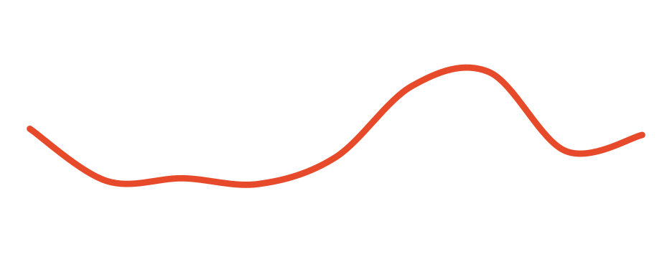
Six firmware banks — four DIP-selected algorithms each
The flashed firmware image chooses the algorithm bank. The two rear DIP switches then select one of four algorithms inside that bank at power-up. Classic contains Perlin, Brownian, Bezier and LFO; Organic contains Fractal, Vector, Rain and Attractor; Generative contains Turing, Markov, Motif and Urn; Ambient contains Current, Anchor, Breath and Fog; Electronica contains Pump, Acid, Shuffle and Polymeter; Percussion contains Euclid, Repeat, Probability and Humanize.

NOTE
The bank is chosen by the flashed firmware image. The rear DIP switches choose an algorithm inside that bank and are sampled only at startup — see sections 4–7.

2 Panel overview
Three knobs sit above two CV inputs and the output. From top to bottom: Speed, Texture and Attenuation, then the Speed and Texture CV inputs, then the output jack with its level LED. The algorithm DIP switch is on the back.
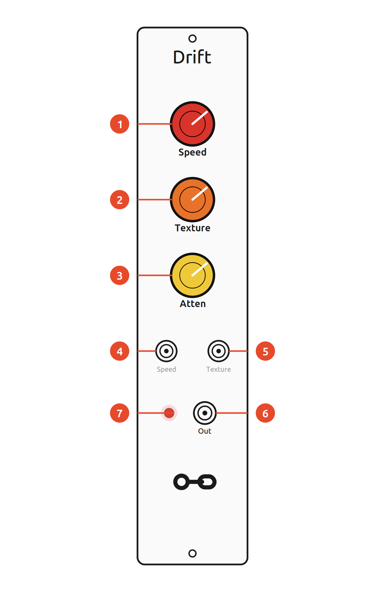
Ref. | Panel element
 | Speed knob — how quickly the voltage changes (with CV)
 | Texture knob — secondary shape parameter (with CV)
 | Attenuation knob — scales the output level
 | Speed CV input
 | Texture CV input
 | Output — 0–10 V unipolar modulation signal
 | Output-level LED

ON THE BACK
The rear two-position DIP switch selects one of four algorithm slots inside the flashed bank. It does not change banks. Cycle the power after changing the switch position.
Installation
Drift needs a standard Eurorack power cable (2×8 pin). Line up the red stripe with the −12 V side of the header and check seating before powering up.

3 Controls
 | Control | What it does
 | Speed  knob + CV | time scale or activity; exact mapping depends on the selected algorithm
 | Texture  knob + CV | secondary character parameter; meaning depends on the selected algorithm
 | Attenuation  knob | scales the final analogue output level; not readable by the firmware
 | Output  jack + LED | 0–10 V unipolar modulation signal; the LED shows the output level

Speed
Speed controls time scale or activity. Classic Perlin, Bezier and LFO, Organic Fractal, Vector and Attractor, and all four Generative modes use the shared approximately 1 V/oct mapping. Ambient uses the same mapping at a 1/16 macro-time scale. Electronica uses a free-running internal 30–240 BPM tempo. Percussion uses the Speed knob for that 30–240 BPM internal tempo, but repurposes Speed CV as an optional 0–5 V quarter-note clock input. Brownian is deliberately different and, like Rain, uses direct activity/decay control instead.
WARNING — PERCUSSION CLOCK INPUT
Percussion clocking on the original Drift hardware is 0–5 V only. Do not patch 10 V Eurorack triggers or clocks into Speed CV. The analogue input was designed for 0–5 V and firmware cannot add overvoltage protection. Two valid edges acquire the external clock; on clock loss, Percussion returns automatically to the Speed-knob clock.
Texture
Texture controls the secondary character of the active algorithm. The knob and CV each range 0–5 V and are normally summed and clamped to the valid range. In Classic it controls roughness, interpolation/timing shape, smoothing or LFO skew; in Organic it controls multiscale detail, vector coupling, event density or attractor structure; in Generative it controls mutation, exploration, phrase editing or reinforcement; in Ambient it redistributes Current weights, sets Anchor spread, varies Breath cycles or sets Fog occupancy; in Electronica it controls Pump recovery, Acid accent/slide strength, Shuffle timing ratio or Polymeter meter selection; in Percussion it controls Euclidean density, repeat/ratchet activity, weighted hit probability or Humanize timing/level variation. For Euclid, Repeat and Probability the same macro control also selects phrase length and fill strength.
Attenuation and output
Attenuation scales the final modulation signal from its full 0–10 V range (fully clockwise) down to 0 V (fully counter-clockwise). It is an analogue control after the DAC, so the firmware cannot use its position as an algorithm parameter. In Rain this final level naturally acts as Intensity. The LED indicates the instantaneous output level.

4 Algorithm banks
Drift started with four algorithm concepts in the original Free Modular firmware. The bank architecture turns the same hardware into a much broader modulation platform: the current firmware now provides twenty-four algorithms across six compile-time banks. Classic preserves the original vocabulary, Organic explores continuous and nonlinear motion, Generative adds memory and evolving structure, Ambient focuses on slow spacious long-form modulation, Electronica turns the same controls toward internally timed rhythmic movement, and Percussion adds event-oriented rhythms with phrase-level fills and optional external quarter-note clocking.
That breadth does not mean twenty-four algorithms are simultaneously selectable. The existing hardware exposes two binary rear DIP switches, which provide exactly four physical selector states. The firmware image therefore chooses one bank, and the switches choose one of its four algorithms. Only one algorithm runs at a time. Software can add new banks, but it cannot create additional physical switch states; changing banks requires flashing a different firmware image.
Twenty-four algorithms do introduce one mildly inconvenient consequence: choosing a bank means not having the other five available at the same moment. This is less a firmware defect than an invitation to capacity planning. A second Drift allows two banks at once; a third improves matters further. At some point the question ceases to be whether another Drift is necessary and becomes whether there is any compelling technical evidence that enough Drift has ever been reached. None is presently known.
Bank overview
Choose the bank that best matches the musical role you need, flash that firmware image, then use the same four DIP positions inside the selected bank. The small switch symbols show the rear-panel position for each algorithm slot.
Bank | Alg. 1 | Alg. 2 | Alg. 3 | Alg. 4
Classic | Perlin | Brownian | Bezier | LFO
Organic | Fractal | Vector | Rain | Attractor
Generative | Turing | Markov | Motif | Urn
Ambient | Current | Anchor | Breath | Fog
Electronica | Pump | Acid | Shuffle | Polymeter
Percussion | Euclid | Repeat | Probability | Humanize
Musical character and origin
The origin column names a historical algorithm or concept where that attribution is meaningful. Project-specific constructions are labelled as such instead of assigning them a fictitious inventor. The musical value column is a patching-oriented summary, not a ranking.
Algorithm | Origin / inventor | Musical value
Perlin (Classic) | Ken Perlin; Drift mode: Quinn Freedman | Smooth, non-repeating motion for filters, timbre and spatial movement.
Brownian (Classic) | Brown / Wiener lineage; Drift mode: Quinn Freedman | Drifting motion with memory; coherent wandering without a fixed cycle.
Bezier (Classic) | Paul de Casteljau / Pierre Bézier; Drift mode: Quinn Freedman | Smooth random target transitions for evolving macro-CV without steps.
LFO (Classic) | No single inventor; Drift mode: Quinn Freedman | Predictable periodic motion with skew; strong for deliberate rhythmic cycles.
Fractal (Organic) | This firmware project; multiscale Perlin-derived | Macro drift plus fine detail; rich organic movement across several time scales.
Vector (Organic) | This firmware project | Directed deterministic motion that continually rephases without obvious looping.
Rain (Organic) | This firmware project | Sparse-to-dense stochastic events for irregular accents and event-like modulation.
Attractor (Organic) | Michel Hénon; Drift adaptation: this firmware project | Complex deterministic nonlinear motion with changing orbit structure.
Turing (Generative) | Tom Whitwell / Music Thing Modular; independent Drift adaptation | Recognisable loops that slowly mutate; excellent for repeating generative motifs.
Markov (Generative) | Andrey Markov; Drift adaptation: this firmware project | Recurring voltage vocabulary with changing routes instead of a fixed sequence.
Motif (Generative) | This firmware project | Phrase identity survives controlled edits; strong structured generative variation.
Urn (Generative) | Eggenberger & Pólya inspired; leaky Drift variant | Temporary statistical favourites emerge and fade, creating autonomous habits.
Current (Ambient) | This firmware project; quasiperiodic superposition inspired | Long coherent motion without a short obvious loop; strong for pads, timbre and spatial movement.
Anchor (Ambient) | Ornstein–Uhlenbeck inspired; bounded Drift variant | Random motion that keeps returning toward a musical centre instead of wandering away.
Breath (Ambient) | This firmware project | Natural recurring swells for amplitude, filters and effects without rigid LFO repetition.
Fog (Ambient) | This firmware project; filtered-pulse-process inspired | Soft overlapping bipolar events for diffuse depth, motion and spatial texture.
Pump (Electronica) | This firmware project; sidechain/ducking gesture inspired | Immediate rhythmic breathing for VCA, filter, sends and timbre without requiring audio detection.
Acid (Electronica) | This firmware project; acid/TB-303 sequencing vocabulary inspired | Deterministic stepped, accented and sliding CV for squelchy filters, folds and bass timbre.
Shuffle (Electronica) | No single inventor; Drift mode: this firmware project | Machine-tight swing: rhythmic feel changes without random timing or long-term tempo drift.
Polymeter (Electronica) | No single inventor; Drift mode: this firmware project | Long organised accent cycles that evolve against a four-step anchor without randomness.
Euclid (Percussion) | Bjorklund / Godfried Toussaint lineage; Drift adaptation: this firmware project | Evenly distributed hits with phrase-end fills; strong for kicks, snares, hats and repeating percussion figures.
Repeat (Percussion) | No single inventor; ratchet/flam vocabulary adapted by this firmware project | Quarter-note anchors with doubles, triples, ratchets and escalating phrase-end rolls.
Probability (Percussion) | This firmware project; weighted stochastic rhythm | A stable metric skeleton gains controlled secondary and ghost hits without losing the beat.
Humanize (Percussion) | No single inventor; Drift adaptation: this firmware project | Fixed event count with bounded microtiming and level variation, reducing machine rigidity without tempo drift.
Choosing a bank
Classic is the broadest general-purpose set and stays closest to the original Drift vocabulary. Organic focuses on continuous, nonlinear and event-like movement. Generative focuses on stepped modulation with explicit memory, repetition and evolving structure. Ambient is the slowest and most spacious set, aimed at long-form drift, mean-reverting motion, natural swells and diffuse stochastic clouds. Electronica supplies deterministic club-oriented modulation such as ducking, acid contours, shuffle and polymetric accents. Percussion is the event-oriented choice for Euclidean hits, repeats/ratchets, weighted stochastic rhythms and bounded humanization, with optional 0–5 V quarter-note clock synchronization. The best bank is therefore a musical choice rather than a hierarchy: the hardware can host only one bank image at a time.
5 Classic bank
Classic is the compatibility-oriented bank. It contains Perlin, Brownian, Bezier and LFO and preserves the four Drift concepts derived from the original firmware while applying the verified numerical and state-handling corrections documented by this project.
DIP switch selection
With the Classic firmware flashed, DIP 1 and DIP 2 select the four Classic algorithms shown below. ON is the upper switch position. Power-cycle the module after changing either switch.

Classic bank — DIP-switch positions on the back (ON = up)
Perlin mode (default)
Perlin mode is the default algorithm. It is based on Ken Perlin's noise algorithm, designed to produce very smooth yet organic and unpredictable landscapes.
- Speed — how quickly the algorithm travels through the random landscape.
- Texture — roughness of the output. Fully counter-clockwise the output is completely smooth; as Texture increases, higher-frequency noise is blended in and the output becomes rougher.
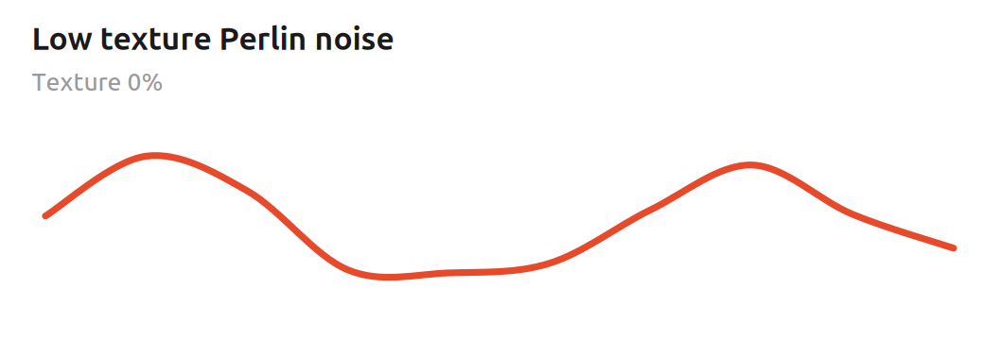
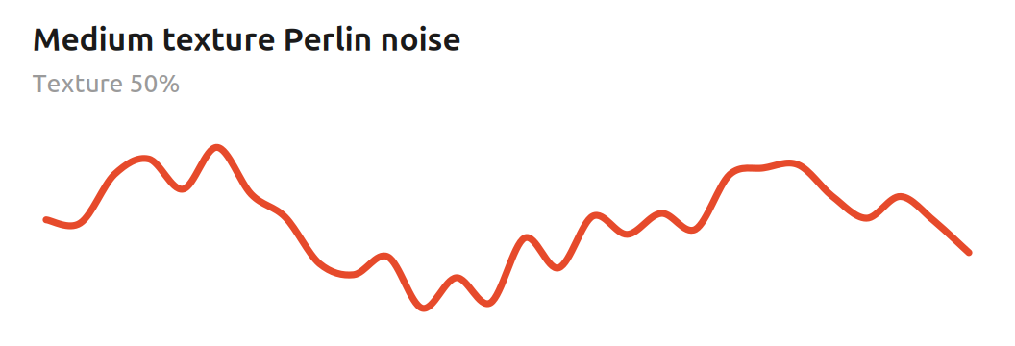

Mathematical foundations
Perlin mode uses one-dimensional gradient noise. Rather than choosing random voltages and simply interpolating between them, each lattice point receives a signed random gradient. Within one segment, normalised phase t from 0 to 1 and neighbouring gradients g₀ and g₁ define two local ramps that are blended with the canonical quintic fade function:
f(t) = 6t⁵ - 15t⁴ + 10t³
n(t) = (1 - f(t)) g₀ t + f(t) g₁ (t - 1)
The fade function has zero first and second derivatives at both endpoints. Adjacent segments therefore meet smoothly even though their gradients are random, which is why Perlin noise can wander unpredictably without the corners of ordinary sample-and-hold modulation.
Speed advances the phase exponentially: each additional volt doubles the rate.
f(V) = f₀ · 2^V
Drift runs two such noise layers. The second layer advances four times faster than the base layer. If τ is normalised Texture, the blend is proportional to
y(t) ∝ (4 - τ) n₀(t) + τ n₁(4t)
so Texture adds a faster octave while retaining the slower motion underneath. At low Texture the signal is broad and fluid; at higher Texture it gains smaller, quicker detail without turning into uncorrelated noise.
Musically, this makes Perlin mode useful when an ordinary LFO feels too repetitive but completely random steps feel too abrupt. It works particularly well for slow filter movement, timbral drift, wavefolder depth and other parameters that benefit from correlated motion.
Bezier mode
Bezier mode interpolates between random points using smooth cubic Bezier curves.
- Speed — the average time between random values.
- Texture — controls segment-to-segment timing variation. Near 12 o'clock, with Texture CV at 0 V, the segments occur at a fixed interval. Moving the knob away from centre widens a symmetric triangular random offset in logarithmic speed space; Texture CV widens it further. The resulting segment durations therefore vary multiplicatively rather than following a Gaussian distribution.
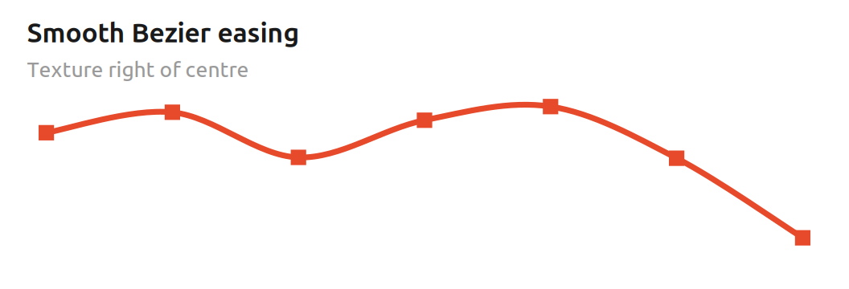
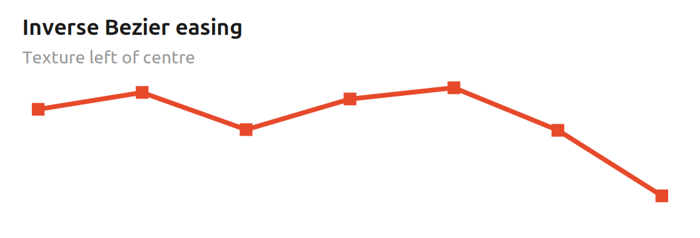
KNOB, NOT CV
Texture also controls the shape of the curves, and only the knob does this — not the CV. The curve morph is continuous: right of centre produces smooth easing into and out of each random value, the centre is effectively linear, and left of centre uses the inverse easing shape to accentuate transitions. Texture CV affects timing variation, not curve shape.

Mathematical foundations
Bezier mode connects successive random values A and B with a cubic easing curve. With normalised segment phase t from 0 to 1, the firmware uses two monotone cubic shapes:
C_s(t) = 3t² - 2t³ C_r(t) = 2t³ - 3t² + 2t
The Texture knob continuously blends between them. If τ is the normalised knob position, the curve is
C(t, τ) = (1 - τ) C_r(t) + τ C_s(t)
At τ = 0.5 the two cubics average to C(t) = t, so the centre position is linear. To the right, the smoothstep curve has zero slope at both endpoints and gently settles on each random value. To the left, the inverse curve is steeper at the endpoints and slower around the middle, which emphasises the transitions.
Timing randomness is separate. A symmetric triangular random variable r in approximately [-1, 1] is scaled by a width derived from the distance of the Texture knob from centre plus Texture CV. The resulting offset δ is applied in the logarithmic 1 V/oct speed domain:
f_segment = f_base · 2^δ
Musically, this means the centre setting can give evenly timed, straight transitions, while moving away from centre adds both characteristic curvature and irregular spacing. Because the timing offset is exponential, the variation feels proportional across slow and fast settings rather than being a fixed number of milliseconds.
Brownian mode
Brownian mode implements a bounded, centre-biased random walk. At each processing step the value may move up or down by a Speed-dependent amount; over time this produces jittery motion at high activity settings and slower, emergent wandering at low settings. It is inspired by Brownian motion rather than being a literal Wiener process.
- Speed — controls both how likely the random walk is to move and how large each movement can be.
- Texture — smooths the motion with a proportional filter; more smoothing is applied as the Texture value gets lower.
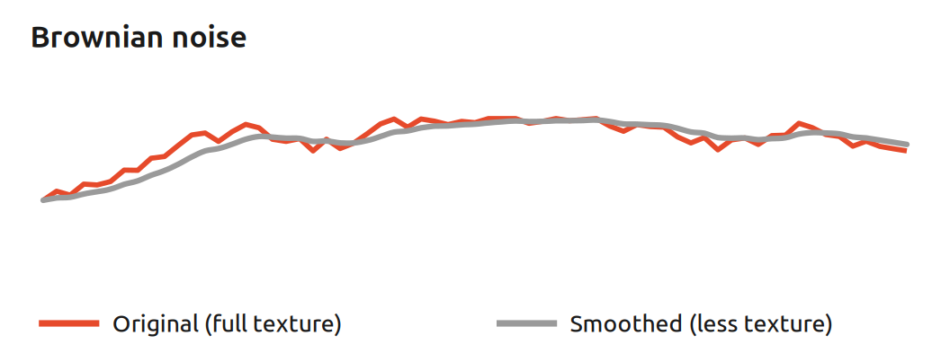
Mathematical foundations
This mode is a discrete, bounded random walk rather than an exact mathematical Brownian/Wiener process. Let c be the combined 10-bit Speed control, 0…1023. On each 2.5 kHz processing step the probability that the target moves is approximately
P(move) = c / 1024
and the movement size in the internal 16-bit state is
s(c) = ⌊(256 + c) / 2⌋
so raising Speed makes the walk move both more often and farther. Near the numerical limits, the direction probability is biased back toward the centre to keep the walk bounded instead of pinning permanently at 0 or maximum.
Texture controls a first-order proportional smoother. If q[n] is the random-walk target and x[n] the smoothed output state, each update follows
x[n+1] = x[n] + α(T) · (q[n] - x[n])
where α(T) rises from about 1/4096 at minimum Texture to 1/8 at maximum Texture. Small α creates strong inertia; large α follows the walk more closely. Fractional movement is accumulated internally so very small corrections are not lost to integer rounding.
Musically, Brownian mode has memory: the next value depends on where the walk already is. Low Speed and low Texture produce slow, drifting parameter motion; increasing Speed creates more energetic wandering, while increasing Texture reduces the lag and reveals more of the underlying jitter.
LFO mode
LFO mode is a skewable triangle/saw LFO. Unlike the other three modes it is periodic rather than random.
- Speed — the frequency of the LFO.
- Texture — morphs continuously between a falling saw (left), triangle (centre) and rising saw (right).
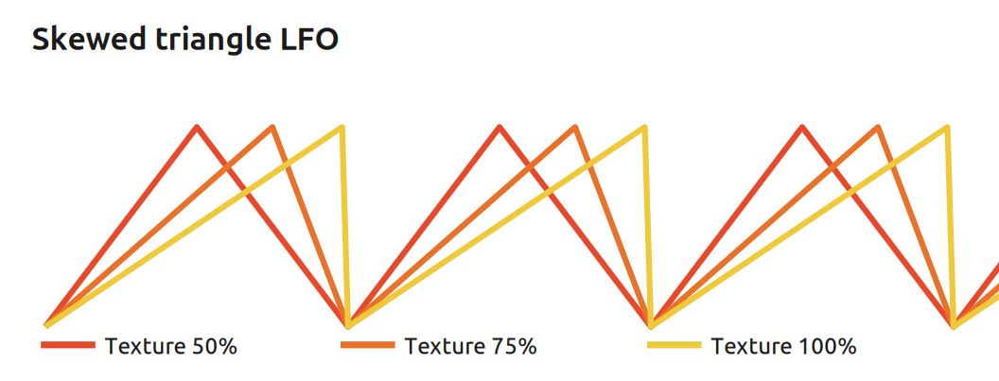

Mathematical foundations
The LFO uses a normalised phase p from 0 to 1 and an apex position a set by Texture. For 0 < a < 1, the waveform is piecewise linear:
y(p) = p/a for p ≤ a
y(p) = (1 - p)/(1 - a) for p > a
At a = 0.5 the rise and fall have equal duration and the result is a triangle. At a = 0 the limiting case is a falling saw, y = 1 - p; at a = 1 it is a rising saw, y = p. Speed changes the phase increment with the same approximately 1 V/oct exponential mapping used by Perlin and Bezier.
Changing Texture moves the point in the cycle at which the waveform reaches its peak without changing the nominal period. The firmware remaps phase during live Texture changes so the current output voltage is preserved as closely as the finite representation allows. The exact saw endpoints necessarily retain the normal sawtooth discontinuity at cycle wrap.
Musically, the apex position is a direct control over rhythmic emphasis. A centred triangle gives balanced up/down modulation; moving the peak earlier creates a fast attack and long decay, while moving it later creates a long rise and fast fall. The saw endpoints are useful when a steady ramp is more useful than symmetric modulation.
6 Organic bank
Organic is the alternative motion-design bank. It keeps the same Speed and Texture controls, CV inputs, output stage and four rear DIP slots, but maps those slots to Fractal, Vector, Rain and Attractor.
DIP switch selection
With the Organic firmware flashed, DIP 1 and DIP 2 select the four Organic algorithms shown below. ON is the upper switch position. Power-cycle the module after changing either switch.

Organic bank — DIP-switch positions on the back (ON = up)
Fractal mode
Fractal extends the smooth gradient-noise idea across three linked time scales. The large-scale layer always remains present while Texture transfers part of the constant total gain into 4× and 16× detail.
- Speed — traversal rate through the noise landscape; approximately 1 V/oct with Speed CV.
- Texture — Roughness/detail: low values favour macro motion; high values add progressively finer movement.

Mathematical foundations
Let n(t) be the same continuous gradient-noise primitive used by the Classic Perlin implementation. Fractal combines three scales:
F(t) = w₀(T)n(t) + w₁(T)n(4t) + w₂(T)n(16t)
The integer weights always sum to 1024. Texture 0% uses 1024/0/0; full Texture reaches 512/320/192. Because the total weight remains constant, Texture changes the distribution of detail rather than acting as another output-level control.
Musically, low Texture behaves like broad landscape motion. Raising Texture preserves that macro contour while adding smaller and faster fluctuations, which is useful when one CV should carry both slow drift and surface detail.
Vector mode
Vector is deterministic rather than random. It maintains two continuous phase coordinates on a torus. Each axis advances forward while Texture cross-couples its rate to the triangle-wave projection of the other axis. The output is the average projection of both axes.
- Speed — base flow rate; approximately 1 V/oct with Speed CV.
- Texture — cross-axis coupling: zero leaves the two rates independent; higher values bend the trajectory while keeping both axes forward-moving.

Mathematical foundations
If x[n] and y[n] are bipolar triangle projections of the two phase coordinates, the implemented coupling has the form
φx[n+1] = φx[n] + Δx · (1 + c(T)y[n])
φy[n+1] = φy[n] + Δy · (1 - c(T)x[n])
with the second base rate fixed at three quarters of the first. Full Texture limits the cross-coupling to roughly ±25% of each base increment. The final output is the unipolar projection of the average of x and y.
Musically, Vector produces repeating-looking but continually rephased motion. It is useful when a modulation should feel coordinated and directed without using random events.
Rain mode
Rain is a stochastic impulse process. Random arrivals add finite positive impulses to one shared envelope; between arrivals the envelope leaks toward zero. Overlapping events accumulate naturally and saturate only at the internal full-scale limit.
- Speed — drop-tail decay speed. Higher values make the shared envelope fall faster.
- Texture — Density: higher values increase the probability of a new rain event.
- Attenuation — final analogue Intensity. It scales the result after the algorithm.

Mathematical foundations
Density d is mapped quadratically to a 16-bit Bernoulli event cutoff, giving more useful resolution in the sparse region:
cutoff(d) = ⌊d² / 64⌋
Speed s maps linearly to the unsigned Q0.16 decay coefficient
α(s) = 4 + 8s
and the aggregate envelope is reduced by α each processing step before any new impulse is added. Fractional decay is retained between steps so quiet tails cannot freeze solely because of integer truncation.
Musically, Density moves from isolated drops through irregular showers to dense overlapping rain. Speed changes how long each arrival remains as modulation, while the physical Attenuation knob sets the final intensity without changing the event process itself.
Attractor mode
Attractor is deterministic nonlinear modulation based on a fixed-point Hénon map. Texture changes the map parameter while Speed controls how quickly the output interpolates from one map state to the next.
- Speed — travel/interpolation rate between successive map states; approximately 1 V/oct with Speed CV.
- Texture — Structure: selects the Hénon a parameter from approximately 1.20 to 1.40. It should not be read as a guaranteed monotonic amount of chaos.

Mathematical foundations
The state update is
x[n+1] = 1 - a x[n]² + y[n]
y[n+1] = b x[n]
where Texture selects a ≈ 1.20…1.40 and b remains ≈ 0.30. The implementation uses signed Q2.14 fixed point and linearly interpolates the x coordinate between map updates before converting it to the 12-bit unipolar output.
The MCU state space is finite, so every digital trajectory is ultimately periodic. In practice Texture selects different nonlinear structures and orbit lengths; it does not create mathematical infinity. Musically, the attraction is the tension between recurring shapes and irregular return times.
7 Generative bank
Generative is the memory-driven stepped-modulation bank. Its four algorithms remember a loop, a state, a phrase or a set of statistical preferences, so the future depends on what has already happened. It is aimed at patches where modulation should develop motifs and habits rather than merely wander.
DIP switch selection
With the Generative firmware flashed, DIP 1 and DIP 2 select the four Generative algorithms shown below. ON is the upper switch position. Power-cycle the module after changing either switch.

Generative bank — DIP-switch positions on the back (ON = up)
Turing mode
Turing produces a stepped 16-bit loop whose feedback can be probabilistically mutated. At low Texture the same voltage pattern repeats; raising Texture lets individual feedback bits change so the loop slowly rewrites itself instead of being replaced wholesale.
- Speed — shift rate; approximately 1 V/oct with Speed CV.
- Texture — mutation probability, from exact lock at 0% to maximum useful randomness at 50%.

Mathematical foundations
Let b be the recycled feedback bit and B(p) a Bernoulli variable. The incoming bit is
b' = b ⊕ B(p), 0 ≤ p ≤ 1/2
At p = 0 the 16-bit register rotates exactly and the sequence locks. At p = 1/2 the incoming bit is maximally independent of the recycled bit. Mapping Texture to p = 1 would be wrong because every bit would then invert deterministically rather than becoming more random.
y = R >> 4
The upper twelve register bits drive the DAC directly. Musically, Turing is the strongest persistent-loop mode in the bank: it can repeat recognisable CV motifs for a long time and then let them drift through small mutations.
Markov mode
Markov moves among eight symbolic states. Each state belongs to a fixed shuffled voltage vocabulary; what changes is the route through that vocabulary. Low Texture follows a constrained transition grammar, while higher Texture increasingly allows free next-state selection.
- Speed — state-transition rate; approximately 1 V/oct with Speed CV.
- Texture — exploration, from the fixed transition grammar to uniform next-state choice.

Mathematical foundations
At minimum Texture, the structured grammar stays in the current state with probability 1/2, moves one state forward with probability 1/4, one state backward with probability 1/8, or jumps four states with probability 1/8. Texture τ mixes that grammar with uniform exploration:
Pτ = (1 − τ) Ps + τ U
At full Texture the next symbolic state is uniformly chosen from all eight possibilities, but the voltage vocabulary itself remains fixed. Musically, this creates familiar places with changing routes: variation remains coherent because the same small set of voltages keeps returning.
Motif mode
Motif stores an explicit eight-step phrase and changes its structure only at phrase boundaries. Instead of redrawing the whole sequence, it performs at most one small edit, so a recognisable identity can survive many cycles.
- Speed — phrase step rate; approximately 1 V/oct with Speed CV.
- Texture — probability of one structural edit after a completed eight-step phrase.

Mathematical foundations
P(edit) = τ
When an edit occurs, one of four equally likely operations is selected: rotate the phrase, swap one adjacent pair, reverse one circular three-step span, or replace one value. Three of those four operations preserve the complete voltage vocabulary. The edit is applied before step 0 of the next cycle, so each audible phrase remains internally consistent.
Musically, Motif is the strongest identity-through-variation mode: it is useful when a sequence should remain recognisable while its ordering and occasional values evolve over time.
Urn mode
Urn uses eight fixed voltage states with mutable selection weights. Recently selected states become more likely to be selected again, but every draw also relaxes all weights toward a common baseline, so temporary favourites can emerge and later disappear.
- Speed — draw rate; approximately 1 V/oct with Speed CV.
- Texture — reinforcement strength; higher values make recent selections more likely to recur.

Mathematical foundations
All eight weights start at baseline b = 32. Before each draw, any excess above baseline is reduced by a factor of 31/32:
wᵢ' = b + floor(31(wᵢ − b) / 32)
The next state is then drawn in proportion to the current weights,
P(X = i) = wᵢ / Σⱼ wⱼ
and the selected state receives Texture-controlled reinforcement from 0 to 64, bounded at 1023. This is a deliberately leaky, bounded Pólya-inspired process rather than an exact classical Pólya urn. Musically, it creates temporary statistical habits: some voltage regions become favourites for a while and then lose that advantage.
8 Ambient bank
Ambient is the long-form modulation bank. Its four algorithms are deliberately slower than the other banks and focus on spacious continuous evolution rather than short loops or stepped sequences. Current creates deterministic multi-rate motion, Anchor wanders around a statistical home, Breath repeats a natural swell with cycle-to-cycle variation, and Fog layers soft bipolar stochastic cloudlets.
DIP switch selection
With the Ambient firmware flashed, DIP 1 and DIP 2 select the four Ambient algorithms shown below. ON is the upper switch position. Power-cycle the module after changing either switch.

Ambient bank — DIP-switch positions on the back (ON = up)
Current mode
Current combines three deterministic slow currents with fixed non-harmonic rate ratios. Their continually shifting relationship creates coherent contours without a short obvious musical loop.
- Speed — shared macro rate for all three currents; the common Drift exponential mapping is slowed by a factor of sixteen.
- Texture — redistributes a constant total weight from the primary current toward the two secondary currents, adding more internal motion without acting as another level control.

Mathematical foundations
The three phase rates use AVR-friendly rational approximations to 1, √2 and the golden ratio φ:
f₀ : f₁ : f₂ ≈ 1 : 362/256 : 414/256
Each phase is projected through a cubic-softened triangle. Texture changes only the mix weights; their sum remains constant:
w₀ + w₁ + w₂ = 1024
At minimum Texture the weights are 768/192/64; at maximum 512/320/192. The finite digital trajectory repeats only after a long practical cycle. Musically, Current suits pads, timbre and spatial movement.
Anchor mode
Anchor is stochastic motion with a statistical home at the output midpoint. Random innovation pushes the voltage away; a Speed-dependent restoring term pulls it back toward centre.
- Speed — mean-reversion / correlation rate on the Ambient macro-time scale; higher values pull the state back more quickly.
- Texture — target spread around the midpoint, from a deterministic centre at 0% to a broad but bounded wandering region at 100%.

Mathematical foundations
The implemented process is an OU-inspired fixed-point AR(1) recurrence rather than an exact Gaussian Ornstein–Uhlenbeck process:
x[n+1] = a x[n] + g(a) s(T) ξ[n]
Here ξ is the firmware’s symmetric triangular innovation with variance 1/6. A generated lookup table approximately normalises its stationary spread across Speed using
g(a) ≈ √(6(1 − a²))
Texture maps spread from zero to about 0.30 in signed Q1.15. Triangular innovation and finite fixed-point state make this bounded rather than an exact Gaussian OU simulation. Musically, Anchor keeps random CV near a stable tonal or timbral centre.
Breath mode
Breath always performs one recognisable gesture: baseline → one peak → baseline. The overall shape remains intact, while each completed cycle can receive a new duration, peak height and peak position.
- Speed — nominal swell rate on the Ambient macro-time scale.
- Texture — cycle-to-cycle variation of duration (0.75…1.25×), peak amplitude (0.65…1.00 full scale) and peak position (0.25…0.50 of the cycle).

Mathematical foundations
Each attack and release uses the cubic smoothstep function
S(t) = 3t² − 2t³
If p is cycle phase and k the latched peak position, the envelope rises with S(p/k) before k and falls with 1 − S((p − k)/(1 − k)) afterwards. Texture zero locks the nominal duration, amplitude and peak position; non-zero Texture draws new values only when a cycle rolls over.
baseline → one peak → baseline
Because randomness is latched only at the boundary, Breath never turns into sample-by-sample noise and its topological identity is preserved. Musically, it behaves like a living macro-envelope: useful for VCA swells, filter opening, reverb depth or slow harmonic movement when a rigid LFO feels too mechanical.
Fog mode
Fog sums up to four independent bipolar cloudlets. Each cloudlet appears softly, reaches one rounded maximum and returns exactly to zero; positive and negative events can overlap so the resulting modulation forms diffuse moving layers around the midpoint.
- Speed — cloudlet duration on the Ambient macro-time scale; faster Speed makes each individual cloud shorter.
- Texture — target mean cloud occupancy, from about 0.125 to 3.0 simultaneously active voices.

Mathematical foundations
Every cloudlet uses the finite-support quartic kernel
g(u) = 16u²(1 − u)², 0 ≤ u ≤ 1
and is zero outside that interval. Event probability is compensated against cloud duration so Texture controls expected overlap rather than changing accidentally with Speed. Before the four-voice ceiling is reached, the target is approximately
P(start per sample) ≈ Δφ · N_target
where Δφ is the cloud phase increment and N_target the Texture-controlled occupancy. If all four voices are active, a new event is dropped. Musically, Fog gives soft irregular bipolar movement for spatial modulation, timbral depth and effects.
9 Electronica bank
Electronica is the rhythm-first modulation bank for house, acid, techno and related electronic music. Its four algorithms use an internal musical grid rather than external clocking: Pump creates ducking motion, Acid produces a deterministic 16-step accent/slide contour, Shuffle deforms straight timing, and Polymeter creates long accent cycles from competing meter lengths. The original Drift hardware has no clock input, so the documented BPM range is an internal reference rather than transport lock.
DIP switch selection
With the Electronica firmware flashed, DIP 1 and DIP 2 select the four Electronica algorithms shown below. ON is the upper switch position. Power-cycle the module after changing either switch.

Electronica bank — DIP-switch positions on the back (ON = up)
Pump mode
Pump creates the familiar duck-then-recover motion associated with sidechain-heavy electronic music. It does not listen to audio and is not a compressor: every internal quarter-note boundary simply resets the CV to zero and starts a smooth recovery.
- Speed — internal quarter-note tempo, nominally 30–240 BPM.
- Texture — recovery endpoint, from 1/4 to 15/16 of the beat; higher Texture keeps the signal ducked for longer.

Mathematical foundations
With saturated Speed control u between 0 and 1, Electronica uses the internal tempo law
B(u) = 30 · 2^(3u) BPM
For normalized beat phase p, cubic smoothstep S(x) = 3x² − 2x³ shapes the recovery. Texture τ moves its endpoint according to
e(τ) = 1/4 + 11τ/16 ; y(p) = S(clamp(p/e(τ), 0, 1))
The next beat intentionally resets the contour to zero. Musically, Pump is useful for VCA ducking, filter breathing, effect sends and timbre movement. Because no external trigger is available, it should be treated as a free-running rhythmic modulator rather than a synchronized sidechain envelope.
Acid mode
Acid generates a deterministic 16-step CV contour with project-defined accent and slide positions. It borrows the musical vocabulary of acid sequencing, but it is not a TB-303 emulator, pitch sequencer or recreation of Roland circuitry or factory patterns.
- Speed — internal grid tempo; the algorithm advances in sixteenth-note steps derived from the 30–240 BPM quarter-note reference.
- Texture — jointly increases accent contribution and slide interpolation on the fixed project-defined pattern.

Mathematical foundations
For step n from 0 to 15, a permutation generates every 4-bit level code exactly once per cycle:
qₙ = (5n + 3) mod 16 ; Lₙ = 1024 + 128qₙ
Accent steps satisfy n mod 4 = 0 or n mod 7 = 0. Slide steps satisfy (5n mod 16) < 4. Texture increases both the decaying accent contribution and the amount of smooth interpolation from the previous target.
Amax(τ) = 768τ ; D(p) = 1 − (3p² − 2p³)
At Texture zero Acid is a dry 16-step contour; higher Texture adds accent and slide. Strong destinations are resonant filter cutoff, wavefolding, oscillator timbre and distortion drive.
Shuffle mode
Shuffle changes timing without adding randomness. Each pair of sixteenth-note subdivisions keeps the same total duration, while Texture delays the second onset to create a progressively stronger long-short feel.
- Speed — internal pair tempo derived from the 30–240 BPM quarter-note reference.
- Texture — second-onset position, from exactly 1/2 of the pair (straight) to 3/4 (maximum 3:1 long/short ratio). The value is latched at each pair boundary.

Mathematical foundations
For Texture τ between 0 and 1, the second onset occurs at
r(τ) = 1/2 + τ/4 , 1/2 ≤ r ≤ 3/4
The two interval lengths are Δ₁ = r and Δ₂ = 1 − r, so their total is invariant:
Δ₁ + Δ₂ = 1
At minimum Texture the two intervals are equal; at maximum they form an exact 3:1 ratio. Because pair length never changes, Shuffle adds deterministic swing without cumulative tempo drift or random humanization.
Polymeter mode
Polymeter layers a fixed four-step accent cycle against one Texture-selected odd cycle while both share the same sixteenth-note grid. Every subdivision emits a short CV pulse; primary starts, secondary starts and coincidences receive progressively stronger emphasis.
- Speed — internal sixteenth-note grid derived from the 30–240 BPM quarter-note reference.
- Texture — selects the secondary meter discretely: 3, 5, 7 or 9 steps. Changes take effect at the next four-step primary boundary.

Mathematical foundations
The primary meter has length 4. Texture selects the secondary length
b ∈ {3, 5, 7, 9}
The two cycles share one grid and realign after their least common multiple. The four possible composite recurrence lengths are therefore
P = lcm(4, b) ∈ {12, 20, 28, 36} sixteenth steps
This produces organised medium-length evolution without probability: the listener retains a four-step anchor while the odd cycle walks through it. Texture is intentionally stepped because fractional meter lengths would destroy the polymetric meaning.
10 Percussion bank
Percussion is the event-oriented rhythm bank for drum voices, samplers, envelopes and other triggerable destinations. With no valid signal on Speed CV, the Speed knob supplies the internal 30–240 BPM quarter-note clock. In this bank only, Speed CV becomes an optional 0–5 V external quarter-note clock: two valid rising edges acquire sync, and clock loss after 2.5 measured periods automatically returns to the Speed-knob clock. Euclid, Repeat and Probability share a 16-step bar plus 4/8/12/16-bar phrase engine; Humanize keeps a fixed eight-event-per-bar grid.
Percussion clock input: 0–5 V only on the original Drift hardware. Do not patch 10 V Eurorack triggers or clocks into Speed CV. Firmware cannot add overvoltage protection to the existing analogue input stage.
DIP switch selection
With the Percussion firmware flashed, DIP 1 and DIP 2 select Euclid, Repeat, Probability or Humanize as shown below. ON is the upper switch position. Power-cycle the module after changing either switch.

Percussion bank — DIP-switch positions on the back (ON = up)
Euclid mode
Euclid selects a verified E(k,16) pulse pattern with 2–13 evenly distributed hits per 16-step bar. Texture increases hit density and also drives the shared phrase macro. On the final bar of each phrase, fill strength may add hits only in steps 12–15; existing Euclidean hits are never removed.
- Speed — internal 30–240 BPM quarter-note tempo from the Speed knob. In Percussion only, Speed CV accepts an optional 0–5 V quarter-note clock; two valid rising edges acquire external timing.
- Texture — Euclidean hit density plus shared phrase length/fill activity. Low values favour sparse rhythms and 16-bar phrases; high values become denser and can fill every 4 bars.

Mathematical foundations
With Texture code t clamped to 0…1023, the implemented hit count is
k = 2 + floor(12t / 1024), 2 ≤ k ≤ 13
The firmware looks up the corresponding verified canonical E(k,16) mask. The shared phrase engine quantizes phrase length to
L(t) ∈ {16, 12, 8, 4} bars
The fill only adds tail hits; the Euclidean core remains intact. Musically, Euclid gives recognisable kick, snare, hi-hat and percussion patterns with periodic fills.
Repeat mode
Repeat guarantees a quarter-note anchor and can add short doubles, triples or four-pulse ratchets inside the first half of that beat. Texture raises the chance and depth of repeats. The shared phrase engine intensifies the final bar into increasingly obvious rolls.
- Speed — internal quarter-note tempo from the Speed knob, or the measured external quarter-note period when a valid 0–5 V clock is present on Speed CV.
- Texture — repeat probability, ratchet depth and shared phrase/fill activity. Maximum Texture reaches 75% spontaneous repeat probability and four-pulse clusters.

Mathematical foundations
For normalized Texture τ between 0 and 1, the repeat probability approaches
P(repeat) = 3τ / 4
If N pulses are selected, sub-events are distributed through the first half of the quarter note at normalized positions
tⱼ = j / (2N), j = 0…N−1, N ∈ {2,3,4}
Phrase fills force stronger tail ratchets. Musically, Repeat adds hi-hat doubles, snare flams, percussion stutters and short phrase-end rolls.
Probability mode
Probability keeps the quarter-note skeleton deterministic and adds optional detail according to metric position. Steps 0/4/8/12 always hit; the even offbeats become secondary candidates and odd sixteenths become lower-probability ghost positions. Phrase fills raise only those optional probabilities.
- Speed — internal 30–240 BPM tempo from the Speed knob, or an optional 0–5 V quarter-note clock on Speed CV.
- Texture — probability of secondary and ghost hits plus shared phrase/fill activity. The four primary quarter-note hits remain guaranteed at every setting.

Mathematical foundations
For normalized Texture τ, secondary eighth-note positions use the linear law
Psecondary = τ
Odd ghost positions rise more slowly, following
Pghost = τ² / 2
Fill bars boost only optional hits, so the metric skeleton remains audible. Musically, Probability adds ghost snares, hats and evolving detail while preserving the beat.
Humanize mode
Humanize keeps exactly eight nominal eighth-note events per bar and changes only their timing and level. Every event is displaced relative to its own ideal grid point, so timing errors never accumulate into a drifting tempo. Humanize deliberately ignores the phrase-fill flag.
- Speed — internal 30–240 BPM quarter-note tempo from the Speed knob, or an optional 0–5 V quarter-note clock on Speed CV. External timing remains the nominal grid from which jitter is measured.
- Texture — bounded microtiming and pulse-level variation. At maximum Texture the timing radius is ±30 processing samples, i.e. ±12 ms at the 2.5 kHz scheduler rate.

Mathematical foundations
Each nominal event time t⁰ₙ receives an independent bounded offset δₙ:
tₙ = t⁰ₙ + δₙ, |δₙ| ≤ 12 ms
Pulse level is centred at DAC code 3840 and varies by at most 255 codes at full Texture:
A ∈ [3585, 4095] DAC codes ≈ 8.75…10 V
Each offset is measured from its own nominal grid point, so random timing cannot become random tempo. Musically, Humanize loosens hats, shakers and ghost percussion without changing event count.
11 Signals at a glance
Signal | Range / behaviour
Output | 0–10 V, unipolar; waveform/statistics depend on the selected bank and algorithm
Speed CV | 0–5 V; approximately 1 V/oct exponential base mapping in phase/step-rate modes. Ambient uses the same mapping at a 1/16 macro-time scale (Anchor: correlation/reversion rate). Electronica uses a free-running internal 30–240 BPM tempo. Percussion repurposes Speed CV as an optional 0–5 V quarter-note clock input and otherwise takes internal tempo from the Speed knob. Brownian/Rain use direct activity/decay control. 10 V triggers/clocks are not supported on the original hardware.
Texture CV | 0–5 V, normally summed with the knob and clamped; algorithm-specific secondary parameter
Attenuation | 0 V (CCW) to full 0–10 V scale (CW); analogue post-DAC control

NOTE
The electrical ranges above apply to the original Free Modular Drift hardware. The original module is 4 HP wide and is documented at maximum current draws of +5 V: 25 mA, +12 V: 5 mA and −12 V: 5 mA. Modified hardware revisions may differ.

COLOPHON
Drift — User Manual. Typeset in Ubuntu.

This manual is licensed under a Creative Commons Attribution–NonCommercial 4.0 International (CC BY-NC 4.0) license. You are free to share and adapt this material for non-commercial purposes, provided you give appropriate credit and indicate changes. Full terms: creativecommons.org/licenses/by-nc/4.0/
Drift is a Free Modular module; its hardware and firmware are covered by Free Modular's own licence (GPL-3.0-or-later). This independent manual — text, layout and illustrations — is licensed separately under CC BY-NC 4.0.
Illustrations and visual design were created with the assistance of AI tools — Claude (Anthropic) and ChatGPT (OpenAI), 2026.
Manual: Axel Napolitano. Original module design: Quinn Freedman / Free Modular.
Independent, unofficial manual. Not affiliated with Free Modular.
© 2026 Axel Napolitano · From Munich with 

