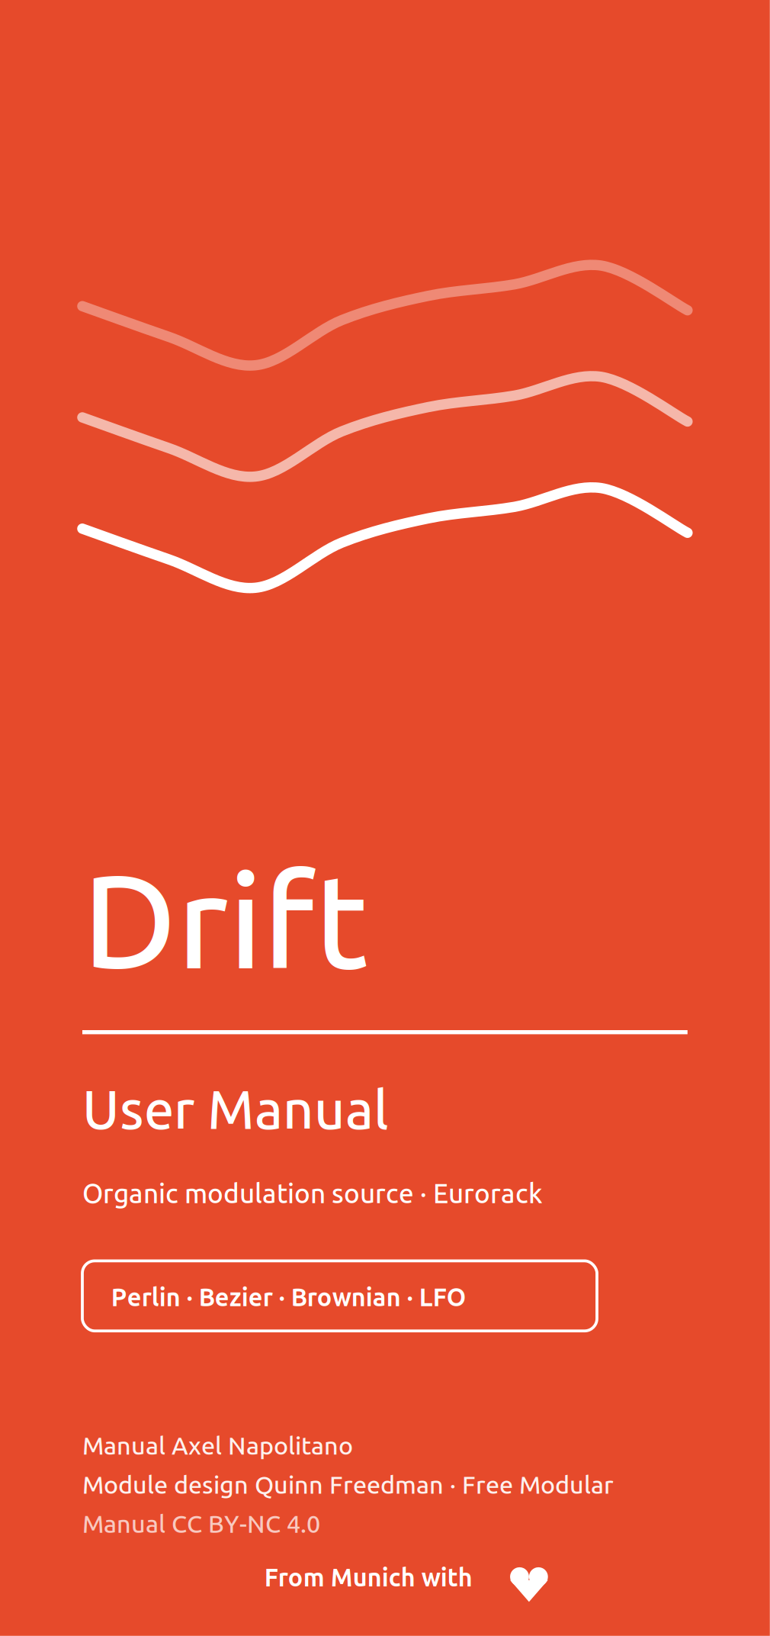
1 Introduction
Drift is a modulation source for organic, continuously evolving control voltages. Three modes are stochastic and non-repeating; the fourth is a periodic LFO. Two main controls — Speed and Texture — each have a CV input, while Attenuation scales the final output level.
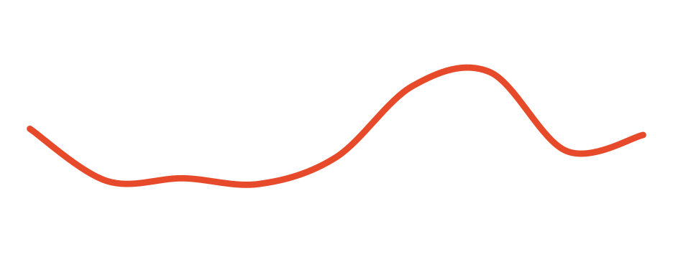
Organic modulation from stochastic motion or a skewable LFO
Drift can run four different algorithms, selected by a configuration DIP switch on the back of the module: a stacked Perlin noise generator, cubic Bezier interpolation, Brownian motion, or a simple LFO.

NOTE
The algorithm is chosen on the back of the module and takes effect after a power cycle — see section 5, Configuration.

2 Panel overview
Three knobs sit above two CV inputs and the output. From top to bottom: Speed, Texture and Attenuation, then the Speed and Texture CV inputs, then the output jack with its level LED. The algorithm DIP switch is on the back.
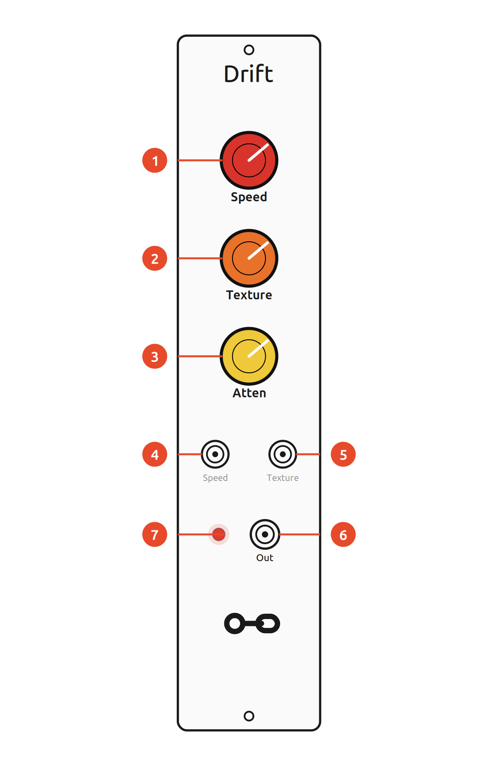
Ref. | Panel element
 | Speed knob — how quickly the voltage changes (with CV)
 | Texture knob — secondary shape parameter (with CV)
 | Attenuation knob — scales the output level
 | Speed CV input
 | Texture CV input
 | Output — 0–10 V unipolar modulation signal
 | Output-level LED

ON THE BACK
A two-position DIP switch on the rear selects the algorithm. It is not reachable from the front — plan the mode before the module is racked, and cycle the power after changing it.
Installation
Drift needs a standard Eurorack power cable (2×8 pin). Line up the red stripe with the −12 V side of the header and check seating before powering up.

3 Controls
 | Control | What it does
 | Speed  knob + CV | rate of change; approximately 1 V/oct in Perlin, Bezier and LFO, direct random-walk activity in Brownian
 | Texture  knob + CV | a secondary shape/activity parameter; its meaning depends on the algorithm
 | Attenuation  knob | scales the output level
 | Output  jack + LED | 0–10 V unipolar modulation signal; the LED shows the output level

Speed
Speed controls the rate of change. In Perlin, Bezier and LFO modes it follows an approximately 1 V/oct exponential mapping: the knob spans twelve octaves and the 0–5 V CV shifts the rate around the knob setting. At the minimum setting the base rate is about 1/40 Hz, or roughly one segment/cycle every 40 seconds. Brownian mode is deliberately different: Speed directly increases both the probability and the size of random-walk steps, so 1 V/oct does not apply there.
Texture
Texture controls a secondary parameter whose meaning varies with the selected algorithm (see Modes). The knob and CV each range 0–5 V; they are summed and then clamped to 5 V. In Bezier mode, curve shape is the exception: it is controlled by the knob alone, while Texture CV contributes to timing variation.
Attenuation and output
Attenuation scales the modulation signal from its full 0–10 V range (fully clockwise) down to 0 V (fully counter-clockwise). The output is unipolar; Perlin, Bezier and Brownian are stochastic, while LFO mode is periodic. The LED indicates the instantaneous output level.

4 Modes
Drift runs one of four algorithms at a time, chosen by the DIP switch on the back (section 5). In every mode Speed sets the pace and Texture shapes the character — but exactly what they do depends on the algorithm.
Perlin mode (default)
Perlin mode is the default algorithm. It is based on Ken Perlin's noise algorithm, designed to produce very smooth yet organic and unpredictable landscapes.
- Speed — how quickly the algorithm travels through the random landscape.
- Texture — roughness of the output. Fully counter-clockwise the output is completely smooth; as Texture increases, higher-frequency noise is blended in and the output becomes rougher.
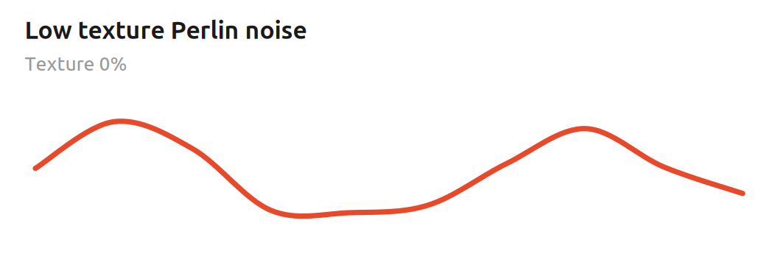
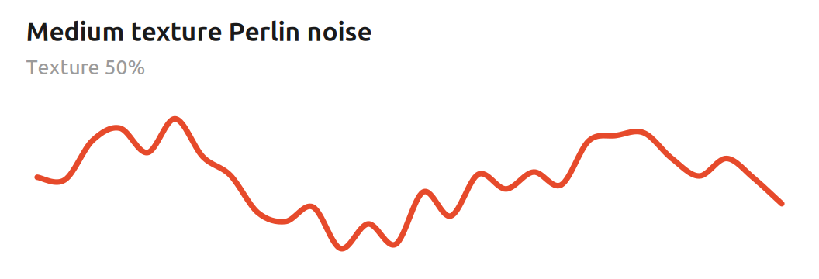

Mathematical foundations
Perlin mode uses one-dimensional gradient noise. Rather than choosing random voltages and simply interpolating between them, each lattice point receives a signed random gradient. Within one segment, normalised phase t from 0 to 1 and neighbouring gradients g₀ and g₁ define two local ramps that are blended with the canonical quintic fade function:
f(t) = 6t⁵ - 15t⁴ + 10t³
n(t) = (1 - f(t)) g₀ t + f(t) g₁ (t - 1)
The fade function has zero first and second derivatives at both endpoints. Adjacent segments therefore meet smoothly even though their gradients are random, which is why Perlin noise can wander unpredictably without the corners of ordinary sample-and-hold modulation.
Speed advances the phase exponentially: each additional volt doubles the rate.
f(V) = f₀ · 2^V
Drift runs two such noise layers. The second layer advances four times faster than the base layer. If τ is normalised Texture, the blend is proportional to
y(t) ∝ (4 - τ) n₀(t) + τ n₁(4t)
so Texture adds a faster octave while retaining the slower motion underneath. At low Texture the signal is broad and fluid; at higher Texture it gains smaller, quicker detail without turning into uncorrelated noise.
Musically, this makes Perlin mode useful when an ordinary LFO feels too repetitive but completely random steps feel too abrupt. It works particularly well for slow filter movement, timbral drift, wavefolder depth and other parameters that benefit from correlated motion.
Bezier mode
Bezier mode interpolates between random points using smooth cubic Bezier curves.
- Speed — the average time between random values.
- Texture — controls segment-to-segment timing variation. Near 12 o'clock, with Texture CV at 0 V, the segments occur at a fixed interval. Moving the knob away from centre widens a symmetric triangular random offset in logarithmic speed space; Texture CV widens it further. The resulting segment durations therefore vary multiplicatively rather than following a Gaussian distribution.
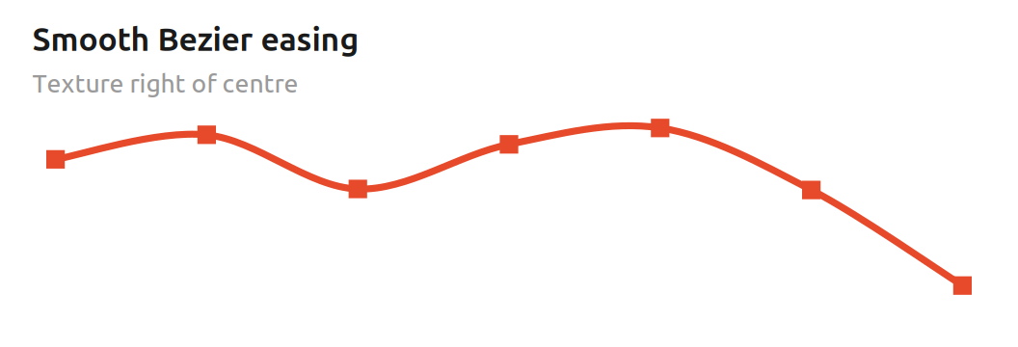
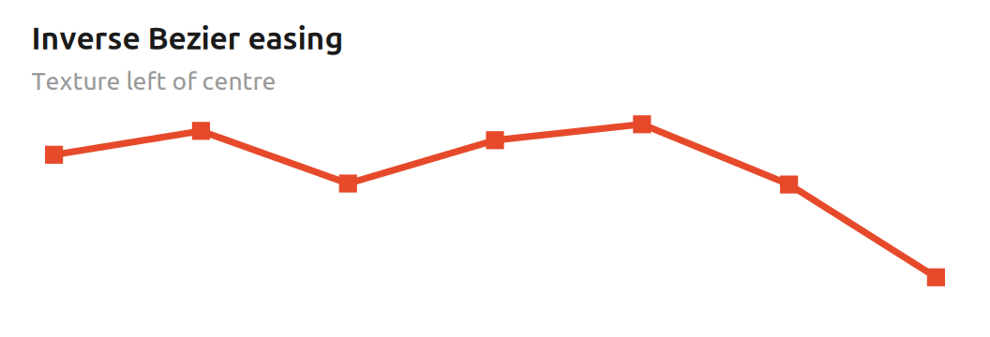
KNOB, NOT CV
Texture also controls the shape of the curves, and only the knob does this — not the CV. The curve morph is continuous: right of centre produces smooth easing into and out of each random value, the centre is effectively linear, and left of centre uses the inverse easing shape to accentuate transitions. Texture CV affects timing variation, not curve shape.

Mathematical foundations
Bezier mode connects successive random values A and B with a cubic easing curve. With normalised segment phase t from 0 to 1, the firmware uses two monotone cubic shapes:
C_s(t) = 3t² - 2t³ C_r(t) = 2t³ - 3t² + 2t
The Texture knob continuously blends between them. If τ is the normalised knob position, the curve is
C(t, τ) = (1 - τ) C_r(t) + τ C_s(t)
At τ = 0.5 the two cubics average to C(t) = t, so the centre position is linear. To the right, the smoothstep curve has zero slope at both endpoints and gently settles on each random value. To the left, the inverse curve is steeper at the endpoints and slower around the middle, which emphasises the transitions.
Timing randomness is separate. A symmetric triangular random variable r in approximately [-1, 1] is scaled by a width derived from the distance of the Texture knob from centre plus Texture CV. The resulting offset δ is applied in the logarithmic 1 V/oct speed domain:
f_segment = f_base · 2^δ
Musically, this means the centre setting can give evenly timed, straight transitions, while moving away from centre adds both characteristic curvature and irregular spacing. Because the timing offset is exponential, the variation feels proportional across slow and fast settings rather than being a fixed number of milliseconds.
Brownian mode
Brownian mode implements a bounded, centre-biased random walk. At each processing step the value may move up or down by a Speed-dependent amount; over time this produces jittery motion at high activity settings and slower, emergent wandering at low settings. It is inspired by Brownian motion rather than being a literal Wiener process.
- Speed — controls both how likely the random walk is to move and how large each movement can be.
- Texture — smooths the motion with a proportional filter; more smoothing is applied as the Texture value gets lower.
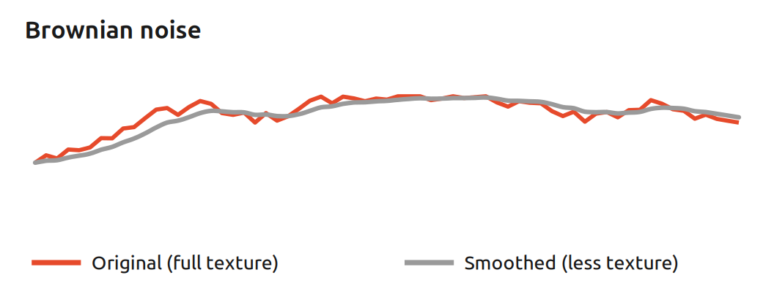
Mathematical foundations
This mode is a discrete, bounded random walk rather than an exact mathematical Brownian/Wiener process. Let c be the combined 10-bit Speed control, 0…1023. On each 2.5 kHz processing step the probability that the target moves is approximately
P(move) = c / 1024
and the movement size in the internal 16-bit state is
s(c) = ⌊(256 + c) / 2⌋
so raising Speed makes the walk move both more often and farther. Near the numerical limits, the direction probability is biased back toward the centre to keep the walk bounded instead of pinning permanently at 0 or maximum.
Texture controls a first-order proportional smoother. If q[n] is the random-walk target and x[n] the smoothed output state, each update follows
x[n+1] = x[n] + α(T) · (q[n] - x[n])
where α(T) rises from about 1/4096 at minimum Texture to 1/8 at maximum Texture. Small α creates strong inertia; large α follows the walk more closely. Fractional movement is accumulated internally so very small corrections are not lost to integer rounding.
Musically, Brownian mode has memory: the next value depends on where the walk already is. Low Speed and low Texture produce slow, drifting parameter motion; increasing Speed creates more energetic wandering, while increasing Texture reduces the lag and reveals more of the underlying jitter.
LFO mode
LFO mode is a skewable triangle/saw LFO. Unlike the other three modes it is periodic rather than random.
- Speed — the frequency of the LFO.
- Texture — morphs continuously between a falling saw (left), triangle (centre) and rising saw (right).
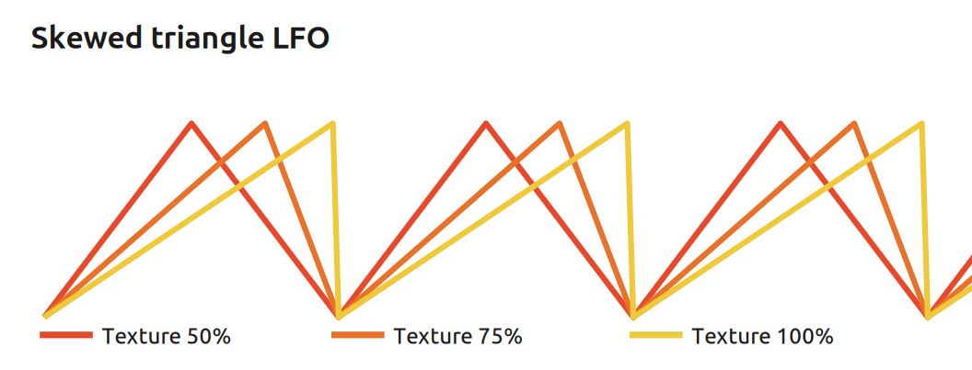

Mathematical foundations
The LFO uses a normalised phase p from 0 to 1 and an apex position a set by Texture. For 0 < a < 1, the waveform is piecewise linear:
y(p) = p/a for p ≤ a
y(p) = (1 - p)/(1 - a) for p > a
At a = 0.5 the rise and fall have equal duration and the result is a triangle. At a = 0 the limiting case is a falling saw, y = 1 - p; at a = 1 it is a rising saw, y = p. Speed changes the phase increment with the same approximately 1 V/oct exponential mapping used by Perlin and Bezier.
Changing Texture moves the point in the cycle at which the waveform reaches its peak without changing the nominal period. The firmware remaps phase during live Texture changes so the current output voltage is preserved as closely as the finite representation allows. The exact saw endpoints necessarily retain the normal sawtooth discontinuity at cycle wrap.
Musically, the apex position is a direct control over rhythmic emphasis. A centred triangle gives balanced up/down modulation; moving the peak earlier creates a fast attack and long decay, while moving it later creates a long rise and fast fall. The saw endpoints are useful when a steady ramp is more useful than symmetric modulation.
5 Configuration
One of the four algorithms is selected by the two DIP switches on the back of the module (or by soldering the desired connections directly). Cycle the power for a change to take effect.
Switch 1 | Switch 2 | Algorithm
OFF | OFF | Perlin (default)
ON | OFF | Brownian
OFF | ON | Bezier
ON | ON | LFO

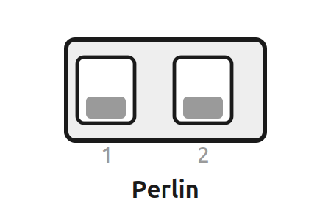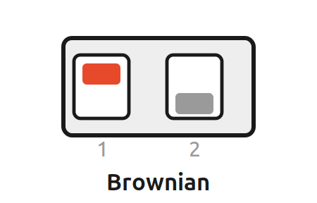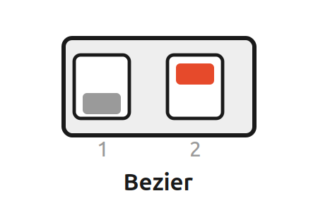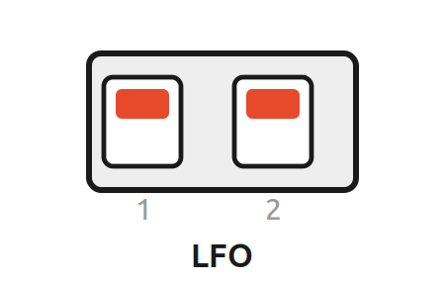
DIP-switch positions on the back (ON = up)

6 Signals at a glance
Signal | Range / behaviour
Output | 0–10 V, unipolar; stochastic in Perlin/Bezier/Brownian, periodic in LFO
Speed CV | 0–5 V; approximately 1 V/oct in Perlin/Bezier/LFO, direct activity control in Brownian
Texture CV | 0–5 V, summed with the knob and clamped to 5 V
Attenuation | 0 V (CCW) to 10 V (CW)

NOTE
The electrical ranges above apply to the original Free Modular Drift hardware. The original module is 4 HP wide and is documented at maximum current draws of +5 V: 25 mA, +12 V: 5 mA and −12 V: 5 mA. Modified hardware revisions may differ.

COLOPHON
Drift — User Manual. Typeset in Ubuntu.

This manual is licensed under a Creative Commons Attribution–NonCommercial 4.0 International (CC BY-NC 4.0) license. You are free to share and adapt this material for non-commercial purposes, provided you give appropriate credit and indicate changes. Full terms: creativecommons.org/licenses/by-nc/4.0/
Drift is a Free Modular module; its hardware and firmware are covered by Free Modular's own licence (GPL-3.0-or-later). This independent manual — text, layout and illustrations — is licensed separately under CC BY-NC 4.0.
Illustrations and visual design were created with the assistance of AI — Claude (Anthropic), 2026.
Manual: Axel Napolitano. Original module design: Quinn Freedman / Free Modular.
Independent, unofficial manual. Not affiliated with Free Modular.
© 2026 Axel Napolitano · From Munich with 
