1 Introduction
Drift is a modulation source for organic, continuously evolving control voltages. This firmware is available in two compile-time algorithm banks: Classic preserves the four Drift modes derived from the original firmware, while Organic adds four alternative motion models. Speed and Texture each have a CV input, while Attenuation scales the final analogue output level.
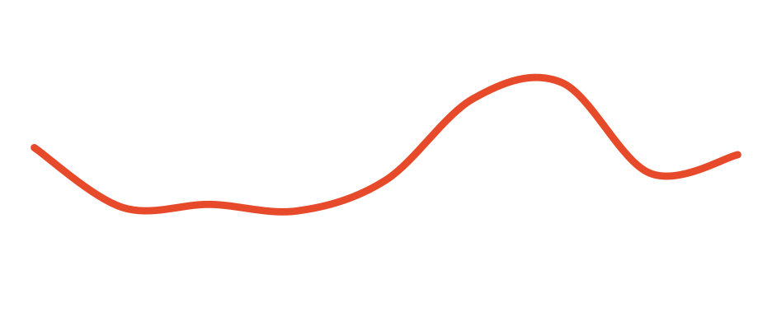
Two firmware banks — four DIP-selected algorithms each
The flashed firmware image chooses the algorithm bank. The two rear DIP switches then select one of four algorithms inside that bank at power-up. Classic contains Perlin, Brownian, Bezier and LFO; Organic contains Fractal, Vector, Rain and Attractor.

NOTE
The bank is chosen by the flashed firmware image. The rear DIP switches choose an algorithm inside that bank and are sampled only at startup — see section 5, Configuration.

2 Panel overview
Three knobs sit above two CV inputs and the output. From top to bottom: Speed, Texture and Attenuation, then the Speed and Texture CV inputs, then the output jack with its level LED. The algorithm DIP switch is on the back.
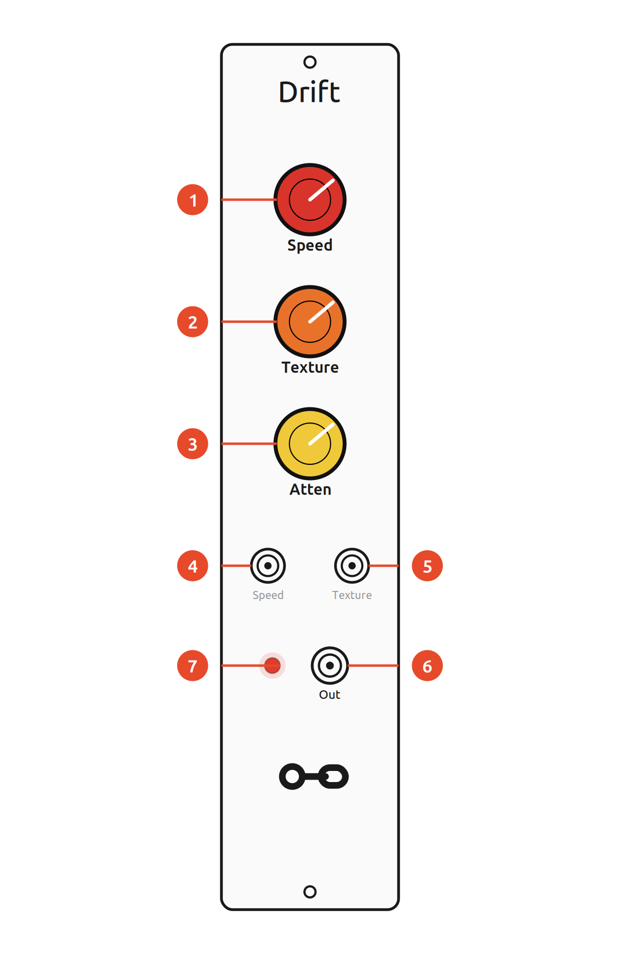
Ref. | Panel element
 | Speed knob — how quickly the voltage changes (with CV)
 | Texture knob — secondary shape parameter (with CV)
 | Attenuation knob — scales the output level
 | Speed CV input
 | Texture CV input
 | Output — 0–10 V unipolar modulation signal
 | Output-level LED

ON THE BACK
The rear two-position DIP switch selects one of four algorithm slots inside the flashed bank. It does not change banks. Cycle the power after changing the switch position.
Installation
Drift needs a standard Eurorack power cable (2×8 pin). Line up the red stripe with the −12 V side of the header and check seating before powering up.

3 Controls
 | Control | What it does
 | Speed  knob + CV | time scale or activity; exact mapping depends on the selected algorithm
 | Texture  knob + CV | secondary character parameter; meaning depends on the selected algorithm
 | Attenuation  knob | scales the final analogue output level; not readable by the firmware
 | Output  jack + LED | 0–10 V unipolar modulation signal; the LED shows the output level

Speed
Speed controls the time scale or activity. In Classic Perlin, Bezier and LFO and in Organic Fractal, Vector and Attractor it uses the same approximately 1 V/oct exponential mapping: the knob spans twelve octaves and 0–5 V Speed CV shifts the rate around the knob setting. Brownian is deliberately different because Speed directly changes random-walk activity. Rain is also different: Speed directly controls the per-sample decay coefficient of the shared rain envelope, so higher settings make drops decay faster.
Texture
Texture controls the secondary character of the active algorithm. The knob and CV each range 0–5 V and are normally summed and clamped to the valid range. In Classic Bezier, curve shape is the exception: the knob selects curve shape while Texture CV contributes to timing variation. In Organic the same combined Texture control becomes Fractal detail, Vector coupling, Rain Density or the Attractor structure parameter.
Attenuation and output
Attenuation scales the final modulation signal from its full 0–10 V range (fully clockwise) down to 0 V (fully counter-clockwise). It is an analogue control after the DAC, so the firmware cannot use its position as an algorithm parameter. In Rain this final level naturally acts as Intensity. The LED indicates the instantaneous output level.

4 Algorithm banks and modes
Drift runs one algorithm at a time. The firmware image fixes the active four-algorithm bank at compile time; the rear DIP switch then selects one slot in that bank at startup (section 5). Speed and Texture keep the same physical controls, but their musical meaning changes with the selected algorithm.
Classic bank
Classic is the compatibility bank: Perlin, Brownian, Bezier and LFO preserve the four Drift concepts derived from the original firmware while applying the verified numerical and state-handling corrections documented by this project.
Perlin mode (default)
Perlin mode is the default algorithm. It is based on Ken Perlin's noise algorithm, designed to produce very smooth yet organic and unpredictable landscapes.
- Speed — how quickly the algorithm travels through the random landscape.
- Texture — roughness of the output. Fully counter-clockwise the output is completely smooth; as Texture increases, higher-frequency noise is blended in and the output becomes rougher.
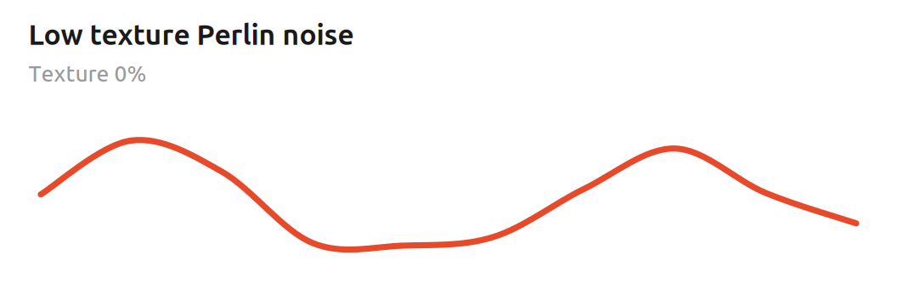
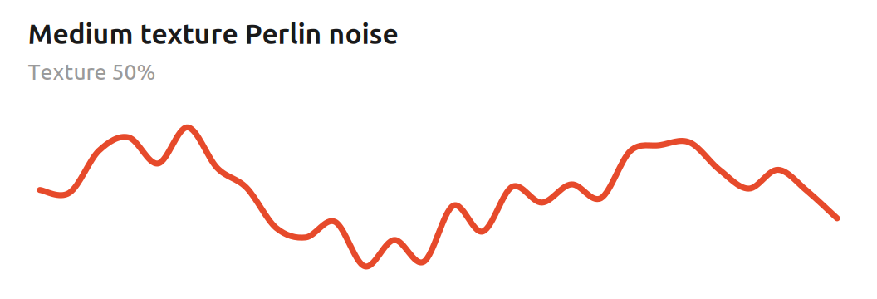

Mathematical foundations
Perlin mode uses one-dimensional gradient noise. Rather than choosing random voltages and simply interpolating between them, each lattice point receives a signed random gradient. Within one segment, normalised phase t from 0 to 1 and neighbouring gradients g₀ and g₁ define two local ramps that are blended with the canonical quintic fade function:
f(t) = 6t⁵ - 15t⁴ + 10t³
n(t) = (1 - f(t)) g₀ t + f(t) g₁ (t - 1)
The fade function has zero first and second derivatives at both endpoints. Adjacent segments therefore meet smoothly even though their gradients are random, which is why Perlin noise can wander unpredictably without the corners of ordinary sample-and-hold modulation.
Speed advances the phase exponentially: each additional volt doubles the rate.
f(V) = f₀ · 2^V
Drift runs two such noise layers. The second layer advances four times faster than the base layer. If τ is normalised Texture, the blend is proportional to
y(t) ∝ (4 - τ) n₀(t) + τ n₁(4t)
so Texture adds a faster octave while retaining the slower motion underneath. At low Texture the signal is broad and fluid; at higher Texture it gains smaller, quicker detail without turning into uncorrelated noise.
Musically, this makes Perlin mode useful when an ordinary LFO feels too repetitive but completely random steps feel too abrupt. It works particularly well for slow filter movement, timbral drift, wavefolder depth and other parameters that benefit from correlated motion.
Bezier mode
Bezier mode interpolates between random points using smooth cubic Bezier curves.
- Speed — the average time between random values.
- Texture — controls segment-to-segment timing variation. Near 12 o'clock, with Texture CV at 0 V, the segments occur at a fixed interval. Moving the knob away from centre widens a symmetric triangular random offset in logarithmic speed space; Texture CV widens it further. The resulting segment durations therefore vary multiplicatively rather than following a Gaussian distribution.
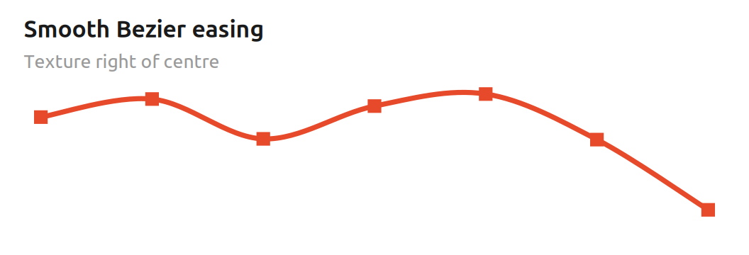
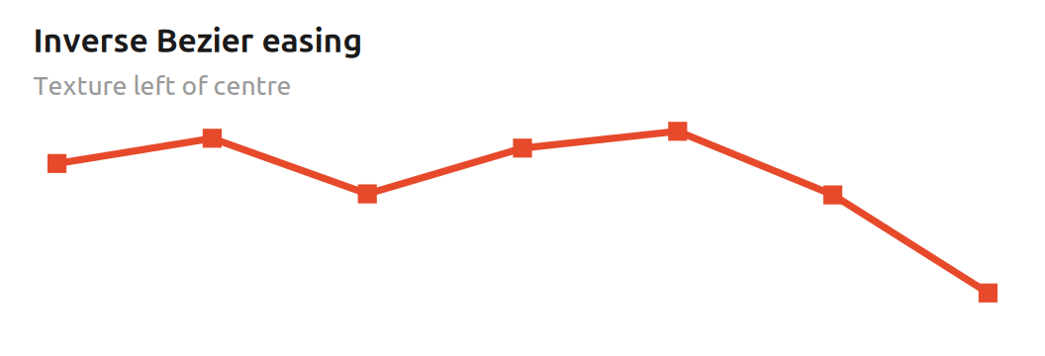
KNOB, NOT CV
Texture also controls the shape of the curves, and only the knob does this — not the CV. The curve morph is continuous: right of centre produces smooth easing into and out of each random value, the centre is effectively linear, and left of centre uses the inverse easing shape to accentuate transitions. Texture CV affects timing variation, not curve shape.

Mathematical foundations
Bezier mode connects successive random values A and B with a cubic easing curve. With normalised segment phase t from 0 to 1, the firmware uses two monotone cubic shapes:
C_s(t) = 3t² - 2t³ C_r(t) = 2t³ - 3t² + 2t
The Texture knob continuously blends between them. If τ is the normalised knob position, the curve is
C(t, τ) = (1 - τ) C_r(t) + τ C_s(t)
At τ = 0.5 the two cubics average to C(t) = t, so the centre position is linear. To the right, the smoothstep curve has zero slope at both endpoints and gently settles on each random value. To the left, the inverse curve is steeper at the endpoints and slower around the middle, which emphasises the transitions.
Timing randomness is separate. A symmetric triangular random variable r in approximately [-1, 1] is scaled by a width derived from the distance of the Texture knob from centre plus Texture CV. The resulting offset δ is applied in the logarithmic 1 V/oct speed domain:
f_segment = f_base · 2^δ
Musically, this means the centre setting can give evenly timed, straight transitions, while moving away from centre adds both characteristic curvature and irregular spacing. Because the timing offset is exponential, the variation feels proportional across slow and fast settings rather than being a fixed number of milliseconds.
Brownian mode
Brownian mode implements a bounded, centre-biased random walk. At each processing step the value may move up or down by a Speed-dependent amount; over time this produces jittery motion at high activity settings and slower, emergent wandering at low settings. It is inspired by Brownian motion rather than being a literal Wiener process.
- Speed — controls both how likely the random walk is to move and how large each movement can be.
- Texture — smooths the motion with a proportional filter; more smoothing is applied as the Texture value gets lower.
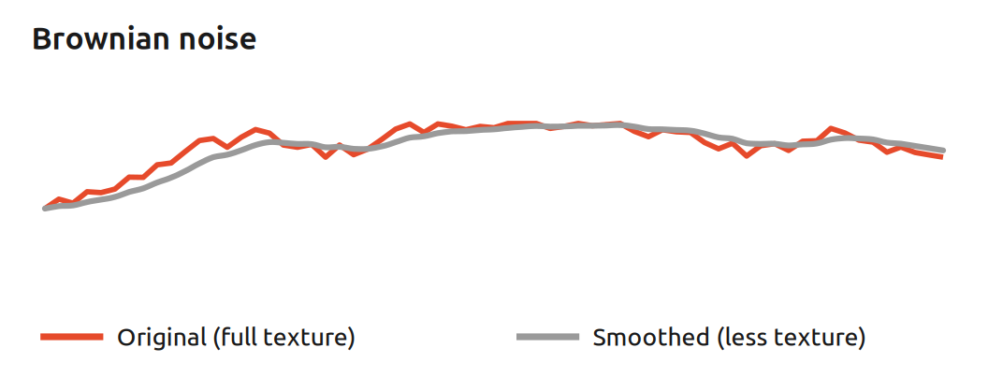
Mathematical foundations
This mode is a discrete, bounded random walk rather than an exact mathematical Brownian/Wiener process. Let c be the combined 10-bit Speed control, 0…1023. On each 2.5 kHz processing step the probability that the target moves is approximately
P(move) = c / 1024
and the movement size in the internal 16-bit state is
s(c) = ⌊(256 + c) / 2⌋
so raising Speed makes the walk move both more often and farther. Near the numerical limits, the direction probability is biased back toward the centre to keep the walk bounded instead of pinning permanently at 0 or maximum.
Texture controls a first-order proportional smoother. If q[n] is the random-walk target and x[n] the smoothed output state, each update follows
x[n+1] = x[n] + α(T) · (q[n] - x[n])
where α(T) rises from about 1/4096 at minimum Texture to 1/8 at maximum Texture. Small α creates strong inertia; large α follows the walk more closely. Fractional movement is accumulated internally so very small corrections are not lost to integer rounding.
Musically, Brownian mode has memory: the next value depends on where the walk already is. Low Speed and low Texture produce slow, drifting parameter motion; increasing Speed creates more energetic wandering, while increasing Texture reduces the lag and reveals more of the underlying jitter.
LFO mode
LFO mode is a skewable triangle/saw LFO. Unlike the other three modes it is periodic rather than random.
- Speed — the frequency of the LFO.
- Texture — morphs continuously between a falling saw (left), triangle (centre) and rising saw (right).
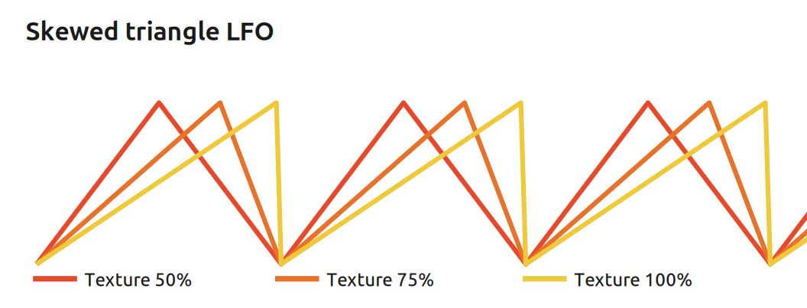

Mathematical foundations
The LFO uses a normalised phase p from 0 to 1 and an apex position a set by Texture. For 0 < a < 1, the waveform is piecewise linear:
y(p) = p/a for p ≤ a
y(p) = (1 - p)/(1 - a) for p > a
At a = 0.5 the rise and fall have equal duration and the result is a triangle. At a = 0 the limiting case is a falling saw, y = 1 - p; at a = 1 it is a rising saw, y = p. Speed changes the phase increment with the same approximately 1 V/oct exponential mapping used by Perlin and Bezier.
Changing Texture moves the point in the cycle at which the waveform reaches its peak without changing the nominal period. The firmware remaps phase during live Texture changes so the current output voltage is preserved as closely as the finite representation allows. The exact saw endpoints necessarily retain the normal sawtooth discontinuity at cycle wrap.
Musically, the apex position is a direct control over rhythmic emphasis. A centred triangle gives balanced up/down modulation; moving the peak earlier creates a fast attack and long decay, while moving it later creates a long rise and fast fall. The saw endpoints are useful when a steady ramp is more useful than symmetric modulation.
Organic bank
Organic is an alternative compile-time bank for the same hardware. It keeps the four rear DIP slots and the Speed/Texture/CV interface, but replaces the Classic algorithms with Fractal, Vector, Rain and Attractor. Flashing chooses the bank; the DIP switches only choose a slot within that bank.

Fractal mode
Fractal extends the smooth gradient-noise idea across three linked time scales. The large-scale layer always remains present while Texture transfers part of the constant total gain into 4× and 16× detail.
- Speed — traversal rate through the noise landscape; approximately 1 V/oct with Speed CV.
- Texture — Roughness/detail: low values favour macro motion; high values add progressively finer movement.

Mathematical foundations
Let n(t) be the same continuous gradient-noise primitive used by the Classic Perlin implementation. Fractal combines three scales:
F(t) = w₀(T)n(t) + w₁(T)n(4t) + w₂(T)n(16t)
The integer weights always sum to 1024. Texture 0% uses 1024/0/0; full Texture reaches 512/320/192. Because the total weight remains constant, Texture changes the distribution of detail rather than acting as another output-level control.
Musically, low Texture behaves like broad landscape motion. Raising Texture preserves that macro contour while adding smaller and faster fluctuations, which is useful when one CV should carry both slow drift and surface detail.
Vector mode
Vector is deterministic rather than random. It maintains two continuous phase coordinates on a torus. Each axis advances forward while Texture cross-couples its rate to the triangle-wave projection of the other axis. The output is the average projection of both axes.
- Speed — base flow rate; approximately 1 V/oct with Speed CV.
- Texture — cross-axis coupling: zero leaves the two rates independent; higher values bend the trajectory while keeping both axes forward-moving.

Mathematical foundations
If x[n] and y[n] are bipolar triangle projections of the two phase coordinates, the implemented coupling has the form
φx[n+1] = φx[n] + Δx · (1 + c(T)y[n])
φy[n+1] = φy[n] + Δy · (1 - c(T)x[n])
with the second base rate fixed at three quarters of the first. Full Texture limits the cross-coupling to roughly ±25% of each base increment. The final output is the unipolar projection of the average of x and y.
Musically, Vector produces repeating-looking but continually rephased motion. It is useful when a modulation should feel coordinated and directed without using random events.
Rain mode
Rain is a stochastic impulse process. Random arrivals add finite positive impulses to one shared envelope; between arrivals the envelope leaks toward zero. Overlapping events accumulate naturally and saturate only at the internal full-scale limit.
- Speed — drop-tail decay speed. Higher values make the shared envelope fall faster.
- Texture — Density: higher values increase the probability of a new rain event.
- Attenuation — final analogue Intensity. It scales the result after the algorithm.

Mathematical foundations
Density d is mapped quadratically to a 16-bit Bernoulli event cutoff, giving more useful resolution in the sparse region:
cutoff(d) = ⌊d² / 64⌋
Speed s maps linearly to the unsigned Q0.16 decay coefficient
α(s) = 4 + 8s
and the aggregate envelope is reduced by α each processing step before any new impulse is added. Fractional decay is retained between steps so quiet tails cannot freeze solely because of integer truncation.
Musically, Density moves from isolated drops through irregular showers to dense overlapping rain. Speed changes how long each arrival remains as modulation, while the physical Attenuation knob sets the final intensity without changing the event process itself.
Attractor mode
Attractor is deterministic nonlinear modulation based on a fixed-point Hénon map. Texture changes the map parameter while Speed controls how quickly the output interpolates from one map state to the next.
- Speed — travel/interpolation rate between successive map states; approximately 1 V/oct with Speed CV.
- Texture — Structure: selects the Hénon a parameter from approximately 1.20 to 1.40. It should not be read as a guaranteed monotonic amount of chaos.

Mathematical foundations
The state update is
x[n+1] = 1 - a x[n]² + y[n]
y[n+1] = b x[n]
where Texture selects a ≈ 1.20…1.40 and b remains ≈ 0.30. The implementation uses signed Q2.14 fixed point and linearly interpolates the x coordinate between map updates before converting it to the 12-bit unipolar output.
The MCU state space is finite, so every digital trajectory is ultimately periodic. In practice Texture selects different nonlinear structures and orbit lengths; it does not create mathematical infinity. Musically, the attraction is the tension between recurring shapes and irregular return times.
5 Configuration
The flashed firmware image selects Classic or Organic. The two rear DIP switches then select one of the four algorithms inside that bank (or the corresponding connections may be soldered directly). The switches are sampled at startup; cycle the power for a change to take effect.
Classic bank
Switch 1 | Switch 2 | Algorithm
OFF | OFF | Perlin (default)
ON | OFF | Brownian
OFF | ON | Bezier
ON | ON | LFO
Organic bank
Switch 1 | Switch 2 | Algorithm
OFF | OFF | Fractal (default)
ON | OFF | Vector
OFF | ON | Rain
ON | ON | Attractor

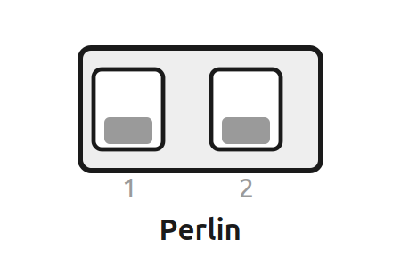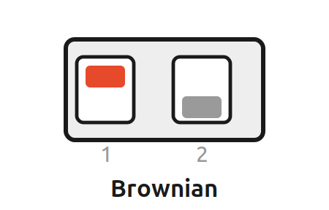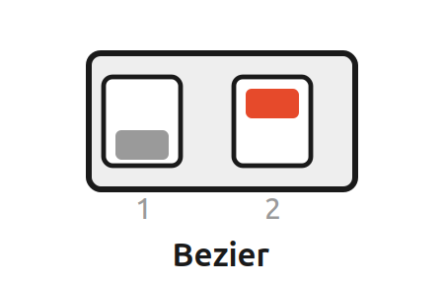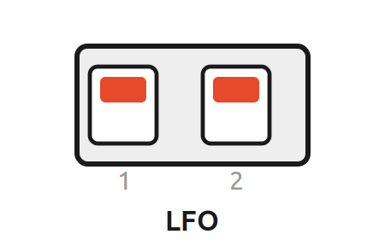
DIP-switch positions on the back (ON = up)

6 Signals at a glance
Signal | Range / behaviour
Output | 0–10 V, unipolar; waveform/statistics depend on the selected bank and algorithm
Speed CV | 0–5 V; approx. 1 V/oct for Perlin/Bezier/LFO/Fractal/Vector/Attractor, direct activity/decay control for Brownian/Rain
Texture CV | 0–5 V, normally summed with the knob and clamped; algorithm-specific secondary parameter
Attenuation | 0 V (CCW) to full 0–10 V scale (CW); analogue post-DAC control

NOTE
The electrical ranges above apply to the original Free Modular Drift hardware. The original module is 4 HP wide and is documented at maximum current draws of +5 V: 25 mA, +12 V: 5 mA and −12 V: 5 mA. Modified hardware revisions may differ.

COLOPHON
Drift — User Manual. Typeset in Ubuntu.

This manual is licensed under a Creative Commons Attribution–NonCommercial 4.0 International (CC BY-NC 4.0) license. You are free to share and adapt this material for non-commercial purposes, provided you give appropriate credit and indicate changes. Full terms: creativecommons.org/licenses/by-nc/4.0/
Drift is a Free Modular module; its hardware and firmware are covered by Free Modular's own licence (GPL-3.0-or-later). This independent manual — text, layout and illustrations — is licensed separately under CC BY-NC 4.0.
Illustrations and visual design were created with the assistance of AI tools — Claude (Anthropic) and ChatGPT (OpenAI), 2026.
Manual: Axel Napolitano. Original module design: Quinn Freedman / Free Modular.
Independent, unofficial manual. Not affiliated with Free Modular.
© 2026 Axel Napolitano · From Munich with 

