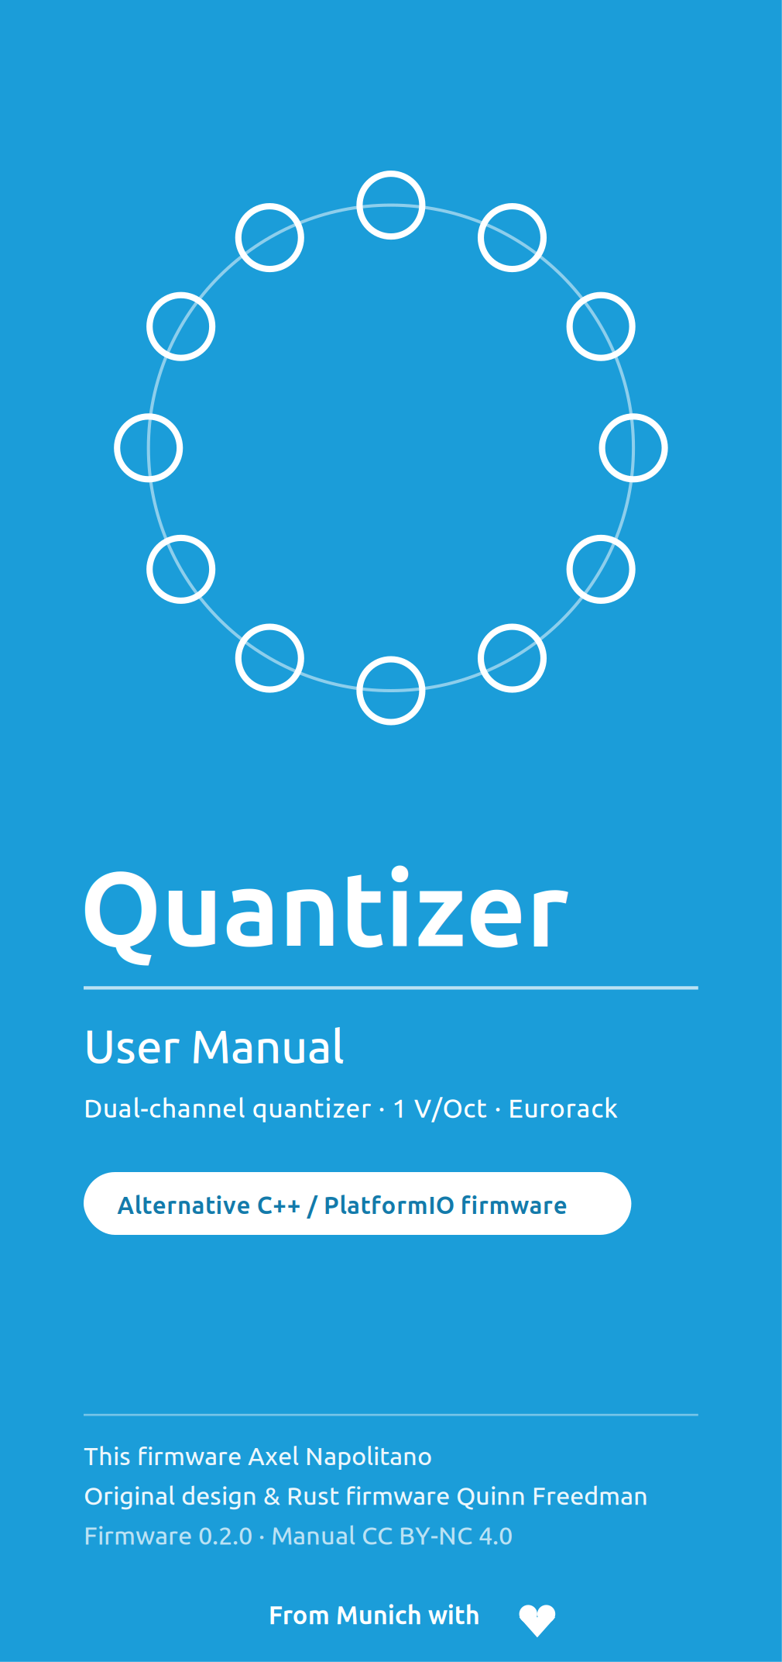
1 Introduction
A quantizer rounds any control voltage to the nearest note of a chosen scale. This keeps LFOs, random voltages and sequencers musical by constraining them to a scale — or just a few notes. This module has two independent quantizing channels that can share the same scale or use different ones. It takes 1 V/Oct in and, after rounding, transposing and further processing, outputs 1 V/Oct again.
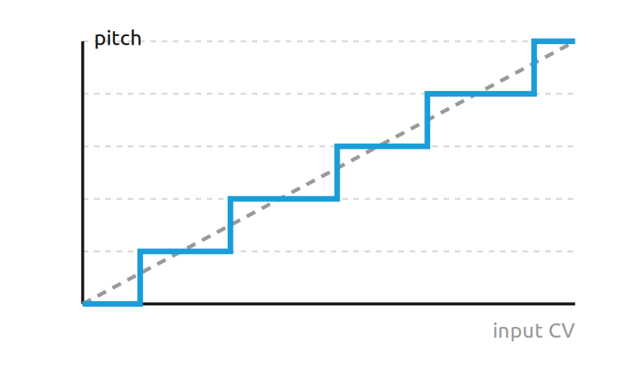
Quantization: a smooth input is snapped to discrete scale steps
This manual describes the module running the alternative C++ / PlatformIO firmware by Axel Napolitano, based on the original design and Rust firmware by Quinn Freedman. The core behavior and hardware mapping are preserved; individual functions were fixed or added.
What this firmware adds
- Factory-start behavior: with no valid live state, the chromatic default scale makes the module immediately playable.
- Factory fallback bank: 12 built-in full-configuration presets are available behind otherwise empty user slots.
- Robust persistence: versioned, CRC-checked EEPROM records; invalid ones are rejected, including a redundant ADC/DAC calibration journal.
- LED calibration: red and green tunable independently across the full brightness range.
- Arpeggiator: a full second performance layer: patterns, shapes, clock, swing.
- Fast layer switching: a symmetric SHIFT double-click enters and leaves the Arpeggiator layer without changing the primary scale-editing workflow.

NOTE
This manual is the working manual for the Unreleased development target planned as firmware 0.2.2. The latest declared public release remains 0.2.1 until 0.2.2 is explicitly released. Behavior may differ from the original (Rust) firmware; the main differences are summarized in section 10.

2 Panel overview
The panel is organized into the note ring with twelve buttons, the three system buttons SHIFT, LOAD and SAVE, and two identical channels A and B, each with two inputs and two outputs.
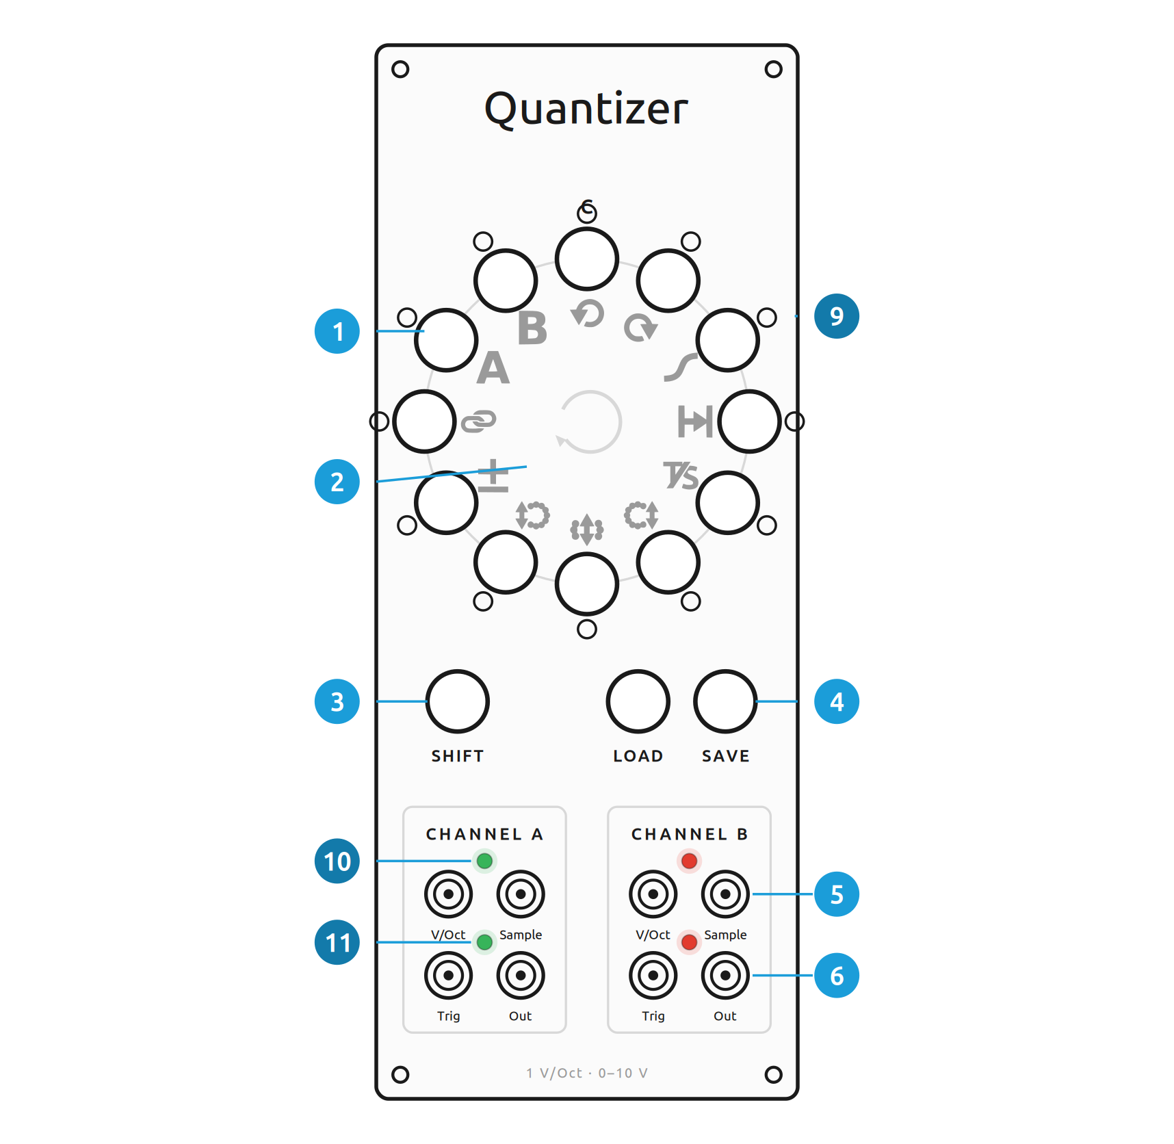
Front panel of the Quantizer (alternative firmware)
Ref. | Panel element
 | Note buttons (12) — scale selection, C at the top, clockwise
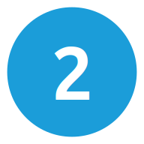 | SHIFT secondary functions (pictograms inside the ring)
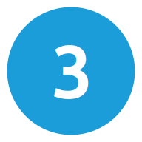 | SHIFT button
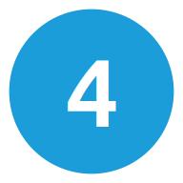 | LOAD / SAVE
 | Inputs per channel: V/Oct (top left), Sample gate (top right)
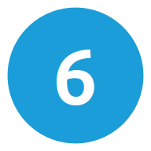 | Outputs per channel: Trigger (bottom left), CV out (bottom right)
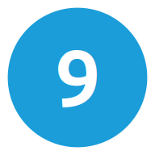 | Note-ring LEDs — per-note state (green / red / amber)
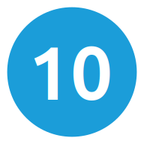 | Track/Sample LED — top, centerd above the input jacks (A green · B red)
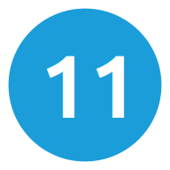 | Trigger LED — bottom, centerd above the output jacks
Installation
The module needs a standard 16-pin (2×8) Eurorack power cable and uses the +12 V, −12 V and +5 V rails. The red stripe must line up with the −12 V side of the power header. Check polarity and seating before powering up.

3 Basics
Selecting notes
The twelve buttons are the twelve semitones of an octave — C at the top, clockwise. A press toggles whether that note is in the scale. The note-ring LEDs show which notes are active and which one is currently played.
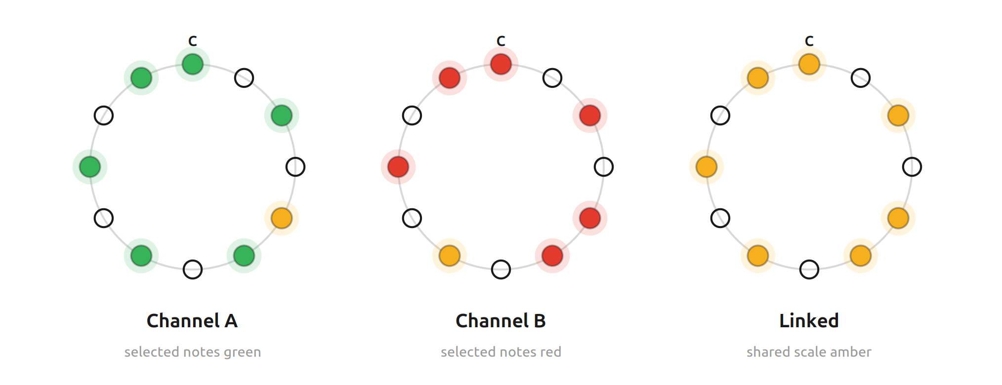
Note-ring states — unlinked: A scale green, B scale red, selected quantized scale note amber · linked: scale amber, A note green, B note red
GOOD TO KNOW
The factory scale is chromatic, so a module with no valid live state is ready to play immediately. During normal use the firmware restores the last valid live state at boot instead of reapplying factory defaults. The firmware also prevents the last active note from being turned off by accident.
Channels A and B
Both channels always run. Menus and the unlinked note-ring view, however, apply to the selected channel. Active scale notes are green for A and red for B; the selected channel's quantized scale note is amber. This note indication is before Post-shift and Arpeggiator offsets. In linked mode the common scale is amber, channel A's quantized note is green and channel B's is red; if both land on the same pitch class, A/green has priority. Select with SHIFT + channel button:
 Channel A ·  Channel B
SHIFT
Each of the twelve note buttons has a secondary function, printed as a pictogram inside the ring . Hold SHIFT and press a note button to use it. All secondary functions are described in section 5.
LEDs
The module has two LED groups: the state-dependent note-ring LEDs and four discrete activity LEDs, one centerd just above each jack row of each channel.
Discrete LED | Meaning
Top (between V/Oct & Sample) | Track/Sample — input sampling activity
Bottom (between Trig & Out) | Trigger — quantized-note change / enabled Arpeggiator step trigger

NOTE
The discrete LEDs are activity indicators. Channel A is always green and channel B always red — amber is never used on these four LEDs.

4 Inputs, outputs & signal flow
Each channel has two inputs and two outputs. The Quantizer path is: input voltage → Track/Sample + delay → Pre-shift → quantize to the active scale → Scale-shift → Post-shift → Glide → output. The Arpeggiator, when enabled, adds its scale-degree offset after this base-pitch processing.
Jack | Function
V/Oct input | CV to be quantized, 0–10 V. 0 V = C.
Sample gate | Mode-dependent Sample/Gate input. In Track-and-Hold, HIGH tracks and LOW holds. In Sample-and-Hold, only a LOW→HIGH edge captures a new value. The jack is normalled HIGH; with no cable, the default Track mode behaves like a continuously running quantizer.
Trigger out | Quantizer note changes generate a short trigger during normal signal processing. Arpeggiator steps add a 5 ms trigger only when Step Trigger is enabled.
CV out | Quantized 1 V/Oct signal, clamped to 0–10 V.

Track-and-hold vs sample-and-hold
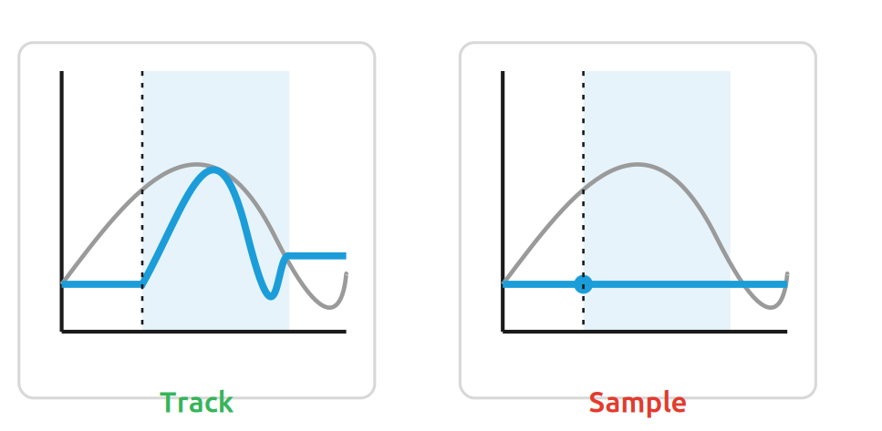
Track follows the input while the gate is high; Sample holds the value from the rising edge
The default is track-and-hold. While the gate is high the output follows the input continuously and re-quantizes; on low it holds the last value. In sample-and-hold only the rising edge samples, holding the value until the next edge. Because an open sample input is normalled HIGH, track-and-hold behaves like a plain quantizer with no cable. Toggle with SHIFT + 4 (section 5).

5 The twelve SHIFT functions
Hold SHIFT and press a note button to use its secondary function. The ring position n is counted from C (top, position 0) clockwise.
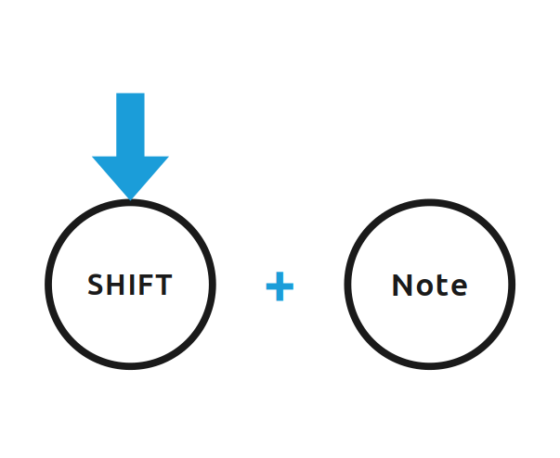
 | Function | Effect | Default
 | Rotate scale left  SHIFT + 0 | scale down one semitone | —
 | Rotate scale right  SHIFT + 1 | scale up one semitone | —
 | Glide / portamento  SHIFT + 2 | transition length 0–11 | 0
 | Sample-delay  SHIFT + 3 | 0–11 ms after a trigger | 0 ms
 | Track / Sample  SHIFT + 4 | toggle · green track, red sample | Track
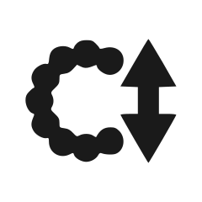 | Post-shift  SHIFT + 5 | output ± semitones (after) | 0
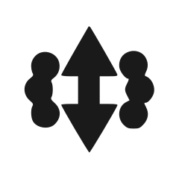 | Scale-shift  SHIFT + 6 | ± steps within the scale | 0
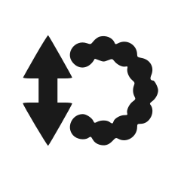 | Pre-shift  SHIFT + 7 | input ± semitones (before) | 0
 | Relative pitch (B)  SHIFT + 8 | B = A + B · green rel, red abs | Off
 | Link channels  SHIFT + 9 | shared config · green on, red off | Off
 | Select channel A  SHIFT + 10 | A / green | A
 | Select channel B  SHIFT + 11 | B / red | —

Rotate / transpose
Rotate scale left — shift the whole scale one semitone down.
Rotate scale right — shift the whole scale one semitone up. This only changes which target notes are available; it does not transpose the input or output directly.
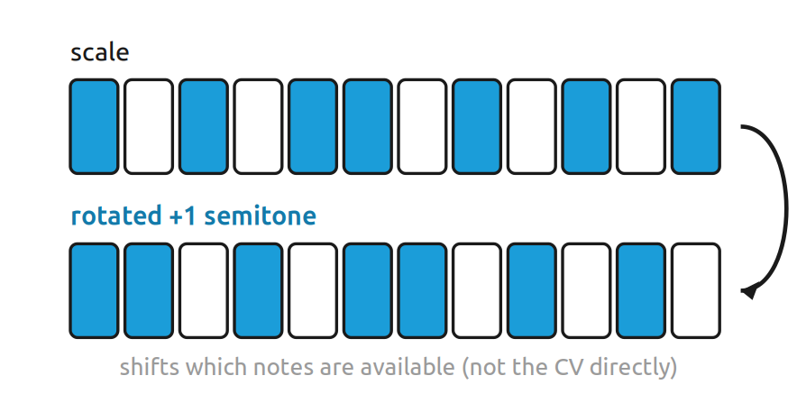
Glide and sample-delay
Glide — transition time between notes (portamento). Default 0.
Sample-delay — wait 0–11 ms after a rising edge / gate start before capture begins. Default 0 ms. In Track mode the delay runs once, then the input continues tracking while HIGH; in Sample mode one value is captured after the delay. Useful when a sequencer's V/Oct is not yet settled at trigger time.
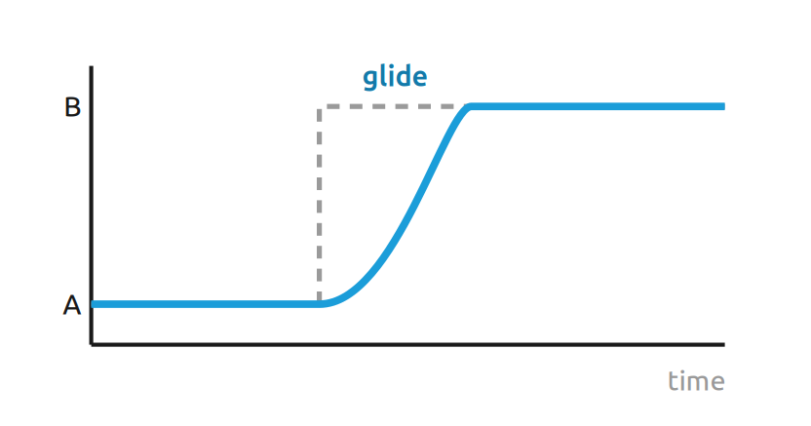
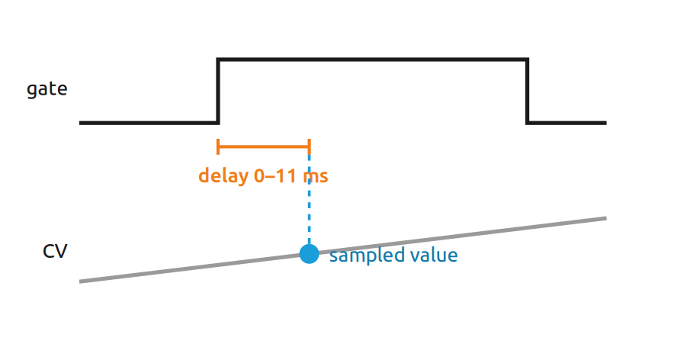
Set a value: keep holding SHIFT after the pictogram and press a note button (0 at the left, increasing clockwise). The LEDs show the value.
Track / Sample
Track / Sample — one press toggles track-and-hold vs sample-and-hold. The LED briefly shows the new state: green = track, red = sample. Default Track.

Pre-, scale- and post-shift
Three shifts act at different points of the path (all default 0):
Pre-shift — offset the input in semitones before quantizing.
Scale-shift — move by whole steps within the scale (after quantizing).
Post-shift — transpose the output in semitones after quantizing (like tuning an oscillator; can clip at 0–10 V).
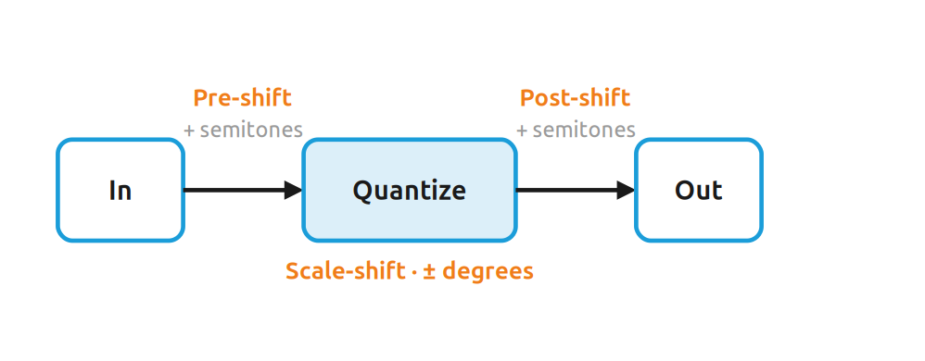
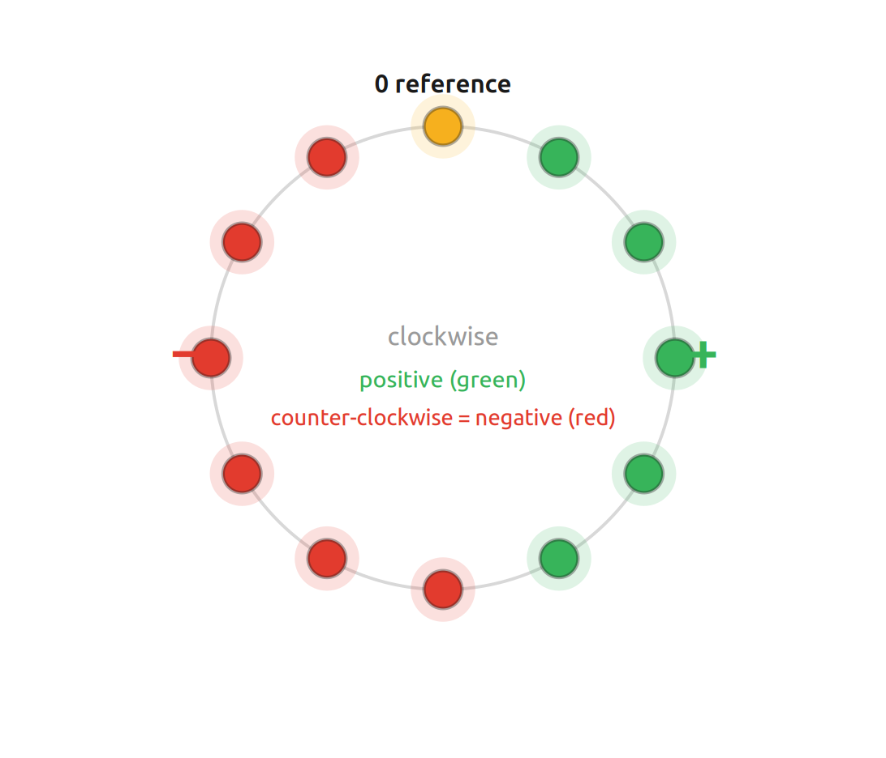
Signed value: amber = 0, clockwise positive (green), counter-clockwise negative (red)
FIXED VS THE ORIGINAL FIRMWARE
Negative scale-shift values now work and step downward correctly. In the original firmware negative values had no effect.
Relative pitch and linking
Relative pitch (B) — default Off: A and B are independent. On: channel B's input is the sum of CV inputs A and B.
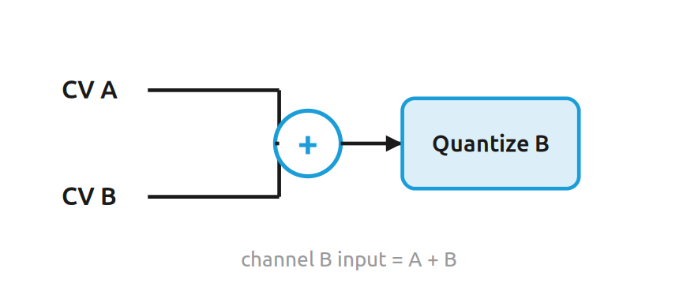
Link channels — default Off. Linked, A and B share one configuration and only the inputs stay separate. Linking copies A's config to B and resets the selection to A. The two options are independent — use either, both or neither.
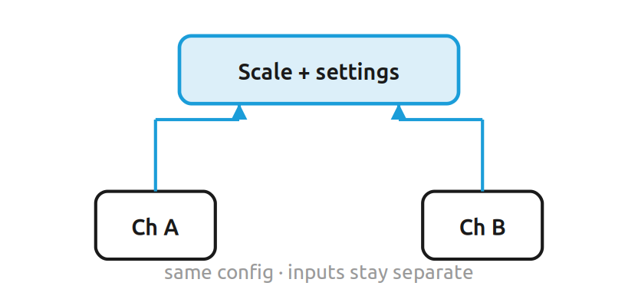

6 Saving and loading
There are two memory layers. SAVE/LOAD stores or recalls only the active scale of the selected channel. SHIFT + SAVE/LOAD uses the twelve full-configuration slots. A Full Configuration contains both Quantizer channels, both Arpeggiator configurations, the selected channel and the active UI layer. LED brightness calibration is not part of a Full Configuration. Each layer has twelve slots — the note button picks the slot.
Save or load a scale
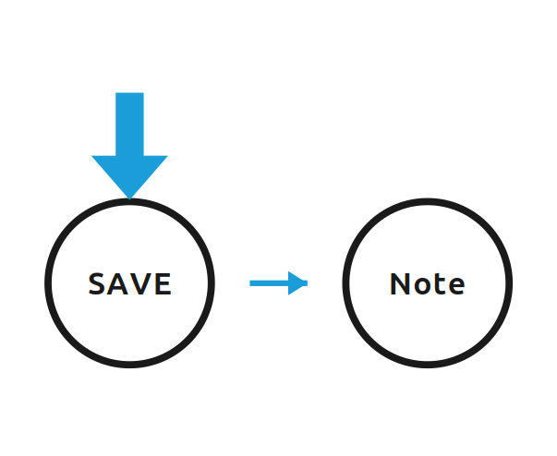
Press SAVE, then a note button as the slot. To recall a scale, press LOAD and then the slot button. When channels are linked, loading a scale applies it to both channels.
Save a full configuration
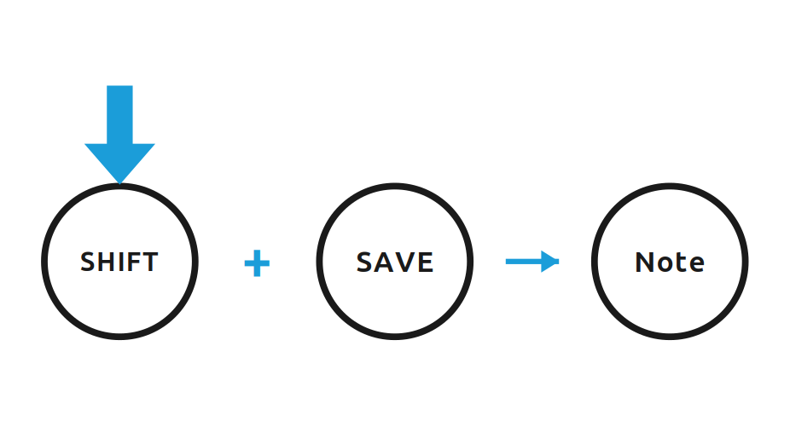
Hold SHIFT and press SAVE, then choose a note-button slot to store a Full Configuration. To recall one, hold SHIFT and press LOAD, then choose the slot. Loading restores the saved Quantizer state, both Arpeggiator configurations, selected channel and UI layer together.
Factory presets
When a full-config slot has no valid user data, SHIFT + LOAD recalls its built-in factory fallback. The listed scale is applied to both channels; the rest of that preset uses factory defaults: Track-and-Hold, Glide/Delay/Shifts 0, channels unlinked, channel B absolute, channel A selected, both Arpeggiators OFF with their default parameters, and the Quantizer UI layer. Saving valid user data takes precedence over the fallback; clearing user slots exposes it again. Factory presets are firmware data and are never written to EEPROM automatically.
Slot | Preset | Notes (root C)
1 | Chromatic | C C# D D# E F F# G G# A A# B
2 | Major / Ionian | C D E F G A B
3 | Natural minor / Aeolian | C D Eb F G Ab Bb
4 | Harmonic minor | C D Eb F G Ab B
5 | Melodic minor | C D Eb F G A B
6 | Dorian | C D Eb F G A Bb
7 | Phrygian | C Db Eb F G Ab Bb
8 | Lydian | C D E F# G A B
9 | Mixolydian | C D E F G A Bb
10 | Major pentatonic | C D E G A
11 | Minor pentatonic | C Eb F G Bb
12 | Blues | C Eb F F# G Bb

Clear all user slots
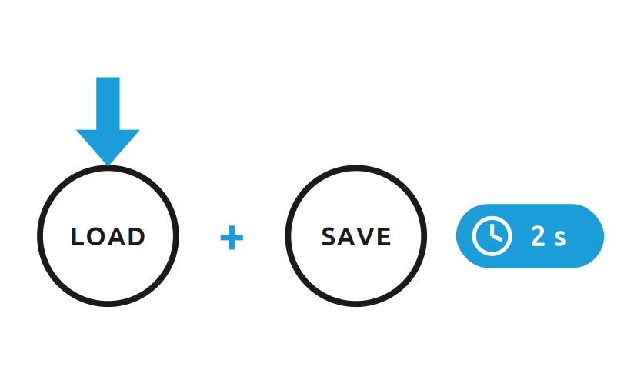
Hold LOAD + SAVE for two seconds to clear all user Scale and Full Configuration slots. This does not change the current working state, the live-state autosave, or LED calibration. Afterwards an empty Full Configuration slot again resolves to its built-in factory fallback; Scale slots remain empty until saved again.
PERSISTENCE
Stored records are versioned and CRC-checked; invalid ones are rejected, and valid user data always takes precedence over the factory preset. Live state is also auto-saved to a wear-levelled ring and restored on the next boot. EEPROM writes run non-blocking in the background.

7 Arpeggiator
The Arpeggiator is a complete second performance layer. It ranges from fast, scale-aware pitch cycling for 8-bit-style chord textures to a clocked, triggered and swung arpeggiator. The quantizer always remains the source of the base pitch and scale.
Two UI layers
The front panel has two layers: the Quantizer layer (scale editing and the Quantizer SHIFT functions) and the Arpeggiator layer (enable, timing, pattern, shape, length, range, trigger, sync, swing). The factory/default UI layer is Quantizer; a valid live state can restore either layer at boot.
Switch layers with a SHIFT double-click (both presses short, the second within 350 ms of the first release). The gesture is symmetric — it enters the Arpeggiator layer and leaves it again. Entering enables the selected channel's arpeggiator (both when linked) and the ring flashes green twice; leaving disables playback on both channels and flashes red twice. A note, SAVE or LOAD while SHIFT is held cancels a pending double-click. The layer is remembered across power cycles: if the module was powered down in the Arpeggiator layer, the first double-click after boot leaves it and turns the arpeggiator off.
SAME PANEL, NEW MEANING
The printed pictograms do not change. In the Arpeggiator layer, SHIFT + note reaches a different set of functions (mapped in the table below); plain note presses still edit the scale. The three channel controls — Link, Channel A, Channel B — keep their Quantizer meaning.
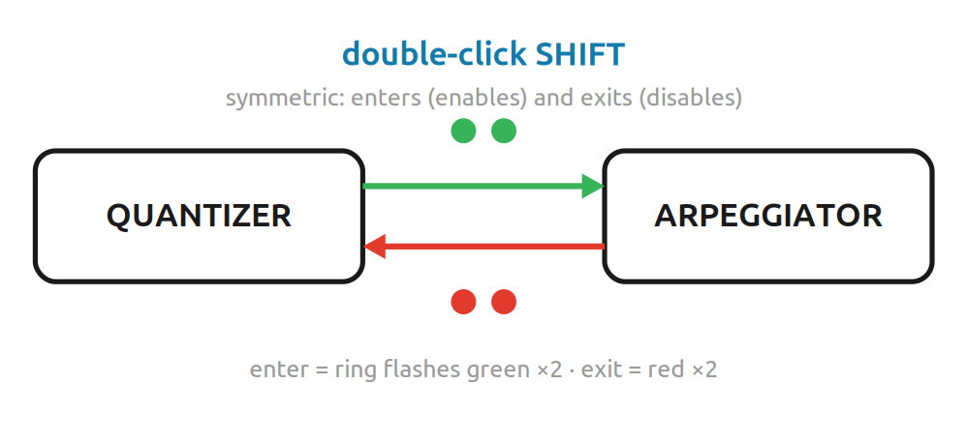
CHANNELS
A and B have independent arpeggiator settings and phase. Channel management is the same in both layers: SHIFT + A links/unlinks, SHIFT + A# selects A, SHIFT + B selects B. Linking copies A's full quantizer and arpeggiator config to B. Clock inputs are not rerouted — A uses Sample/Gate A, B uses Sample/Gate B.

Arpeggiator layer at a glance
The front panel does not change — the same twelve pictograms are printed on it. Only the meaning of SHIFT + note differs. The map on the next page pairs each pictogram with its Arpeggiator function.
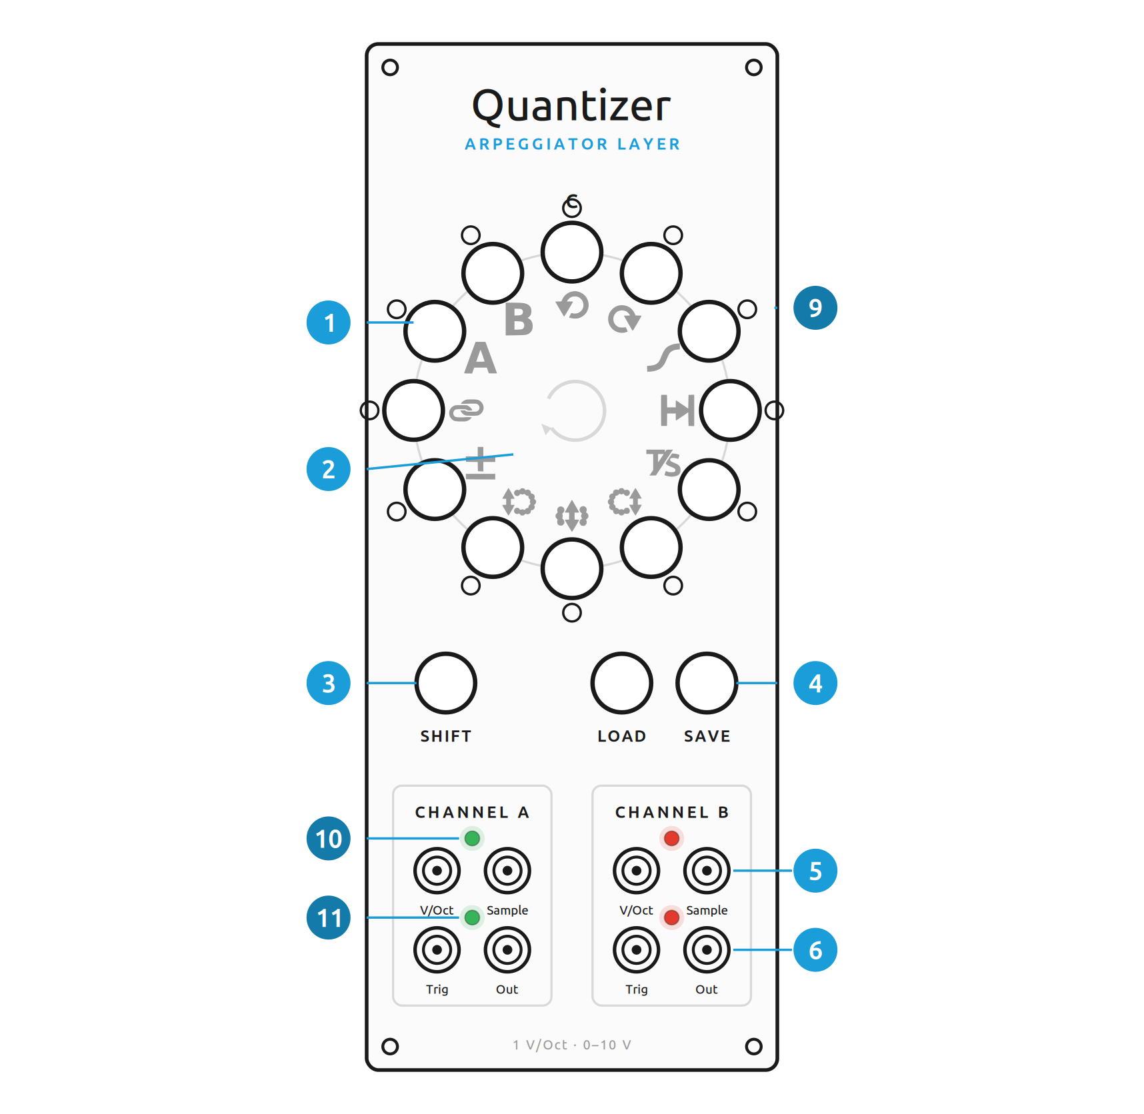
Same panel, same pictograms — only the SHIFT meaning changes
Ref. | In the Arpeggiator layer
 | Note buttons — edit and show the scale (same as the Quantizer layer)
 | SHIFT + note = Arpeggiator function (same pictograms, new meaning)
 | SHIFT — double-click to switch layer
 | LOAD / SAVE — unchanged
 | Channels, jacks and activity LEDs are identical to the Quantizer panel

Arpeggiator-layer map
While the Arpeggiator layer is active, hold SHIFT and press the note under each pictogram:
 | Function (SHIFT + note) | Default
 | Enable  SHIFT + C | Off
 | Rate / clock ratio  SHIFT + C# | 24 ms (index 3)
 | Pattern  SHIFT + D | Up
 | Shape  SHIFT + D# | 1-3-5
 | Length  SHIFT + E | 3
 | Range  SHIFT + F | 1 octave
 | Step trigger  SHIFT + F# | Off
 | Sync mode  SHIFT + G | FREE
 | Swing  SHIFT + G# | straight
 | Link / unlink (unchanged)  SHIFT + A | Off
 | Select channel A (unchanged)  SHIFT + A# | A
 | Select channel B (unchanged)  SHIFT + B | —
The last three (Link, Channel A, Channel B) behave exactly as in the Quantizer layer — same pictograms, same function.

The interaction grammar matches the Quantizer layer: an unmodified note press still edits the selected scale and the ring still shows it — only the SHIFT menu changes. To set a scalar value, SHIFT + its function button opens the page; after releasing SHIFT the twelve note buttons become values 0–11 (A, A#, B act as 9, 10, 11).
ON-PANEL FEEDBACK
There is no separate arpeggiator dashboard — the ring keeps showing the scale in both layers. SHIFT + C confirms enable with two green ring flashes and disable with two red flashes, then the scale display returns. Inside a parameter page the selected value lights at its note position in the channel color (green A, red B).

Parameters
Enable (SHIFT + C) — per channel; linked toggles both. Default OFF. Enabling or changing timing resets that channel's phase.
Rate / clock ratio (SHIFT + C#) — meaning depends on the sync mode:
Value | FREE / RESET | CLOCK
C | 12 ms | ÷8
C# | 16 ms | ÷6
D | 20 ms | ÷4
D# | 24 ms ★ | ÷3
E | 32 ms | ÷2
F | 48 ms | ×1
F# | 64 ms | ×2
G | 96 ms | ×3
G# | 125 ms | ×4
A | 167 ms | ×6
A# | 250 ms | ×8
B | 500 ms | ×12
★ default. For divisions the arpeggiator advances after N clock edges; for multiplications it measures the period and generates substeps, re-anchoring on every real edge.
Pattern (SHIFT + D) — Up (default), Down, Up/Down, Down/Up, Rotate, Outside In, Inside Out, Random. Value buttons: C=Up, C#=Down, D=Up/Down, D#=Down/Up, E=Rotate, F=Outside In, F#=Inside Out, G=Random; G#–B are ignored on this page. Up/Down and Down/Up don't duplicate the end points; Random is deterministic and restarts on a phase reset.
Shape (SHIFT + D#) — relationships in scale degrees, not fixed intervals: 1-3-5 (default), 1-2-5, 1-4-5, 1-3-6, 1-5-8, 1-2-3-4, 1-3-5-7, Stacked thirds. Value buttons: C=1-3-5, C#=1-2-5, D=1-4-5, D#=1-3-6, E=1-5-8, F=1-2-3-4, F#=1-3-5-7, G=Stacked thirds; G#–B are ignored. So 1-3-5 gives C-E-G in C major and the matching minor third in a minor scale.
Length (SHIFT + E) — 1 to 12 steps (default 3). C selects 1 step, C# selects 2, continuing clockwise through B = 12. Length may differ from the shape size; longer lengths repeat through the octave range. Odd lengths move the emphasis against an even grid.
Range (SHIFT + F) — 1 to 4 octaves (default 1). C=1 octave, C#=2, D=3, D#=4; E–B are ignored on this page. The result is clamped to the 0–120-semitone output range.
Step trigger (SHIFT + F#) — OFF (default): steps change pitch only (classic 8-bit effect). ON: every step also fires the normal 5 ms trigger and ~65 ms activity LED. Quantizer and arpeggiator triggers are ORed at the output.
Sync mode (SHIFT + G) — FREE (default), RESET or CLOCK. Value buttons: C=FREE, C#=RESET, D=CLOCK; D#–B are ignored. FREE uses the internal ms rate. RESET keeps internal timing but a rising Sample/Gate edge resets to the first position. CLOCK turns Sample/Gate into the external clock (Rate becomes the ratio table); that channel then quantizes continuously regardless of the stored sample mode. Clocking needs real LOW→HIGH edges — a normalled-HIGH input is not a clock.
Swing (SHIFT + G#) — twelve levels from straight 50:50 (default) up to about 66:34. C selects straight / level 0 and the values increase clockwise through B = level 11. Swing changes placement, not overall speed; real external clock edges stay the anchors.

Where it sits in the signal path
CV in → Track/Sample + delay → Pre-shift → quantize → Scale-shift → Post-shift → Glide → base pitch → Arpeggiator scale-degree offset → final pitch → DAC. The Arpeggiator uses its own channel's active scale; it keeps no second note mask.
Starting points
Classic 8-bit texture: Enable ON, 24 ms, Up, 1-3-5, length 3, 1 octave, step trigger OFF, FREE, no swing — very fast pitch cycling through scale-aware chord degrees.
Clocked groove: ×4, Up/Down or Outside In, 1-3-5-7 or 1-2-5, length 5, 2 octaves, step trigger ON, CLOCK, moderate swing.
PERSISTENCE
A Full Configuration save stores the Quantizer state, both Arpeggiator configurations, the selected channel and the active UI layer; LED brightness calibration is not part of a Full Configuration. Live-state autosave is enabled: after a quiet interval the complete musical state (both scales and all parameters, linking, channel-B absolute/relative, both Arpeggiator configs including on/off, selected channel, active UI layer and LED calibration) is written to a wear-levelled ring and restored on the next boot.

8 LED calibration & startup
Red and green of the bi-color LEDs differ a lot in perceived brightness depending on LED type, forward voltage, efficiency and series resistors. The firmware values are only starting points; the final balance must be set empirically on the assembled module.
Start calibration
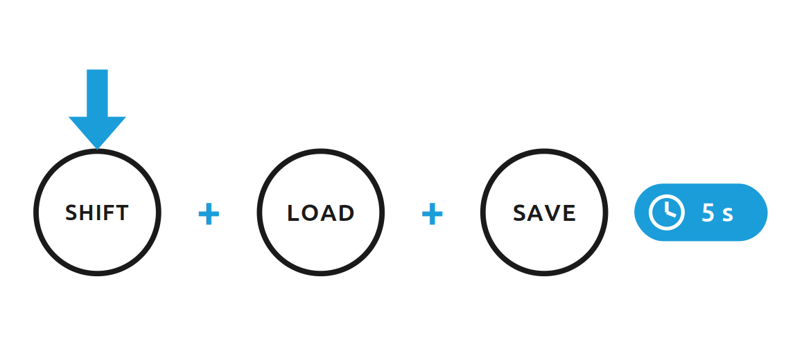
- Enter: hold SHIFT + LOAD + SAVE for five seconds. Channel A / green is selected first.
- SHIFT + A selects green, SHIFT + B selects red.
- The twelve ring positions span the full 0…4095 range (12 o'clock = 0, increasing clockwise, last position = maximum).
- The display is a bar filled from 12 o'clock; the active color is previewed live at the chosen brightness.
- Save and exit: hold SHIFT alone for five seconds.
Aim for a comfortable green, a red balanced against it and a convincing amber mix — not maximum brightness. CV/DAC maintenance is handled by the separate calibration image in the Unreleased development target; the firmware calibration guide contains the complete procedure.
Startup fade
At power-up all twelve note LEDs run one fixed 700 ms fade: off → green → amber → red → off. The complete effect is compile-time limited to at most 750 ms, then the actual persisted/current UI frame is restored immediately. The former rotating animations, EEPROM selector and discrete four-status-LED startup chase are removed.

SELF-TEST
If the automatic button-ladder rest check fails at startup, the ring flashes red three times and the firmware continues with the nominal ladder value.

9 Clearing user preset slots
There is no dedicated one-button factory reset. Holding LOAD + SAVE for two seconds clears only the twelve user Scale slots and twelve user Full Configuration slots. It does not change the current working state, live-state autosave or LED calibration. Empty Full Configuration slots then expose their built-in factory fallbacks again; this operation is therefore not equivalent to restoring the complete module to a shipping state.
10 Differences from the original firmware
The alternative firmware keeps the same operating model but fixes a few points of the original (Rust) firmware and adds features. The most relevant for players:
- Factory scale was empty → chromatic factory scale, playable at once; last note protected
- Negative scale-shift had no effect → negative values step downward correctly
- Trigger-delay didn't apply in track-and-hold → separate timing, works as indicated
- 1023 didn't hit the endpoint exactly → exact 0→0 / 1023→120-semitone mapping with persistent per-channel input/output affine calibration
- Sentinel-only storage, no checksum → versioned + CRC-checked, factory presets as fallback
- LED brightness fixed in code → red/green independently calibratable
- — → new: Arpeggiator performance layer with SHIFT double-click, factory fallback presets, compact startup fade and live-state restore

11 Specifications & quick reference
Specifications
Parameter | Value
Channels | two, independent or linked
V/Oct input | 0–10 V · 0 V = C
CV output | 0–10 V · 1 V/Oct
Sample gate | normalled HIGH
Trigger output | short pulse on Quantizer note change; optional 5 ms per Arpeggiator step
Memory | 12 scale + 12 full-config user slots · CRC-protected · wear-levelled live state · redundant ADC/DAC calibration journal
Platform | Arduino Nano / ATmega328P · 16 MHz
Calibration / maintenance | separate flash image · 115200 baud · persistent ADC/DAC calibration + loopback selfcal
Power | Eurorack +12 V / −12 V / +5 V via 16-pin (2×8) ribbon
License | GPL-3.0-or-later

Shortcuts
Gesture | Function
SAVE → note | save active scale to a slot
LOAD → note | load a scale from a slot
SHIFT + SAVE → note | save full configuration
SHIFT + LOAD → note | load full config (else factory preset)
SHIFT + note | secondary function (section 5)
LOAD + SAVE · 2 s | clear all user slots
SHIFT + LOAD + SAVE · 5 s | LED calibration
SHIFT double-click | switch Quantizer / Arpeggiator layer (enter enables, leave disables)

Credits
C++ / PlatformIO reimplementation: Axel Napolitano. Original design and Rust firmware: Quinn Freedman (github.com/QuinnFreedman/modular). Independent reimplementation, not affiliated with Free Modular.

12 Firmware installation
Prebuilt firmware ships as an Arduino .hex file. Flash it to the module's Arduino Nano with AVRDUDESS, a graphical front-end for AVRDUDE by Zak Kemble — no development tools required. This is the Windows end-user path; on macOS or Linux use AVRDUDESS or AVRDUDE per their documentation.
SAFETY — READ FIRST
Turn the Eurorack case OFF and disconnect the power ribbon before attaching USB. Never power the module from the bus and USB at the same time. Handle the module by the panel edges only and keep the PCB clear of anything conductive while USB is connected.
1 · Choose the right .hex
Tagged releases provide two Nano images. If unsure, try the new-bootloader image first; if AVRDUDESS cannot communicate, use the old-bootloader image.
Nano bootloader | File · baud
New / Optiboot | …-new-bootloader.hex · 115200
Old Nano bootloader | …-old-bootloader.hex · 57600
2 · Configure AVRDUDESS
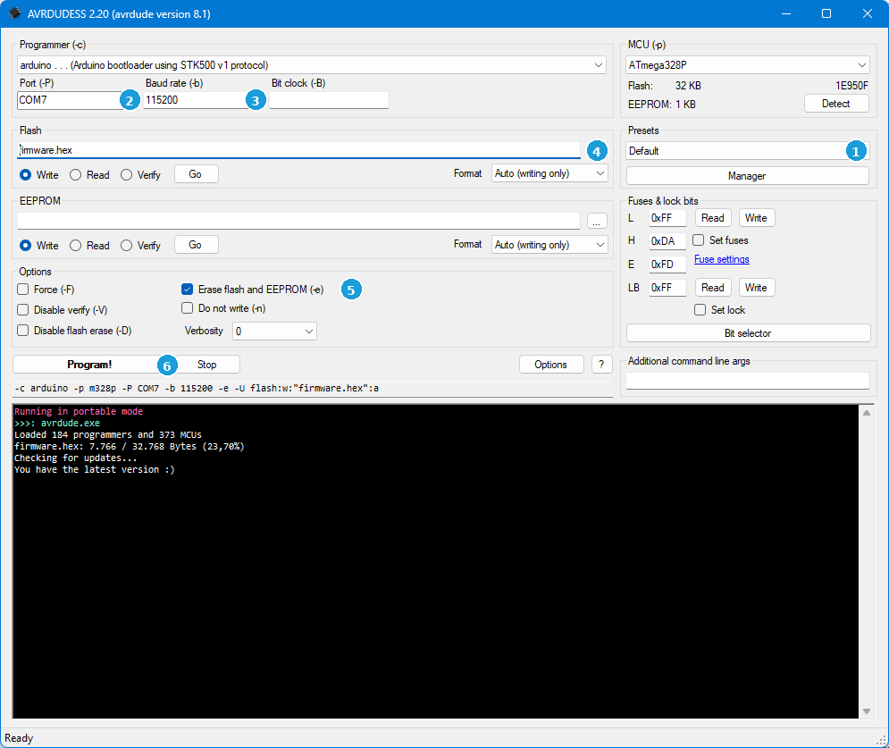
AVRDUDESS 2.20 — the six numbered controls for an update
 | Control | What to do
1 | Presets | not required — keep the default configuration
2 | Port | select the COM port of the connected Nano
3 | Baud rate | 115200 (new bootloader) or 57600 (old)
4 | Flash file | click …, pick the release .hex, keep Write selected
5 | Erase flash+EEPROM (-e) | leave OFF for a normal update
6 | Program! | start the upload; watch the log below
DO NOT ERASE EEPROM
For a normal update, Erase flash and EEPROM (-e) must stay OFF — otherwise your saved scales, full configurations, live state, LED calibration and persistent ADC/DAC calibration are wiped. Keep Disable flash erase (-D) ON, leave verify enabled, and never change fuses or lock bits.
Also confirm: programmer arduino (STK500 v1), MCU ATmega328P, EEPROM file empty, Force (-F) off, Do not write (-n) off.
3 · Program and finish
- Confirm the ribbon is disconnected and the COM port, baud and .hex are correct, with -e OFF.
- Click Program! and don't touch the module or USB while it writes and verifies.
- Wait for “avrdude done. Thank you.” in the log.
- For the production image, let the fixed startup fade finish and confirm the normal UI appears. For the calibration image, confirm the 115200-baud maintenance console is available. Only then treat the image as booted successfully.
- Disconnect USB, then (case still off) reconnect the ribbon, reinstall the module and power up.
Troubleshooting
- No COM port: try another cable/port and close serial monitors; some clone boards need the CH340/CH341 driver.
- No communication: confirm ATmega328P, the arduino programmer and the port; try the other bootloader/baud; reconnect USB.
- Settings gone after update: -e was left on and erased the EEPROM; recreate presets, LED calibration and the persistent ADC/DAC calibration profile.
A missing or damaged bootloader is a separate recovery that needs a second Arduino as ISP programmer — see Arduino's bootloader-burning guide. It is not needed for normal updates. AVRDUDESS: github.com/ZakKemble/AVRDUDESS.

13 CV calibration & maintenance image
The Unreleased development target planned for firmware 0.2.2 stores independent affine calibration for ADC A/B and DAC A/B in a redundant CRC16-protected EEPROM journal. Production firmware only reads and applies this profile; AnalogConfig.h remains the factory/fallback profile.
When calibration is required
Analog calibration is not periodic maintenance and is not required merely because firmware was updated. Use the maintenance image only if the module has never been individually calibrated, if the persistent calibration data were erased or lost, after a relevant analog CV input/output or reference-path hardware change, or when measurement shows a meaningful pitch / 1 V/oct error. A valid verified calibration survives normal EEPROM-preserving firmware updates.
Power and connection safety
For firmware updates and the complete calibration/maintenance session, power the module from the Arduino Nano USB connection only. Switch the Eurorack case off, remove the module, disconnect the Eurorack power ribbon and leave it disconnected until the production image has been restored and USB has been removed. Never power the module from the Eurorack bus and USB at the same time.
External precision voltage sources, DMMs and loopback cables are measurement connections only; do not use them to introduce a second power supply to the module. Keep the exposed PCB on a clean, dry, nonconductive surface while USB power is present.
Using the maintenance image
With the Eurorack ribbon disconnected, connect the Nano to the computer by USB; USB powers the module for the complete maintenance session. Flash the matching calibration/maintenance HEX without erasing EEPROM, then connect a serial terminal at 115200 baud. The maintenance image boots directly to the console; there is no SHIFT-at-power-on entry. Use cal show/load/save/defaults for the profile, cal adc a|b for guided ADC calibration, cal set adc|dac … for manual affine edits, eeprom status/backup for read-only persistence diagnostics, and cal report for a final read-only verification record and label block.
Manual calibration
Calibrate each ADC input first against a trustworthy external 0 V / 10 V reference using cal adc a and cal adc b. Input calibration is the measurement reference for loopback self-calibration. Manual affine corrections can be entered with cal set adc|dac a|b OFFSET NUM DEN and remain in RAM until cal save.
Loopback self-calibration
Patch CV OUT A directly to CV IN A and run cal self a; use OUT B → IN B with cal self b. The maintenance firmware checks for a plausible monotonic loop, measures RAW support points, fits only the selected DAC affine correction, verifies the candidate at independent points and saves it only after PASS. cal verify a|b repeats independent verification.
Calibration report / module label
After ADC calibration and both DAC self-calibrations have been stored, patch CV OUT A → CV IN A and CV OUT B → CV IN B at the same time and run cal report. The command requires a valid stored calibration record, re-verifies both DAC loops at independent points, prints the active journal generation and all four affine coefficient sets, and does not write EEPROM. The active in-RAM profile must match the newest stored record; unsaved edits make the report abort until they are either saved or discarded with cal load.
Only a full PASS produces the compact LABEL block intended for a manufacturing or service label. The label states ADC A/B: STORED PROFILE rather than claiming a new absolute ADC verification: loopback uses the established ADC calibration as its reference and cannot independently prove the ADC voltage scale. If either DAC fails verification, the firmware prints OVERALL: FAIL and explicitly says not to apply a calibration label.
The Nano has no real-time clock. Calibration date/time, module serial number, builder/tester identity and similar manufacturing metadata must therefore be added by the host-side report or label workflow; the firmware does not invent them.
Measurement boundary
Loopback is not an independent absolute voltage standard. The active ADC calibration is the measurement reference, so ADC and DAC errors cannot be separated from the same closed loop. An incorrect ADC calibration can be transferred into the DAC correction instead of being removed.
If loop detection, fitting, verification or EEPROM persistence fails, the previous active calibration is restored and the existing valid EEPROM profile is retained. Missing or incorrect patching therefore cannot replace a known-good calibration.
The current Unreleased implementation deliberately uses affine gain/offset correction only. It does not reserve EEPROM for a 121-note residual table; such a correction is justified only if repeatable hardware sweeps show relevant non-linearity beyond the affine model.
EEPROM
Normal image swaps preserve calibration when EEPROM erase is disabled. The maintenance writer is hard-limited to EEPROM bytes 967…1022; presets and live state are outside its address space. A full flash+EEPROM erase (-e) deletes presets, live state, LED calibration and the ADC/DAC journal. Holding LOAD + SAVE to clear user slots does not delete the ADC/DAC profile.
14 Version history
This manual is prepared for the Unreleased development target planned as firmware 0.2.2. The latest declared release is 0.2.1.
Unreleased — planned 0.2.2
Planned next-release changes: persistent affine ADC/DAC calibration with a redundant CRC16 EEPROM journal, a separate calibration/maintenance image, hard writer isolation to EEPROM bytes 967…1022, verified CV OUT → CV IN loopback self-calibration, a read-only calibration report with PASS-only module-label output, safe migration of a newest former twelfth live-state record from firmware 0.2.1 and earlier, and one compact ≤750 ms startup fade.
0.2.1 — 2026-08-17
Maintenance and calibration-verification release: RAW/CAL console semantics, broader native verification and release qualification, and the 95% AVR flash engineering ceiling. Core hardware and musical workflow remain unchanged.
0.2.0 — 2026-08-09
Turns the alternative firmware into a broader performance release while preserving the original hardware and core quantizer workflow.
- Complete second Arpeggiator layer: scale-aware patterns and shapes, internal/external clock, swing, 1–12 step length, 1–4 octave range and optional per-step triggers.
- Symmetric SHIFT double-click enter/exit replaces the former hold gesture; entering enables, leaving disables.
- Live-state and full-configuration persistence now include both arpeggiator configs, the selected channel and the active UI layer.
- Microsecond external-clock capture, button-ladder plausibility window and an initial-hysteresis fix.
- Clearer LED calibration (live green/red/amber comparison) and a 1500 ms startup-animation cap.
- 29 native test suites / 237 tests; first end-user manual for firmware 0.2.0. No hardware changes.
0.1.1 — 2026-08-07
Patch release restoring and correcting the native CI test suite; runtime behavior unchanged from 0.1.0.
0.1.0 — 2026-08-07
Initial public C++/PlatformIO reimplementation for Arduino Nano / ATmega328P: two quantizer channels, twelve-note scales, Track/Sample, glide and delay, pre-/scale-/post-shift, relative/absolute channel B, linking, 12 scale + 12 full-config slots with a factory preset bank, CRC-checked EEPROM, independent red/green LED calibration, four startup animations and a scale-aware arpeggiator mode.
COLOPHON
Quantizer — User Manual for the alternative C++ / PlatformIO firmware. Typeset in Ubuntu.

This manual is licensed under a Creative Commons Attribution–NonCommercial 4.0 International (CC BY-NC 4.0) license. You are free to share and adapt this material for non-commercial purposes, provided you give appropriate credit and indicate changes. Full terms: creativecommons.org/licenses/by-nc/4.0/
The firmware is licensed separately under GPL-3.0-or-later; that licence does not extend to this manual. Text, layout and illustrations are deliberately kept under CC BY-NC 4.0.
Illustrations and visual design were created with the assistance of AI — Claude (Anthropic), 2026.
Documentation and firmware: Axel Napolitano. Original module design and Rust firmware: Quinn Freedman.
Independent reimplementation. Not affiliated with Free Modular.
© 2026 Axel Napolitano · From Munich with 
